Individual Assignment

semtb001

In this assignment I have created a game that implements all the main features, all of the additional features, and a few extra features.

## A pause feature.

If the player wants to pause the game, they can touch the pause button located at the top right corner of the screen as seen in *Figure 1*. This pause icon is semi-transparent so that it doesn’t obstruct the view of the game.

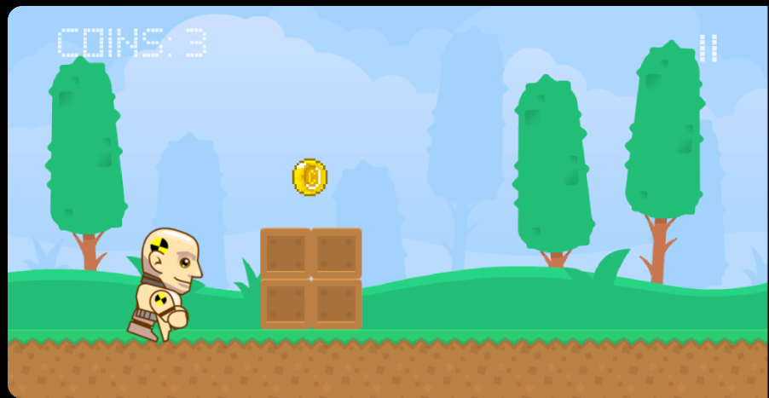

*Figure 1: Pause functionality icon.*

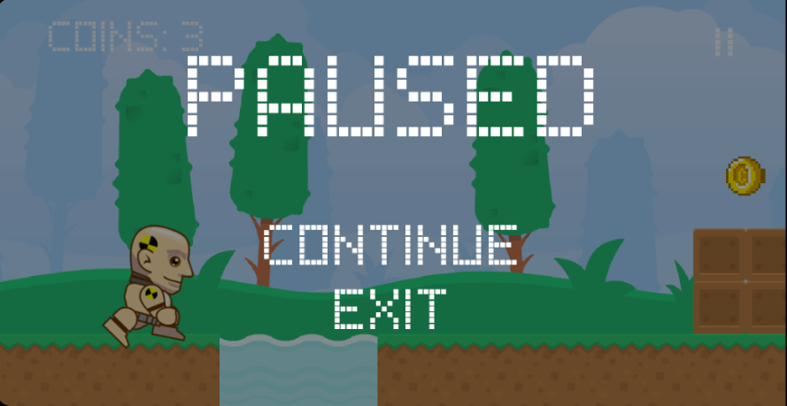

*Figure 2: Pause menu.*

Once the pause icon has been touched, the paused menu will be displayed as can be seen in *Figure 2* above, all game movement will come to a halt, and all game sounds will stop.The pause menu dims the game screen so that the text on the screen is more readable and the fact that the game is paused is more obvious to the user. From here the user can touch ‘continue’ to resume the game and they can also touch ‘exit’ to exit to the main menu. *(Note: the pause button is not included when the user touches the top half of the screen to jump, this means that the user can pause the game without making the player jump)*

## Sounds

I have implemented sounds to most aspects of the game. From the beginning in the main menu, there is a ‘click’ sound that plays every time the user selects an option in the menus. In the game, the player has 3 different ‘grunt’ sounds and a random one plays every time the player jumps. Also, there are 3 different ‘shh’ sounds and a random one plays every time the player slides. When the player ‘fails’, a ‘ouch’ sound plays. Both the flying and ground enemies have their own sound (‘sludge’ sound for the slimes and ‘bzzz’ sound for the bees) that gets louder as the player approaches them. Once they pass the player and become further away, their sound volume decreases. When the player collects a coin, a ‘cha-ching’ sound plays.

## Looping background music

There is looping back-ground music that plays when the user is playing a level provided that the game isn’t paused.

## Unique graphical style

This game comes with a unique graphical style. Whilst the player and ground texture remain the same, the textures used in the levels and for the flying enemy have been customized.

## Second level (or more)

At the start of the game *(from a fresh install)* there is only 1 playable level as indicated in *Figure 3* belowwith ‘level: 2’ being greyed-out. The next levels are only available to play when the user collects all the coins and gets to the end of the previous level. So, in order to play level 2, the player must collect all the coins in level 1 and make it to the finish line. Level 2 adds a new element in the game that wasn’t in Level 1. When the user is near a pool of lava, the screen shakes rapidly as if an earthquake is happening. This makes the game harder as it distracts the player.

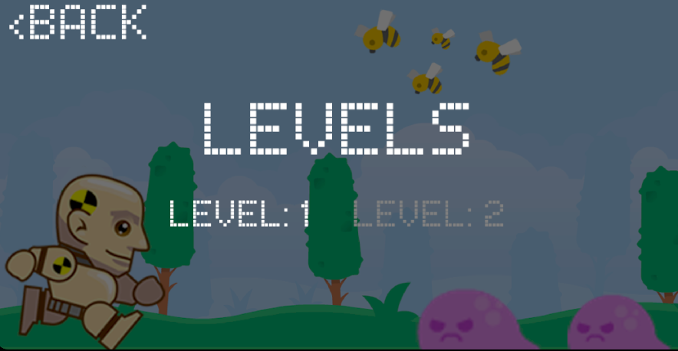

*Figure 3: Level’s menu.*

## Slide action and associated threats

The player can slide by touching the bottom half of the screen. This makes the player’s Box2D box shorter so that it can slide under obstacles that are 2 blocks off the ground. The player normally is 2.1 blocks tall so if the player does not slide, they will hit their head on the enemy/obstacle and will die.

The enemy that proposes a threat in the air is a bee. They do not move on the y axis so they stay a fixed height when created. If the player comes into contact with a bee, they instantly die.

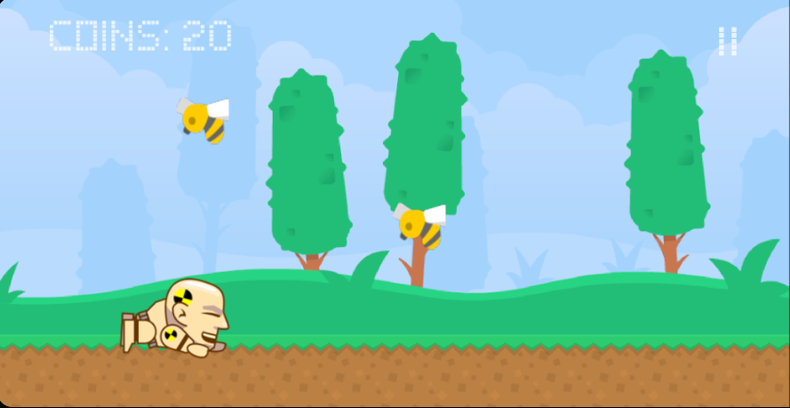

*Figure 4: Slide functionality.*