|  |
| --- |
| http://4.bp.blogspot.com/-u_FvUul3YWY/TdHhy1hZ3aI/AAAAAAAAAVI/rebdBLO4sj0/s1600/domino2.jpg |
| The All Purpose Guide to : |
| Dominos! |
|  |
| **Bonnie Tseng** |
|  |

|  |
| --- |
| **Brought to you by the creators of** ***Dices!*** |

**Table of Contents**

**Origins of the Game………………….. ….. 3**

**How to Play…………………………………. 4**

**Features of *Dominos!***

**Setup……………………………………... 5**

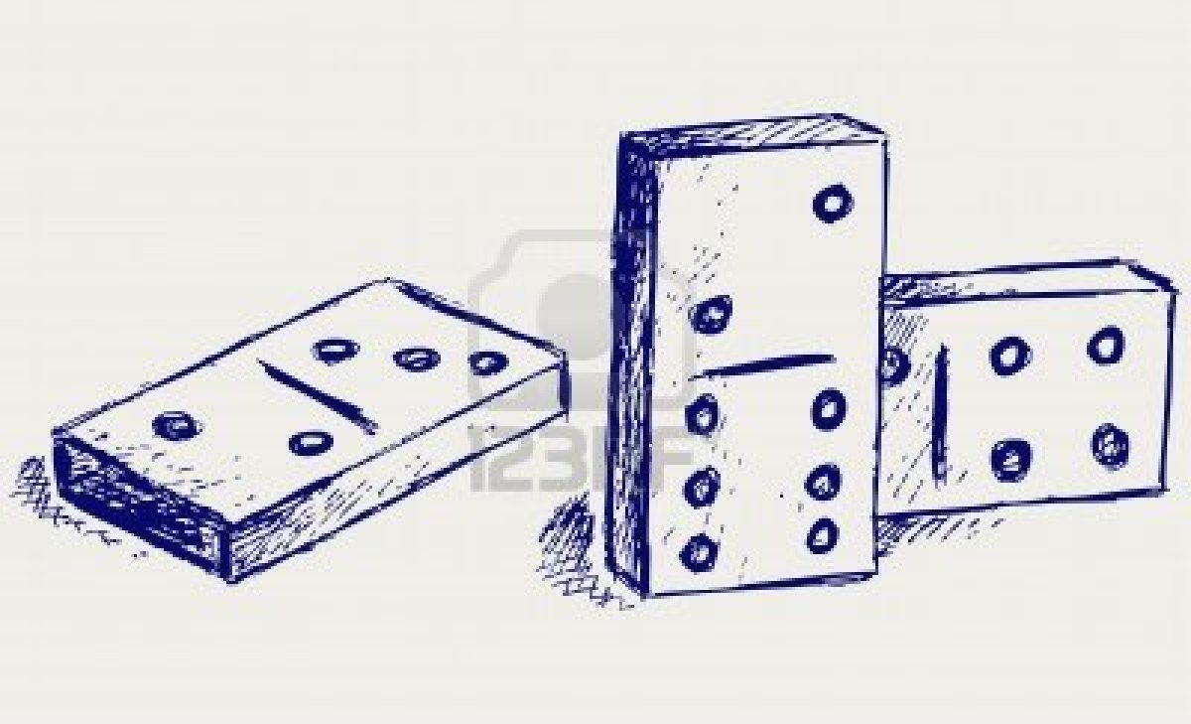**User Interface…………………………. 6**

**Disclaimer……………………………........... 8**

**Origins of the Game:**

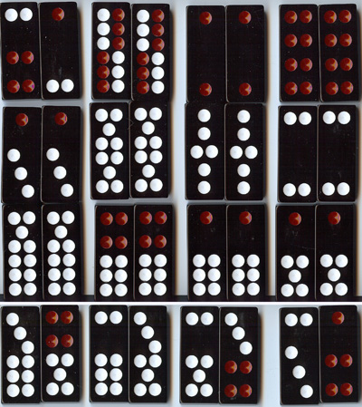 The game of dominos is a classic; it can be traced back to as early as the 12th century! This simple game originated from China and eventually gained popularity in Europe in the 17th century.

Soon, it became the most popular game to play while enjoying leisure in family parlours and pubs. The domino set today consists of twenty eight unique dominos with tiles combining two values between zero and six.

Figure 1: Chinese Dominoes

**How to Play:**

The game of Dominos is played with a 28 dominoes set distributed among four players.

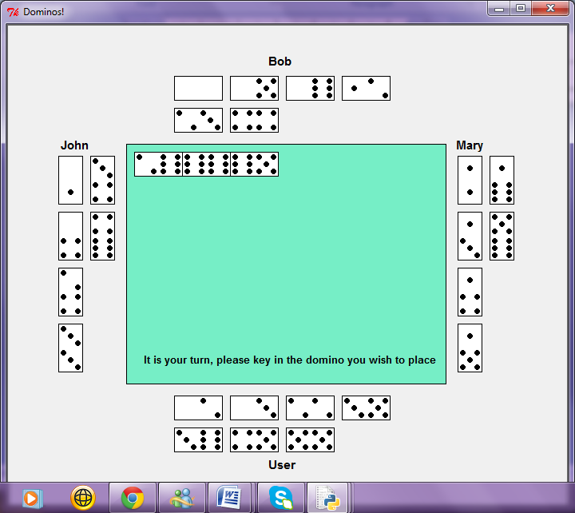 In the game, the notation *a-b* is used to describe the tiles where *a* is the smaller value on the tile and *b* is the larger value:  
 ***1 – 3***

The player with the 6 – 6 domino goes first and places the double six on the table. The players then take turns playing their tiles. The value of the tile being played must correspond to the value of the tile at the end of the chain.

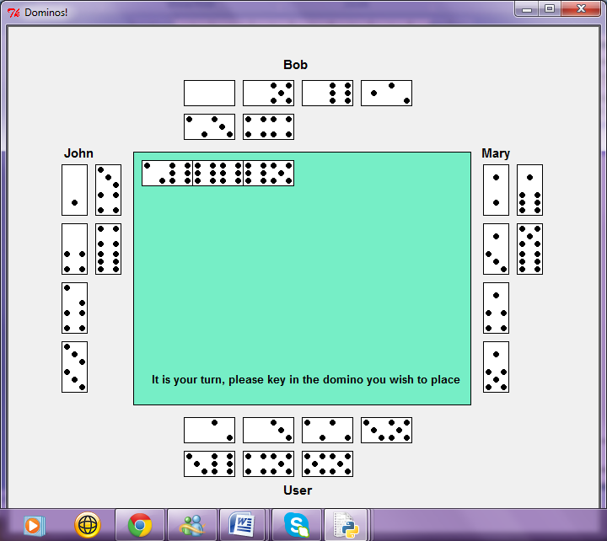For example:

If the existing chain was:

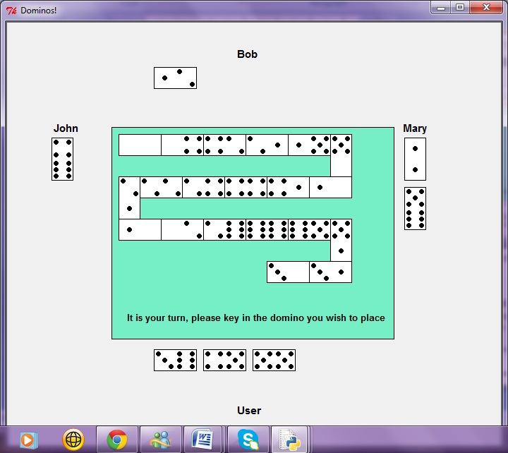The next tile to be played must contain either a *2* or a *5*:

The first player to play all of his/her tiles wins.

**Features of *Dominos!*:**

**Setup:**

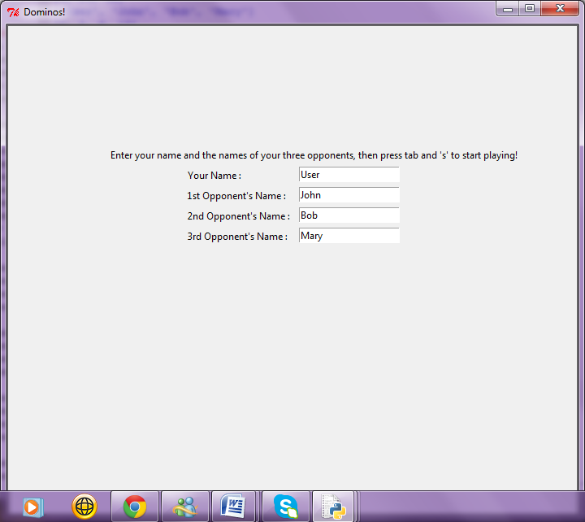 When you first begin the game, the screen will ask you to enter your name as well as your opponent’s names.

If you prefer the default names, simply press*‘s’* to begin the game. Otherwise, enter the names then press tab before pressing*‘s’* to begin.

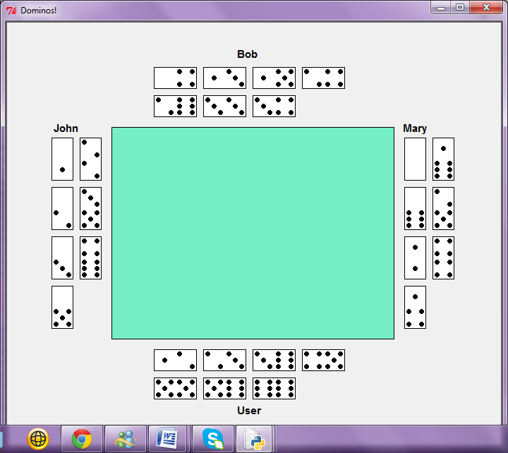

Once you press*‘s’*, the set up of the game will appear:

The green rectangle in the centre will act as a table on which the dominos will be played. The rectangles that border the table are the hands of your opponents, labeled according to the names you inputted prior to the game.

**User Interface:**

Your hand will be along the bottom of table with the dominos facing up so that you can see the value of the dominos.



When it is your turn to place a domino, you press a series of keys to specify which domino you want to play and where.  
 First, you determine which domino you want to play. To do this, you key in the number that corresponds to the position of the domino in the hand:

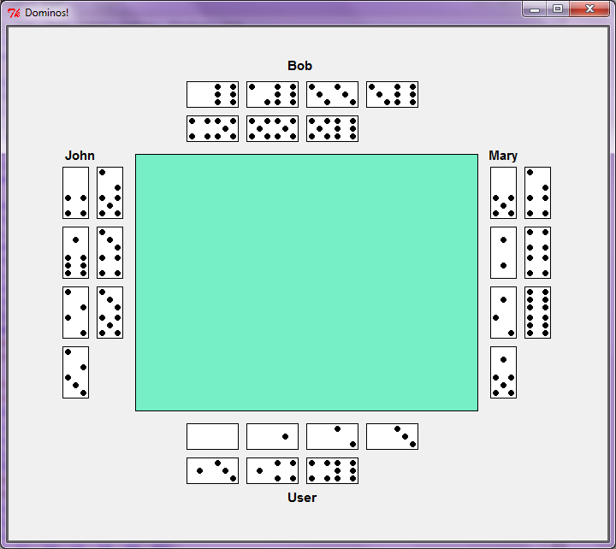***Positions:***  *1* *2 3 4*

*5 6 7*

Next, you need to specify which side you are planning to place the domino. If you key in *‘l’,* the domino will be placed at the beginning of the chain. If you key in *‘r’*, the domino will be added to the end.

For example:

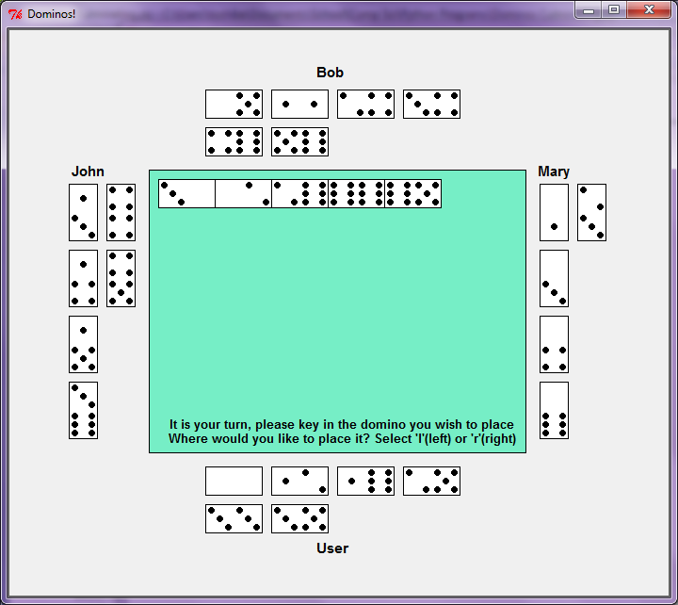

*If you want to add the 3 – 5 domino to the beginning of the chain, you would key in “6”, for the 6th domino, then “l” for the left side of the table.*

If you do not have a valid domino to play at your turn, simply press *‘p’* to pass.

The game will continue until of the players had played all of his/her tiles.

**Disclaimer:**

Some of the information and pictures were taken from other sources. The sources are listed below:

“Chinese Dominos.” Web. 17 June 2013.<http://www.inventchina.org/>

“Domino Sketch.” Web. 17 June 2013.<http://4.bp.blogspot.com/>

“Domino Title Page.” Web. 17 June 2013.<http://us.123rf.com/>

“The History of Dominoes.” *Domino-Games.com.* 2013. Web. 17 June  
 2013. <http://www.dominogames.com/>