Control Signals – Initially loading channel message and message passing to CNU

- Signal instantiation: llr_fetch, v2c_src, v2c_msg_en, v2c_load
- Note
  - Although one codeword decoding process is only required fetching the channel messages from channel buffer in one clock cycle, the llr_fetch is still asserted for four rising edges of read clock. This is because the propagation delay from channel buffer till VNUs may be so long that message passing cannot be completed in one clock cycle. Thus the additional Q-bit registers of depth 4 are inserted in between.

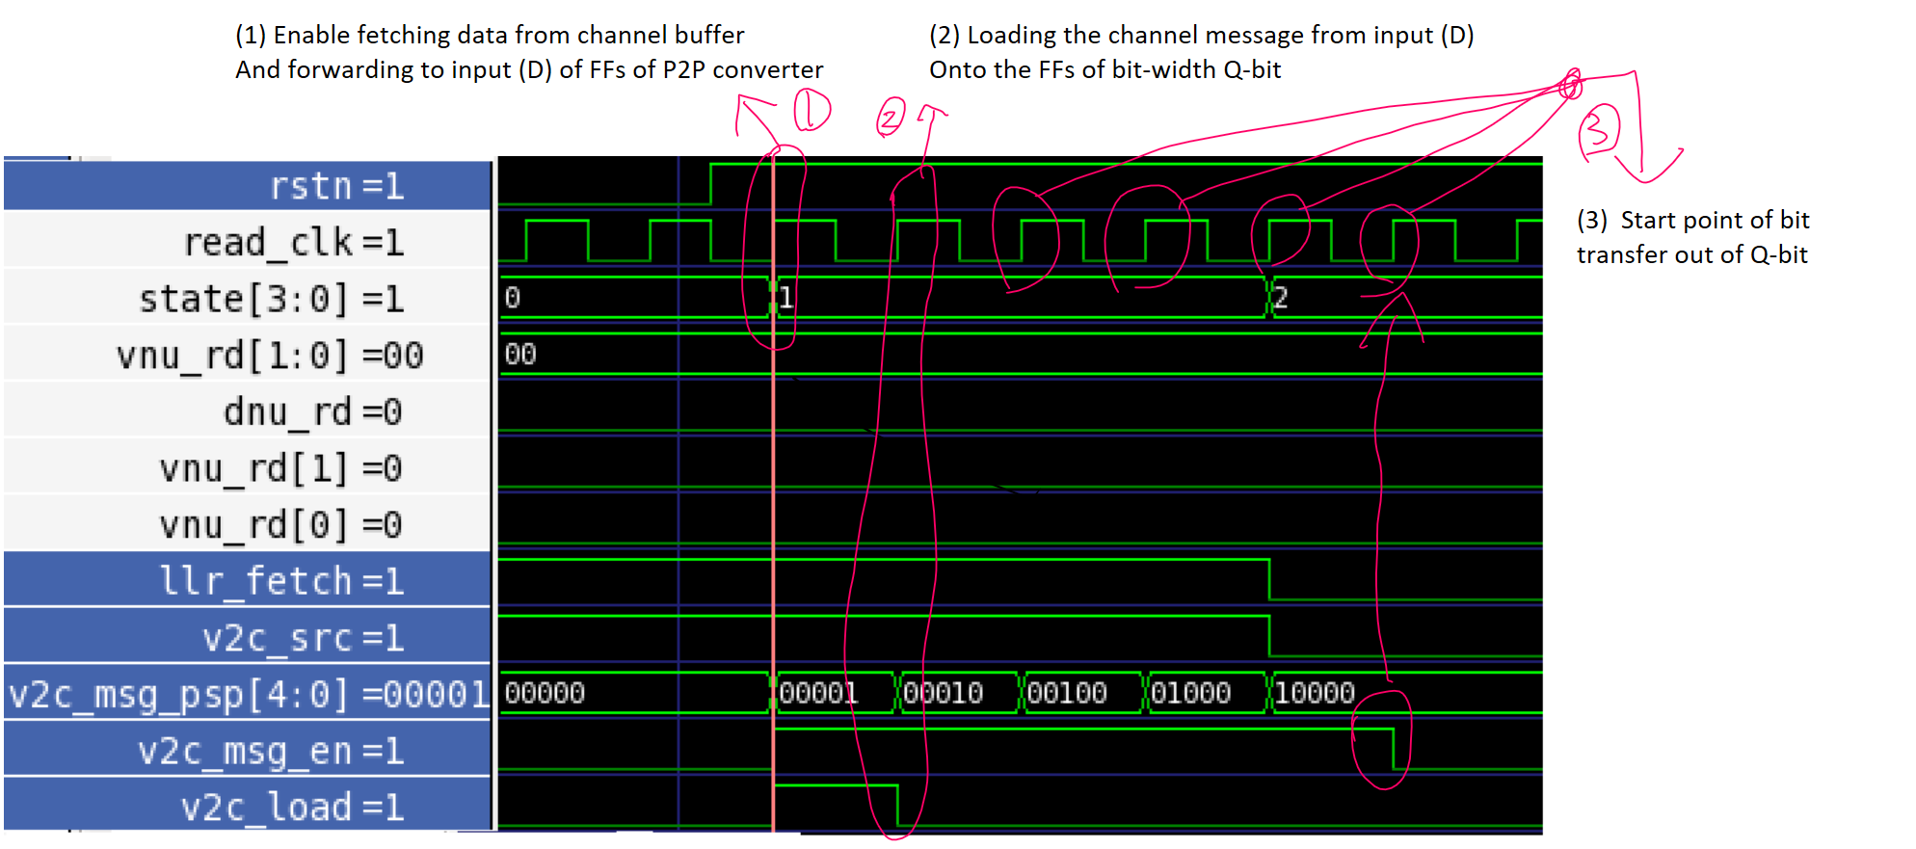

- Signal instantiation: cnu_rd, c2v_load, c2v_msg_busy, c2v_msg_en and c2v_msg_psp
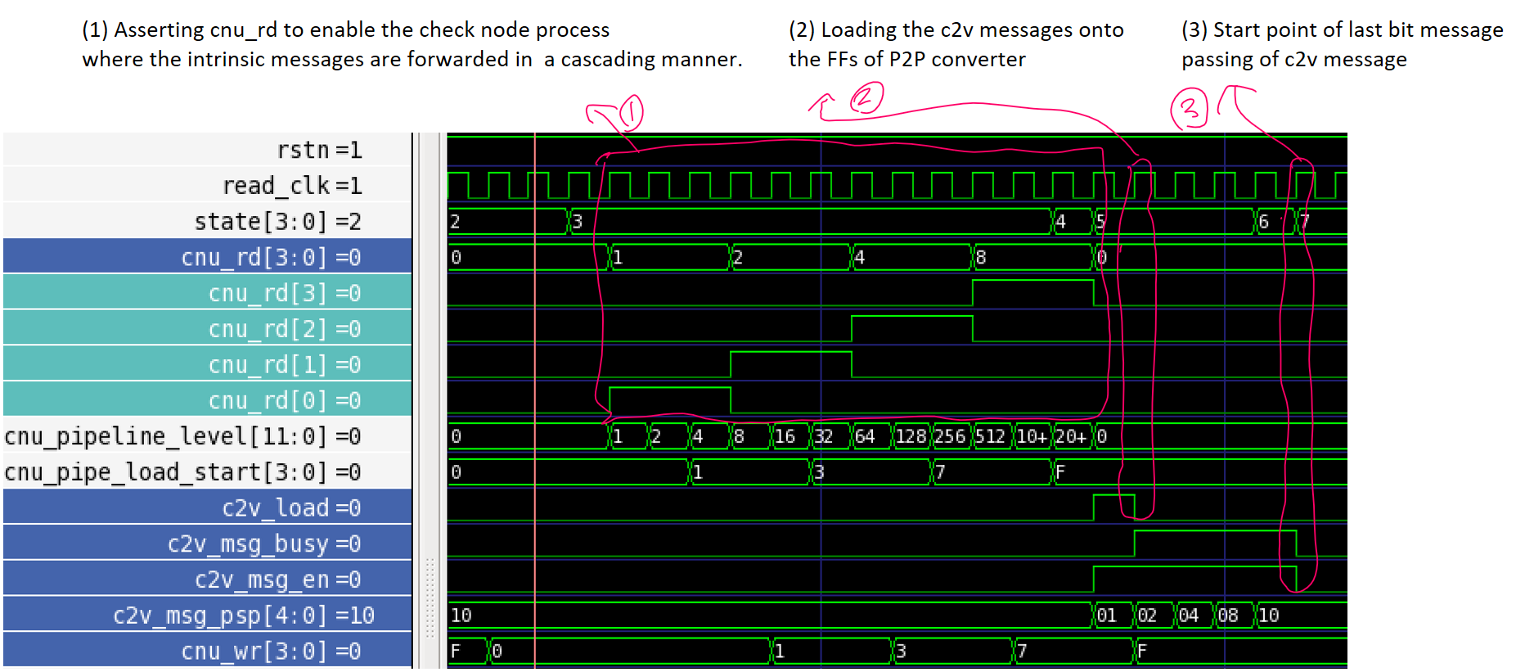

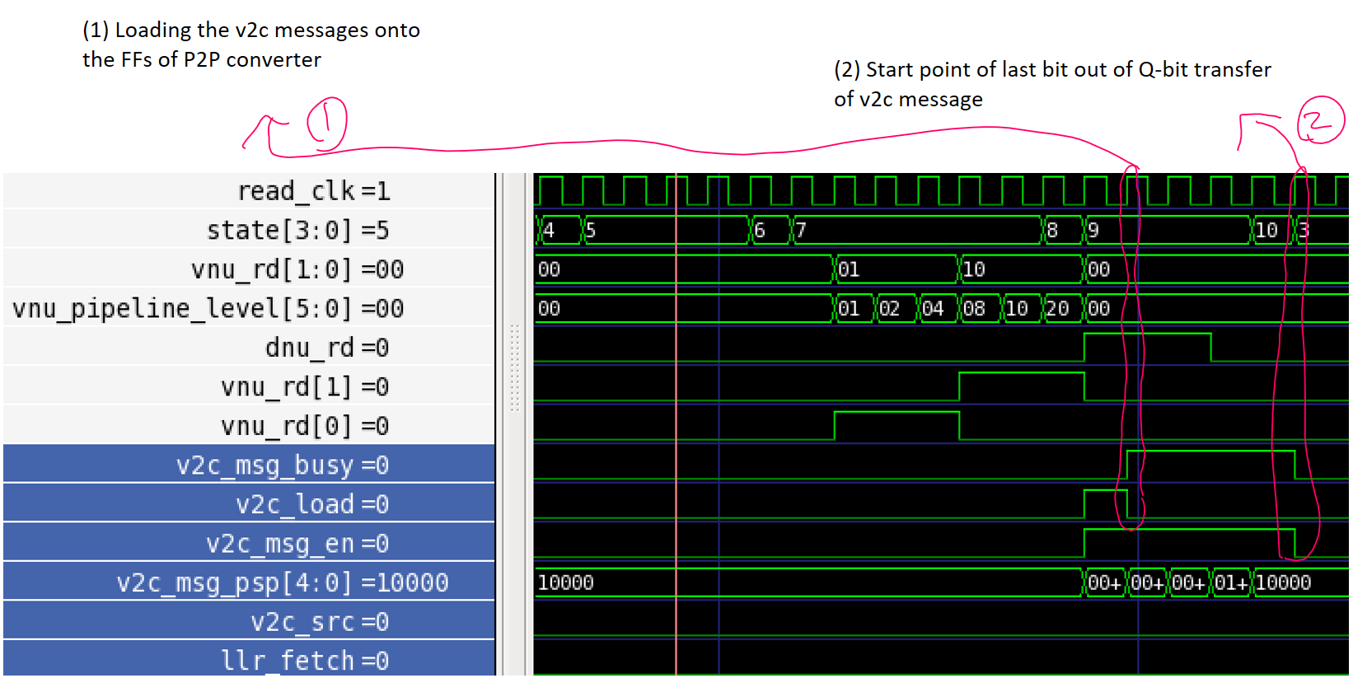
- Signal instantiation: v2c_msg_busy, v2c_load and v2c_msg_en

Signal instantiation: c2v_parallel_in, extrinsic_route, c2v_parallel_out, c2v_latch, c2v_msg_en, c2v_load

