Testbench

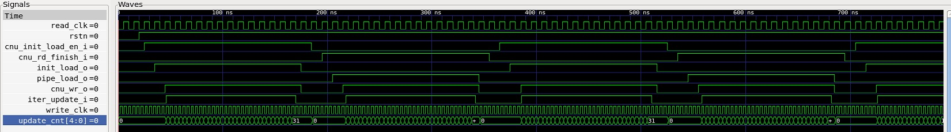

Schematic – Asynchronous Handshaking Scheme

