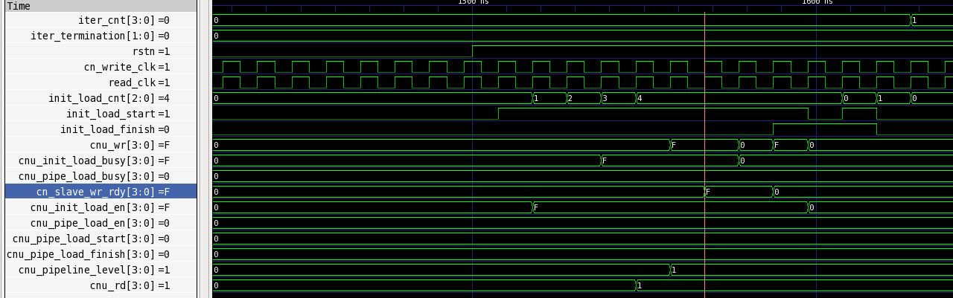
Issue – cn_wr signal is de-asserted too early
1st rising edge
2nd rising edge

Root Cause of the issue:

The issue arises from the timing of cn_slave_wr_rdy assertion. When cnu_wr is asserted, the CNU.Iter_Write.FSM will assert it iter_update signal to cn_slave_wr_rdy one clock cycle later due the equality of read_clk and cn_wr_clk clock rate. But however, we hope that the cn_slave_wr_rdy can be asserted before 2nd rising edge of read_clk, otherwise the XNOR input by a) cn_wr and b) cn_slave_wr_rdy would be (1 XNOR 0) = 0. That is the reason why cn_wr is de-asserted again at 3rd rising edge of read_clk (actually is 4th rising edge, because I intentionally insert one more D-FF at output of cn_wr. Such attempt ought to be removed later).

Solution:

Redesign the handshaking circuit for the case where the clock rates of both read and write operations are ever too close.

