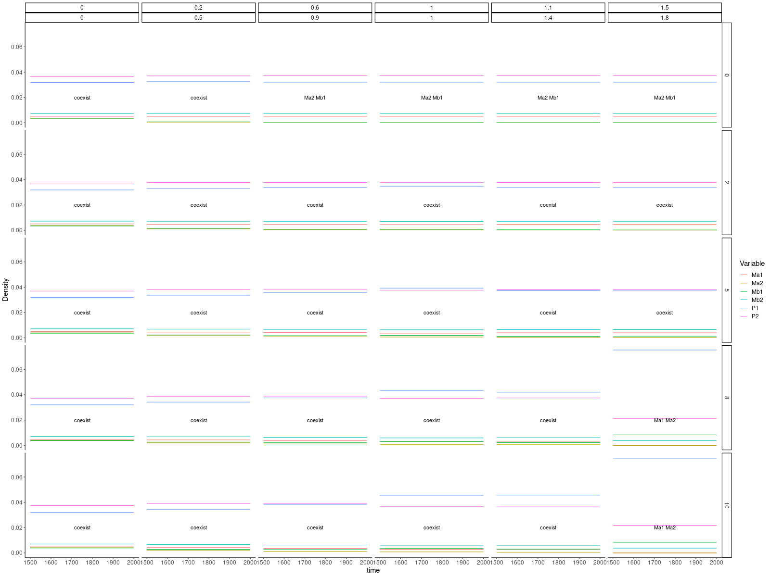

Jazen-Connell scenario with strong microbial effect

* Growth rates for home microbes were different, Mb2 was higher than Ma1.
* When increasing the ratio of interspecific competition, away microbes went to extinction with no dispersal.
* When the ratio of interspecific competition was high, the Ma went to extinction. Since the growth rate of Mb2 is higher. With a high dispersal rate, Mb2 had the mass effect to replenish Mb1, though Mb1 had lower interspecific competition, however, the high density of Mb1 still can outcompete the home microbe of P1 (Ma1).
* With low enough interspecific competition of microbes and low enough dispersal, plant competition most affects the result. P2 will have a higher density than P1 since the original parameter space was set as higher intraspecific competition for P1 than P2, moreover higher interspecific competition on P1 than P2. A high enough dispersal rate can let Mb use mass effect to overwhelm Ma while the interspecific competition was larger enough than intraspecific competition. Subsequently, making P1 more than P2.
* Keep increasing the dispersal to check whether higher dispersal will make the extinction with lower interspecific competition of microbe.
* Keep increasing the interspecific competition of microbe to check whether lower dispersal will make the extinction.
* Using the two heat maps to show the extinct player and the plant with higher density.
* What if we set the growth rate of two microbes the same?

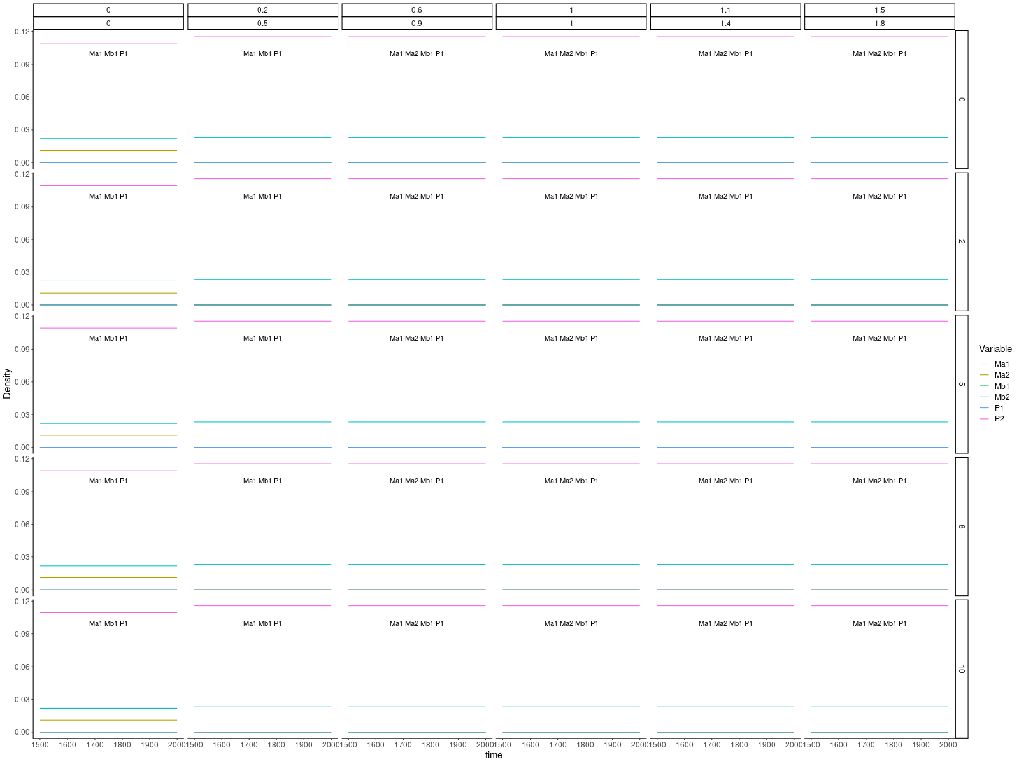

Jazen-Connell scenario with weak microbial effect

* When there was a low microbial effect, P2 had lower intraspecific competition, and P1 also had a lower interspecific competition on P2, therefore P2 will win. With the extinction of P1, both Ma1 and Mb1 went extinct since no carrying capacity.
* When there was no microbial competition or the ratio of intraspecific competition of microbe was high enough (alpha = 0.2, 0.5), Ma2 and Mb2 could coexist on P2.
* Dispersal did not have an obvious effect on the dynamic.
* With not strong enough microbial effect, plants will not be affected by microbes. Microbial competition affects microbial dynamic but dispersal.

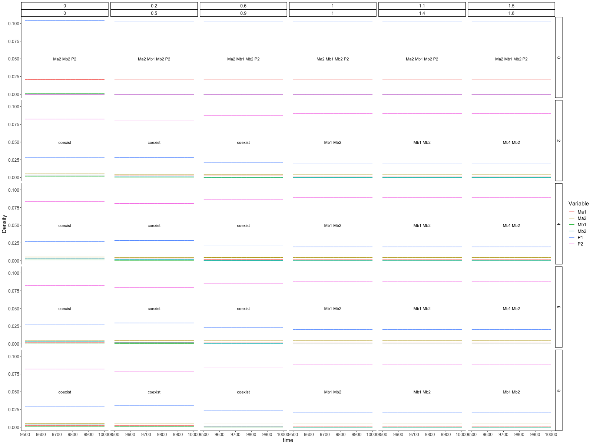

Mutual facilitation scenario with strong microbial effect

* When there was no dispersal, P1 had lower intraspecific competition, and P2 also had a lower interspecific competition on P1, therefore P1 will win. With the extinction of P2, both Ma2 and Mb2 went extinct since no carrying capacity. Only when there was no competition between microbes then Ma1 and Mb1 coexist on P1.
* When interspecific competition between microbe was high, Mb went extinct, since the condition of Mb is too low that Ma1 will outcompete Mb1 on P1. Ma2 was replenished by Ma1 through dispersal the mass effect made a high density of Ma2 which overwhelmed the low condition rate of Mb2 therefore Mb2 was outcompeted.

Coexistence happens when there is a difference in conditioning ability between plants and microbes

Mutual facilitation increases the diversity when the host-specific is not so strong

How does the strength of host-specific affect the dynamic?

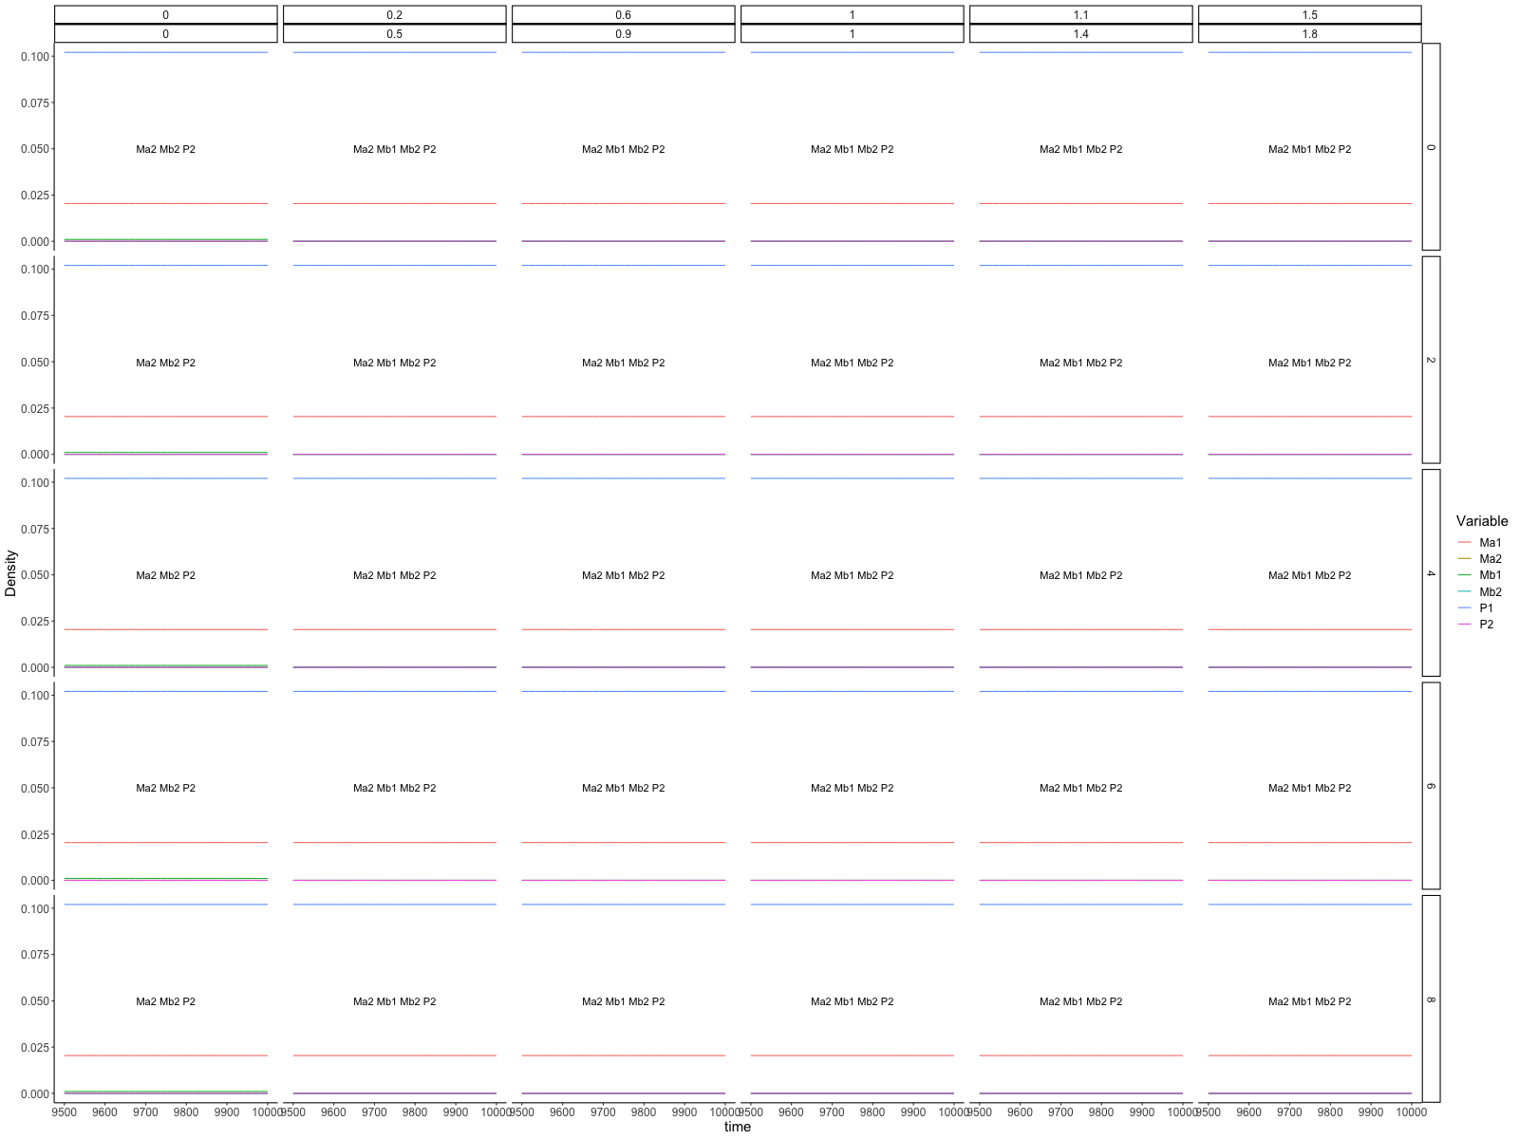

Mutual facilitation scenario with weak microbial effect

* When there was a low microbial effect, P1 had lower intraspecific competition, and P2 also had a lower interspecific competition on P1, therefore P1 will win. With the extinction of P2, both Ma2 and Mb2 went extinct since no carrying capacity.
* When there was no microbial competition (or I think the ratio of intraspecific competition of microbe was high enough, maybe alpha was smaller than growth rate), Ma1 and Mb1 could coexist on P1.
* Dispersal did not have an obvious effect on the dynamic.

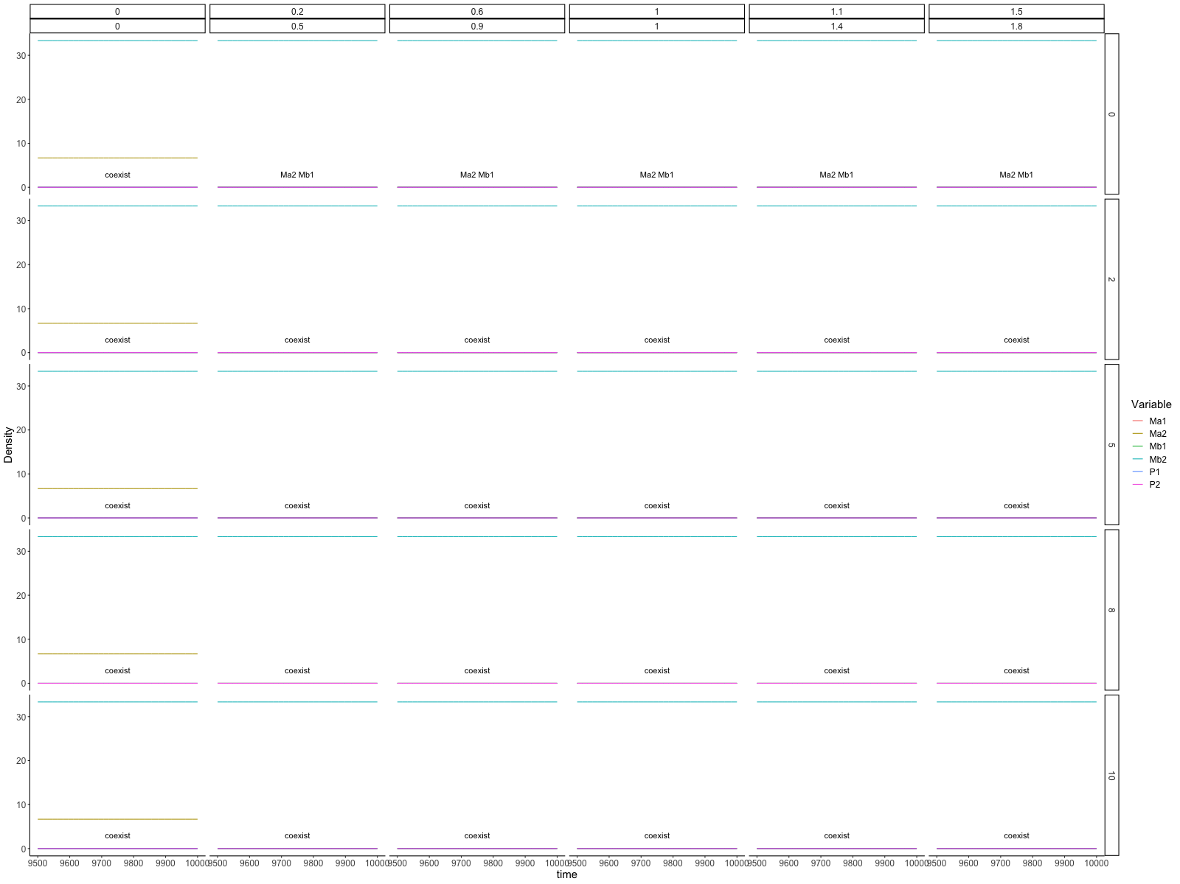

Enemy release scenario with a strong microbial effect

* Coexistence happened when there was no microbial competition.
* P2 had 10000 times higher density than P1, therefore when there was no microbial competition, both Ma2 and Mb2 had high density.
* When microbial competition existed with no dispersal, away microbes (Ma2 and Mb1) went extinct.

Enemy release scenario

I cannot find a parameter space that satisfies both weak and strong enemy releases to have contrast results (i.e., with both coexistence or both with competitive exclusion). Therefore, cannot investigate how microbial competition and dispersal affect the system dynamic.

It seems that the microbial effect on another patch is not effective. Since the microbes could only affect the patch that they stay on. Though the microbes from another patch have high density, due to density dependence for microbes on plants, the effective microbes cannot disperse to the focal plant. Finally, the result is that although the microbial effect (sigma) is high, the microbial density is too low due to their density dependence on the focal plant, which makes the microbes not affect plants.