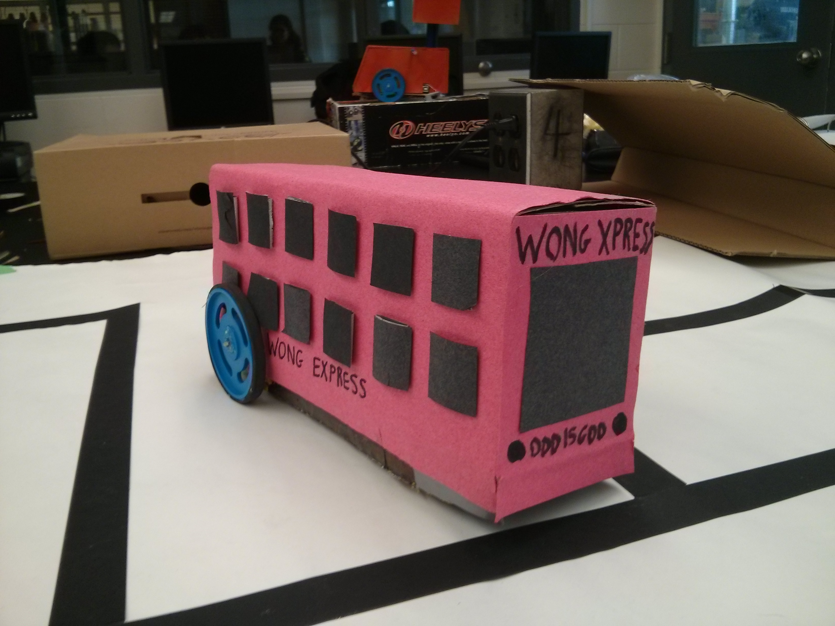

Intelligent Car (iCar)

David tsenter, ryan odd, erik trinh

For Mr Wong tej 4m 6/9/2014

**Introduction:**

Our group’s ICar will resemble a London double-decker bus design. It will contain a gear box in D mode, a set of wheels, a breadboard, an H-bridge, Arduino, and 2 power supplies (one for motors, and one for the Arduino). Additionally, there will be a single LDR used, placed near the wheels (refer to photograph) with an LED paired with it to ensure more consistent readings in different environments. One of the more distinctive features of our car is that it is significantly longer than an average car, or that of any other group. This design was selected in attempts to closely match the design of a double decker bus, and to provide an aesthetic enhancement. The group understood that making the car longer could create problems when solving the maze, namely with the turns and sharp corners, but the design was chosen nonetheless. This was done because we believed that due to the strategic placement of the LDR close to the wheels, it would still be able to solve the maze despite its irregular size, especially since there were no physical walls in the maze (just the 2d lines on paper). Thus, it was decided that function should be forfeited to a certain degree in exchange for aesthetic pleasure. Here is the design:

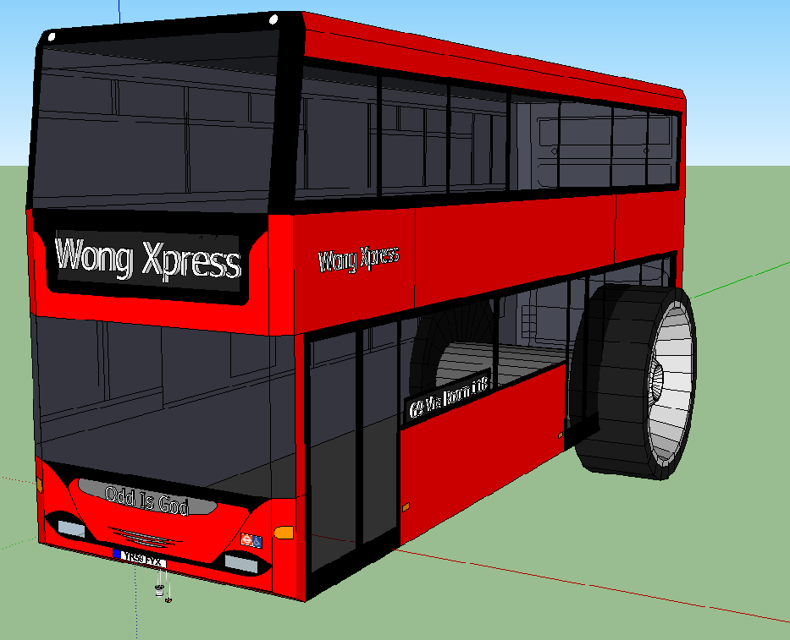

**Investigation:**

The first step in the creation of our project was planning. Our group spent 2-4 days debating on which design should be chosen based on a variety of factors such as; reliability, stability, size, efficiency, and whether it would be reasonable to finish it given our time constraint. After these discussions, it was mutually decided that a double decker bus design should be implemented.

Following the planning, the group began with the construction of the car’s exterior. David and Ryan planned out the exterior of the car by creating a prototype out of cardboard to ensure satisfaction before moving on to the actual design. With aid from Mr. Wong as well as a student from woodshop, the car’s final design was completed. At this point in time, the group was debating on whether a second shelf would be needed to create spacing between the power source, Arduino, and breadboard. In the end, it was decided that given the length of the car, a second floor was not needed, and would only weigh the car down, take longer to build, and potentially create more problems.

After the structure was complete, the group began putting on the components, which include: the gear box, Arduino, breadboard, and power supply. The gear box and breadboard were hot glue gunned down to the wooden board, and the wheels were put on the gear box. It is at this point that wiring, and coding began. The Arduino was secured above the gear box, and the H-bridge was installed and configured on the breadboard by Erik. The group had some difficulty with the H-bridge since we could not get the wheels to turn properly until around the third day of the wiring process. It was discovered that the problem consisted of improper power supply to the H-bridge, and so an extra supply of 6 volts needed to be added. The wheels worked fine after that.

Following the H-bridge, Erik wired the LDR and the LED. There were no issues with these components since group members had experience wiring them from the ISP from grade 11 (the intersection). It is important to note that originally, the LDR and LED were placed in the front of the car, on a platform built specifically for them. However, after some testing, it was decided that they should be moved down closer to the wheels since the large distance between them and the wheels was creating problems during left turns. After shifting them further down the car, these problems were resolved, and the design was finalized with the modification. Conveniently, the specially created platform was then used to hold a 6 volt battery pack for the motors, and did not need to be removed. This 6 volt battery pack for the motors was added after it was noticed the motors did not behave normally when the power for the motors was taken from the 5V pin on the Arduino.

The code did not take up too much of our group’s time since the logic was developed by David in advance, and it was fairly straightforward and simple to code. The code consists of the simple logic of turning left when the car is on the black line, and then turning right as soon as it goes off the line, or when white is detected. This made it so the car is constantly hugging the left wall of the maze, and will never fall off course. This also meant that the robot can solve any maze since it will constantly follow the left wall, and reach the end at one point by going through every single point on the maze. After the code was uploaded to the Arduino, there were some issues. The main issue was that the car was too slow, and it exceeded the time limit. As a result, the speed was doubled, and worked fine. However, as it was solving the cross intersection, some problems came up. Because of how fast the car was moving, it failed to slow down after a 360 degree turn, and continued spinning. Fortunately, during one of its turns, the LDR managed to get a proper reading, and the car finished the maze. Otherwise, everything worked smoothly, and the group is extremely happy with the turnout of this project, and there was no conflicts/fighting of any sort. We all think that the group worked perfectly together and the workload was distributed fairly.

**Evaluation**

In the end, our project worked 90% of the time, and the only problem that we came across while solving the mazes was that the power supply at the front of the car was not properly secured, causing it to fall and stop providing power to the motors. After securing it firmly with duct tape, this problem no longer occurred, and the car worked perfectly.

There were several minor changes made along the way such as the decision to not include a second floor to the car since the length was sufficient to hold all the required components. Another change was the decision to move the LDR and LED down the car, closer to the wheels, so that the wheels begin to turn as soon as the car is on the black line, and a much sharper and accurate turn is achieved. This change was necessary because before it, the LDR and LED were so far away from the wheels that by the time the wheels began to turn, the car was already well off the track. After the change, the car worked perfectly and no other modifications were needed.

If we were to do this project again, then we would most likely allocate some more time to planning since we found that there was a lack of strategic logic in our design, namely the placement of the LDR. We believe that an error like this could have been easily prevented if more though was put into planning the design. In fact, some group members were contemplating on changing the LDR’s location, but were unable to put their ideas in motion because it was decided that building needed to be started. We would also take into consideration the placement of the components such as the Arduino, breadboard, batteries, and motors in order to make wiring easier, and use space more efficiently.

Another thing we would change is that we would be less vocal about how our robot works, and let other groups plan their own way. We were so excited about the robot working, that we ended up telling many other groups about how it worked, and in the end, they ended up using the same ideas, and the majority of the working cars in the class function off of our design.

Additionally, we would most likely work on better work-distribution, and try to involve every group member in all tasks so that everyone can learn all the aspects of the creation of the car.

To conclude, the group believes that the ICar project was a great success, and we are all pleased with the turnout. Despite a few minor changes, and improvements for next time, the group believes that it was otherwise an amazing accomplishment, and is left with only positive memories as well as ambitious aspirations for the future.