C:\ALEX\NEW_INITIATIVE_FALL_2015\nexelus-logo-200.png

**Optimization**

Technical Requirements (TR)

Version 0.1

|  |  |  |  |  |  |  |  |
| --- | --- | --- | --- | --- | --- | --- | --- |
| Company confidential | | | | | | | |
|  | | | | | | | |
| NEXELUS | | | | | Confidentiality Notice  This document is issued in confidence and contains information, which is confidential to NEXELUS. Information presented herein must not be used against its purpose or against the interests of NEXELUS. Information should not be made public or otherwise disclosed to third parties without the written consent of NEXELUS. This document remains the property of NEXELUS. | | |
| Document Information  Document: TR-001  Version: 0.1  Status: Draft | | | | |  | | |
| Revisions | | | | | | | |
| Date | Version Number | | Revised By | | Reason for Changes | | |
| 2019-05-23 | 0.1 | | Asim Jamil | | Initial Draft | | |
| 2020-01-06 | 0.2 | | Asim Jamil | | updated based on Feedback from client and Imran. | | |
| 2020-01-16 | 0.3 | | Asim Jamil | | Page 15 New Rule added Page 23 ‘Planned (Editable)” section updated | | |
| **Approvals** | | | | | | | |
| Role | | Name | | Title | | Signature | Date |
| Business Owner | | Imran Rahman | |  | |  |  |
| Project Owner | | Asim Jamil | |  | |  |  |
| Development Manager | | Tauseef | |  | |  |  |
| System Architect | | Abid | |  | |  |  |
| User Experience Lead | | TBD | |  | |  |  |
| QA Lead | | TBD | |  | |  |  |
| Nexelus Consultant Lead | | TBD | |  | |  |  |

|  |  |
| --- | --- |
| **Open Items** | |
| Location | Description |
|  |  |
|  |  |

Table of Contents

2.4.36.4 Sample Data 190

2.4.36.5 Expected volume of data and SELECT/INSERT/UPDATE/DELETE procedures considerations 190

2.5 Modified Tables 190

2.5.1 Table 1 190

2.5.1.1 Description 190

2.5.1.2 New Table Structure 190

2.5.1.3 Additional/Modified Constraints 191

2.5.1.4 Sample Data 191

2.5.1.5 Expected volume of data and SELECT/INSERT/UPDATE/DELETE procedures considerations 191

2.5.2 Table 2 191

2.6 <Other Repository Media - XML, JSON, Text files, proprietary format> 191

2.6.1 Structure 1 191

2.6.1.1 Description 191

2.6.1.2 Structure Definition 191

2.6.1.3 Sample Data 192

3 Interfaces 192

3.13.1.5 User Defined Fields setup screens 216

3.1.5.1 Screens Mockup 216

3.1.5.2 Description and Business Logic 221

3.1.6.2 Description and Business Logic 243

3.2 Modified Screens 244

3.2.1 Screen 1 244

3.2.1.1 Modified Screen Mockup 244

3.2.1.2 Description and Business logic 244

3.2.1.3 Updated Flow Diagram 244

3.2.2 Screen 2 244

3.3 New Reports 244

3.3.1 Report 1 244

3.3.1.1 Description 244

3.3.1.2 Report Rendering 244

3.3.1.3 Sample Data 245

3.3.1.4 Report Selection Interface 245

3.3.1.5 Report Business Logic 245

3.3.2 Report 2 245

3.4 Modified Reports 245

3.4.1 Report 1 245

3.4.1.1 Description 245

3.4.1.2 Report Rendering 245

3.4.1.3 Sample Data 245

3.4.1.4 Report Selection Interface 246

3.4.1.5 Report Business Logic 246

3.4.2 Report 2 246

3.5 API 246

3.5.1 API Definition 246

3.5.2 API Constants, Data Types, Structures and Methods 246

3.5.3 Code Examples 246

3.5.4 API Client System Requirements 246

.

# Introduction

## Project Summary

### Definition

Campaign optimization is a continuous process where media team constantly observes the performance of the campaign based on delivery and consider adjusting keywords, ad copy, moving spend from / to different vendors based on performance, and various targeting choices.

This project will focus on optimization of media spend across vendors / sites based on delivery or AP (received vendor costs) information, which will allow agency to move media spend across different vendors based on past performance and future forecasting.

### Problem Statement

Optimization is a continuous process where media team continuously observes and enhances performance of campaign based on past performance and future forecasting to determine how much and with whom to spend for future goals by adjusting keyword, audience targeting and moving spend from / to different vendors. However, currently Nexelus doesn’t deal with keywords and targeting and users are managing it directly in platforms, that’s why this version of optimization functionality will focus on media spend part of optimization based on performance and future forecasting (even though Nexelus has ads feature available in Nexelus media module, but we will not consider ads in this release). [THIS is not correct, we are not focusing on keywords or on demographic based optimization). Reword/rewrite the above.

There are different factors considered by the media team during the optimization process which helps team to make certain decisions to move / add spend from one vendor to another vendor, however we are focusing only on media spend based on performance and/or received vendor costs. (WE are focusing on spend ONLY).

Some of examples are given below.

1. Media Team planned to spend 5,000 with Bing in Jan, however instead of spending 5,000 Bing delivered only 4,000 in Jan, in this case media team typically move the under spend amount (1,000 in this case) to other vendor(s) with better performance on reaching targets, these vendors may be in the current plan or be added as part of the optimization process.
2. Using the same Example in point 1 above, consider that Bing did spend 5,000 in Jan, however Google performed better (There are different factors to compare performance delivery i.e. targeted audience based on geographical location or based on age group, in this example if TTD delivered more targeted result than BING in less than $5,000 spend, this will be considered as better performance, please remember all these performance tracking is being handled outside Nexelus, this example is given just for illustration purpose and media team will be performing these analysis outside of Nexelus)and delivered better result for same spend so media team may consider moving some of Bing spend to TTD for future period.

Moving spend from / to another vendor (based on Under delivery and/or performance requires several steps to adjust future spend/orders, this is time consuming and laborious work and requires several hours of work, considering example above in point 1, media team has to go through following steps (Please see below) to move spend from Bing to TTD in current version (Nexelus12.5) of Nexelus.

1. Create New Revision of Media Plan.
2. Export Vendor Placements.
3. Because there is no delivery information available in Excel and on media plan, that’s why user must refer different sheets (delivery reports from Nexelus and/or from platform) to find out who is under spending.
4. Change Media spend manually in Excel for Bing and TTD.
5. Upload Media Spend.
6. Send media plan for approval (in some cases media team will generate client facing as well, however normally finance is responsible for generating client schedule).
7. Approve media Plan.
8. Go to Buying UI.
9. Revise IO for Bing and TTD.
10. Readjust Bing Budget (currently users are managing budgets directly in Bing) and TTD campaign and sync it to platform.
11. Furthermore, if user is optimizing multiple campaigns, user must go through same steps for each media plan in Nexelus.

This whole process involves different users and different user interfaces and/or delivery reports, which requires several human hours and efforts.

This new feature of optimization will resolve this issue and will allow users to perform all these steps from withint one interface, which will save multiple hours of efforts and will give user an option to review/optimize multiple plan in one place.

### Purpose

### Scope

Scope of this project is to provide an easy to use UI with rules/config driven optimization options or allowing users to make changes and complete each “current” step through a single user interface in one step. This will involve moving media spend to future months within the same vendor or to other vendors within the same media plan or across different media. Key point here is to complete or finalize these changes which entails approving media plans, issuing or revising IOs, and updating spend or date changes on ad tech platforms in one step. In the future we may consider allowing users to optimize media plan at placement level in future versions, however changes in spend will be reflected at the placement level as part of this project

### Readership

The Primary Audience on this document is the Development, QA and Infrastructure managers along with the respective team members.

### Abbreviations

| Abbreviation | Explanation |
| --- | --- |
|  |  |
|  |  |
|  |  |
|  |  |
|  |  |
|  |  |

### Terms & Definitions

| Terms | Explanation |
| --- | --- |
| AP | Account Payable, MPM or Vendor Invoice |
| under-spend | If AP / Delivery is less than planned amount for specific month |
| Under-Spend amount OR  Under-Spend Media spend | If placement is under spend than under spend amount will be Planned – AP or Planned – Delivery is AP is not available.  If there is no delivery or AP amount, user will have to manually edit media spend. |
|  |  |
|  |  |

## System Requirements

### Operating Environment

<Provide description of the operating environment where the system will be hosted. Include software and hardware platforms, type of offering (Client's deployment or SaaS), space requirements, connectivity requirements (bandwidth, etc.) and any other platform specifications deem applicable.>

### Assumptions

<*List all the functional assumptions related to the implementation, business rules execution, database, middle-tier and front-end layers, deployment and dependencies to other parts of system. For example, it may be assumed that pdi\_\* table records are maintained internally and no screen is provided - the initial setup is handled during deployment and may be changed by Nexelus Consultant or client's system administrator based on the user's documentation.>*

### Dependencies

<*List dependencies on other modules and/or functionality, any integration to be or already implemented. List both database and middle-tier dependencies. Please list overall dependency considerations as detailed specific dependency should be listed with each individual section below>*

### Performance Requirements

<*List overall performance requirements in terms of user waiting time for the screen functions to come back, report(s) generation time, initial screen loading/rendering time, etc.>*

### Security Considerations

<*Provide list of authorization/authentication requirements if any, OWASP vulnerability items pertain to this module functionality and requirements to the module in terms of avoiding these vulnerabilities>*

### Auditing Requirements

<*Provide auditing requirements to the module from preservation of database records modifications point of view and any other audit trail requirements>*

## References and Related Documents

The references included in this TR document are:

1. Optimization.pptx
   1. *Explains Flow diagram and Locking mechanism*

*2*

# Data Structures

## New Tables

### Pdd\_optimization\_log

New table pdd\_optimization\_log will be created to maintain history of optimization, following will be the columns in this table.

|  |  |  |
| --- | --- | --- |
| **Column Name** | **Type** | **Description** |
| Optimization\_log\_id | Int | Identity column |
| Optimization\_by | Varchar (32) | resource id of person who has done optimization |
| Optimization\_date | datetime | Date time when optimization was done. |

### Pdd\_optimization\_media\_plan\_log

New table pdd\_optimization\_og will be created to maintain history of optimization, following will be the columns in this table.

|  |  |  |
| --- | --- | --- |
| **Column Name** | **Type** | **Description** |
| Optimization\_log\_id | Int | FK from table above |
| Media\_plan\_id | int | Media plan id from pdd\_media\_plan  FK |
| Source\_revision | int | Source revision of media plan which was used for optimization. |
| Target\_revision | int | Revision Id of media plan which was created during optimization process |
| comments | Varchar(264) | ? we will discuss if we need it, we may need other columns to record the steps which were performed during optimization process and which steps were skipped. |

## Modified Tables

### Pdd\_media\_plan\_revision

This existing table will be changed for locking/unlocking of media plan during optimization process.  
please go over “Optimization.pptx” to understand how locking will work.

|  |  |  |
| --- | --- | --- |
| Column Name | Type | Comments |
| Optimization\_lock\_status | int | 1. Unlocked 2. Locked (optimization in process) 3. Soft lock (loaded in optimization UI) 4. Completed |
| Optimization\_by | Varchar(32) | Resource id of person who is working on optimization. FK from pdd\_resources |
| Optimization\_date | Datetime | Date and time when optimization was done |

## Store Procedures

## <Other Repository Media - XML, JSON, Text files, proprietary format>

### Structure 1

### Description

<*Describe functional purpose of this repository, list any assumptions in terms of data, provide reference to the paragraph in the BRD specification>*

### Structure Definition

<*Give detailed description of the structure with names, hierarchy and comments for each item>*

### Sample Data

<*Provide data samples listing edge (top and bottom range for each structure element) data too>*

# Rules

### New Rule:

### Base Revision for Optimization System will allow users to select media plan from Optimization UI, however there can be multiple revisions for media plan, this rule will identify which revision system should use as source for optimization (for loading data and to copy new revision during optimization process), details of new rule is as following. Level: Company Rule Label: Base revision For optimization Options: This rule will have following 2 options.

### Approved Revision (Default Selection)

System will always use approved revision as basis for optimization, and system will not display any media plan in lookup if there is no approved revision for that plan.

Latest Revision

System will use latest revision for optimization if this option is selected.

# Interfaces

## New Screens

* + - 1. **Optimization**

**Note:** *Please note all UI’s shown in this document are for illustration and conceptual purpose as currently we are working with UI/UX designer to come up with better UIs, we will replace these UI’s with actual once we finalize UIs.*  
  
This will be main UI for optimization and new menu link “**Optimization**” under media node will be added in system, user can come to this user interface from following places.

* By Clicking “Optimization” on Menu Link
* From Media Plan by clicking on “Optimize” option.
  + This will automatically load media plan in UI.
* By Clicking on “Optimize” option from Campaign UI.

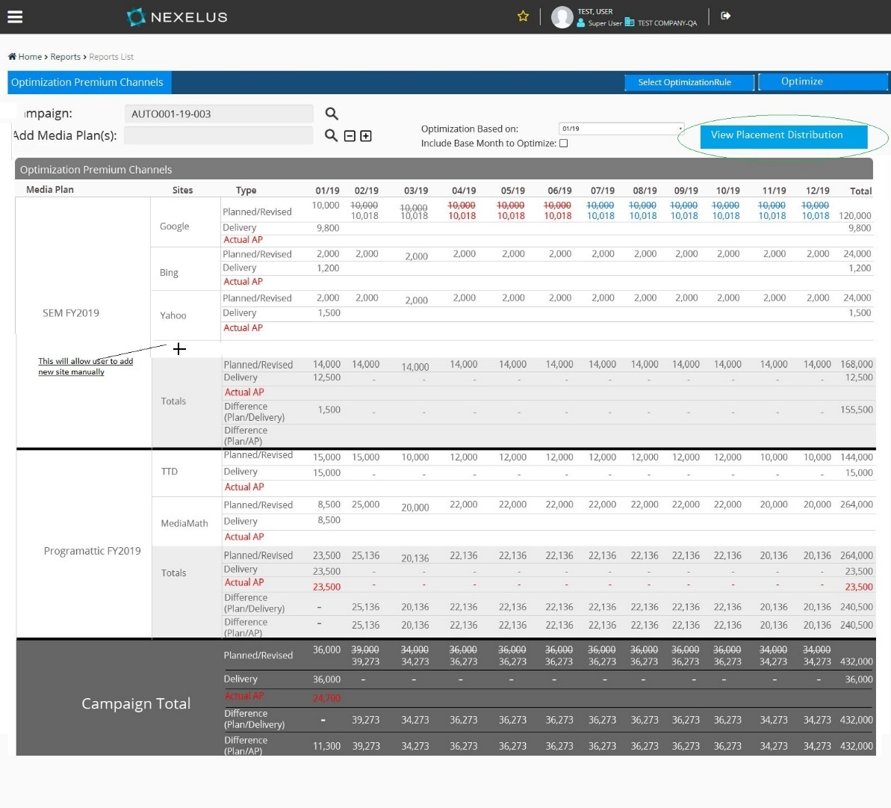

This UI will display period-based (some clients use non-calendar based fiscal periods, we can provide period category dropdown to let user select period for distribution i.e. some clients define one placement for whole year and would like to see data by year instead of monthly spend, however this option can be provided in phase2 of optimization, this version will focus on displaying data by month) media spend along with delivery and vendor invoice information and will allow user to adjust spend across vendor and/or multiple media plan(s).

Following will be basic flow of this user interface.

* + - * **UI Flow**

Select campaign.

Add media plan by selecting media plan from lookup, user can add multiple media plans.

System will load all selected media plan in grid.

Select base month (default will be the past month),

Select optimization Rule(s), user can select multiple rules, and system will create different option for each rule selected.

User will review / compare options created in step above and will select an option to be used (user has to select option to be used by optimization for each media plan).

User will start optimization process with selected option, before starting the process user can manually update the selected version.

System will create media plan(s) revision based on optimization rule, as it updates data in respective media plan(s).

System will allow user to generate / update Client schedule based on new revision.

User can approve new revisions for media plan(s) if he has rights.

System will revise Ad tech IO if applicable (if ad tech is configured for media plan based on ad tech setting at level2).

User can revise IO based on new revision based on rights.

User update / revise BO based on user’s rights.

User update / revise Facebook and TTD campaign based on user’s rights.

User can revert any or all actions at any time.

End

* + - * **UI Fields**

This UI will have following fields.

1. *Campaign Lookup*

Filed Type: Lookup:

Default Value: Blank

This lookup will display all open and approved campaigns which has at-least one approved media plan.

This field will become read only if any of media plan is loaded on UI.

1. *Media Plan*

Filed Type: Lookup:

Default Value: Blank

This lookup will display all open and approved media plans for selected campaign, however if campaign is not selected than system will display all open and approved media plans and once plan is selected, System will default campaign in campaign lookup field based on media plan selected.

User can add multiple media plan by selecting “+’ sign in front of media plan filed.

once user selects media plan, system will load plan details in grid.  
  
System will load following data from media plan once user selects a media plan.  
  
“System will pull all vendor placements from media plan, from approved / latest revision (based on rule, rule will define if system should pick approved revision or should always use latest) of selected media plan, and will display it in respective filed in grid based on logic described below in “*Details Grid*“ section below”  
  
**Please note**, system won’t add separate text box for each media plan, rather system will load plan in grid once selected and clear this filed, so user can select another plan if needed.  
 ­­­

1. *Optimization basis:*

Filed Type: Dropdown list:

Default Value: Blank  
Label: Optimized based on  
Default Value: Last month

This dropdown will have months in form of “MM/YY”, the month’s range will be based on minimum start of media plan(s) and current date.

i.e. if 2 plans are selected Plan A and Plan B with dates as following and current month is July 2019, drop down will have months from 01/19 to 12/19 and default value will be Jun 2019.

Plan A   
Min Star date 03/15/2019

Max End date 11/15/2019

Plan B   
Min Star date 01/15/2019

Max End date 12/15/2019

1. ***Details Grid***

Filed Type: Grid:

Default Value: blank  
  
This grid will display media plan details, system will load media plan’s information once user selects media plan from lookup, every media plan will have its own section which will clearly distinguish it from another media plan.

**System will use following logic to load and display data in this grid.**

This grid will display media spend by month (Grid will have separate column for each month based on media plan(s) span) for each individual vendor/site in respective media plan, consider following placements in media plan A

Google

Placement A Jan 1st to Jan 31st 10,000

Placement B Feb 1st to March 31st 20,000

MSN

Placement A Jan 1st to Jan 31st 10,000

Placement B Jan 1st to Feb 29st 5,000

Placement C Feb 1st to Aril 30th 11,000

System will display following data for each vendor/site and month.  
  
 Jan Feb March April

Google 10,000 9,666.67 10,333.33

MSN 12,583.33 5961.11 3788.89 3666.68

Calculation for overlapping dates are based on weightage formula as shown below.

No of days in month \* (Total Spend / total No of days)

**Note:** “No of days in month” are days of month which based on start / end date of placement, i.e. if placement is starting from Feb 15th than only 14 days will be considered for Feb.

i.e. Google’s spend for March is calculated as following

Google March Spend =31 \* (20,000 / 60) = 10333.33

Usually 28 days in Feb except for the leap year, use a different month to illustrate the example

This detail grid will have following columns.

First field can be Campaign if we are allowing more than one campaign

* 1. **Media Plan:**

media plan name.

* + 1. **Site:**

Name of site, system will display one grid line for each site.

* + 1. **Type:**

Each site line will display different types of information and this column indicates type of information being displayed in row.

There will be 3 types of information 3 lines per site “row”, including Totals line:

1. Planned / Revised:

Media spend (Cost amount) from media plan for month and site (Monthly spend will be calculated based on logic described above in “Detail Grid” section).

1. Delivery:

This column will display delivery information using existing logic and priority for delivery, logic to display delivery is described below in delivery section

1. Actual AP.  
     
   Voucher amount created based on service month, system will calculate monthly AP based on accrual dates stamped on MPM UI.
   * 1. **Month (Range):**

These will be dynamically created columns and system will add these columns based on min start and max end date of vendor placements in selected media plan(s) i.e. if user selects a media plans with placement dates as shown below than grid will have column as “02/19 03/19 04/19 up-to 10/19”.

**Media Plan A**

Placement A 02/15/2019 – 02/28/2019

Placement B 03/01/2019 – 06/30/2019

Placement C 07/01/2019 – 08/30/2019

**Media Plan B**

Placement A 07/01/2019 – 08/30/2019

Placement B 09/01/2019 – 10/30/2019

Each column will display planned, delivery and actual amount for that month, system will use following logic to display each type of amount.

* + Planned:

System will display proportional media spend (cost amount from vendor placement) for each month based on logic describe above in “Detail Grid” section, below is another scenario to illustrate media spend calculation for Jan month.

i.e. 4 placements for Vendor Google as

Placement Media Spend Dates

Placement A 2,000.00 01/01/19 - 02/28/19

Placement B 2,000.00 03/01/19 - 04/15/19

Placement C 3,000.00 01/01/19 - 01/31/19

Placement D 12,000.00 01/01/19 – 12/31/19

System will use following formula to calculate media spend for each month from every placement line.

(Media spend / (number of days in Duration)) \* number of days in month

Based on this formula **Jan spend** will be calculated as following from each placement

Placement A (2000 / 59) \* 31 = 1,050.85

Placement B 0

Placement C (3000 / 31) \* 31 = 3,000

Placement D (1,2000 / 365) \* 31 = 1,019.18

Total Amount for Jan will be 5070,03.

* + **Planned (Editable)** Once you select rules for optimization, user cannot edit it until it selects the option to edit. Editing should be done explicitly (based on action button “Edit”, this UI will become editable only if user explicitly clicks on Edit button. ) even if the user does not select any flags/rules/config items to see “proposed” spend.  
      
    User can manually edit media spend from this UI if needed, system will provide an editable cell under each planned amount, which will allow user to enter media spend directly for each month.  
      
      
    **System will allocate amount** to all placements which falls into specific month based on weightage if user edits media spend manually.   
      
    i.e. consider following Placements

Placement A Jan 1st to Feb 28th 10,000

Placement B Jan 15th to Feb 28th 5,000

Initially Jan spend will be 7,143.13 (5,254.23 from Placement A and 1,888.89 from Placemen B), and if user adds 2,000 into Jan’s spend system will distribute amount to both placements based on their weightage.  
2,000 \* 0.74 = 1480 to Placement A (as .74 from Placement A is part of Jan spend)

2,000 \* 0.26 = 520 to Placement B (.26 from placement B is part of Jan spend)  
  
**if user enters media spend in empty cell** ( there is not media spend for that month for specific site), system will create new placement for that period.  
  
i.e. Google has data only for Jan and Feb (Google doesn’t have any placement for March and further months) and user enters media spend in march for Google ( other sites can have media spend for March that’s why system will be displaying March month, if none of sites have data in March then system will not display March month to begin with), system will create new placements for google with media spend entered by user and date of new placements will be start date of month and end date of month, in case if user enters 10,000 for google in March, system will create following new placement for Google  
  
Placement Name Start Date End Date Rate Quantity Cost   
Placement A – 03/01/2020 – 03/31/2020 1 1 10,0000  
However, it raises 2 questions, what will be placement name and 2nd is that what UOM will be used?, we will discuss it further.

**System will use same logic** to add new placements (user can enter media spend manually or during optimization rule move some under spent to new site) for new site if user adds any.

Following restriction will be applicable when entering amount  
  
1 - User cannot enter media spend less the received amount (received amount is sum of vendor invoices (MPM) matched for IO for specific vendor, system has to perform this validation at IO level instead of Month or at placement level. an example is given below in “Example for received amount Check”section). for example if received amount of google for Jan is 2,500 than user can’t enter media spend less than 2,500.

System will strike through original planned amount for that month once user enters media spend manually.

**Note**: purpose of this column is to allow user to edit media spend, however once user edit media spend, system will display original and edited media spend in grid, that’s why we need two columns, we can finalize how UI will work once we finalize UI.  
  
**Example for received amount Check**

Consider the following IO for Google.

**PO00001**Placement A Jan 1st – Feb 31st 10,000

Placement B Jan 1st – March 31st 15,000   
  
Received Amount: 8,000  
System should consider both posted and un-posted vouchers when calculating received amount for IO.  
Tables: pdd\_transaction\_pst, pdd\_transaction\_inp based on query below  
(select sum(amt\_1) from pdd\_transaction\_inp/ pdd\_transaction\_pst where po\_code=’@PO\_CODE’ and tr\_type = 8001,)  
  
Placements in example above span across 3 months that’s why system will distribute amount from these placements in 3 columns for “Jan”, “Feb” and “March”, however as received amount restriction will be at IO level that’s why system can’t apply received amount check on any single placement /month (User doesn’t match IO at placement level that’s why total IO amount is important to be considered rather than considering placement level amount), in this case system should not allow to edit collective media spend for “Jan”, “Feb” and “March” below received amount which is 8,000.

* + Delivery:

Nexelus pulls delivery data from ad-server and other ad tech platforms on nightly basis and saves it in local database, however user can override it in Nexelus from delivery override and / or from billing override UIs.

Delivery column will display delivery information based on delivery date in specific month for each site.  
  
System will display delivery information based on same precedence which is being used on buying UI to display delivery from billing, delivery override or from actual API based on availability such as if Billing override is available than system will display delivery from billing UI, this only applies to POSTPAY scenario (reader should learn and understand the POSTPAY billing process) and if billing override is not available than the system will display delivery from delivery override UI If available else will display actuals as delivery.  
  
System will display delivery based on logic below.  
  
**From Billing Override.**

If billing override exists for month, system will display delivery from billing override (remember billing override is applicable only in case of post-pay billing).  
  
**From Delivery Override.**  
  
if billing override is not available than system will pick delivery from delivery override UI, for approved or whatever the approval method setup for delivery override, for that month based on override period user has specified during delivery override.  
  
i.e. for Jan system will pick delivery override which has dates as ‘01/01/2019’ to ‘01/31/2019’.

**Actual Delivery**

If billing and delivery override isn’t available than system will display actual delivery coming from ad-server, based on delivery dates. i.e. for Jan system will display all delivery between 1st Jan and 31st Jan for campaign(s) tagged on IO which has placement for that month.  
  
i.e. there could be 2 placements as   
  
 IO Number Campaign ID  
Placement A 01/01/2019 to 01/31/2019 PO000008 00015  
Placement A 01/01/2019 to 06/30/2019 PO000001 00013  
  
both of these placements may belongs to different IO, however system will display only one column for Jan, that’s why system will pick Jan delivery against both Placements.

* + **Actual AP**

This will be vendor invoices (MPM UI) amount created for specific month for each site, system will pick AP based on accrual/API dates matching with specific month.

i.e. for Jan system will pick AP from MPM where accrual date is defined as ‘01/01/2019 to 01/31/2019’.

* + **Add Site**There will be “+” sign at the end of site list for every media plan loaded, which will allow user to add new site into media plan, system will open vendor/site lookup once user clicks on “+”, this lookup will display all sites excluding sites which are already part of media plan, and once user selects a site, system will add new line for selected site with 0 values ( as it’s new site so there won’t be any media spend, delivery or AP), user can edit media spend for this site manually or from rules (using distribute send to other vendor/sites)
  + **Totals:**

Totals column will display totals for each amount type at line level and at media plan level (in bottom).

Furthermore, grid will have a section for totals which will display totals for planned, delivery, AP and difference between API planned amount and delivery or AP amount for selected campaign.



* + 1. **­­­­­­Action Buttons**

This UI will have following Action buttons.

* + - 1. **Edit**

This action button will allow user to edit media spend manually, user has to click “Edit” button explicitly if he/she wants to edit media spend manually, and once user clicks on Edit button, system will make “Select Optimization Rule” disabled and label for this button will become “Cancel Edit”, which will allow user to undo Edit action, however once user actually start editing (edits at least one column), system will disable this button.

* + - 1. ***Action Button- Select Optimization Rule*:**

Nexelus will provide multiple rules (which will be used by system to redistribute under-spend and/or projected under spend across multiple sites) for optimization,

This action button will allow user to select optimization rule, once user clicks this action button, system will open “optimization rule” UI, optimization UI and optimization rules are explained in “Optimization Rules” section below.

“We need this type of illustration on how to show multiple options using tab see below for a reference:

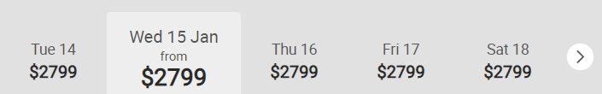

**Days above would be those Options, clicking on such will display data based on those rules selected,** however UI we will let UI/UX resource finalize it**”**

**Please note** that user can select **Multiple Rules** from optimization UI, and each rule will create separate options for media plan(s) included in the process to be optimized based on rule and will display all options to user for comparison as shown in below image, we will provide an option to user in grid to remove Media Plan from UI, we will finalize this during UI review.

i.e. in 1st version can be based on optimization rule “distribute under-spend evenly in future months” and in 2nd version can be based on “distribute based on proportion” and in 3rd version can be based on “Distribute under-spend evenly to other site / vendor under same plan”.  
  
This will help user to review media spend adjustments based on different rules without altering actual data and will help to choose right optimization rule to apply.

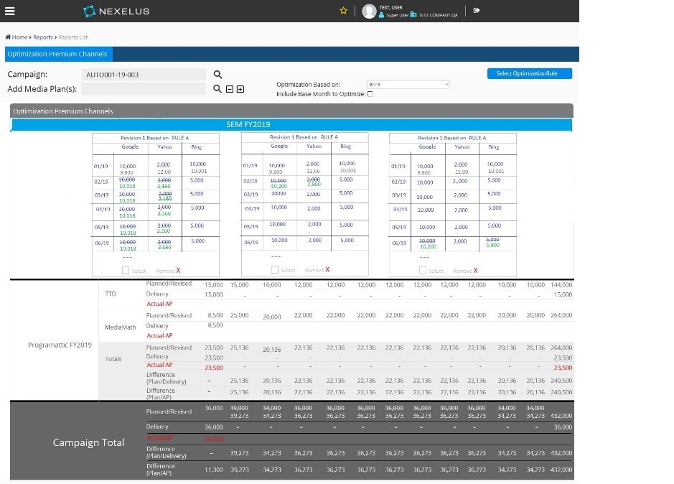

* + - 1. Reset  
           
         Reset button will allow user to reset changes made by user, once user clicks on reset, system will undo all changes made by user (including rule selection and/or options if there is any).
      2. ***Action Button- Optimize:***

Default state of this action button will be disabled, and system will enable this button only when user has selected optimization rule or user has made any change with manual editing.

Once “Process” button is enabled system can initiate optimization process by pressing this action button.

System will start optimization process once user clicks on “Optimize” action button, optimization process will create new revision for media plan(s) and take user through different steps, each step is explained in detail below.

* 1. **Media Plan Revision**:

System will create new revision for media plan using the source revision (approved) and will update vendor placement(s) based on optimization rule user has selected, once all media plan(s) are revised successfully, system will display successful message as shown below.

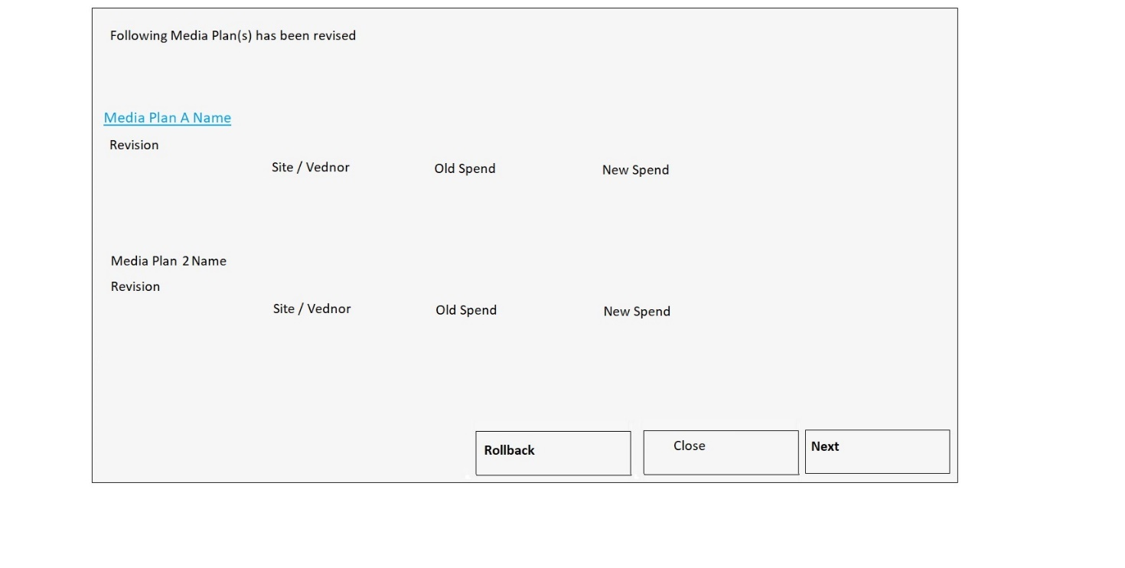

Image A

This popup will have 2 action buttons as

Rollback

This action button will allow user to rollback changes done during optimization, once user clicks rollback, system will remove newly created revision and will prompt message on successful rollback as “Changes has been rolled back successfully” and will close pop-up once user clicks on ok button on prompted message box.

Close

Close button will close the UI and will end optimization process, once user clicks on close button, system will display message as “Are you sure you want to end optimization Process?” with OK and cancel button, and once user clicks on OK button, system will hide popup and take user back to optimize UI (blank UI).

Next

once user clicks on “Next” button system will move to point “iv” below.

* 1. **Client Schedule**

System will display popup window as shown in image B below which will allow user to revise client schedule if needed, user can skip this step only if there is no change in media spend (Remember if media spend is not changed, we may not need to revise client schedule, however if media spend is changed than updating client schedule is mandatory for plan’s approval which will be next step).

This UI will display current (from source revision which was used to create revision for optimization), along with rate type and mgmt. fee rate used to generate billing schedule (what should be fee rate and UOM if it’s different on each client line) in current column and new values based on revised revision, system will calculate tech fee based on media spend (if tech fee is defined at vendor placement level, remember we have setting on level2 which defines if tech fee is at vendor placement level of at client level).

This UI will have 3 action buttons.

1. Rollback  
     
   This action button will allow user to rollback changes, once user clicks on this button, system will prompt as “this action will rollback all changes made” with Ok and cancel option, and once user clicks on “OK” button, system will delete revision created for optimization and will prompt as “Changes has been rolled back” and will close pop-up and will redirect user to Optimization main UI ( all media plan loaded with approved revision).
2. Process  
     
   Once user clicks this button, system will process and generate billing schedule for each media plan.  
   System will display process wheel when generating schedule for each media plan and once billing schedule is generated system will display status in-front of each media plan as “Processed” or “Failed” (in-case there is any error during process), and if process if failed for any media plan system will display reason once user clicks on “Failed” button.

Once proceed system will change label of this button to “Approve Media Plan(s)”.

Once user clicks on approve media plan(s) system will approve or send plan(s) for approval based on user’s permission as following.

If user has rights to approve all levels and media spend is not changed, system will approve media plan fully (remember system approves last level automatically if media spend is not changed so system should approve plan fully even if user doesn’t have rights for last level of approval as long as media spend is not changed), and if user doesn’t have rights to approve all level or if media spend is changed than system will approve levels based on user’s permission (if user has right to approve 2 levels, system will approve 2 leve2 and if user doesn’t have rights for any level than system will just mark media plan and ready).

Once plan(s) are approved system will display prompt message accordingly as “N plan(s) has been approved, N Plan(s) has been sent for approval” with ok button.

System will change label to “Next” if at-least one plan is fully approved, and if none of plan is fully approved system will keep the label and will disable button, so that user will have only option to close or rollback.  
  
if label is changed to “Next” than system will go to point “Revise IO” below once user clicks this button.

1. Close

This action will close window and will reload media plan(s) user has selected.

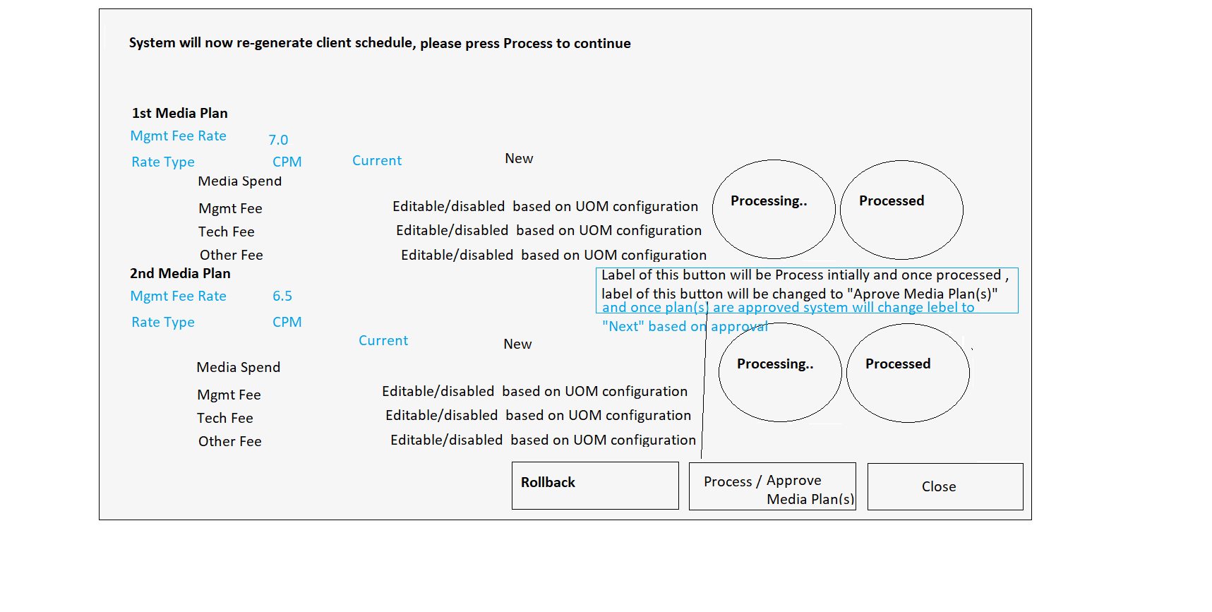 Image B

* 1. **Revise IO**

System will display pop-up shown below in Image C which will allow user to revise IO(s), please note that user cannot create IOs from this UI, user can only revise existing IOs.

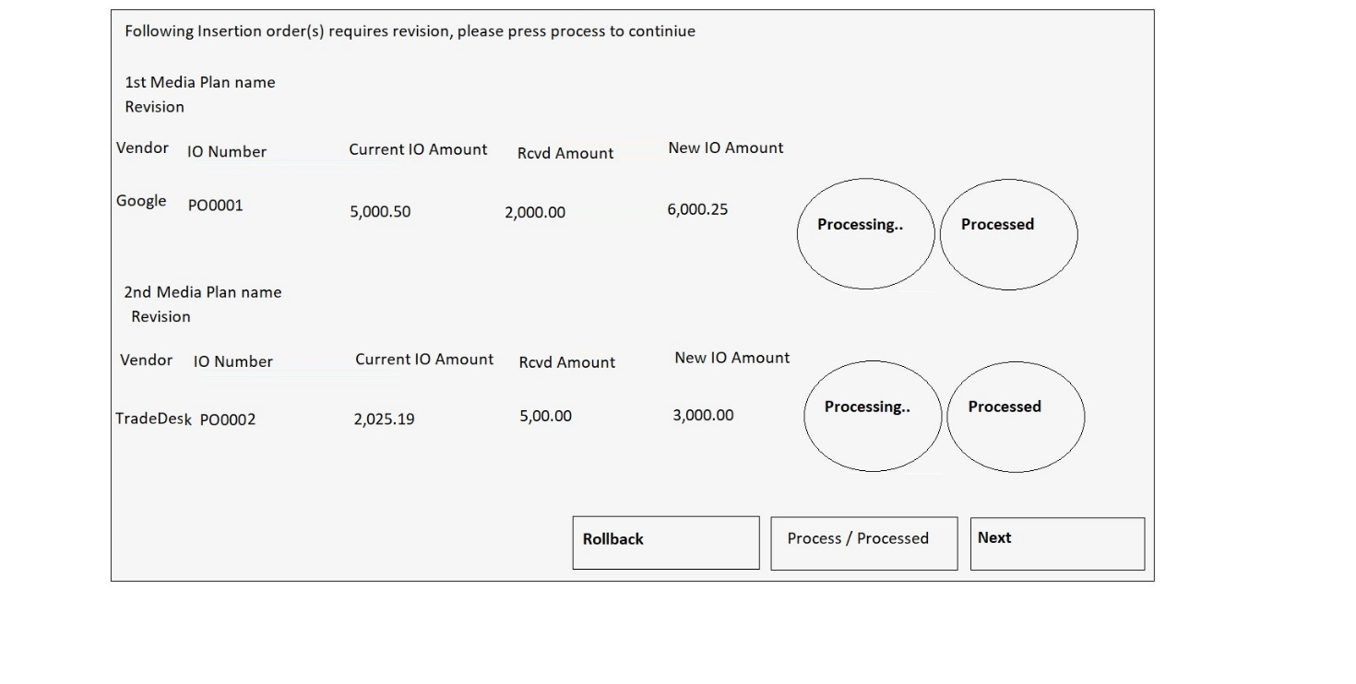

Image C

This UI will display list of IO(s) which requires revision based on optimization, IO will require revision if media spend is changed for lines which are part of IO(s).  
this UI will display following information for IO.  
Vendor Name  
IO Number  
Current IO Amount

Received amount

New IO Amount  
System will use same label for these filed which is being used in buying UI.

If IO can’t be revised (There is only one reason why system won’t be able to revise IO which is if new IO amount is less than received amount) than system will display message in red color as “IO can’t be revised” as a link and will display error message once user clicks on link.  
  
this UI will have 3 action buttons as

* + 1. Rollback  
         
       System will rollback all changes done by system up to this point during optimization (delete newly created revision and mark previously approved revision as approved) if user decides to rollback changes, system will prompt message as “This action will rollback all changes” once user clicks this action button, and system will rollback changes (if IO’s are revised than system will delete newly created revision and re-active last revision and will perform rollback action for media plan as described in section “iv” above) and will prompt as “Changes has been rolled back” and will close pop-up and take user back to main UI with all media plan(s) loaded in initial state.
    2. Process  
         
       System will initiate IO revision process once this button is clicked, this button will be enabled only if at-least one IO is available for revision, and if none of IO is available for revision (if all IO’s new amount is less than received amount or there is no IO created) than this button will remain disabled.  
         
       once user clicks on this button, system will initiate revision process, and will display process wheel in-front of each IO when processing specific IO, and   
       display result as “Revised” or “Failed” based on revision status, if revision is successful than system will display “Revised” in green and if revision is failed because of any reason than system will display “Failed” in red as link and will display proper message once user clicks on “Failed”.  
         
       once processed system will disable this action button and will enable “Next” button only if
    3. Next

System will enable this button once IO(s) are successfully revised and at least one Facebook/TTD Campaign and/or BO exists for at least one of IO revised, and if there is no Campaign/ BO requires revision than label of this button will be changed to close and system will close pop-up and will reload main UI based on filters ( media plan(s) selected) user has selected.  
  
System will move to point “Budget Order Revision”, “TTD Campaign” or “Facebook Campaigns” based on revision required for BO / TTD/ Facebook Campaign.

* 1. **Budget Order Revision**  
       
     System will display pop up UI shown in Image D below only if there is at least one BO which requires revision, this UI will allow user to revise BO(s) if any of BO needs revision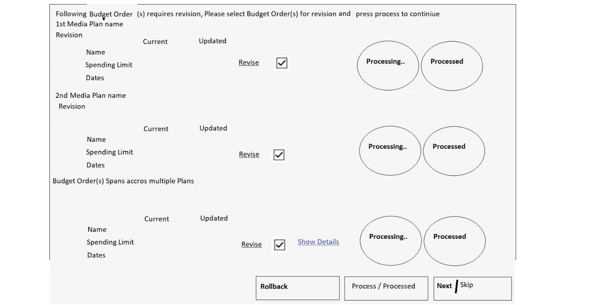

Image D

this UI will display all BO which needs revision based on optimization, this UI will show budget orders from all media plans optimized successfully in steps above, and will display information for each BO as following   
  
Budget Order Name  
spending limit (current and new based on optimization)  
Dates (current and new based on optimization, however as we are not changing dates in optimization so current and new should be same ideally, however it can be changed if someone has changed plan outside of this window)  
  
System will display above information’s for each BO, and will display “This BO cannot be Revised” as link if BO cannot be revised and will display proper message once user clicks on “This BO cannot be Revised” (There are mainly 2 reasons why BO can’t be revised, 1st if new end date is in past, or new limit is less than already spent amount).  
  
System will display check box in front of each IO which will allow user to include or exclude BO from revision process, Default state for this check will be un-checked.  
  
We are displaying BO under media plan which belongs to that specific plan, however as Nexelus allows to create BO which spans multiple Media plans that’s why system will display such BO in sperate section under “Budget Order Spans across multiple plans”, this section will display all Budget Orders which needs revision based on optimization process and each BO is linked to multiple IO ( regardless if all IOs are under same plan or multiple).  
System will display “Show detail” as link in front of such a budget orders and once user clicks on “Show Details” button than system will show details of Budget orders shown in Image E below which will display all IOs which are part of this BO.  
system will evaluate these BO for revision as well using the same logic which is being described above for BO for single IO (to verify new spending limit and dates, however in case if BO spans across multiple BO, system will have to verify it for AL IO/), and if BO can’t be revises, than “Revise” check box will be disabled in this case, same applies on section above where we are displaying BO against single IO.  
  
This UI will have following action buttons  
  
1 - Rollback.  
  
this action button will allow user to rollback changes, however user can rollback only if BO revision process is not initiated, once BO revision process is initiated and completed, this button will become disabled, system will perform same action mention above in point “Rollback” under “Revise IO”, once user clicks on this button.  
  
2 – Process.  
  
This action button will initiate BO revision process once user clicks on this.  
Default state of this action button will be disabled and system will enable it only if there is at-least one BO selected for revision.  
  
once user clicks this action button, system will start revision process and will display process wheel in front of each BO being revised and will display status once revision for each BO is completed which can’t be either “Revised Successfully” (system will hide revise check box after successful revision) in green color and “Failed” in red as link (if there is any issue during revision) and will display proper reason for failure once user clicks on “Failed”.  
  
Once all BO selected are revised system will disable “rollback” option (system cannot rollback this action as AdWords doesn’t allow to re-revise budget orders for next 20 minutes once revised).  
  
System will disable this action button if all BO(s) are revised successfully revised (user can select one BO and revise at a time).  
  
3 - Next  
  
Label of this action button will be “Skip” initially, which will allow user to skip BO revision, and once user clicks on skip action button , system will prompt user as “are you sure you want to skip Budget Order Revision, press OK to continue.”  
and system will move to next step (TTD campaign or Facebook campaign only if TTD/Facebook campaign exists for revision(s) otherwise system will close UI and will reload main UI for media plan(s) user has selected) if user presses Ok button.  
   
after user has successfully revised BO or there is no BO which can be revised and there is at least one TTD/Facebook campaign which needs revision than label of this button will be change to “next”, and system will land user into next UI ( TTD Campaign Revision) .  
  
label of this action button will change to “close” from Skip if there is no TTD/Facebook campaign for revision and system will close this pop-up and will reload main UI based on users selection once user clicks this action button.

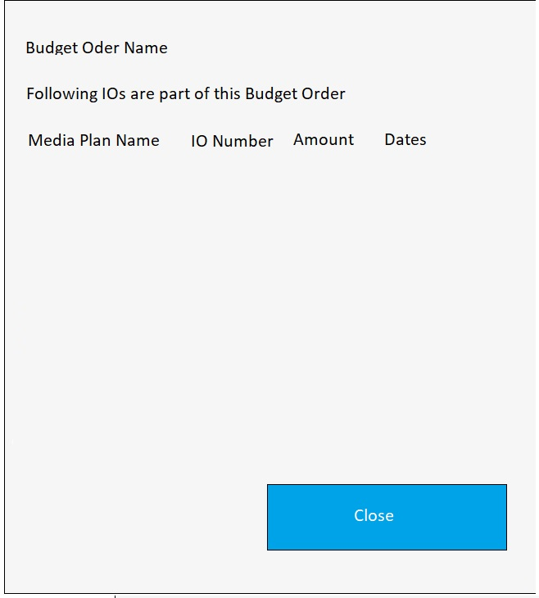  
Image E

* 1. **TTD Campaign Revision**

System will open this UI shown in Image F below once user clicks on “Next” button from “BO revision” UI above, this UI will allow users to revise TTD campaign which needs revision because of changes.  
  
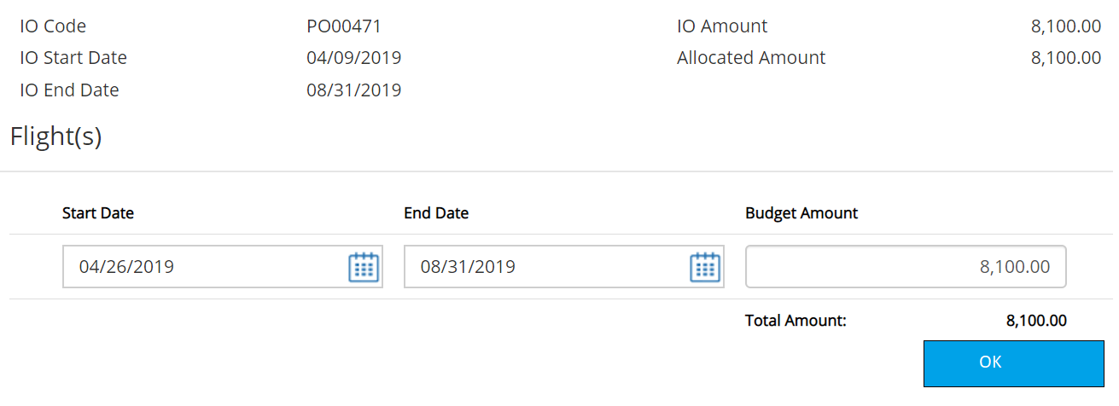  
 Flight UI  
  
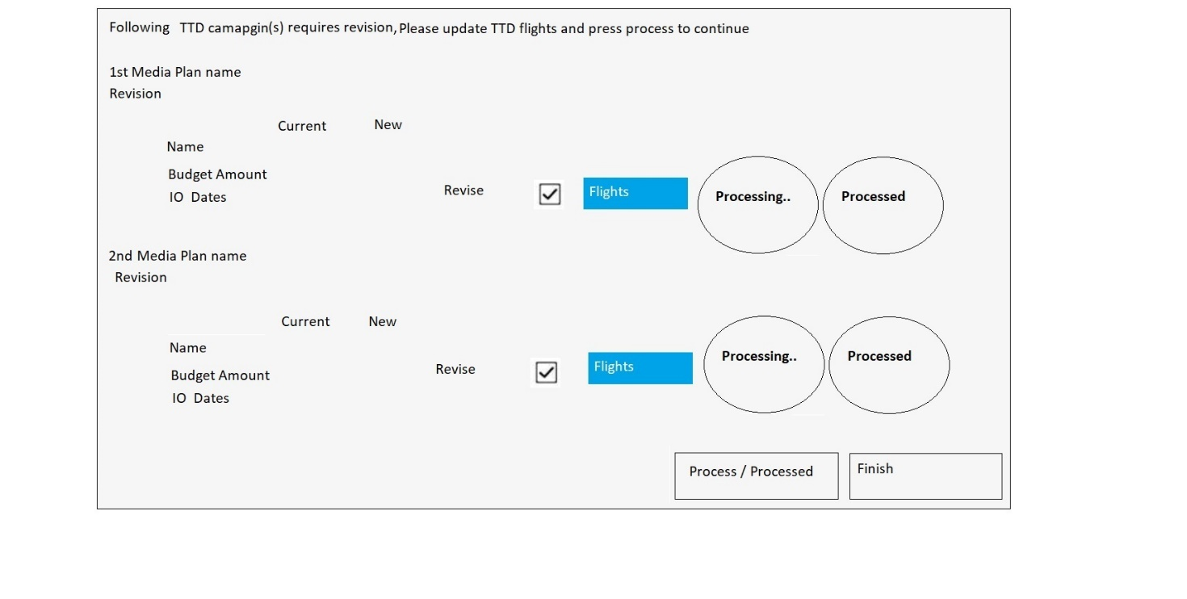  
 Image F  
  
This UI will display TTD campaign(s) which require revision based on IO revised in point “v” above (TTD campaign will need revision only if IO being used for this campaign has been revised, and same is true for BO as well.) under each media plan, and this UI will display following information.  
  
Name  
Budget Amount (current and new)  
Dates (current and new)  
   
**Auto readjusting of Flights?**  
  
System will display “flights” action button in front of each TTD campaign which will open “Flight UI” (shown below, it’s same UI we are displaying on Buying UI without any action button to add/delete line, start and end date will be disabled as well) and allow users to view and adjust flights.  
  
System will display “Revise” check box in front of each TTD campaign as well which will allow user to select TTD campaign(s) for revision, by default this check box will be unchecked and disabled and system will enable and check it automatically only once user open flights UI and press “OK” from flights UI.  
this UI will have following action buttons.  
  
**1- Flights**  
  
This action button will be shown in front of each TTD campaign which will allow user to view and adjust flights.  
once user adjust flight system will enable revise check box and will auto check it for particular campaign.  
  
**2 - Process**  
  
Initial state will be disabled for this button and system will enable this button only when at least one TTD campaign is selected for revision.  
  
system will initiate revise process once user clicks this button, and system will display process wheel on front of each campaign when revising it, system will display status once revision is done based on revision status which can be “Revised” in green (and revise checkbox will be disabled for revised campaign) or “Failed” in red as link, system will display error message(s) once user clicks on “Failed” incase if revision is failed, system will display error messages in front of each flight in “Flights UI” as well if error is related to specific flight.  
  
System will disable this button once all TTD campaigns has been revised successfully.   
  
**3 - Finish**  
  
label of this button will be “Skip” initially if there is at least one Facebook campaign which requires revision, otherwise label will be “Finish” for this button,  
  
if Facebook campaign requires revision, user can press skip button to go to Facebook Revision UI.

if none of Facebook campaign(s) requires revision then label will be finish for this button and user can finish optimization process any time from this UI even without revising TTD campaigns, once user clicks on “Finish” checkbox, system will close this UI and will land user on main UI and will reload main UI in initial state using the filters user has selected originally (media plan(s) user has selected to optimize).   
  
If user successfully revised TTD campaign ( at least one) label of this button will be changed to “Next” and system will land user to Facebook Campaign Revision UI.

* 1. **Face Campaign Revision**

System will open this UI shown in Image E below once user clicks on “Next” button from “BO revision/TTD Campaign” UI above, this UI will allow users to revise Facebook campaigns which needs revision because of changes.  
  
  
 Flight UI  
  
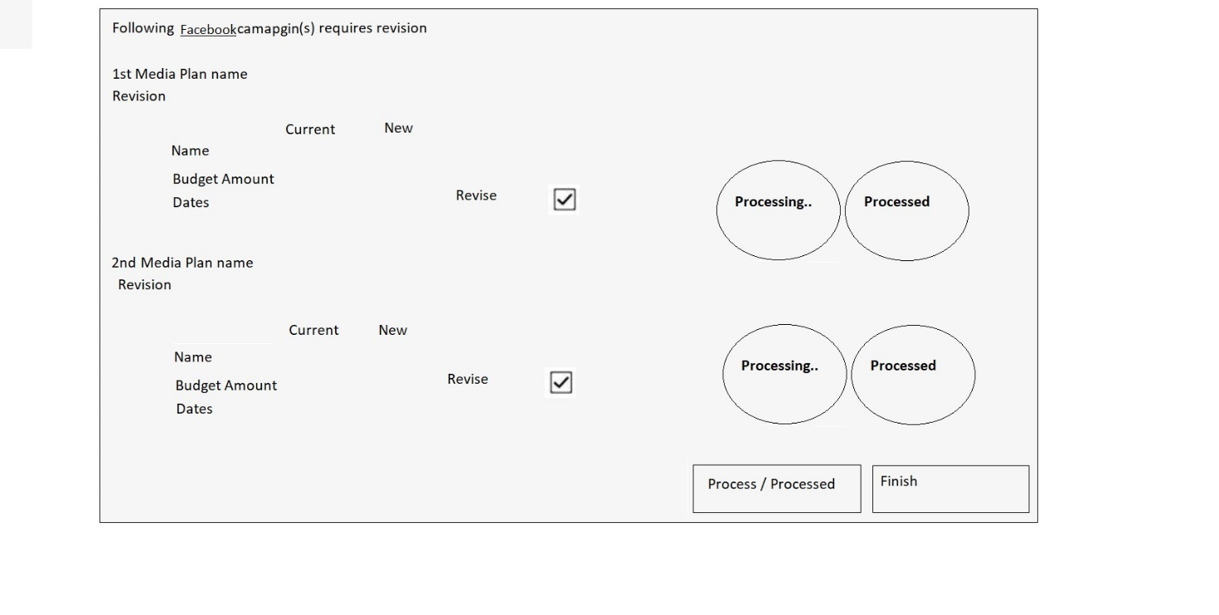  
 Image E  
  
This UI will display Facebook campaign(s) which require revision based on IO revised in point “v” above (Facebook campaign will need revision only if IO being used for this campaign has been revised.) under each media plan, and this UI will display following information.  
  
Name ( Facebook Campaign Name)  
Budget Amount (current and new)  
Dates (current and new)  
  
  
System will display “Revise” check box in front of each Facebook campaign as well which will allow user to select Facebook campaign(s) for revision, by default this check box will be unchecked.  
  
this UI will have following action buttons.  
  
  
**2 - Process**  
  
Initial state will be disabled for this button and system will enable this button only when at least one Facebook campaign is selected for revision.  
  
system will initiate revise process once user clicks this button, and system will display process wheel on front of each campaign when revising it, system will display status once revision is done based on revision status which can be “Revised” in green (and revise checkbox will be disabled for revised campaign) or “Failed” in red as link, system will display error message(s) once user clicks on “Failed” incase if revision is failed, system will display error messages once user clicks on “Failed”.  
  
System will disable this button once all Facebook campaigns has been revised successfully.   
  
**3 - Finish**  
  
User can finish optimization process any time from this UI even without revising Facebook campaigns, once user clicks on “Finish” checkbox, system will close this UI and will land user on main UI and will reload main UI in initial state using the filters user has selected originally (media plan(s) user has selected to optimize).

## Optimization Rules

This user interface will allow users to select optimization rules which will be used by system to optimize media plan(s).

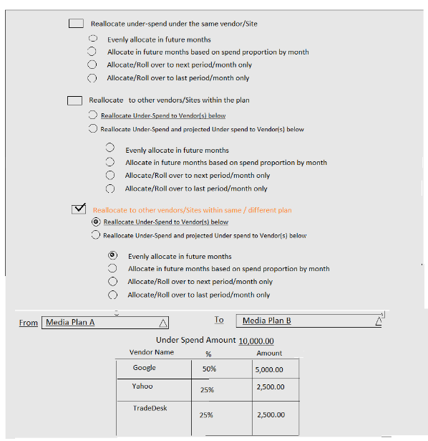

This UI will have following options.

* + - * **Reallocate under-spend under same Vendor / Site.**

If this rule is selected than system will distribute under-spend media spend to future placements for same vendor / site.

User can choose one of following options under this rule to distribute media spend.

Evenly allocate in future months

If this option is selected than system will distribute under-spend media evenly in future months (or starting from current month as well if “include base month to optimize” is checked,).

i.e. if under-spend media for Sep is $3,000 and there are 3 future months in date range than system will allocate $1,000 to each month.

Allocate in future months based on spend proportion by month

If this option is selected than system will distribute under-spend media in future months (or starting from current month as well if “include base month to optimize” is checked,) based on proportion.

For example, if

Under-Spend Media 3,000

There are 3 Future Months and media spend for each month is as following

Media Spend for Oct is $5,000

Media Spend for Nov is $12,500

Media Spend for Dec is $7,500

Total Media Spend is 25,000.00

Media Spend for Oct 20% of total media spend for 3 months

Media Spend for Nov is 50% of total media spend for 3 months

Media Spend for Dec is 30% of total media spend for 3 months

Based on this weightage system will allocate 20% ($600) of under-spend media to Oct, 50% to Nov and 30% to Dec.

Allocate/Roll over to next period/month only

If This option is selected than system will allocate all under-spend media to next month.

i.e. if user is adjusting May than system will assign all under-spend media to Jun.

However, if selected month is last month than this option will be disabled.   
  
If there are multiple lines for next month/period, system will evenly distribute to all month for next period), i.e. if base month is April and under spend is 4000 and there are 2 lines for May, system will distribute 4000 evenly to both lines (2000 to each line).

Allocate/Roll over to last period/month only

If This option is selected than system will allocate all under-spend media to last month.

i.e. if user is adjusting May and Aug is last month than system will assign all under-spend media to Aug.

However, if selected month is last month than this option will be disabled.

If there are multiple lines for last month/period, system will evenly distribute to all month for next period), i.e. if under spend is 4000 and last month for vendor placement line is May and there are 2 lines for May, system will distribute 4000 evenly to both lines (2000 to each line).

* + - * **Reallocate to other Vendors / Sites within the plan**.

This rule will allow user to distribute under-spend media spend among different vendors within media plan, once user selects this option, system will display vendor’s list, list will display only vendors which doesn’t have any under spend, system will display total underspend amount as well.

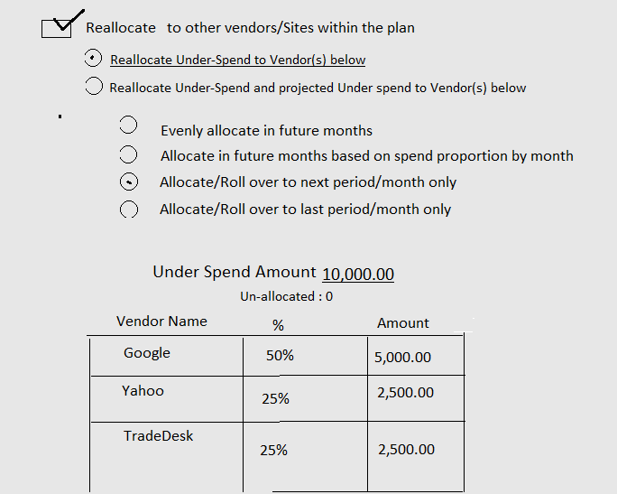

User can assign under spend to vendors in list by editing percentage or directly entering amount.

Following restriction will be applicable on entry.

Sum of amount can’t exceed under spend amount.

Sum of percentage cannot exceed 100%

Once user enters percentage, system will automatically calculate amount based on percentage amount of under spend.  
system will adjust unallocated spend amount with every user entry in percentage or in amount field.

User can choose one of following options under this option.

Allocate under spend amount to vendors below.

This option will distribute under spend amount to vendor below.

Allocate under spend and projected under spend amount to vendors below.

This option will distribute under spend amount in addition to projected under spend amount to vendors below.

System will calculate **projected underspend amount** based on percentage of under spend using logic below.

Media Spend for May was 10,000 and under spend is 2,000, under spend percentage will be 20% in this case, system will use this percentage to get projected underspend for future months, for example based on same scenario if Jun has media spend as 5,000 then projected under spend will be 1,000 based on 20%.  
once this option is selected, system will calculate project under spend amount and will display it with vendor list as shown below.

While subtracting with user entry,

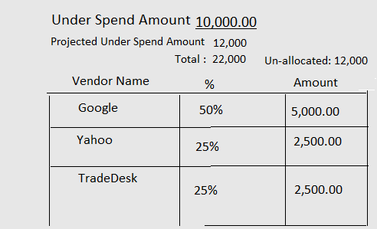

Once user selected one of above options, system will display following option to choose from to select distribute method.

Evenly allocate in future months

Allocate in future months based on spend proportion by month

Allocate/Roll over to next period/month only

Allocate/Roll over to last period/month only

1

Note: Details of all 4 distribution options is already given “Reallocate under-spend under same Vendor / Site”.

* + - * **Reallocate under-spend to other Vendors / Sites in another plan.**

This rule will allow user to distribute under-spend media spend among different vendors into different media plan.

Once user selects this option than system will display an option to select from and to media plan and once user selects “To” media plan, system will display list of all vendors (only vendor having future Placements?) from “To” media plan**.**User cannot select same media plan as “From” and “To”.

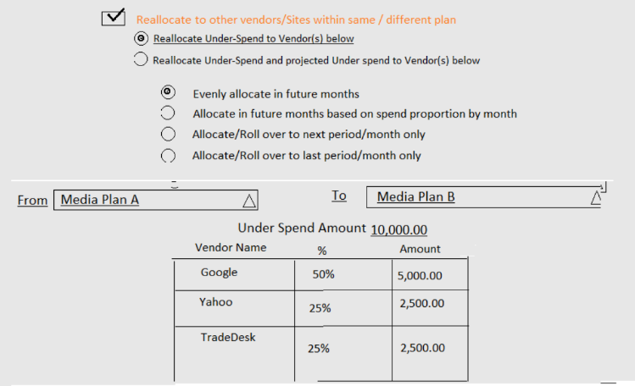

User can assign under spend to vendors in list by editing percentage or directly entering amount.

Following restriction will be applicable on entry.

Sum of amount can’t exceed under spend amount.

Sum of percentage cannot exceed 100%

Once user enters percentage, system will automatically calculate amount based on percentage amount of under spend.  
system will adjust unallocated spend amount with every user entry in percentage or in amount field.

This option will allow user to distribute projected under spend in addition to under spend amount, user can choose one of following options

Allocate under spend amount to vendors below.

This option will distribute under spend amount to vendor below.

Allocate under spend and projected under spend amount to vendors below.

This option will distribute under spend amount in addition to projected under spend amount to vendors below.

System will calculate projected underspend amount using logic mention above in (iii section of “Reallocate to other Vendors / Sites within the plan”).

Once user selects one of above options, system will display following option to choose distribute method.

Evenly allocate in future months

Allocate in future months based on spend proportion by month

Allocate/Roll over to next period/month only

Allocate/Roll over to last period/month only

1

Note: Details of all 4 distribution options is already given “Reallocate under-spend under same Vendor / Site”.

This UI will have 2 action buttons as following.  
  
1 - **Select**  
   
System will close “optimization rule” UI and will perform in-session (nothing will be saved in database at his point, system will adjust media spend for future months based on optimization rule(s) selected and will display version to user) optimization based on rules user has selected.

Once user clicks this button system will close this UI and will update media spend for each plan/vendor based on rule(s) selected, if user has selected multiple rules, system will generate separate optimized version for media plan which will allow user to review spend calculation for each rule.

System will strikeout original panned amount for each month which has been adjusted based on rule and will display adjusted amount under original planned amount, User can than override adjusted amount from main UI as well if needed.

2- **Cancel**  
  
This action button will close “optimization rule” UI without any further action.  
  
Please note that mockup has different buttons, but we will replace those buttons with action buttons mentioned above.

## Modified Screens

### Impact Analysis

DEV:

?

DB:  
?

QA:

?

### Description and Business

### Logic

<*Provide detailed description of screen functionality, workflow and navigation for all states and conditions. List all associated actions, list tables participating in screen data. Provide business logic for all possible screen states. Provide samples of the data shown on the screen. Provide navigations and interactions with all other screens if necessary. List all warning and error messages given to the user.>*

### Flow Diagram

<*Provide simple and understood screen flow diagram(s) to simplify screen business logic development. >*

## New Reports

### Report 1

### Description

<*Provide detailed description of the report - what is the purpose of the report, who are the primary users. Provide header, footer, section(s), each column definition, grouping, sorting etc.>*

### Report Rendering

<*Provide mockup of the report using MS Word. Use multiple mockups if necessary to show variations of the report.>*

### Sample Data

<*Provide report sample data>*

### Report Selection Interface

<*Provide report selection criteria interface screen mockup and description>*

### Report Business Logic

<*Provide detailed report business logic - where data are selected, how they are grouped, sorted, transformed, etc. Provide snippets of the query(s) if necessary>*

### Report 2

...

## Modified Reports

### Report 1

### Description

<*Provide detailed description of the modified report - what is the purpose of the report, who are the primary users. Provide header, footer, section(s), each column definition, grouping, sorting etc. Provide changes to be implemented - report "delta" functionality.>*

### Report Rendering

<*Provide mockup of the modified report using MS Word. Use multiple mockups if necessary to show variations of the report. Clearly show modified elements>*

### Sample Data

<*Provide report sample data>*

### Report Selection Interface

<*Provide modified report selection criteria interface screen mockup and description. Clearly identify changed elements and functionality>*

### Report Business Logic

<*Provide detailed report modifications/additions to the business logic - where data are selected, how they are grouped, sorted, transformed, etc. Provide snippets of the query(s) if necessary>*

### Report 2

...

## API

### API Definition

<*Provide API detailed description and its purpose. State registration, authentication and authorization requirements. Provide platform to be implemented on (for example, .NET based Web Service deployed on IIS)>*

### API Constants, Data Types, Structures and Methods

<*Describe in details each available to the client of this API constant, structure, enum, data types and methods with parameters and return values>*

### Code Examples

<*Provide code examples how client will be using this API>*

### API Client System Requirements

<*Provide any system requirements to the client of this API, how to deploy and attach this API library to the client environment>*

### Design Questions

### Selection of multiple media plan, we can change media plan field to dropdown instead of text filed, as user can add multiple media plans which can take space on top of page, we can change it to dropdown and can keep adding media plan’s user is selecting in drop down.

### Optimization month should be multi-select dropdown, however user may want to adjust different months for different plans.

### How to define month’s range, if single media plan is selected than we can create date range based on placement date of media plan, however as each site can have different range that’s why I think it’s better to create column for single month for entire range of vendor placement dates, we can display data with proportion if placement falls into multiple months.

### Delivery amount, do we need to display delivery amount based on same logic we are displaying it on rest of UI as we display delivery information from billing override, delivery override and actual delivery based on order.

### System will display proportional Estimate, Delivery and actual amount.

### How to proportion AP amount.

### No way for user to select amount for distribution.

### Not user friendly?

### Same rule is being applied on all sites.

### a

### a

### How to define month’s range, if single media plan is selected than we can create date range based on placement date of media plan, however as each site can have different range that’s why I think it’s better to create column for single month for entire range of vendor placement dates, we can display data with proportion if placement falls into multiple months.

### Q&A from offshore

Q&A - January 2020

Check box for Include base month should no be there or is confusing. Should optimize based on dropdown selection?

**Ans: Remove this checkbox**

If selected 5 plans and we do not change anything in 4 plans should we revise 4?

**Ans: No**  
      
Placement rates would be updated based on calculation but when UOM's are different units should be updated as well?

**Ans: Units should be recalculated again, there is a rule to calculate either Units or rate we need to rethink on this point as some clients put amount in rate and use 1 in units**  
      
We are allowing user to add sites/placements and not allowing them to create IOs against those, we should either consider this for future release or should allow them to create new IO lines.

**Ans: Allow to create IO**

5.1.3    If base period is November 2019, current calendar month is January 2020, how will distribution work for December 2019.  
    what will be “Future” month for system?

**Ans: System will pick under spend for Nov and Dec(till to date) and will distribute in future months.**

5.1.7    Please explain red Vs Blue color

**Ans: Color will represent different IOs**

5.1.9    Can media spend be less than delivery amount

**Ans: Need to add a group rule**

5.1.14    Which option system should use when generating client schedule?

We have 2 options as “Adjust in future months” and “Adjust in current month”, system will use the option which is selected in company rules.  
As far as UOM is concern, use the UOM from 1st client line.

**Ans: We already have a company rule and system will pick selected option from this rule**.

Q&A – January 8, 2021

**Plan and vendor placement questions**:

1. If Delivery is for optimization month (January 2020?) for one site, while placements for other sites start after two months, how will system distribute in other sites based on Rule#2 ?
2. What is projected underspend? Also it is not clear for user on UI.
3. Will system allow creating new placements if no placement exists in a period targeted by optimization?

If we have three sites (Google,Yahoo, Bing), each distributed for different periods

Google: January – Dec

Bing: January – March

Yahoo: February – Dec

In case of Optimization of March, we select to distribute Google underspend to other sites in next month or for future months, how will optimization work? Will it create new vendor placements? Example:

|  |  |  |  |  |  |  |  |
| --- | --- | --- | --- | --- | --- | --- | --- |
|  |  | Jan, 2019 | Feb-19 | March | April | .. | December |
| Google | Planned | 10000 | 10000 | 10000 | 1000 | .. | 10000 |
| Delivery | 9000 | 0 | 0 | 0 | .. | 0 |
|  |  |  |  |  | .. |  |
| Facebook | Planned | 5000 | 5000 | 5000 |  |  |  |
| Delivery | 5000 | 0 | 0 |  |  |  |
|  |  |  |  |  | .. |  |
| Yahoo | Planned |  |  | 8000 | 8000 | .. | 8000 |
| Delivery |  |  | 0 | 0 | .. | 0 |
|  |  |  |  |  |  |  |

If a single placement is created for Google from January to December. How will optimization work? In case of following example of single placement:

Google: From: Jan, 1 2021 to: Feb 15,2021,

Placement: $15,000 Delivery:9,000 (January),

Optimization UI will show as follows:

|  |  |  |  |  |
| --- | --- | --- | --- | --- |
|  |  | Jan, 2019 | Feb-19 | Total |
| Google | Planned | 10108.7 | 4891.304 | 15000 |
| Delivery | 9000 | 0 | 9000 |
|  |  |  |  |

**Ans: Will not perform optimization in this case.**

1. Media plan approvals have multiple warning message how to show/manage those warnings?
2. Locking would always be at DB level or should we have to show message to user as well that this plan is being optimized so is locked.
3. If use is in middle of optimization and we are providing to revise IO only and he needs to create IO first that is from buying UI. He has to cancel the process cause of lock on buying and then create IO for respective ad server.
4. ~~We are considering only placement in UI what about packages and link placements.~~
5. Can we create/optimize placements with 0 or negative amount.
6. In creating new placements for future months what attributes should we default like AdTech, and if we have manually set ad tech amount should it default as well.
7. If a targeted placement is across multiple months including base month how will we deduct from base month and add to future month if there is only one placement?
8. If user does not have approval rights for base Media plan or second media plan
9. What will be new placement name and that UOM would be used.

**Client Schedule questions**:

1. what should be fee rate and UOM if it’s different on each client line.

Ans: Will be selected on Optimization Wizard

1. What options will be selected to generate client schedule.

Ans: Will be selected on Optimization Wizard

Session with Imran - January 12, 2021

* + 1. No New media Plan will be created
    2. Media Plans will be selected against only one media campaign
    3. Base Month checkbox will always be checked
    4. Base period will be based on client profile (Calendar month or Fiscal Period). If fiscal period is tagged on client profile, it will be used. Else Calendar month will be used
    5. Total Spend for all media plans will be displayed at bottom of UI
    6. Show Total Media Spend for Media Plan in Gray box for each media plan
    7. Show all vendors/sites for media plan on dashboard
    8. Add logo upload functionality in vendor profile
    9. Add Summary page for optimization before creating plan revision
    10. Always show summary level details and not placement level details
    11. Reallocate from one plan to another will be possible from any selected media plan to another.
    12. Minimum Optimization period will start from first period of all media plans
    13. Ad tech values should be displayed on optimization wizard at create media revision UI
    14. Finish/Save button on all UIs of Wizard
    15. User can continue Wizard as long as he has revision rights.
    16. After Plan(s) approval, perform Sync to DCM if applicable.
    17. On rollback show disclaimer that new revisions will be created that will be identical to revision before initiating optimization process
    18. Locking still needs some brainstorming
    19. What will be revision names?

Ans: prompt user for Revision names on Optimization Wizard

* + 1. On Generate schedule show all custom fields where applicable.
    2. In case of Optimization Rule #1, vendor/Site distribution Grid section will be hidden. Rule 1 will apply to all media plans
    3. Rule 2 will enable Distribution Grid with from Media Plan combo box.
    4. Rule 3 will enable Distribution Grid with from and to Media Plan combo boxes.
    5. Only on Rule will be applicable at one time
    6. In case of adding or removing additional media plans, optimization revisions will be reset
    7. DCM flighting will be adjusted on weighted basis

Session with Asim - January 25, 2021

* + 1. More than three rules can be selected at a time – Asim
    2. If campaign and/or Plans are changed than reset applied Optimization rules.

Suggestions in Session with Imran/Asim - January 29, 2021

1. Remove R1, R2 R3 from Media Plan Summary Screen.
2. If media spend is not changed for a media plan than user can skip generate client sch for that media plan.
3. Approval discussion next week with Asim and Arif Khan.
4. Rule Selected in Optimization Rule UI should be selected
5. Move Option and Sie on top (Next to Optimize button)
6. Only one option will be used to Optimize
7. Change label Next to Optimization Rule to 'Select Optimization Rule'
8. Show text box for Revision Row all the time
9. Change text color for edited cell to blue (Color may be decided later)
10. Make space for 'From and To' plan Drop down
11. Maximum 4 Revision will be applicable a one time. Add Remove/Replace functionality for more options
12. There should be back button instead of X icon on details
13. Move the buttons to right on dash screen to give more space to select.
14. Validate values and remove check for 0 vendor sites to show on dash
15. Hand icon on mouse over throughout
16. Details should have only base month delivery
17. Show one plan on click of MP, Show all plans checkbox.
18. Strike-out header values and change color of amounts
19. Allocated underspend label on top of rule lookup, allocation to multiple plans.
20. Period code with Tool tip on header of details section
21. Group by plan name and rev on top of create media plan revision tab with name of rev on top as well
22. Clicks and Rate on generate schedule tab with same rule applied.
23. Authorization values checked by default. Enable the next button if all plans are fully approved.
24. Existing IO amount should be relabeled to previous and new to current amount on Revise insertion order tab
25. Should have DCM tab after approval or at the end of wizard to sync with DCM.
26. Allocate under spend for rule 3 based on amount added not recalculated.