We used three textures in this problem.

Landscape (Dry land) Gradient Animal(Jelly Fish)

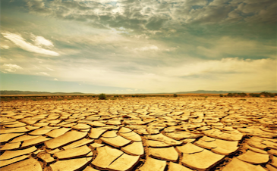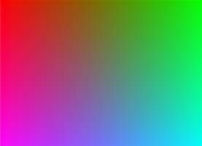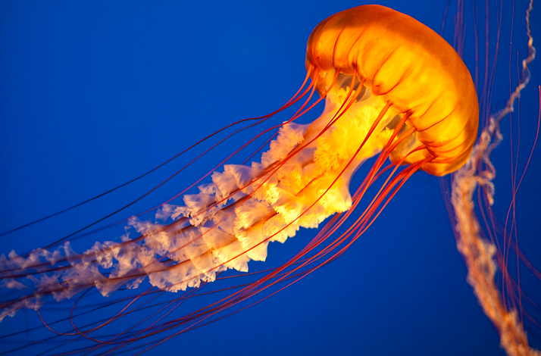

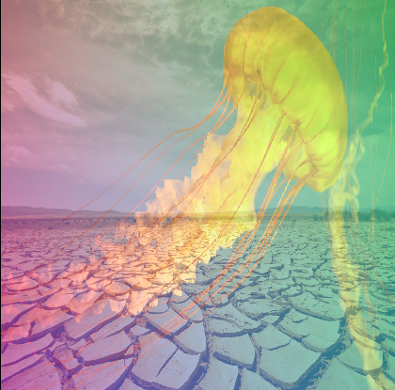**Results:**

Blend Mode 1:

Color = ( Landscape_color + Gradient_color + Animal_color)

We used a self-developed blend mode, which take the sum of RGB of each pixel and get an average value. In this way, the new texture will have all three textures in it. Any of the texture will have same weight on each pixel. The reason why we blended in this way is that we realized only summing each value of RGB made the new texture too bright to identify the picture. We understand that when all three value of RGB on a pixel are too close to 255, the pixel will turn into white. If we sum all the value for each pixel, most of the pixel turned into white.

Blend Mode 2:

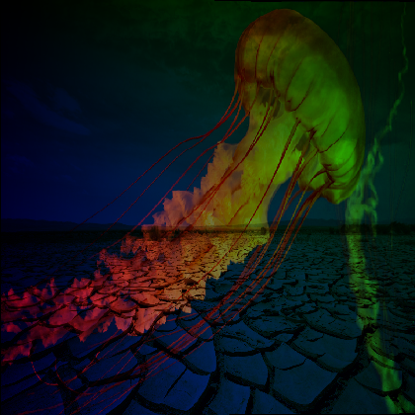Color = Landscape_color * Gradient_color * Animal_color

This second blend mode is also self-developed. This time, we used the product of each texture’s RGB value to get the new texture color. This time, the color is very dark. It is caused by overflow of the value. If the product value is too large, the value actually started over from 0 again.

The largest obstacle is modifying the multi-textures code. We spend hours on understanding the code and adding the third textures. And also, finding the right format of .bmp image takes us lots of time as well.