We used two image as textures in this problem.

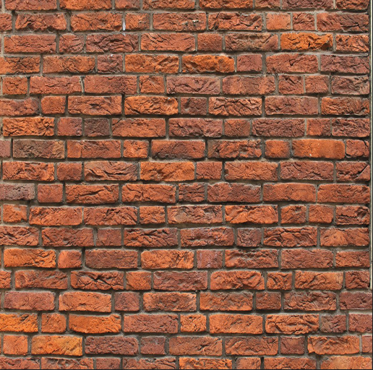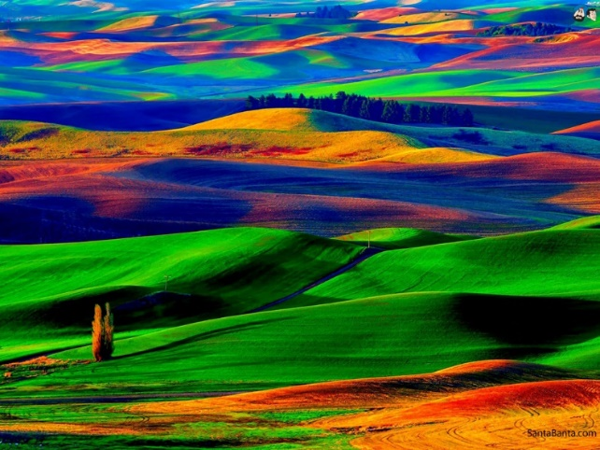Landscape image Noise image

**Results:**

We used the formula that professor provide and we change the “0.035” value to different value to get the different output.

We find the color value of the noise map texture. We are only interested in the color value hence we only save the xyz values in the noiseVec which a vector of size 3. We normalize to convert the vector to unit vector length. Then apply noiseVec * 2.0 – 1.0 formula. This converts the noise map color values to normal map color values. The normal map color value will mostly look blue but will have the darker color showing the texture features. Like in our brick image an outline of the bricks will be saved as darker lines on the blue normal map. This color information will be used as texture coordinates to displace the original landscape image. This is done in the last step. Where only the xy values of the noiseVec is used to manipulate the textcoord vector and is used to extract the color information of the original landscape image.

Vec3 noiseVec = normalize(texture(texture_foreground, pass_TexCoord.xy).xyz);

noiseVec = (noiseVec *2.0 – 1.0) * 0.035;

color = texture(texture_background, pass_TexCoord.xy + noiseVec.xy);

We notice that when we have the higher value, we get greater displacement of the original of landscape image.

When the value = 0.035, we got the image which shown on the left. When value = 0.55, which shown on the right.

