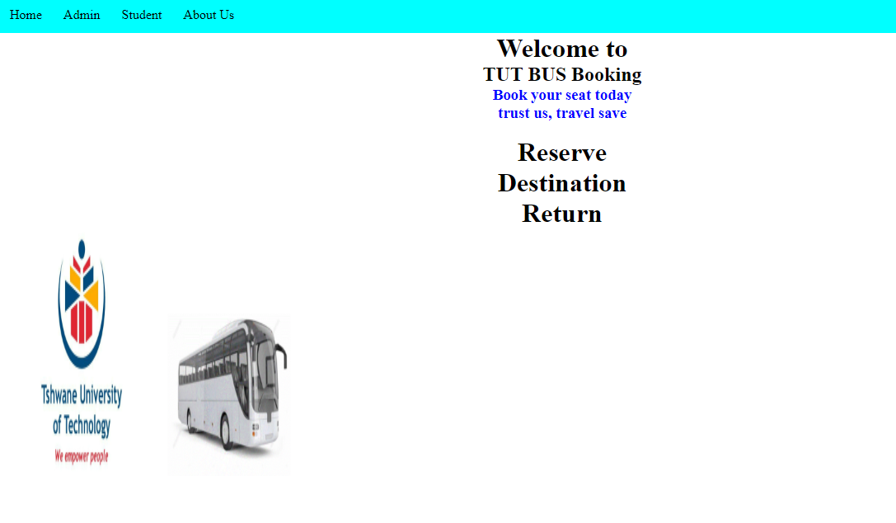

Introduction

-This system allow the user to reserve their space so that we’ll know how many bus we need for which campus.

-it is a web-based application so it requires internet access to operate.

-Users register them as student or admin

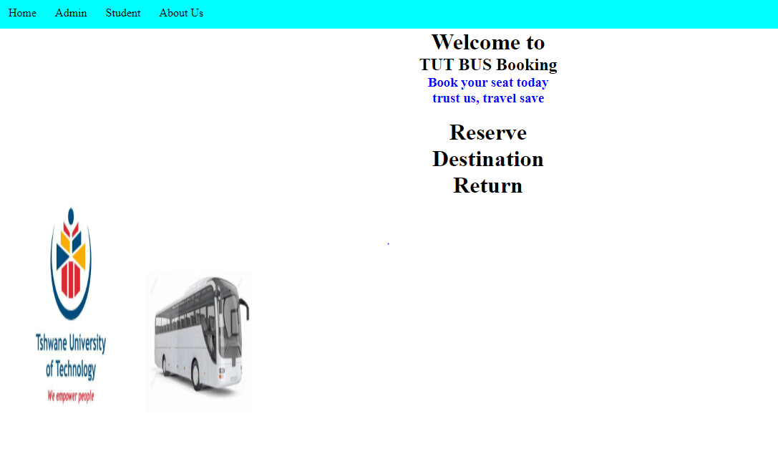

Step1:

Click on the admin as shown on the image above

Step 2: Click on the “need account? Register” link to register if you don’t have an account.

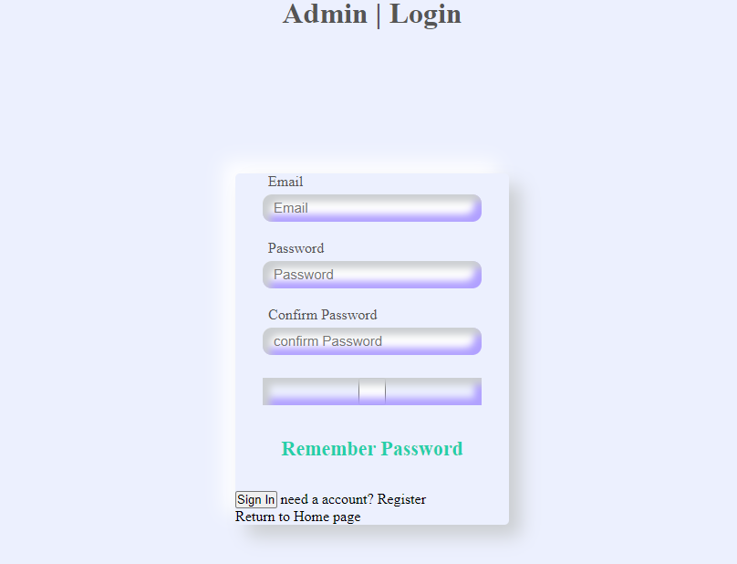

Step 3: after filling In the form you click the register button to register.

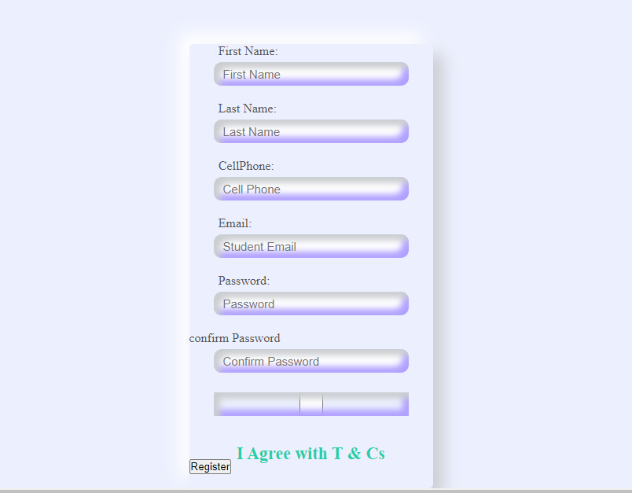

Step 4: Admin chooses either to check student and booking data or click home.



Step 5: the student now choose the “register “ link to register if they don’t have an account.

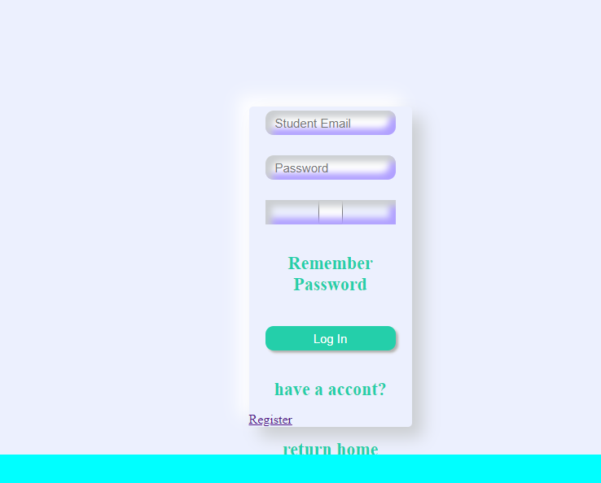

Step 6: student enter their details and press the register button to register.

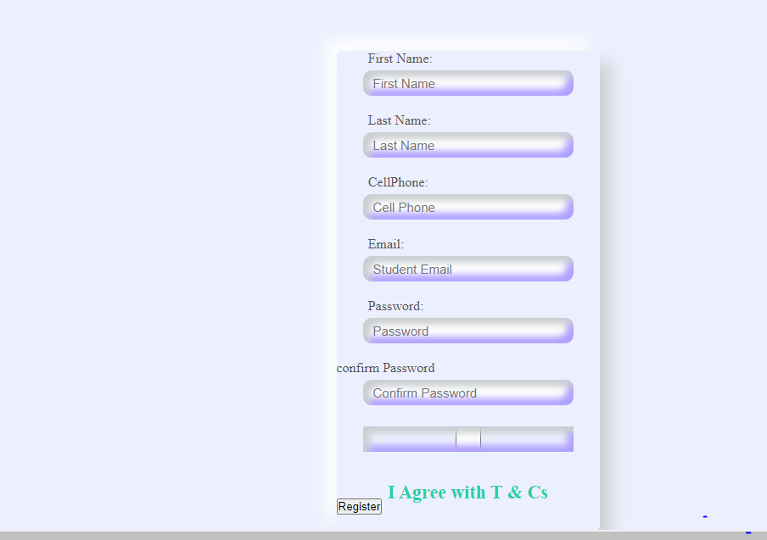

Step 7: student enter the detail and book or cancel the click return home after booking.

