SYSTEM ARCHITECTURE DOCUMENT
CyberHRMS Platform
A multi-tenant HRMS/ERP SaaS: an ASP.NET Core (.NET 10) Clean-Architecture backend and a React 19 SPA, paired with a standalone Home portal that federates every subsystem behind one workspace.
AT A GLANCE
ASPECT | CHOICE
Backend | ASP.NET Core · .NET 10
Frontend | React 19 · Vite · TypeScript
Database | SQL Server (EF Core 10)
Architecture pattern | Clean Architecture (Dom ← App ← Inf, Api root)
Multi-tenancy | Finbuckle, enforced in the data-access layer
Applications | HRMS SPA + Home portal (shared identity store)
CONTENTS

01 System Overview
CyberHRMS is one product built as two independently-deployed halves that share a single SQL Server database and a common identity store.

The two applications
- HRMS application — the full back-office system: organization structure, employees, recruitment, performance, leave, compensation and every administrative module. A React SPA talking to the HRMS API.
- Home portal — a lean, standalone workspace (its own Dom/App/Inf/Api and its own React SPA) that acts as the master hub across subsystems. It owns only coreNotification, deep-links into subsystems via coreSubsystem.Url, and shares the Core.User / Core.Tenant identity tables with HRMS while keeping its own migration history.
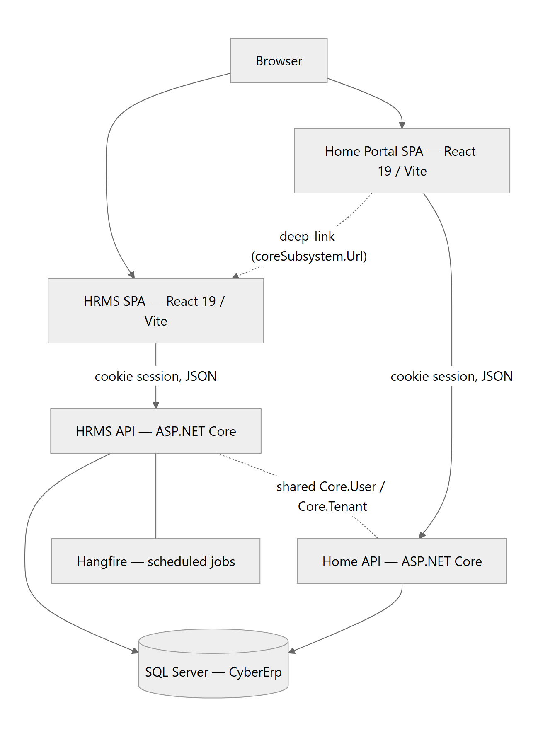
Fig 1.1 — System context: two SPAs, two APIs, one database, one shared identity store.

02 Technology Stack
Every dependency earns its place; wiring is explicit rather than convention-magic.
BACKEND — ASP.NET CORE (.NET 10)
CONCERN | TECHNOLOGY | ROLE
Runtime / API | ASP.NET Core, .NET 10 | Versioned REST controllers (api/v{version}) + minimal-API endpoints
ORM | EF Core 10 | Code-first; migrations in the Inf project; SQL Server provider
Multi-tenancy | Finbuckle.MultiTenant | Per-request tenant resolution + MultiTenantDbContext
Validation | FluentValidation | Per-slice validators, thrown from handlers
Time | NodaTime | Instant for all timestamps (never raw DateTime)
Reporting | Dapper | Stored-procedure execution for the report engine
Background jobs | Hangfire | Recurring jobs: leave rollover, due movements, settlement reminders
Logging | Serilog | Structured logs, configured at the composition root
Auth | Cookie / session (+ JWT config) | Controllers gate on the Cookies scheme via BaseController

FRONTEND — REACT 19 SPA (SHARED BY HRMS + HOME)
CONCERN | TECHNOLOGY | ROLE
Framework / build | React 19 + Vite + TypeScript | @ → src alias; typecheck gates the build
Styling | Tailwind CSS v4 | Token-driven, theme-aware (light / dark)
Server state | TanStack React Query | Caching, invalidation, request cancellation
Client state | React Context + Preact Signals | Stores aggregated in store/index
Routing | React Router | Pages lazy + memo; ProtectedRoute + PermissionGate
i18n | i18next / react-i18next | Locale resources under src/locales
Data viz / docs | ECharts, Recharts, @react-pdf, TipTap | Dashboards, PDF export, rich-text templates; bespoke SVG org chart

03 Backend Architecture
Four projects in a strict Clean-Architecture dependency flow — Dom ← App ← Inf, with Api as the composition root. Nothing inner knows anything outer.
D | CyberErp.Hrms.Dom — Domain  Entities, domain events, constants. Zero external dependencies. BaseEntity is the aggregate base: Guid Id, TenantId, NodaTime Instant stamps, a byte[] RowVersion concurrency token, and a domain-events list. | no deps

A | CyberErp.Hrms.App — Application  Use cases as vertical slices under Features/{Domain}/{Entity}/{Operation}/. Each slice is an I{Operation} interface + a plain handler (primary-constructor DI, no MediatR), its DTOs, its repository interface, and a FluentValidation validator. | → Dom

I | CyberErp.Hrms.Inf — Infrastructure  EF Core implementation: HrmsDbContext : MultiTenantDbContext, the generic Repository<T> and concrete repositories, Finbuckle wiring, migrations, and Hangfire job registration. | → App, Dom

API | CyberErp.Hrms.Api — Composition root  Versioned controllers + minimal-API endpoints. Program.cs is a thin chain of AddHrms* extension methods. New wiring is registered there and in the two DependencyInjection.cs files — no assembly-scanning auto-registration. | → App, Inf

The composition root reads as a declarative pipeline:
// Program.cs — the composition root
builder.Services
.AddHrmsAuthentication(config) // cookie scheme + JWT config
.AddHrmsControllers()
.AddHrmsValidators() // FluentValidation
.AddHrmsDbContext(config) // EF Core -> SQL Server
.AddHrmsMultiTenancy() // Finbuckle strategy + store
.AddHrmsBackgroundJobs(config) // Hangfire
.AddInfrastractureServices() // Inf/DependencyInjection.cs
.AddApplicationServices() // App/DependencyInjection.cs
.AddHrmsApiVersioning();
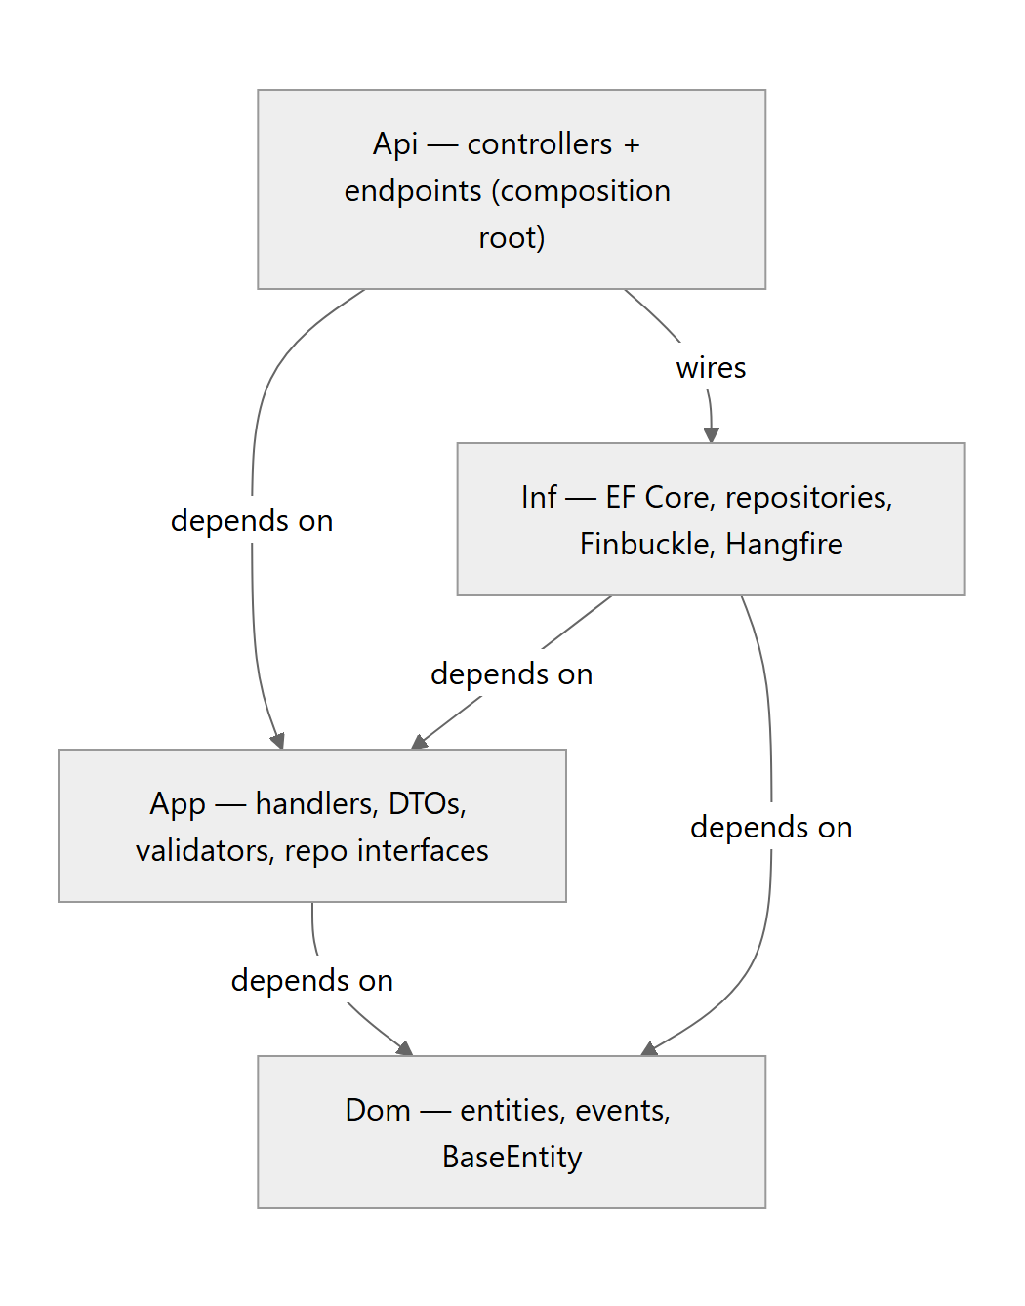
Fig 3.1 — Dependency direction — arrows point at what a project references; the domain sits at the centre and references nothing.
CONVENTION
Global OnModelCreating reflection applies column conventions to every BaseEntity: Guid → uniqueidentifier, Instant/DateTime → datetime2, and RowVersion → varbinary(8) concurrency token. New entities inherit this automatically.

04 Multi-Tenancy & Security
Isolation is enforced at the data-access layer on every read, keyed off a per-request tenant resolved from the session.

Tenant resolution
A HybridTenantStrategy resolves the current tenant from — in order — an X-Tenant-Id header, a TenantId cookie, then JWT claims. The DatabaseTenantStore loads the tenant and Finbuckle populates the per-request context.

Data isolation
The generic Repository<T>.GetAll() applies the filter on every query: a tenant filter (TenantId == currentTenant) and, for entities implementing IBranchScoped, a branch filter — a branch administrator sees only their branch, while Head Office sees all. Globally-shared reference data (the lookup tables) is explicitly exempt.

Authorization
- Server — BaseController applies [Authorize(AuthenticationSchemes="Cookies")]; the data-access filter is the real wall.
- Client — ProtectedRoute gates on an authenticated session; PermissionGate blocks navigation to any menu operation the role has not been granted (deny-by-default, fail-open while the menu/catalog load).
SCHEMA NAMING
HRMS tables live in the dbo schema with no underscore — dbo.hrmsEmployee, dbo.hrmsPosition. Non-HRMS tables (Core.CorePerson, Core.User, Core.Tenant, Core.FiscalYear, lookups) remain in the Core schema. Report/lookup stored procedures keep their Core.hrms_* names.

05 Database Relationships
The schema is large (100+ entities across a dozen modules) but hangs off a small, stable spine. Every entity carries Id, TenantId, RowVersion and NodaTime stamps from BaseEntity; the diagrams below show the load-bearing relationships.

Identity & organization spine
An Employee is an employment record over a shared Person. It holds a Position (a thin placement) which is classified by a reusable PositionClass and sits in an OrganizationUnit — a self-referencing tree. Managerial resolution is relational: a unit's manager is any IsManagerial employee whose position belongs to that unit, climbing ParentId.
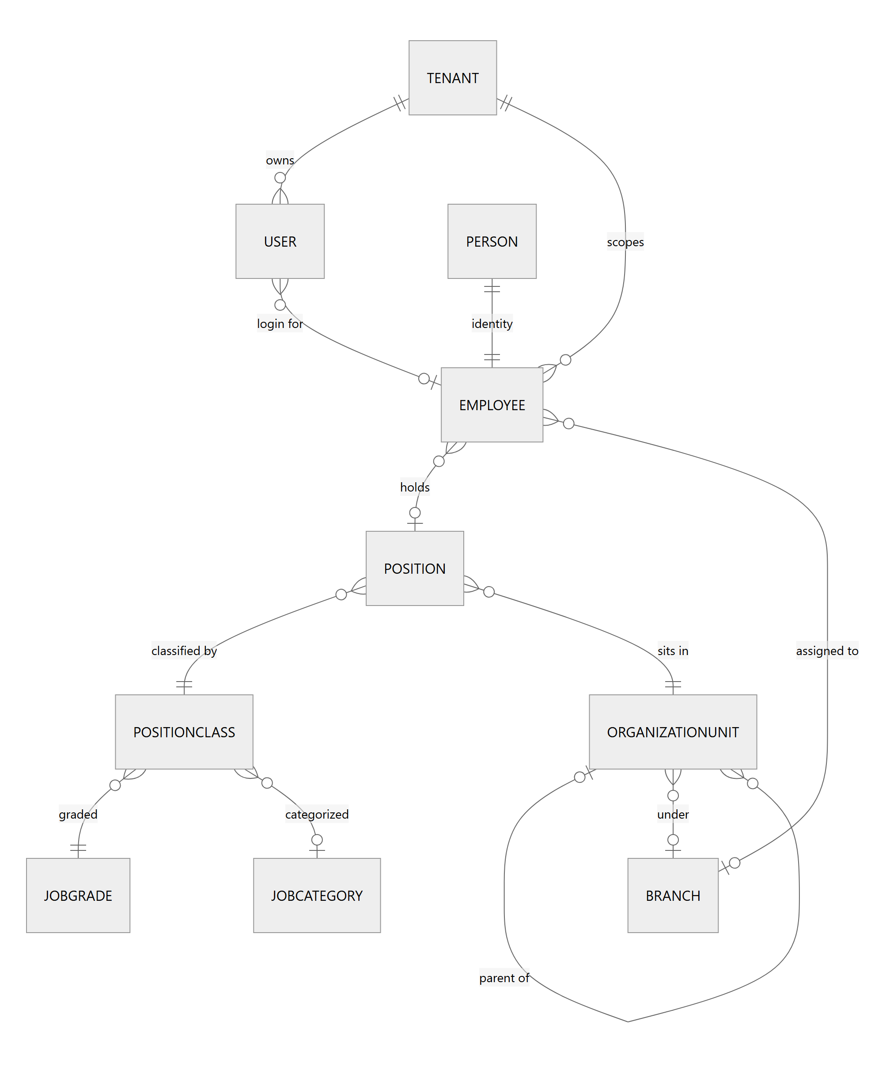
Fig 5.1 — Core identity & organization structure — the foundation the whole lifecycle builds on.

Leave ledger
Leave balances are an append-only ledger, not a mutable counter. A LeaveBalance row fixes employee + fiscal year + leave type; every accrual, deduction, carry-forward or expiry is a LeaveBalanceTransaction. An annual-leave request charges a specific ledger row — and the balance is only ever debited after the approval workflow's final step.
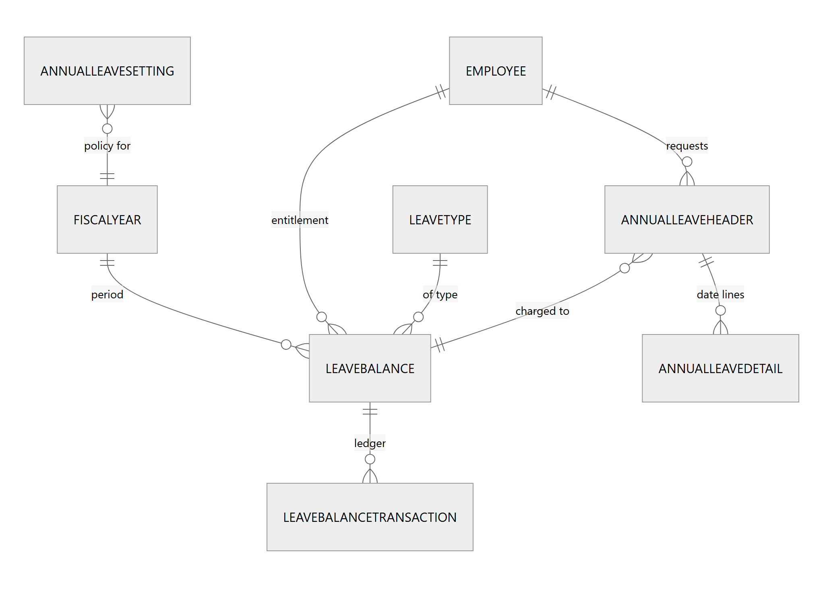
Fig 5.2 — Leave as a ledger — the transaction table is the source of truth; balances move only on approval.

Workflow engine (polymorphic)
One generic approval engine governs every process. A WorkflowDefinition has ordered WorkflowSteps, each with authorized WorkflowStepApprovers (a user, a role, or a dynamic approver resolved from the org tree at decision time). A WorkflowInstance points at any governed record by EntityType + EntityId — no FK, which is exactly what makes the engine module-agnostic. Decisions append to WorkflowActionLog.
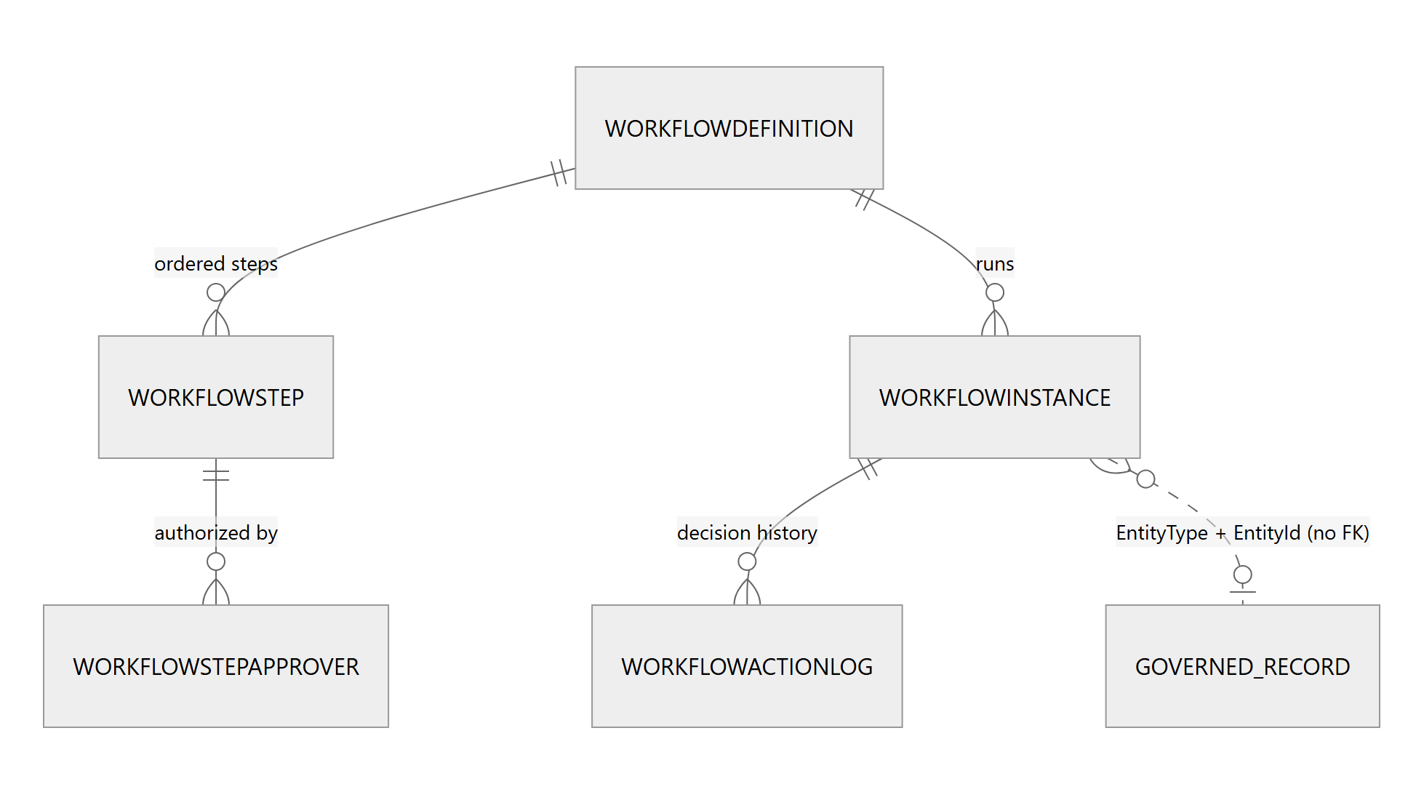
Fig 5.3 — The approval engine — the dotted link is polymorphic: any module attaches by key, not by foreign key.

06 Component Data Flow
Two paths carry almost all traffic: the standard CRUD request lifecycle, and the approval workflow that sits between a submitted record and its committed outcome.

Standard request lifecycle
The frontend is templated: a page composes useEntityCrudModule / useEntityList, which call per-entity services built from createPagedQuery, which call apiClient (fetch with credentials: include). React Query caches and dedupes. A 401 fires the AUTH_ERROR_EVENT and redirects to login.
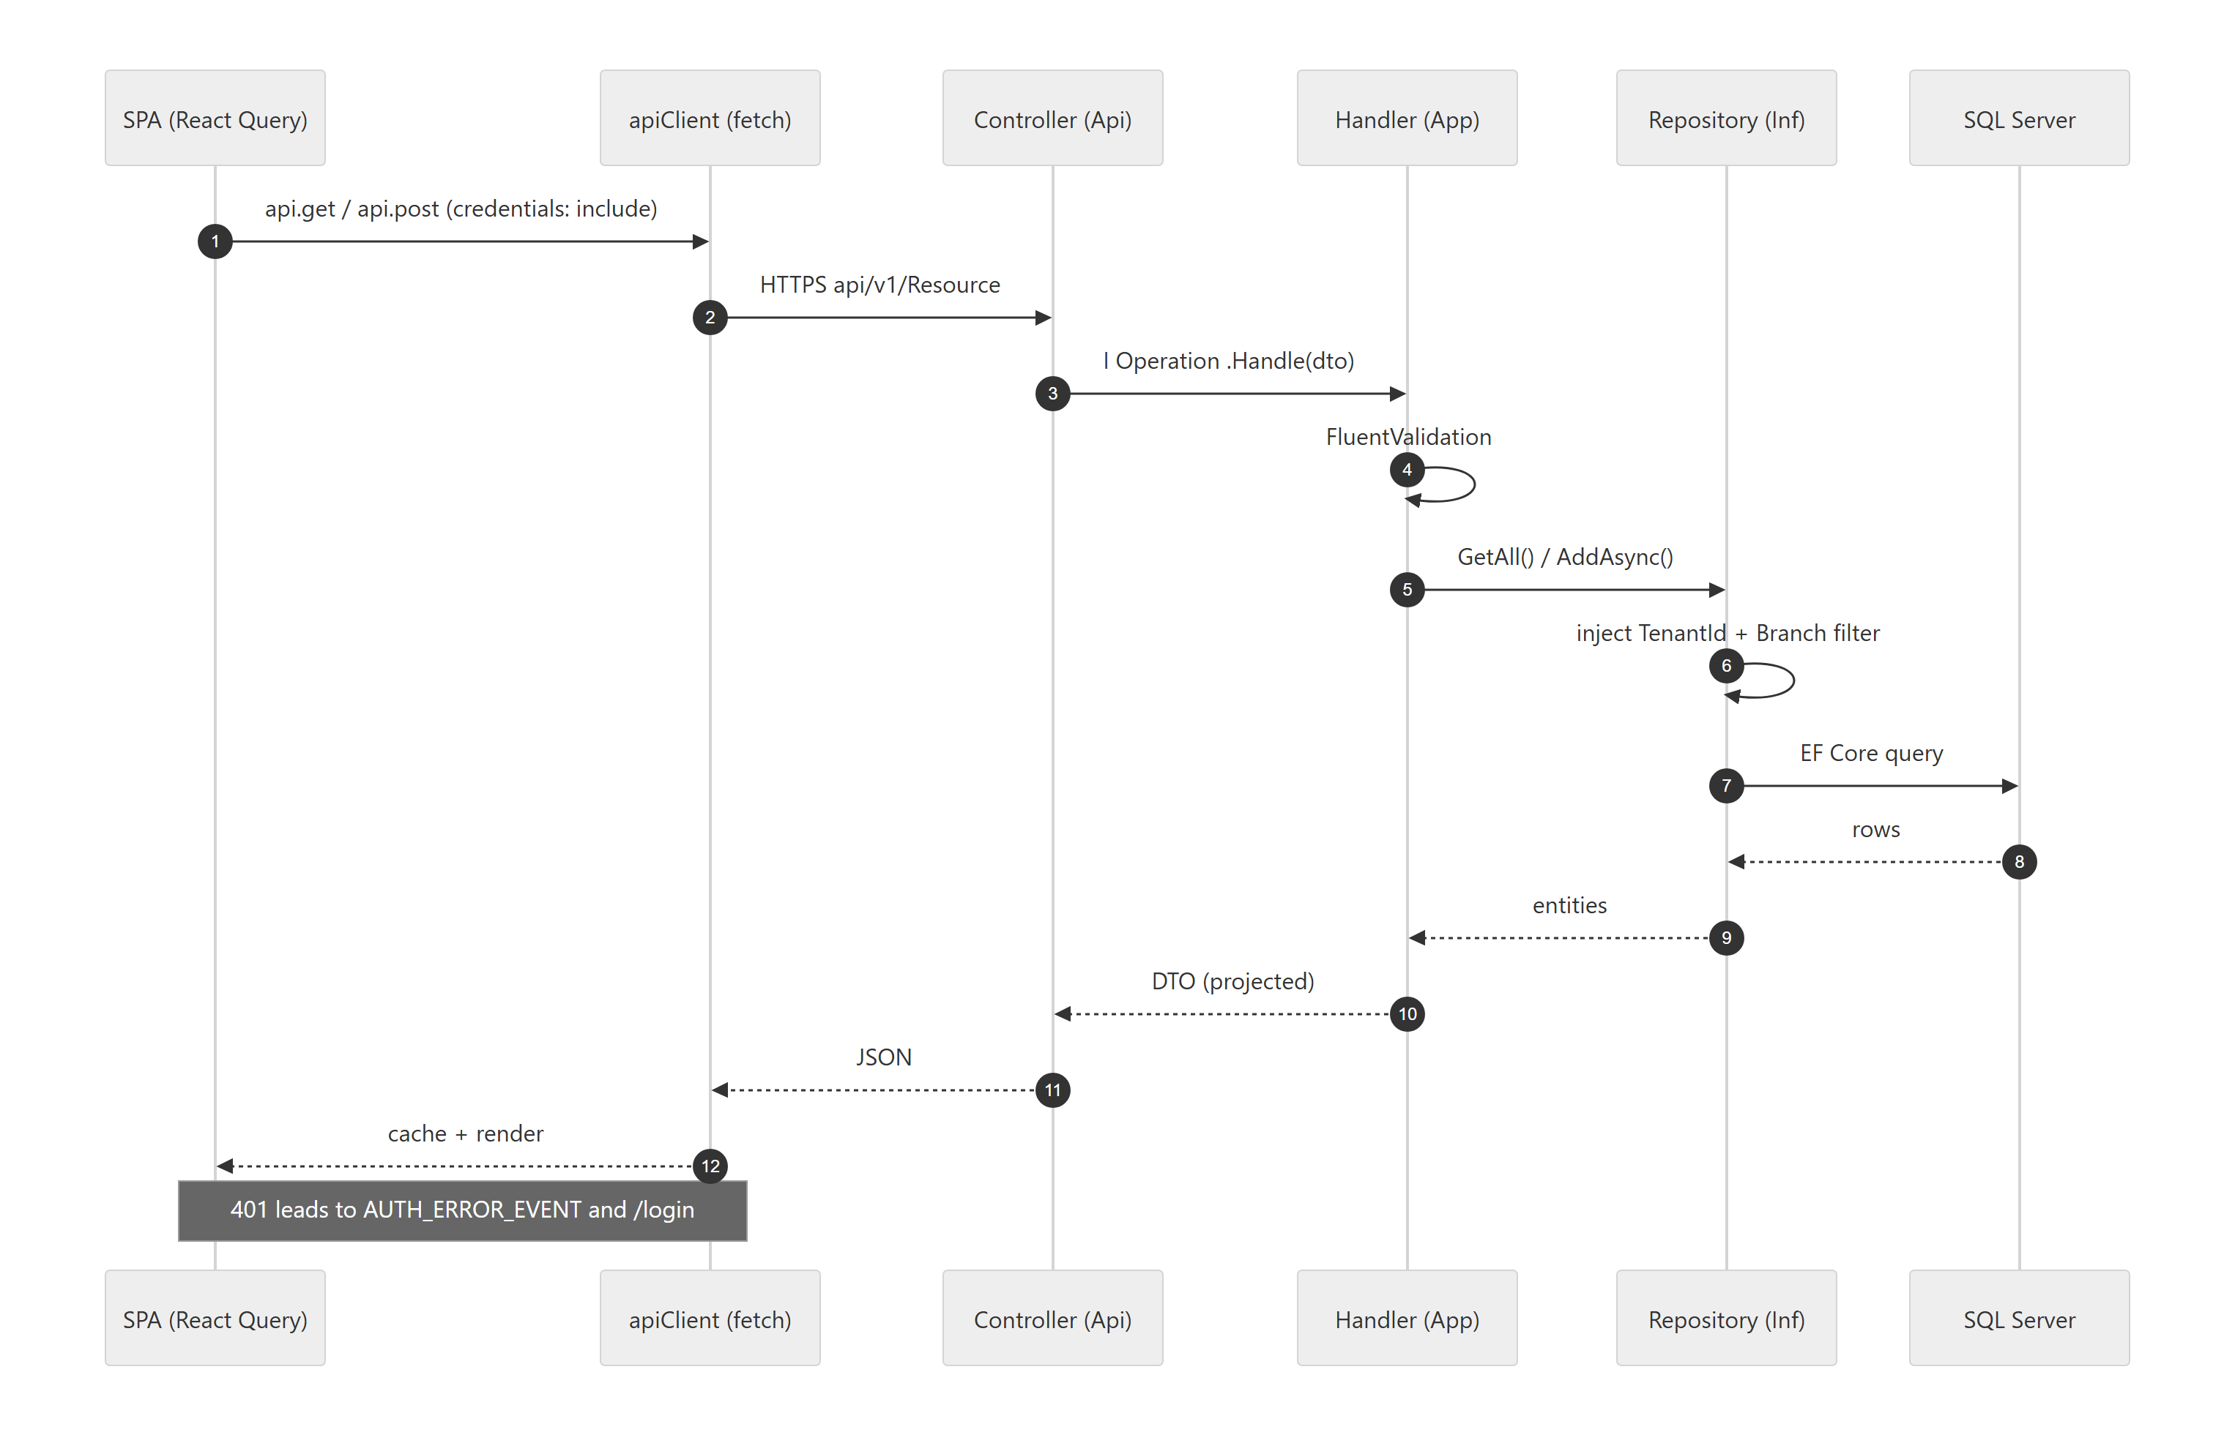
Fig 6.1 — CRUD lifecycle — tenant/branch isolation is applied inside the repository, so no handler can read across tenants.

Approval workflow
When a governed record is saved, its module calls StartIfDefinedAsync. The engine pre-validates that every dynamic approver resolves, opens an instance at step one, and notifies that step's approvers (a coreNotification surfaces in the Home portal). Each approval advances the instance; the final approval completes it and invokes the module's IWorkflowEntityHandler.OnApprovedAsync — where the real side-effect happens (debit the leave ledger, execute the movement, disburse a loan).
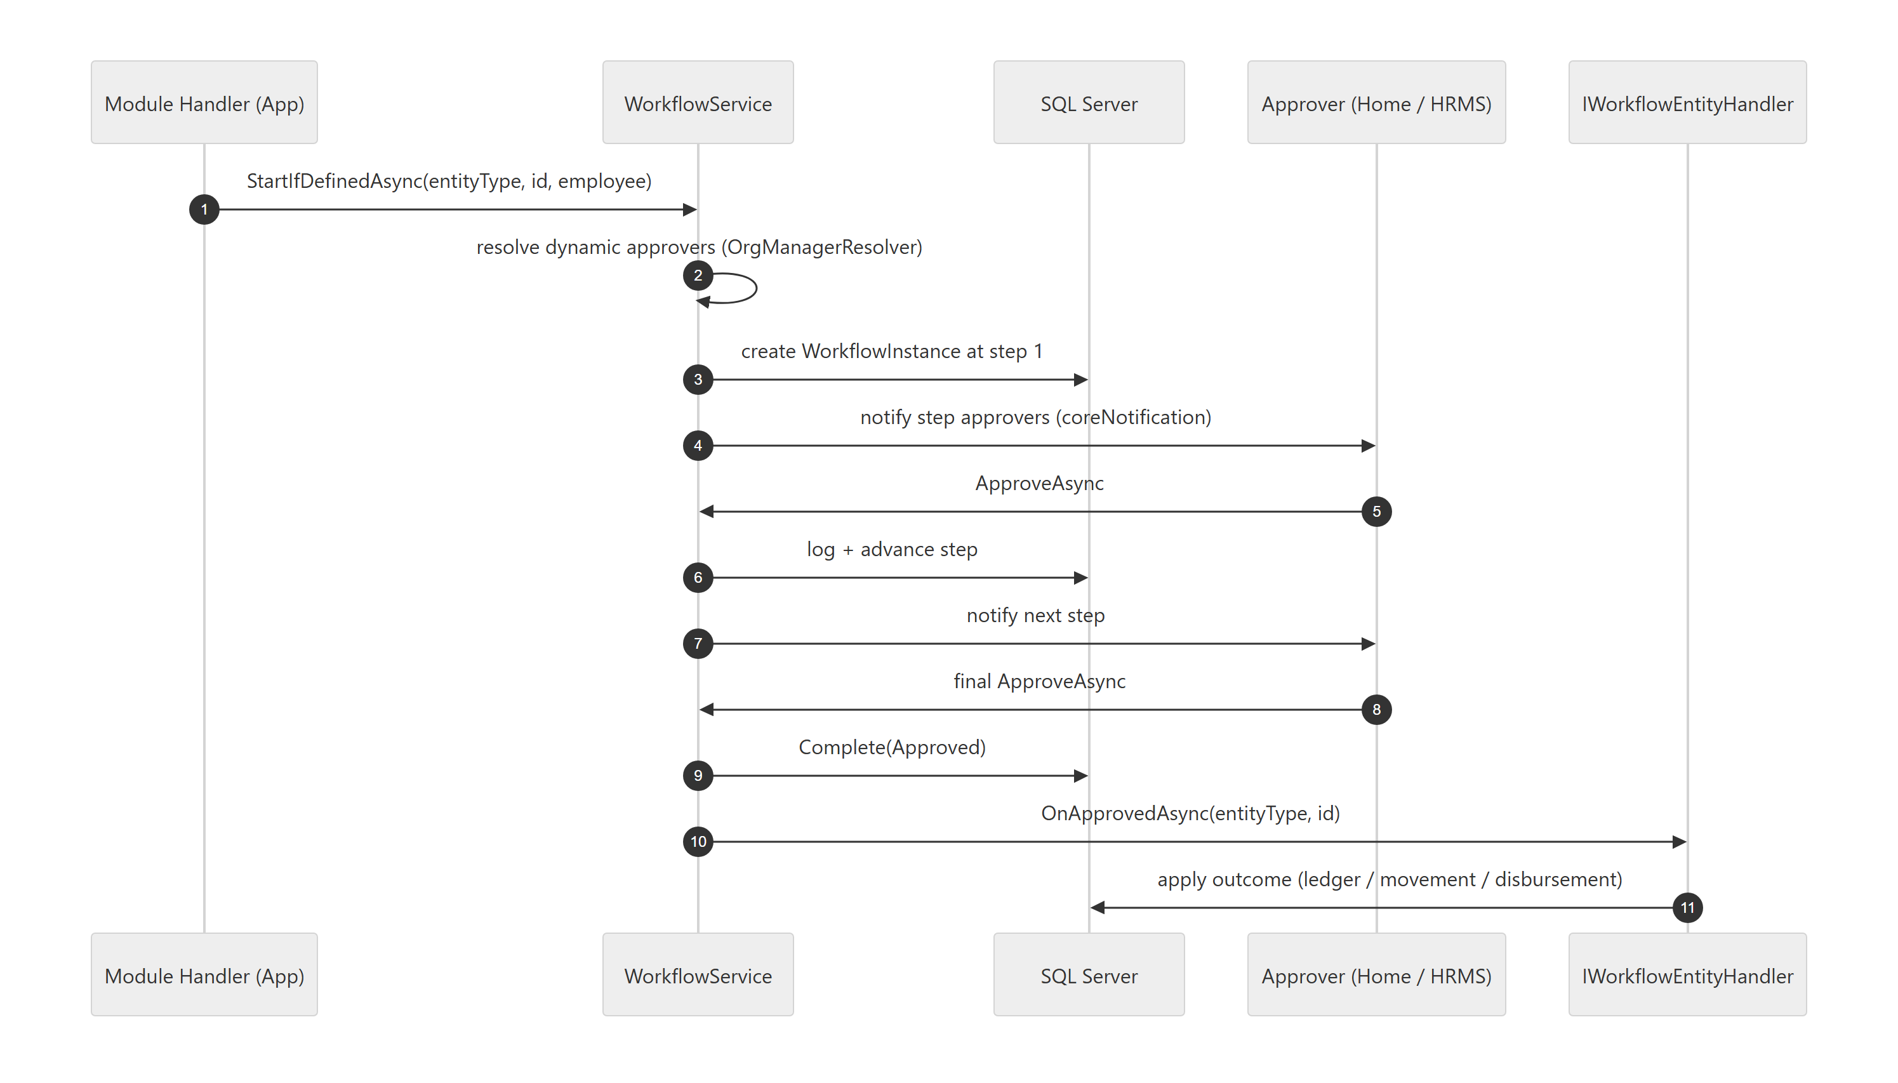
Fig 6.2 — Approval flow — the record stays pending and untouched until the final step; outcomes are applied by the owning module's handler.

07 Cross-Cutting Engines
Generic, reusable subsystems that any module plugs into — the reason the codebase scales to dozens of modules without dozens of bespoke implementations.
REUSABLE ENGINES
ENGINE | WHAT IT DOES
Workflow engine | Config-driven multi-step approval chains, dynamic org-tree approvers, per-module outcome handlers. Add a process = one definition + one handler.
Report engine | SP-driven reports: an hrms_Report registry, a Dapper executor with @TenantId injection, and a dynamic viewer.
Lookup system | A generic two-table lookup (category + list), global across tenants, behind one Lookup API and a useLookupOptions hook.
Dynamic navigation & permissions | Sidebar driven by coreSubsystem/Module/Operation + RolePermission.canView; the same grants power the route PermissionGate.
Global search | A pluggable ISearchProvider per module fans out from one endpoint; the header palette is debounced and permission-filtered.
Custom-field engine | User-defined fields and SAP-style custom tabs stored as JSON documents, module-agnostic, via a shared field renderer.
Document templates | A {{placeholder}} merge engine over a TipTap-authored template — generate and print letters from any record.
Notifications | The Home portal owns coreNotification; workflow steps raise per-user alerts routed to the bell.

08 Module Map & Employee Lifecycle
The modules are not islands — they are a lifecycle. Organization structure defines the establishment; recruitment consumes approved vacancy; a hire becomes an employee; movements, leave, performance and compensation all read and write the same position and vacancy state through shared services.
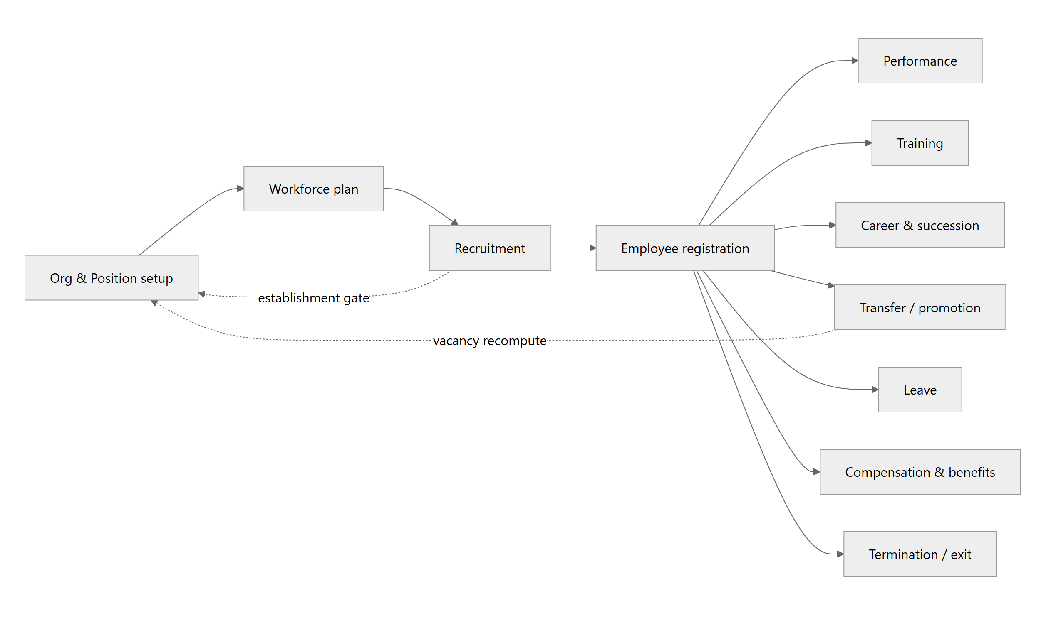
Fig 8.1 — The HRMS lifecycle — recruitment is gated by establishment; movements and exits feed position vacancy back to the org structure.

How modules stay interconnected
- Establishment as the gate — recruitment (hiring request → requisition → posting → candidate → application) validates against live vacancy before demand becomes a job opening.
- One employee, many events — a hire routes through the movement module rather than minting a duplicate; transfers/promotions vacate and occupy positions, recompute unit vacancy, and register internal experience via shared services (EmployeeShared, EstablishmentShared).
- Approvals everywhere — leave, movements, recruitment, compensation, and medical/insurance/loan/trip claims all attach to the same workflow engine; outcomes commit only on final approval.
- Exit closes the loop — termination runs clearance, reopens the position, and settles balances, feeding vacancy back to the establishment.

09 Environments & Operations
RUNTIME ENDPOINTS
COMPONENT | ADDRESS | NOTES
HRMS API | http://localhost:5014 · https 7013 | Swagger in Development; versioned under api/v1
HRMS SPA | :5174 | VITE_API_BASE_URL points at the HRMS API
Home API | :5015 | Own DbContext + migration history
Home SPA | :5175 | Deep-links into subsystems
Database | SQL Server · CyberErp | Shared by both APIs

Build & migrations
# Backend (from backend/)
dotnet build CyberErp.Hrms.slnx
dotnet run --project CyberErp.Hrms.Api
# EF migrations live in Inf, startup is Api
dotnet ef migrations add <Name> -p CyberErp.Hrms.Inf -s CyberErp.Hrms.Api
# Frontend (from frontend/)
npm run dev # Vite dev server
npm run build # tsc -b && vite build (typecheck gates the build)
npm run scaffold:entity <Entity> <domain> # prints the CRUD file set
BACKGROUND WORK
Hangfire runs the recurring jobs the lifecycle depends on: due-movement execution (deferred transfers apply on their effective date), fiscal-year leave-rollover, and trip settlement reminders — each a single indexed query, never blocking a request.

CyberHRMS · System Architecture Document · Clean Architecture (.NET 10) + React 19 · multi-tenant SaaS
A living reference — the code is the source of truth for stack facts. Peripheral modules follow the patterns shown here.

