**Introduction**

In order to estimate the value of distributed wind systems to prospective customers, the dWind model calculates the cost of electricity with and without a distributed wind system for each customer type. These costs of electricity are derived from location-specific retail electric rates. Users of the dWind model are able to select from three types of retail rate structures to model: real-world complex rate tariffs, flat rate structures derived from annual averages of real-world rates, and user-defined flat rates structures. This document details the data sources for each of these rate structures, as well as the method by which they are assigned to customer types in the model.

**Data Sources**

*Complex Rate Tariffs*

Complex utility rate tariff structures in dWind are modeled using rate data from the Utility Rate Database (URDB). Rate data from the URDB provide very detailed information about various tariff parameters, including seasonal and time-of-use rates, rate tiers, demand charges, and energy charges. The URDB contains a large number of rates, with geographic coverage of most of the US (see Figure 1).

Figure 1. Add caption. Source: <http://prod-http-80-800498448.us-east-1.elb.amazonaws.com/w/images/f/fd/OpenEI_Utility_Rate_Coverage.png>

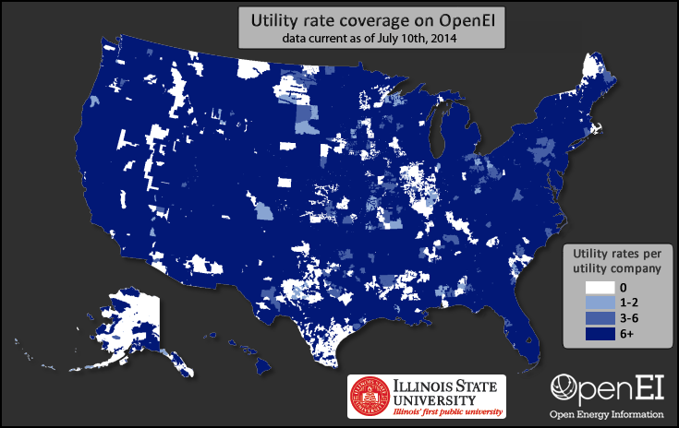

As shown in Figure 1, most utility territories include several rate tariffs. To help identify the type of customer to which each rate applies, the URDB associated each rate with a sector: residential, commercial, or industrial; however, for many utility territories, there may be multiple rates within a single sector.

This multiplicity of utility rates for a given location poses a challenge for using URDB rates in the dWind model because, within the model, a single rate must be assigned to each customer type. Because the customer types in each dWind model run are generated stochastically, it is not feasible to predetermine the rate that should be assigned to each customer. Therefore, where multiple rates are available in a customer’s utility area and sector, the model must dynamically and automatically select the most applicable rate.

The URDB includes a series of parameters that may be used to determine the rate applicability, such as minimum and maximum demand (kW), energy (kWh), voltage, and characteristics for phase wiring; however, these attributes are not populated for the majority of rates in the database. Commonly, it takes review of the URDB text description of the rate, or even the source description of the rate tariff by the utility company, to accurately determine the applicability of the rate.

To solve the challenge of automating the selection of rates for each customer type in a model run, the dWind model uses only a subset of rate data from the URDB. This subset of rates includes two separate groups of rates: 1) a selection of rates that were manually reviewed by NREL to determine the rate type (i.e., time-of-use, seasonal, tiered, etc.) and the range of applicable demand levels (minimum and maximum demand in kW); and 2) a selection of rates that are the only available option in their utility territory and sector.

The first set of rates includes approximately 1130 tariffs that were manually reviewed by NREL between June and August 2014. For each of these rates, NREL staff reviewed the source rate sheet from the utility company and determined the rate type (e.g., seasonal, time of use, tiered, etc.), as well as the minimum and maximum demand level (kW) allowed for the rate. These rates were selected for review because they correspond to the most populous utility companies in each state of the US. In total, these rates cover 242 utility companies which serve approximately 75 percent of residential and commercial customers and load in the US. Together, the rate type and range of applicable demand levels provide a basis for automating the selection of an applicable rate for customers in the dWind model corresponding to these utility areas.

The second set of rates includes approximately 1240 additional tariffs. Each rate in this set is the only available rate in their utility territory and sector which drastically simplifies the issue of selecting an applicable rate for each customer type. Because it is possible that other rates exist in reality, but simply were not added to the URDB, we extracted the range of demand levels for these rates where that information was provided. These rates cover an additional 1050 utility territories; however, in contrast to the manually reviewed data, these tend to be municipal utilities with small populations of customers.

In total, we extracted approximately 2370 rates from the URDB for use in the dWind model. Together, these rates approximately 80 percent of residential and commercial customers and load in the US. Figure 2 shows the geographic coverage of the two combined subsets of rates extracted from the URDB for use in the dWind model. For geographic regions lacking rate coverage, we developed a backfilling methodology, as described in the next section.

Figure 2

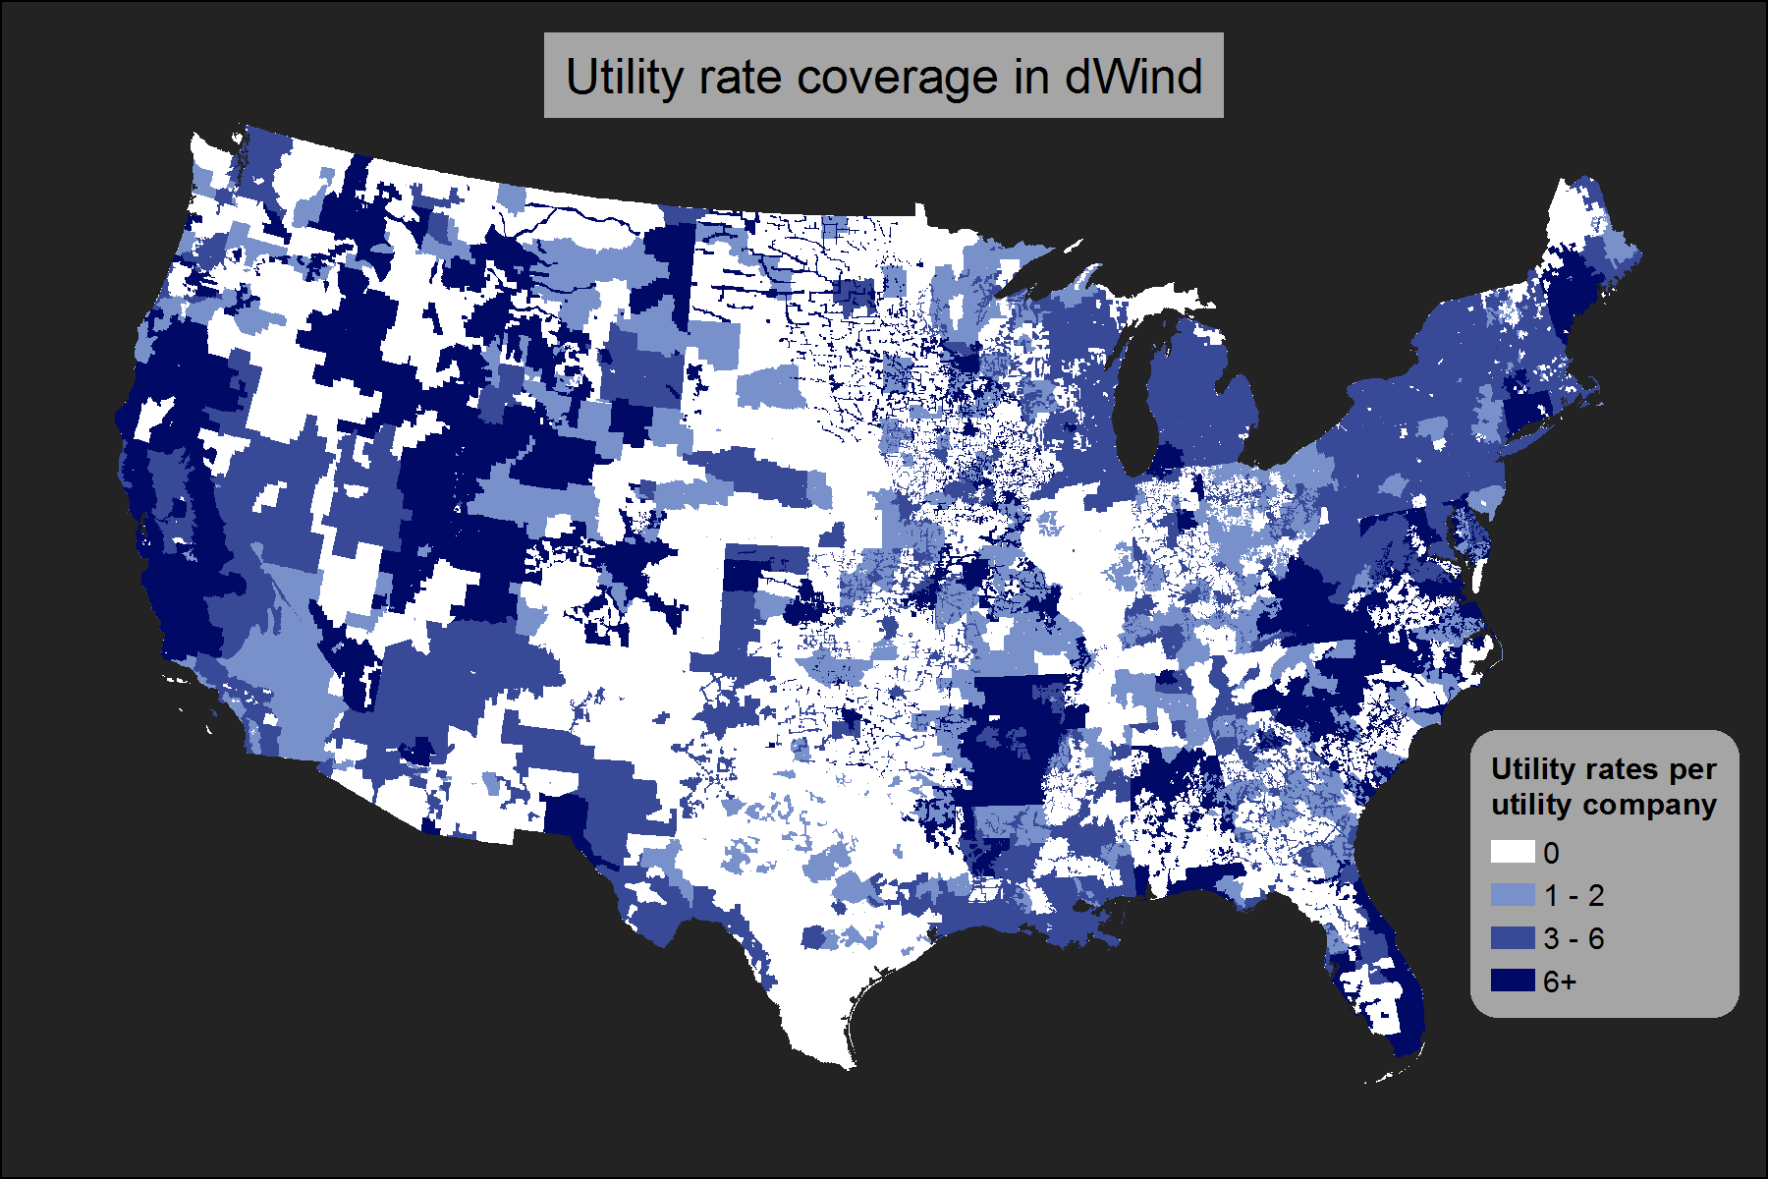

It is notable that the URDB rates extracted for use in the dWind model represent only residential and commercial sector rates. Although the URDB includes industrial rates, these have not been included in the model at this time because the manual review effort that yielded the first set of rates used in the model was actually performed for a different NREL project. That project was focused on determining breakeven prices for solar photovoltaics (Davidson et al., forthcoming) for the commercial and residential sectors, and due to the labor-intensive effort of reviewing source tariff sheets, focused only on rates for those sectors. In compiling the second set of singular rates, we decided to continue to limit our collection to residential and commercial rates for consistency. Because industrial rates are not included in the dWind model, we use commercial rates to assess the economics of distributed wind for industrial customers. In the future, it would be possible to incorporate industrial rates from the URDB into the dWind model, contingent on sufficient funding to perform the labor intensive review needed to determine their applicability to different demand levels.

It is also important to note that the utility rates extracted from the URDB for use in the dWind model represent a snapshot of real world rate structures, as of the time they were downloaded (December 2014). Currently, we have no short-term plans to update the rates used within the model due to the time consuming nature of reviewing new rate structures and the computational complexity of integrating them into the model; however, future updates to the rates used in the model are possible given sufficient time and funding.

**Selecting Potential Rates for Each Customer Type**

During each model run, the dWind model dynamically assigns a set of potential rates to each customer type according to the customer location and nearby rates within the same state. For many customer locations, the set of potential rates are based solely on the set of rates for the customer sector and the encompassing utility territory. However, due to the geographic gaps in rate coverage across the US shown in Figure 2, several customer locations in the dWind model are missing actual rates associated with their utility territory.

To allow modeling of the economics of distributed wind at these locations, the dWind model assigns a set of potential rates from nearby utility types according to a multi-step algorithm. First, the pool of potential rates is limited to the customer sector. Residential customers are limited to residential rates, while commercial and industrial customers are both limited to commercial rates due to the lack of industrial rates extracted from the URDB. Next, because rates are typically governed by state regulations, the set of potential rates for each customer location is limited to the rates within the customer’s state. WIthi

Priority is given to rates within 50 miles and the same utility type (muni, coop, etc.), based on proximity

* + - * why? Because for nearby utility territories, location based drivers for differences in rates (e.g., climate zone) are less likely, so it seems like the bigger driver of costs would be the utility type
    - If no matches under those constraints, priority is based on proximity
      * farther distances, you may starting getting into different climate zones and therefore different rates, so pure proximity seems more important
  + For customer locations in utilities with rates, those rates will be selected
* Determining the applicable rate from the set of potential rates:
  + Need to look at code for this but I believe it is determined first by demand min and max (where we have them), and secondly by user defined priorities for different rate types and a stochastic sampling method…

**Alternative Rates**

* EIA Annual average rates