**Technical Summary:**

**Retail Electric Rate Data in the dWind Model**

Michael Gleason – GIS Scientist

National Renewable Energy Laboratory

5/27/15

**Introduction**

To estimate the value of distributed wind systems to prospective customers, the dWind model calculates the cost of electricity with and without a distributed wind system for each customer type in the model. These costs of electricity are derived from location-specific retail electric rates. Users of the dWind model are able to select from three types of retail rate structures to model: real-world complex rate tariffs, flat rate structures derived from annual averages of real-world rates, and user-defined flat rates structures. This document details the data sources for each of these rate structures, as well as the method by which they are assigned to customer types in the model.

**Data Sources**

*Complex Rate Tariffs*

Complex utility rate tariff structures in dWind are based on rate data from the Utility Rate Database (URDB) (OpenEI 2015). Rate data stored in the URDB provide very detailed information about various tariff parameters, including seasonal and time-of-use rates, rate tiers, demand charges, and energy charges. The URDB contains a large number of rates, with geographic coverage of most of the US (Figure 1).

**Figure 1.** Map showing geographic coverage of all rates in the URDB . Source: OpenEI 2014.

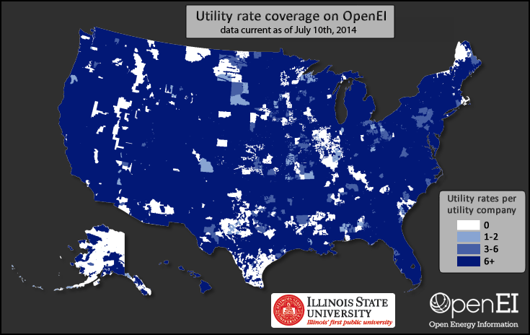

As shown in Figure 1, most utility territories include several rate tariffs. This multiplicity of utility rates for a given location poses a challenge for using URDB rates in the dWind model because, within the model, a single rate must be automatically and dynamically assigned to each customer type. The URDB includes several parameters that may be used to help determine the applicability of a rate to a given customer, including sector (e.g., residential, commercial), phase wiring, and ranges for demand, energy, and voltage; however, with the exception of sector, these attributes are not populated for the majority of rates in the database. As a result of the sparseness of this information, we were unable to incorporate all URDB rates into the dWind model; instead, we curated a subset of rates for which it is more tractable to determine the applicability to various customer types.

Specifically, we curated two different collections of rates from the URDB: (1) a selection of rates that were manually reviewed by NREL to determine the rate type (i.e., time-of-use, seasonal, tiered, etc.) and the range of applicable demand levels (minimum and maximum demand in kW); and (2) a selection of rates that are the only available option in their utility territory and sector. This set includes approximately 1130 tariffs reviewed by NREL staff during mid-2014. These rates were selected for review because they correspond to the most populous utility companies in each state of the US; in total, they correspond to 242 utility companies serving approximately 75 percent of residential and commercial customers and load in the US. The second set of rates includes approximately 1240 additional tariffs. Each rate in this set is the only available rate in its utility territory and sector. Because it is possible that other rates exist, but simply were not added to the URDB, we extracted the range of demand levels for these rates where that information was provided. For rates without known demand ranges, we assumed that there were no limits on maximum or minimum energy demand. These rates cover an additional 1050 utility territories; however, in contrast to the manually reviewed data, these tend to be municipal utilities with small populations of customers.

In total, we extracted approximately 2370 rates from the URDB for use in the dWind model. The full set of extracted rates is associated with utility territories serving approximately 80 percent of residential and commercial customers and load in the US. Figure 2 shows the geographic coverage of the two combined subsets of rates extracted from the URDB for use in the dWind model. For geographic regions lacking rate coverage, we developed a ranked backfilling methodology, as described in the next section.

The URDB rates extracted for use in the dWind model represent only residential and commercial sector rates. Although the URDB includes industrial rates, these have not been included in the model at this time because the manual review effort that yielded the first set of URDB rates used in the model was actually performed for a different NREL project. That project was focused on determining breakeven prices for solar photovoltaics for the commercial and residential sectors (Davidson et al., forthcoming). Due to the labor-intensive effort of reviewing source tariff sheets, that project focused only on rates for those two sectors. In compiling the second set of rates, we decided to continue to limit our collection to residential and commercial rates for consistency. Because industrial rates are not included in the dWind model, we use commercial rates to assess the economics of distributed wind for industrial customers. In the future, it would be possible to incorporate industrial rates from the URDB into the dWind model, contingent on sufficient funding to perform the labor intensive review needed to determine their applicability to different demand levels.

**Figure 2.** Map showing geographic coverage of rates extracted from URDB for use in the dWind model.

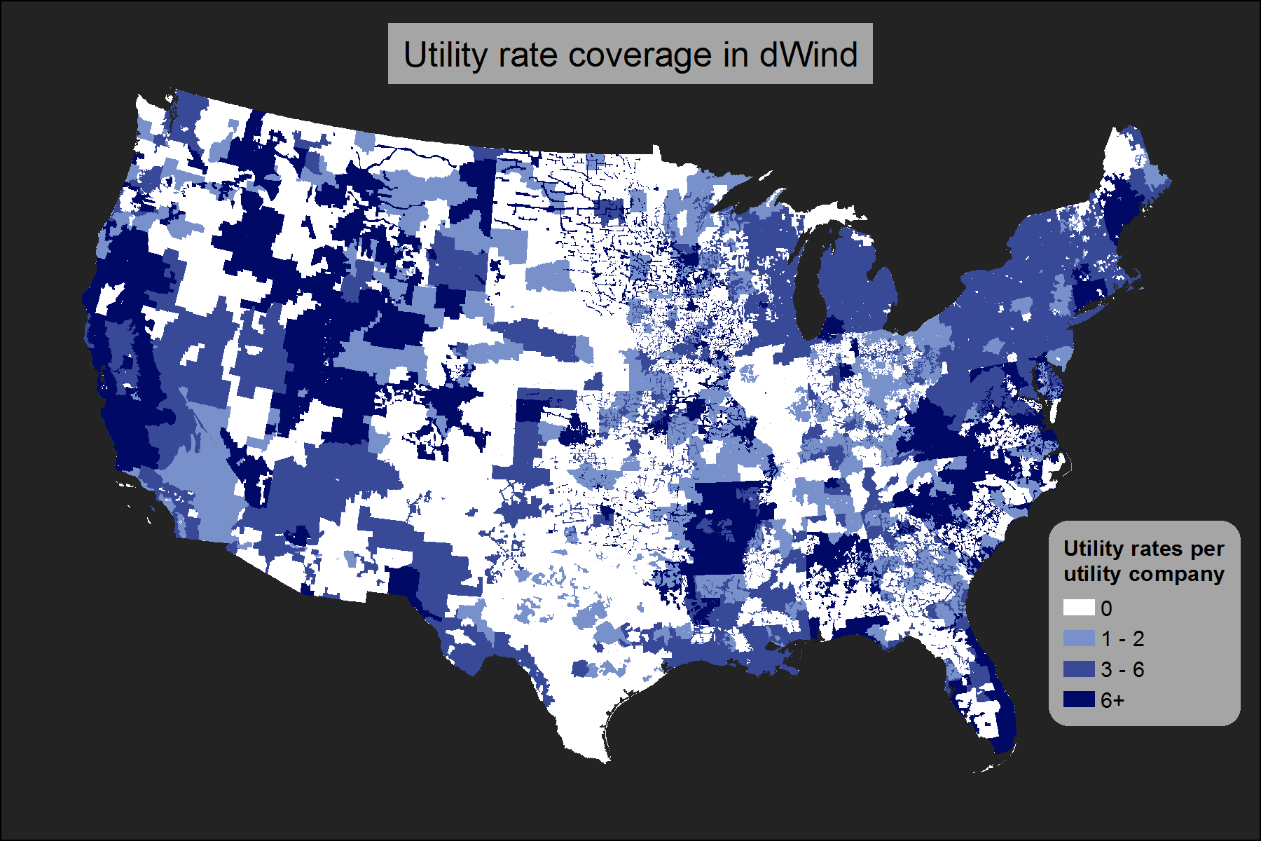

It is also important to note that the utility rates extracted from the URDB for the dWind model represent a snapshot of real world rate structures, as of the time they were downloaded (December 2014). Currently, we have no short-term plans to update the rates used within the model due to the time-consuming nature of reviewing new rate structures and the computational complexity of integrating them into the model; however, future updates to the rates used in the model are possible given sufficient time and funding.

*Annual Average Flat Rates*

To allow for comparison, the dWind model allows users to model the economics of distribute wind using annual average flat rates as well. These flat rates are derived from average retail price data by sector and utility territory provided by the US Energy Information Administration (EIA) (EIA 2015b). These data were downloaded in December 2014 by NREL; at that time, the most recent release were rates for 2012. We mapped the rates to counties using the utility territory to county lookup table included in the EIA 861 for 2012 (EIA 2015c). For counties with multiple utility territories, we calculated a simple average rate from the overlapping utility territory rates. The resulting dataset provides annual average flat retail rates for each county in the US for 2012.

*User-Defined Flat Rates*

As a final option, users of the dWind model may also choose to provide user-defined flat retail rates. Users can specify a unique rate for each state and sector. Default values in the input table for user-defined rates are based on the state annual average flat rates from 2012, as provided by the EIA (EIA 2015a).

**Selecting a Rate for Each Customer Type**

Each customer type that is evaluated in the dWind model is assigned a single retail rate. When the model is run using either annual average or user-defined flat rates, rates are tied to regions (counties or states, respectively); therefore, one and only one rate is available for each customer location. In the case of complex rate structures, the process of selecting an appropriate rate is significantly more dynamic and complicated.

The first step in selecting a complex rate structure for each customer type in the model is to determine the most applicable rates for each customer location. First, the pool of potential rates for each customer is filtered to match the customer sector. Residential customers are limited to residential rates, while commercial and industrial customers are both limited to commercial rates due to the lack of industrial rates extracted from the URDB. Next, because rates are typically governed by state regulations, the set of potential rates for each customer location is limited to the rates within the customer’s state.

The resulting subset of rates is then ranked from most applicable to least applicable for each customer location. In this ranking, priority is assigned in tiers. In the first tier, all rates associated with a utility territory within 50 miles of the customer location and matching the utility type (municipal, cooperative, investor-owned, or other) of the customer are ranked in order of distance from the customer location. For customers located in utility territories with rate coverage (as shown Figure 2), these criteria automatically result in prioritizing the rates from the customer’s own utility territory; meanwhile, for customer locations without rate coverage, these criteria limit the influence of location-based drivers for differences in rates, such as differing climate and utility company structure. The remaining set of rates (i.e., rates that do not meet the two criteria) comprise the second tier of rates, and are ranked purely using their proximity to the customer location. The two tiers of rate rankings are then consolidated, in order, into a single seamless set of rankings of potential rates for each customer location.

The rate rankings often include ties between rates from the same utility territory; breaking of ties is dealt with dynamically within the dWind model. During each model run, a stochastic process is used to generate a set of customer types by sampling from customer locations and annual electric loads. Each customer type is also assigned a normalized annual electric load profile. Using this profile and the annual electric load of the customer, the dWind model determines the maximum demand required by the customer over the course of a typical year. This maximum demand hour is compared to the demand ranges associated with each of the curated URDB complex rate structures to filter out inapplicable rates. The remaining rate with the highest rank is then selected as the most applicable. If there is a tie amongst the most highly ranked rates, a weighted random sample is then performed to determine the single rate to use for the customer. The weights for this random sampling are based on user-defined inputs which give the prevalence of different rate types by sector (Table 1).

**Table 1.** User input table for defining the relative prevalence of different rate structures, by sector.

|  |  |  |
| --- | --- | --- |
|  | Residential | Commercial / Industrial |
| Flat | 0.2 | 0.05 |
| Demand | 0 | 0.2 |
| Seasonal | 0.2 | 0.05 |
| Tiered | 0.2 | 0.05 |
| Time of Use | 0.15 | 0.1 |
| Demand Tiered | 0 | 0.3 |
| Tiered Seasonal | 0.2 | 0.05 |
| Demand Time of Use | 0 | 0.15 |
| Other | 0.05 | 0.05 |
| SUM | 1 | 1 |

This random sampling approach for breaking ties is consistent with other techniques used in the dWind model. In the absence of better data or knowledge, we are uncertain which rate to use for certain customers. Therefore, rather than make a potentially incorrect or biased choice, the model allows users to use random sampling to investigate the effects of this uncertainty on model outputs.

This complicated process overcomes gaps in both data coverage and attributes to

incorporate real-world, complex rate structures into the dWind model. Due to the importance of rate structures as a first-order driver of the economics of distributed generation, this is a unique and highly valuable capability of the dWind model.

**References Cited**

OpenEI (2014). “Utility rate coverage on OpenEI”. Accessed May 27, 2015: http://prod-http-80-800498448.us-east-1.elb.amazonaws.com/w/images/f/fd/OpenEI_Utility_Rate_Coverage.png.

OpenEI (2015). “U.S. Utility Rate Database”. Accessed May 27, 2015: http://en.openei.org/wiki/Utility_Rate_Database.

U.S Energy Information Adminstration (EIA) (2015). “Detailed State Data: Average Price by State by Provider (EIA-861)”. Accessed January 2, 2015: http://www.eia.gov/electricity/data/state/avgprice_annual.xls.

U.S Energy Information Adminstration (EIA) (2015). “Electric Sales, Revenue, and Average Price: Tables T6, T7, and T8 (2012)”. Accessed January 2, 2015: http://www.eia.gov/electricity/sales_revenue_price/.

U.S Energy Information Adminstration (EIA) (2015). “Electric Power Sales, Revenue, and Energy Efficiency Form EIA-861 Detailed Data Files: service_territory_2012.xls.” Accessed January 2, 2015: http://www.eia.gov/electricity/data/eia861/zip/f8612012.zip.