一．创建branch

Code -main

二．创建file

确保在相应的branch下，添加文件，创建新文件，命名文件，输入内容

提交更改

三 Open a pull request 发起拉取请求

可自动可手动

1. 手动拉取In the header menu of your repository, click the **Pull requests** tab .
2. Click the **New pull request** button.
3. Select the following branches using the dropdown menus.
   * **base:** main
   * **compare:** my-first-branch

[](https://private-user-images.githubusercontent.com/37269996/400052433-140ca348-b6de-4c3c-b29f-fd57944d98a9.png?jwt=eyJhbGciOiJIUzI1NiIsInR5cCI6IkpXVCJ9..NdNUrJ65R0vt7BiB6j3TXmt1DMVaUlNlf3SPf4HcBHw)

1. Click **Create pull request**.
2. Enter a title for your pull request. By default, the title will automatically be the name of your branch. For this exercise, let's edit the field to say Add my first file.
3. The next field helps you provide a **description** of the changes you made. Please enter a short description of what you’ve accomplished so far. As a reminder, you have: created a new branch, created a file, and made a commit.

[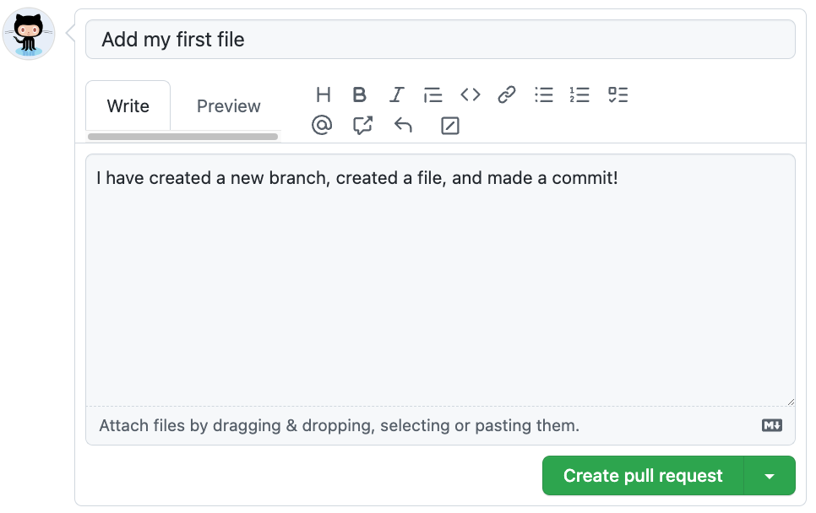](https://private-user-images.githubusercontent.com/37269996/400052660-e03171f9-98cc-4067-a473-78424618f1f8.png?jwt=eyJhbGciOiJIUzI1NiIsInR5cCI6IkpXVCJ9..c5n9TCbNnxf7l-u8rdv7KrSXew2hPDx5AbDVHQwMlWs)

1. Click **Create pull request**.

四．Merge pull request 合并拉取的请求

五Git pages

步骤一Open a new browser tab, and work on the steps in your second tab while you read the instructions in this tab.

Under your repository name, click Settings.点击设置

Click Pages in the Code and automation section.选择Pages

Ensure "Deploy from a branch" is selected from the Source drop-down menu, and then select main from the Branch drop-down menu.

Click the Save button.点击保存

步骤二We’ll work in a branch, my-pages, that I created for you to get this site looking great. :sparkle: 在my pages分支中

Jekyll uses a file titled _config.yml to store settings for your site, your theme, and reusable content like your site title and GitHub handle. You can check out the _config.yml file on the Code tab of your repository.

We need to use a blog-ready theme. For this activity, we will use a theme named “minima”.

:keyboard: Activity: Configure your site

Browse to the _config.yml file in the my-pages branch.

In the upper right corner, open the file editor.

Add a theme: set to minima so it shows in the _config.yml file as below:

theme: minima

(optional) You can modify the other configuration variables such as title:, author:, and description: to further customize your site.

Commit your changes.

(optional) Create a pull request to view all the changes you’ll make throughout this course. Click the Pull Requests tab, click New pull request, set base: main and compare:my-pages.

步骤三 浏览my pages分支中的index.md文件

在文件编辑器中编辑