

To Katooosh, 2015-08-16

This is the day Katooosh is forty four

But...still living adjcent to the south shore

With a kid in harbor and another going to high school

Hopefully she will grow in height since soon to see one of them she'll need a stool

Katoooosh has a dog that loves her and she take all over the place

Especially to the park where there is a lot of space

To the YMCA she goes almost every day

and lately she took the guys so they could play

In the morning Katooosh likes to drink coffee and eat string cheese

And in between she has a very cute sneeeze

Driving a Prius to save some fuel

She is in between bat mitzvahs at the shull

Shull Katooosh goes to every Saturday

She meets the Sues, Star, Jane and Cheryl but the rabbi doesn't hold much sway

Every June she used to organize the Israeli Day Parade

But ever since Netanyahu got reelected instead she prayed

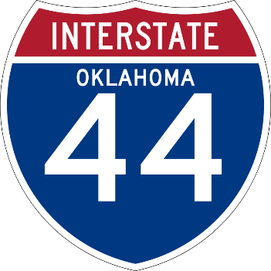

In polticis she wants Bernie Sanders to be the president from Vermont up North

And if he wins she will wear red white and blue not only on the fourth

Although she watches his TV show she doesn't want a President Trump

From one of his building she hopes he will jump

After Jeremy's next turn to get an iphone plus her eyes are set

Getting it from him won't put her in much debt

Hopefully this year Katoosh will play the guitar while we eat a cookie

And together we will sing to the tune about yosi the tookie

I wish Katooosh the best 45th year of her life

She makes everybody world better as a mother and a wife!

Love,

XOXOXXXX Mystery Lover!

(and now I'll read you mine...)

This poem is brought to you by:   
