MD SHAIHAN ISLAM

ISLMDS002

EEE3096S: EMBEDDED SYSTEMS II

TUTORIAL 1

Link to GitHub repo:

<https://github.com/tshaihan/EEE3096S.git>

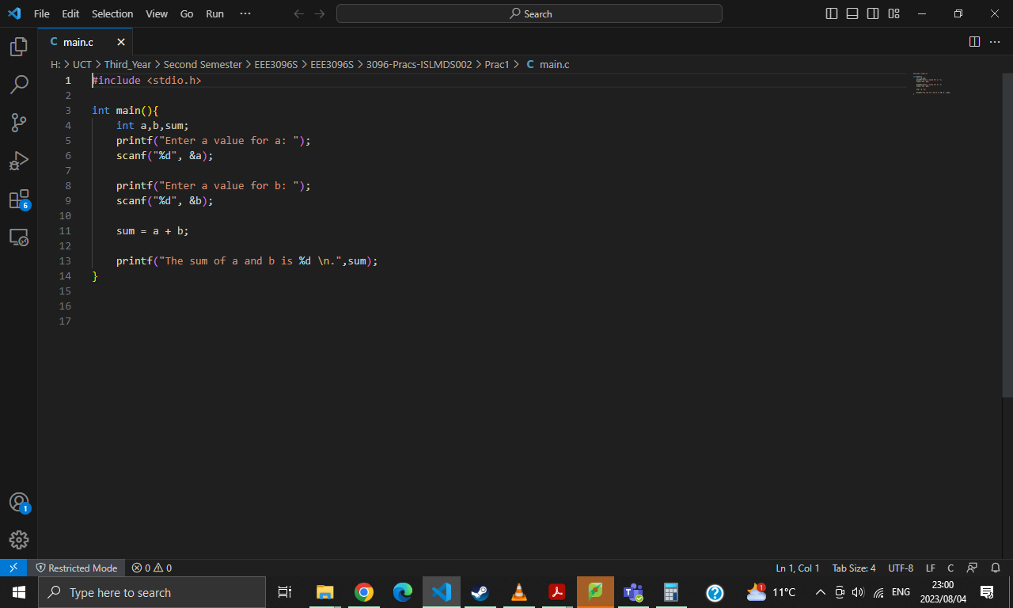Corrected (working) code: