SQL practical Exercise_1 Bright_Coffee_Dataset

---QUERY 1: Viewing the first 10 rows of the table
select * from `workspace`.`default`.`bright_coffee_shop_analysis_case_study_1` limit 10;

Expected Output
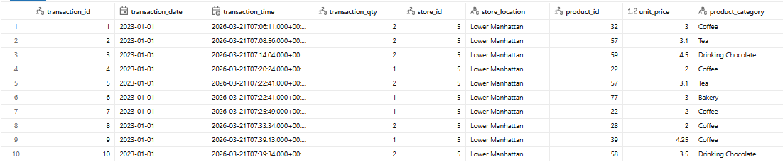
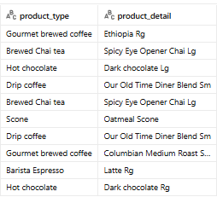

---QUERY 2: Viewing distinct store locations
SELECT DISTINCT store_location
FROM `workspace`.`default`.`bright_coffee_shop_analysis_case_study_1`;

Expected Output
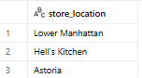
---QUERY 3: Selecting specific columns
SELECT DISTINCT transaction_id,
product_category,
unit_price
FROM `workspace`.`default`.`bright_coffee_shop_analysis_case_study_1`
LIMIT 10;

Expected Output
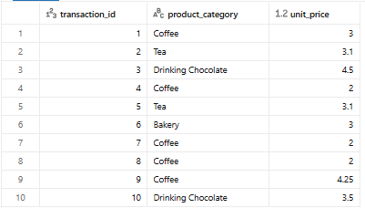
---QUERY 4: Using A Column alias
SELECT product_category AS Category,
unit_price AS Price
FROM `workspace`.`default`.`bright_coffee_shop_analysis_case_study_1`
LIMIT 100;

Expected Output
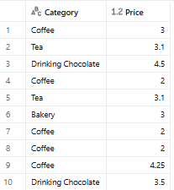

---QUERY 5: Filtering Using WHERE
SELECT *
FROM `workspace`.`default`.`bright_coffee_shop_analysis_case_study_1`
WHERE product_category = 'Coffee'
LIMIT 10;

Expected Output
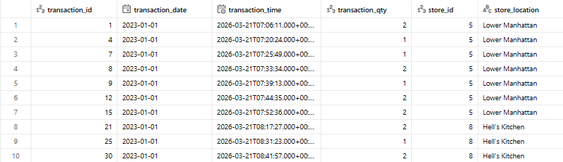
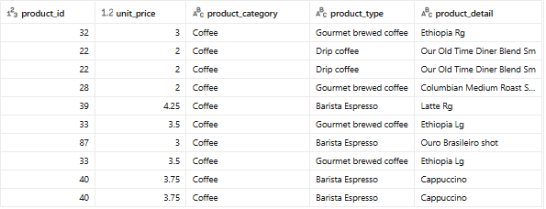

---QUERY 6: Filtering using WHERE and AND
SELECT *
FROM `workspace`.`default`.`bright_coffee_shop_analysis_case_study_1`
WHERE product_category = 'Coffee beans' AND unit_price > 10;

Expected Output
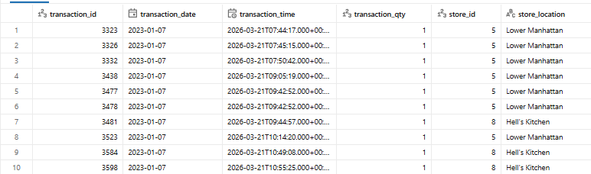
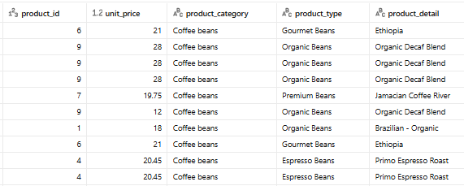
---QUERY 7: Finding the minimum unit price
SELECT MIN(unit_price) AS Min_Price
FROM `workspace`.`default`.`bright_coffee_shop_analysis_case_study_1`;

Expected Output
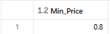

---QUERY 8: Finding the maximum unit price
SELECT MAX(unit_price) AS Min_Price
FROM `workspace`.`default`.`bright_coffee_shop_analysis_case_study_1`;

Expected Output
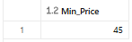
---QUERY 9 Filtering using WHERE and OR
SELECT *
FROM `workspace`.`default`.`bright_coffee_shop_analysis_case_study_1`
WHERE product_category = 'Coffee'
OR product_category - 'Tea'
Limit 10;

Expected Output
