**RESERVED**

**Version No.: 1.1**

**Date: 07/12/2018**

**Project Name: Reserved! – Restaurant Management System**

**Presented by:**

**Lynn Miro A20414970**

**Taru Sharma A20422576**

**Nastaran Ghane A20388942**

**Revision History**

|  |  |  |  |
| --- | --- | --- | --- |
| **Version No.** | **Date** | **PrePared By** | **Phase** |
| 1.0 | 11.14.2018 | Nastaran  Lynn  Taru | One |
| 2.0 | 12.07.2018 | Nastaran  Lynn  Taru | Two |

**Github Repository Link:**

[**https://github.com/lynnmiro/JavaPro**](https://github.com/lynnmiro/JavaPro)

**Overview of the Project:**

This application aims to manage the reservation of a restaurant. In this app, you will find the abstract class “User” that has the children “Customer” and “Admin.” Instance of Customer and Admin are instantiated in “Login Class.” Admin has the functionalities to do CRUD functionalities on the tables of the restaurant through “Admin Class & Table Class.” Customer has the functionality to make a reservation entering the time and the number of guests and this functionality has been built using “Customer Class & Reservation Class.”



**Login** [**functionality**](https://docs.google.com/document/d/1f9-rIGXozSOaUpBwqv6kqQ_B5efTTWE74ZaI7jXO11A/edit#heading=h.ywhf8zj6inmr) **& logout**

Admin has login functionality

Customer has login functionality

Admin has logout functionality

Customer has logout functionality

**Showing a successful login for Customer**

Username of Customer: Lynn

Password of Customer: Lynn

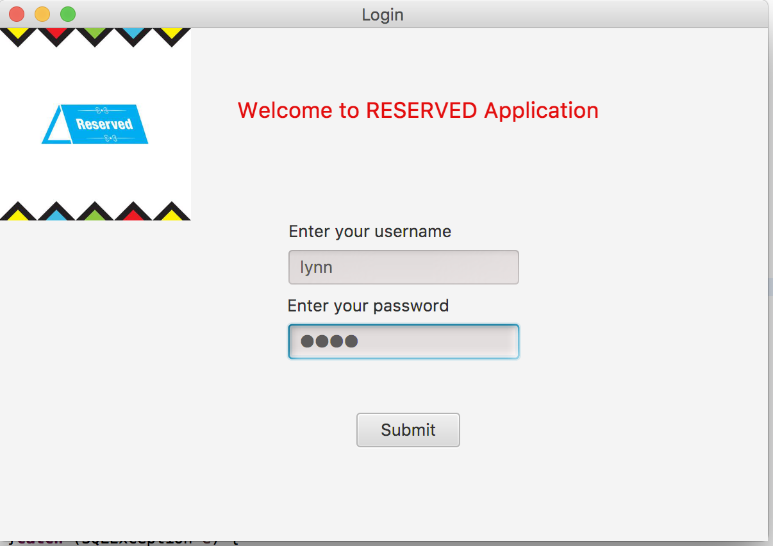

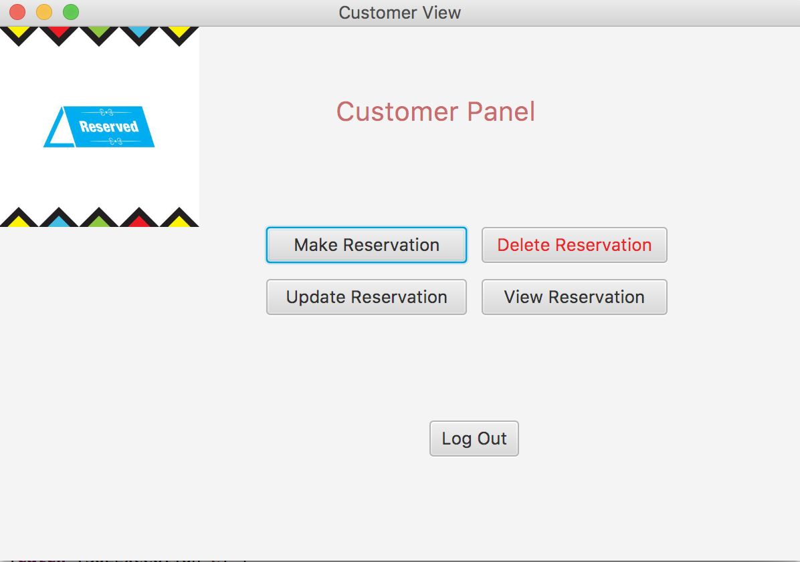

**Showing if user left empty textfield (password or username)**

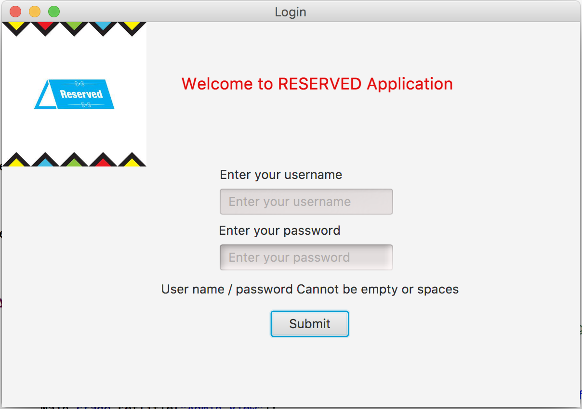

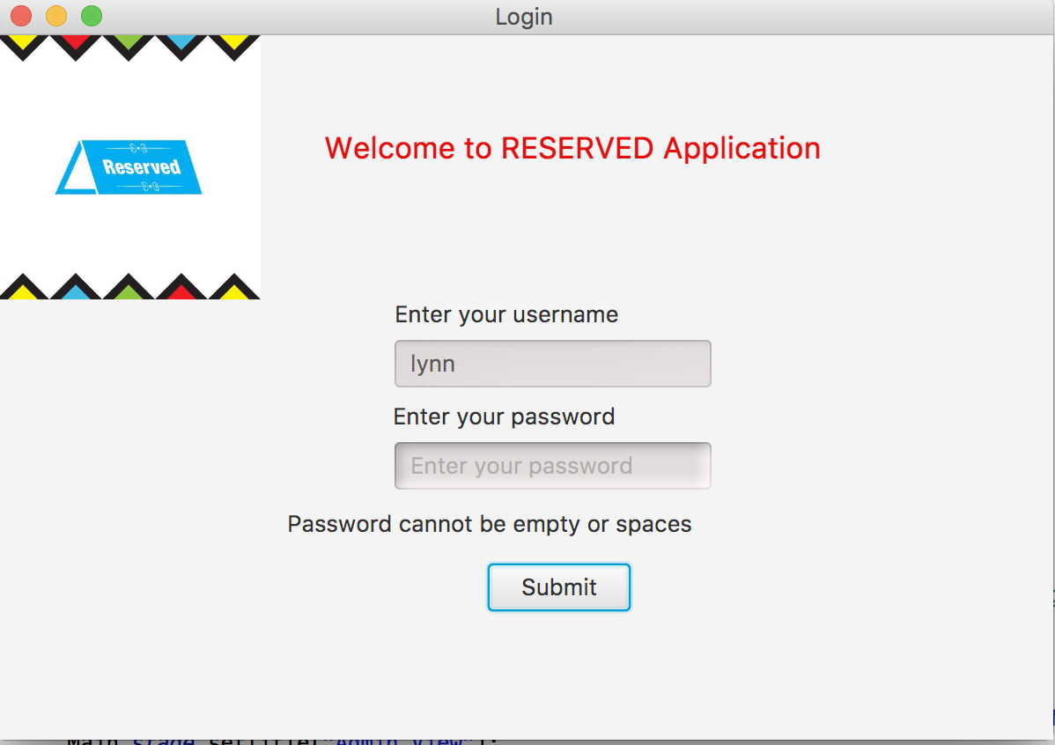

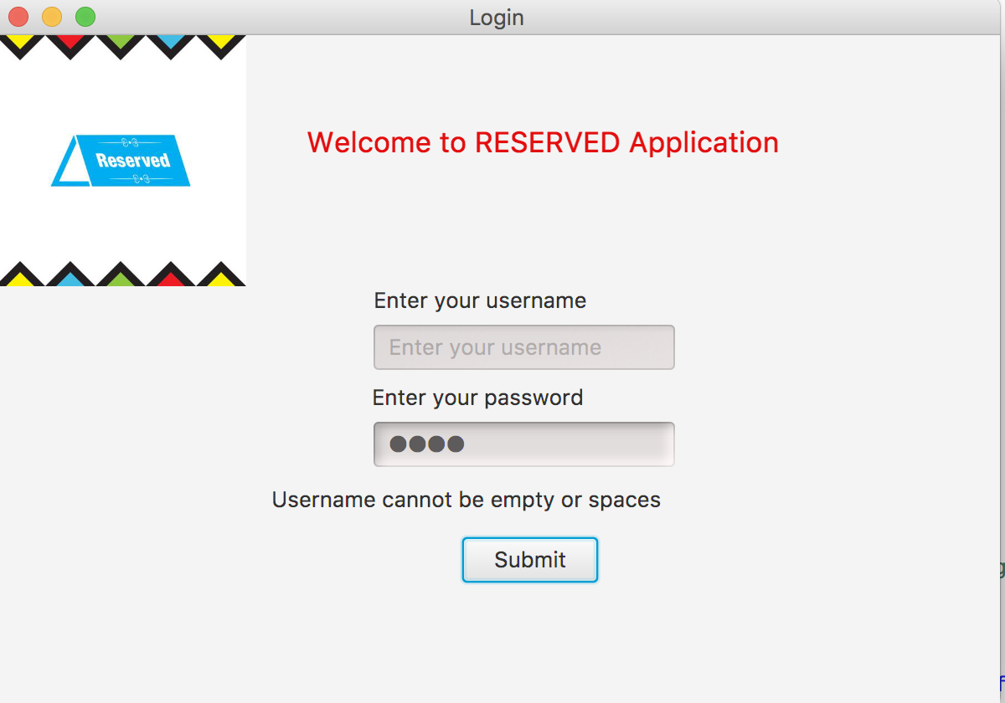

**Showing if user entered non exist account**

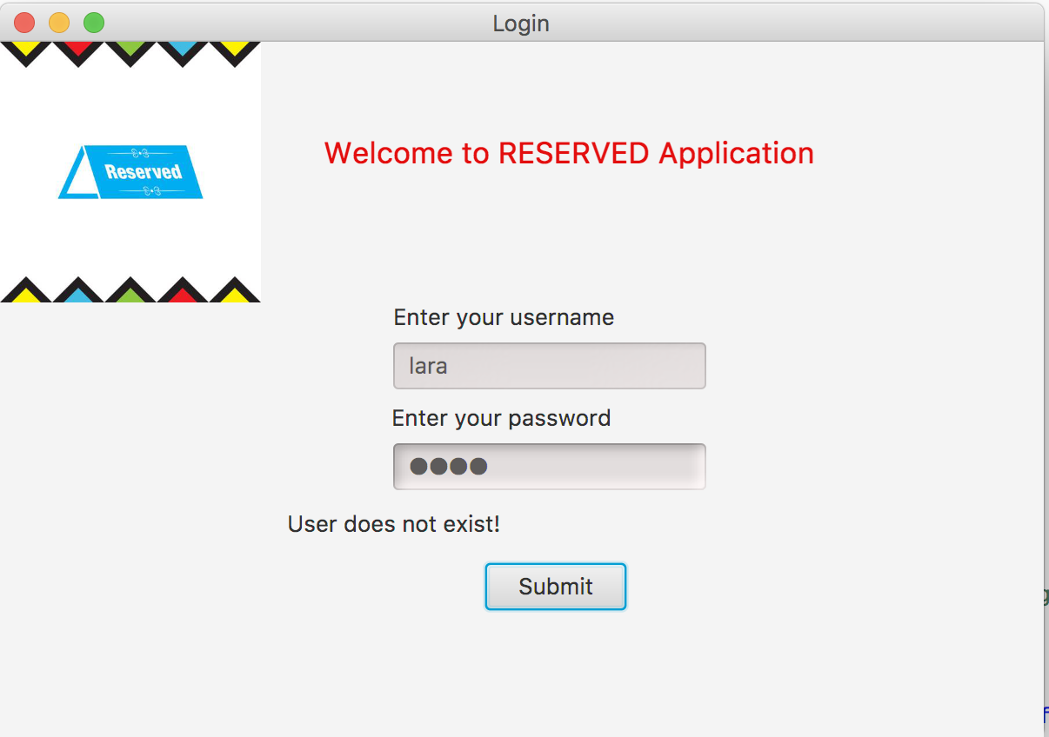

**Showing a snapshot of your user table (i.e., the user login credentials)**

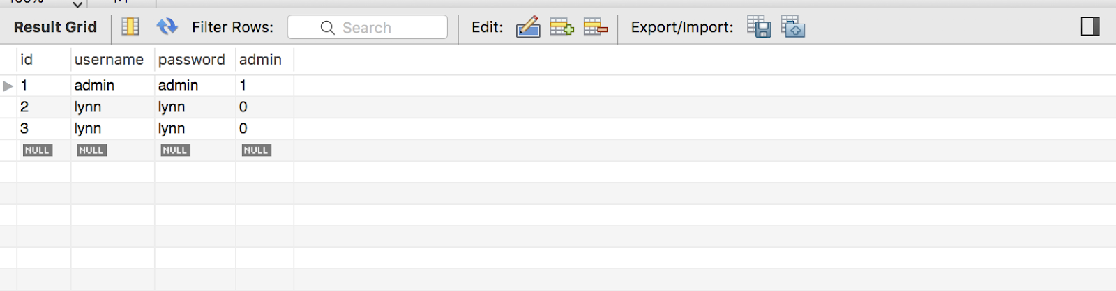

All the snapshots are showing that user has the functionality of logging out and it is working properly.

[**Admin functionality 5**](https://docs.google.com/document/d/1f9-rIGXozSOaUpBwqv6kqQ_B5efTTWE74ZaI7jXO11A/edit#heading=h.ywhf8zj6inmr)

[Retrieve restaurant table’s information 6](https://docs.google.com/document/d/1f9-rIGXozSOaUpBwqv6kqQ_B5efTTWE74ZaI7jXO11A/edit#heading=h.1bde33jor0w0)

[Adding new restaurant table 7](https://docs.google.com/document/d/1f9-rIGXozSOaUpBwqv6kqQ_B5efTTWE74ZaI7jXO11A/edit#heading=h.orxzy9ioc8og)

[Added Table message 9](https://docs.google.com/document/d/1f9-rIGXozSOaUpBwqv6kqQ_B5efTTWE74ZaI7jXO11A/edit#heading=h.b956dwo77pxs)

[Error Message 9](https://docs.google.com/document/d/1f9-rIGXozSOaUpBwqv6kqQ_B5efTTWE74ZaI7jXO11A/edit#heading=h.wg12d130fko1)

[Update an existing table 10](https://docs.google.com/document/d/1f9-rIGXozSOaUpBwqv6kqQ_B5efTTWE74ZaI7jXO11A/edit#heading=h.kepq444qv3ey)

[Updated table message 11](https://docs.google.com/document/d/1f9-rIGXozSOaUpBwqv6kqQ_B5efTTWE74ZaI7jXO11A/edit#heading=h.oedynkspdmct)

[Deleting an existing table: 11](https://docs.google.com/document/d/1f9-rIGXozSOaUpBwqv6kqQ_B5efTTWE74ZaI7jXO11A/edit#heading=h.4l3tzlbwa00t)

[Deleted table message 12](https://docs.google.com/document/d/1f9-rIGXozSOaUpBwqv6kqQ_B5efTTWE74ZaI7jXO11A/edit#heading=h.loonjzu87vzv)

Admin functionality

When we open the app what we see as a interface is like the following picture.

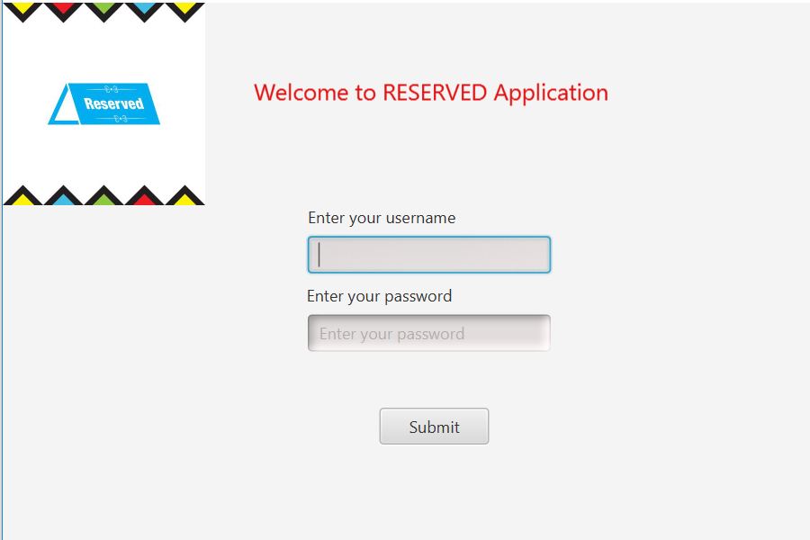

Then we need to login in as a user (admin).

Username: Admin

Password: Admin

The admin panel is like this:

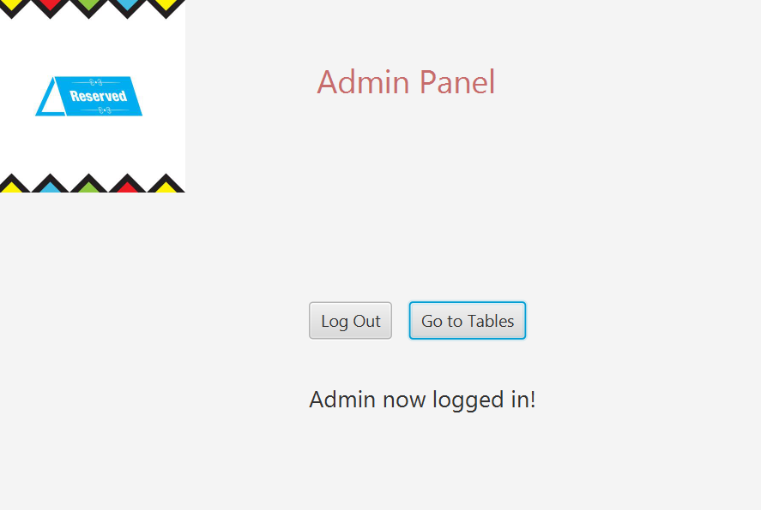

As you can see, we have “Go to Tables” button! When admin goes to the tables the following picture will be shown:

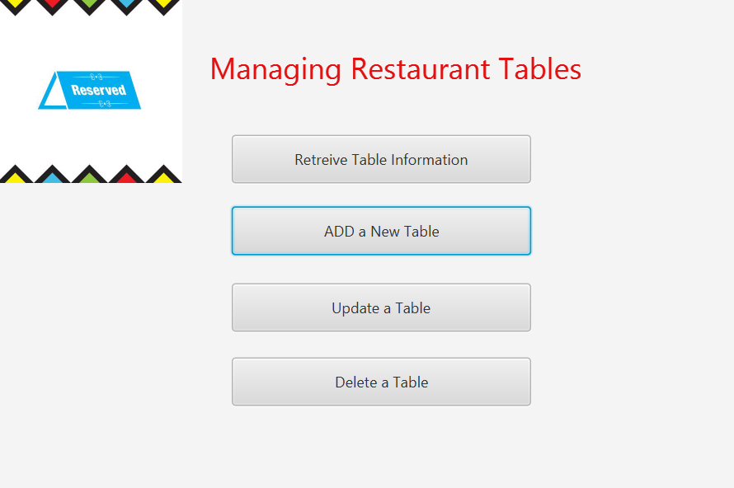

As you can see, the admin can manage the restaurant tables. The admin can Retrieve information about a table, Add a new table, Update a new table or Delete a table from the tables that are in the lnt_table entity of our database.

**Retrieve restaurant table’s information**

Let’s start with the first button. The admin wants to retrieve information about a table. If admin hits the “Retrieve Table Information”, will go to the following page.

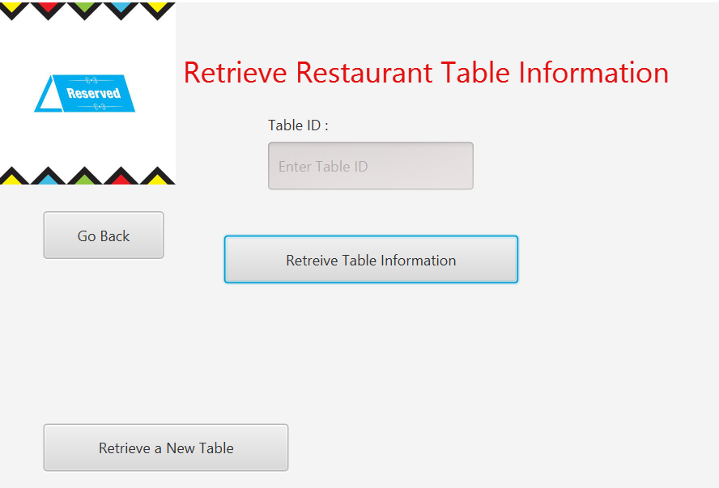

Suppose admin wants to fetch information about table number 12, that what the capacity of the table is and it is for which restaurant.

If the admin enters number 12 on the Table ID section and hit the “Retrieve Table Information”

button will get the following result:

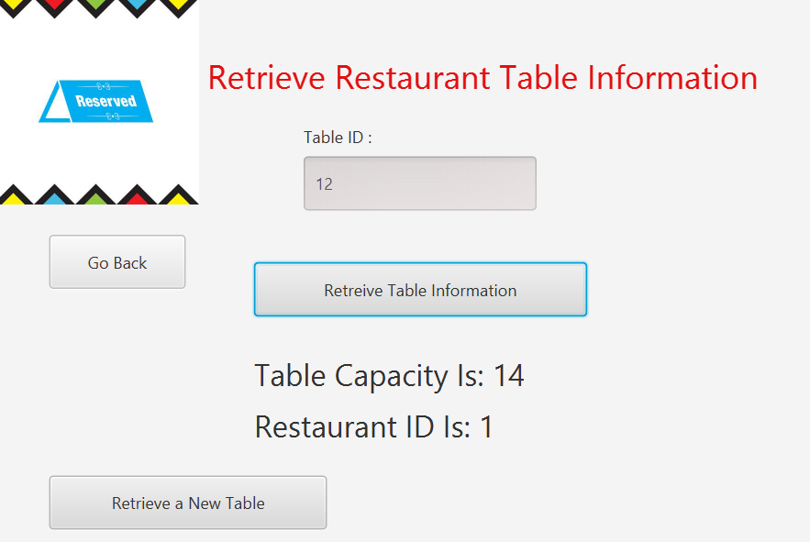

It is showing that Table ID number 12’s capacity is for 14 people and it is belonged to restaurant with ID equal to one!

Admin has an option to add a new table. If he/she clicks on the “Retrieve a New Table” Button, cleared page will be shown.

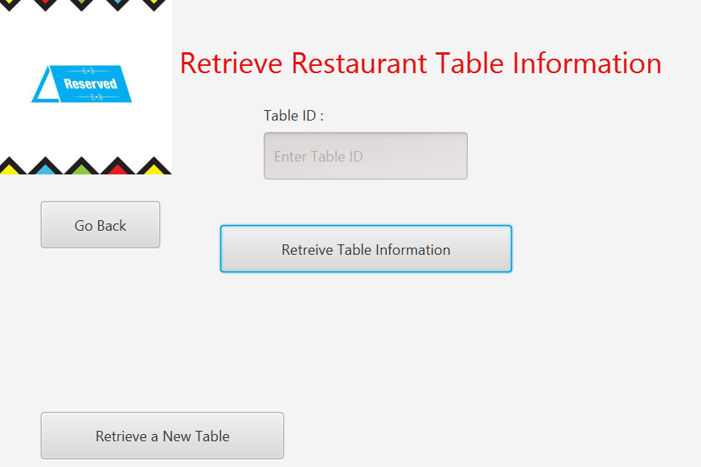

Also, as you see there is always an option for admin to go back to “Manage Restaurant Table” page. The button is located on the left side of the page; “Go Back”.

**Adding new restaurant table**

An admin is authorized to add a new table in the restaurant management app. To do so, when he/she logged in to the admin page, he/she should hit the button “Add a new table”.

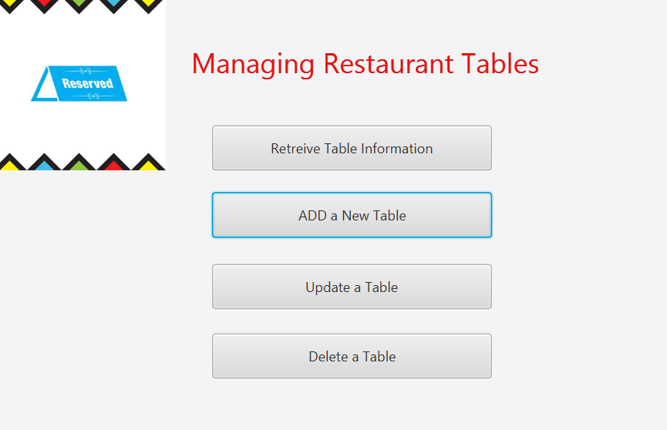

When the admin hit the button, the following page will be appeared:

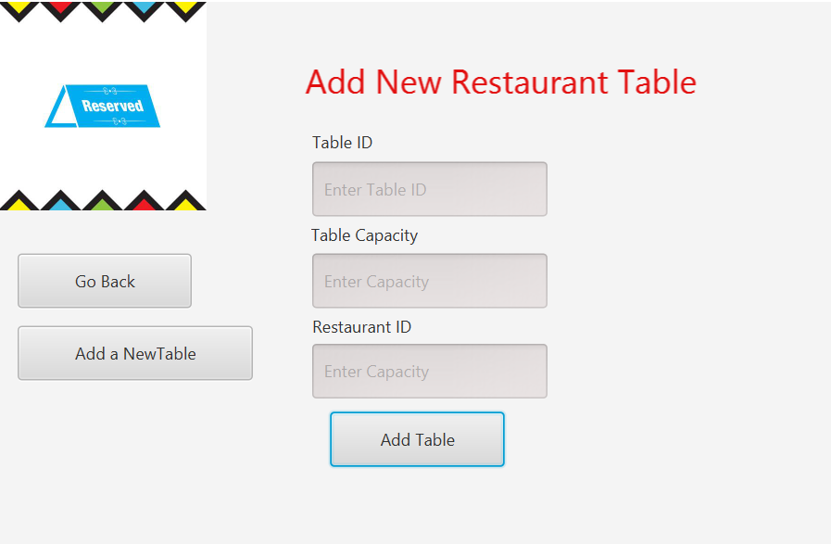

Now admin needs to enter the information about the table, such as Table ID, Table Capacity and Restaurant ID. Then by hitting the “Add Table” button, new table will be added to the database or an error will be appeared if the entered information is not right. The following snap shots will show them:

Added Table message

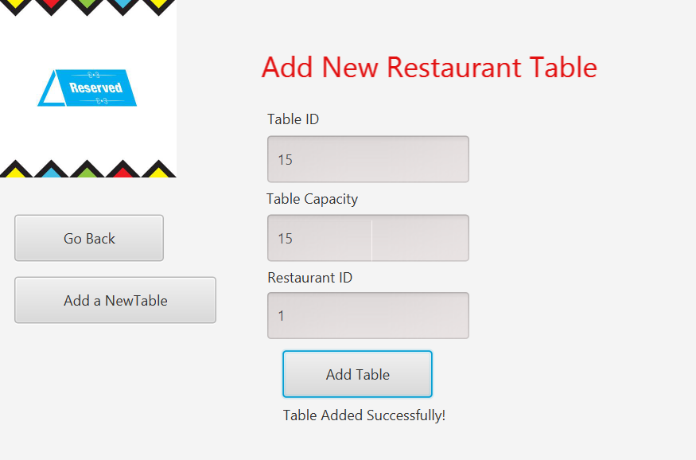

Error Message

Since we just created table with table ID 15, when admin tries to add the same table, the error will be shown:

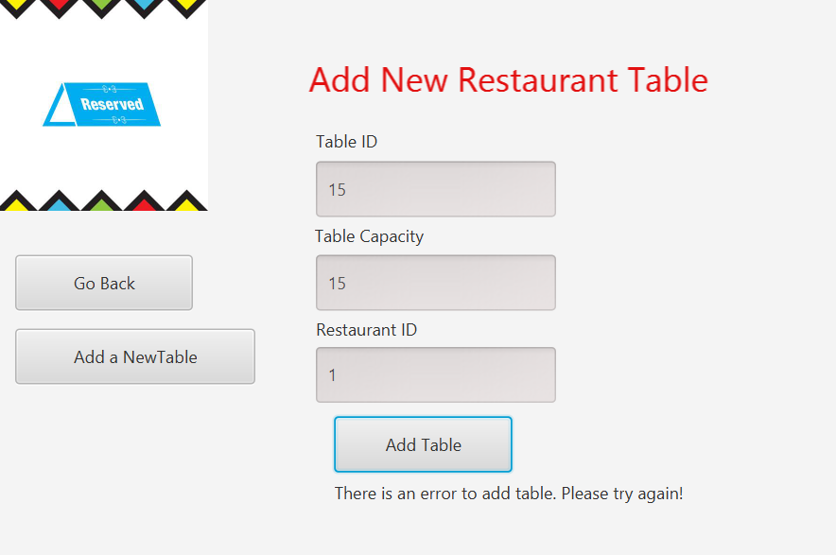

Admin can add a new table and have a clear page by clicking on “Add a new Table” button.

Update an existing table

Also, admin has access to alter and update a table capacity. On the manage table page, he needs to hit the button “Update a Table”.

The following screenshot will be shown “update a table” page.

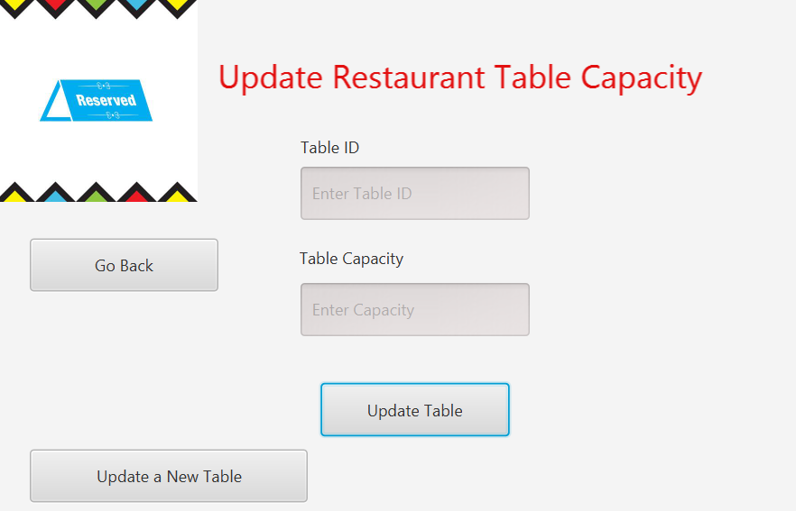

Admin should enter the table ID that wants to be updated and the new capacity. Let’s try it with table ID 15 that we just added to the database.

If you remember, we considered it to have capacity of 15 people. Now we will update it to 8 people capacity.

The following screenshot shows the result.

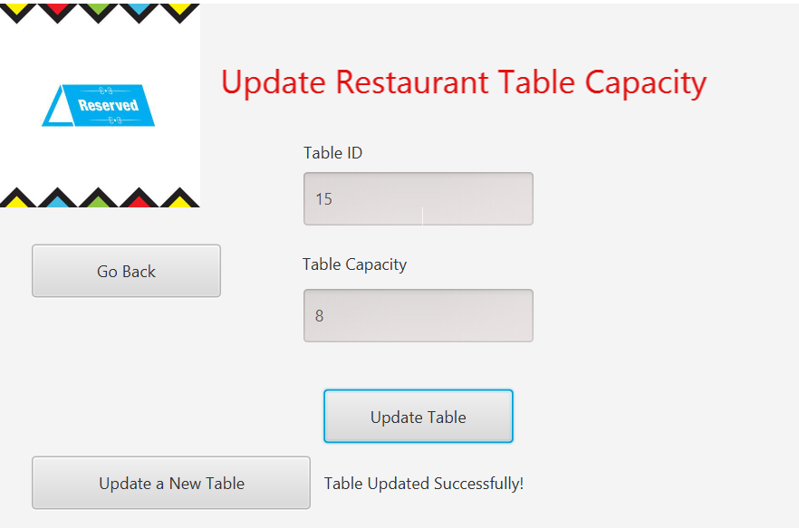

Updated table message

As it is shown in the previous picture, admin will get a message “ Table Updated Successfully!”.

Also, admin can click on “Update a New Table” button to update a new table and access to a cleared page.

Deleting an existing table:

When ever admin wants to delete a table, he/she can simply does it. From managing table page, admin accesses to do it. When admin hit the button “Delete a Table”, the following page will come up.

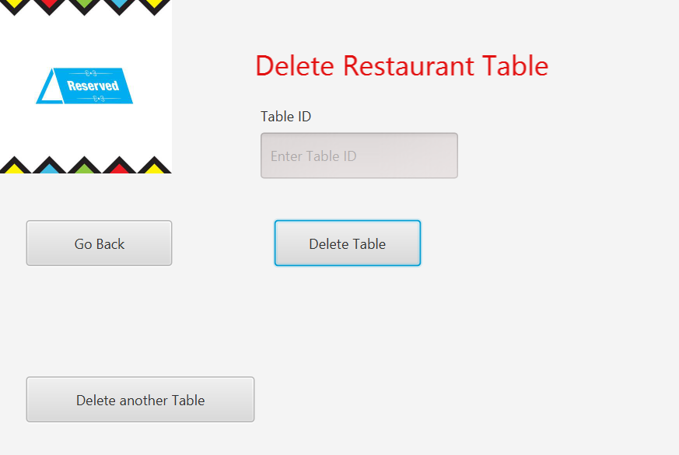

Let’s go ahead and delete the table that we already created!

Admin should enter Table ID to the required section to be able to delete the table.

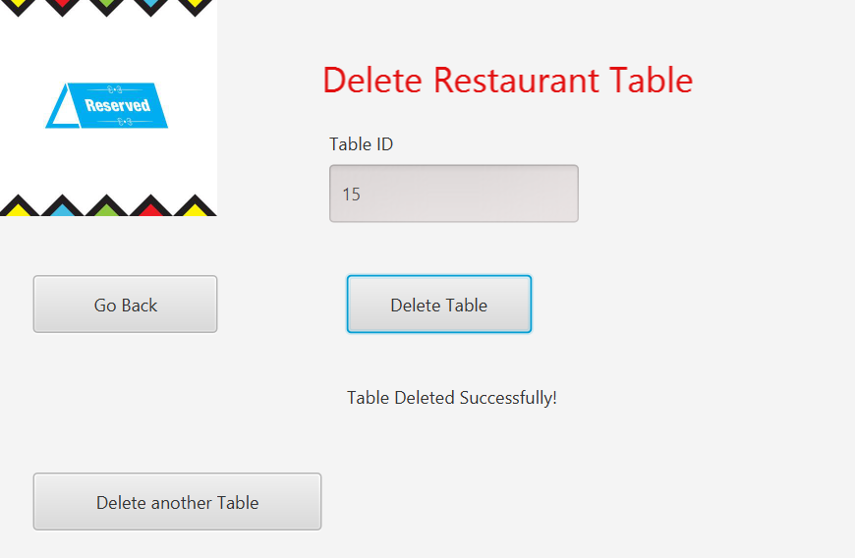

Deleted table message

After a successful delete, admin will get a massage “ Table Deleted Successfully!”.

Customer making reservation:

Customer has the functionality to make a reservation by filling the fields of number of guests and at what date the reservation needs to be made.

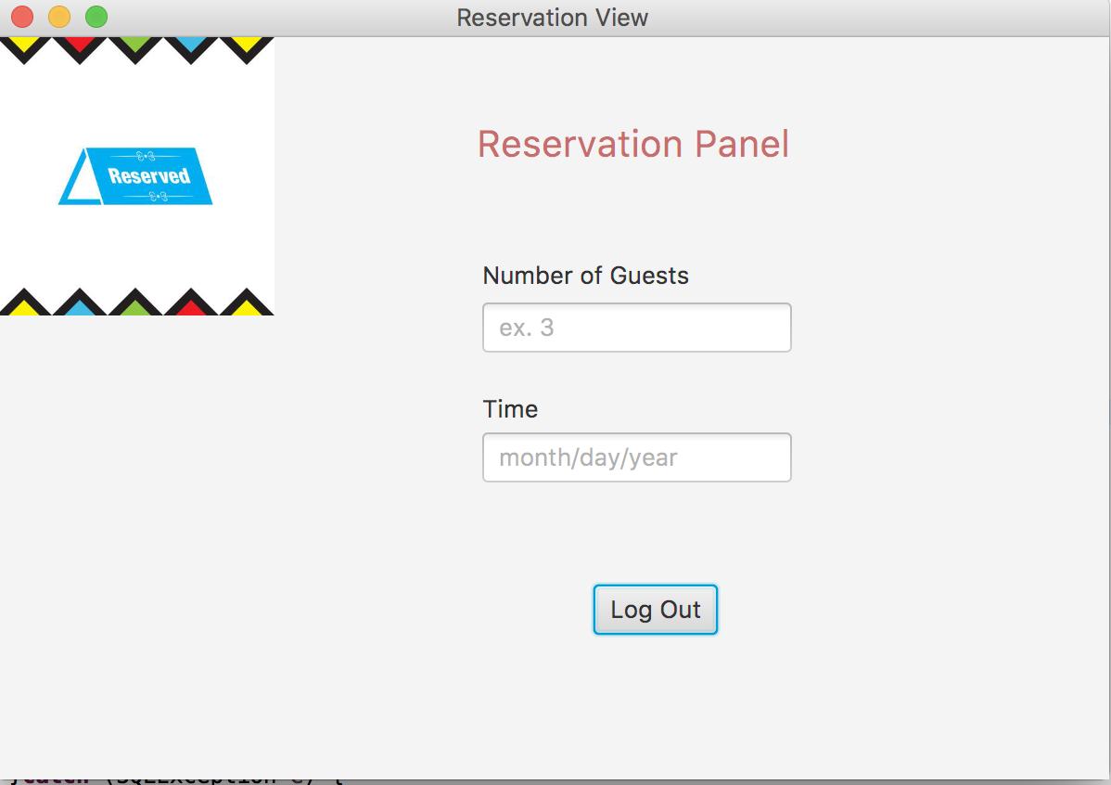

After entering number of guests and Date for the reservation, application should display the below desired output.

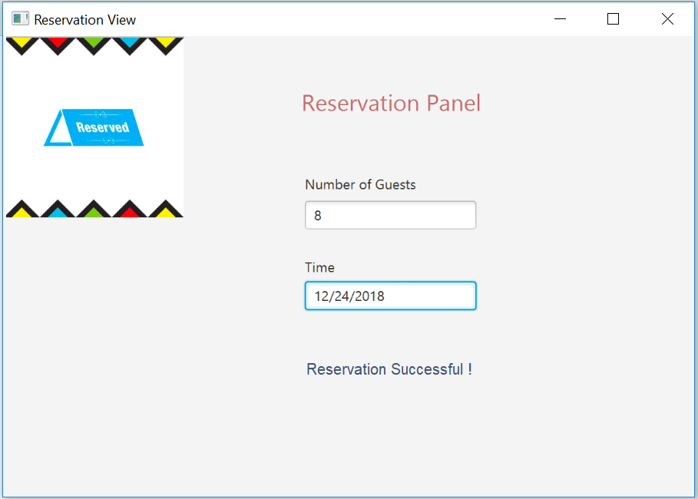

**This is a simulated output but not the output delivered from application**

ERD Diagram:

