LEED country outline

**Introduction**

* Sustainability and why it is important
* Sustainability developing and developed countries
* LEED
* LEED benefits
* LEED version 2009
* LEED in decision making process for buildings

**Background**

* Previous research on LEED
* Previous research on data related to LEED
* Signaling of points
* More projects in cities with LEED accredited professionals.
* Why we chose private buildings. Difference in private building points versus government.
* Sustainability in Turkey, China, and Brazil. Prevalence of LEED.

**Hypothesis**

* Sustainable performance varies by culture and country. The US leads in sustainability rating using LEED because of early adopters. Diffusion of technologies. Skilled engineers/architects in LEED.
* Expect Brazil to perform well on
* Expect Turkey to perform well on
* Expect China to perform well on
* Expect US scores to continue going up over time.

**Methods**

* Only include buildings that had been certified and scored 39 points.
* Only countries with more than 50 LEED 2009 certified buildings
* Only includes corporate private buildings not government
* The actual number of buildings are

TR Corporate: Privately Held 30

CN Corporate: Privately Held 43

BR Corporate: Privately Held 25

US Corporate: Privately Held 592

* We looked at the mean median and mode for total score data
* Checked for normal distribution. US was not normally distributed.

TR Normaltest (statistic=4.049, pvalue=0.13203)

US Normaltest(statistic=106.82, pvalue=6.37916e-24)

CN Normaltest(statistic=1.276, pvalue=0.528433)

BR Normaltest(statistic=2.43, pvalue=0.3)

* Ran two sample student t test for Turkey, China, and Brazil to identify if the mean scores for buildings in each country are statistically similar or different by country.
* Ran Mann Whitney U test to compare Turkey, China, and Brazil building scores with USA.
* Used credit level scores for all buildings from USGBC database.
* Regional Priority credits were excluded from the credit analysis. Excluded because they vary within the USA and each country. This does not effect our hypothesis.
* For credits with varying levels of possible achievement. For example, EAc1 Optimize energy performance can range from 1 to 19 points. Normal distribution of points scored was check for buildings in each country.
* Three statistical tests were used based on type of credit. T-test, Mann Whitney U test and Chi square.
* A two sample t test was used
* A Mann Whitney U Test was used
* A Chi square test was used
* Credit scores were plotted for each country.
* Plots were used to visually verify credits with statistical significance and to identify which country was better performing on average for ach statically significant credit.

**Results**

two sample means are compared to discover whether they come from the same population (meaning there is no difference between the two population means). Now, because the question is whether two populations are actually one and the same, the first step is to obtain the SE mean from the sampling distribution of the difference between two sample means.

NEED standard deviation for each group.

Mean, median, mode for all of the country

TR

Buildings Included: 59,

removed: 142,

mean: 62.0,

median: 62.0,

mode: ModeResult(mode=array([ 60.]), count=array([6])),

largest: 92.0,

lowest: 42.0

US

Buildings Included: 3166,

removed: 6050,

mean: 55.10328490208465,

median: 53.0,

mode: ModeResult(mode=array([ 50.]), count=array([224])),

largest: 97.0,

lowest: 40.0

CN

Buildings Included: 140,

removed: 270,

mean: 59.15714285714286,

median: 60.0,

mode: ModeResult(mode=array([ 64.]), count=array([11])),

largest: 87.0,

lowest: 40.0

BR

Buildings Included: 51,

removed: 121,

mean: 54.745098039215684,

median: 53.0,

mode: ModeResult(mode=array([ 51.]), count=array([6])),

largest: 81.0,

lowest: 41.0

T- Test results with high level score

TR, US

t 4.643908223483067, p 5.638557687964413e-05

TR, CN

t 0.24100620169474948, p 0.8104081077921602

TR, BR

t 3.0467075834925725, p 0.003780096119642822

US, CN

t -5.782041872308198, p 4.873129705171188e-07

US, BR

t -1.7693664842549446, p 0.08691070553139825

CN, BR

t 3.405440858065395, p 0.0011344508354554346

Cant look at US

Ran Mann Whiteny U test with high level score

TR, US

MannwhitneyuResult(statistic=4323.5, pvalue=1.0190524052380321e-06)

TR, CN

MannwhitneyuResult(statistic=631.5, pvalue=0.4419573210567016)

TR, BR

MannwhitneyuResult(statistic=208.5, pvalue=0.0024271230944570591)

US, CN

MannwhitneyuResult(statistic=6168.5, pvalue=7.9101733986702824e-09)

US, BR

MannwhitneyuResult(statistic=5853.5, pvalue=0.03812763362142884)

CN, BR

MannwhitneyuResult(statistic=291.0, pvalue=0.00085886848551532677)

Include plots of all four countries.

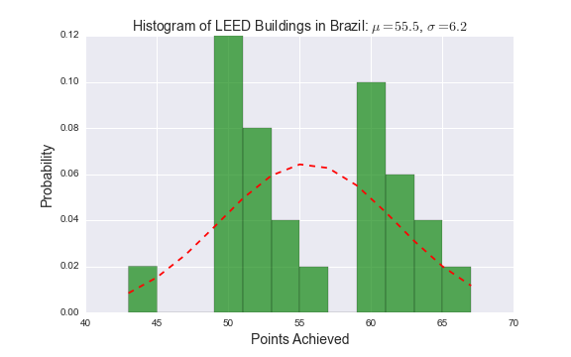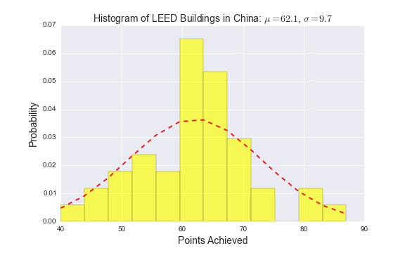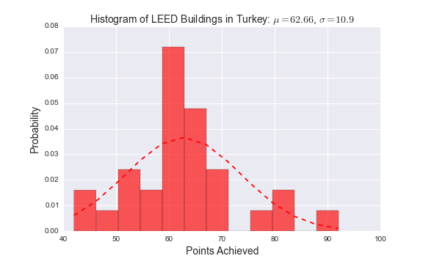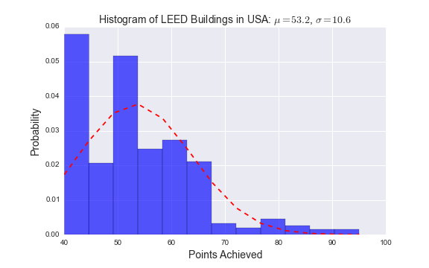

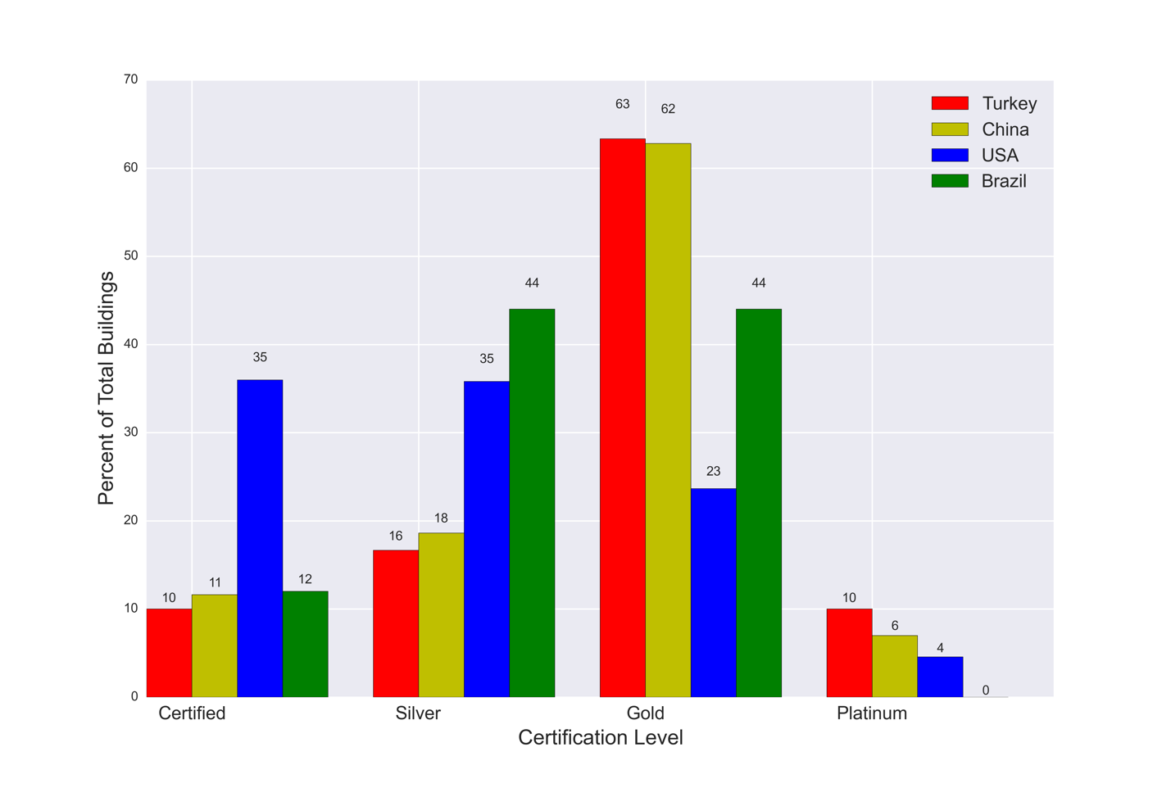

**Individual credit data**

Looked at credits invidiuallly

Used three different statistical measurements t-test, mann, and chi

Used t-test for credits EAc1, EAc2, IDc1 because the points were numerical

Brazil statistaically is more likley (p=0.003) to meet Innovation and design credit 1 compared to china

IDc1: t 3.0956712584310764, p 0.0029993595184039123

Brazil is statistically more than the USA to meet EAc1 and IDc1

EAc1: t -6.85255472773124, p 7.589062860528424e-08

IDc1: t 5.858214180265654, p 1.3887849660477289e-06

China is statisically more likely (p=0.007) to meet EAc2 compared to Turkey

EAc2: t 2.8126004002188094, p 0.006846959297280327

China does not do well on EAc1 compared to the USA. They do however do much better than the USA on EAc2. They are also slightly better on IDc1.

EAc1: t -11.753365595180709, p 1.3053533246248377e-22

EAc2: t 3.067690041182334, p 0.0037295742835399223

IDc1: t 2.0284895050327143, p 0.046909834484615866

Turkey does really poorly on EAc1 but does better than the USA on IDc1.

EAc1: t -18.045264541587972, p 6.070549165247458e-58

IDc1: t 3.493203144528725, p 0.0012803276186032521

**Mann Whiteney U test**

Credits to consider - WEc1, WEc3, MRc1.1, MRc2, MRc3, MRc4, MRc5,

Brazil is statiscially different to china on MRc3, MRc4, WEc3.

MRc3: MannwhitneyuResult(statistic=473.0, pvalue=0.01107312103065373)

MRc4: MannwhitneyuResult(statistic=394.5, pvalue=0.024848901490810371)

WEc3: MannwhitneyuResult(statistic=340.0, pvalue=0.00074423288965303348)

China does not meet MRc3

Brazil does worse on MRc4

Brazil does worse on WEc3 compared to china

**Brazil is statisically different to turkey on MRc4 and WEc1 and WEc3**

MRc4: MannwhitneyuResult(statistic=245.0, pvalue=0.0086083655275030584)

WEc1: MannwhitneyuResult(statistic=287.0, pvalue=0.042446521581592032)

WEc3: MannwhitneyuResult(statistic=270.5, pvalue=0.015506023455711946)

**Turkey does better than brazil on all three**

**Brazil statistically different than the USA**

MRc2: MannwhitneyuResult(statistic=6097.5, pvalue=0.048861519401053898)

MRc3: MannwhitneyuResult(statistic=6808.5, pvalue=0.03064718120955922)

MRc4: MannwhitneyuResult(statistic=5453.0, pvalue=0.0070134447585492952)

MRc5: MannwhitneyuResult(statistic=6001.0, pvalue=0.035015444900773275)

WEc1: MannwhitneyuResult(statistic=3706.0, pvalue=4.4711467848901822e-06)

WEc3: MannwhitneyuResult(statistic=5314.5, pvalue=0.0072487468100006997)

Mrc2 and MRc5 brazil does better than the US

MRc4 US does better than brazil

US does better than brazil on WEc1 and WEc3

**China Statisically different than turkey**

MRc2: MannwhitneyuResult(statistic=464.0, pvalue=0.0041866298572602904)

MRc3: MannwhitneyuResult(statistic=559.0, pvalue=0.0075287572312117542)

China better on MRc2

Turkey better on MRC3 (china doesn’t meet this credit)

**China Statisutcall different than USA**

MRc2: MannwhitneyuResult(statistic=9155.5, pvalue=0.00028292665062429936)

MRc5: MannwhitneyuResult(statistic=9254.5, pvalue=0.0003179930895000959)

WEc1: MannwhitneyuResult(statistic=6979.0, pvalue=1.104474636969341e-07)

China does better on both MRc2 and MRc5

US lead in WEc1

**Turkey statistically difernt than usa**

MRc3: MannwhitneyuResult(statistic=8033.0, pvalue=0.0079161140867656399)

MRc5: MannwhitneyuResult(statistic=6395.0, pvalue=0.0016215020698953581)

WEc1: MannwhitneyuResult(statistic=6211.5, pvalue=0.0017825368446797961)

Turkey is better on MRc5

US better on WEc1

**Chi squared – rest of the credits – 38 in total**

**Brazil and china**

**EAc6, EQc1, EQc2, EQc3.2, EQc7.1, EQc7.2**

EAc6

Test Statistic: 7.274795127353265

p-value: 0.006992886843753955

Brazil beating china

EQc1

Test Statistic: 9.832687622455065

p-value: 0.001714376671604285

China beating brazil

EQc2

Test Statistic: 11.417417281149557

p-value: 0.000727587689077776

China beating brazil

EQc3.2

Test Statistic: 26.0285817400296

p-value: 3.364001134902113e-07

China beating brazil

EQc7.1

Test Statistic: 10.82945419145484

p-value: 0.0009989808188233832

China beating brazil

EQc7.2

Test Statistic: 12.905112871624501

p-value: 0.00032768577260394944

China beating brazil

**Brazil and Turkey**

Turkey beats brazil on all credits except MRc7

EAc4

Test Statistic: 12.699862637362635

p-value: 0.00036568243678656475

EQc2

Test Statistic: 7.803277777777779

p-value: 0.005215154696519386

EQc3.2

Test Statistic: 8.556225633528266

p-value: 0.003443425938109135

EQc5

Test Statistic: 11.846888354700857

p-value: 0.000577577757869295

EQc6.1

Test Statistic: 8.723734318996414

p-value: 0.0031409403924595723

EQc7.1

Test Statistic: 13.017321428571424

p-value: 0.0003086229428224596

MRc7

Test Statistic: 14.552482578397214

p-value: 0.00013630893082228548

**Brazil and USA**

USA does better than brazil on all EQ

EQc4.3

Test Statistic: 48.777252867080286

p-value: 2.867462801639523e-12

EQc4.4

Test Statistic: 25.131600903280027

p-value: 5.354812119286899e-07

EQc5

Test Statistic: 8.08555947940214

p-value: 0.004461935414114691

EQc6.1

Test Statistic: 23.019226644233143

p-value: 1.6038931793197784e-06

EQc7.1

Test Statistic: 17.820422004714857

p-value: 2.4276362627429996e-05

Brazil beat USA on SS

SSc4.1

Test Statistic: 13.894012878211147

p-value: 0.0001934136042273233

SSc5.2

Test Statistic: 11.122689644090523

p-value: 0.0008527803347130125

SSc7.1

Test Statistic: 10.5551654915964

p-value: 0.0011586383870284545

Brazil beats USA on WEc2

WEc2

Test Statistic: 133.61189515844873

p-value: 6.643108946941762e-31

**China and Turkey**

EAc5

Test Statistic: 7.339174613584796

p-value: 0.00674678107156543

EQc6.2

Test Statistic: 9.521992724058208

p-value: 0.00203024005994654

**China and USA**

USA does better

EAc3

Test Statistic: 10.5988116052391

p-value: 0.0011316037075125697

China does better

EAc4

Test Statistic: 14.43607717697474

p-value: 0.0001449977873002621

USA does better

EAc6

Test Statistic: 27.32581149402373

p-value: 1.719013662680265e-07

**China does better on EQ1, 2, 3.2**

EQc1

Test Statistic: 9.558029730831645

p-value: 0.00199076666154216

EQc2

Test Statistic: 29.043734791928085

p-value: 7.076258169104238e-08

EQc3.2

Test Statistic: 46.79475996670304

p-value: 7.88238896884248e-12

**US does better on EQ4.3**

EQc4.3

Test Statistic: 43.7957182680556

p-value: 3.645015920486808e-11

**US does better on EQ4.3**

EQc4.4

Test Statistic: 46.00619453262521

p-value: 1.178796698740004e-11

**USA does better**

EQc6.2

Test Statistic: 9.06572888511956

p-value: 0.0026044469663259744

EQc7.2

Test Statistic: 10.394227579315134

p-value: 0.0012640986848924706

**China does better**

EQc8.1

Test Statistic: 19.501843009523164

p-value: 1.0050266756556902e-05

**The only country is USA**

SSc3

Test Statistic: 9.921637029392711

p-value: 0.0016334703195101223

**China does better**

SSc4.1

Test Statistic: 26.650762146128457

p-value: 2.437546205299427e-07

SSc4.2

Test Statistic: 9.765294658806566

p-value: 0.0017783701077291963

SSc4.4

Test Statistic: 16.69840853493441

p-value: 4.381774135502284e-05

SSc5.1

Test Statistic: 26.5991412149075

p-value: 2.5035501208516354e-07

SSc5.2

Test Statistic: 10.797791349161999

p-value: 0.0010162126526239623

**USA does better**

SSc6.2

Test Statistic: 12.980213968224524

p-value: 0.0003147999906411268

**China does better**

SSc7.1

Test Statistic: 20.04660972235673

p-value: 7.55773990077584e-06

WEc2

Test Statistic: 137.80897751981354

p-value: 8.023536986549052e-32

**Turkey and USA**

**Turkey does better**

EAc4

Test Statistic: 33.56979596638992

p-value: 6.8752077332854744e-09

EAc5

Test Statistic: 11.91957487309645

p-value: 0.0005554715563453505

**USA does better**

EAc6

Test Statistic: 19.24233903848877

p-value: 1.1513145040058881e-05

Turkey does better

EQc2

Test Statistic: 17.13130376095985

p-value: 3.488261162175123e-05

EQc3.2

Test Statistic: 7.878217782036674

p-value: 0.005003376416805841

**US does better**

EQc4.1

Test Statistic: 17.36801967576455

p-value: 3.0796443911129035e-05

EQc4.3

Test Statistic: 46.73403843801603

p-value: 8.130446397441546e-12

**US does better**

EQc4.4

Test Statistic: 35.14329338693899

p-value: 3.06314518668403e-09

**Turkey does better**

EQc8.1

Test Statistic: 10.741257077313549

p-value: 0.001047731378922466

**Turkey does better**

MRc6

Test Statistic: 7.873552014702084

p-value: 0.005016302201463108

**US does better**

MRc7

Test Statistic: 7.600666325143267

p-value: 0.00583467338840666

**Turkey does better than US**

SSc4.1

Test Statistic: 20.643137610476575

p-value: 5.533516439891415e-06

SSc4.2

Test Statistic: 8.989917381018666

p-value: 0.0027147327389648096

SSc4.4

Test Statistic: 7.167464260686402

p-value: 0.007423763817124279

**US does better**

SSc7.2

Test Statistic: 7.306987845375239

p-value: 0.006868696833493134

**Turkey does best**

WEc2

Test Statistic: 128.0022436791699

p-value: 1.1211615588746427e-29

**Only USA does a good job**

EAc1, EAc3, EAc6, EQc4.3, EQc4.4, SSC3, SS6.2, WEc1

**USA does poorly compared to others**

EAc4, EQc2, EQc3.2, IDc1, SS4.1, SSc4.2, SSc5.2, SSc7.1,

**Only Turkey does well**

EQc5, EQc6.2WEc2

**Turkey, China do well**

EAc4, EQc2, SSC2, SSC4.4,

**Brazil does well**

IDc1, SSc5.2

**Low Achieving credits (all countries)**

**High achieving credits (all countries)**

**Only include the ones with a clear winner or clear loser – meaning all three lower perform to one or all three are higher than one**

**Sustainable Sites**

SSc3  Brownfield redevelopment

* SSc3 - **The only country is USA**
  + Test Statistic: 9.921637029392711
  + p-value: 0.0016334703195101223

SSc4.1  Alternative transportation - public transportation access

* SSc4.1 - **Brazil beat USA**
  + Test Statistic: 13.894012878211147
  + p-value: 0.0001934136042273233
* **SSc4.1 - Turkey does better than US**
  + Test Statistic: 20.643137610476575
  + p-value: 5.533516439891415e-06
* SSc4.1 **- China does better than US**
  + Test Statistic: 26.650762146128457
  + p-value: 2.437546205299427e-07

SSc4.2  Alternative transportation - bicycle storage and changing rooms

* **SSc4.2 – China does better than the US**
  + Test Statistic: 9.765294658806566
  + p-value: 0.0017783701077291963
* **SSc4.2 – Turkey does better than the US**
  + Test Statistic: 8.989917381018666
  + p-value: 0.0027147327389648096

SSc4.4 Alternative transportation - parking capacity

* **SSc4.4** - **Turkey does better than US**
  + Test Statistic: 7.167464260686402
  + p-value: 0.007423763817124279
* **SSc4.4 – China does better than the US**
  + Test Statistic: 16.69840853493441
  + p-value: 4.381774135502284e-05

SSc5.1  Site development - protect or restore habitat

* SSc5.1 - **China does better than US**
  + Test Statistic: 26.5991412149075
  + p-value: 2.5035501208516354e-07

SSc5.2  Site development - maximize open space

* SSc5.2 - **China does better than US**
  + Test Statistic: 10.797791349161999
  + p-value: 0.0010162126526239623
* SSc5.2 - **Brazil beat USA**
  + Test Statistic: 11.122689644090523
  + p-value: 0.0008527803347130125

SSc6.2  Stormwater design - quality control

* SSc6.2 - **USA does better than China**
  + Test Statistic: 12.980213968224524
  + p-value: 0.0003147999906411268

SSc7.1  Heat island effect - nonroof

* SSc7.1 - **Brazil beat USA**
  + Test Statistic: 10.5551654915964
  + p-value: 0.0011586383870284545
* SSc7.1 - **China does better than US**
  + Test Statistic: 20.04660972235673
  + p-value: 7.55773990077584e-06

SSc7.2  Heat island effect - roof

* SSc7.2- **US does better Turkey**
  + Test Statistic: 7.306987845375239
  + p-value: 0.006868696833493134

**Water Efficiency**

WEc1  Water efficient landscaping

* WEc1: **Turkey out performs Brazil** 
  + Mannwhitneyu (statistic=287.0, pvalue=0.042446521581592032)
* **WEc1: US out performs brazil**
  + Mannwhitneyu (statistic=3706.0, pvalue=4.4711467848901822e-06)
* WEc1: **US out performs china**
  + Mannwhitneyu (statistic=6979.0, pvalue=1.104474636969341e-07)
* WEc1: **US outperforms Turkey**
  + MannwhitneyuResult(statistic=6211.5, pvalue=0.0017825368446797961)
* WEc1: USA out performs Brazil
  + Mannwhitneyu (statistic=3706.0, pvalue=4.4711467848901822e-06)

WEc2  Innovative wastewater technologies

* All perform better than the US
* **WEc2: Brazil out performs USA**
  + Test Statistic: 133.61189515844873 (chi-square)
  + p-value: 6.643108946941762e-31
* **WEc2: Turkey out performs USA**
  + Test Statistic: 128.0022436791699 (chi-square)
  + p-value: 1.1211615588746427e-29

WEc3  Water use reduction

* **US out performs everyone**
* **WEc3**: **Turkey out performs Brazil** 
  + Mannwhitneyu (statistic=270.5, pvalue=0.015506023455711946)
* **WEc3**: **China out performs brazil**
  + Mannwhitneyu (statistic=340.0, pvalue=0.00074423288965303348)
* **WEc3: USA out performs brazil**
  + Mannwhitneyu (statistic=5314.5, pvalue=0.0072487468100006997)
* **WEc3: US out performs Brazil** 
  + Mannwhitneyu (statistic=5314.5, pvalue=0.0072487468100006997)

**Energy and Atmosphere**

EAc1  Optimize energy performance

* USA outperforms all other countries
* EAc1: USA out performs Brazil
  + t -6.85255472773124, p 7.589062860528424e-08
* EAc1: USA out performs China
  + t -11.753365595180709, p 1.3053533246248377e-22
* EAc1: USA out performs Turkey
  + t -18.045264541587972, p 6.070549165247458e-58

EAc2 On-site renewable energy

* EAc2: China out performs Turkey
  + t 2.8126004002188094, p 0.006846959297280327
* EAc2: China out performs USA
  + t 3.067690041182334, p 0.0037295742835399223

EAc3 Enhanced commissioning

* **EAc3: USA out performs China**
  + Test Statistic: 10.5988116052391
  + p-value: 0.0011316037075125697

EAc4 Enhanced refrigerant management

* EAc4: Turkey out performs brazil
  + Test Statistic: 12.699862637362635
  + p-value: 0.00036568243678656475
* EAc4: Turkey out performs USA
  + Test Statistic: 33.56979596638992
  + p-value: 6.8752077332854744e-09
* EAc4: China out performs US
  + Test Statistic: 14.43607717697474
  + p-value: 0.0001449977873002621

EAc5 Measurement and verification

* EAc5: Turkey out performs China
  + Test Statistic: 7.339174613584796
  + p-value: 0.00674678107156543
* EAc5: Turkey out performs US
  + Test Statistic: 11.91957487309645
  + p-value: 0.0005554715563453505

EAc6 Green power

* EAc6: Brazil out performs china
  + Test Statistic: 7.274795127353265
  + p-value: 0.006992886843753955
* EAc6: USA out performs China
  + Test Statistic: 27.32581149402373
  + p-value: 1.719013662680265e-07
* EAc6: US out performs Turkey
  + Test Statistic: 19.24233903848877
  + p-value: 1.1513145040058881e-05

**Materials and Resources**

MRc2  Construction waste management

* China does the best
* MRc2: Brazil out performs USA
  + Mannwhitneyu (statistic=6097.5, pvalue=0.048861519401053898)
* MRc2: China out performs Turkey
  + Mannwhitneyu (statistic=464.0, pvalue=0.0041866298572602904)
* MRc2: China out performs USA
  + Mannwhitneyu (statistic=9155.5, pvalue=0.00028292665062429936)

MRc3 Materials reuse

* Very few projects achieve this credit
* None of the Chinese projects achieve this credit
* MRc3: Brazil out performs China
  + Mannwhitneyu (statistic=473.0, pvalue=0.01107312103065373)
* MRc3: Turkey out performs USA
  + Mannwhitneyu (statistic=8033.0, pvalue=0.0079161140867656399)
* MRc3: Turkey out performs china
  + Mannwhitneyu (statistic=559.0, pvalue=0.0075287572312117542)

MRc4 Recycled content

* MRc4: China out performs brazil
  + Mannwhitneyu (statistic=394.5, pvalue=0.024848901490810371)
* MRc4: Turkey out performs brazil
  + Mannwhitneyu(statistic=245.0, pvalue=0.0086083655275030584)
* MRc4: USA out performs brazil
  + Mannwhitneyu (statistic=5453.0, pvalue=0.0070134447585492952)

MRc5 Regional materials

* MRc5: Brazil out performs USA
  + Mannwhitneyu (statistic=6001.0, pvalue=0.035015444900773275)
* MRc5: Turkey out performs USA
  + Mannwhitneyu (statistic=6395.0, pvalue=0.0016215020698953581)
* MRc5: China out performs USA
  + Mannwhitneyu (statistic=9254.5, pvalue=0.0003179930895000959)

MRc6 Rapidly renewable materials

* Very few projects meet this credit
* None of the Brazil projects meet this credit
* MRc6: Turkey out performs USA
  + Test Statistic: 7.873552014702084
  + p-value: 0.005016302201463108

MRc7 Certified wood

* MRc7: Brazil out performs Turkey
  + Test Statistic: 14.552482578397214
  + p-value: 0.00013630893082228548
* MRc7: USA outperforms Turkey
  + Test Statistic: 7.600666325143267
  + p-value: 0.00583467338840666

**Indoor Environmental Quality**

EQc1 Outdoor air delivery monitoring

* EQc1: China out performs brazil
  + Test Statistic: 9.832687622455065
  + p-value: 0.001714376671604285
* EQc1: China outperforms USA
  + Test Statistic: 9.558029730831645
  + p-value: 0.00199076666154216

EQc2 Increased ventilation

* China and Turkey outperform USA and Brazil
* EQc2: China outperforms brazil
  + Test Statistic: 11.417417281149557
  + p-value: 0.000727587689077776
* EQc2: Turkey outperforms brazil
  + Test Statistic: 7.803277777777779
  + p-value: 0.005215154696519386
* EQc2: China out performs USA
  + Test Statistic: 29.043734791928085
  + p-value: 7.076258169104238e-08
* EQc2: Turkey outperforms USA
  + Test Statistic: 17.13130376095985
  + p-value: 3.488261162175123e-05

EQc3.2 Construction IAQ management plan - before occupancy

* EQc3.2: China out performs Brazil
  + Test Statistic: 26.0285817400296
  + p-value: 3.364001134902113e-07
* EQc3.2: Turkey out performs Brazil
  + Test Statistic: 8.556225633528266
  + p-value: 0.003443425938109135
* EQc3.2: China out performs USA
  + Test Statistic: 46.79475996670304
  + p-value: 7.88238896884248e-12
* EQc3.2: USA out performs USA
  + Test Statistic: 7.878217782036674
  + p-value: 0.005003376416805841

EQc4.1 Low-emitting materials - adhesives and sealants

* EQc4.1: USA out performs Turkey
  + Test Statistic: 17.36801967576455
  + p-value: 3.0796443911129035e-05

EQc4.3 Low-emitting materials - flooring systems

* EQc4.3: USA out performs Brazil
  + Test Statistic: 48.777252867080286
  + p-value: 2.867462801639523e-12
* EQc4.3: USA out performs China
  + Test Statistic: 43.7957182680556
  + p-value: 3.645015920486808e-11
* EQc4.3: USA out performs Turkey
  + Test Statistic: 46.73403843801603
  + p-value: 8.130446397441546e-12

EQc4.4 Low-emitting materials - composite wood and agrifiber products

* EQc4.4: USA out performs Brazil
  + Test Statistic: 25.131600903280027
  + p-value: 5.354812119286899e-07
* EQc4.4: USA outperforms China
  + Test Statistic: 46.00619453262521
  + p-value: 1.178796698740004e-11
* EQc4.4: USA out performs Turkey
  + Test Statistic: 35.14329338693899
  + p-value: 3.06314518668403e-09

EQc5 Indoor chemical and pollutant source control

* EQc5: Turkey out performs Brazil
  + Test Statistic: 11.846888354700857
  + p-value: 0.000577577757869295
* EQc5: USA out performs Brazil
  + Test Statistic: 8.08555947940214
  + p-value: 0.004461935414114691

EQc6.1 Controllability of systems - lighting

* EQc6.1: Turkey out perform Brazil
  + Test Statistic: 8.723734318996414
  + p-value: 0.0031409403924595723
* EQc6.1: USA out perform Brazil
  + Test Statistic: 23.019226644233143
  + p-value: 1.6038931793197784e-06

EQc6.2 Controllability of systems - thermal comfort

* EQc6.2: USA out performs China
  + Test Statistic: 9.06572888511956
  + p-value: 0.0026044469663259744
* EQc6.2: Turkey out performs China
  + Test Statistic: 9.521992724058208
  + p-value: 0.00203024005994654

EQc7.1 Thermal comfort - design

* EQc7.1: China out performs Brazil
  + Test Statistic: 10.82945419145484
  + p-value: 0.0009989808188233832
* EQc7.1: Turkey out performs Brazil
  + Test Statistic: 13.017321428571424
  + p-value: 0.0003086229428224596
* EQc7.1: USA out performs Brazil
  + Test Statistic: 17.820422004714857
  + p-value: 2.4276362627429996e-05

EQc7.2 Thermal comfort - verification

* EQc7.2: china out performs brazil
* Test Statistic: 12.905112871624501
* p-value: 0.00032768577260394944
* EQc7.2: china out performs usa
* Test Statistic: 10.394227579315134
* p-value: 0.0012640986848924706

EQc8.1 Daylight and views - daylight

* EQc8.1: china out performs usa
  + Test Statistic: 19.501843009523164
  + p-value: 1.0050266756556902e-05
* EQc8.1: turkey outperforms usa
  + Test Statistic: 10.741257077313549
  + p-value: 0.001047731378922466

**Innovation**

IDc1 Innovation in design

* Brazil out performs USA
  + IDc1: t 5.858214180265654, p 1.3887849660477289e-06
* China out performs USA
  + IDc1: t 2.0284895050327143, p 0.046909834484615866
* Turkey out performs USA
  + IDc1: t 3.493203144528725, p 0.0012803276186032521

**Sustainable Sites**

SSc1  Site selection

SSc2  Development density and community connectivity

SSc3  Brownfield redevelopment

SSc4.1  Alternative transportation - public transportation access

SSc4.2  Alternative transportation - bicycle storage and changing rooms

SSc4.3  Alternative transportation - low-emitting and fuel-efficient vehicles

SSc4.4 Alternative transportation - parking capacity

SSc5.1  Site development - protect or restore habitat

SSc5.2  Site development - maximize open space

SSc6.1  Stormwater design - quantity control

SSc6.2  Stormwater design - quality control

SSc7.1  Heat island effect - nonroof

SSc7.2  Heat island effect - roof

SSc8 Light pollution reduction

**Water Efficiency**

WEp1 Water use reduction

WEc1  Water efficient landscaping

WEc2  Innovative wastewater technologies

WEc3  Water use reduction

**Energy and Atmosphere**

EAp1  Fundamental commissioning of building energy systems

EAp2  Minimum energy performance

EAp3  Fundamental refrigerant management

EAc1  Optimize energy performance

EAc2  On-site renewable energy

EAc3  Enhanced commissioning

EAc4  Enhanced refrigerant management

EAc5  Measurement and verification

EAc6  Green power

**Materials and Resources**

MRc1.1  Building reuse - maintain existing walls, floors and roof

MRc1.2  Building reuse - maintain interior nonstructural elements

MRc2  Construction waste management

MRc3  Materials reuse

MRc4  Recycled content

MRc5 Regional materials

MRc6 Rapidly renewable materials

MRc7 Certified wood

**Indoor Environmental Quality**

EQc1 Outdoor air delivery monitoring

EQc2 Increased ventilation

EQc3.1 Construction IAQ management plan - during construction

EQc3.2 Construction IAQ management plan - before occupancy

EQc4.1 Low-emitting materials - adhesives and sealants

EQc4.2 Low-emitting materials - paints and coatings

EQc4.3 Low-emitting materials - flooring systems

EQc4.4 Low-emitting materials - composite wood and agrifiber products

EQc5 Indoor chemical and pollutant source control

EQc6.1 Controllability of systems - lighting

EQc6.2 Controllability of systems - thermal comfort

EQc7.1 Thermal comfort - design

EQc7.8 Thermal comfort - verification

EQc8.1 Daylight and views - daylight

EQc8.2 Daylight and views - views

**Innovation**

Dc1 Innovation in design

IDc2 LEED Accredited Professional