Sentinel AI: Intelligent Suspicious Transaction Detection and Decision Support for Financial Institutions
Sol Plaatje University Data Science Club Finance & Digital Innovation Hackathon 2026
Team: PEAK TRANSFORMERS

Executive Summary
Financial institutions process millions of transactions every day, making it increasingly difficult to identify suspicious activities using traditional rule-based fraud detection systems. As financial crime becomes more sophisticated, intelligent data-driven solutions are required to detect potentially fraudulent transactions while minimizing false alarms.
The objective of this project was to develop an intelligent suspicious transaction detection system capable of identifying potentially fraudulent transactions and supporting fraud analysts through explainable machine learning insights. The solution was developed using a dataset containing 636,262 simulated financial transactions, calibrated using real African financial services data. Of these transactions, only 849 (0.13%) were fraudulent, creating a highly imbalanced classification problem.
The project followed a structured machine learning pipeline comprising data exploration, preprocessing, feature engineering, class imbalance handling, model development, and performance evaluation. Three classification models: Logistic Regression and Extreme Gradient Boosting (XGBoost) were developed and evaluated
Among the evaluated models, XGBoost achieved the best overall performance with an accuracy of 99.94%, precision of 73.33%, recall of 90.59%, F1-score of 81.05%, and an ROC-AUC of 0.9997. These results demonstrate the model's ability to accurately identify suspicious transactions while significantly reducing false positive alerts, making it well suited for deployment within modern banking fraud detection systems.
Finally, the project proposes Sentinel AI, an intelligent fraud detection and decision support platform that enables financial institutions to monitor transactions in real time, prioritize high-risk activities, and support faster, data-driven fraud investigations.
Mobile money has transformed financial inclusion by providing millions of people with convenient access to digital financial services. However, the rapid growth of digital transactions has also increased the risk of fraudulent activities, resulting in significant financial losses for banks and customers. Detecting fraudulent transactions remains a challenging task because fraud occurs very rarely and often resembles legitimate customer behaviour.
The objective of this project was to develop a machine learning model capable of accurately identifying fraudulent mobile money transactions while minimising false alarms. The dataset consisted of 636,262 simulated mobile money transactions, of which only 849 transactions (0.13%) were fraudulent, presenting a highly imbalanced classification problem.
The project followed a structured data science workflow consisting of data exploration, preprocessing, feature engineering, handling class imbalance, model development, and performance evaluation. Two classification models: Logistic Regression and Extreme Gradient Boosting (XGBoost) were developed and compared using Accuracy, Precision, Recall, F1-score, and ROC-AUC.
Among the evaluated models, XGBoost produced the best overall performance, achieving 99.94% accuracy, 73.33% precision, 90.59% recall, 81.05% F1-score, and an ROC-AUC of 0.9997. These results demonstrate that the model effectively detects fraudulent transactions while significantly reducing false positive alerts, making it suitable for real-world fraud detection.

1. Introduction
Financial institutions process millions of digital transactions every day across banking channels, payment platforms, and electronic financial services. As transaction volumes continue to grow, detecting suspicious activities has become increasingly challenging due to the speed, complexity, and evolving nature of financial fraud.
Traditional fraud detection systems rely heavily on predefined business rules, which often struggle to identify previously unseen fraud patterns and may generate excessive false positive alerts. Consequently, financial institutions are increasingly adopting machine learning techniques capable of learning complex behavioural patterns from historical transaction data.
This study aims to develop an intelligent suspicious transaction detection system capable of accurately identifying potentially fraudulent transactions while minimizing false alarms. Using a large synthetic transaction dataset calibrated to reflect real African financial services data, the study evaluates multiple machine learning models and proposes an explainable decision support framework suitable for deployment within banking institutions.

2. Dataset Description and Data Preparation
The dataset used in this study consisted of 636,262 simulated money transactions generated using a financial transaction simulation engine calibrated to reflect real-world mobile money behaviour. Each transaction contained operational and financial information describing the sender, recipient, transaction amount, account balances, and transaction type.
The original dataset contained 11 variables, including transaction amount, transaction type, customer account identifiers, and balance information before and after each transaction. The target variable, isFraud, identified whether a transaction was legitimate or fraudulent.
An initial assessment of the dataset showed that there were no missing values, indicating that the dataset was complete and required no imputation. Duplicate values observed within the customer identifier fields (nameOrig and nameDest) were expected because customers naturally perform multiple transactions over time. These duplicates therefore represented repeated customer activity rather than data quality issues and were retained.
A major challenge identified during data exploration was the extreme class imbalance. Only 849 transactions (0.13%) were labelled as fraudulent, while the remaining transactions were legitimate. This imbalance required specialised modelling strategies to ensure that fraudulent transactions were correctly identified during model training.
3. Exploratory Data Analysis (EDA)
The analysis focused on understanding the distribution of fraud, transaction behaviour, and relationships between variables.

3.1 Distribution of Fraudulent Transactions
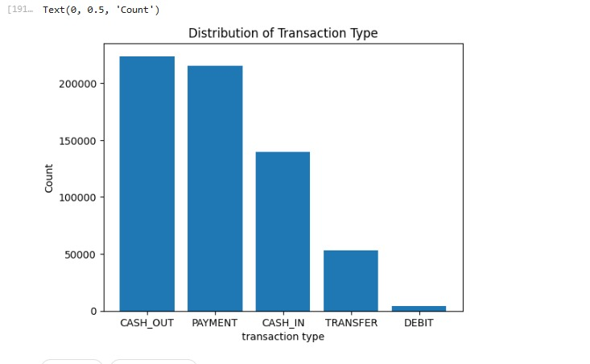
Figure 1: Distribution of Legitimate and Fraudulent Transactions.
The class distribution shows that fraudulent transactions represent only 849 out of 636,262 transactions (0.13%), while legitimate transactions account for 99.87% of the dataset. This confirms that fraud detection is a highly imbalanced classification problem.
Such an imbalance presents a significant modelling challenge because a model that predicts every transaction as legitimate would achieve very high accuracy while failing to detect fraud. Consequently, specialised techniques including SMOTE and class weighting were considered during model development to improve the model's ability to identify the minority class.

3.2 Fraud Across Transaction Types
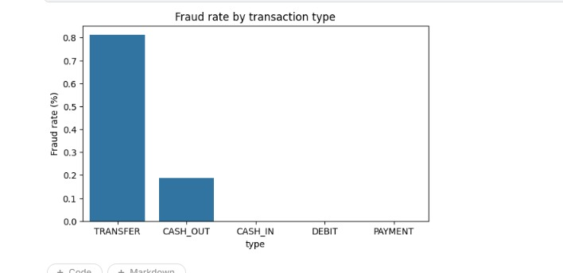
Figure 2: Distribution of Fraudulent Transactions by Transaction Type.
The analysis revealed that fraudulent transactions occur almost entirely within TRANSFER and CASH_OUT transaction types, while PAYMENT, DEBIT, and CASH_IN transactions exhibited little to no fraudulent activity.
This finding suggests that fraudsters primarily exploit transaction types that facilitate rapid movement or withdrawal of funds. From a business perspective, financial institutions can prioritise monitoring and additional authentication for these higher-risk transaction categories to improve fraud prevention while reducing unnecessary checks on lower-risk transactions.

3.3 Transaction Amount
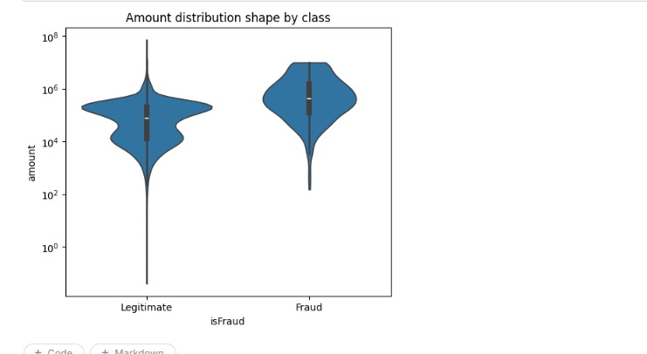
Figure 3: Distribution of Transaction Amounts by Fraud Class.
The transaction amount distribution indicates that fraudulent transactions generally involve larger monetary values than legitimate transactions. This behaviour is consistent with the objective of maximising financial gain before detection.
Although transaction amount alone cannot distinguish fraudulent from legitimate activity, it provides valuable predictive information when combined with behavioural features such as transaction type and account balance changes.

3.4 Correlation Analysis
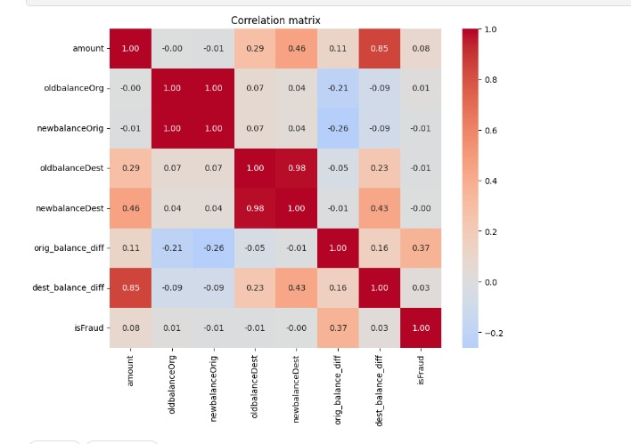
Figure 4: Correlation Matrix of Numerical Features.
The correlation analysis was performed to examine relationships between numerical variables and identify features that may contribute to fraud detection.
The heatmap indicates that the engineered balance-related variables exhibit stronger relationships with fraudulent behaviour than the original balance variables. In particular, the balance difference features capture changes in account behaviour that are not directly observable from the raw balances alone.
These findings validated the feature engineering strategy adopted during data preprocessing and suggested that behavioural indicators would provide greater predictive power than static account information.

4. Feature Engineering
To improve model performance, additional behavioural features were created from the original transaction data. Rather than relying solely on raw account balances, new variables were engineered to capture changes in customer behaviour during each transaction.
The following features were introduced:

Feature | Description
orig_balance_diff | Difference between the sender's balance before and after the transaction.
dest_balance_diff | Difference between the recipient's balance before and after the transaction.
orig_emptied | Indicates whether the sender's account was completely emptied during the transaction.
dest_was_empty | Indicates whether the recipient's account initially had a zero balance.
Additionally, the categorical transaction type variable was transformed using One-Hot Encoding to enable its use within the machine learning models. The customer identifier variables (nameOrig and nameDest) were removed because they uniquely identify customers rather than transaction behaviour and therefore do not contribute meaningful predictive information.
The resulting dataset provided a richer representation of transaction behaviour, enabling the machine learning models to learn behavioural patterns associated with fraudulent activity rather than relying solely on raw transaction values.

5. Handling Class Imbalance
One of the primary challenges encountered during this study was the severe imbalance between legitimate and fraudulent transactions. Since fraudulent transactions represented only 0.13% of the dataset, training a model on the original data could result in poor fraud detection performance.
To address this challenge, two different imbalance handling strategies were evaluated:
- SMOTE, where synthetic minority samples were generated to create a more balanced training dataset.
- Class weighting, where fraudulent transactions were assigned greater importance during model training without modifying the original data distribution.
These two approaches were compared using multiple evaluation metrics, including Accuracy, Precision, Recall, F1-score, and ROC-AUC, to determine the most suitable model for real-world fraud detection.

6. Model Development and Evaluation
To evaluate the effectiveness of different machine learning approaches for fraud detection, two classification models were developed and compared: Logistic Regression and Extreme Gradient Boosting (XGBoost).
Logistic Regression was selected as a baseline model due to its simplicity and interpretability, while XGBoost was chosen because of its ability to capture complex, non-linear relationships and its proven effectiveness on structured datasets with class imbalance.
Model performance was evaluated using Accuracy, Precision, Recall, F1-score, and ROC-AUC. These metrics were selected because fraud detection requires balancing the ability to detect fraudulent transactions while minimising false positive predictions.

6.1 Logistic Regression Performance
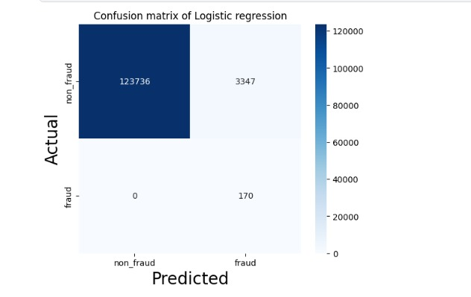
Figure 5: Confusion Matrix for Logistic Regression.
The Logistic Regression model achieved an accuracy of 97.37% and successfully detected all fraudulent transactions, resulting in a recall of 100%. However, the model produced a large number of false positive predictions, leading to a precision of only 4.83% and an F1-score of 9.22%.
Although detecting every fraudulent transaction is desirable, the high false positive rate would require a financial institution to investigate thousands of legitimate transactions unnecessarily. Such a system would increase operational costs, delay customer transactions, and reduce customer satisfaction.
These results demonstrate that high recall alone is insufficient for an effective fraud detection system.

6.2 XGBoost Performance
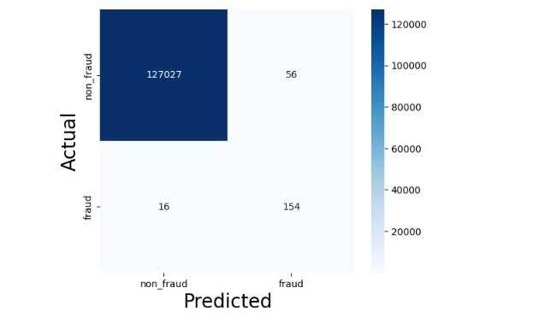
Figure 6: Confusion Matrix for XGBoost.
The XGBoost model achieved superior overall performance, with an accuracy of 99.94%, precision of 73.33%, recall of 90.59%, F1-score of 81.05%, and an ROC-AUC of 0.9997.
The confusion matrix further demonstrates the model's effectiveness:
- True Positives: 154
- False Positives: 56
- False Negatives: 16
- True Negatives: 127,027
Compared with Logistic Regression, XGBoost substantially reduced the number of false positive predictions while maintaining a high fraud detection rate. This balance makes the model more practical for deployment in real-world banking environments.

6.3 Model Comparison
Table 1 compares the performance of the two machine learning models.
Table 1: Performance Comparison of Machine Learning Models
Metric | Logistic Regression | XGBoost
Accuracy | 97.37% | 99.94%
Precision | 4.83% | 73.33%
Recall | 100.00% | 90.59%
F1-Score | 9.22% | 81.05%
ROC-AUC | – | 0.9997

While Logistic Regression achieved perfect recall, its’ extremely low precision indicates that most of the transactions flagged as fraudulent were actually legitimate. In contrast, XGBoost maintained a high recall while significantly improving precision and overall model performance.
Based on these findings, XGBoost was selected as the final fraud detection model because it offers the most effective balance between identifying fraudulent transactions and reducing unnecessary fraud investigations.

7. Feature Importance Analysis
Feature importance analysis was conducted to identify the variables that contributed most to fraud detection. The XGBoost model ranked orig_balance_diff and orig_emptied as the two most influential predictors, followed by transaction amount and transaction type.
The importance rankings indicate that behavioural changes in account balances provide stronger predictive information than static account balances alone. This finding confirms that the engineered features successfully captured meaningful transaction behaviour associated with fraudulent activity.
The results also demonstrate that feature engineering played a critical role in improving model performance by enabling the model to learn patterns that were not directly observable from the original dataset.
8. Business Recommendations
The results of this study demonstrate that machine learning can significantly improve fraud detection by identifying suspicious transactions before financial losses occur. Based on the findings, we propose the implementation of Sentinel AI, an intelligent fraud detection framework designed to support real-time transaction monitoring within financial institutions.
The system would analyse every transaction as it occurs and assign a fraud risk score based on the trained XGBoost model. Transactions classified as low risk would proceed without interruption, ensuring a seamless customer experience. Medium-risk transactions could trigger additional authentication measures, such as One-Time Password (OTP) verification, before approval. High-risk transactions would be automatically flagged for manual investigation or temporarily blocked until reviewed by fraud analysts.
By prioritising transactions according to their level of risk, Sentinel AI would reduce unnecessary investigations while allowing fraud analysts to focus on genuinely suspicious activities. This approach improves operational efficiency, reduces financial losses, and strengthens customer confidence in digital banking services.
The findings also highlight the importance of behavioural features in fraud detection. Variables describing changes in account balances proved to be more informative than static account balances, suggesting that future fraud detection systems should focus on customer transaction behaviour rather than individual transaction values alone.

9. Limitations and Future Work
Although the proposed model achieved excellent predictive performance, several limitations should be considered.
Firstly, the dataset used in this study consisted of simulated mobile money transactions. While the data closely resembles real-world financial behaviour, evaluating the model on real banking transaction data would provide a more comprehensive assessment of its practical performance.
Secondly, fraudulent transactions represented only a very small proportion of the dataset. Although class imbalance techniques improved model performance, future research could investigate additional approaches such as ADASYN, cost-sensitive learning, or ensemble anomaly detection to further enhance fraud detection.
Future work could also incorporate explainable artificial intelligence (XAI) techniques such as SHAP to provide fraud analysts with explanations for each prediction, improving transparency and trust in the model's decisions.
Finally, integrating real-time transaction streams and continuously retraining the model would enable the system to adapt to evolving fraud patterns over time.

10. AI Usage Reflection
AI tools were used for code interpretation, report refinement, and documentation. AI-assisted explanations helped improve understanding of machine learning concepts, feature engineering techniques, and evaluation metrics.
However, all data preprocessing, feature engineering, model development, performance evaluation, and interpretation of results were completed by the team. AI served as a supporting tool for productivity rather than replacing analytical decision-making.
- How do we handle class imbalance?
- How to use SMOTE?
- What is the code for class weighting?
- What is the difference between SMOTE and class weighting?
- Explain precision, recall, and F1-score
- What score should precision be for a model to be considered good enough?
- Is it normal for my accuracy to be so high?
- How do I increase precision?
- Tell me everything on how to use XGBoost.
- Please remind me of the metrics I need to import when building a model
- How do I answer business questions using the confusion matrix?

11. Conclusion
Among the evaluated models, XGBoost demonstrated the best overall performance, achieving an accuracy of 99.94%, precision of 73.33%, recall of 90.59%, F1-score of 81.05%, and an ROC-AUC of 0.9997. These results indicate that the model can effectively identify fraudulent transactions while maintaining a low false positive rate, making it suitable for practical deployment.
The study further demonstrated that engineered behavioural features—particularly changes in account balances—provide stronger predictive power than the original transaction variables. This highlights the value of feature engineering in improving fraud detection performance.
To translate these findings into practice, the proposed Sentinel AI framework provides a scalable approach for real-time fraud detection by combining machine learning with risk-based decision making. By reducing fraud losses while minimising disruption to legitimate customers, the solution has the potential to enhance both operational efficiency and customer trust within digital financial services.

