Assignment 1

Q1. What are your goals for this course?  
 My goals are:  
 a. Gain practical knowledge in designing and operating a pipeline for basic image processing of data from our two Panoptes units on campus.  
 b. Conduct light curve studies on the Blaze Star and other transit events.  
 d. Learn the process and methodology for writing research papers.

Q2. What topics in Astronomy interest you?  
 I am fascinated by the study of space-time curvature and the theoretical exploration of artificial wormholes. I am also interested in satellite design and development, as well as applying Python programming to create algorithms that facilitate astronomical discoveries—similar to the TESS mission, where an algorithm was developed to detect planetary transits.

Assignment 2: Unix commands

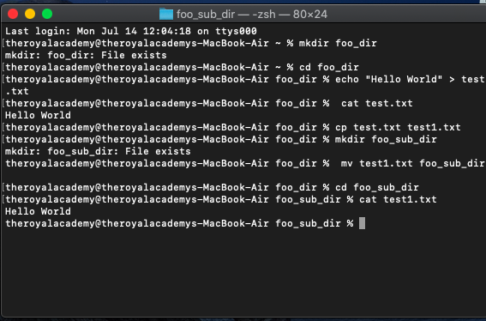

Assignment 3

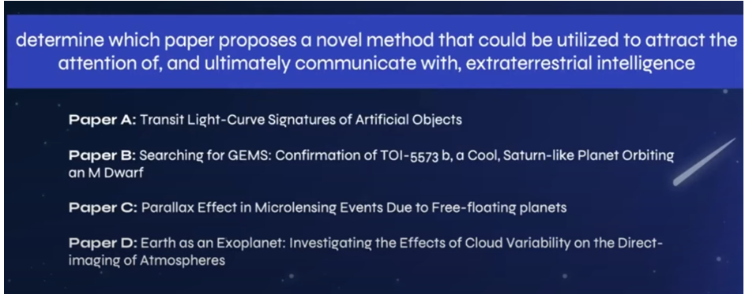

After skimming through the four suggested papers, the one that really stood out to me was *"Transit Lightcurve Signatures of Artificial Objects."* This paper details the method of creating and observing artificial objects that would create light curves on the observing screens which differ from that of natural planets and such. It puts forward an interesting idea — if we could build a large, oddly shaped artificial object, it might catch the attention of other alien civilizations. That could even lead them to try and reach out to us.