Drew Weisserman Intro2Astro Assignment: Exoplanet Detection Methods

Question 1 – Exoplanet Characterization

*In this question, you will estimate the mass and radius of a planet from its radial velocity and transit data.*

A mysterious new (and fake!) planet, GJ 8999 b, has been detected orbiting the M dwarf GJ 8999. GJ 8999 is a *very* small star, with a mass of 0*.*2*M*⊙ and a radius of 0*.*2*R*⊙. (If you haven’t seen those symbols before, *M*⊙ and *R*⊙ are the mass and radius of the Sun, respectively.)

The cunning astronomer you are, you have been measuring transit and radial velocity data of this star to figure out the planet’s mass and radius of this planet, so you can publish a paper on the system! Let’s characterize this planet now.

a) What is the inclination of GJ 8999 b?

The inclination of GJ 8999 b is very close to 90°, because we are able to observe both transits and radial velocity variations. A

transit occurs only when a planet passes directly in front of its

star from our point of view, which requires the orbit to be

nearly edge-on.

b) New transit data from the Transiting Exoplanet Survey Satellite (TESS) has come in, and it very much looks like we have some exoplanet transits! A plot of the flux from the full 28-day observation period of TESS is shown here, as well as a plot that is zoomed into a single transit.

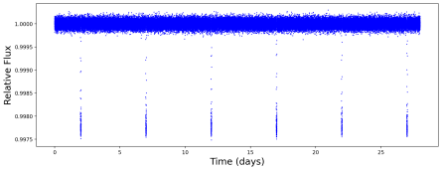Figure 1: A plot of the flux of GJ 8999 over time over a 28-day

period.

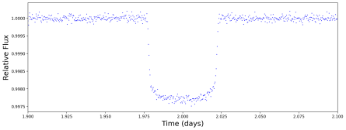Figure 2: A plot of the flux of GJ 8999 over time, zoomed into a single exoplanet transit. What is the period of this exoplanet?

- From the first data plot we can observe that GJ 8999 has

passed in front of the star 6 times due to the dips from our

viewpoint which means it takes 28/6 days to complete one

revolution around the star which is almost 5 days.

Therefore the period of this exoplanet is approximately 5

days or slightly less.

c) What is the radius of this planet?



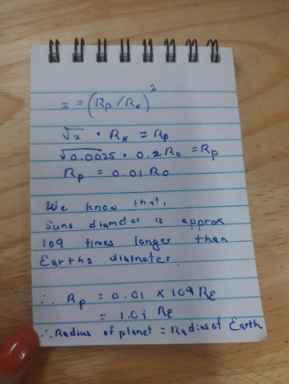Thus, the radius of the planet is approximately

equal to that of Earth's.

d) Luckily for us, we have gotten some radial velocity data to

figure out this planet’s mass, too. This data, taken over a period of 30 days, measures the star’s Doppler shift as it moves back and forth due to the planet’s gravity.

Figure 3: A plot of the radial velocity of GJ 8999 over time. What is the semi-amplitude *K* of this planetary signal?

As visible the Maximum Radial Velocity is around 2 m/s and Minimum Radial Velocity is around -2 m/s

Therefore the Semi-Amplitude will be = change in Radial Velocity / 2 = [2 - (-2)]/2

= 2 m/s

e) What is the mass of this planet?

**- From the equation:**

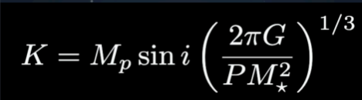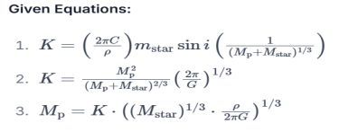

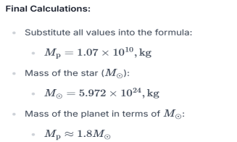

f) So, now that we’ve found the mass and radius of our

planet, let’s try to figure out what it’s made of!

The following plot shows (very rough) ’mass-radius curves’ of rocky exoplanets of

different compositions. A planet lying on a given curve has a mass and radius consistent with being made of the corresponding composition.

Figure 4: A plot showing the mass-radius curves for different exoplanet compositions.

The five rocky planets (plus Ganymede) are all shown on the plot as well. For example, Earth lies very near the ’67% rock, 33% iron’ curve, and Earth’s composition IS indeed about 67% rock and 33% iron.

With this in mind, what is the composition of GJ 8999 b?

- 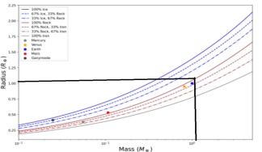- It seems like it is almost 100% rock.