Link to my github acc: <https://github.com/tsheltrim-lhamo/Intro-to-Astro2025>

First 3 authors who discovered TOI-6324 b:

1. Lee, Rena A,
2. Dai, Fei,
3. Howard, Andrew W

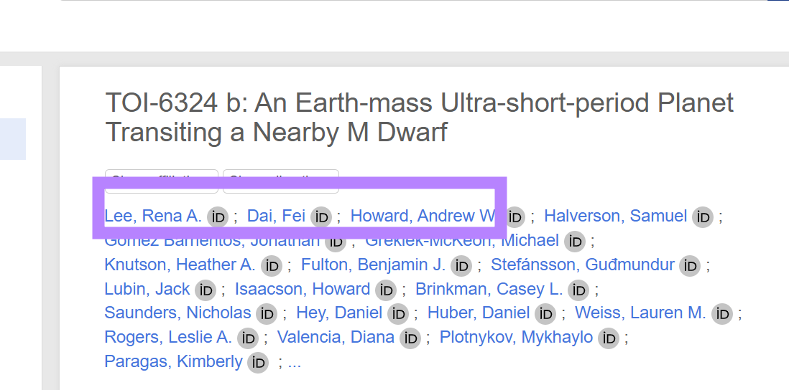

How many systems list position information (RA, Dec) from sources that are not the TICv8 (TESS Input Catalog)?

- 264 positions

Explore one of these position reference papers. What was the purpose of their survey?

- Microlensing events indicate that super-Earth exoplanets are common in Jupiter-like orbits.The purpose of the paper is to determine the frequency of super-Earths on wide orbits and to provide insights into the formation processes of these planets.