**Table of Contents**

**1. Overview 2**

**2. System Development Life Cycle 3**

**3. List of resources 4**

**4. Resource specifications 5**

**Overview**

This document indicates the resources required needed for the project to be completed in the specified time. The required resources are but then they are not limited to, laptops, a tester, a front-end developer, a github private account, a server, an office where the development will be taking place, and a few software for both developers and a tester. The plan shows that the software can be developed within the specified period or before. The indicated processes only include the development of the web application not the mobile application, the mobile application will not take much time because the system will be done, and the android will just consume the services of the system which is why the system has to be done first before the mobile part can be implemented. This document only shows the core resources that are required for the system to be done some might come later but we can use open source where possible.

**Software Development Life Cycle**

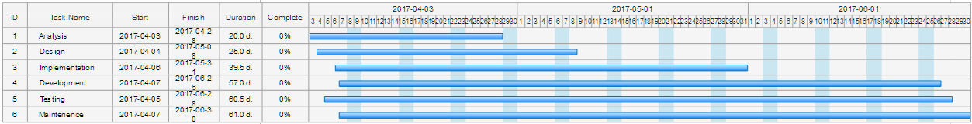

List of resources required to complete the project

|  |  |
| --- | --- |
| **NAME** | **AMOUNT** |
| * Laptop | X 3 |
| * Front- End Developers | X1 |
| * Testers | X1 |
| * Github private account | X1 |
| * Server | X1 |
| * JetBrains Intelij |  |
| * Apache Mentis |  |
| * JetBrains Android Studio |  |

* **Laptop Specifications**

|  |  |
| --- | --- |
| **HARDWARE** | **REQUIRED** |
| * Random Access Memory | >= 16GB |
| * HARD DRIVE DISC | ANY |
| * Central Processing Unit | >= 4GHz |

* **FRONT END DEVELOPER SPECIFICATIONS**

|  |
| --- |
| **SKILLS REQUIRED** |
| * JAVA |
| * Angular JavaScript |
| * MaterializeCSS |
| * Bootstrap |

* **TESTER**

|  |
| --- |
| **SKILLS REQUIRED** |
| * ABILITY TO TEST WEB APPLICATION |