NIT2102 CYBER SECURITY ESSENTIALS
Ransomware Detection and Automated Response Using Wazuh SIEM and Snort IDS
Healthcare-focused security emulation in an isolated virtual lab

Unit | NIT2102 Cyber Security Essentials
Student Name | Ugyen Tshephel Dorji
Student ID | s8162795
Submission Date | 15 September 2026

Project objective
Design, implement and evaluate a layered detection-and-response solution combining network IDS, SIEM analytics and real-time file integrity monitoring against controlled ransomware-like activity.
Report prepared to the assessment template: threat analysis • solution design • implementation/testing • ethics • results • references

Executive Summary

Ransomware presents a high-impact availability and privacy risk to healthcare because clinical workflows depend on timely access to digital records, diagnostic systems and supporting services. This project designed and tested a layered security solution using Snort 3 for network intrusion detection and Wazuh for centralised security monitoring, file-integrity monitoring (FIM), custom analytics and response workflow integration. A controlled Kali Linux endpoint (192.168.64.10) generated reconnaissance and ransomware-like file activity against a Metasploitable target (192.168.64.11), while a Wazuh server (192.168.64.14) centralised alerts. The solution produced a Level 8 custom network alert (Rule 100100), a Level 12 ransomware-related FIM alert (Rule 100200), and MITRE ATT&CK mapping to T1486. The lab therefore supports the NIST CSF 2.0 Detect and Respond functions through observable, evidence-backed security events (NIST, 2024).
Implementation scope note. The supplied lab evidence places Snort and the Wazuh endpoint agent/FIM on Kali for compatibility, while Metasploitable remains the protected target. The conceptual target design supplied separately places these controls on or adjacent to the protected workload. The report keeps this distinction explicit rather than overstating the evidence.

Threat Analysis & Research

Problem statement and healthcare relevance
Ransomware is an impact-focused threat in which adversaries encrypt data to interrupt access to systems and information. MITRE ATT&CK describes T1486, Data Encrypted for Impact, as the deliberate encryption of data on local or remote systems to deny availability; ransomware commonly combines encryption with file renaming or markers (MITRE ATT&CK, 2026). In healthcare, loss of availability can directly affect patient-care continuity, scheduling, pathology, imaging, pharmacy and revenue-cycle operations. The 2024 Change Healthcare cyberattack illustrated this systemic dependency: the U.S. Department of Health and Human Services described the incident as having unprecedented, widespread effects on patients and healthcare providers and investigated potential protected-health-information exposure (HHS, 2025).

Attack vectors represented in the lab
- Reconnaissance: Nmap service discovery was used to identify exposed TCP services on the target. This corresponds to MITRE ATT&CK T1046 (Network Service Scanning).
- Network probing: ICMP and TCP SYN traffic provided deterministic test traffic for Snort rule validation without exploiting external systems.
- Ransomware-like activity: harmless test files were renamed with a .locked extension and modified rapidly. No real encryption, malware payload or destructive ransomware was executed.
- Central monitoring: Snort alerts and Wazuh FIM events were forwarded to the SIEM for correlation and custom-rule evaluation.

Why existing controls can fail
A single control is insufficient against ransomware. Network-only monitoring may miss host-side encryption activity, while endpoint-only monitoring can miss reconnaissance and lateral-movement indicators. Legacy systems may also be difficult to instrument directly. A layered design therefore combines network visibility, host file-change detection, central analytics and a response workflow so that suspicious activity can be detected at more than one stage of the attack lifecycle.

Threat Analysis & Research — Continued

Threat impact
Impact area | Healthcare consequence
Availability | Encrypted or inaccessible records can delay clinical and administrative workflows.
Confidentiality | Ransomware operations may include data theft or exposure before encryption.
Integrity | Unauthorised modification or deletion undermines trust in patient and operational records.
Financial / operational | Downtime, recovery, incident response and notification obligations increase cost.
Safety / reputation | Disrupted access to information can affect patient-service continuity and public trust.

MITRE ATT&CK mapping
Technique | Lab behaviour | Detection | Project control
T1046 | Nmap/TCP SYN service scanning | Snort + Rule 100100 | Network detection
T1486 | Safe .locked file modification simulation | Wazuh FIM + Rule 100200 | Host/SIEM detection

Compliance and control alignment
The solution maps naturally to NIST CSF 2.0: Identify is supported by asset and service discovery; Detect by Snort, Wazuh and FIM; Respond by the custom response workflow; Recover by the recommendation for tested backups and restoration procedures. ISO/IEC 27001:2022 provides a broader information-security management context for logging, monitoring, incident management and access control. These frameworks do not prescribe a specific product; they provide outcomes and governance expectations that the lab controls can support.

Threat model and assumptions
- The attacker is represented by a controlled Kali Linux system on the same isolated virtual subnet.
- Metasploitable is intentionally vulnerable and contains no real patient or production information.
- The objective is detection and response validation, not persistence, privilege escalation or destructive exploitation.
- Ransomware behaviour is emulated using benign file extension and content changes rather than actual encryption.
- Any production deployment would require role-based access, trusted certificates, segmentation, secure backup and formal change control.

Security Solution Design
The proposed control stack uses complementary layers rather than relying on one sensor. Snort inspects network traffic and generates deterministic IDS alerts; Wazuh centralises endpoint and IDS telemetry; FIM detects creation, deletion and checksum changes within monitored healthcare data; custom Wazuh rules raise the severity and add MITRE context; and a response script provides a controlled remediation path. This design supports defence-in-depth and produces evidence that is suitable for audit, incident investigation and demonstration.
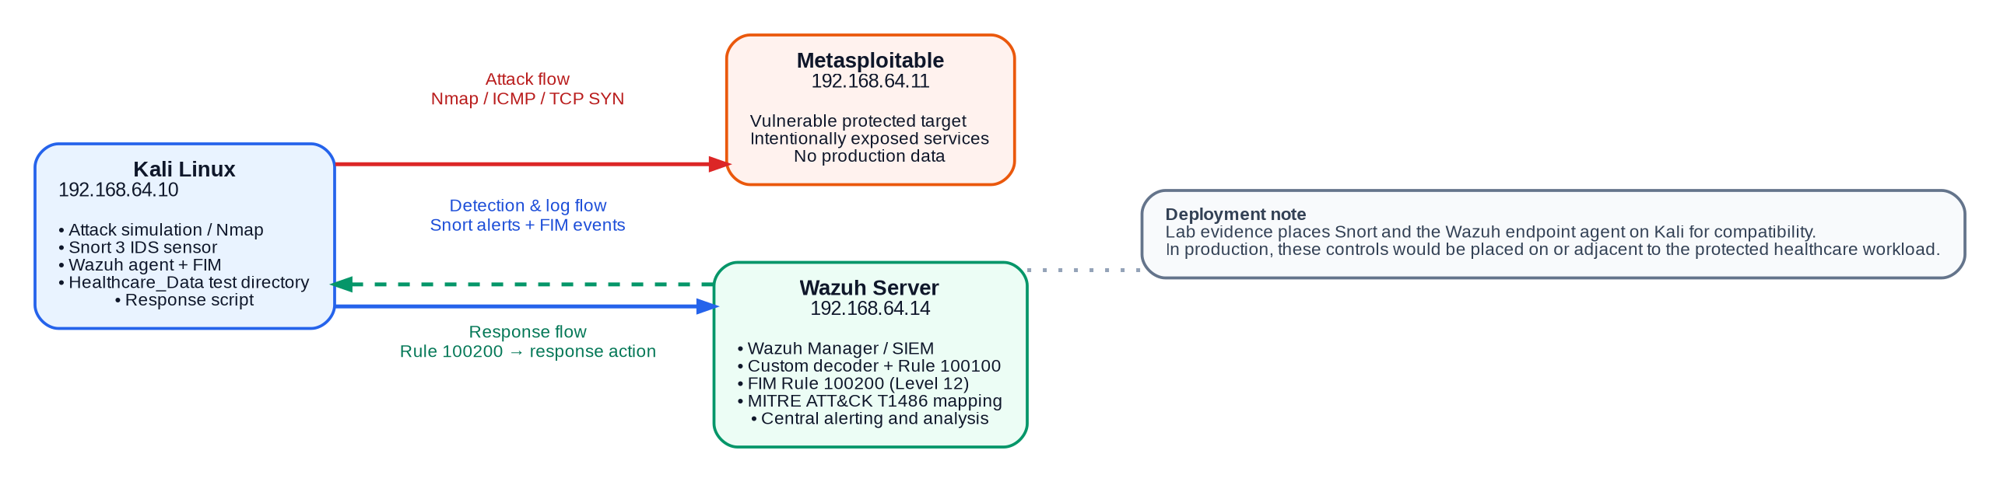
Figure 1. Evidence-aligned lab architecture and security-event flows. Mermaid.js source for the requested conceptual target architecture is supplied in the configuration pack.

Architectural rationale
- Snort provides network-layer visibility and is well suited to signature and rule-based detection of scanning or suspicious traffic.
- Wazuh provides centralised analysis and a single place to correlate alerts from Snort and endpoint FIM.
- FIM closes a key visibility gap by detecting file creation, modification and deletion in real time; Wazuh compares current attributes and checksums with the stored baseline (Wazuh, n.d.-a).
- Custom Rule 100200 raises ransomware-like .locked-file modifications to Level 12 and tags the event with MITRE ATT&CK T1486.
- A reversible response script is preferred over destructive automation so the lab can demonstrate containment without deleting evidence or disabling the VM.

Security Solution Design — Configuration

Snort 3 detection rule (tuned submission version)
alert tcp any any -> 192.168.64.11 any (
msg:"HEALTHCARE LAB - Possible TCP SYN Scan to Protected Server";
flags:S;
detection_filter:track by_src,count 20,seconds 10;
sid:1000002; rev:2;
)
The detection_filter requires a burst of SYN packets before generating an event, reducing the alert flood observed with the original broad test rule. Snort 3 supports detection_filter as a post-detection rate control (Cisco, n.d.).

Wazuh custom decoder and rules
<decoder name="snort3_healthcare">
<prematch>HEALTHCARE LAB</prematch>
</decoder>
<rule id="100100" level="8">
<decoded_as>snort3_healthcare</decoded_as>
<description>Healthcare IDS: Snort detected suspicious network traffic</description>
<mitre><id>T1046</id></mitre>
</rule>
<rule id="100200" level="12">
<if_sid>550</if_sid>
<field name="syscheck.path">\.locked$</field>
<description>Healthcare Ransomware Alert: suspicious locked-file modification</description>
<mitre><id>T1486</id></mitre>
</rule>

File Integrity Monitoring and response binding
<directories realtime="yes" report_changes="yes">/home/kali/Healthcare_Data</directories>
<active-response>
<disabled>no</disabled>
<command>ransomware-containment</command>
<location>local</location>
<rules_id>100200</rules_id>
<timeout>600</timeout>
</active-response>
The full, commented decoder, rules, FIM snippet, Mermaid source and reversible Python response script are supplied separately in the configuration pack. Wazuh supports binding Active Response actions to specific rule IDs and running custom actions on monitored endpoints (Wazuh, n.d.-b).

Implementation & Testing

1. Reconnaissance and attack-surface discovery
Connectivity between Kali (192.168.64.10) and the Metasploitable target (192.168.64.11) was verified inside the isolated 192.168.64.0/24 virtual network. Nmap service-version scanning then identified 23 open TCP services and 977 closed ports, including FTP, SSH, Telnet, SMTP, DNS, HTTP, SMB, databases, VNC, IRC and Tomcat. This established a realistic, intentionally exposed attack surface for controlled testing without exploiting external infrastructure.
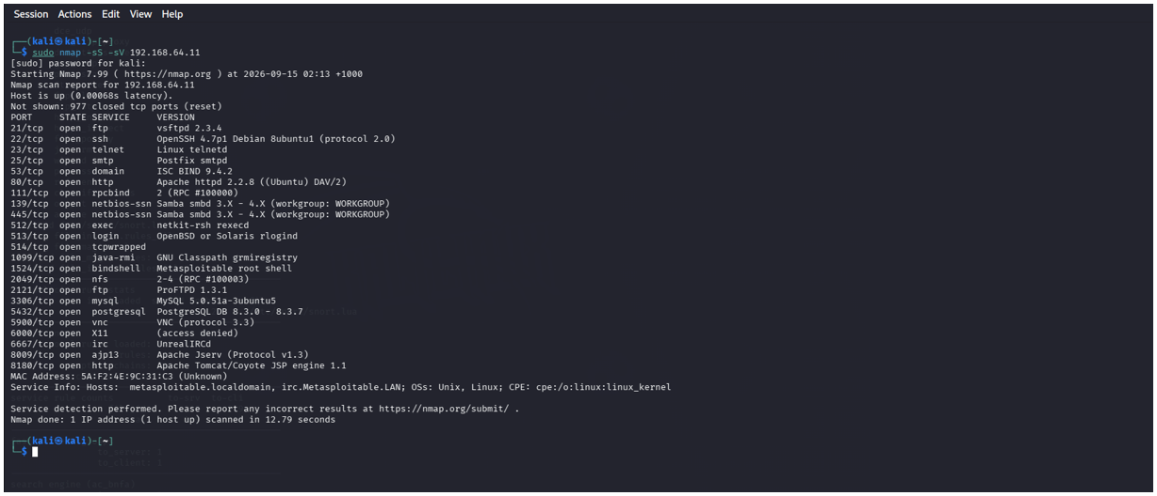
Figure 2. Service discovery against 192.168.64.11 identified 23 open TCP services.

2. Snort IDS detection
Snort 3 was configured with local ICMP and TCP SYN rules. During the controlled tests, Snort generated alerts for traffic from 192.168.64.10 to 192.168.64.11 and wrote fast-format alerts for collection by Wazuh. The screenshot below confirms that the IDS rule fired against the protected target.
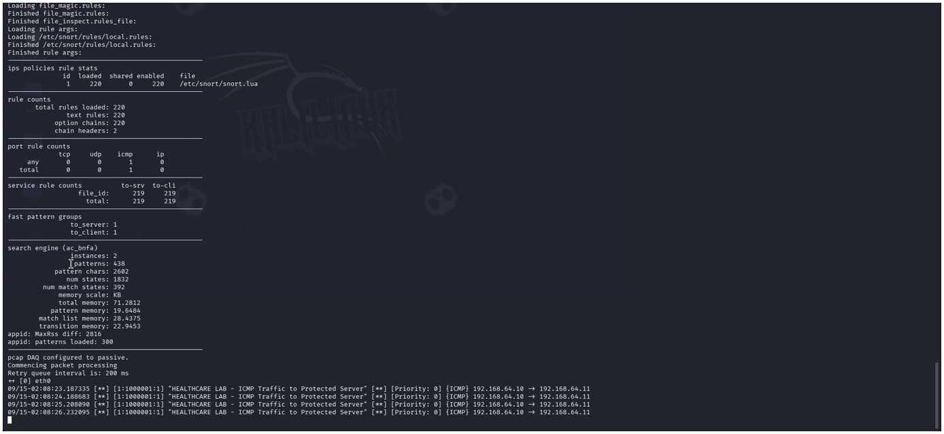
Figure 3. Snort detecting simulated ICMP traffic to the protected server.

Implementation & Testing — SIEM Analytics

3. Snort-to-Wazuh integration and Rule 100100
The Wazuh endpoint agent monitored the Snort fast-alert file and forwarded events to the Wazuh manager. A custom decoder matched the HEALTHCARE LAB message prefix and Rule 100100 elevated matching IDS events to Level 8. The dashboard recorded 1,817 hits during the controlled scan window. This demonstrates end-to-end telemetry flow, but the high count also shows why rate limiting and threshold tuning are necessary in a production IDS.
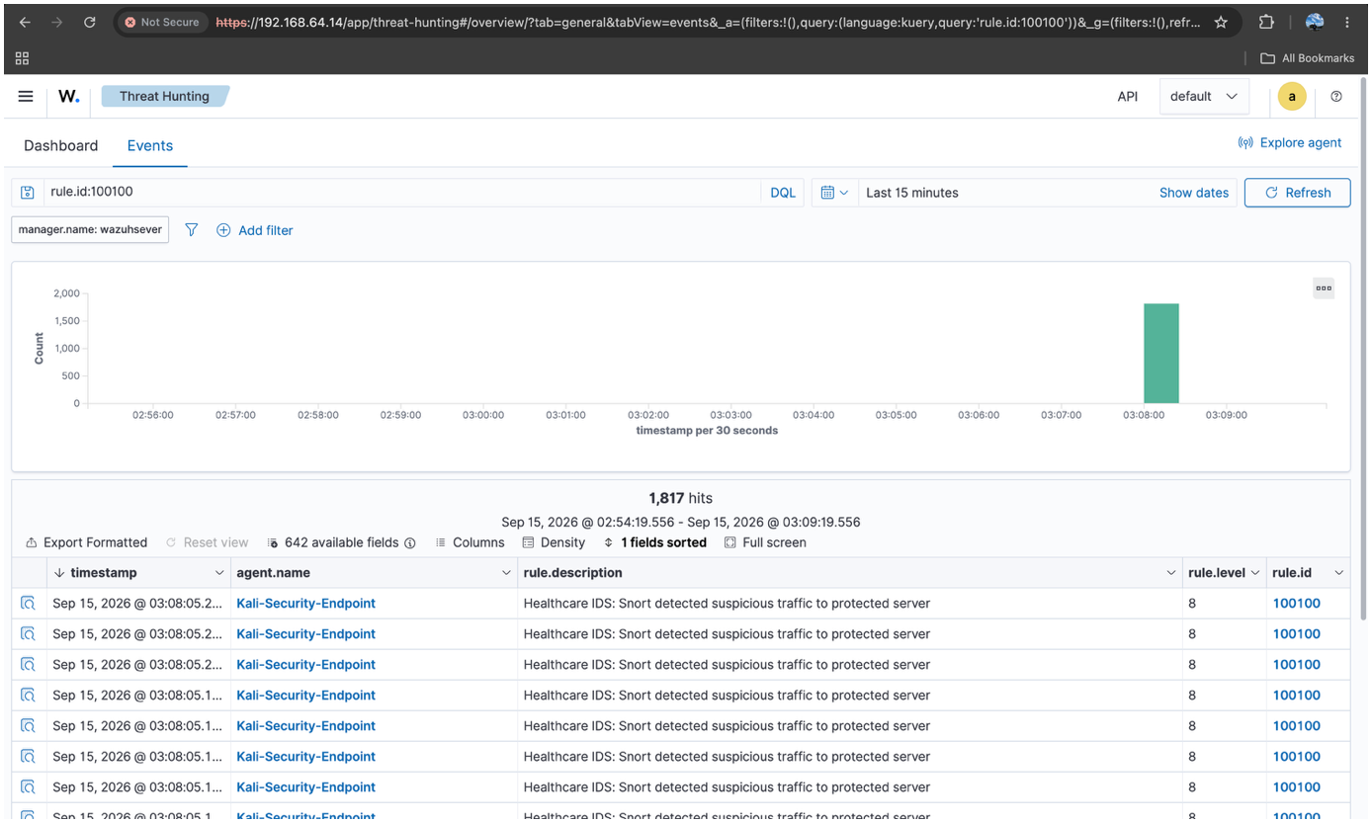
Figure 4. Level 8 IDS events centralised in Wazuh; 1,817 alerts were observed during the broad scan test.

4. Ransomware-like FIM test and Rule 100200
A dedicated Healthcare_Data directory was monitored using Wazuh FIM with real-time and report-changes options. Harmless patient-record files were renamed with the .locked extension and modified to emulate observable ransomware behaviour. Native FIM events confirmed file additions, deletions and checksum changes; the custom Rule 100200 matched a .locked file modification, raised the event to Level 12 and mapped it to MITRE ATT&CK T1486. This is an emulation of an indicator associated with encryption impact—not proof that actual encryption occurred.
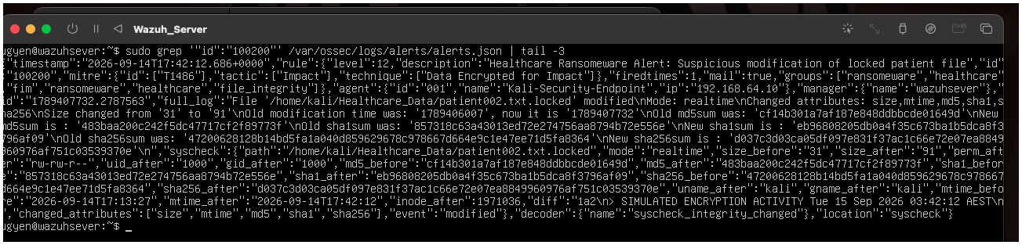
Figure 5. Wazuh server evidence for the Level 12 custom ransomware alert with T1486 mapping.

Implementation & Testing — Response & Validation

5. Response script validation
A custom response script was created to record ransomware-like activity and identify .locked files in the protected test directory. The supplied evidence confirms successful manual execution and identification of three simulated locked patient files. For submission, a Wazuh Active Response binding is supplied so Rule 100200 can invoke a reversible containment action automatically. Because the available screenshots demonstrate manual script validation rather than the automatic trigger itself, end-to-end automatic invocation should be re-tested before any production deployment.
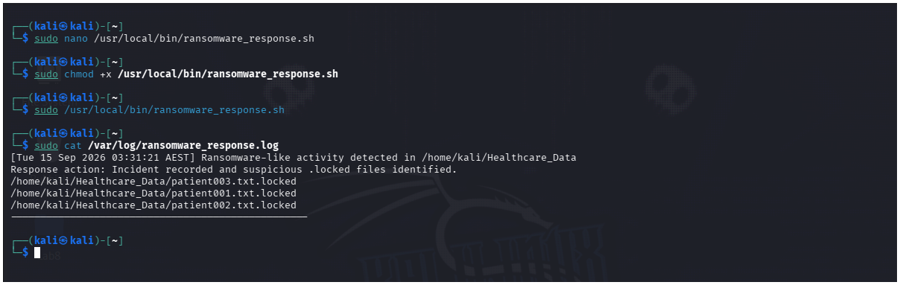
Figure 6. Response script logging the incident and identifying three .locked test files.

Testing methodology and outcomes
Test | Evidence / Metric | Interpretation
Reconnaissance | 23 open TCP services; 977 closed | Attack surface successfully enumerated in the isolated lab.
Snort network detection | ICMP/TCP alerts generated | IDS rules matched controlled traffic to 192.168.64.11.
Wazuh correlation | Rule 100100, Level 8; 1,817 hits | Central collection worked; alert volume requires tuning.
Ransomware-like FIM | Rule 100200, Level 12; T1486 | Real-time .locked-file modification detected and contextualised.
Response validation | 3 .locked files identified | Script operated safely; automatic binding supplied for final integration.
Overall test result: The multi-tool detection chain operated successfully across network IDS, SIEM correlation and host file-integrity monitoring. The main technical limitation observed was alert noise from the broad SYN rule, which is addressed in the tuned submission rule.

Ethical & Legal Considerations
All testing was conducted in an isolated private virtual network using RFC1918 addresses and an intentionally vulnerable Metasploitable target. No public systems, external organisations or real patient records were targeted. The ransomware component used benign file renaming and text modification rather than malware or destructive encryption. These boundaries reflect responsible dual-use practice: tools such as Kali Linux, Nmap and Snort are legitimate security technologies, but their use must be authorised and limited to systems for which permission has been granted.
Healthcare environments also require strong governance because logs and endpoint telemetry may contain sensitive information. A production deployment should implement least privilege, role-based access, log retention rules, trusted TLS certificates, secure backups and privacy controls. NIST CSF 2.0 supports governance, detection and response outcomes, while ISO/IEC 27001:2022 provides an information-security management framework for policy, risk treatment and continuous improvement. Evidence should be retained in a manner that supports audit and incident investigation without unnecessarily exposing personal information.

Results & Future Improvements

Results
- Layered detection was demonstrated using Snort, Wazuh SIEM and Wazuh FIM rather than a single security control.
- Network reconnaissance generated observable Snort alerts and Wazuh Rule 100100 Level 8 events.
- Ransomware-like file changes triggered the custom Level 12 Rule 100200 with MITRE ATT&CK T1486 mapping.
- A response script safely recorded the incident and identified three .locked files without deleting data.
- The 1,817-alert scan test provided a useful operational finding: visibility was high, but rule tuning is required to reduce analyst noise.

Limitations and recommended improvements
- Verify the Rule 100200 → Active Response path end-to-end on the endpoint and capture dashboard evidence of the automated action.
- Use tuned Snort detection_filter thresholds, network segmentation and firewall/IPS controls to reduce noisy alerts and contain malicious sources.
- Add immutable/offline backups and conduct restoration drills so ransomware recovery is tested, not assumed.
- Add phishing-resistant MFA, email controls and security-awareness exercises to reduce credential-driven initial access.
- Integrate YARA/EDR telemetry and threat intelligence for richer malware detection; Wazuh documents FIM-to-YARA workflows for this purpose.
- Replace self-signed lab certificates with enterprise PKI, centralise time synchronisation and consider high availability for the SIEM in larger deployments.

References

Cisco. (n.d.). Snort 3 Rule Writing Guide: detection_filter. https://docs.snort.org/rules/options/post/detection_filter
International Organization for Standardization. (2022). ISO/IEC 27001:2022 Information security management systems — Requirements.
MITRE ATT&CK. (2026). T1486: Data Encrypted for Impact. https://attack.mitre.org/techniques/T1486/
National Institute of Standards and Technology. (2024). The NIST Cybersecurity Framework (CSF) 2.0 (NIST CSWP 29). https://doi.org/10.6028/NIST.CSWP.29
U.S. Department of Health and Human Services. (2025). Change Healthcare Cybersecurity Incident Frequently Asked Questions. https://www.hhs.gov/hipaa/for-professionals/special-topics/change-healthcare-cybersecurity-incident-frequently-asked-questions/
Wazuh. (n.d.-a). File integrity monitoring. https://documentation.wazuh.com/current/getting-started/use-cases/file-integrity.html
Wazuh. (n.d.-b). How to configure Active Response. https://documentation.wazuh.com/current/user-manual/capabilities/active-response/how-to-configure.html

