

|  |  |  |
| --- | --- | --- |
| **Name and ST** | Tshepo Mahlanyana ST10493152 | |
| **Module Name** | WEDE5020 – Web Development | |
| **Assignment** | Website Project Proposal | |
| **Lecturer** | Charlotte Nukeri | |
| **Programme** | Higher Certificate in Mobile Application and Web Development | |
|  | | **Date:**  27 August 2025 |

. Organisation Overview 1

2. Website Goals and Objectives 1

3. Current Website Analysis 1

4. Proposed Website Features and Functionality 1

5. Design and User Experience 1

6. Technical Requirements 1

7. Timeline and Milestones 1

8. Budget (Estimated) 1

9 Project structure10. Sitemap 1

11. Assets and References 1

12. Expected Outcome 1

13.Assets 1

14. Research and Content 1

References: 1

1. Organisation Overview 1

2. Motivation 1

4. Proposed Website Features & Functionality 1

5. Design & User Experience 1

6. Technical Requirements 1

7. Milestones & Timeline 1

8. Budget (Estimated) 1

9. Sitemap 1

11.Assets 1

12.Project Team Roles 1

13. Research and Content 1

References (IIE Harvard Style): 1

**Website Project Proposal 1: The Daily Grind**

### **. Organisation Overview**

**Name:** The Daily Grind

**Brief History:**  
 The Daily Grind is a fictional artisan coffee shop established in 2023 by a group of coffee enthusiasts passionate about crafting unique blends and creating a cozy atmosphere for the local community. Although still in concept stage, the business aims to capture the warmth and artistry of specialty coffee culture.

**Mission Statement:**  
 To provide high-quality artisan coffee and baked goods while fostering a welcoming space for social connection, creativity, and relaxation.

**Vision Statement:**  
 To become the most loved neighbourhood coffee shop, recognized for its craftsmanship, community engagement, and sustainable practices.

**Motivation**

In today’s digital age, an online presence is essential for small businesses. Research by Statista (2024) shows that over 70% of consumers research businesses online before visiting them in person. For coffee shops in particular, a well-designed website allows potential customers to browse menus, place orders, and connect with the brand before physically visiting. The Daily Grind’s website will motivate customer engagement, improve visibility, and ensure competitive advantage against established cafés in the area.

**Target Audience:**

* Local coffee lovers
* Students and freelancers looking for study/work-friendly spaces
* Young professionals seeking quality artisan beverages
* Tourists exploring the town

### **2. Website Goals and Objectives**

**Goals:**

* Establish a strong online presence and digital identity.
* Showcase the menu and unique offerings with appealing visuals.
* Enable customers to place takeaway orders online.
* Share the café’s story and connect with the community.

**Objectives:**

* Increase customer awareness of The Daily Grind before launch.
* Encourage online orders to improve sales.
* Build customer loyalty through storytelling and brand personality.

**Key Performance Indicators (KPIs):**

* Website traffic (unique visitors per month)
* Number of completed online orders
* Average session duration on the menu page
* Contact form submissions and inquiries

### **3. Current Website Analysis**

The Daily Grind is a new, fictional small business, no existing website currently exists. This provides an opportunity to design the website from the ground up with a focus on user experience, branding, and functionality.

### **4. Proposed Website Features and Functionality**

* **Homepage:** Café introduction, hero image, and call-to-action (“Order Now”).
* **Menu Page:** Coffee and baked goods menu with descriptions, prices, and photos.
* **Order Form:** Simple takeaway order request with name, contact, and preferred pickup time.
* **About Us Page:** The story of The Daily Grind and profiles of its founders.
* **Gallery Page:** High-quality images showcasing the ambiance and drinks.
* **Contact Page:** Location map, contact form, phone number, and social media links.

### **5. Design and User Experience**

**Typography:**

* Headings: *Montserrat Bold* (modern, clean)
* Body Text: *Open Sans Regular* (readable and friendly)

**Layout and Design Approach:**

* Minimalist, grid-based layout with large visuals of coffee and cozy café atmosphere.
* Easy navigation bar at the top (Home | Menu | About | Gallery | Contact).
* Prominent call-to-action buttons (e.g., “Order Now,” “View Menu”).

**User Experience Considerations:**

* Responsive design (mobile-first).
* Consistent branding across all pages.
* Accessibility (alt text for images, clear colour contrast).

**WIREFRAMES**

<https://www.canva.com/design/DAGxSQ_6LFk/Y8L86tyt2JvdZAK5cXG86w/edit>

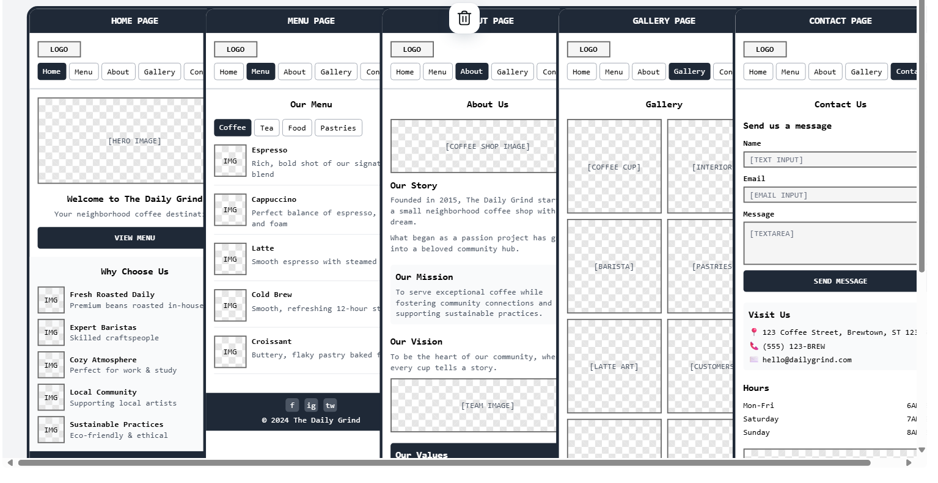

### **6. Technical Requirements**

* **Hosting & Domain:** Shared hosting plan (~R80/month), domain name (*thedailygrind.co.za*).
* **Languages & Frameworks:**
  + HTML5, CSS3, JavaScript
  + Bootstrap for responsive styling
  + PHP or Google Forms integration for order submissions

### **7. Timeline and Milestones**

* **Week 1:** Research, planning, and content collection
* **Week 2:** Wireframe and design mock-ups
* **Week 3:** Development of homepage and menu page
* **Week 4:** Development of additional pages (About, Contact, Gallery)
* **Week 5:** Integration of online order form and testing
* **Week 6:** Final testing, debugging, and deployment

### **8. Budget (Estimated)**

|  |  |  |
| --- | --- | --- |
| Item | Cost (ZAR) | Notes |
| Domain name (.co.za) | R100/year | Approximate cost |
| Hosting | R960/year(R80/month) | Shred hosting |
| SSL Certificate | R200/year | For secure connections |
| Design Assets (stock photos/icons) | R300 | Optional |
| Maintenance | R2000/year | Updates, backups,fixes |

**Total Estimated Budget:** ~ **R3,560/year**

## **9** **Project structure****10. Sitemap**

* Home
  + Menu
  + About Us
  + Gallery
  + Contact

### **11. Assets and References**

**Assets:**

* Logo (to be designed with a coffee cup + bean motif)
* Colour palette (earth tones)
* Typography (Montserrat, Open Sans)
* Icons (Font Awesome coffee icons)

**References:**

* Inspiration: Starbucks South Africa
* Stock image source: Unsplash – Coffee Photos
* Design inspiration: Behance coffee shop websites showcase

### **12. Expected Outcome**

The Daily Grind Coffee website will serve as a professional online platform that reflects the café’s brand identity, attracts customers through visuals and storytelling, and enables simple online orders. It will improve brand visibility, customer engagement, and sales, helping The Daily Grind establish itself as a go-to local café.

## **13.Assets**

**Assets:**

* Logo: coffee cup + bean motif.
* Colour palette: earthy tones (deep brown, cream, olive green).
* Typography: Montserrat (headings), Open Sans (body).
* Icons: Font Awesome coffee icons.

## **14. Research and Content**

The demand for specialty coffee continues to rise globally. According to Mordor Intelligence (2025), the global specialty coffee market is projected to grow at a CAGR of 8.2% between 2024–2029. This indicates that The Daily Grind has strong potential to capture an audience of coffee enthusiasts. Additionally, studies show that local cafés benefit greatly from digital marketing and online presence, as consumers often prefer to check menus, prices, and ambiance online before visiting (Smith, 2023).

A user-friendly website will also encourage repeat customers by offering features such as an online menu, pre-ordering, and social media links. Combining storytelling with visuals allows The Daily Grind to differentiate itself from larger chains by focusing on community and personalized service.

## **References:**

* Mordor Intelligence. (2025) *Specialty Coffee Market – Growth, Trends, and Forecasts (2024–2029)*. Available at: https://www.mordorintelligence.com (Accessed: 27 August 2025).
* Smith, J. (2023) *Digital marketing strategies for local businesses*. Journal of Small Business Marketing, 15(2), pp. 45–58.
* Statista. (2024) *Share of consumers researching local businesses online worldwide*. Available at: https://www.statista.com/ (Accessed: 27 August 2025).
* Starbucks South Africa. (2025) *Starbucks Official Website*. Available at: https://www.starbucks.co.za (Accessed: 27 August 2025).
* Unsplash. (2025) *Free coffee shop images*. Available at: https://unsplash.com (Accessed: 27 August 2025).
* Behance. (2025) *Coffee shop web design inspiration*. Available at: https://www.behance.net (Accessed: 27 August 2025).

**Project Proposal 2 – GreenSteps: Youth Environmental Awareness Initiative**

## **1. Organisation Overview**

**Name:** GreenSteps  
**Brief History:**  
GreenSteps is a fictional non-profit initiative founded in 2023 to encourage youth to take active roles in protecting the planet. It aims to educate young people about climate change, sustainability, and eco-friendly practices while providing opportunities for community involvement.

**Mission Statement:**  
To empower youth through knowledge, resources, and opportunities to lead positive environmental change in their communities.

**Vision Statement:**  
To create a generation of environmentally conscious leaders who protect and preserve the Earth for future generations.

**Target Audience:**

* Youth aged 13–25
* Schools and youth groups
* Community members and eco-volunteers

## **2. Motivation**

The increasing challenges of climate change, pollution, and waste highlight the urgent need for environmental education. Young people are often overlooked in formal environmental programs, yet they represent the future. GreenSteps bridges this gap by creating a digital platform where youth can learn, get inspired, and take real-world action.

**3. Website Goals & Objectives**

**Goals:**

* Establish a strong online presence for GreenSteps.
* Provide engaging educational content.
* Promote volunteerism through event sign-ups.
* Inspire eco-friendly action at local and global levels.

**Objectives:**

* Publish at least 2 new eco-guides monthly.
* Organize quarterly clean-up events with volunteer sign-ups.
* Reach 500+ unique monthly website visitors within 6 months of launch.

**Key Performance Indicators (KPIs):**

* Website traffic analytics.
* Number of event sign-ups.
* Downloads of eco-guides.
* Social media engagement linked from the site.

## **4. Proposed Website Features & Functionality**

* **Home Page:** Mission statement, hero image, quick links to resources/events.
* **Events Page:** Upcoming activities with dates, locations (Google Maps API), and volunteer sign-up forms.
* **Resources Page:** Eco-friendly guides, tips, and downloadable PDF materials.
* **Gallery:** Showcase past events with images.
* **Contact Page:** Form for inquiries + social media links.

## **5. Design & User Experience**

**Typography:**

* Headings: Montserrat Bold (modern, clean).
* Body: Open Sans Regular (legible and approachable).

**Layout Approach:**

* Modern, clean design with plenty of whitespace.
* Mobile-first responsive grid system.
* Icons representing eco-actions (recycling, trees, water conservation).

## **6. Technical Requirements**

* Hosting & Domain (~R80/month).
* Languages: HTML5, CSS3, JavaScript.
* Framework: Bootstrap for responsiveness.
* Integration: Google Maps API for events.

## **7. Milestones & Timeline**

* **Week 1:** Research & planning (content gathering).
* **Week 2:** Wireframes & sitemap design.
* **Week 3:** Develop homepage & events page.
* **Week 4:** Add resources, gallery, and contact page.
* **Week 5:** Integrate Google Maps & test contact form.
* **Week 6:** Testing, bug fixes, and deployment.

## **8. Budget (Estimated)**

|  |  |  |
| --- | --- | --- |
| **Item** | **Cost (ZAR)** | **Notes** |
| **Domain Name (.org/.co.za)** | **R150/year** | **Non-profit rate possible** |
| **Hosting** | **R960/year** | **Shared hosting(~R80/month)** |
| **SSL Certificate** | **R200/year** | **Security for forms** |
| **Design Assets (photos/icons)** | **R300** | **Stock/royalty-free resource** |
| **Maintenance & Updates** | **R1500/year** | **Bug fixes, security patches** |

**Total Estimated Budget:** ~ **R3,110/year**

## **9. Sitemap**

* Home
* About Us
* Events
* Resources
* Gallery
* Contact

**10. Wireframe**

[**Wireframe Design for GreenSteps Non-Profit Website - Doc**](https://www.canva.com/design/DAGxStqutLE/8TExwJ4KRBSfTwtUJm_h1Q/edit)

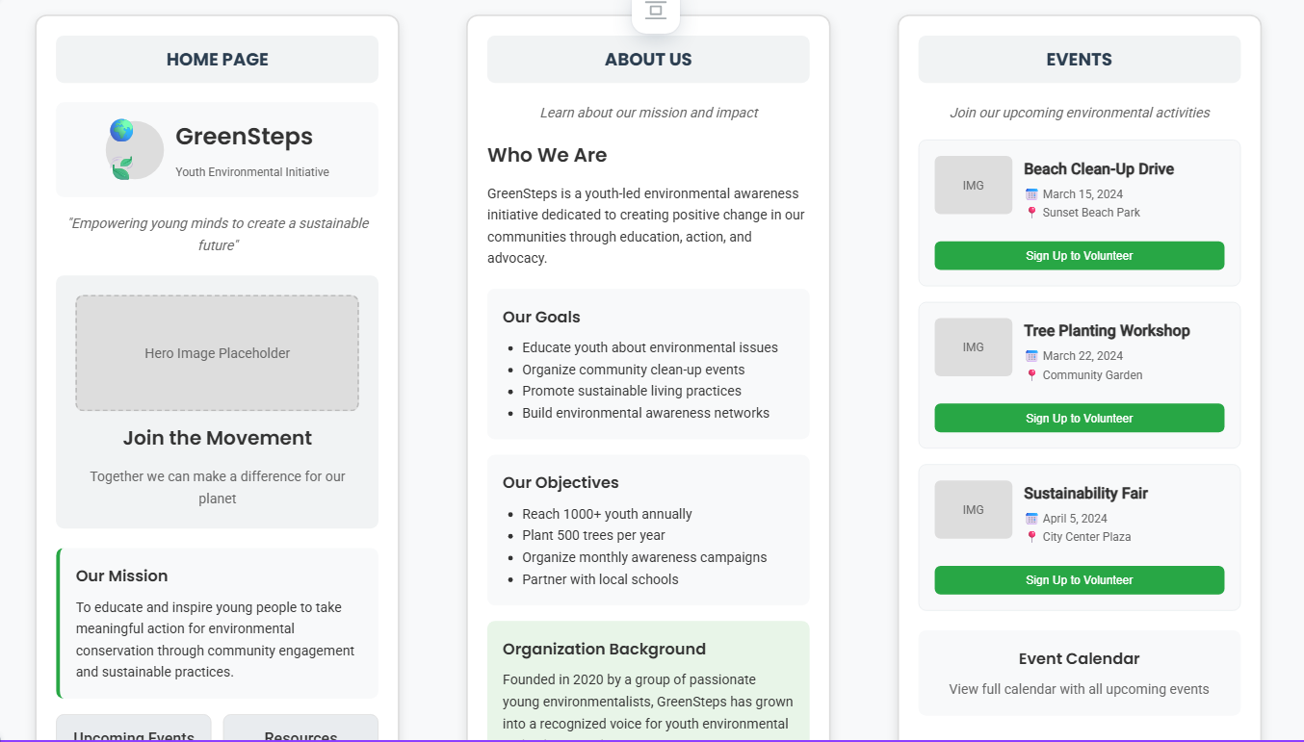

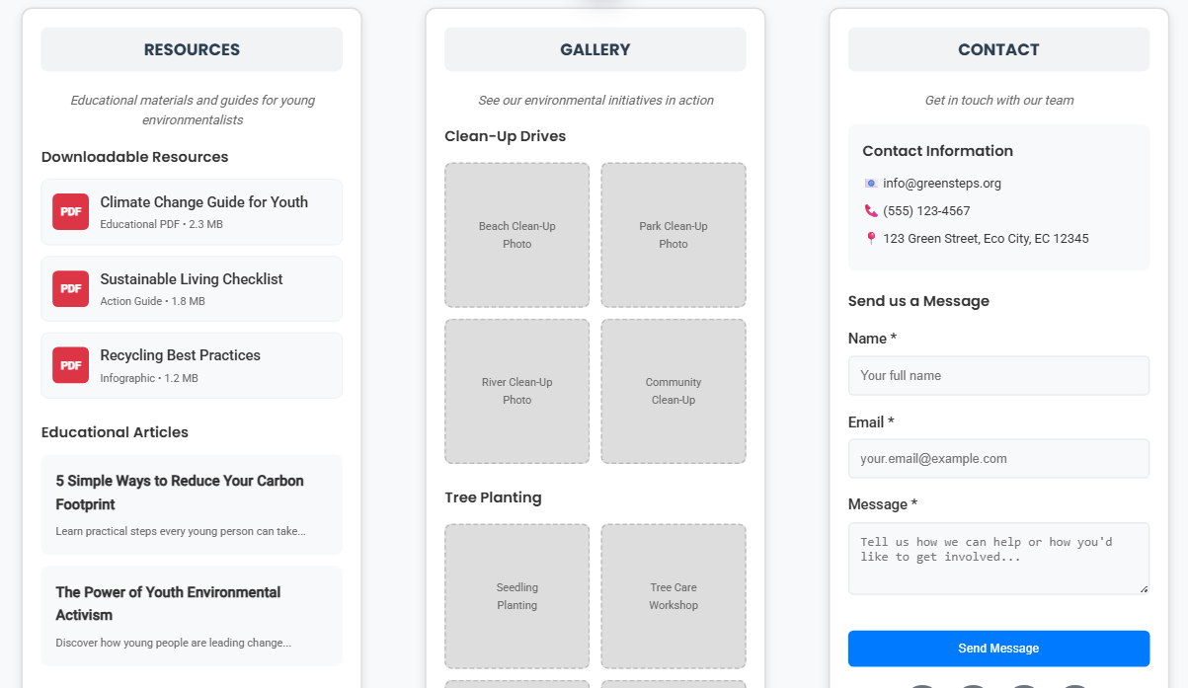

## **11.Assets**

**Assets:**

* Logo: Leaf and globe motif symbolising youth + environment.
* Colour palette: Green (growth), Blue (trust), White (clean environment).
* Typography: Poppins (headings), Roboto (body text).
* Icons: Eco-related vector icons.

## **12.Project Team Roles**

Project Manager – Oversees project execution, ensures deadlines are met, and coordinates between stakeholders.

Web Designer – Creates the visual design, layouts, and user interface elements.

Web Developer – Builds the website functionality (HTML, CSS, JavaScript, and CMS integration if required).

Content Creator – Prepares educational materials, event details, and blog content.

Volunteer Coordinator – Manages event listings, volunteer sign-ups, and feedback collection.

IT Support – Provides maintenance, security updates, and hosting support.

2. Project Phases

Planning & Research – Define objectives, collect content, identify technical requirements.

Design – Create sitemap, wireframes, and mockups for mobile and desktop.

Development – Build pages (Home, About, Events, Resources, Gallery, Contact) and implement forms.

Testing – Check responsiveness, usability, forms, and download functionality.

Launch – Deploy site, connect domain, enable SSL security.

Maintenance – Ongoing updates, event uploads, and bug fixes.

3. Deliverables

Sitemap and wireframes

Functional homepage with hero section and quick links

Events page with calendar and registration

Resources page with downloadable materials

Gallery with image uploads

Contact page with form and map integration

Final tested and launched website

4. Governance and Communication

Weekly progress check-ins with the team.

Monthly report to stakeholders on KPIs (visitors, event sign-ups, downloads).

Email and WhatsApp group for daily coordination.

## **13. Research and Content**

Research shows that youth involvement is critical to addressing environmental challenges. The United Nations (2023) emphasises that young people play a vital role in achieving the Sustainable Development Goals (SDGs), particularly Goal 13 (Climate Action) and Goal 15 (Life on Land). Non-profit organisations such as Greenpeace and WWF have successfully leveraged websites to engage youth by providing learning materials and promoting volunteer-driven projects.

For GreenSteps, the website will serve as a knowledge hub with easy-to-access educational resources, event details, and inspirational case studies. By combining visual storytelling with practical resources, the site will empower youth to participate in environmental activities.

**14. Expected Outcome**

The GreenSteps website will serve as a hub for youth environmental education and action. It will encourage awareness, increase volunteer engagement, and create measurable community impact while establishing the organization as a trusted resource for environmental initiatives.

## **References (IIE Harvard Style):**

* United Nations. (2023) *Youth and Environmental Sustainability*. Available at: <https://www.un.org> (Accessed: 27 August 2025).
* Greenpeace. (2025) *Youth Engagement and Climate Action*. Available at: https://www.greenpeace.org (Accessed: 27 August 2025).
* WWF. (2025) *Youth in Conservation*. Available at: https://www.wwf.org (Accessed: 27 August 2025).
* Nonprofit Source. (2024) *Global NGO Technology Report*. Available at: https://nonprofitsource.com (Accessed: 27 August 2025).
* United Nations. (2023) *Youth and Environmental Sustainability*. Available at: <https://www.un.org> (Accessed: 27 August 2025).
* Unsplash. (2025) *Free environmental images*. Available at: https://unsplash.com (Accessed: 27 August 2025).
* Behance. (2025) *NGO website design inspiration*. Available at: https://www.behance.net (Accessed: 27 August 2025).

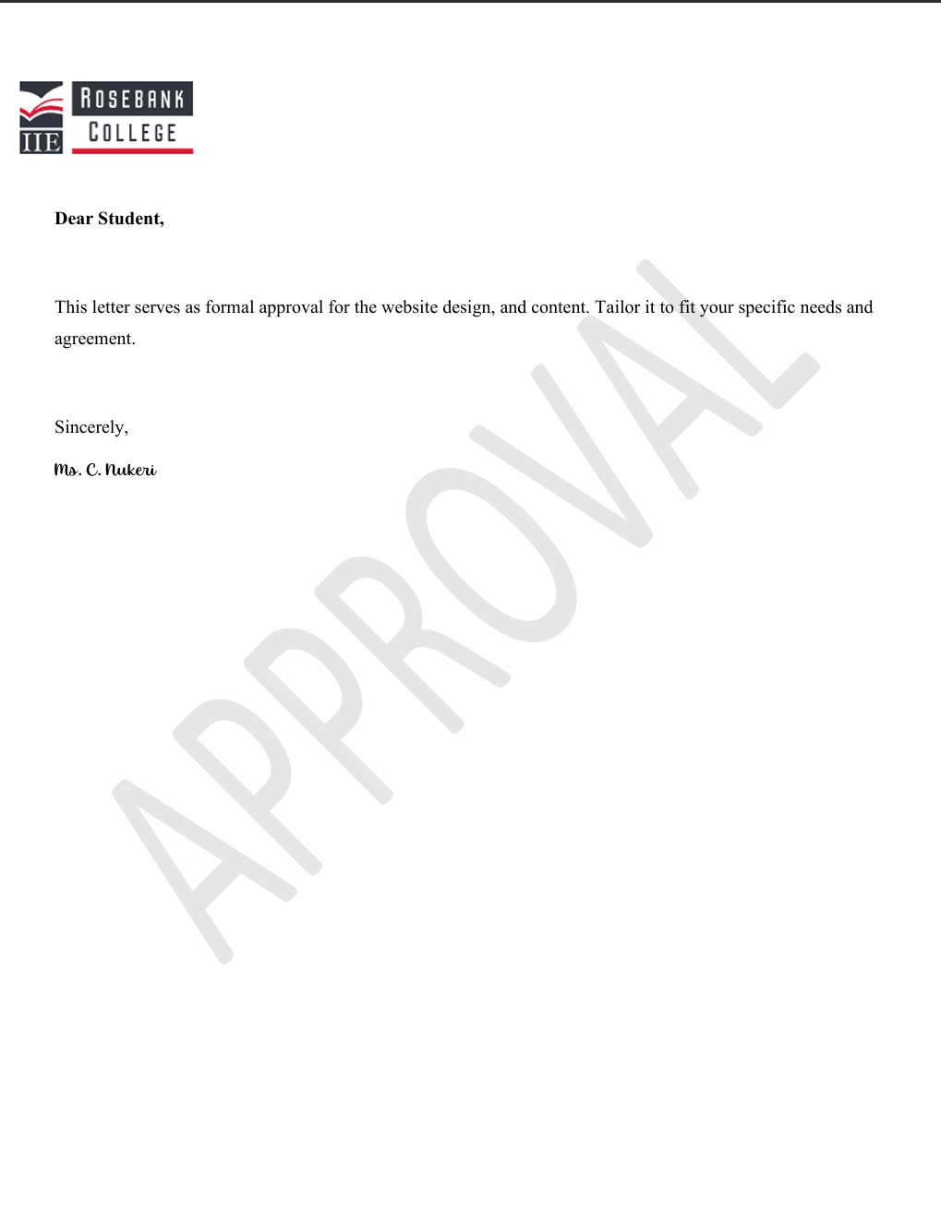

GitHub Link:

<https://github.com/tshepoc123/the-daily-grind>