COLLEGE OF SCIENCE AND TECHNOLOGY
ROYAL UNIVERSITY OF BHUTAN

Thimphu HomeFinder
  - Rental House Discovery and Viewing Management Platform

MINI PROJECT REPORT
Implementation and Continuous Integration and Delivery

Field | Details
Module | CTE412 Integrated Systems Technology
Submitted to | Manoj Chhetri
Submitted by | [Enter five member names and student numbers]
Project period | Weeks 8 to 14 in the module schedule
Submission date | [Enter submission date]

Implementation baseline: main branch, commit 86436b1. Deployment environment: Ubuntu ARM64 virtual machine running in VMware Fusion.

Executive summary
Thimphu HomeFinder is a rental discovery and viewing management application with an Angular frontend, an Express backend and a PostgreSQL database. The implemented system supports account access, landlord property management, property discovery, favourites, viewing workflows and administrative moderation. Its delivery process connects source changes to repeatable container deployments on an Ubuntu ARM64 virtual machine.
Continuous integration is implemented in verify.yml. Pull requests and pushes to the configured branches trigger backend checks, frontend tests, an Angular build and Docker build checks. After verification succeeds for a push to main, a separate publish job builds AMD64 and ARM64 images and uploads them to GitHub Container Registry (GHCR). Each release is identified by its Git commit SHA.
Continuous delivery is implemented in deploy.yml. An operator starts it manually on main after the matching images are available. A self-hosted GitHub Actions runner inside the VM pulls those images, starts PostgreSQL, applies database migrations, updates the API and web containers, and checks the application through Caddy. The frontend, backend and database all run in the VM; the database used by CI is a separate, temporary test service.
The reported deployment reached running web, API and database containers, and HTTP requests from the VM and the host Mac returned the Angular application. This demonstrates delivery to a local network environment. It does not establish public hosting, complete browser regression coverage, high availability or measured performance. The release process is manual continuous delivery rather than automatic deployment of every successful commit.

Report guide
1 Project purpose and implementation approach
2 Runtime architecture and application behaviour
3 CI and CD release flow
4 Verification workflow
5 Publishing versioned container images
6 Deployment workflow in the VM
7 Configuration and persistent data
8 Validation and troubleshooting
9 Findings and conclusion
References and demonstration procedure

1 Project purpose and implementation approach

1 1 Problem and implemented scope
Rental information shared through informal channels can be difficult to compare, maintain and follow up. HomeFinder provides a shared platform where seekers discover properties and manage viewing requests, landlords maintain their listings and respond to requests, and administrators oversee accounts and reported content. The application integrates these interactions with persistent data and role-based access checks.
Role | Implemented responsibilities
Seeker | Browse and compare properties; maintain favourites; request and manage viewings.
Landlord | Create and edit listings, manage property images and handle viewing requests.
Administrator | Review reported content and manage account status through administrative workflows.

1 2 How the project was carried out
Development proceeded through feature branches and pull-request integration. Authentication, landlord management, administrator screens, viewings and community features were implemented in separate changes before being connected through the frontend. Shared API documentation, database migrations and integration checks supported this work. The repository history records these implementation and integration milestones.
The delivery work then packaged the application into Docker images, established verification and publishing in GitHub Actions, and added a deployment procedure. A local Ubuntu ARM64 server VM was selected as the demonstration target. The deployment workflow was adapted to execute inside that VM through a self-hosted runner, removing the need for the earlier external SSH deployment setup.
Repository milestone | Contribution
b09bf42 and c5183fc | Integrated viewings, favourites and moderation; connected frontend workflows.
a99ccd6 | Added property comparison.
69b523a | Normalized migration checksums across Windows and Linux.
13af295 and 86436b1 | Refined CI/CD and the VM deployment workflow.

This sequence reflects incremental implementation, integration, packaging and operational debugging. Source: repository history and implementation at revision 86436b1 [1].

2 Runtime architecture and application behaviour
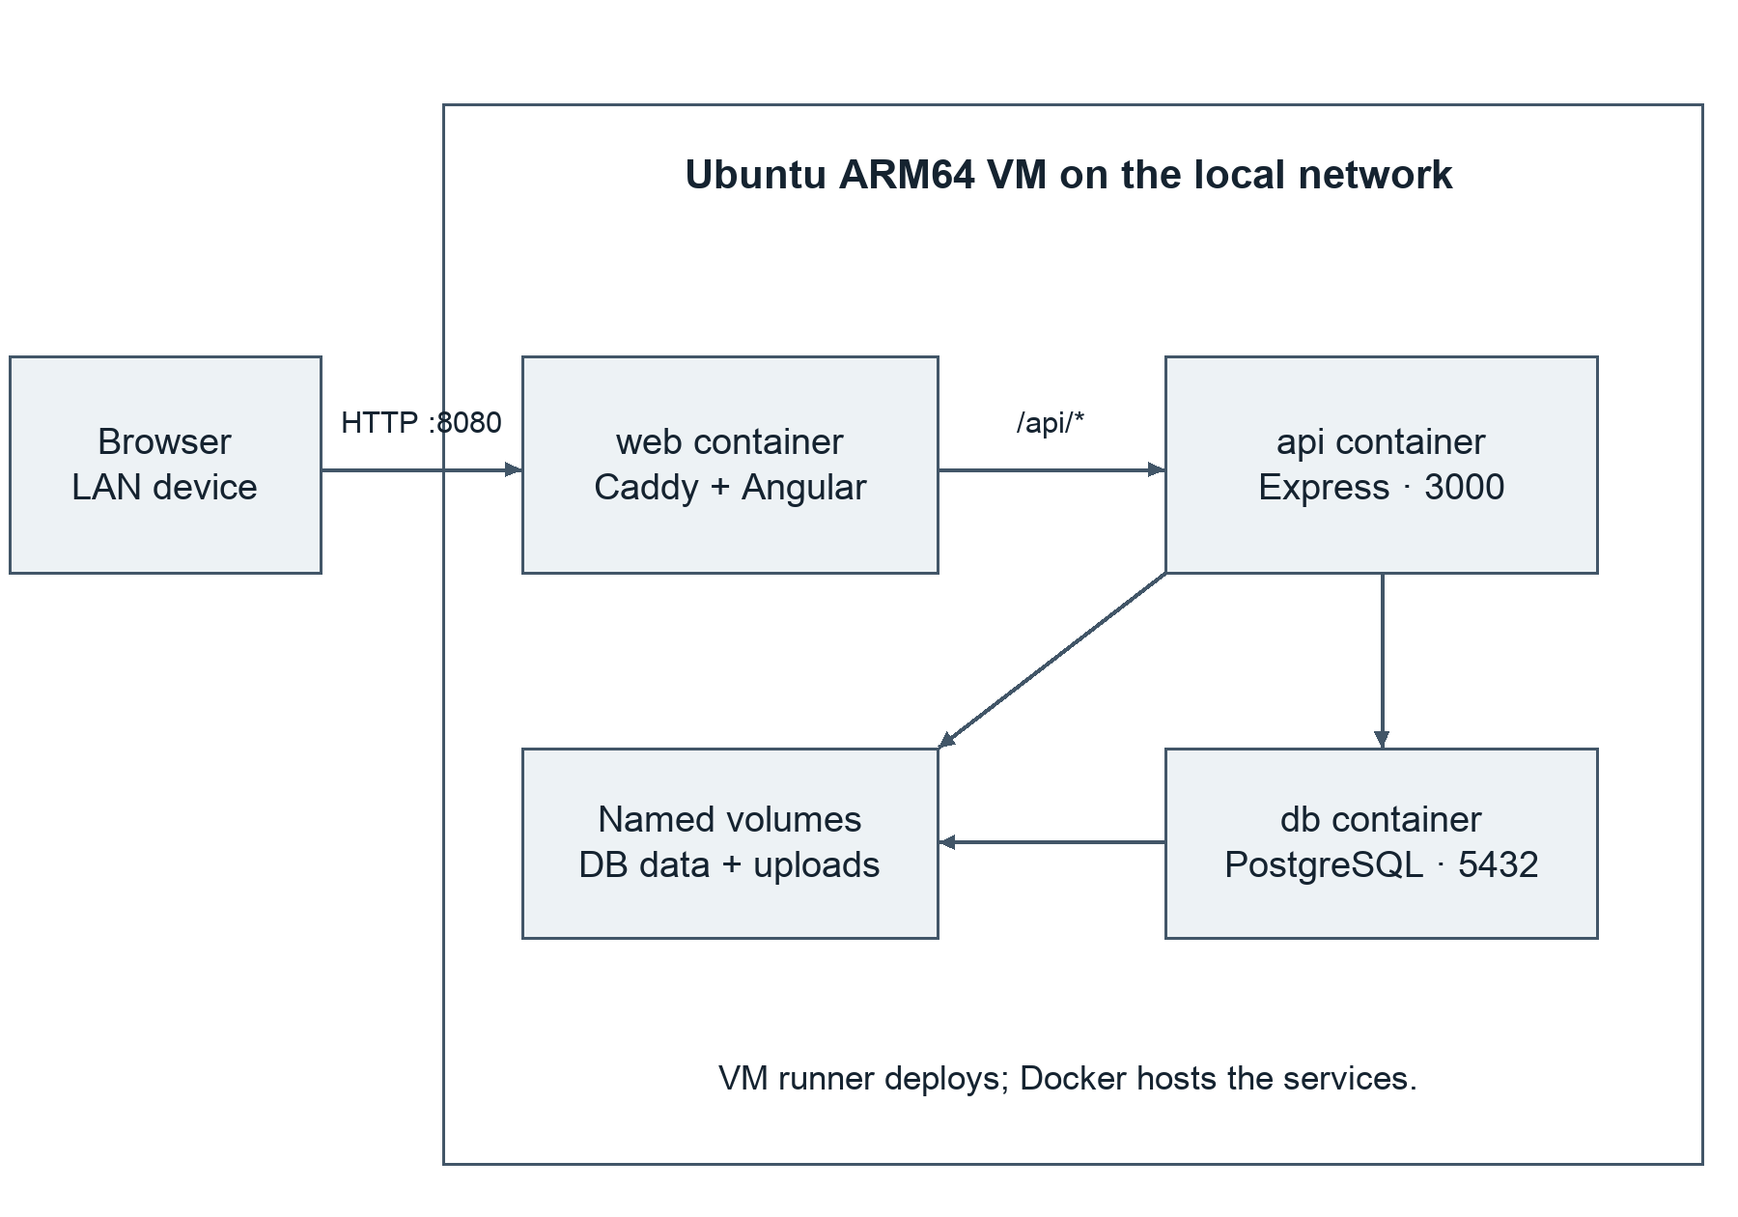
Figure 1. Runtime deployment in the VM. Source: compose.yaml and deployment/Caddyfile [1].
A browser connects to the VM on port 8080. The web container runs Caddy, which serves the compiled Angular files and forwards /api/* requests to the Express API on the private Docker network. Express accesses PostgreSQL using the service name db. API port 3000 and database port 5432 are not published directly to the local network in this Compose configuration.

2 1 Caddy and the request path
Caddy acts as both a static file server and a reverse proxy [5]. Its single browser-facing origin avoids requiring the frontend to know a separate backend address. The SPA fallback serves index.html for frontend routes. In the VM demonstration, CADDY_SITE=http://:80 selects HTTP inside the container; mapping port 8443 does not itself enable a working HTTPS site.

2 2 Authentication and data integrity
The backend stores sessions in PostgreSQL and hashes passwords with bcrypt. Session cookies are HttpOnly and use SameSite=Lax; Secure cookies are enabled in production mode. Server-side middleware checks authentication, active account status and role permissions, while services enforce ownership. Input validation and parameterized SQL support safe data handling. These checks remain necessary even when a frontend screen hides unauthorized controls.
Versioned SQL migrations establish accounts, properties, images, account status history, viewings, favourites, reports and later notification features. The readiness endpoint queries the migration state, so readiness depends on database access and the expected schema rather than only on a running Node process.

3 CI and CD release flow
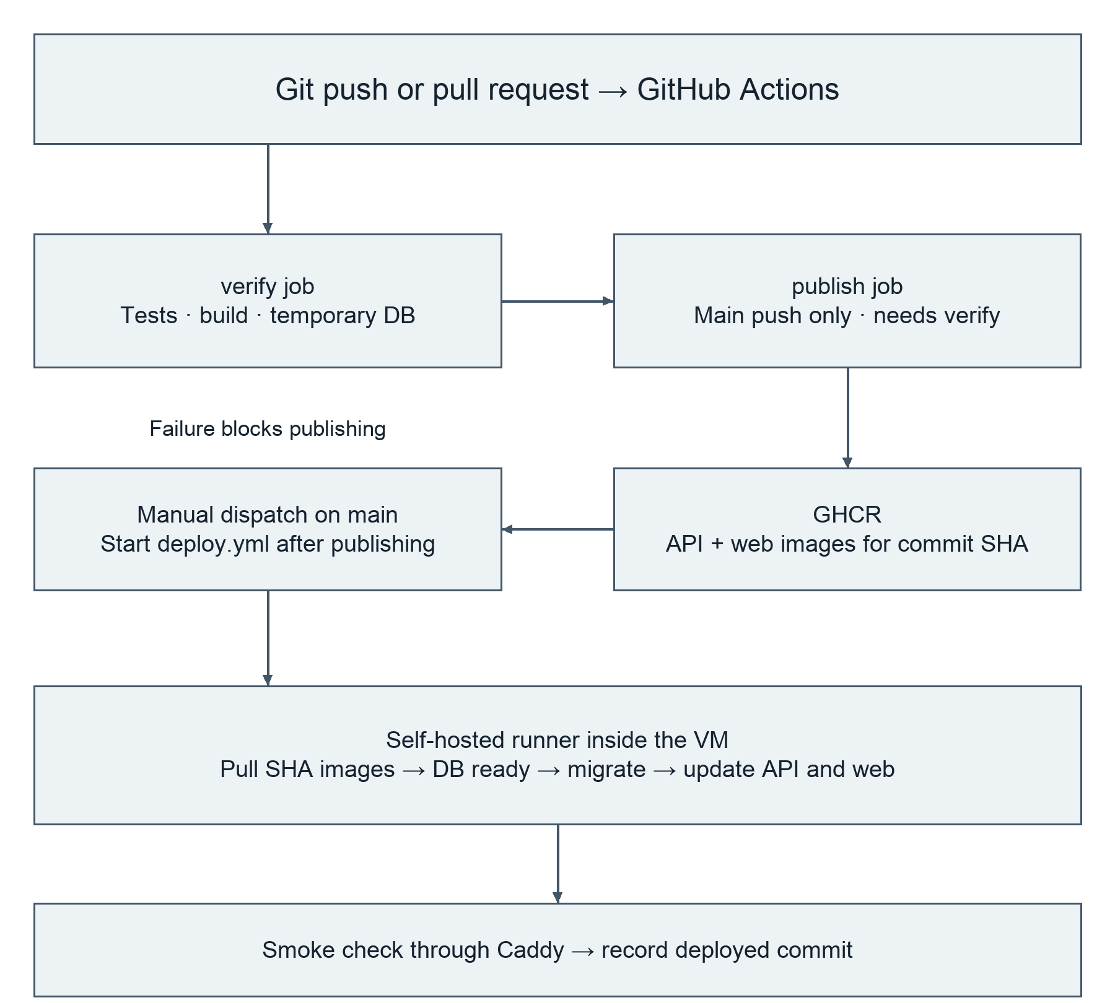
Figure 2. From a source change to a VM deployment. Source: verify.yml and deploy.yml [1].
CI provides repeatable feedback before a change is released. Publishing turns a verified source revision into deployable images. CD then installs the selected revision in the demonstration environment. These are separate stages: a successful GHCR upload stores images but does not update the running application.
The operator must wait for both verify and publish to succeed for the selected main commit before manually running deploy.yml. The two workflow files are not connected by a cross-workflow needs dependency. Deployment derives its tag from its own GITHUB_SHA; if the corresponding images have not been published, the pull step fails.
The VM runner must be online and able to use Docker when deployment starts. Once services are running, Docker keeps them running independently of whether the Actions runner is currently accepting jobs. The VM itself must remain powered on for other devices to reach the application.

4 Verification workflow

4 1 Triggers and the test environment
Code 1. Trigger and job excerpt from .github/workflows/verify.yml.
on:
pull_request:
push:
branches: [main, master]

jobs:
verify:
runs-on: ubuntu-latest
timeout-minutes: 20

Verification runs on a GitHub-hosted Ubuntu runner, not on the persistent deployment VM. It creates a PostgreSQL 17 Alpine service with a database named homefinder_test and waits for pg_isready. TEST_DATABASE_URL points the backend tests at that temporary service. The CI-only database credentials are not the VM database credentials, and CI does not operate on the demonstration database.

4 2 What is checked
Stage | Purpose and boundary
Install dependencies | npm ci uses the backend and frontend lockfiles; Node.js 24 is configured.
Backend checks | Linting, OpenAPI document validation and backend tests. API contract validation does not call the live VM.
Frontend checks | Run tests without watch mode and produce a production Angular build.
Docker checks | Build the backend and frontend images to catch packaging failures before publishing.

Code 2. Verification commands from verify.yml; comments identify working directories.
# Backend working directory
npm run lint && npm run check:api && npm test

# Frontend working directory
npm test -- --watch=false && npm run build

Backend test files cover areas including authentication, authorization, properties, images, viewings, community features, migrations and operations. The existence of these tests defines the automated scope; a particular run’s logs establish its outcome. A failed required step fails verification and prevents the dependent publish job from running. No measured coverage percentage or current test count is claimed here.

5 Publishing versioned container images

5 1 The publish gate
Code 3. Publishing gate from .github/workflows/verify.yml.
publish:
needs: verify
if: github.event_name == 'push' && github.ref == 'refs/heads/main'
runs-on: ubuntu-latest
permissions:
contents: read
packages: write

Pull requests are checked but do not publish release images. Pushes to master also run verification, while publishing is restricted to main. The publish job authenticates to GHCR with GITHUB_TOKEN and grants package-write access only for this job. The repository namespace is converted to lowercase for the image paths.

5 2 Why the images support two architectures
The deployment VM uses ARM64, while typical GitHub-hosted Ubuntu build runners use AMD64. QEMU and Docker Buildx enable publishing images for linux/amd64 and linux/arm64 [3]. Docker selects the matching platform when the VM pulls the image. This provides architecture compatibility, but the workflow does not run the entire test suite independently on both architectures.
Code 4. Backend build-and-push inputs; the web image follows the same tag scheme.
platforms: linux/amd64,linux/arm64
push: true
tags: |
${{ steps.image.outputs.prefix }}-api:sha-${{ github.sha }}
${{ steps.image.outputs.prefix }}-api:latest

The API image contains the Node backend and migrations. The web image uses a multi-stage build: Node builds Angular, then Caddy serves the compiled output. PostgreSQL is obtained from the upstream postgres:17-alpine image; this project does not build a custom database image.

5 3 Traceability and reproducibility
The sha-<commit> tag links the deployed application to a source revision. latest is a moving convenience tag, while deploy.yml uses the SHA-based tag. Publishing rebuilds the images from the verified source in a separate job; it does not promote the exact local Docker image built by verify. Lockfiles improve repeatability, but floating base-image tags and tag-based deployment are weaker guarantees than pinned image digests.

6 Deployment workflow in the VM

6 1 Trigger and execution location
Code 5. Selected deployment settings from .github/workflows/deploy.yml.
on:
workflow_dispatch:

# Under jobs.deploy
if: github.ref == 'refs/heads/main'
runs-on: [self-hosted, linux, ARM64, home-finder-deploy]
environment: production-vm

workflow_dispatch makes deployment an operator action [2]. The runner labels select the Ubuntu ARM64 VM. The production-vm environment name groups the deployment in GitHub; it does not automatically set NODE_ENV, configure HTTPS or make the VM public. The runner executes the commands, while Docker hosts the application services.
The job checks Docker access, Compose availability and the presence of $HOME/house-rental/.env for the runner user. It logs into GHCR with read permissions using an isolated temporary Docker configuration. It copies the Compose files into the persistent deployment directory and sets IMAGE_BASE and IMAGE_TAG=sha-${GITHUB_SHA}. Configuration validation and image pulling happen before the service update.

6 2 Ordered deployment and migration
Code 6. Deployment commands from deploy.yml.
"${compose[@]}" up -d --no-build --wait --wait-timeout 180 db
"${compose[@]}" run --rm --no-deps migrate
"${compose[@]}" up -d --no-build --no-deps --wait --wait-timeout 180 api web
"${compose[@]}" ps

The compose array includes the project name, .env and both Compose files. First, PostgreSQL must become healthy. Next, the one-off migrate service applies pending schema changes using the backend image. Finally, API and web services are started or recreated from the pulled images, with no build on the VM. Migration checksums detect changed migration files, and a database advisory lock coordinates migration execution.
set -euo pipefail stops the shell step on errors. Workflow concurrency prevents overlapping active deployments to this target. A failed migration prevents the later application update, but a failed deployment does not automatically roll back the database or containers. This is a single-VM deployment, without a guaranteed zero-downtime rollout.

7 Configuration and persistent data

7 1 The demonstration configuration
Code 7. Non-secret VM demonstration settings; replace the IP if the VM address changes.
NODE_ENV=development
APP_ORIGIN=http://172.20.10.3:8080
CADDY_SITE=http://:80
BIND_HOST=0.0.0.0
HTTP_PORT=8080
HTTPS_PORT=8443

APP_ORIGIN is the browser-facing origin, including scheme and port. The backend compares Origin or Referer on state-changing requests against this value. BIND_HOST=0.0.0.0 publishes the web port on the VM interfaces; 127.0.0.1 would restrict it to the VM loopback interface. CADDY_SITE describes Caddy’s listener and is not the address of a deployment server.
The .env also requires separate strong POSTGRES_PASSWORD and SESSION_SECRET values. These remain outside the checkout and must not be committed or pasted into the report. After changing environment settings, the relevant containers must be recreated through the deployment process so they receive the new values. Changing the VM’s IP requires checking APP_ORIGIN and the URL used by clients.

7 2 Where application data lives
PostgreSQL runs in the db container inside the same VM as the web and API containers. Its database files live in a Docker named volume mounted at /var/lib/postgresql/data. Uploaded property images use another named volume mounted in the API container. Caddy also has data and configuration volumes. These volumes survive normal container replacement [4].
The deployment does not erase and recreate the database on every release. The migration service updates the existing schema while the persistent volume retains records. Removing a container is different from deleting its volume: docker compose down -v can delete named volumes, and loss of the VM disk can also destroy the data. Volume persistence is not a backup strategy.

7 3 Access from another device
A device on a network that can route to the VM can use http://172.20.10.3:8080 while that remains its address. Actual reachability also depends on VMware networking, host and guest firewalls, and local network isolation. This private address is not a public Internet deployment. The laptop and VM must stay running during the demonstration.

8 Validation and troubleshooting

8 1 Checks after deployment
The deployment smoke check runs Node inside the API container and makes requests through the web service. It requires HTTP 200 from http://web/ and an <app-root marker in the HTML, then HTTP 200 from http://web/api/v1/ready. Requests have five-second timeouts, and the check retries up to ten times. This validates the Caddy path, served Angular entry page and database-backed API readiness.
The check does not execute Angular in a browser, log in, create a property or confirm access from another device. Those interactions require browser or end-to-end verification in addition to service readiness. The workflow summary records the deployed commit and image tags for comparison with the publish run.
Evidence | Result and interpretation
Operator reported successful CD run | The configured workflow completed in the VM; retain the Actions run link with submission evidence.
docker ps output supplied | Web, API and PostgreSQL were running; API and database reported healthy.
curl from VM and host Mac | HTTP 200 and Angular entry HTML were returned, demonstrating host-to-VM HTTP reachability.
Browser issue follow-up | Access was reported working after settings changes; the exact successful browser change was not recorded.

8 2 Issues encountered and lessons
Issue | Diagnosis or corrective action
Missing DEPLOY_HOST | The earlier SSH approach lacked a remote target. The current workflow instead executes on the VM runner.
Docker socket permission denied | The runner account needed Docker access; runner processes must receive the updated permissions.
Web bound to 127.0.0.1 | External devices could not use the VM address. BIND_HOST was changed to 0.0.0.0 and the web container recreated.
VM IP changed | Client URL and APP_ORIGIN needed to follow the new address.
Action not permitted message | Root cause was not confirmed. Inspect response status, session, active account, role and request origin before choosing a fix.

9 Findings and conclusion

9 1 What the project demonstrates
HomeFinder demonstrates a delivery chain that includes integration checks, container packaging, a registry and a repeatable deployment target. Branch-based development and pull-request integration connect application work to automated feedback. SHA-based image tags make it possible to relate a running application to its source revision. Multi-platform publishing allows the same release process to support the ARM64 VM used for the demonstration.
The main operational lesson is that deployment includes more than starting a frontend container. A release must also account for database readiness, schema compatibility, persistent uploads, session configuration and the network path used by the browser. Caddy provides a common entry point, while Compose records how the services and volumes fit together.

9 2 Limits of the current implementation
The system runs on one local VM and shares that machine’s power, storage and network availability. It is suitable for a controlled CI/CD demonstration, but public hosting and production availability have not been established. The demonstrated configuration uses HTTP and development cookie settings. A public release would require an appropriate domain, TLS and matching production application settings.
The workflows provide useful correctness checks, but they do not include a complete browser-based user journey, automated image vulnerability scanning, verified backup restoration, an automatic rollback or a measured performance test. No numerical coverage, response-time or availability claim follows from the reported successful deployment.
The database is persistent, so application rollback requires attention to schema compatibility. Redeploying an older API image alone may be unsafe after an incompatible migration. Backup and restore practice, deliberate migration design and a documented recovery procedure are important next improvements.

9 3 Recommended next improvements
Add an end-to-end test that signs in, creates a landlord property, confirms it is listed and exercises a viewing request. Add automated backup scheduling with a tested restoration procedure. Record release evidence, including the Actions run, commit, image digest, migration result and browser demonstration. For hosting beyond the local network, establish a stable server address and HTTPS before changing the deployment’s exposure.

9 4 Conclusion
The project has moved from a proposed design to an implemented application with automated verification, multi-platform image publication and manual delivery to a VM. The frontend, backend and PostgreSQL database run together in that VM, with persistent data kept outside replaceable containers. The result demonstrates CI/CD without requiring public hosting: changes are checked, packaged, selected and deployed through a documented release process.

References
[1] Thimphu HomeFinder repository. Main revision 86436b19bb2d289abc0988f554151acac0004035. Primary implementation sources: .github/workflows/verify.yml; .github/workflows/deploy.yml; compose.yaml; deployment/compose.prod.yaml; deployment/Caddyfile; backend and frontend source, tests and Dockerfiles. https://github.com/tsherabs/House_Rental_Project/tree/86436b19bb2d289abc0988f554151acac0004035
[2] GitHub Docs. Manually running a workflow. https://docs.github.com/en/actions/how-tos/manage-workflow-runs/manually-run-a-workflow
[3] Docker Docs. Multi-platform image with GitHub Actions. https://docs.docker.com/build/ci/github-actions/multi-platform/
[4] Docker Docs. Volumes. https://docs.docker.com/engine/storage/volumes/
[5] Caddy Documentation. reverse_proxy. https://caddyserver.com/docs/caddyfile/directives/reverse_proxy
[6] College of Science and Technology, Royal University of Bhutan. CTE412 Integrated Systems Technology module descriptor. Course document supplied for the project.

Appendix A Demonstration procedure
1. Start the VM and its self-hosted runner. Confirm Docker is accessible to the runner account and that the persistent deployment .env contains the current VM origin and required secrets.
2. Make a small visible application change through the repository workflow. Show the verification result, then the successful publish job for the merged main commit. Record its full commit SHA.
3. Run deploy.yml manually on that main revision. Show the image pull, migration, service update and Caddy smoke-check steps. Confirm the summary identifies the expected commit.
4. Open the current VM URL from the host or another reachable device. Show the visible change, sign in, and demonstrate a property or viewing operation. Existing data should remain available after ordinary redeployment.
Code 8. Read-only demonstration checks; use the current VM IP.
cd "$HOME/house-rental"
docker ps
curl -I http://172.20.10.3:8080/
curl http://172.20.10.3:8080/api/v1/ready

Capture the Actions run URL, commit SHA, container image tags and browser result as submission evidence. Avoid including passwords, session cookies or the secret values from .env in screenshots.

