

Distribution Prime
Standard Operating Procedure
Visual Summary Guide

Version 1.2 | Effective June 16, 2026
Application: https://distribution-prime.pages.dev
Professional distribution management for bottlers and distributor networks
Isolated workspaces · Orders · Targets · Shipping · Reports

1. Purpose
This Visual Summary SOP explains how to operate Distribution Prime end-to-end: creating a company workspace, configuring master data, running the order approval and dispatch workflow, and using reports and stock tools. It is intended for platform operators, workspace admins, shipping staff, and distributors.
Each organization (workspace) has its own isolated data. Users always sign in with a Workspace ID so they only see their company's distributors, orders, targets, and reports.

2. Scope
In scope | Out of scope
Workspace sign-up and branding | Supabase / server administration
Admin, Shipping, Distributor dashboards | Custom software development
Orders, targets, rates, schemes, GST | Unless you are a platform operator: /platform console internals
Inventory, physical stock, stock lifting
Reports, activity log, team invites
Gmail for order approval emails

3. System overview — multi-tenant architecture
Distribution Prime uses one shared database. Every table row (orders, distributors, targets, etc.) includes an organization_id. Supabase Row Level Security (RLS) plus application filters prevent cross-company data access.
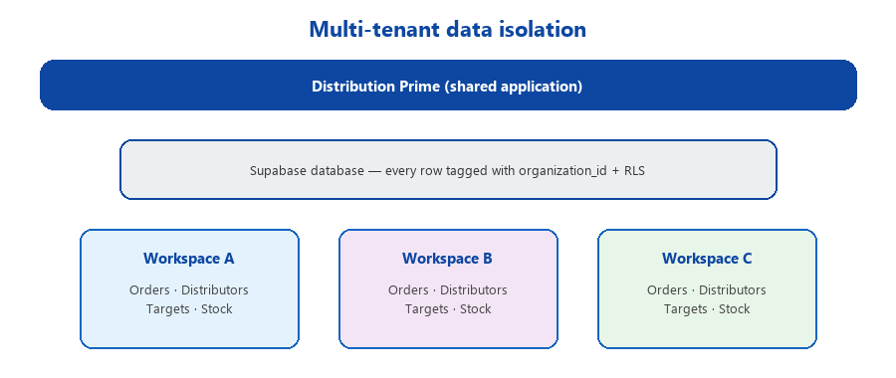
Figure 1 — Each workspace is logically separate inside one platform.

- Workspace ID: short login name (e.g. acme-beverages). Login URL: /w/{workspace-id}/login
- Admin & shipping sign in with email + password. Distributors sign in with code + password.
- Platform operator manages all workspaces at /platform and sets Gmail API credentials for all orgs.

4. User roles and dashboards
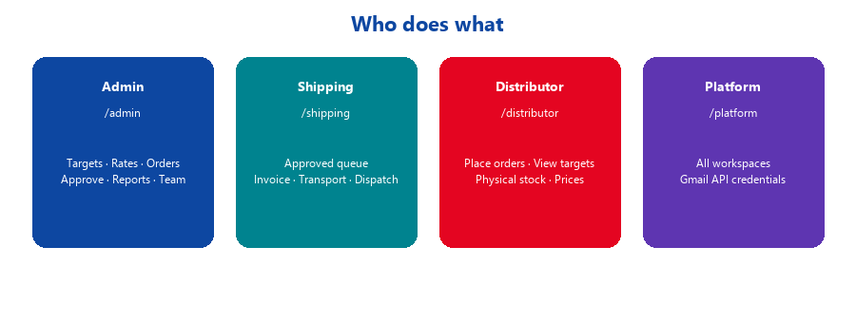
Figure 2 — Role-based dashboards and responsibilities.

Role | Sign-in credentials | Dashboard path | Key tasks
Admin | Workspace ID + email + password | /admin | Configure workspace, approve orders, manage rates/targets/team
Viewer | Same as admin | /admin | Read-only access to dashboards and reports
Shipping | Workspace ID + email + password | /shipping | Invoice upload, transport entry, dispatch
Distributor | Workspace ID + code + password | /distributor | Place orders, view targets/prices, physical stock
Platform admin | Email at /platform/login | /platform | Manage workspaces; configure Gmail API for all tenants

5. Initial setup — visual timeline
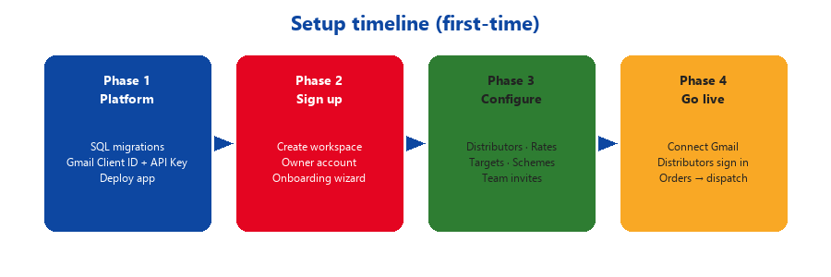
Figure 3 — Recommended setup sequence from platform to go-live.

5.1 Platform operator (once per environment)
- Deploy app with REACT_APP_SUPABASE_URL and REACT_APP_SUPABASE_ANON_KEY.
- Run SQL migrations: tenant RLS, workspace signup RPC, platform admin, platform Gmail credentials.
- Sign in at /platform/login.
- Platform console → Gmail → save Google OAuth Client ID and API Key (copied to every workspace).

5.2 Organization owner — create workspace
- Open /signup → enter company name, workspace ID, owner email, password (min. 8 chars).
- Optional: invoice letterhead (address, post no., GST) in collapsible section.
- Complete onboarding wizard → Authorize Gmail (connect once per browser/device).
- Share branded login link: https://distribution-prime.pages.dev/w/{workspace-id}/login

5.3 Admin — configure workspace
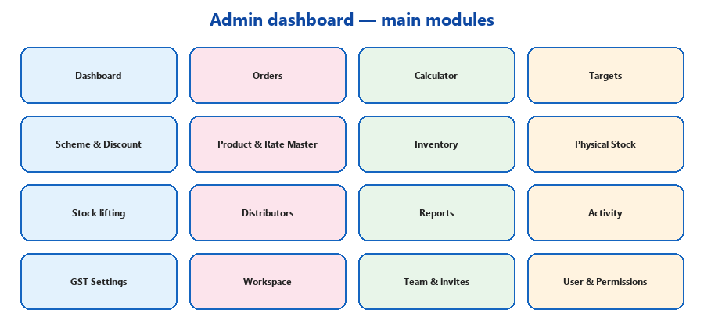
Figure 4 — Admin sidebar modules (configuration and operations).

- Workspace — company name, address, GST, theme color, login URL.
- Distributors — add codes, regions, passwords; import bulk if needed.
- Product & Rate Master — SKUs, CSD/Water/CAN categories, rates, UC divisor.
- Targets — set global target period; enter PC and UC targets per distributor.
- Scheme & Discount — free cases or % discount by SKU/category and date range.
- Team & invites — invite admin, viewer, shipping; User & Permissions for roles.

6. Order lifecycle
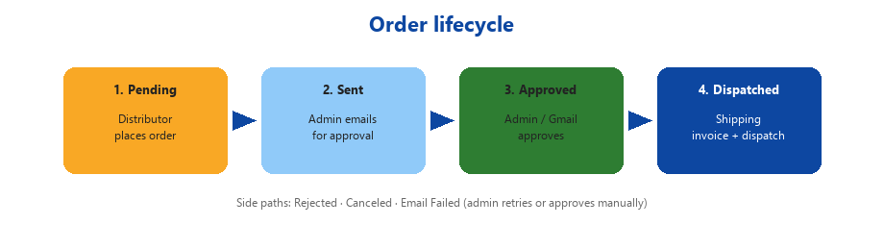
Figure 5 — Standard order path from placement to dispatch.

Step | Status | Who | Action
1 | Pending | Distributor → Admin | Distributor submits order; appears in Admin Orders queue
2 | Sent / Email Failed | Admin | Send approval email via Gmail; retry if failed
3 | Approved / Rejected | Admin / GM | Approve manually or via Gmail reply keywords
4 | Dispatched | Shipping | Upload invoice, transport details, click Dispatch
— | Canceled | Distributor | Cancel while Pending or Sent only

On Dispatch: distributor target achievement (PC/UC) updates automatically and stock lifting records are created. Distributor can download the shipping invoice from their Orders view.

7. Daily operating procedures

7.1 Admin — morning checklist
Step | Module | Action
1 | Dashboard | Review regional/distributor performance vs targets
2 | Orders | Process Pending and Sent tabs — view, email, approve, reject
3 | Physical Stock | Review new distributor stock submissions (badge indicator)
4 | Stock lifting / Reports | Export or review dispatched sales data
5 | Activity | Check audit log for errors or unusual actions
6 | Gmail chip (app bar) | Ensure Gmail shows connected before sending order emails

7.2 Distributor — order day
Step | Screen | Action
1 | Home | Check target balance (CSD/Water PC & UC) and days remaining
2 | Place Order | Select products, enter cases; schemes apply automatically
3 | Orders | Confirm new order shows as Pending
4 | Stock | Submit physical stock by SKU and MFG date if required
5 | Prices | Reference read-only rate list from Rate Master

7.3 Shipping — dispatch day
Step | Requirement | Details
1 | Order status | Must be Approved
2 | Invoice | Upload shipping invoice (PDF/image)
3 | Transport | Transporter, vehicle type, vehicle number, charges
4 | Dispatch | Click Dispatch → status Dispatched; achievement updates

8. Gmail integration (optional)
Layer | Who configures | What it does
API credentials | Platform operator | Client ID + API Key saved in Platform console → applies to all workspaces
OAuth connection | Each workspace admin | Authorize Gmail once per browser — sends order emails from admin's Gmail
Status indicator | Admin app bar | Shows Gmail connected / not configured / connect prompt
Auto-approval | System (optional) | Reads Gmail replies for approve/reject keywords after Send Email

- Google Cloud: add app URL to Authorized JavaScript origins.
- Testing mode: add admin emails as Test users in OAuth consent screen.
- Allow browser popups when clicking Authorize Gmail.

9. Key terms
Term | Definition
PC (Physical Case) | Case count by product category; CAN products excluded from PC totals
UC (Unit Case) | Normalized volume: (cases × UC multiplier) ÷ UC divisor — used for targets
CSD / Water / CAN | Product categories in Rate Master
Stock lifting | Sales volume recorded automatically when shipping dispatches an order
Physical stock | Distributor-reported on-hand inventory by SKU and MFG date
Workspace | Isolated company tenant; all data scoped by organization_id
Dispatched | Final shipment status in UI (stored as delivered in database)

10. Troubleshooting
Symptom | Likely cause | Fix
Signup fails — email exists | Email already in Supabase Auth | Sign in instead or use new email
No access to workspace | Wrong workspace ID or no admin row | Use correct workspace ID; re-signup or invite
Gmail not configured | Platform Gmail not saved | Platform console → Gmail → save credentials
Gmail popup timeout | Popups blocked | Allow popups for site; retry Authorize Gmail
Google unverified app | OAuth app not verified / not test user | Add test users or submit Google verification
Cannot dispatch | Missing invoice or transport | Complete all shipping fields on Approved order
Distributor login fails | Wrong code or password | Admin resets in Distributors dialog

11. Security and data handling
- Never share passwords between users. Distributors use codes; staff use email accounts.
- Sign out on shared computers (admin/shipping). Distributor sessions may persist if Remember me is used.
- Workspace data isolation enforced by organization_id + Supabase RLS.
- Gmail OAuth tokens stored in browser localStorage on connected devices only.
- Platform operators can access all workspaces for support — restrict platform admin accounts.

12. Document control
Version | Date | Changes
1.0 | March 2025 | Initial SOP
1.1 | June 2025 | Summary SOP with platform Gmail and multi-tenant notes
1.2 | June 2026 | Visual summary with logo, diagrams, expanded role/setup/order sections



Distribution Prime — Visual Summary SOP
Support: codewynbuild@gmail.com
Privacy: https://distribution-prime.pages.dev/legal/privacy-policy

