**Department of Cottage and Small Industry**

* **Application for change of cottage & small-scale industry license.**

**Electronic Government to Citizen Service Delivery System- Upgradation**

Version 1.0

**Submitted By:**



**NGN Technologies Ltd.**

Software Requirement Specification Document



|  |  |  |
| --- | --- | --- |
| **DOCUMENT RELEASE NOTICE** | | |
| **Document Title** | **:** | **Electronic Government to Citizen Service Delivery System- Upgradation** |
| **Release (Number)** | : | 1.0 |
| **Date of Release** | : |  |
| **Department** | : | Dept. of Cottage and Small Scale Industry |
| **Process Owner(s)** | : | Mr. Muna Mukhia |
| **Author(s) / Date** | : | Tshewang Tenzin |
| **Reviewer(s) / Date** | : | Mr. Sonam Chedup |
| **Approved by / Date** | : |  |

|  |  |  |  |
| --- | --- | --- | --- |
| Document Acceptance | | | |
| **Process Owner** | **Designation** | **Agency** | **Sign Off** |
| Mr. Muna Mukhia | Head | Dept. of Cottage and Small Scale Industry |  |

Table of Contents

1 Introduction 4

1.1 Purpose 4

1.2 Scope 4

1.3 Glossary 5

1.4 References 5

2 Service Specification 6

2.1.1 Application for cottage & small scale industry license 6

2.1.2 Application for Renewal/Duplicate/Cancellation of cottage & small scale industry license 8

2.1.3 Application for Change of cottage & small scale industry license 10

Use Case# 2.2.1: Submission of License Application 11

2.2.1.1 Description 11

2.2.1.2 Actor(s) 12

2.2.1.3 Detailed process flow 12

Use Case# 2.2.2: Application for Renewal/Duplicate/Cancellation of cottage & small scale industry license 26

2.2.2.1 Description 26

2.2.2.2 Actor(s) 26

2.2.1.3 Detailed process flow 26

# Introduction

The Department of Cottage and Small Scale Industry, Royal Government of Bhutan, hereby referred to as DCSI, intends to undertake upgradation of existing system built under the G2C phase II. The existing services automation was done in order to achieve an overall improvement in service delivery and other satisfaction for the citizens.

This document describes the detailed work flow structure of all services of DCSI and detailed process flow, Actors, envisaged benefits and screen captures from the indicative prototype. This document will serve as the main contention for developing the online service delivery framework for the said agency and will form the basis on which the actual system will be designed and implemented.

## 1.1 Purpose

This Software Requirement Specification provides the design details for the existing system and the TO-BE system. It will explain the AS-IS and TO-BE process of all services delivery work flow, features of the system and the interfaces of the system under DCSI. This document is intended for both the stakeholders and the developers of the system.

This will also serve as a reference document for the maintenance team who will be responsible for the maintenance of the system after the final release of the product.

## 1.2 Scope

This document contains the complete description and design for all services under DCSI. This assignment is to upgrade, design, develop and deploy web-based service delivery and processes includes:

* Submission of application by applicants.
* Verification of the application by Data Manager in Regional Office.
* Approval of application by Regional Director in RTIO.

## 1.3 Glossary

|  |  |
| --- | --- |
| SRS | Software Requirement Specification |
| G2C | Government to Citizen |
| ICT | Information Communication Technology |
| UAT | User Acceptance Test |
| DCSI | Department of Cottage and Small Industry |
| RTIO | Regional Trade and Industry Office |
| RD | Regional Director |
| CC | Community Centre |
| CID | Citizenship Identity Card |
| SCC | Security Clearance Certificate |

## 1.4 References

* Existing Software Requirement Specifications documents
* Brainstorming session held during the System study period
* Documents supplied by G2C and MoEA during the course of requirement study

# Service Specification

###### 2.1 Process Flow

### 2.1.1 Application for Change of cottage & small scale industry license

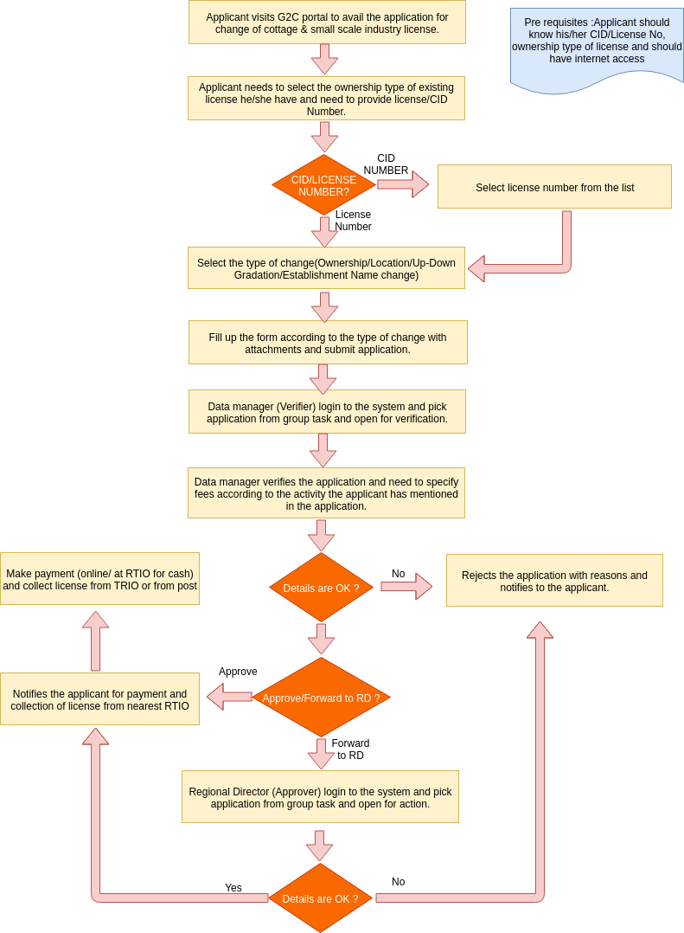

The process flow shown above depicts the AS-IS and TO-BE scenario of **Application for Change of Cottage and Small Scale Industry License**. It has mainly three use-cases that includes (i) Application submission for Change of License, (ii) Verification of application by Data Manager, RTIO, (iii) Approval of the same by RD.

Functionality wise there will be the following parts–

1. Apply for change of license- will be made open to public where applicant can apply without having to log-in to the system.
2. Check the status of application- is exposed to the Common G2C Service Gateway without any log-in i.e. accessible to all.
3. Verification of applications by Data Manager, RTIO- only accessed by Data Manager from RTIO internally after having login to the system.
4. Approve applications by RD- only accessed by Data Manager from RTIO internally after having login to the system.