
Bhutan Life Expectancy Report
Course: Data Science / Healthcare Analytics Project

Year: 2025
Group: 1

Table of Contents
1. Introduction 2
2. Dataset Description 2
3. Exploratory Data Analysis (EDA) 2
4. Feature Engineering 3
5. Machine Learning Modelling 3
6. Streamlit Web Application 4
7. Conclusion 5

1. Introduction
This report analyses life expectancy trends in Bhutan from 2000 to 2021 using World Health Organization (WHO) data. The project includes data cleaning, exploratory data analysis (EDA), feature engineering, machine learning modelling, and deployment using a Streamlit web application. The focus indicator is life expectancy at birth (years), disaggregated by sex.

2. Dataset Description
The dataset was sourced from the WHO / Humanitarian Data Exchange (HDX) Bhutan health indicators. From the broader set of indicators, the project filters specifically to the WHO indicator code WHOSIS_000001, corresponding to life expectancy at birth (years). The cleaned dataset contains yearly observations from 2000 to 2021 for Bhutan, split by three sex categories: Male, Female, and Both sexes.

3. Exploratory Data Analysis (EDA)
The EDA step examines how life expectancy has changed over time in Bhutan and how it differs between males and females. The first figure below shows life expectancy by sex from 2000 to 2021.
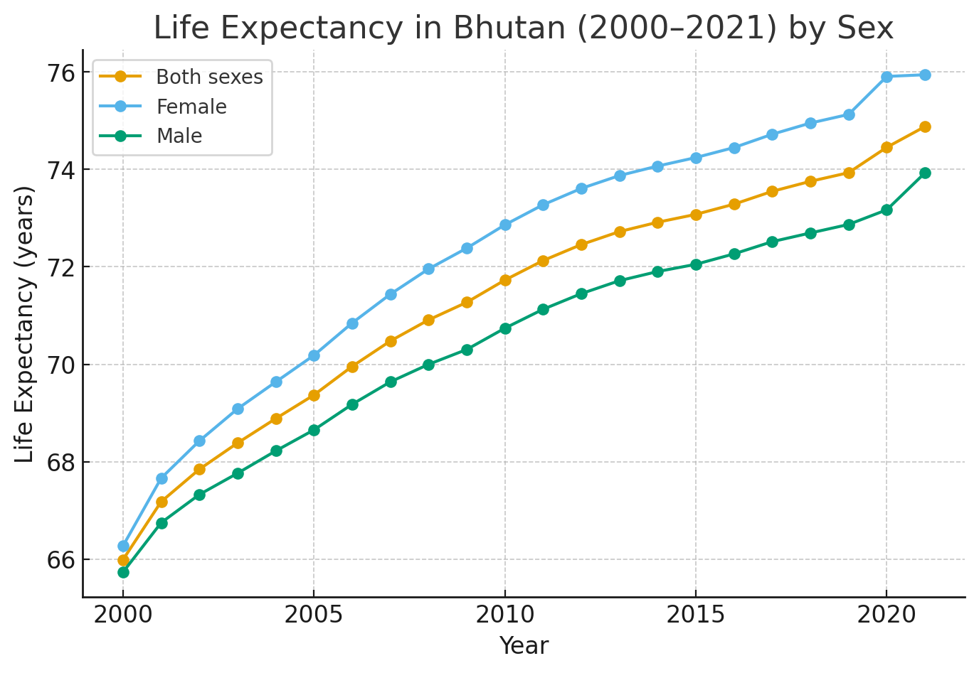
Figure 1: Life expectancy in Bhutan (2000–2021) by sex.
The second figure adds WHO confidence intervals (lower and upper bounds) around the estimates. This helps illustrate the uncertainty in the underlying estimates, although for Bhutan the intervals are relatively narrow, indicating reasonably precise measurements.
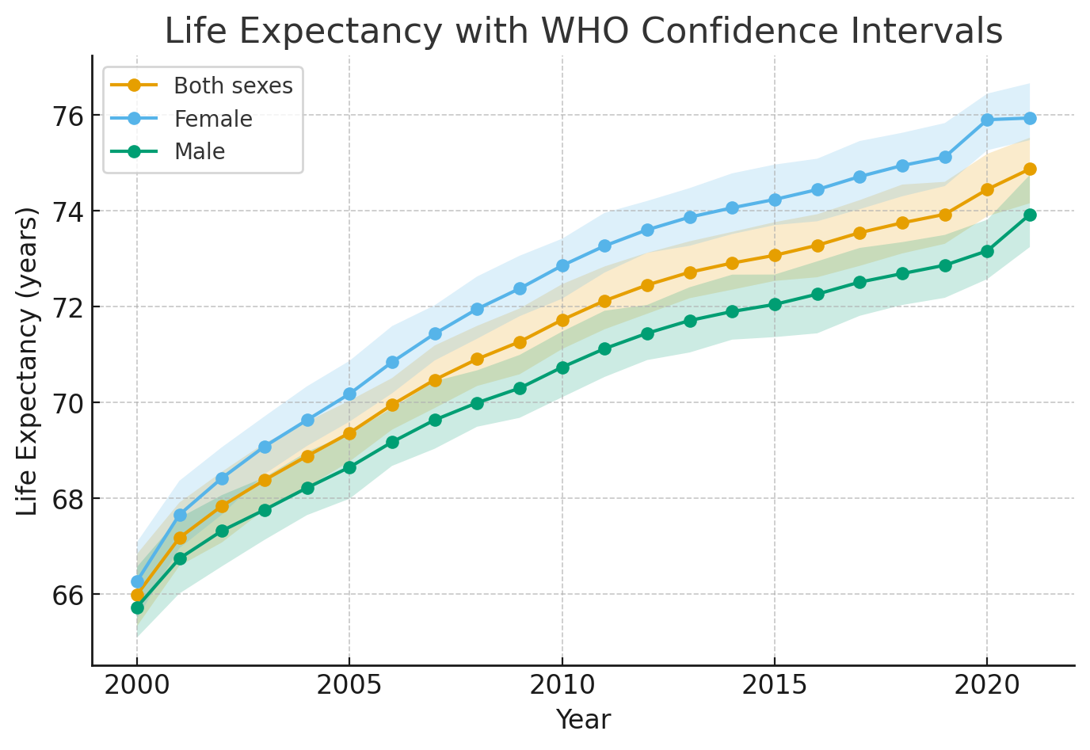
Figure 2: Life expectancy with WHO confidence intervals by sex.

4. Feature Engineering
To support machine learning modelling, several additional features were derived from the cleaned data. These include a time index (years_since_2000), binary indicators for sex (is_female, is_male), and the width of the confidence interval (ci_span). A three-year moving average of life expectancy was also computed to smooth short-term fluctuations. These engineered features help the model capture the underlying trend and sex differences more effectively.

5. Machine Learning Modelling
A RandomForestRegressor model was trained using the engineered features to predict life expectancy. The data was split into training and testing sets, and evaluation metrics such as Root Mean Squared Error (RMSE) and R-squared (R²) were computed. The model achieved an RMSE of approximately 0.126 years and an R² of about 0.997 on the test set, indicating that it explains almost all of the variation in life expectancy in the dataset and predicts within a fraction of a year on average.

6. Streamlit Web Application
To make the analysis accessible to non-technical users, a Streamlit web application was developed and deployed. The app allows users to load the default Bhutan life expectancy dataset or upload their own CSV files, run basic cleaning, explore summary statistics and trends, train simple machine learning models, and generate predictions interactively. The life expectancy analysis forms the main case study used in the app for this project.

7. Conclusion
The project demonstrates a complete end-to-end data science pipeline applied to Bhutan's life expectancy data. The analysis confirms a strong upward trend in life expectancy between 2000 and 2021, with females consistently living longer than males. The machine learning model accurately captures this trend, and the deployed Streamlit app provides an interactive interface for further exploration and demonstration.

