What does the following code fragment do to the queue q?

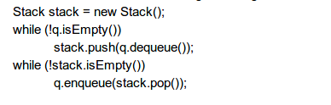

In the given code, when we implement the first two lines of code, we can push and store the elements in the stack from the queue.

But when we implement the next two lines of code, we will be able to pop the elements from the stack and store the elements in the queue in a **reverse order**.