

Reference Guide
The Open Distribution System Simulator™
(OpenDSS)

Roger C. Dugan
Sr. Technical Executive
Electric Power Research Institute, Inc.
March 2012

License
Copyright (c) 2008-2012, Electric Power Research Institute, Inc.
All rights reserved.

Redistribution and use in source and binary forms, with or without modification, are permitted provided that the following conditions are met:

Redistributions of source code must retain the above copyright notice, this list of conditions and the following disclaimer.
Redistributions in binary form must reproduce the above copyright notice, this list of conditions and the following disclaimer in the documentation and/or other materials provided with the distribution.
Neither the name of the Electric Power Research Institute, Inc., nor the names of its contributors may be used to endorse or promote products derived from this software without specific prior written permission.

THIS SOFTWARE IS PROVIDED BY Electric Power Research Institute, Inc., "AS IS" AND ANY EXPRESS OR IMPLIED WARRANTIES, INCLUDING, BUT NOT LIMITED TO, THE IMPLIED WARRANTIES OF MERCHANTABILITY AND FITNESS FOR A PARTICULAR PURPOSE ARE DISCLAIMED. IN NO EVENT SHALL Electric Power Research Institute, Inc., BE LIABLE FOR ANY DIRECT, INDIRECT, INCIDENTAL, SPECIAL, EXEMPLARY, OR CONSEQUENTIAL DAMAGES (INCLUDING, BUT NOT LIMITED TO, PROCUREMENT OF SUBSTITUTE GOODS OR SERVICES; LOSS OF USE, DATA, OR PROFITS; OR BUSINESS INTERRUPTION) HOWEVER CAUSED AND ON ANY THEORY OF LIABILITY, WHETHER IN CONTRACT, STRICT LIABILITY, OR TORT (INCLUDING NEGLIGENCE OR OTHERWISE) ARISING IN ANY WAY OUT OF THE USE OF THIS SOFTWARE, EVEN IF ADVISED OF THE POSSIBILITY OF SUCH DAMAGE.

Table of Contents
License 3
Summary 13
Brief History and Objectives of the DSS 15
Why Delphi? 17
Installation 19
Summary of Simulation Capabilities 21
Power Flow 21
Fault Studies 22
Harmonic Flow Analysis 23
Dynamics 23
Load Parametric Variation 24
Geomagnetically Induced Current (GIC) Analysis 24
Basic Usage 25
OpenDSS Control Panel 25
Export Menu Commands 27
Plot Menu Commands 29
Overall Circuit Model Concept 34
Bus and Terminal Models 35
Bus Definition 35
Terminal Definition 35
Bus Naming 36
Bus Instantiation and Life 36
Terminal References 37
Phases and other Conductors 37
Specifying Connections 38
Power Delivery Elements 40
Power Conversion Elements 41
Putting it All Together 43
DSS Command Language Syntax 45
Command Syntax 45
Parameters 46
Properties 46
Delimiters and Other Special Characters 47
Array Properties [and Quote Pairs] 47
Standard Ways to Define Array Properties 48
Enhanced Syntax 48
Special Reserved File Name 48
Matrix Properties 49
String Length 49
Default Values 49
In-line Math 50
RPN Expressions 50
RPN Examples 51
DSS Command Reference 53
Specifying Objects 53
Command Reference 54
(comment) and ! (inline comment) 54
? [Object Property Name] 54
About 54
AddMarker 54
AlignFile 54
AllocateLoads 54
BatchEdit 55
BuildY 55
BusCoords 55
CalcVoltageBases 55
Capacity 56
CD Directoryname 56
CktLosses 56
Clear 56
Close [Object] [Term] [Cond] 56
CloseDI 56
Comparecases 56
Compile or Redirect [fileName] 57
Currents 57
DI_plot 57
Disable [Object] 57
Distribute 57
DOScmd /c ...command string ... 58
Dump <Circuit Element> [Debug] 58
Edit [Object] [Edit String] 58
Enable [Object] 58
Estimate 58
Export <Quantity> [Filename or switch] 59
Fileedit [filename] 60
Formedit [Class.Object] 60
Get [Opt1] [opt2] etc. 61
Guids 62
Help 62
Init 62
Interpolate {All | MeterName} 62
LatLongCoords 62
Losses 62
MakeBusList 62
MakePosSeq 62
More | M | ~ | [Edit String] 63
New [Object] [Edit String] 63
[Object Property Name] = value 64
NodeDiff 65
Obfuscate 65
Open [Object] [Term] [Cond] 65
PhaseLosses 65
Plot (options …) 65
Powers 68
Pstcalc 68
Reconductor Line1=name1 Line2=name2 {Linecode= | Geometry=} 68
Redirect [filename] 69
Reduce {All | MeterName} 69
Rephase 69
ReprocessBuses 70
Reset {Meters | Monitors } 70
Rotate angle=degrees 70
Sample 70
Save 70
Select [elementname] [terminal] 71
SeqCurrents 71
SeqPowers 71
SeqVoltages 71
Set [option1=value1] [option2=value2] (Options) 71
SetkVBase [bus=…] [kvll=..] 71
Show <Quantity> 72
Solve [ see set command options …] 73
Summary 74
Totals 74
UpdateStorage 74
Variable 74
Varnames 74
VarValues 74
Vdiff 74
Visualize 74
Voltages 75
YearlyCurves 75
Ysc 75
Zsc 75
Zsc10 76
ZscRefresh 76
Options Reference 77
%growth = 77
%mean = 77
%Normal = 77
%stddev = 77
Addtype = 77
Algorithm = 77
AllocationFactors = 77
AllowDuplicates = 78
AutoBusList = 78
Basefrequency = 78
Bus = 78
capkVAR = 78
casename = 78
Cfactors= 78
circuit = 78
CktModel = 78
Class = 79
ControlMode = 79
Datapath = 79
DefaultBaseFrequency= 79
DefaultDaily = 79
DefaultYearly = 79
DemandInterval = 80
DIVerbose = 80
EarthModel = 80
Editor= 80
Element = 80
Emergvmaxpu = 80
Emergvminpu = 80
Frequency = 80
Genkw = 80
GenMult = 80
Genpf = 81
h = 81
Harmonics = 81
Hour= 81
KeepList = 81
LDcurve = 81
LoadModel= 81
LoadMult = 81
Log = 82
LossRegs = 82
LossWeight = 82
Markercode = 82
Markswitches = 82
Marktransformers = 82
Maxcontroliter = 83
Maxiter = 83
Mode= 83
Mode=Snap: 83
Mode=Daily: 83
Mode=Direct: 83
Mode=Dutycycle: 83
Mode=Dynamics: 83
Mode=FaultStudy: 83
Mode=Harmonics: 83
Mode=Yearly: 84
Mode=LD1 84
Mode=LD2 84
Mode=M1 84
Mode=M2 85
Mode=M3 85
Mode=MF 85
Mode=Peakdays: 85
Nodewidth = 85
Normvmaxpu = 85
Normvminpu = 85
NumAllocIterations = 85
Number= 86
Object (or Name)= 86
Overloadreport = 86
PriceCurve = 86
PriceSignal = 86
Random= 86
Recorder = 86
ReduceOption = 86
Sec = 87
ShowExport= 87
Stepsize (or h)= 87
Switchmarkercode = 87
Terminal = 87
Time= 87
tolerance= 87
TraceControl = 87
TransMarkerCode = 87
TransMarkerSize = 88
Trapezoidal = 88
Type= 88
Ueregs = 88
Ueweight= 88
Voltagebases= 88
Voltexceptionreport= 89
Year= 89
ZoneLock = 89
General OpenDSS Object Property Descriptions 90
LineCode 90
LineGeometry 92
Line Constants Examples 93
LoadShape 93
GrowthShape 95
TCC_Curve 96
WireData 97
Source and Other Objects 99
Vsource Object 99
Isource Object 101
Fault Object 102
Power Delivery Elements (PDelement) 104
Capacitor Object 104
Line Object 106
Reactor Object 109
Transformer Object 111
GICTransformer Object 113
Generator Step-Up Banks 113
Three-Winding Transformers 114
Autotransformers 116
Power Conversion Elements (PCelement) 119
GICLine Object 119
Load Object 122
Generator Object 125
Control Elements 130
CapControl Object 130
RegControl Object 132
Meter Elements 135
EnergyMeter Object 135
Registers 135
Meter Zones 136
.Zones on Meshed Networks 137
Sampling 138
EEN and UE Definitions 139
EnergyMeter EEN and UE Registers 139
Registers 9 and 10: Overload EEN and UE 140
Properties 141
Monitor Object 143
Default Circuit 145
Examples 146
Example Circuit 1 146
DSS Circuit Description Script 146
Example Circuit 2 148
DSS Circuit Description Script 148
COM Interface Reference 150
Interfaces 150
Example MS Excel VBA Code for Driving the COM Interface 151
Declarations 151
Startup 151
Compiling the Circuit 151
Solving the Circuit 152
Bringing Results into the Spreadsheet 152
Example: Obtaining all Capacitor Names and Locations in Microsoft Excel VBA 156
Example: GIC Calculation 157
OpenDSS Script for Example System 159

Figures
Figure 1. OpenDSS Structure 14
Figure 2. OpenDSSEngine in the Windows Registry 19
Figure 3. GUID points to the In-Process Server File (OpenDSSEngine.DLL) 20
Figure 4. Example of the Control panel window for the DSS 26
Figure 5. Do command and speed buttons 26
Figure 6. Compiling a File containing a circuit description script from a script window in the control panel. 27
Figure 7: Color-shaded plot of harmonic resonance 31
Figure 8: Thickness-weighted plot of harmonic resonance 32
Figure 9. Voltage Profile Plot from IEEE 8500-Node Test Feeder 33
Figure 10: Electrical Circuit with Communications Network 34
Figure 11: Bus Definition 35
Figure 12: Terminal Definition 36
Figure 13: Power Delivery Element Definition 40
Figure 14: Power Conversion Element Definition 41
Figure 15. Compensation Current Model of PC Elements (one-line) 42
Figure 16. OpenDSS Solution Loop 43
Figure 17: Definition of Capacitor Object 104
Figure 18. Three-phase Model of a Generator Step-Up Transformer 113
Figure 19. GSU Model in OpenDSS 114
Figure 20. Three-phase Model of a Three-Winding Transformer (Grounded-Wye, Grounded-Wye, Delta) 115
Figure 21. Two-winding and Three-winding Transformer model in DSS 115
Figure 22 Three-phase Model of a Three-Winding Autotransformer 116
Figure 23. Two-winding and Three-winding Autotransformer model in DSS 117
Figure 24. GICLine Model 119
Figure 25. Substation Location Coordinates 120
Figure 26. Default Meter Zones for a Simple Network 138
Figure 27. Using Additional Meters to Control the Definition of Meter Zones 138
Figure 28. Default Circuit 145
Figure 29. OpenDSSEngine COM interface as seen with MS Excel VBA 154
Figure 30. VBA Object Browser listing of the OpenDSS Circuit Interface 155
Figure 31. One Line Diagram of Example GIC System 157
Table 1. GIC Example Substation Location and Grid Resistance 158
Table 2. GIC Example Transmission Line Data 158
Table 3. GIC Example Transformer Data 159

Summary
The Open Distribution System Simulator (OpenDSS, or simply, DSS) is a comprehensive electrical system simulation tool for electric utility distribution systems. OpenDSS refers to the open-source implementation of the DSS. It is implemented as both a stand-alone executable program and an in-process COM server DLL designed to be driven from a variety of existing software platforms. The executable version has a basic text-based user interface on the solution engine to assist users in developing scripts and viewing solutions.
The program basically supports all rms steady-state (i.e., frequency domain) analyses commonly performed for utility distribution systems. In addition, it supports many new types of analyses that are designed to meet future needs, many of which are being dictated by the deregulation of US utilities and the formation of distribution companies worldwide. Many of the features found in the program were originally intended to support distributed generation analysis needs. Other features support energy efficiency analysis of power delivery and harmonics analysis. The DSS is designed to be indefinitely expandable so that it can be easily modified to meet future needs.
The OpenDSS program has been used for:
- Distribution Planning and Analysis
- General Multi-phase AC Circuit Analysis
- Analysis of Distributed Generation Interconnections
- Annual Load and Generation Simulations
- Wind Plant Simulations
- Analysis of Unusual Transformer Configurations
- Harmonics and Interharmonics analysis
- Neutral-to-earth Voltage Simulations
- Development of IEEE Test feeder cases
- PV System Simulation
- Phase Shifter Simulation
- Arc Furnace Simulation
- And more ….

The program has several built-in solution modes, such as
- Snapshot Power Flow
- Daily Power Flow
- Yearly Power Flow
- Harmonics
- Dynamics
- Faultstudy
- And others …

Through the COM interface, the user is able to design and execute custom solution modes and features from an external program and perform the functions of the simulator, including definition of the model data. Thus, the DSS could be implemented entirely independently of any database or fixed text file circuit definition. For example, it can be driven entirely from a MS Office tool through VBA, or from any other 3rd party analysis program that can handle COM. Users commonly drive the OpenDSS with the familiar Mathworks MATLAB program, Python, C#, R, and other languages. This provides powerful external analytical capabilities as well as excellent graphics for displaying results.
Many users find the text scripting interface of the stand-alone executable version sufficient for nearly all their work. As users find themselves repeatedly needing a feature for their work, the feature is implemented within the solution and connected to the text-based command interface.
The COM interface also provides direct access to the text-based command interface. It also provides access to numerous methods and properties for accessing many of the properties of the simulator's models. Through the command interface, user-written programs can generate scripts to do several desired functions in sequence. The input may be redirected to a text file to accomplish the same effect as macros and also provide some database-like characteristics. Many of the results can be retrieved through the COM interface as well as from various output files. Output files are typically written in Comma-Separated Value (CSV) format that import easily into other tools for post-processing.
The experienced software developer has two additional options for using the OpenDSS tool:
- Downloading the source code and modifying it to suit special needs.
- Developing DLLs that plug into generic containers the OpenDSS provides [being revised!]. This allows developers to concentrate on the model of the device of interest while letting the DSS executive take care of all other aspects of the distribution system model. Such DLLs can be written in most common programming languages.
The DSS structure is illustrated in Figure 1
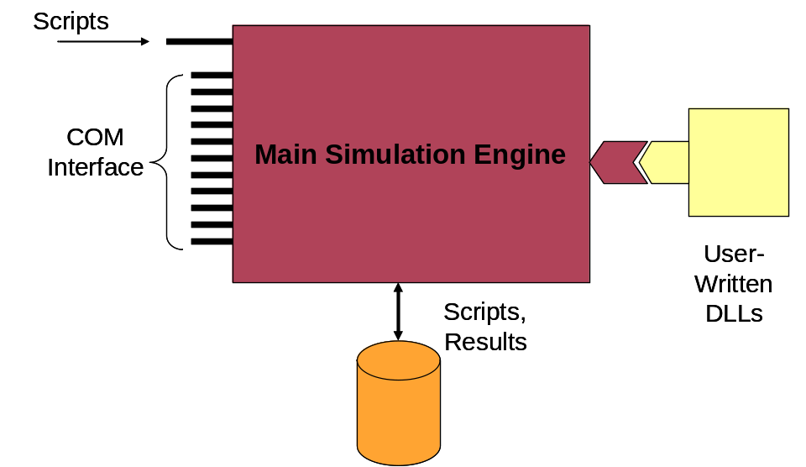
Figure 1. OpenDSS Structure

Brief History and Objectives of the DSS
Development of the DSS began in April 1997 at Electrotek Concepts, Inc. Roger Dugan was the principal author of the software supported shortly thereafter by Tom McDermott. The two comprised the development team until late 2001 when Tom left Electrotek. Roger continued maintaining and evolving the program alone until recently when Tom again became part of the development team through the OpenDSS project. The DSS had been acquired by EPRI Solutions in 2004, which was united with EPRI in 2007. In 2008, EPRI released the software under open source to cooperate with other grid modernization efforts active in the Smart Grid area.
There were two events that triggered the development of the DSS in 1997:
- EPRI had issued an RFP earlier for software to support the application of distributed generation to distribution systems. While Electrotek was not awarded a contract there had been enough thinking about the project to have arrived at a function spec for a simulator that would support the vast majority of electrical system analysis for evaluating DG for distribution planning purposes.
- Roger Dugan was serving as Chair of the IEEE PES Software Engineering Working Group and one of the hot topics at that time was object-oriented programming and data representations. The late Mark Enns of Electrocon had issued a challenge to the group for someone to implement some of the principles we had been discussing in a power system analysis program. The distribution system simulator concept seemed the perfect vehicle to experiment with some of those ideas and also provide a useful tool to support the needs of a consulting company.
Prior to 1997, Electrotek had been performing DG studies for distribution planning using conventional distribution system analysis methods that are still employed by many tools today. We were well aware of the limitations of these methods and wanted a tool that was more powerful and flexible. One issue we discovered early on is that no two DG planning studies were exactly alike and we were frequently having to adjust our models. Thus, we needed a tool that would not lock us in to particular types of analysis. Other issues we set out to address were:
- The distribution system model data we received from utilities came in all sorts of different formats, each with various strengths and various modeling limitations. One design goal was to develop an object-oriented circuit description language that minimized the conversion effort.
- Window-based programs can be very user friendly, but we noticed some of the distribution system analysis tools really limited what you can do by limiting the interaction to what is available on the dialog forms. By being fundamentally script-driven, the DSS program gets around much of the limited-dialog issue and allows the user to better adapt the analysis process to the problem at hand.
- The greater value of DG is often found on the subtransmission system serving a distribution planning area. Many distribution planning tools represent only the radial distribution system. Because of the methods employed by the economists we were working with at the time, we wanted a tool that would allow us to model several substations and the distribution circuits between them simultaneously. This is actually the concept of “distribution” used by much of the rest of the world outside North America.
- A key capability desired for the tool was to capture the time- and location- dependent value of DG. The location-dependent value is captured by modeling the DG in its actual location on the circuit. Capturing the time-dependent value requires extraordinary loadshape modeling capability.
- There are many instances where it becomes necessary to model elements with many phases – not just three. For example, power poles in North America with multiple circuits may have as many as 4 circuits sharing a common neutral. Also, we wanted to be able to model what happens when a 69 kV line falls into the 13.2 kV distribution line. Or to model a communications signal passing from one voltage level to another through the interwinding capacitance of the transformer – this was not possible with many traditional distribution system analysis tools.
- We wanted a tool that could seamlessly incorporate harmonics analysis into the power flow analysis without requiring the user to laboriously enter nonlinear device models. We also recognized that we would need at least simple dynamics analysis sufficient for DG interconnection evaluation. Simple dynamics models are presently built in to the program and this feature continues to be developed.
- Recognizing that distribution automation was going to become increasingly important, we wanted a testbed upon which to evaluate control algorithms and their impact on the operation of the system.
- Recognizing that it was impossible to satisfy all possible user needs, we wanted a program that would allow users to write their own models or solution procedures commensurate with their capabilities.
- We wanted a program that would simulate the behavior of devices on the distribution system as they would actually occur for changing load and system faults and other disturbances. This is important for modeling DG interactions and it also allows the tool to be used for many other things as well, such as energy efficiency analysis.
The present version of the OpenDSS has achieved the majority of these goals and has evolved into an extraordinary tool that has acquired many other features not commonly found in other distribution system analysis tools. While DG analysis continues to be one of its key uses, many other types of analysis have been performed with the tool.
The OpenDSS is a general-purpose frequency-domain simulation engine that has special features for creating models of electric power distribution systems and performing many types of analysis related to distribution planning and power quality. It does not perform electromagnetic transients (time domain) simulations; all types of analysis are currently in the frequency domain (i.e., sinusoidal steady state, but not limited to 60 Hz). It does perform electromechanical transients, or dynamics analysis.
Most electrical engineers learned how to write nodal admittance equations in their early University courses, and this is how the DSS represents circuits. Each element of the system is represented by a “primitive” nodal admittance (Y) matrix. This is generally straightforward, although it can be tricky for some power system elements such as transformers. Each primitive Y is then coalesced into one large system Y matrix, and the system of equations representing the distribution system is solved using sparse matrix solvers like one might also find in programs like MATLAB. One trick is that nonlinear behaviors of some devices (e.g., some load models) are modeled by current source injections, which some refer to as “compensation” currents. That is, the current predicted from the linear portion of the model that resides in the system Y matrix is compensated by an external injection to iteratively obtain the correct current. This is a common technique for representing loads in distribution system analysis tools. One advantage of this method is that it allows for quite flexible load models, which is important for performing some types of analysis such as done in energy efficiency studies.
The program’s heritage is closer to a harmonic flow analysis program, or even a dynamics program, than a typical power flow program. This may seem a strange place to start designing a tool that will be used mostly for power flow studies, but it gives the tool great modeling flexibility particularly for accommodating all sorts of load models and unusual circuit configurations. It is easier to make a harmonics program solve the power flow problem than the opposite.

Why Delphi?
The top structure of the OpenDSS that maintains the data definitions of the circuit elements is written in Object Pascal using the Delphi environment (originally from Borland, now from Embarcadero.com). The various linear solvers employed by the DSS over the years have been written in C and C++.
Since Pascal is seldom taught in engineering education any more, we are often asked why we used Delphi. At the time the DSS was started, the main developer, Roger Dugan, had been tinkering with the relatively new 32-bit versions of Delphi for a couple of years and wanted to try it on a large, hard-working engineering program that would not have the usual fixed problem size limitations of typical engineering programs of the time. A rapid development environment was needed because he was also doing engineering work and the DSS was mainly developed in spare time. Another reason stems from the desire to have a COM interface to allow easy access from other programs. Delphi provided an easy way to build these interfaces early on. The main alternative at the time would have been Visual Basic, but the performance of VB was not acceptable. Fortunately, when Tom McDermott joined Electrotek a few months later, he also knew Pascal and was able to contribute immediately to the development. Thus, the die was cast and the main part of the program has remained in Delphi as it has evolved.
While the choice of programming languages is largely one of personal preference, here are a few things that might be considered advantages with Delphi:
- The compiler is fast. A typical full build of the 60,000+ line program takes only about 10-15 seconds. Re-builds are even faster. This allows fast debug-and-test cycles.
- By default, the program is completely linked into one relatively compact EXE file and can be installed simply by copying the program to a desired disk location. This has made it convenient to distribute new versions to users. No complicated installs.
- The text processing speed for reading circuit scripts has exceeded expectations and has proven more than adequate for the task. Our previous experience with other engineering programs had led us to believe this was going to be a problem, but we were pleasantly surprised that it was not. You should find that the OpenDSS processes large circuit description scripts with relative ease. The math processing speed appears to be comparable to any compiled programming language.
- Writing COM interfaces and DLLs is a relatively easy task for a programmer.
- The structure of the Pascal language enforces a discipline that helps avoid the introduction of bugs. Most of the time, once you can get it to compile it will work. You should also find the code fairly readable. So if you are only interested in seeing how we did something, it should be easy to understand.
While we develop using the professional Delphi version, there are open source Pascal compilers available on the Web, such as Free Pascal/Lazarus, that we strive to maintain as much compatibility with as possible.

Installation
Note: This installation procedure does not apply to Version 8 and later; only the 32-bit Version 7.4.3, the last 32-bit only version. Installation of the OpenDSS program is one of the easiest you will encounter in programs today: Simply copy the program files to a folder of your choosing (such as C:\OpenDSS) and start the program.
The following are the key program files:
- OpenDSS.exe (Stand alone executable)
- OpenDSSEngine.DLL* (The COM DLL version)
- KLUSolve.DLL (Sparse matrix solver)
- DSSgraph.DLL (Support for DSS graphics output)
* The OpenDSSEngine.DLL will have to be registered if you intend to access it from other programs/languages such as MATLAB and VBA in MS Office. You can do this by issuing the following command to the DOS command prompt when in the folder you have placed the files:
Regsvr32 OpenDSSEngine.DLL

Note: You will need Administrator privileges on your computer to do this. This more evident on Windows 7 and Vista than Windows XP.
There is a .BAT file provided with the standard zip file to perform this action. Registration need only be done once. You may simply double-click on the .BAT file and it will execute the registration.
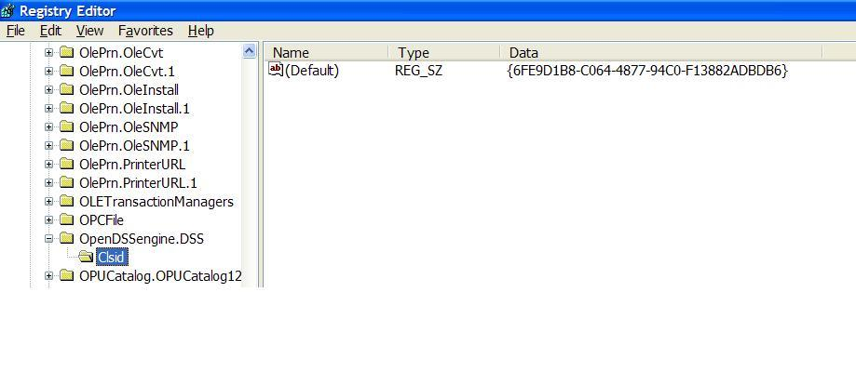
The Server shows up as “OpenDSSEngine.DSS” in the Windows Registry

GUID
Figure 2. OpenDSSEngine in the Windows Registry
On windows Vista and 7 you will have to execute the .BAT file from an elevated Admin status. One way to do this is go to All Programs > Accessories and right-click on the Command Prompt and select Run as Administrator. Then run the .BAT file.
After registration, if you start the Windows registry editor (Type ‘regedit’ in the command box on the start menu) you will find the OpenDSSEngine listed under Classes as shown in Figure 2. If you then look up the GUID in the registry, it should point to the OpenDSSEngine.DLL file in the folder where you installed it (Figure 3).
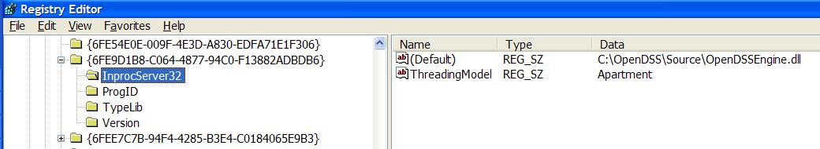
Figure 3. GUID points to the In-Process Server File (OpenDSSEngine.DLL)

The OpenDSSEngine will show up as “OpenDSS Engine” or “OpenDSSEngine.DSS” in the list of available object references in most development environments. For example, to instantiate an OpenDSSEngine object in MATLAB, you would issue the following statement:
%instantiate the DSS Object
Obj = actxserver('OpenDSSEngine.DSS');

Except for the two DLLs indicated, the program in its present form is completely self-contained. If you are solely interested in creating scripts and executing the program manually, you can simply start the EXE file and operate the DSS through the user interface provided. Most users use this mode most of the time. For convenience, you might drag a short cut to the desktop or some other convenient spot. You may also pin the EXE file to your start menu (right-click on the EXE file and look at your options).
Note that when the program is executed, it will create an “.ini” file in the folder in which you installed the program files. The purpose of this file is to remember the contents of the user control panel and some global settings. Thus, the program will start the next time with the same script window contents and defaults as left in the previous session.

Summary of Simulation Capabilities
The present version of the DSS is capable of performing the following analyses/simulations:

Power Flow
While the power flow problem is probably the most common problem solved with the program, the OpenDSS is not best characterized as a power flow program. Its heritage is from general-purpose power system harmonics analysis tools. Thus, it works differently than most existing power flow tools. This heritage also gives it some unique and powerful capabilities. The program was originally designed to perform nearly all aspects of distribution planning for distributed generation (DG), which includes harmonics analysis. It is relatively easy to make a harmonics analysis program solve a power flow, while it is quite difficult to make a power flow program perform harmonics analysis. To learn more about how the algorithm works for the power flow problem, see “Putting It All Together” below.
The OpenDSS is designed to perform a basic distribution-style power flow in which the bulk power system is the dominant source of energy. However, it differs from the traditional radial circuit solvers in that it solves networked (meshed) distribution systems as easily as radial systems. It is intended to be used for distribution companies that may also have transmission or subtransmission systems. Therefore, it can also be used to solve small- to medium-sized networks with a transmission-style power flow.
The circuit model employed can be either a full multi-phase model or a simplified positive-sequence model. The default is the full multi-phase model. For capacity studies, the latter is often sufficient and will execute faster. Due to the complex multi-phase models that may be created with myriad unbalances, the user may have to create positive-sequence models outside the DSS by defining a single-phase model of the circuit. However, the “MakePosSeq” command with attempt to convert a multi-phase model to at positive-sequence model. By setting the proper flag, all power reports for a positive-sequence equivalent will report 3-phase quantities.
The power flow executes in numerous solution modes including the standard single Snapshot mode, Daily mode, Dutycycle Mode, Monte Carlo mode, and several modes where the load varies as a function of time. (See the Help command for the "Mode" option for the up-to-date listing of solution modes). The time can be any arbitrary time period. Commonly, for planning purposes it will be a 24-hour day, a month, or a year. Users may also write external macros or programs to drive the load models in some other manner.
When a power flow is completed, the losses, voltages, flows, and other information are available for the total system, each component, and certain defined areas. For each instant in time, the losses are reported as kW losses, for example. Energy meter models may be used to integrate the power over a time interval,.
The power flow can be computed for both radial distribution (MV) circuits and network (meshed) systems. While the accuracy of some algorithms, such as the calculation of expected unserved energy, may depend on part of the circuit model being radial, the power flow solution is general. It works best on systems that have at least one stiff source.
The two basic power flow solution types are
- Iterative power flow
- Direct solution
For the iterative power flow, loads and distributed generators are treated as injection sources. In the Direct solution, they are included as admittances in the system admittance matrix, which is then solved directly without iterating. Either of these two types of solutions may be used for any of the several solution modes by setting the global LoadModel property to “Admittance” or “Powerflow” (can be abbreviated A or P). The default is “Powerflow”.
There are two iterative power flow algorithms currently employed:
- "Normal" current injection mode
- "Newton" mode.
The Normal mode is faster, but the Newton mode is somewhat more robust for circuits that are difficult to solve. The default is Normal. The Normal mode method is a simple fixed-point iterative method and works well for nearly all distribution systems with a stiff bulk power source. It is the preferred method for Yearly-mode simulations due to its speed.
Typically, power flow calculations will use an iterative solution with non-linear load models, and fault studies will use a direct solution with linear load models.

Fault Studies
The OpenDSS will perform fault (short-circuit) studies in several ways:
- A conventional fault study for all buses ("Set Mode=Faultstudy"), reporting currents and voltages on all phases for all types of faults: All-phase fault, SLG faults on each phase, L-L and L-L-G faults. Since transformers will be represented in actual winding configuration, this is an excellent circuit model debugging tool as well as a tool for setting relays and sizing fuses.
- A single snapshot fault. The user places one, or more, faults on the system at selected buses, defining the type of fault and the value of the fault resistance. A fault is a circuit element (a resistor network) just like any other element and can be manipulated the same way.
- Applying faults randomly. (Monte Carlo fault study mode -- solution mode= "MF"). User defines Fault objects at locations where faults are desired. This is useful for such analyses as examining what voltages are observed at a DG site for various faults on the utility system.

Harmonic Flow Analysis
The OpenDSS is a general-purpose frequency domain circuit solver. Therefore, harmonic flow analysis is quite natural and one of the easiest things to do with the program. The user defines various harmonic spectra to represent harmonic sources of interest. The spectra are connected to Load, Generator, voltage source (Vsource), and current source (Isource) objects as desired. More recently, PVSystem and Storage models contribute harmonics. There are reasonable default spectra for each of these elements.
A snapshot power flow is first performed to initialize the problem. The solution must converge before proceeding. If convergence is difficult to achieve, a direct solution is generally sufficient to initialize the harmonic solutoin. Harmonic sources are then initialized to appropriate magnitudes and phases angles to match the solution.
Once a power flow solution is achieved, the user simply issues the command:
Solve mode=harmonics

The OpenDSS then solves for each frequency presently defined in any of the circuit elements. Users may also specify which harmonics are to be computed. Monitors are placed around the circuit to capture the results.
Frequency sweeps are performed similarly. The user defines spectra containing values for the frequencies (expressed as harmonics of the fundamental) of interest and assigns them to appropriate voltage or current sources. These sources may be defined to perform the sweeps in three different ways:
- Positive Sequence: Phasors in 3-phase sources maintain a positive-sequence relationship at all frequencies. That is, all three voltages and currents are equal in magnitude and displaced by 120 degrees in normal ABC, or 123, rotation.
- Zero Sequence: All three voltages or currents are equal in magnitude and in phase.
- No sequence: Phasors are initialized with the power flow solution and are permitted to rotate independently with frequency. If they are in a positive sequence relationship at fundamental frequency, they will be in a negative sequence relationship at the 2nd harmonic, and a zero sequence relationship at the 3rd harmonic, etc. In between integer harmonics, the phasors will be somewhere in between.

Dynamics
The DSS can perform basic electromechanical transients, or dynamics, simulations. The original intent was to provide sufficient modeling capability to evaluate DG interconnections. The built-in Generator model has a simple single-mass model that is adequate for many DG studies for common distribution system fault conditions. In additional, users may implement more sophisticated models by writing a DLL for the Generator model or by controlling the Generator model from an external program containing a more detailed governor and/or exciter model.
An induction machine model was developed and used to help develop the IEEE Test Feeder benchmark dealing with large induction generation on distribution systems. This is called “IndMach01a.DLL” and is provided with the program. It can perform both power flow and dynamics simulations using a simple symmetrical component model internally.

Load Parametric Variation
The capabilities for doing parametric evaluation are provided for a variety of variables. Certain variables will be allowed to vary according to a function (e.g., load growth) or vary randomly for Monte Carlo and statistical studies. See the Set Mode command documentation for descriptions of the Monte Carlo solution modes.

Geomagnetically Induced Current (GIC) Analysis
OpenDSS is capable of performing geomagnetically induced current (GIC) analysis of power systems. Currently, the analysis capability is limited to three-phase systems, and cannot be integrated into other types of simulations, e.g. load flow. The GIC analysis takes advantage of the N-phase modeling capability of OpenDSS to perform the analysis on a three-phase basis as opposed to a single-phase basis.
GIC are quasi-dc; thus, GIC simulations involve performing a low frequency analysis of the resulting dc network. The driving force behind the flow of GIC in the network is the induced voltage in the transmission lines. The induced voltage is generated by the coupling of the transmission lines with the induced geoelectric field at the surface of the earth. Specialized quasi-dc models, which are described in other sections of the manual, have been added to the program circuit element models for transmission lines, transformers, substation ground grids, and GIC blocking devices.
Once the dc model of the network has been constructed the following two OpenDSS commands are used to perform the analysis:
Set frequency=0.1
Solve

The solution frequency is set to 0.1 Hz and then a standard OpenDSS snapshot solution is performed. The sources in the problem at this frequency are the voltages induced along the lines. These sources are contained in the GICLine model. Transformers are modeled by special transformer models using the GICTransformer element.

Basic Usage

OpenDSS Control Panel
There is a multiple-window "Control Panel" for constructing and testing scripts, but the main access to scripts and results is generally through script files and output files or the COM interface.
Communication to the DSS is fundamentally accomplished through text strings passed to the DSS command processor. However, if you are driving the DLL version from another program, there are many functions provided in the COM interface to directly execute common commands (like "solve") and set properties of circuit elements without going through the command language. That might be a little faster for some operations, although the DSS command processor’s text parsing is often more than fast enough for most applications.
Simulation results can be returned as arrays of values in the COM interface or in text through CSV files. Only a few standard text file reports will be provided by the base DSS software component (see Show and Export commands). The intent is for users to add customized reports through Excel worksheets or whatever application they use to control the DSS in special ways.
The DSS control panel automatically appears in the EXE version. The panel may also be invoked from the DSS COM DLL using the Panel or Show Panel commands or the ShowPanel method in the DSS COM interface.
(Caveat: When invoked from a MS Excel application, Excel may trap some of the key strokes, so it doesn't always work as smoothly as it does in the standalone application.)
The control panel (Figure 4) is a typical Windows multiple-document interface. There is a parent window containing several child windows. In Figure 4, the windows are tiled. There can be multiple script windows open at any one time. The user may execute a script, or a portion of a script, in any of the open windows at any time. This allows the user to organize scripts in a logical manner and have them available at any time. All scripts operate on the presently active circuit, or they may define a new circuit that becomes active.
Scripts or script fragments are executed by selecting the script lines to be executed. The user can right-click on the selection and then click on the Do Selected option, which has a short-cut key (ctrl-d). The selection may also be executed from the Do menu or the speed button directly below the Do menu item (Figure 5).
Of course, the script in the windows can redirect the DSS command input to a file, which can, in turn, redirect to another file. Thus, scripts can be quite voluminous without having to appear in a window on the control panel.
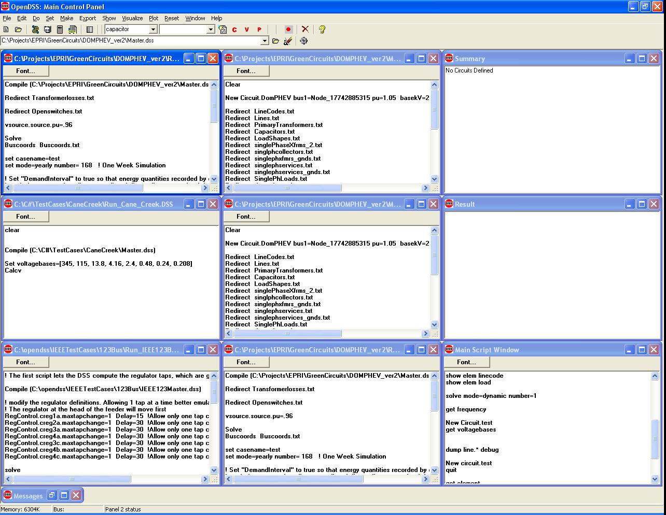
Figure 4. Example of the Control panel window for the DSS

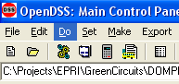
Figure 5. Do command and speed buttons
Each script window on the Control panel implements a Windows RichEdit text form. Thus, it has many of the standard text editing features one might expect. However, third party text editors (we use Editplus) can provide substantially more capability. It is recommended that one of the first commands to issue after starting the DSS for the first time is
Set Editor= filename
It is generally necessary to issue this command only one time. The program will remember this value in the Windows Registry after it is shut down. Likewise the default base frequency (50 or 60 Hz) is set one time. The assumed default base frequency is displayed at the top of the main screen. If you work on both types of systems (as we do), always make sure it is set to the correct value!
When a user right-clicks on a file name in one of the script windows, the popup menu gives the user the option of “Open” or “Edit” for the selected file (Figure 6). “Open” will open the selected file in another script window in the DSS program. “Edit” will open the selected file in the Editor of the user’s choosing. If no Editor was specified, the program will attempt to open the Notepad editor supplied with Windows.
If the file name contains no blanks, one need only click anywhere within the file name to execute the Open or Edit commands.
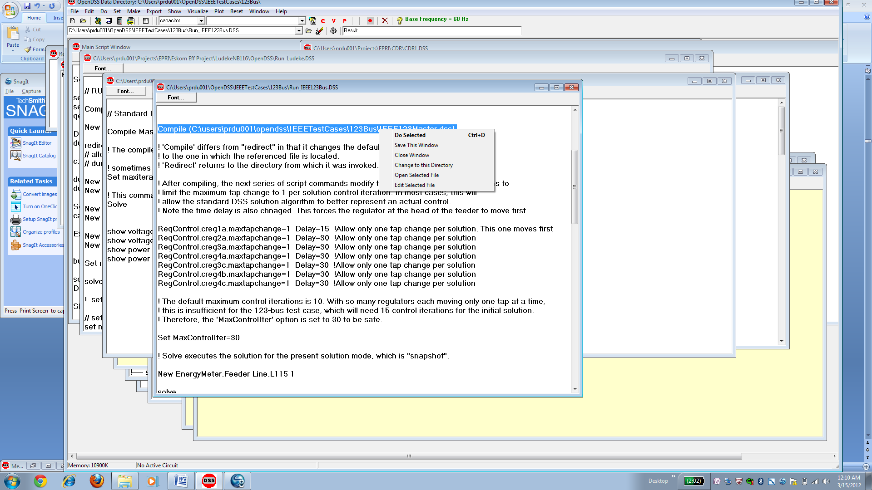
Figure 6. Compiling a File containing a circuit description script from a script window in the control panel.
You may change the font for a window by clicking the “Font…” button. The size of the font is remembered by the program. Font information is not kept with the script files: these are simple text files.

Export Menu Commands
The voltage and current exports have been updated to be more consistent and useful when you load them into Excel or another program.
- The output tables now stretch out horizontally instead of vertically. This is also done to fit in better with modifications to the Plot command
- Note: Current exports are keyed on device (Circuit Element) name
- Note: Voltage exports are keyed on bus name
- Residual values were added (sum of all conductors or nodes at a branch or bus). This is also true for the sequence current and sequence voltage exports because the residuals can be different than the zero-sequence values.

The export options include (check help – there are frequently updated):
Export Voltages [Filename] (EXP_VOLTAGES.CSV) Voltage, magnitude and angle
Export SeqVoltages [Filename] (EXP_SEQVOLTAGES.CSV) Sequence voltage, magnitude only
Export Currents [Filename] (EXP_CURRENTS.CSV) All currents, magnitude and angle
Export Overloads [Filename] ( EXP_OVERLOADS.CSV) % overload for overloaded elements
Export Capacity [Filename] (EXP_CAPACITY.CSV) Capacity report on lines and transformers
Export Estimation [Filename] (EXP_ESTIMATION.CSV) Results of Estimate command
Export Unserved [UEonly] [Filename] EXP_UNSERVED.CSV) Unserved energy values; requires energymeter
Export SeqCurrents [Filename] (EXP_SEQCURRENTS.CSV) Sequence currents, magnitude
Export Powers [MVA] [Filename](EXP_POWERS.CSV) Powers into each terminal, kW and kvar
Export P_ByPhase [Filename] (EXP_P_BYPHASE.CSV) Powers by phase
Export SeqPowers [MVA] [Filename](EXP_SEQPOWERS.CSV) Positive-, negative-, and zero-sequence powers
Export Faultstudy [Filename] (EXP_FAULTS.CSV) Results of Solve Mode=Faultstudy
Export Generators [Filename | /m ] (EXP_GENMETERS.CSV) Values of Generator Energy Meters
Export Loads [Filename] (EXP_LOADS.CSV) Values for each Load
Export Meters [Filename | /m ] (EXP_METERS.CSV) Energy meter exports. Adding the switch "/multiple" or "/m" will cause a separate file to be written for each meter.
Export Monitors monitorname (file name is assigned) Specified monitor value
Export YPrims [Filename] (EXP_YPRIMS.CSV) All primitive Y matrices
Export Y [Filename] (EXP_Y.CSV) System Y matrix (full, complex). Could be huge !
Export SeqZ [Filename] (EXP_SEQZ.CSV) Sequence Impedances at each bus
Export Summary [filename] (EXP_SUMMARY.CSV) Time-stamped summary of present solution. (Cumulative) One record per solution
Export Profile [Filename] (EXP_Profile.CSV) Data to enable you to recreate a voltage profile plot in another program.
For additional description see the Export Command description in the command reference. Also, see the help from running the program. There are frequent additions.
The circuit name or casename is prepended onto the file names above. This is the name you gave the circuit when it was created. You can also change the name that gets prepended by the “Set Casename= …” option.
At the conclusion of an Export operation (as well as any other DSS operation that writes a file) the name of the output file appears in the Result window. You can quickly display/edit the file by:
- Edit | Result File menu item
- ctrl-R
- There is a button on the tool bar for this purpose (see hints by holding the mouse over the buttons)
Alternatively, you may set the option “Set Showexport=Yes” and the exported file will be automatically displayed in the default text editor.

Plot Menu Commands
The Plot command has been updated significantly recently. Check the Wiki on SourceForge.net and the Help in the executable for up-to-date information.
As of this writing, the help text for the “Type” property of the help command is:
One of {Circuit | Monitor | Daisy | Zones | AutoAdd | General (bus data) | Loadshape | Profile} A "Daisy" plot is a special circuit plot that places a marker at each Generator location or at buses in the BusList property, if defined. A Zones plot shows the meter zones (see help on Object). Autoadd shows the autoadded generators. General plot shows quantities associated with buses using gradient colors between C1 and C2. Values are read from a file (see Object). Loadshape plots the specified loadshape.
See the description of the Plot command below in this document or refer to the online information in the Help menu and on the Wiki site. Some tips on creating plots are provided here.
The existing “circuit” plot creates displays on which the thicknesses of LINE elements are varied according to:
- Power
- Current
- Voltage
- Losses
- Capacity (remaining)

Circuit plots are usually unicolor plots (specified by color C1). However, Voltage plots are multicolor depicting 3 levels for voltage. Meter zone plots use a different color for each feeder.
The following example will display the circuit with the line thickness proportional to POWER relative to a max scale of 2000 kW:
plot circuit Power Max=2000 dots=n labels=n subs=n C1=$00FF0000

Colors may be specified by their RGB color number or standard color names. The above example expresses the number in hexadecimal, which is a common form. The last 6 digits of the hexadecimal form give the intensity of the colors in this format: $00BBGGRR. In this way, any color can be produced. The standard color names are:
- Black
- Maroon
- Green
- Olive
- Navy
- Purple
- Teal
- Gray
- Silver
- Red
- Lime
- Yellow
- Blue
- Fuchsia
- Aqua
- LtGray
- DkGray
- White

The existing “general plot” creates displays on which the color of bus marker dots (see Markercode option) are varied according to an arbitrary quantity entered through a CSV file . The following gives a nice yellow-red variation of data field 1 (the bus name is assumed to be in the first column of the csv file) with the min displayed as color C1 (yellow) and the max=0.003 being C2 (red). Values in between are various shades of orange.
plot General 1 Max=.003 dots=n labels=n subs=y object=filename.csv C1=$0080FFFF C2=$000000FF

Example results: This plot clearly shows the extent of harmonic resonance involving the residual current (likely, the zero sequence, too) on the circuit.
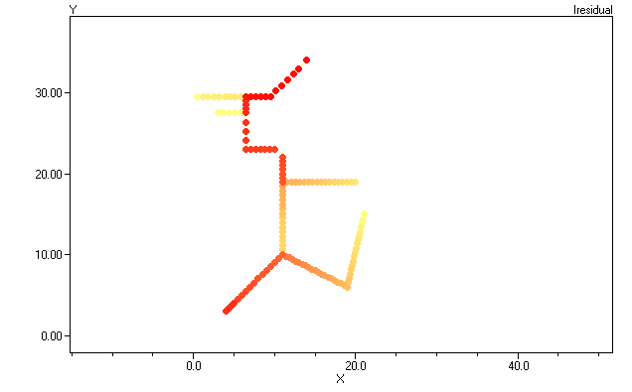
Figure 7: Color-shaded plot of harmonic resonance
There is also an option on the plot circuit command that will permit you to draw the circuit with lines proportional to some arbitrary quantity imported from a CSV file. The first column in the file should be the LINE name specified either by complete specification “line.elementname” or simply “elementname”. If the command can find a line by that name in the present circuit, it will plot it.
The usual thing you would do is to export a file that is keyed on branch name, such as
Export currents, or
Export seqcurrents
Then you would issue the plot command, for example:
Plot circuit quantity=1 Max=.001 dots=n labels=n Object=feeder_exp_currents.CSV
The OpenDSS differentiates this from the standard circuit plot by:
- A numeric value for “quantity” (representing the field number) instead of “Power”, etc
- A non-null specification for “Object” ( the specified file must exist for the command to proceed).
The Plot > Circuit Plots > General Line Data menu will guide you through the creation of this command with menus and list prompts (turn the recorder on). The first line in the CSV file is assumed to contain the field names, which is common for CSV files.
For example, the same plot as above with line thicknesses instead of colored dots.
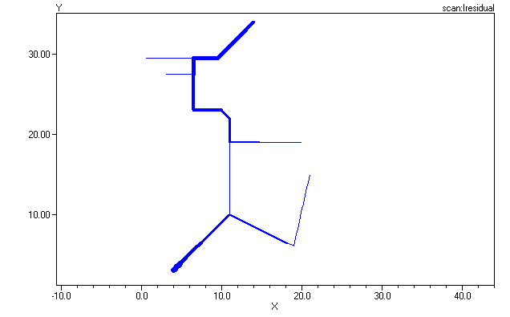
Figure 8: Thickness-weighted plot of harmonic resonance

Much more information is available on the Wiki at this URL:
http://sourceforge.net/apps/mediawiki/electricdss/index.php?title=TechNote_Using_the_General_Plot
Profile Plots
Voltage profile plots are a relatively new addition that are quite useful. Figure 9 shows the result from the unbalanced IEEE 8500-Node Test Feeder case. This was generated by issuing the following command after the solution:
Plot Profile Phases=ALL

A prerequisite for this command is to have an Energymeter at the head of the feeder and the voltage bases defined. The program plots the per unit voltage magnitude at each node for each Line object in the Energymeter’s zone. LV (secondary) lines are plotted in a dotted line.
Refer to the Wiki on SourceForge.net for more Plot command features. This is updated more frequently than the User Manual.
Note: You may also export the data for this plot using the Export Profile command. The resulting CSV file gives you coordinates you may use in other graphics tools.
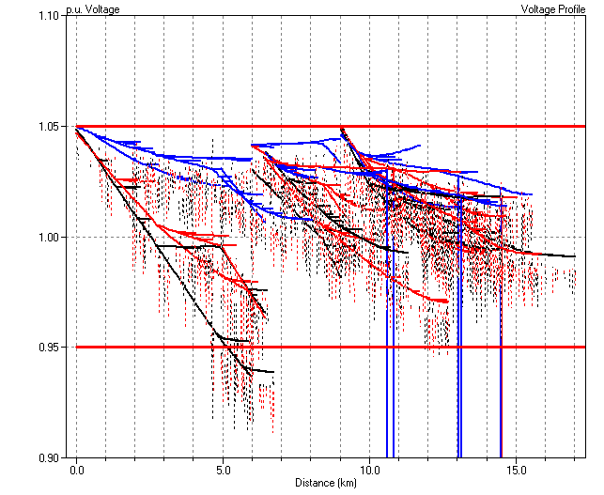
Figure 9. Voltage Profile Plot from IEEE 8500-Node Test Feeder

Overall Circuit Model Concept

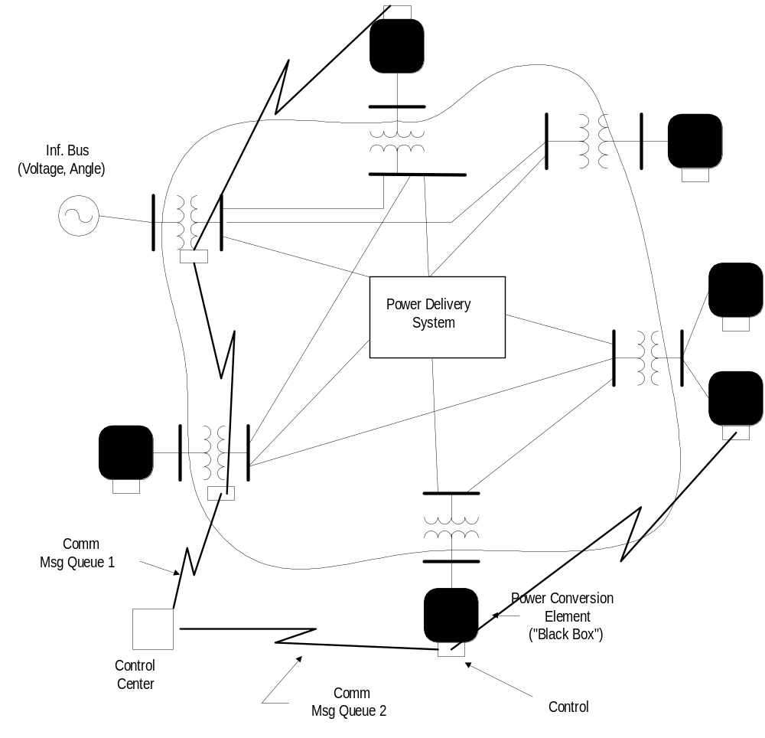
Figure 10: Electrical Circuit with Communications Network
The DSS consists of a model of the electrical system in the rms steady state, overlaid with a communications network that interconnects controls on power delivery elements and on power conversion elements.
[The communications message queues are not completely developed in this version -- one of the control queues is functional and used by the controls that are implemented. Preliminary simulations of packets have been performed using separate tools and the scripting capability of OpenDSS. This work continues.]

Bus and Terminal Models

Bus Definition
A bus is a circuit element having [1..N] nodes. Buses are the connection point for all other circuit elements. In many power system analysis programs, “bus” and “node” are nearly synonymous, but there are distinctively different in OpenDSS. Bus is the container of Node.
The main electrical property of a Bus is voltage. Each node has a voltage with respect to the zero voltage reference (remote ground). There is a nodal admittance equation written for every node (i.e., the current is summed at each node).
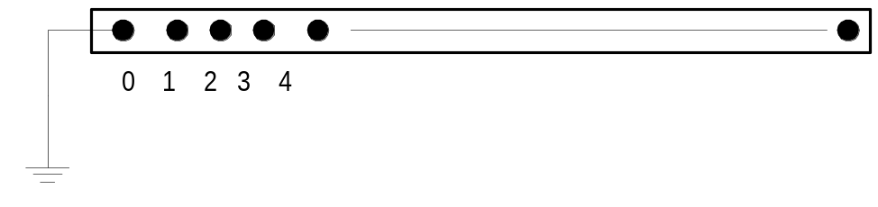
Figure 11: Bus Definition

Terminal Definition
Each electrical element in the power system has one or more terminals. Each terminal has one or more conductors. Each conductor conceptually contains a disconnect switch and a TCC (fuse) curve [The Fuse simulation has been disabled in this version and is being redesigned; a Relay object or a separate Fuse object can be used, if needed, to control the switches in the terminal conductors.]. The conductors are numbered [1, 2, 3,…].
If the terminal is connected to an N-phase device, the first N conductors are assumed to correspond to the phases, in order. The remaining conductors may be neutrals or other non-power conductors.
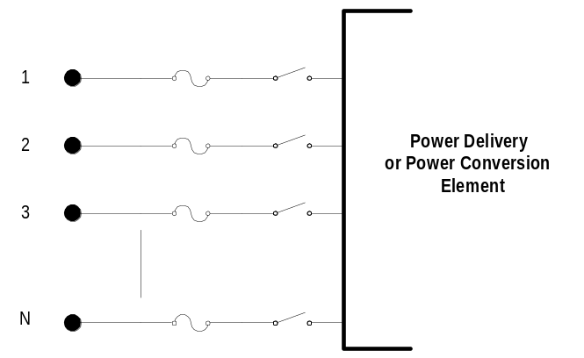
Figure 12: Terminal Definition

The DSS bus is a connecting place with 1 or more nodes for connecting individual phases and other conductors from the terminals of both power delivery elements and power conversion elements.
Buses are named with null-terminated strings of arbitrary length. Therefore, you may use quite long names.
Node 0 of each bus is implicitly connected to the voltage reference (i.e., the node's voltage is always zero and is never explicitly included in the Y matrix).

Bus Naming
Buses are named by an alphanumeric string of ASCII (ANSI) characters. The names may be numbers, but are always treated as strings. Internally, buses will be numbered (actually, each node is numbered), but will be referenced through the COM or command interface by name. The internal index number is subject to change if something in the circuit changes and is not a reliable way to refer to a bus or node.
It is better if names do not contain blanks, tabs, or other “white space” or control characters. If the name contains a blank, for example, it must be enclosed in quotes (single or double, parens, or brackets). This can be a source of errors because of the different entry points for the names (user interface, files, COM interface).
Names may be any length and are passed to the OpenDSS through the COM interface as standard null-terminated strings. This is the common way for representing strings in the Windows environment. Thus, it is a simple matter to drive the DSS from most programming languages and from Visual Basic in particular.

Bus Instantiation and Life
One of the features of the OpenDSS that takes some getting used to for users familiar with other power system analysis platforms is that a Bus does not exist until it is needed for a solution or some other purpose. A list of buses is made from the presently enabled devices. Then each bus is instantiated.
The reason for this behavior of the OpenDSS is to avoid having to define all the buses in the problem ahead of time. If you want to add a new bus, simply define a device that is connected to the bus or change the bus connections of an existing device. Since the DSS does not need to know the voltage bases to perform its solution, there is no need to define the base voltages ahead of time. However, the voltage bases are useful for reports and certain simulations. Just remember to set the voltage bases AFTER the buses exist.
Bus instantiation can be forced without performing a solution by issuing the “MakeBusList” command.
The “CalcVoltageBases” command will automatically set the voltage bases where practical by performing a no-load power flow. The legal voltage bases for a problem are defined using the Set Voltagebases= [array of voltagebases].
Otherwise, you can use the SetkVBase command to set the voltage base for a selected bus.
The bus list is reorganized whenever there is a change in the circuit.
Implications/Side Effects of Bus Instantiation Rules:
- You can’t define the voltage base for a bus until it exists. The CalcVoltageBases command is a solution type that will automatically instantiate all the buses currently defined.
- You can’t define a bus’s coordinates until the bus exists.
- Once the bus list exists, properties are copied to new bus objects when a change occurs that requires rebuilding the bus list. However, if there are new buses created by the changes, they will not have any of the special properties defined. That must be done subsequently, if necessary.
- It does not hurt to redefine base voltage or coordinates if there is any question whether they have the proper value.
- Once instantiated, a bus object will persist until another command forces rebuilding the bus list. Thus, if there are edits performed on the circuit elements, the bus list could be out of synch with the present configuration.
- There is also a Node list that is constructed at the same time as the bus list. The order of elements in the system Y matrix is governed by the order of the Node list. The Node list order is basically the order in which the nodes are defined during the circuit model building process.

Terminal References
Terminals are not named separately from the device. Each device will have a name and a defined number of multiphase terminals. Terminals will be referenced explicitly by number [1, 2, 3 …] or by inference, in the sequence in which they appear. Internally, they will be sequenced by position in a list.

Phases and other Conductors
Each terminal has one or more phases, or normal power-carrying conductors and, optionally, a number of other conductors to represent neutral, or grounding, conductors or conductors for any other purpose. By convention, if a device is declared as having N phases, the first N conductors of each terminal are assumed to be the phase conductors, in the same sequence on each terminal. Remaining conductors at each terminal refer to “neutral” or “ground” or "earth" conductors.
All terminals of a device are defined to have the same number of conductors. For most devices, this causes no ambiguity, but for transformers with both delta and wye (star) winding connections, there will be an extra terminal at the delta connection. The neutral is explicit to allow connection of neutral impedances to the wye-connected winding. The extra conductor for the delta connection is simply connected to ground (voltage reference) and the admittances are all set to zero. Thus, the conductor effectively does not appear in the problem; it is ignored. However, you may see it appear in reports that explicitly list all the voltages and currents in a circuit.
The terminal conductors and bus nodes may be combined to form any practical connection.
Bus Nodes: A bus may have any number of nodes (places to connect device terminal conductors). The nodes may be arbitrarily numbered. However, the first N are by default reserved for the N phases. Thus, if a bus has 3-phase devices connected to it, connections would be expected to nodes 1, 2, and 3. So the DSS would use these voltages to compute the sequence voltages, for example. Phase 1 would nominally represent the same phase throughout the circuit, although there is nothing to enforce that standard. It is up to the user to maintain a consistent definition. If only the default connections are used, the consistency is maintained automatically.
Any other nodes would simply be points of connection with no special meaning. Each Bus object keeps track of the allocation and designation of its nodes.
Node 0 of a bus is always the voltage reference (a.k.a, ground, or earth). That is, it always has a voltage of exactly zero volts.

Specifying Connections
The user can define how terminals are to be connected to buses in three ways, not just one way:
Generically connect a circuit element’s terminal to a bus without specifying node-to-conductor connections. This is the default connection. Normal phase sequence is assumed. Phase 1 of the terminal is connected to Node 1 of the Bus, and so on. Neutrals default to ground (Node 0).
Explicitly specify the first phase of the device is connected to node j of the bus. The remaining phases are connected in normal 3-phase sequence (1-2-3 rotation). Neutral conductors default to ground (Node 0).
Explicitly specify the connection for all phases of each terminal. Using this mode, neutrals (star points) may be left floating. Any arbitrary connection maybe achieved. The syntax is:
BUSNAME.i.j.k, where i, j, k refer to the nodes of a bus.
This is interpreted as the first conductor of the terminal is connected to node i of the bus designated by BUSNAME; the 2nd conductor is connected to node j, etc.
The default node convention for a terminal-to-bus connection specification in which the nodes are not explicitly designated is:
BUSNAME.1.0.0.0.0.0.0. … {Single-phase terminal)
BUSNAME.1.2.0.0.0.0.0. … {two-phase terminal)
BUSNAME.1.2.3.0.0.0.0 … {3-phase terminal}
If the desired connection is anything else, it must be explicitly specified. Note: a bus object "learns" its definition from the terminal specifications. Extra nodes are created on the fly as needed. They are simply designations of places to connect conductors from terminals. For a 3-phase wye-connected capacitor with a neutral reactor, specify the connections as follows:
BUSNAME.1.2.3.4 {for 3-phase wye-connected capacitor}
BUSNAME.4 {for 1-phase neutral reactor (2nd terminal defaults to node 0)}

Power Delivery Elements
Power delivery elements usually consist of two or more multiphase terminals. Their basic function is to transport energy from one point to another. On the power system, the most common power delivery elements are lines and transformers. Thus, they generally have more than one terminal (capacitors and reactors can be an exception when shunt-connected rather than series-connected). Power delivery elements are standard electrical elements generally completely defined in the rms steady state by their impedances. Thus, they can be represented fully by the primitive y matrix (Y_{prim}).

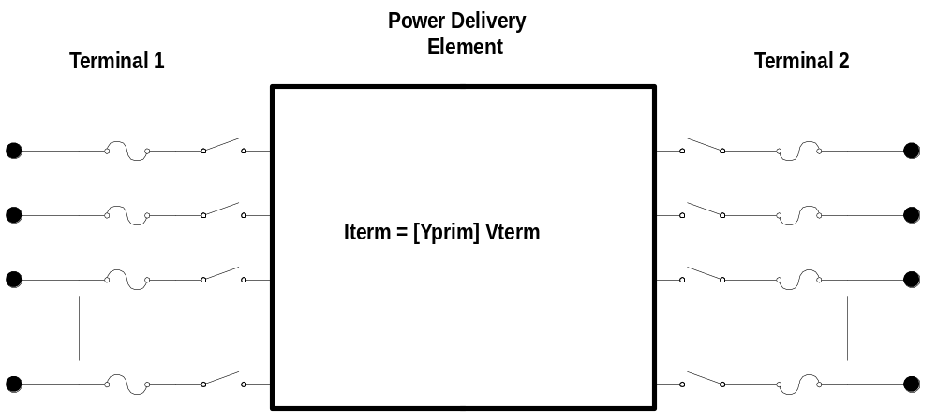
Figure 13: Power Delivery Element Definition

Power Conversion Elements
Power conversion elements convert power from electrical form to some other form, or vice-versa. Some may temporarily store energy and then give it back, as is the case for reactive elements. Most will have only one connection to the power system and, therefore, only one multiphase terminal. The description of the mechanical or thermal side of the power conversion is contained within the "Black box" model. The description may be a simple impedance or a complicated set of differential equations yielding a current injection equation of the form:
I_{Term}(t) = F(V_{Term}, [State], t)
The function F will vary according to the type of simulation being performed. The power conversion element must also be capable of reporting the partials matrix when necessary:
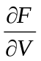
In simple cases, this will simply be the primitive y (admittance) matrix; that is, the y matrix for this element alone.
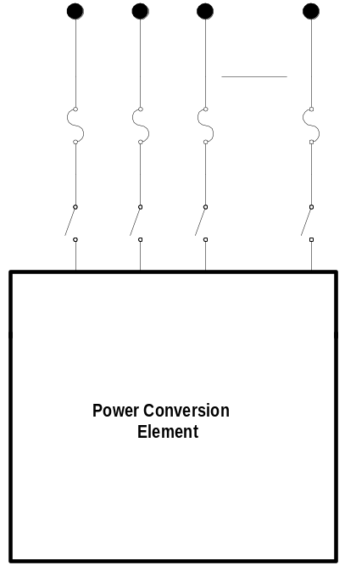
Figure 14: Power Conversion Element Definition
Within the OpenDSS, the typical implementation of a PC element is as shown in Figure 15. Nonlinear elements, in particular Load and Generator elements, are treated as Norton equivalents with a constant Yprim and a “compensation” current or injection current that compensates for the nonlinear portion. This works well for most distribution loads and allows a wide range of models of load variation with voltage. It converges well for the vast majority of typical distribution system conditions. The Yprim matrix is generally kept constant for computational efficiency, although the OpenDSS does not require this. This limits the number of times the system Y matrix has to be rebuilt, which contributes greatly to computational efficiency for long runs, such as annual loading simulations.
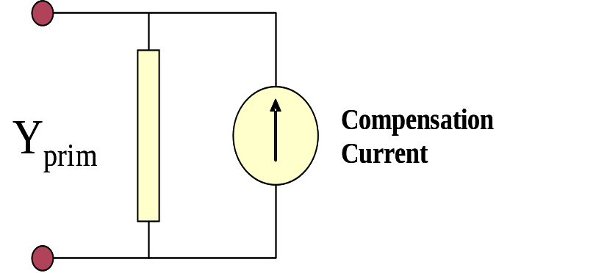
Figure 15. Compensation Current Model of PC Elements (one-line)

The Compensation current is the current that is added into the injection current vector in the main solver (see next section). This model accommodates a large variety of load models quite easily. The Load element models presently implemented are:
- Conventional constant P, Q load model. This, and all load models, revert to linear (constant Z) model outside the normal voltage range in an attempt to guarantee convergence even when the voltage drops very low. This is important for performing annual simulations.
- Constant Z load model. P and Q vary by the square of the voltage. Will usually converge in any condition.
- Constant P but Q is modeled as a constant reactance.
- P and Q variation defined by exponential values. For example this is used for Conservation Voltage Reduction (CVR) studies.
- Constant current magnitude (common in distribution system analysis). P and Q vary linearly with voltage magnitude.
- Constant P that can be modified by loadshape multipliers, but Q is a fixed value independent of time.
- Similar to 6, but Q is computed from a fixed reactance (varies with square of voltage)
- A ZIP model containing P and Q exponents for each of the three types of load models
Except where noted, P and Q can be modified by Loadshape multipliers. Loads can also be exempt from loadshape mulitipliers.

Putting it All Together
Figure 16 illustrates how the DSS puts all the PD elements and PC elements together to perform a solution.
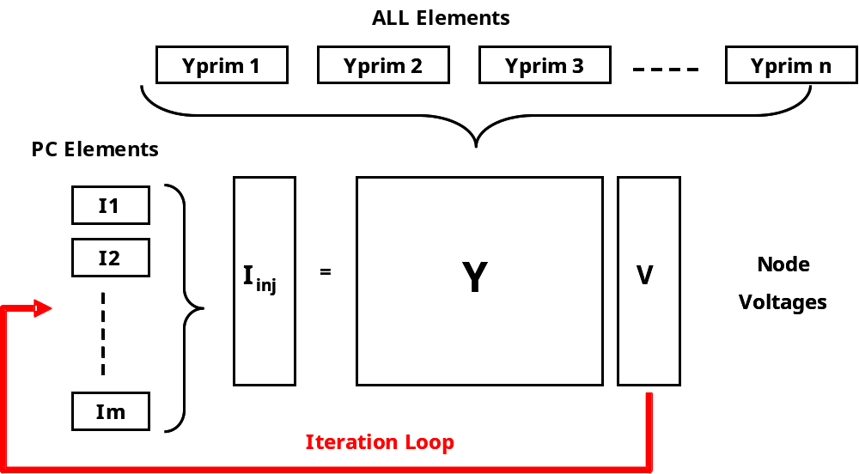
Figure 16. OpenDSS Solution Loop
Basically, the upper structure of the OpenDSS (the part that is written in Delphi) manages the creation and modification of the primitive y matrices (Yprim) for each element in the circuit as well as managing the bus lists, the collection of results through Meter elements, and the execution of Control elements. The Yprim matrices are fed to the sparse matrix solver, which constructs the system Y matrix.
An initial guess at the voltages is obtained by performing a zero load power flow. That is, all shunt elements are disconnected and only the series power delivery elements are considered. This gets all the phase angles and voltage magnitudes in the proper relationship. This is important because the OpenDSS is designed to solve arbitrary n-phase networks in which there can be all sorts of transformer ratios and connections.
The iteration cycle begins by obtaining the injection currents from all the power conversion (PC) elements in the system and adding them into the appropriate slot in the I_{inj} vector. The sparse set is then solved for the next guess at the voltages. The cycle repeats until the voltages converge to typically 0.0001 pu. The system Y matrix is typically not rebuilt during this process so the iterations go quickly.
This simple iterative solution has been found to converge quite well for most distribution systems that have adequate capacity to serve the load. The key is to have a dominant bulk power source, which is the case for most distribution systems. In the DSS, this is the “Normal” solution algorithm. There is also a “Newton” algorithm for more difficult systems (not to be confused with the typical Newton-Raphson power flow method).
When performing Daily or Yearly simulations, the solution at the present time step is used as the starting point for the solution at the next time step. Unless there is a large change in load, the solution will typically converge in 2 iterations – one to do the solution and one to check it to make sure it is converged. Thus, the DSS is able to perform such calculations quite efficiently.
Control iterations are performed outside this loop. That is, a converged solution is achieved before checking to see if control actions are required.

DSS Command Language Syntax
The DSS is designed such that all functions can be carried out through text-based DSS Command Language scripts. The text streams may come from any of these sources:
- Selecting and executing a script on a Control Panel window,
- Through the COM interface, or
- From a standard text file to which the command interpreter may be temporarily redirected (Compile or Redirect commands).
This makes the DSS an easily accessible tool for users who simply want to key in a small circuit and do a quick study as well as to those who perform quite complicated studies. It also makes the DSS more easily adapted by others who have a great deal invested in their own database and would put forth much effort to conform to another. Text files are the most common means of transferring data from one source into another. The DSS scripts can often be configured to be close to various data transfer formats.
Always refer to the Help command for the latest commands and property names that are recognized by the DSS.

Command Syntax
The command language is of the form:
Command parm1, parm2 parm3 parm 4 ….

Parameters (parm1, etc) may be separated by commas (,) or white space (blank, tab). If a parameter includes a delimiter, enclose it in either
- double quotes (“),
- single quotes(‘), or
- parentheses (… ), or..
- brackets [..], or
- braces {..}.

While any of these will work, double or single quotes are preferred for strings. Brackets are preferred for arrays, and curly braces are preferred for in-line math.
Note: Be careful of using parantheses on Windows & for file names containing full path names because Windows uses the string (x86) for 32-bit programs in the default Program Files folders. Use some other delimiter. Double quotes work fine.

Parameters
Parameters may be positional or named (tagged). If named, an "=" sign is expected.
- Name=value (this is the named form)
- Value (value alone in positional form)
For example, the following two commands are equivalent.
New Object="Line.First Line" Bus1=b1240 Bus2=32 LineCode=336ACSR, …
New “Line.First Line”, b1240 32 336ACSR, …

The first example uses named parameters, which are shown in the default order. The second example simply gives the values of the parameters and the parser assumes that they are in the default order. Note that the name of the object contains a blank, which is a standard DSS delimiter character. Therefore, it is enclosed in quotes or parentheses, etc..
You may mix named parameters and positional parameters. Using a named parameter repositions the parser's positional pointer so that subsequent parameters need not be named. The order of parameters is always given in the DSS help command window. The DSS help window allows for display of commands and properties in either alphabetical order or positional (numerical) order. The properties of elements are by default processed in positional order unless the “=” appears in the field.
Some commands are interpreted at more than one lexical level inside the OpenDSS. In this example, the main DSS command interpreter interprets the New command and essentially passes the remainder of the string to the Executive for adding new circuit elements. It determines the type of element to add (e.g., a Line) and confirms that it is indeed a registered class. It then passes the remainder of the text line on to the module that handles the instantiation and definitions of Line objects. Only the Line model code needs to know how to interpret the property definitions it receives via the parameter list. This design allows great flexibility for future modifications to the Line model that might require adding new properties. This happens with regularity and the main DSS executive does not have to be modified; only the module affected.
For the New command, the first two parameters are always required and positional:
- The New command itself, and
- The name of the object to add.

For circuit elements, the next one, or two, parameters are normally the bus connection properties, which are processed and stored with the circuit element model. Then the definition of the object being created continues, using an editing function expressly devoted to that class of circuit element.

Properties
The parameters of circuit element editing commands are referred to as “properties”. Properties generally set values of some data field in the targeted object, but may also have some side effects. Properties behave like properties in object-oriented programming languages. They may perform an action as well as setting a value.
For example, setting the PF property of a Load object also causes the kvar property to be updated.
Many objects have multiple properties that essentially set the same internal data value. For example, you can set the kVA rating by either the kVA or MVA property is some elements.
This is a different approach than programs using databases typically take where the values are static and the data fields generally fixed.

Delimiters and Other Special Characters
The DSS recognizes these delimiters and other special characters:
Array or string delimiter pairs:
- [ ]
- { }
- ( )
- “ “
- ‘ ‘

Matrix row delimiter: | (vertical bar)
Value delimiters:
- Comma(,)
- any white space (tab or space)

Class, Object, Bus, or Node delimiter: period(.)
Keyword / value separator: =
Continuation of previous line: ~ (actually a synonym for the More command)
Comment line: // or !
In-line comment: !
Query a property: ?

Array Properties [and Quote Pairs]
Array parameters are sequences of numbers. Of necessity, delimiters must be present to separate the numbers. To define an array, simply enclose the sequence in any of the quote pairs. Square brackets, [..], are the preferred method, although any of the other quote pairs: “..”, ‘..’, (..), {..} will work. For example, for a 3-winding transformer you could define arrays such as:
kvs = [115, 6.6, 22]
kvas=[20000 16000 16000]

Standard Ways to Define Array Properties
Arrays can be defined by the following methods:
Entering the numeric values directly
mult=[1, 2, 3, 4, ...]

Entering the numbers from a single column text file:
mult=[File=MyTextDataFile.CSV]

Entering the data from a packed binary file of doubles:
mult=[dblFile=MyFileOfDoubles.dbl]

Entering the data from a packed binary file of singles:
mult=[sngFile=MyFileOfDoubles.sng]

Enhanced Syntax
The 'File=...' capability for text files has been enhanced to allow you to extract a column of data from a multi-column CSV file (like you might get from an Excel spreadsheet or the OpenDSS Export command). The complete syntax is:
mult=[File=myMultiColumnFile.CSV, Column=n, Header=Yes/No]

Enter n for the column number you want. The default is always set to 1 for each array.
Specifying Header=Yes causes the first record in the CSV file to be skipped. This allows for a single line of non-numeric data in the first line, as is common in OpenDSS Export files. Default is “Header=No”.
Example
New Loadshape.Ramp2 npts=4000 sInterval=1
~ mult= (file=MultiChannelTest.csv, column=3, header=yes)

Special Reserved File Name
The name %result% is now used to designate the last result file. For example, if you want to export a file (such as a monitor file) and then immediately read in column 5 to do something with, you could do it with the following syntax:
mult=[File=%result%, Column=5, Header=Yes]

This must be executed before another command is issued that writes a result file.

Matrix Properties
Matrix parameters are entered by extending the Array syntax: Simply place a vertical bar (|) character between rows, for example:
Xmatrix=[1.2 .3 .3 | .3 1.2 3 | .3 .3 1.2] ! (3x3 matrix)

Symmetrical matrices like this example may also be entered in lower triangle form to be more compact.
Xmatrix=[ 1.2 | .3 1.2 | .3 .3 1.2 ] ! (3x3 matrix lower triangle)

String Length
The DSS Command strings may be as long as can be reasonably passed through the COM interface. This is very long. They must generally NOT be split into separate “lines” since there is no concept of a line of text in the standard DSS COM interface; only separate commands. However, New and Edit commands can be continued on a subsequent text line with the More or ~ command.
In general, string values in DSS scripts can be as long as desired. There are, of course, limitations to what can be reasonably deciphered when printed on reports. Also, the DSS “hashes” bus names, device names and any other strings that are expected to result in long lists for large circuits. This is done for fast searching. There have been various hashing algorithms implemented and it is difficult to keep the documentation up with the present release. Some algorithms would hash only the first 8 characters. This does not mean that comparisons are only 8 characters; comparisons are done on full string lengths.
Abbreviations are allowed by default in DSS commands and element Property names. However, if the circuit is very large, script processing will actually proceed more efficiently if the names of commands and properties are spelled out completely. It won’t matter on small circuits. The reason is that the hash lists are much shorter than the linear lists. If the DSS does not find the abbreviated name in a hash list, it will then search the whole list from top to bottom. This can slow performance if there are thousands of names in the list.

Default Values
When a New command results in the instantiation of a DSS element, the element is instantiated with reasonable values. Only those properties that need to be changed to correctly define the object need be included in the command string. Commonly, only the bus connections and a few key properties need be defined. Also, a new element need not be defined in one command line. It may be edited as many times as desired with subsequent commands (see Edit, More and ~ commands).
When an element is created or selected by a command, it becomes the Active element. Thereafter, property edit commands are passed directly to the active element until another element is defined by the New command or selected by some other command. In that respect, the command language mirrors the basic COM interface.
All changes are persistent. That is, a parameter changed with one command remains as it was defined until changed by a subsequent command. This might be a source of misunderstanding with novices using the program who might expect values to reset to a base case as they do in some other programs. When this is a concern, issue a “clear” command and redefine the circuit from scratch.
Changes made “on the fly” are NOT saved back to the original script files. If you wish to capture the present state of the circuit for future analysis, execute the Save Circuit command, which saves the present circuit to a separate folder. It will not overwrite an existing folder. Some manual fixup may be required to get the saved circuit to compile properly.

In-line Math
The DSS scripting language uses a form of reverse Polish notation (RPN) to accommodate in-line math. This feature may be used to pre-process input data before simulation. The parser will evaluate RPN expressions automatically if you enclose the expression in any of the quoted formats (quotation marks or any of the matched parentheses, brackets, etc.).

RPN Expressions
Basically, you enter the same keystrokes as you would with an RPN calculator (such as an HP 48). One difference is that you separate numbers, operators, and functions by a space or comma. The RPN calculator in OpenDSS has a "stack" of 10 registers just like an HP calculator. In the function descriptions that follow, the first stack register is referred to as "X" and the next higher as "Y" as on the HP calculator. When a new number is entered, the existing registers are rolled up and the new number is inserted into the X register.
These functions operate on the first two registers, X and Y:
+ Add the last two operands (X and Y registers; result in X; X = X + Y )
- X = Y - X
* X = X * Y
/ X = Y / X
^ (exponentiation) X = Y to the X power
These unitary functions operate on the X register and leave the result in X.
sqr X=X*X
sqrt take the square root of X
inv (inverse of X = 1/X)
ln (natural log of X)
exp (e to the X)
log10 (Log base 10 of X)
sin for X in degrees, take the sine
cos for X in degrees, take the cosine
tan for X in degrees, take the tangent
asin take the inverse sine, result in degrees
acos take the inverse cosine, result in degrees
atan take the arc tangent, result in degrees
atan2 take the arc tangent with two arguments, Y=rise and X = run,
result in degrees over all four quadrants
The following functions manipulate the stack of registers
Rollup shift all registers up
Rolldn shift all registers dn
Swap swap X and Y
There is one constant preprogrammed: pi

RPN Examples
For example, the following DSS code will calculate X1 for a 1-mH inductance using inline RPN:
// convert 1 mH to ohms at 60 Hz, note the last * operator
line.L1.X1 = (2 pi * 60 * .001 *)
The expression in parentheses is evaluated left-to-right. '2' is entered followed by 'pi'. Then the two are multiplied together yielding 2π. The result is then multiplied by 60 to yield ω (2πf). Finally, the result is multiplied by 1 mH to yield the reactance at 60 Hz. To specify the values of an array using in-line math, simply nest the quotes or parentheses:
// Convert 300 kvar to 14.4 kV, 2 steps
Capacitor.C1.kvar = [(14.4 13.8 / sqr 300 *), (14.4 13.8 / sqr 300 *)]
The Edit | RPN Evaluator menu command brings up a modal form in which you can enter an RPN expression and compute the result. Clicking the OK button on this form automatically copies the result to the clipboard. The purpose of this feature is to enable you to interpret RPN strings you find in the DSS script or to simplify the above script by computing the result and replacing the RPN string with the final value if you choose:
Capacitor.C1.kvar = [ 326.65, 326.65] ! 300 kvar converted to 14.4 kV, 2 steps
This next example shows how to use RPN expressions inside an array. Two different delimiter types are necessary to differentiate the array from the expressions.
// set the winding kvs to (14.4 20)
New Transformer.t kvs=("24.9 3 sqrt /" "10 2 *")

DSS Command Reference
Nearly all DSS commands and parameter names may be abbreviated. This is for convenience when typing commands in directly. However, there is not necessarily any speed benefit to abbreviating for machine-generated text. (See String Length above.) Thus, commands and parameter names should be spelled out completely when placed in script files that are auto-generated from other computer data sources. Abbreviate only when manually typing commands to the DSS.

Specifying Objects
Any object in the DSS, whether a circuit element or a general DSS object, can be referenced by its complete name:
Object=Classname.objname
For example,
object=vsource.source.
In nearly all circumstances, the 'object=' may be omitted as it can for any other command line parameter. The object name is almost always expected to be the first parameter immediately following the command verb.
If the 'classname' prefix is omitted (i.e., no dot in the object name), the previously used class (the active DSS class) is assumed. For example,
New line.firstline . . .
New secondline . . .
The second command will attempt to create a new line object called 'secondline'.
If there is any chance the active class has been reset, use the fully qualified name. Alternatively, use the Set Class command to establish the active class:
Set class=Line
New secondline . . .
Recommendation: Always used the full element name (classname.elementname) to avoid confusion at a later date. It is better to make the text human readable than exploit shortcuts the program allows.

Command Reference
The following documents selected command definitions as of this writing. There are 98 commands as of this writing. Newer builds of the DSS may have additional properties and commands. Execute the Help command while running the DSS to view the present commands available in your version.

// (comment) and ! (inline comment)
The appearance of “//” in the command position indicates that this statement is a comment line. It is ignored by the DSS. If you wish to place an in-line comment at the end of a command line, use the “!” character. The parser ignores all characters following the ! character.
// This is a comment line
New line.line4 linecode=336acsr length=2.0 ! this is an in-line comment

? [Object Property Name]
The “?” command allows you to query the present value of any published property of a DSS circuit element. For example,
? Monitor.mon1.mode
is one way to get the mode defined for the Monitor named Mon1.
The value is returned in the "Result" property of the DSS COM Text interface (See COM interface). It also appears in the Result window of the standalone executable immediately after execution of the command.

About
Displays the "About" box. The Result string is set to the version string.

AddMarker
Add a marker to the active circuit plot. Example:
AddMarker Bus=busname code=nn color=$00FF0000 size=3

See Set Markercode= description below to see a list of marker codes presently implemented.

AlignFile
Aligns the commands and properties of DSS script files into even columns for easier reading. Creates a new file with the string “Aligned_” prepended and opens the file in the default editor. You may use the created file in place of the original if desired.
Alignfile [file=]filename.

AllocateLoads
Estimates the allocation factors for loads that are defined using the XFKVA property. Requires that energymeter objects be defined with the PEAKCURRENT property set. Loads that are not in the zone of an energymeter cannot be allocated. This command adjusts the allocation factors for the appropriate loads until the best match possible to the meter values is achieved. Loads are adjusted by phase. Therefore all single-phase loads on the same phase will end up with the same allocation factors.
If loads are not defined with the XKVA property, they are ignored by this command.

BatchEdit
Batch edit objects in the same class. Useful for wholesale changes to objects of the same class. Example:
BatchEdit Load..* duty=duty_shape

In place of the object name, supply a PERL regular expression. “.*” matches all names. The subsequent parameter string is applied to each object selected. This example is equivalent to creating a script file containing the following commands, for example:
Load.Load1.duty=dutyshape
Load.Load2.duty=dutyshape
Load.Load3.duty=dutyshape
Etc.

BuildY
Forces rebuild of Y matrix upon next Solve command regardless of need. The usual reason for doing this would be to reset the matrix for another load level when using LoadModel=PowerFlow (the default), if the system is difficult to solve when the load is far from its base value. Some of the load elements will recompute their primitive Y to facilitate convergence. Works by invalidating the Y primitive matrices for all the Power Conversion elements.

BusCoords
Define x,y coordinates for buses. Execute after Solve or MakeBusList command is executed so that bus lists are defined.Reads coordinates from a CSV file with records of the form:
busname, x, y.

You may use spaces and tabs as well as commas for value separators.
Example:
BusCoords [file=]xxxx.csv

See also LatLongCoords.

CalcVoltageBases
Estimates the voltage base for each bus based on the array of voltage bases defined with a "Set Voltagebases=..." command. Performs a zero-current power flow considering only the series power-delivery elements of the system. No loads, generators, or other shunt elements are included in the solution. The voltage base for each bus is then set to the nearest voltage base specified in the voltage base array.
Alternatively, you may use the SetkVBase command to set the voltage base for each bus individually. Note that the OpenDSS does not need the voltage base for most calculations, but uses it for reporting. Exceptions include processes like the AutoAdd solution mode where the program needs to specify the voltage rating of capacitors and generators it will automatically add to the system. Also, some controls may need the base voltage to work better.
It is useful to show the bus voltages after the execution of this command. This will help confirm that everything in the circuit is connected as it should be. It is especially useful for devices with unusual connections. Supplement this check with a Faultstudy mode solution to verify that the system impedances are also properly specified.

Capacity
Find the maximum load the active circuit can serve in the PRESENT YEAR. Gradually increases the load until something in the circuit is overloaded. Uses the EnergyMeter objects with the registers set with the SET UEREGS= (..) command for the AutoAdd functions. Syntax (defaults shown):
capacity [start=]0.9 [increment=]0.005

Returns the metered kW (load + losses - generation) and the per unit load multiplier for the loading level at which something in the system reports an overload or undervoltage. If no violations, then it returns the metered kW for peak load for the year (1.0 multiplier). Aborts and returns 0 if no energymeters.

CD Directoryname
Changes the current directory to the specified directory. The current directory is also changed if a full path name is supplied for the Compile command.

CktLosses
Returns the total losses for the active circuit in the Result string in kW, kvar.

Clear
Clears all circuit element definitions from the DSS. This statement is recommended at the beginning of all Master files for defining DSS circuits.

Close [Object] [Term] [Cond]
Opposite of Open command.

CloseDI
Close all Demand Interval (DI) files. This must be issued at the end of the final yearly solution in a Yearly or Daily mode run where DI files are left open while changes are made to the circuit. Reset and Set Year=nnn will also close the DI files. See Set DemandInterval= option. DI files remain open once the yearly simulation begins to allow for changes and interactions from outside programs during the simulation. They must be closed before viewing the results. Otherwise computer system I/O errors may result.

Comparecases
[Case1=]casename [case2=]casename [register=](register number) [meter=]{Totals* | SystemMeter | metername}.
Compares yearly simulations of two specified cases with respect to the quantity in the designated register from the designated meter file. Defaults: Register=9, Meter=Totals.
Example:
Comparecases base pvgens 10

Compile or Redirect [fileName]
The Compile and Redirect commands simply redirect the command interpreter to take input directly from a text file rather than from the Command property of the COM Text interface (the default method of communicating with the DSS) or the text form of the EXE version. The commands are similar except that Redirect returns to the directory from which it was invoked while Compile reset the current directory to that of the file being compiled. In DSS convention, use Compile when defining a new circuit and Redirect within script files to signify that the input is redirected to another file temporarily for the purpose of nesting script files. Use exactly the same syntax that you would supply to the Command property of the COM interface. Do not wrap lines; there is no line concept with the DSS commands. Each command must be on its own line in the file. Use the More command or its abbreviation “~” to continue editing a new line.

Currents
Returns the currents for each conductor of ALL terminals of the active circuit element in the Result string. (See Select command.) Returned as comma-separated magnitude and angle.

DI_plot
[case=]casename [year=]yr [registers=](reg1, reg2,...) [peak=]y/n [meter=]metername

Plots demand interval (DI) results from yearly simulation cases. Plots selected registers from selected meter file (default = DI_Totals.CSV). Peak defaults to NO. If YES, only daily peak of specified registers is plotted. Example:
DI_Plot basecase year=5 registers=(9,11) no

Disable [Object]
Disables object in active circuit. All objects are Enabled when first defined. Use this command if you wish to temporarily remove an object from the active circuit, for a contingency case, for example. If this results in isolating a portion of the circuit, the voltages for those buses will be computed to be zero. (Also see Open, Close commands.)

Distribute
kw=nn how={Proportional | Uniform |Random | Skip} skip=nn PF=nn file=filename MW=nn

Distributes generators over the system in the manner specified by "how". This command is useful for studying distributed rooftop solar PV for example. A file is saved that may be edited, if necessary, and used in subsequent simulations.
kW = total generation to be distributed (default=1000)
how= process name as indicated (default=proportional to load)
skip = no. of buses to skip for "How=Skip" (default=1)
PF = power factor for new generators (default=1.0)
file = name of file to save (default=distgenerators.txt)
MW = alternate way to specify kW (default = 1)
Example
Distribute kW=2000 how=proportional PF=1 file=MyPVGenfile.DSS

DOScmd /c ...command string ...
Execute a DOS command from within the DSS. Closes the window when the command is done. To keep the DOS window open, use /k switch.

Dump <Circuit Element> [Debug]
Writes a text file showing all the properties of the circuit object and displays it with the DSS text editor. You would use this command to check the definition of elements. It is also printed in a format that would allow it to be fed back into the DSS with no, or only minor, editing. If the “dump” command is used without an object reference, all elements in the active circuit are dumped to a file, which could be quite voluminous.
If the Debug option is specified, considerably more information is dumped including the primitive Y matrices and other internal DSS information.
You can limit the dump to all elements of a specific class by using the wildcard, *, character: For example,
Dump Transformer.* debug

Will dump all information on all transformers. Leave “debug” off to just see property values.

Edit [Object] [Edit String]
Edits the object specified. The object Class and Name fields are required and must designate a valid object (previously instantiated by a New command) in the problem. Otherwise, nothing is done and an error is posted.
The edit string is passed on to the object named to process. The DSS main program does not attempt to interpret property values for circuit element classes. These can and do change periodically.

Enable [Object]
Cancels a previous Disable command. All objects are automatically Enabled when first defined. Therefore, the use of this command is unnecessary until an object has been first disabled. (Also see Open, Close commands.)

Estimate
Execute state estimator on present circuit given present sensor values. See also AllocateLoads.

Export <Quantity> [Filename or switch]
Writes a text file (.CSV) of the specified quantity for the most recent solution. Defaults to Export Voltages. The purpose of this command is to produce a file that is readily readable by other programs such as MATLAB (use csvread), spreadsheet programs, or database programs.
The first record is a header record providing the names of the fields. The remaining records are for data. For example, the voltage export looks like this:
Bus, Node Ref., Node, Magnitude, Angle, p.u., Base kV
sourcebus , 1, 1, 6.6395E+0004, 0.0, 1.000, 115.00
sourcebus , 2, 2, 6.6395E+0004, -120.0, 1.000, 115.00
sourcebus , 3, 3, 6.6395E+0004, 120.0, 1.000, 115.00
subbus , 4, 1, 7.1996E+0003, 30.0, 1.000, 12.47
subbus , 5, 2, 7.1996E+0003, -90.0, 1.000, 12.47
subbus , 6, 3, 7.1996E+0003, 150.0, 1.000, 12.47

This format is common for many spreadsheets and databases, although databases may require field types and sizes for direct import. The columns are aligned for better readability.
Valid syntax for the command can be one of the following statement prototypes in bold. If the Filename is omitted, the file name defaults to the name shown in italics in parantheses. (This list is incomplete. Check Help for the Export commands on line. When in doubt, execute the export and observe the result.)
Export Voltages [Filename] (EXP_VOLTAGES.CSV). Exports voltages for every bus and active node in the circuit. (Magnitude and angle format).
Export SeqVoltages [Filename] (EXP_SEQVOLTAGES.CSV) Exports the sequence voltage magnitudes and the percent of negative- and zero-sequence to positive sequence.
Export Currents [Filename] (EXP_CURRENTS.CSV) Exports currents in magnitude and angle for each phase of each terminal of each device.
Export Overloads [Filename] EXP_OVERLOADS.CSV) Exports positive sequence current for each device and the percent of overload for each power delivery element that is overloaded.
Export SeqCurrents [Filename] (EXP_SEQCURRENTS.CSV) Exports the sequence currents for each terminal of each element of the circuit.
Export Powers [MVA] [Filename] (EXP_POWERS.CSV) Exports the powers for each terminal of each element of the circuit. If the MVA switch is specified, the result are specified in MVA. Otherwise, the results are in kVA units.
Export Faultstudy [Filename] (EXP_FAULTS.CSV) Exports a simple report of the 3-phase, 1-phase and max L-L fault at each bus.
Export Loads [Filename] (EXP_LOADS.CSV) Exports the follow data for each load object in the circuit: Connected KVA, Allocation Factor, Phases, kW, kvar, PF, Model.
Export Monitors monitorname (file name is assigned) Automatically creates a separate filename for each monitor. Exports the monitor record corresponding the monitor's mode. This will vary for different modes.
Export Meters [Filename | /multiple ] (EXP_METERS.CSV)
Export Generators [Filename | /multiple ] (EXP_GENMETERS.CSV)
EnergyMeter and Generator object exports are similar. Both export the time and the values of the energy registers in the two classes of objects. In contrast to the other Export options, each invocation of these export commands appends a record to the file. For Energymeter and Generator, specifying the switch "/multiple" (or /m) for the file name will cause a separate file to be written for each meter or generator. The default is for a single file containing all meter or generator elements.
Export Yprims [Filename] (EXP_Yprims.CSV) . Exports all primitive Y matrices for the present circuit to a CSV file.
Export Y [Filename] (EXP_Y.CSV) . Exports the present system Y matrix to a CSV file. Useful for importing into another application. Note: This file can be HUGE!
Export SeqZ [Filename] (EXP_SEQZ.CSV) . Exports the equivalent sequence short circuit impedances at each bus. Should be preceded by a successful “Solve Mode=Faultstudy” command. This will initialize the short circuit impedance matrices at each bus.

Fileedit [filename]
Edit specified file in default text file editor (see Set Editor= option).
Fileedit EXP_METERS.CSV (brings up the meters export file)

Formedit [Class.Object]
Brings up form editor to display the present property of the specified active DSS object. You may change the values of properties on this form for the present solution. However, the changes are NOT automatically saved to the original script files. You must execute a Save Circuit to capture the changes. This command may be executed from the speed button to the right of the two drop-down boxes at the top of the control panel. (to the right of the 1000KVA box in the figure below). The result is shown in the figure.
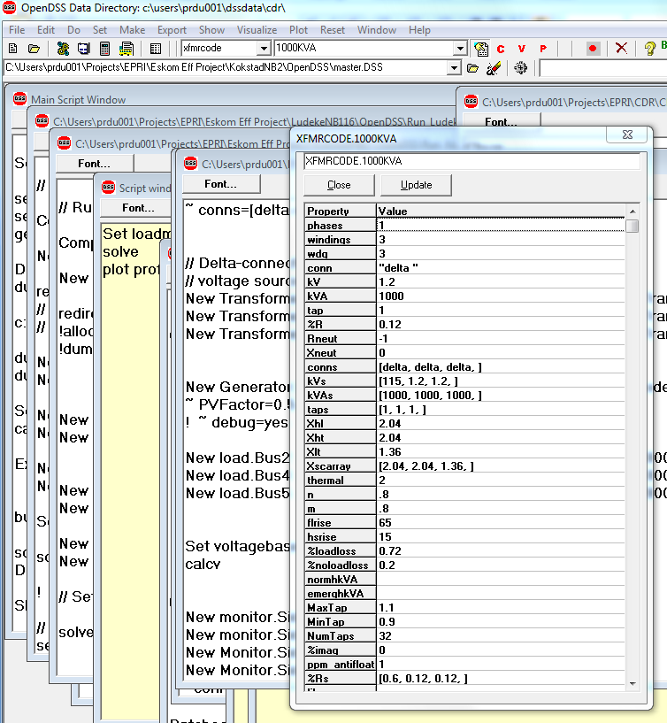

Get [Opt1] [opt2] etc.
Basically, the opposite of the SET command. Returns DSS property values for options set using the Set command. Result is returned in the Result property of the Text interface.
VBA Example:
DSSText.Command = "Get mode"
Answer = DSSText.Result

Multiple properties may be requested on one get. The results are appended and the individual values separated by commas. Array values are returned separated by commas.
See Set command description.

Guids
Read GUIDS (Globally-unique identifiers) for class names. Tab or comma-delimited file with full object name and GUID

Help
Brings up a help window with a “tree” view of all the commands and property names currently accepted by the DSS. (This is generally more up-to-date than the printed manuals because new features are being continually added.) Clicking on the commands will display a brief description of how to use the particular command or property.

Init
This command forces reinitialization of the solution for the next Solve command. To minimize iterations, most solutions start with the previous solution unless there has been a circuit change. However, if the previous solution is bad, it may be necessary to re-initialize. In most cases, a re-initialization results in a zero-load power flow solution with only the series power delivery elements considered.

Interpolate {All | MeterName}
Default is "All". Interpolates coordinates for missing bus coordinates in meter zones. Only affects buses on line sections contained in a Energymeter zone. Fills in evenly spaced coordinates between existing coordinates.

LatLongCoords
Define x,y coordinates for buses using Latitude and Longitude values (decimal numbers). Similar to BusCoords command. Execute after Solve command or MakeBusList command is executed so that bus lists are defined. Reads coordinates from a CSV file with records of the form:
busname, Latitude, Longitude.

Example:
LatLongCoords [file=]xxxx.csv
Note: Longitude is mapped to x coordinate and Latitude is mapped to y coordinate.

Losses
Returns the total losses for the active circuit element (see Select command) in the Result string in kW, kvar.

MakeBusList
Updates the buslist, if needed, using the currently enabled circuit elements. (This happens automatically for Solve command.) See ReprocessBuses

MakePosSeq
Attempts to convert the present 3-phase, or multi-phase, circuit model to a single-phase positive-sequence equivalent. It is recommended that you execute a Save Circuit after issuing this and edit the saved version to correct possible misinterpretations. Some devices such as single-phase regulators will have to be manually converted.

More | M | ~ | [Edit String]
The More command continues editing the active object last selected by a New, Edit, or Select command. It simply passes the edit string to the object's editing function (actually, the active object’s editing function simply takes control of the parser after it is determined that this is a More command).
The More command may be abbreviated with simply M or ~.
Examples:
!Line from Bs1 to Bs2
New Line.Lin2 Bs1 Bs2
More R1=.01 X1=.5 Length=1.3
!Line from Bs1 to Bs2
New Line.Lin2 Bs1 Bs2 R1=.01 X1=.5 Length=1.3
M C1=3.4 R1 = .02 ! define C1 and re-define R1
!Line from Bs1 to Bs2
New Object=Line.Lin2
~ Bus1=Bs1 Bus2=Bs2.2.3.1 ! Transposition line
~ R1=.01 X1=.5
~ Length=1.3

New [Object] [Edit String]
Adds an element described on the remainder of the line to the active circuit. The first parameter (Object=…) is required for the New command. Of course, “Object=” may be omitted and often is for aesthetics.
The remainder of the command line is processed by the editing function of the specified element type. All circuit objects are instantiated with a reasonable set of values so that they can likely be included in the circuit and solved without modification. Therefore, the Edit String need only include definitions for property values that are different than the defaults.
Examples:
New Object=Line.Lin2 ! Min required
New Line.Lin2 ! Same, sans object= …
!Line from Bs1 to Bs2
New Line.Lin2 Bs1 Bs2 R1=.01 X1=.5 Length=1.3

The Edit String does not have to be complete at the time of issuing the New command. The object instantiated may be edited again at any later time by invoking the Edit command or by continuing with the next command line (see More or ~). The ‘later time’ does not have to occur immediately after definition. One can make up a script later that edits one or more object properties.
Immediately after issuing the New command, the instantiated object remains the active object and the Edit command does not have to be given to select the object for further editing. You can simply issue the More command, or one of its abbreviations (~), and continue to send editing instructions. Actually, the DSS command interpreter defaults to editing mode and you may simply issue the command
Property=value …(and other editing statements)
The "=" is required when using this format. When the DSS parser sees this, it will assume you wish to continue editing and are not issuing a separate DSS Command. To avoid ambiguity, which is always recommended for readability, you may specify the element completely:
Class.ElementName.Property = Value
More than one property may be set on the same command, just as if you had issued the New or Edit commands.
Class.ElementName.Property1 = Value1 property2=value2 …
Note that all DSS objects have a Like property inherited from the base class. Users are somewhat at the mercy of developers to ensure they have implemented the Like feature, but this has been done on all DSS objects to date. When another element of the same class is very similar to a new one being created, use the Like parameter to start the definition then change only the parameters that differ. Issue the Like=nnnn property first. Command lines are parsed from left to right with the later ones taking precedence. Throughout the DSS, the design goal is that a property persistently remains in its last state until subsequently changed.
New Line.Lin3 like=Lin2 Length=1.7

While all devices have a Like property, for Line objects and Transformer objects, users generally prefer to use the Linecode and Xfmrcode properties instead when objects have the same properties.

[Object Property Name] = value
This syntax permits the setting of any published property value of a DSS circuit element. Simply specify the complete element and property name, “=”, and a value. For example,
Monitor.mon1.mode=48

Sets the monitor mode queried in the previous example. The DSS command interpreter defaults to the Edit command. If it does not recognize the command it looks for the "=" and attempts to edit a property as specified. Thus, in this example, this method simply invokes the Monitor object’s editor and sets the value. If there is more text on the string, the editor continues editing. For example,
Line.line1.R1=.05 .12 .1 .4

will set the R1, X1, R0, X0 properties of Line.line1 in sequence using positional property rules. This is a convenient syntax to use to change properties in circuit elements that have already been defined.

NodeDiff
The global result variable is set to voltage difference, volts and degrees, (Node1 - Node2) between any two nodes. Syntax:
NodeDiff Node1=MyBus.1 Node2=MyOtherBus.1

In the EXE version, this value will show up in the Result window. From the COM server, you can access the value from the Result property in the Text interface.

Obfuscate
Change Bus and circuit element names to generic values to remove identifying names. Generally, you will follow this command immediately by
Save Circuit Dir=MyDirName.

This is useful when making a circuit model public and you wish the scrub a model of identifying names.

Open [Object] [Term] [Cond]
Opens a specified terminal conductor switch. All conductors in the terminals of all circuit elements have an inherent switch. This command can be used to open one or more conductors in a specified terminal. If the 'Cond=' field is 0 or omitted, all phase conductors are opened. Any other conductors there might be are unaffected. Otherwise, open one conductor at a time (one per command). For example:
Open object=line.linxx term=1 ! opens all phase conductors of terminal 1 of linxx
Open line.linxx 2 3 ! opens 3rd conductor of 2nd terminal of linxx line object
Open load.LD3 1 4 ! opens neutral conductor of wye-connected 3-phase load
No action is taken if either the terminal or conductor specifications are invalid.
Note, this action disconnects the terminal from the node to which it is normally connected. The node remains in the problem. If it becomes isolated, a tiny conductance is attached to it and the voltage computes to zero. But you have to worry less about it causing a floating point exception.

PhaseLosses
Returns the losses for the active circuit element (see Select command) for each PHASE in the Result string in comma-separated kW, kvar pairs.

Plot (options …)
Check the Help in the EXE version for additions to the Plot command. There are many options to the Plot command and it has been moved to its own branch in the Help tree.
Plot is a rather complex command that displays a variety of results in a variety of manners on graphs. You should use the control panel to execute the plot command with the recorder on to see examples of how to construct the plot command. Implemented options include (in order):
Type = {Circuit | Monitor | Daisy | Zones | AutoAdd | General (bus data) | Loadshape | Tshape | Priceshape |Profile}. A Circuit plot requires that the bus coordinates be defined. By default the thickness of the circuit lines is drawn proportional to power. A Daisy plot is a special circuit plot that shows a unique symbol for generators. (When there are many generators at the same bus, the plot resembles a daisy.) The Monitor plot plots one or more channels from a Monitor element. The Zones plot draws the energymeter zones. Autoadd shows autoadded elements on the circuit plot. General expects a CSV file of bus data with bus name and a number of values. Specify which value to plot in Quantity= property. Bus colors are interpolated based on the specification of C1, C2, and C3.
Quantity = {Voltage | Current | Power | Losses | Capacity | (Value Index for General, AutoAdd, or Circuit[w/ file]) } Specify quantity or value index to be plotted.
Max = {0 | value corresponding to max scale or line thickness}
Dots = {Y | N} Turns on/off the dot symbol for bus locations on the circuit plot.
Labels = {Y | N} Turns on/off the bus labels on the circuit plot (with all bus labels displayed, the plot can get cluttered – zoom in to see individual names)
Object = [metername for Zone plot | Monitor name | File Name for General bus data or Circuit branch data | Loadshape name]. Specifies what object to plot: meter zones, monitor or CSV file, or previously defined Loadshape. Note: for Loadshape plot, both the Mult and Qmult properties, if defined, are plotted.
ShowLoops = {Y | N} (default=N). Shows the loops in meter zone in red. Note that the DSS has no problem solving loops; This is to help detect unintentional loops in radial circuits.
R3 = pu value for tri-color plot max range [0.85] (Color C3)
R2 = pu value for tri-color plot mid range [0.50] (Color C2)
C1, C2, C3 = {RGB color number}. Three color variables used for various plots.
Channels = (array of channel numbers for monitor plot). More than one monitor channel can be plotted on the same graph. Ex: Channels=[1, 3, 5]
Bases = (array of base values for each channel for monitor plot). Default is 1.0 for each. This will per-unitize the plot to the specified bases. Set Bases=[ … ] after defining channels.
Subs = {Y | N} (default=N) (show substations) See Transformer definition
Thickness = max thickness allowed for lines in circuit plots (default=7). Useful for controlling aesthetics on circuit plots.
Buslist = {Array of Bus Names | File=filename } This is for the Daisy plot.
Plot daisy power max=5000 dots=N Buslist=[file=MyBusList.txt]

A "daisy" marker is plotted for each bus in the list. Bus names may be repeated, which results in multiple markers distributed in a circle around the bus location. This gives the appearance of a daisy if there are several symbols at a bus. Not needed for plotting active generators.
Phases = {default* | ALL | PRIMARY | LL3ph | LLALL | LLPRIMARY | (phase number)} For Profile plot. Specify which phases you want plotted.
default = plot only nodes 1-3 at 3-phase buses (default)
ALL = plot all nodes
PRIMARY = plot all nodes -- primary only (voltage > 1kV)
LL3ph = 3-ph buses only -- L-L voltages)
LLALL = plot all nodes -- L-L voltages)
LLPRIMARY = plot all nodes -- L-L voltages primary only)
(phase number) = plot all nodes on selected phase
Note: Only nodes downline from an energy meter are plotted.
Loadshapes may be plotted from the control panel of the user interface.
Power and Losses are specified in kW. C1 used for default color. C2, C3 used for gradients, tri-color plots. Scale determined automatically of Max = 0 or not specified. Some examples:
Plot circuit quantity=7 Max=.010 dots=Y Object=branchdata.csv
Plot General Quantity=2 Object=valuefile.csv
Plot type=circuit quantity=power
Plot Circuit Losses 1phlinestyle=3
Plot Circuit quantity=3 object=mybranchdata.csv
Plot daisy power 5000 dots=N
Plot daisy power max=5000 dots=N Buslist=[file=MyBusList.txt]
Plot General quantity=1 object=mybusdata.csv
Plot Loadshape object=myloadshape
Plot Tshape object=mytemperatureshape
Plot Priceshape object=mypriceshape
Plot Profile
Plot Profile Phases=Primary

AutoAdd and General Plots
You can make plots that show values computed for buses in a couple of different ways. If you are auto adding generators, the DSS keeps an "DSS_autoaddlog.csv" file. You can plot the values in the columns of this file by saying something like this (the DSS user interface will help you construct this command if you turn on the recorder):
plot type=Auto quantity=3 Max=2000 dots=n labels=n C1=16711680 C2=8421376 C3=255 R3=0.75 R2=0.5

Max doesn't mean anything here, but the OpenDSS EXE will throw it in anyway.
Quantity=3: Column 3 is % improvement in losses. The DSS will put colored marker circles on the node points, with one of the 3 colors indicated. First the min and max values in the file is determined to set the range of the plot. Then the file is read in again and the node markers are added to the plot in the order they are encountered in the file. If the value is greater than fraction of the total range designated by R3, color C3 is used. If between R2 and R3, then C2 is used, else C1 is used. In this example, C1 is blue, c2 is green and C3 is red.
If you have a lot of overlapping nodes, you may wish to sort the CSV file (use Excel) on the column of interest before plotting. Usually, you will want to sort the column ascending. That way, in the example, the C3 nodes will show up clearly on a background of C2 and C1 respectively. That's usually what you want.
The Autoadd plot is a special case of the General plot. Here is an example of a General plot.
plot General quantity=1 Max=2000 dots=n labels=n object=(C:\Projects\PosSeqModelNoSw2\16-500KW-amps_Fault.csv) C1=16777088 C2=255

Note that this only uses two colors and an object must be specified. This is the file name containing at least two columns: the bus name followed by one or more columns of values. In this case, the first value is used. Again, the max= is superfluous.
For a General plot, the values are depicted as a transition from color C1 to C2. C2 represents the high end of the range and C1 is the low end. The colors are interpolated maintaining their RGB proportions. Generally, you'll want C2 to be some dark color such as solid red and C1 a lighter color. And, if the node markers overlap, it is generally best to sort the file you are plotting in ascending order before executing this command.
General Circuit Plots
If you wish to generate a circuit plot with the width of the lines controlled by something other than voltage, current, losses, power, or capacity, create a csv file with the first column being the full name of the line and one or more columns of values. Set the Quantity= property to the value column of interest. Specify the filename in the Object= property.
The program will generate a circuit plot of the quantity specified with the width being proportional to the value compared to the Max= property.

Powers
Returns the powers (complex) going into each conductors of ALL terminals of the active circuit element in the Result string. (See Select command.) Returned as comma-separated kW and kvar.

Pstcalc
Pst estimation.
PstCalc Npts=nnn Voltages=[array] dt=nnn freq=nn lamp=120 or 230.

Set Npts to a big enough value to hold the incoming voltage array. dt = time increment in seconds. default is 1. freq = base frequency in Hz 50 or 60. Default is default base frequency. Lamp= 120 for North America; 230 for Europe. Default is 120. Example:
PSTCalc Npts=1900 V=[file=MyCSVFile.CSV, Col=3, Header=y] dt=1 freq=60 lamp=120

Reconductor Line1=name1 Line2=name2 {Linecode= | Geometry=}
The Reconductor command will change the Linecode or Geometry definition for all Line objects between Line1 and Line2. You can specify Line1 and Line2 in either order; the OpenDSS figures out how to trace between them, if there is a path. The OpenDSS will trace between Line1 and Line2, replacing either the Linecode property or the Geometry property with the value specified. There is error checking to make sure that the lines exist and there is a path between them. The command works like most other DSS commands. The rightmost specification of a property takes precedence. Normally, you would specify only one of Linecode or Geometry. It is not possible to apply both.
Both lines must be within an Energymeter zone and must be in the same zone. One line must be upline from the other in the path back to the Energymeter location. Otherwise, an error occurs.
Line names are specified without the "Line." prefix since only Line objects are expected. However, if you specify a fully qualified line name (line.xxxx), the "Line." prefix is simply ignored.
Note: The action of the Reconductor command applies only to the active session. It does not change your input scripts. You have to save the circuit to a new circuit script to save the changes. However, you can simply add the Reconductor command to your existing script so that it changes the conductors each time you load the script. The command would be placed after the meter zones are established, which occurs after the initial Solve command or the MakeBusList command.

Redirect [filename]
Redirects the OpenDSS input stream to the designated file that is expected to contain DSS commands. It processes them as if they were entered directly into the command line. Do not wrap lines in the DSS files (you may use the ~, or more, command.) Similar to "Compile", but leaves current directory where it was when Redirect command was invoked. Will temporarily change to subdirectories if there are nested Redirect commands that change to other folders. See Compile.
Example:
redirect filename

Note: If you use a relative file name (no or partial path) the file expected to be in the current default data directory. If you get an unexpected message that a file was not found, check the path listed in the window caption (EXE control panel). Often, if you right-click on the script window and click on the “Change to this directory” option, the problem is resolve. Use full path names for library-type files of general data that are kept in other folders. (See also the CD command.)

Reduce {All | MeterName}
Default is "All". Reduce the circuit according to circuit reduction options. See "Set ReduceOptions" and "Set Keeplist" options The Energymeter objects actually perform the reduction. "All" causes all meters to reduce their zones.

Rephase
Generates a script file to change the phase designation of all Line objects downstream from a starting Line. Useful for such things as moving a single-phase lateral from one phase to another while keeping the phase designation consistent for reporting functions that need it to be (Note: this is not required for simply solving power flow. The OpenDSS doesn’t care what you call the nodes.).
Parameters
StartLine=...
PhaseDesignation="..."
EditString="..."
ScriptFileName=...
StopAtTransformers=Y/N/T/F

Enclose the PhaseDesignation in quotes since it contains periods (dots). You may add an optional EditString to edit any other line properties.
Example:
Rephase StartLine=Line.L100 PhaseDesignation=".2" EditString="phases=1" ScriptFile=Myphasechangefile.DSS Stop=No

This produces a script file that you may edit to achieve the desired result (some complex connections may get misinterpreted). Include this script in subsequent simulations to move the lines in question after building the base circuit. This command was used in the EPRI Green Circuits project to investigate the impacts of balancing the phases by moving entire laterals.

ReprocessBuses
Forces reprocessing of bus definitions whether there has been a change or not. Use for rebuilding meter zone lists when a line length changes, for example or some other event that would not normally trigger an update to the bus list. May be done at any time, but is generally not necessary unless you notice something such as a line length change is not represented on a profile plot. These plots are created from Energymeter zones and it may be necessary to refresh the zones to reflect the proper lengths.

Reset {Meters | Monitors }
{Monitors | Meters | (no argument) } Resets all Monitors or Energymeters as specified. If no argument specified, resets meters and monitors.

Rotate angle=degrees
Rotate the circuit plot coordinates by the specified number of degrees. This comes in handy sometimes to align with maps, etc.

Sample
Force all monitors and Energymeters to take a sample for the most recent solution. Keep in mind that Energymeters will perform integration each time they take a sample.

Save
Syntax:
[class=]{Meters | Circuit | Voltages | (classname)} [file=]filename [dir=]directory

Default class = Meters, which saves the present values in both monitors and energy meters in the active circuit.
"Save Circuit" saves the present enabled circuit elements to the specified subdirectory in standard DSS form with a Master.txt file and separate files for each class of data. If Dir= not specified a unique name based on the circuit name is created automatically. If Dir= is specified, any existing files are overwritten.
"Save Voltages" saves the present solution in a simple CSV format in a text file. Used for VDIFF command.
Any class can be saved to a file. If no filename is specified, the classname is used.
The filename of the file written appears in the Result window after execution of this command.

Select [elementname] [terminal]
Selects an element and makes it the active element. You can also specify the active terminal (default = 1). Syntax:
Select [element=]elementname [terminal=]terminalnumber

Examples:
Select Line.Line1
~ R1=.1(continue editing)
Select Line.Line1 2
Voltages (returns voltages at terminal 2 in Result)

SeqCurrents
Returns the sequence currents into all terminals of the active circuit element (see Select command) in Result string. Returned as comma-separated magnitude only values. Order of returned values: 0, 1, 2 (for each terminal).

SeqPowers
Returns the sequence powers into all terminals of the active circuit element (see Select command) in Result string. Returned as comma-separated kw, kvar pairs.Order of returned values: 0, 1, 2 (for each terminal).

SeqVoltages
Returns the sequence voltages at all terminals of the active circuit element (see Select command) in Result string. Returned as comma-separated magnitude only values.Order of returned values: 0, 1, 2 (for each terminal).

Set [option1=value1] [option2=value2] (Options)
The Set command sets various global variables and options having to do with solution modes, user interface issues, and the like. Works like the Edit command except that you don't specify object type and name.
See the Options Reference for descriptions of the various options you can set with the Set command.
There are new Set command values added periodically. Check the Help on the DSS while it is running.

SetkVBase [bus=…] [kvll=..]
Command to explicitly set the base voltage for a bus. Bus must be previously defined. This will override the definitions determined by CalcVoltageBases. When there are only a few voltage bases in the problem, and they are very distinct, the CalcvoltageBases command will work nearly every time. Problems arise if there are two voltage bases that are close together, such as 12.47 kV and 13.2 kV. Use a script composed of SetkVBase commands to remove ambiguity.
Parameters in order are:
Bus = {bus name}
kVLL = (line-to-line base kV)
kVLN = (line-to-neutral base kV)
kV base is normally given in line-to-line kV (phase-phase). However, it may also be specified by line-to-neutral kV. The following exampes are equivalent:
setkvbase Bus=B9654 kVLL=13.2
setkvbase B9654 13.2
setkvbase B9654 kvln=7.62

Show <Quantity>
See the separate help on the Show command in the OpenDSS executable. Show commands are added frequently, often making this document obsolete.
The Show commands generally writes a text file report of the specified quantity for the most recent solution and opens a viewer (the default Editor -- e.g., Notepad or some other editor) to display the file. Defaults to Show Voltages
Quantity can be one of:
Currents - Shows the currents into each device terminal.
Monitor <monitor name> - Shows a text (CSV) file with the voltages and currents presently stored in the specified monitor.
Faults - Shows results of Faultstudy mode solution: all-phase, one-phase, and adjacent 2-phase fault currents at each bus.
Elements - Shows all the elements in the active circuit.
Buses Shows all buses in the active circuit.
Panel - Same as Panel Command. Opens the internal DSS control panel.
Meter - shows the present values in the energy meter registers in the active circuit.
Generators - Each generator has its own energy meter. Shows the present values in each generator energy meter register in the active circuit.
Losses Loss summary.
Powers [MVA|kVA*] [Seq* | Elements] Show the power flow in various units. Default (*) is sequence power in kVA.
Voltages [LL |LN*] [Seq* | Nodes | Elements]. Shows the voltages in different ways. Default (*) is sequence quantities line-to-neutral.
Zone EnergyMeterName [Treeview] Different ways to show the selected energymeter zone.
AutoAdded (see AutoAdd solution mode)
Taps shows the taps on regulated transformers
Overloads Overloaded PD elements report
Unserved [UEonly] Unserved energy report. Loads that are unserved.
EVentlog Show the event log (capacitor switching, regulator tap changes)
Variables Show state variable values in present circuit.
Isolated Show isolated buses and circuit sections
Ratings Device rating report.
Loops Shows where loops occur in present circuit
Yprim (shows Yprim for active ckt element)
Y (shows the system Y matrix) May be huge!!!
BusFlow busname [MVA|kVA*] [Seq* | Elements]. Power flow report centered on specified bus. Can show values by sequence quantities or by elements (detailed report).
LineConstants [frequency] [none|mi|km|kft|m|ft|in|cm] Show line constants results, at the specified frequency and normalized length, for all the presently-defined LineGeometry objects.

Solve [ see set command options …]
Executes the solution mode specified by the Set Mode = command. It may execute a single solution or hundreds of solutions. The Solution is a DSS object associated with the active circuit. It has several properties that you may set to define which solution mode will be performed next. This command invokes the Solve method of the Solution object, which proceeds to execute the designated mode. You may also specify the Mode and Number options directly on the Solve command line if you wish:
Solve Mode=M1 Number=1000,

for example. Note that there is also a Solve method in the Solution interface in the DSS COM serverimplementation. This is generally faster when driving the DSS from user-written code for a custom solution algorithm that must execute many solutions.
You may use the same options on the Solve command line as you can with the Set command. In fact, the Solve command is simply the Set command that performs a solution after it is done setting the options. For example:
Solve mode=daily stepsize=15m number=96

Summary
Returns a power flow summary of the most recent solution in the global result string.

Totals
Total of all EnergyMeter objects in the circuit. Reports register totals in the result string.

UpdateStorage
Update Storage elements based on present solution and time interval. Causes the kWh stored values to be updated (integrated) based on the present kW charge or discharge values and the present time interval. This is done automatically by most time-sequential solution modes. This command is provided for scripting simulations.

Variable
Syntax:
Variable [name=] MyVariableName [Index=] IndexofMyVariable

Returns the value of the specified state variable of the active circuit element, if a PCelement. Applies only to PCelements (Load, Generator, etc) that contain state variables. Returns the value as a string in the Result window or the Text.Result interface if using the COM server.
You may specify the variable by name or by its index. You can determine the index using the VarNames command. If any part of the request is invalid, the Result is null. These may change from time to time, so it is always good to check.

Varnames
Returns all variable names for active element if PC element. Otherwise, returns null.

VarValues
Returns all variable values for active element if PC element. Otherwise, returns null.

Vdiff
Displays the difference between the present solution and the last one saved using the SAVE VOLTAGES command.

Visualize
[What=] {Currents* | Voltages | Powers} [element=]full_element_name (class.name).
Shows the currents, voltages, or powers for selected element on a drawing in phasor quantities. For example:
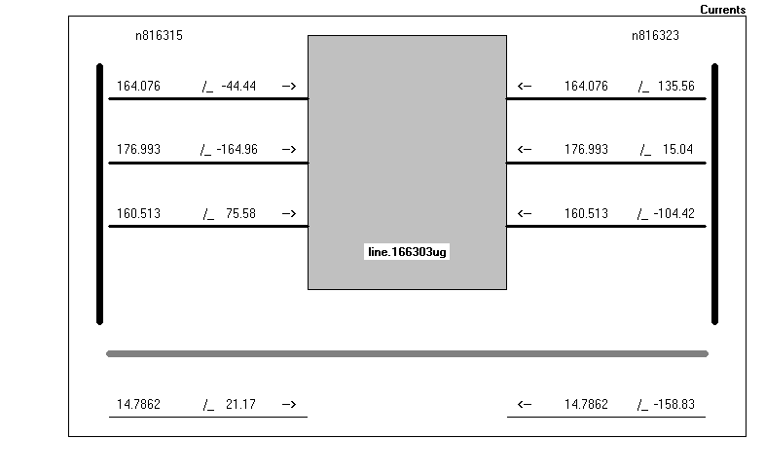
Visualize what=currents element= Line.Line1
Visualize powers Line.Line1

Voltages
Returns the voltages for the ACTIVE TERMINAL ONLY of the active circuit element in the Result string. For setting the active circuit element, see the Select command or the Set Terminal= property. Returned as magnitude and angle quantities, comma separated, one set per conductor of the terminal.

YearlyCurves
[cases=](case1, case2, ...) [registers=](reg1, reg2, ...) [meter=]{Totals* | SystemMeter | metername}
Plots yearly curves for specified cases and registers.
Default: meter=Totals. Example:
yearlycurves cases=(basecase, pvgens) registers=9

Ysc
Returns full short circuit admittance, Ysc, matrix for the ACTIVE BUS in comma-separated complex number form G + jB.

Zsc
Returns full Short circuit impedance, Zsc, matrix for the ACTIVE BUS in comma-separated complex number form.

Zsc10
Returns symmetrical component short-circuit impedances, Z1, Z0 for the ACTIVE BUS in comma-separated R+jX form.

ZscRefresh
Refreshes Zsc matrix for the ACTIVE BUS.
Check the on-line Help while the DSS is running for information on additional commands that might have been added since the printing of this manual.

Options Reference
DSS options are set using either the Set command or the Solve command. The Solve command first executes the Set and then executes a solution. This allows for more concise syntax for some cases. For example, the sequence
Set mode=snapshot
Solve
Set mode=harmonics
Solve

May be accomplished with just 2 lines:
Solve mode=snapshot
Solve mode=harmonics

Selected Options currently implemented are described below. Options are added frequently. Check the on-line Help.

%growth =
Set default annual growth rate, percent, for loads with no growth curve specified. Default is 2.5.

%mean =
Percent mean to use for global load multiplier. Default is 65%.

%Normal =
Sets the Normal rating of all lines to a specified percent of the emergency rating. Note: This action takes place immediately. Only the in-memory value is changed for the duration of the run.

%stddev =
Percent Standard deviation to use for global load multiplier. Default is 9%.

Addtype =
{Generator | Capacitor} Default is Generator. Type of device for AutoAdd Mode.

Algorithm =
{Normal | Newton} Solution algorithm type. Normal is a fixed point current-injection iteration that is a little quicker (about twice as fast) than the Newton iteration. Normal is adequate for most distribution systems. Newton is more robust for circuits that are difficult to solve.

AllocationFactors =
Sets all allocation factors for all loads in the active circuit to the value given. Useful for making an initial guess or forcing a particular allocation of load. The allocation factors may be set automatically by the energy meter elements by placing energy meters on the circuit, defining the PEAKCURRENT property, and issuing the ALLOCATELOADS command. The factors are applied to the XFkVA property of Load objects.

AllowDuplicates =
{YES/TRUE | NO/FALSE} Default is No. Flag to indicate if it is OK to have devices of same name in the same class. If No, then a New command is treated as an Edit command but adds an element if it doesn't exist already. If Yes, then a New command will always result in a device being added.

AutoBusList =
Array of bus names to include in AutoAdd searches. Or, you can specify a text file holding the names, one to a line, by using the syntax (file=filename) instead of the actual array elements. Default is null, which results in the program using either the buses in the EnergyMeter object zones or, if no EnergyMeters, all the buses, which can make for lengthy solution times.
Examples:
Set autobuslist=(bus1, bus2, bus3, ... )
Set autobuslist=(file=buslist.txt)

Basefrequency =
Default = 60. Set the fundamental frequency for harmonic solution and the default base frequency for all impedance quantities. Side effect: also changes the value of the solution frequency. See also DefaultBaseFrequency.

Bus =
Set Active Bus by name. Can also be done with Select and SetkVBase commands and the "Set Terminal=" option. The bus connected to the active terminal becomes the active bus. See Zsc and Zsc012 commands.

capkVAR =
Size of capacitor, kVAR, to automatically add to system. Default is 600.0.

casename =
Name of case for yearly simulations with demand interval data. Becomes the name of the subdirectory under which all the year data are stored. Default = circuit name
Side Effect: Sets the prefix for output files

Cfactors=
Similar to Set Allocationfactors= except this applies to the kWh billing property of Load objects. Sets all Load Cfactor properties to the same value. A typical value is 4. See online help on the Load object.

circuit =
Set the active circuit by name. (Current version allows only one circuit at a time, so this option is basically ignored at present.)

CktModel =
{Multiphase | Positive} Default = Multiphase. Designates whether circuit model is to interpreted as a normal multi-phase model or a positive-sequence only model. If Positive sequence, all power quantities are mulitiplied by 3 in reports and through any interface that reports a power quantity. Any line with sequence parameter inputs will use the long-line equivalent pi section.

Class =
Synonym for Type=. sets class (type) for the Active DSS Object. This becomes the Active DSS Class.

ControlMode =
{OFF | STATIC |EVENT | TIME} Default is "STATIC". Control mode for the solution. Set to OFF to prevent controls from changing.
STATIC = Time does not advance. Control actions are executed in order of shortest time to act until all actions are cleared from the control queue. Use this mode for power flow solutions which may require several regulator tap changes per solution. This is the default for the standard Snapshot mode as well as Daily and Yearly simulations where the stepsize is typically greater than 15 min.
EVENT = solution is event driven. Only the control actions nearest in time are executed and the time is advanced automatically to the time of the event.
TIME = solution is time driven. Control actions are executed when the time for the pending action is reached or surpassed. Use this for dutycycle mode and dynamic mode.
Controls may reset and may choose not to act when it comes their time to respond.
Use TIME mode when modeling a control externally to the DSS and a solution mode such as DAILY or DUTYCYCLE that advances time, or set the time (hour and sec) explicitly from the external program.

Datapath =
Set the data path for files written or read by the DSS. Defaults to the startup path. May be Null. Executes a CHDIR to this path if non-null. Does not require a circuit defined. You can also use the “cd” command from a script.

DefaultBaseFrequency=
Set Default Base Frequency, Hz. The default value when first installed is 60 Hz. Side effect: Sets the solution Frequency and default Circuit Base Frequency. This value is saved in the Windows Registry when the DSS closes down. Therefore, it need only be set one time. This is useful for users studying 50 Hz systems.

DefaultDaily =
Default daily load shape name. Default value is "default", which is a 24-hour curve defined when the DSS is started.

DefaultYearly =
Default yearly load shape name. Default value is "default", which is a 24-hour curve defined when the DSS is started. If no other curve is defined, this curve is simply repeated when in Yearly simulation mode.

DemandInterval =
{YES/TRUE | NO/FALSE} Default = no. Set for keeping demand interval data for daily, yearly, etc, simulations. Side Effect: Resets all meters!!!

DIVerbose =
{YES/TRUE | NO/FALSE} Default = FALSE. Set to Yes/True if you wish a separate demand interval (DI) file written for each meter. Otherwise, only the totalizing meters are written.

EarthModel =
One of {Carson | FullCarson | Deri*}. Default is Deri, which is a fit to the Full Carson that works well into high frequencies. "Carson" is the simplified Carson method that is typically used for 50/60 Hz power flow programs. Applies only to Line objects that use LineGeometry objects to compute impedances.

Editor=
Set the command string required to start up the editor preferred by the user. Defaults to Notepad. This is used to display certain reports from the DSS. Use the complete path name for any other Editor. Does not require a circuit defined. This value is saved in the Windows Registry and need only be specified one time. EPRI uses the EditPlus editor.

Element =
Sets the active DSS element by name. You can use the complete object spec (class.name) or just the name. if full name is specifed, class becomes the active class, also. See also the Select command.

Emergvmaxpu =
Maximum permissible per unit voltage for emergency (contingency) conditions. Default is 1.08.

Emergvminpu =
Minimum permissible per unit voltage for emergency (contingency) conditions. Default is 0.90.

Frequency =
sets the frequency for the next solution of the active circuit.

Genkw =
Size of generator, kW, to automatically add to system. Default is 1000.0

GenMult =
Global multiplier for the kW output of every generator in the circuit. Default is 1.0. Applies to Snapshot, Daily, and DutyCycle solution modes. Ignored if generator is designated as Status=Fixed.

Genpf =
Power factor of generator to assume for automatic addition. Default is 1.0.

h =
Alternate name for time step size (see Stepsize).

Harmonics =
{ALL | (list of harmonics) } Default = ALL. Array of harmonics for which to perform a solution in Harmonics mode. If ALL, then solution is performed for all harmonics defined in spectra currently being used. Otherwise, specify a more limited list such as:
Set Harmonics=(1 5 7 11 13)

Hour=
sets the hour to be used for the start time of the solution of the active circuit. (See also Time)

KeepList =
Array of bus names to keep when performing circuit reductions. You can specify a text file holding the names, one to a line, by using the syntax (file=filename) instead of the actual array elements. Command is cumulative (reset keeplist first). Reduction algorithm may keep other buses automatically.
Examples:
Reset Keeplist (sets all buses to FALSE (no keep))
Set KeepList=(bus1, bus2, bus3, ... )
Set KeepList=(file=buslist.txt)

LDcurve =
name of the Loadshape object to use for the global circuit Load-Duration curve. Used in solution modes LD1 and LD2 (see below). Must be set before executing those modes. Simply define the load-duration curve as a loadshape object. Default = nil.

LoadModel=
{"POWERFLOW" | "ADMITTANCE"} Sets the load model. If POWERFLOW (abbreviated P), loads do not appear in the System Y matrix. For iterative solution types (Mode ≠ Direct) loads (actually all PC Elements) are current injection sources. If ADMITTANCE, all PC elements appear in the System Y matrix and solution mode should be set to Direct (below) because there will be no injection currents.

LoadMult =
global load multiplier to be applied to all "variable" loads in the circuit for the next solution. Loads designated as "fixed" are not affected. Note that not all solution modes use this multiplier, but many do, including all snapshot modes. See Mode below. The default LoadMult value is 1.0. Remember that it remains at the last value to which it was set. Solution modes such as Monte Carlo and Load-Duration modes will alter this multiplier. Its value is usually posted on DSS control panels. Loads defined with "status=fixed" are not affected by load multipliers. (The default for loads is "status=variable".)

Log =
{YES/TRUE | NO/FALSE} Default = FALSE. Significant solution events are added to the Event Log, primarily for debugging.

LossRegs =
Which EnergyMeter register(s) to use for Losses in AutoAdd Mode. May be one or more registers. if more than one, register values are summed together. Array of integer values > 0. Defaults to 13 (for Zone kWh Losses).
For a list of EnergyMeter register numbers, do the "Show Meters" command after defining a circuit.

LossWeight =
Weighting factor for Losses in AutoAdd functions. Defaults to 1.0. Autoadd mode minimizes
(Lossweight * Losses + UEweight * UE).

If you wish to ignore Losses, set to 0. This applies only when there are EnergyMeter objects. Otherwise, AutoAdd mode minimizes total system losses.

Markercode =
Number code for node marker on circuit plots (these are currently the SDL Components MarkAt options with this version). Marker codes are:
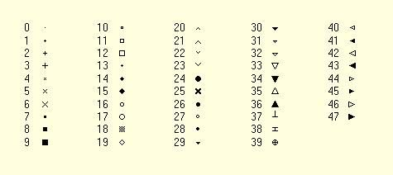

Markswitches =
{YES/TRUE | NO/FALSE} Default is NO. Mark lines that are switches or are isolated with a symbol. See SwitchMarkerCode.

Marktransformers =
{YES/TRUE | NO/FALSE} Default is NO. Mark transformer locations with a symbol. See TransMarkerCode. The coordinate of one of the buses for winding 1 or 2 must be defined for the symbol to show

Maxcontroliter =
Max control iterations per solution. Default is 10.

Maxiter =
Sets the maximum allowable iterations for power flow solutions. Default is 15.

Mode=
Specify the solution mode for the active circuit. Mode can be one of (unique abbreviation will suffice, as with nearly all DSS commands):

Mode=Snap:
Solve a single snapshot power flow for the present conditions. Loads are modified only by the global load multiplier (LoadMult) and the growth factor for the present year (Year).

Mode=Daily:
Do a series of solutions following the daily load curves. The Stepsize defaults to 3600 sec (1 hr). Set the starting hour and the number of solutions (e.g., 24) you wish to execute. Monitors are reset at the beginning of the solution. The peak of the daily load curve is determined by the global load multiplier (LoadMult) and the growth factor for the present year (Year).

Mode=Direct:
Solve a single snapshot solution using an admittance model of all loads. This is non-iterative; just a direct solution using the currently specified voltage and current sources.

Mode=Dutycycle:
Follow the duty cycle curves with the time increment specified. Perform the solution for the number of times specified by the Number parameter (see below).

Mode=Dynamics:
Sets the solution mode for a dynamics solution. Must be preceded by a successful power flow solution so that the machines can be initialized. Changes to a default time step of 0.001s and ControlMode = TIME. Generator models are changed to a voltage source behind the value specified for transient reactance for each generator and initialized to give approximately the same power flow as the existing solution. Be sure to set the number of time steps to solve each time the Solve command is given.

Mode=FaultStudy:
Do a full fault study solution, determining the Thevenin equivalents for each bus in the active circuit. Prepares all the data required to produce fault study report under the Show Fault command.

Mode=Harmonics:
Sets the solution mode for a Harmonics solution. Must be preceded by a successful power flow solution so that the machines and harmonics sources can be initialized. Loads are converted to harmonic current sources and initialized based on the power flow solution according to the Spectrum object associated with each Load. Generators are converted to a voltage source behind subtransient reactance with the voltage spectrum specified for each generator. A Direct solution is performed for each harmonic frequency (more precisely, non-power frequency). The system Y matrix is built for each frequency and solved with the defined injections from all harmonic sources. A solution is performed for each frequency found to be defined in all the spectra being used in the circuit. Note that to perform a frequency scan of a network, you would define a Spectrum object with a small frequency increment and assign it to either an Isource or Vsource object, as appropriate.

Mode=Yearly:
Do a solution following the yearly load curves. The solution is repeated as many times as the specified by the Number= option. Each load then follows its yearly load curve. Load is determined solely by the yearly load curve and the growth multiplier. The time step in past revisions was always 1 hour. However, it may now be any value.. Meters and Monitors are reset at the beginning of solution and sampled after each solution. If the yearly load curve is not specified, the daily curve is used and simply repeated if the number of solutions exceeds 24 hrs. This mode is nominally designed to support 8760-hr simulations of load, but can be used for any simulation that uses an hourly time step and needs monitors or meters.

Mode=LD1
(Load-Duration Mode 1): Solves for the joint union of a load-duration curve (defined as a Loadshape object) and the Daily load shape. Nominally performs a Daily solution (24-hr) for each point on the Load-duration (L-D) curve. Thus, the time axis of the L-D curve represents days at that peak load value. L-D curves begin at zero (0) time. Thus, a yearly L-D curve would be defined for 0..365 days. A monthly L-D curve should be defined for 0..31 days. Energy meters and monitors are reset at the beginning of the solution. At the conclusion, the energy meter values represent the total of all solutions. If the L-D curve represent one year, then the energy will be for the entire year. This mode is intended for those applications requiring a single energy number for an entire year, month, or other time period. Loads are modified by growth curves as well, so set the year before proceeding. Also, set the L-D curve (see Ldcurve option).

Mode=LD2
(Load-Duration Mode 2): Similar to LD1 mode except that it performs the Load-duration solution for only a selected hour on the daily load shape. Set the desired hour before executing the Solve command. The meters and monitors are reset at the beginning of the solution. At the conclusion, the energy meters have only the values for that hour for the year, or month, or whatever time period the L-D curve represents. The solver simply solves for each point on the L-D curve, multiplying the load at the selected hour by the L-D curve value. This mode has been used to generate a 3-D plot of energy vs. month and hour of the day.

Mode=M1
(Monte Carlo Mode 1): Perform a number of solutions allowing the loads to vary randomly. Executes number of cases specified by the Number option (see below). At each solution, each load is modified by a random multiplier -- a different one for each load. In multiphase loads, all phases are modified simultaneously so that the load remains balanced. The random variation may be uniform or gaussian as specified by the global Random option (see below). If uniform, the load multipliers are between 0 and 1. If gaussian, the multipliers are based on the mean and standard deviation of the Yearly load shape specified for the load. Be sure one is specified for each load.

Mode=M2
(Monte Carlo Mode 2): This mode is designed to execute a number of Daily simulations with the global peak load multiplier (LoadMult) varying randomly. Set time step size (h) and Number of solutions to run. "h" defaults to 3600 sec (1 Hr). Number of solutions refers to the number of DAYS. For Random = Gaussian, set the global %Mean and %Stddev variables, e.g. "Set %Mean=65 %Stddev=9". For Random=Uniform, it is not necessary to specify %Mean, since the global load multiplier is varied from 0 to 1. For each day, the global peak load multiplier is generated and then a 24 hour Daily solution is performed at the specified time step size.

Mode=M3
(Monte Carlo Mode 3): This mode is similar to the LD2 mode except that the global load multiplier is varied randomly rather than following a load-duration curve. Set the Hour of the day first (either Set Time=… or Set Hour=…). Meters and monitors are reset at the beginning of the solution. Energy at the conclusion of the solution represents the total of all random solutions. For example, one might use this mode to estimate the total annual energy at a given hour by running only 50 or 100 solutions at each hour (rather than 365) and ratioing up for the full year.

Mode=MF
(Monte Carlo Fault mode). One of the faults defined in the active circuit is selected and its resistance value randomized. All other Faults are disabled. Executes number of cases specified by the Number parameter.

Mode=Peakdays:
Do daily solutions (24-hr) only for those days in which the peak exceeds a specified value.

Nodewidth =
Width of node marker in circuit plots. Default=1.

Normvmaxpu =
Maximum permissible per unit voltage for normal conditions. Default is 1.05.

Normvminpu =
Minimum permissible per unit voltage for normal conditions. Default is 0.95.

NumAllocIterations =
Default is 2. Maximum number of iterations for load allocations for each time the AllocateLoads or Estimate command is given. Usually, 2 are sufficient, but some cases are more difficult. Execute an Export Estimation report to evaluate how well the load allocation has worked.

Number=
specify the number of time steps or solutions to run or the number of Monte Carlo cases to run.

Object (or Name)=
sets the name of the Active DSS Object. Use the complete object specification (classname.objname), or simply the objname, to designate the active object which will be the target of the next command (such as the More command). If 'classname' is omitted, you can set the class by using the Class= field.

Overloadreport =
{YES/TRUE | NO/FALSE} Default = FALSE. For yearly solution mode, sets overload reporting on/off. DemandInterval must be set to true for this to have effect.

PriceCurve =
Sets the curve to use to obtain for price signal. Default is none (null string). If none, price signal either remains constant or is set by an external process. Curve is defined as a loadshape (not normalized) and should correspond to the type of analysis being performed (daily, yearly, load-duration, etc.).

PriceSignal =
Sets the price signal ($/MWh) for the circuit. Initial value is 25.

Random=
specify the mode of random variation for Monte Carlo studies: One of [Uniform | Gaussian | Lognormal | None ] for Monte Carlo Variables May abbreviate value to "G", “L”, or "U" where G = gaussian (using mean and std deviation for load shape); L = lognormal (also using mean and std dev); U = uniform (varies between 0 and 1 randomly). Anything else: randomization disabled.

Recorder =
{YES/TRUE | NO/FALSE} Default = FALSE. Opens DSSRecorder.DSS in DSS install folder and enables recording of all commands that come through the text command interface. Closed by either setting to NO/FALSE or exiting the program. When closed by this command, the file name can be found in the Result. Does not require a circuit defined.

ReduceOption =
{ Default or [null] | Stubs [Zmag=nnn] | MergeParallel | BreakLoops | Switches | TapEnds [maxangle=nnn] | Ends} Strategy for reducing feeders. Default is to eliminate all dangling end buses and buses without load, caps, or taps.
"Stubs [Zmag=0.02]" merges short branches with impedance less than Zmag (default = 0.02 ohms
"MergeParallel" merges lines that have been found to be in parallel
"Breakloops" disables one of the lines at the head of a loop.
"Tapends [maxangle=15]" eliminates all buses except those at the feeder ends, at tap points and where the feeder turns by greater than maxangle degrees.
"Ends" eliminates dangling ends only.
"Switches" merges switches with downline lines and eliminates dangling switches.
Marking buses with "Keeplist" will prevent their elimination.

Sec =
sets the seconds from the hour for the start time for the solution of the active circuit. (See also Time)

ShowExport=
{YES/TRUE | NO/FALSE} Default = FALSE. If YES/TRUE will automatically show the results of an Export command after it is written. Normally, the result of an Export command (a CSV file) is not automatically displayed.

Stepsize (or h)=
sets the time step size (default unit is sec) for the solution of the active circuit. Normally, specified for dynamic solution but is also, used for duty-cycle load following solutions. Yearly simulations typically go hour-by-hour and daily simulations follow the smallest increment of the daily load curves. Yearly simulations can also go in any time increment. Reasonable default values are set when you change solution modes. You may specify the stepsize in seconds, minutes, or hours by appending ‘s’, ‘m’, or ‘h’ to the size value. If omitted, ‘s’ is assumed. Example: “set stepsize=15m” is the same as “set stepsize=900.” Do not leave a space between the value and the character.

Switchmarkercode =
Numeric marker code for lines with switches or are isolated from the circuit. Default is 4. See markswitches option and markercode option.

Terminal =
Set the active terminal of the active circuit element. May also be done with Select command.

Time=
Specify the solution start time as an array : time="hour, sec" or time = (hour, sec): e.g., time = (23, 370) designate 6 minutes, 10 sec past the 23rd hour.

tolerance=
Sets the solution tolerance. Default is 0.0001.

TraceControl =
{YES/TRUE | NO/FALSE} Set to YES to trace the actions taken in the control queue. Creates a file named TRACE_CONTROLQUEUE.CSV in the default directory. The names of all circuit elements taking an action are logged.

TransMarkerCode =
Numeric marker code for transformers. Default is 35. See MarksTransformers option and MarkerCode option.

TransMarkerSize =
Size of transformer marker. Default is 1.

Trapezoidal =
{YES/TRUE | NO/FALSE} Default is "No". Specifies whether to use trapezoidal integration for accumulating energy meter registers. Applies to EnergyMeter and Generator objects. Default method simply multiplies the present value of the registers times the width of the interval. Trapezoidal is more accurate when there are sharp changes in a load shape or unequal intervals. Trapezoidal is automatically used for some load-duration curve simulations where the interval size varies considerably. Keep in mind that for Trapezoidal, you have to solve one more point than the number of intervals. That is, to do a Daily simulation on a 24-hr load shape, you would set Number=25 to force a solution at the first point again to establish the last (24th) interval.

Type=
Sets the active DSS class type. Same as Class=...

Ueregs =
Which EnergyMeter register(s) to use for UE in AutoAdd Mode. May be one or more registers. if more than one, register values are summed together. Array of integer values > 0. Defaults to 11 (for Load EEN).
For a list of EnergyMeter register numbers, do the "Show Meters" command after defining a circuit.

Ueweight=
Weighting factor for UE/EEN in AutoAdd functions. Defaults to 1.0.
Autoadd mode minimizes
(Lossweight * Losses + UEweight * UE).
If you wish to ignore UE, set to 0. This applies only when there are EnergyMeter objects. Otherwise, AutoAdd mode minimizes total system losses.

Voltagebases=
Define legal bus voltage bases for this circuit. Enter an array of the legal voltage bases, in phase-to-phase voltages, for example:
set voltagebases=[.208, .480, 12.47, 24.9, 34.5, 115.0, 230.0]
When the CalcVoltageBases command is issued, a snapshot solution is performed with no load injections and the bus base voltage is set to the nearest legal voltage base. The defaults are as shown in the example above.
The DSS does not use per unit values in its solution. You only need to set the voltage bases if you wish to see per unit values on the reports or if you intend to use the AutoAdd feature.

Voltexceptionreport=
{YES/TRUE | NO/FALSE} Default = FALSE. For yearly solution mode, sets voltage exception reporting on/off. DemandInterval must be set to true for this to have effect.

Year=
sets the Year to be used for the next solution of the active circuit; the base case is year 0. Used to determine the growth multiplier for each load. Each load may have a unique growth curve (defined as a Growthshape object).

ZoneLock =
{YES/TRUE | NO/FALSE} Default is No. if No, then meter zones are recomputed each time there is a change in the circuit. If Yes, then meter zones are not recomputed unless they have not yet been computed. Meter zones are normally recomputed on Solve command following a circuit change.

General OpenDSS Object Property Descriptions
These are objects common to all circuits in the OpenDSS (there may be several circuits loaded into memory at any one time). Any circuit can reference the data contained in the General DSS Objects
The following describes each object class and the parameters that may be defined through the command interface.
Note that all DSS objects have a Like parameter. When another element of the same class is very similar to a new one being created, use the Like parameter to start the definition then change the parameters that differ. Issue the Like=nnnn parameter first. Command lines are parsed and executed from left to right.

LineCode
LineCode objects are general library objects that contain impedance characteristics for lines and cables. The term "line code" is an old term that simply refers to a code that was made up by programmers to describe a line construction. In most distribution analysis programs, one can describe a line by its LineCode and its length. LineCode objects were defined in a separate file. This collection of objects emulates the old linecode files, except that the concept is a little more powerful.
Ultimately, the impedance of a line is described by its series impedance matrix and nodal capacitive admittance matrix. These matrices may be specified directly or they can be generated by specifying the symmetrical component data. Note that the impedances of lines may be specified directly and one does not need to use a line code, although the linecode will be more convenient most of the time. There may be hundreds of lines, but only a few different kinds of line constructions.
LineCode can also perform a Kron reduction, reducing out the last conductor in the impedance matrices, which is assumed to be a neutral conductor. This applies only if the impedance is specified as a matrix. If the impedance is defined as symmetrical components, this function does not apply because symmetrical component values already assume the reduction.
By specifying the values of Rg, Xg, and rho, the DSS will take the base frequency impedance matrix values and adjust the earth return component for frequency. Skin effect in the conductors is not modified. To represent skin effect, you have to define the geometry.
This assumes the impedance matrix is constructed as follows:
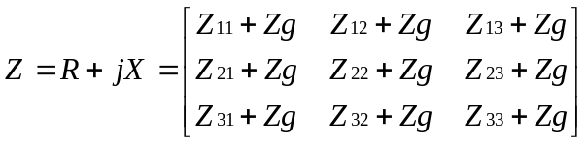
Where, using the 1st term of Carson’s formulation,
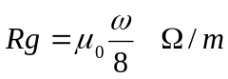
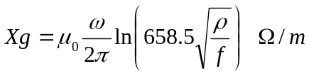
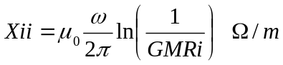
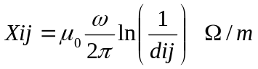
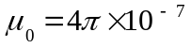
(All dimensional values in meters.)
The LineCode properties, in order, are: (not case sensitive)
Nphases= Number of phases. Default = 3.
R1 = Positive-Sequence resistance, ohms per unit length.
X1 = Positive-Sequence reactance, ohms per unit length.
R0 = Zero-Sequence resistance, ohms per unit length.
X0 = Zero-Sequence reactance, ohms per unit length.
C1= Positive-Sequence capacitance, nanofarads per unit length
C0= Zero-Sequence capacitance, nanofarads per unit length
Units= {mi | km | kft | m | ft | in | cm} Length units. If not specified, it is assumed that the units correspond to the length being used in the Line models.
If any of the Symmetrical Component data is specified, the impedance matrices are determined from that data. You may also enter the matrices directly using the following three parameters. The order of matrices expected is the number of phases. The matrices may be entered in lower triangle form or full matrix. The result is always symmetrical. Matrices are specified by the syntax shown below. The "|" separates rows. Extraneous numbers on each row are ignored.
Rmatrix="11 | 21 22 | 31 32 33"
Rmatrix= Series resistance matrix, ohms per unit length..
Xmatrix= Series reactance matrix, ohms per unit length.
Cmatrix= Shunt nodal capacitance matrix, nanofarads per unit length.
BaseFreq= Base Frequency at which the impedance values are specified. Default = 60.0 Hz.
Normamps= Normal ampacity, amps.
Emergamps= Emergency ampacity, amps.
Faultrate= Number of faults per year per unit length. This is the default for this general line construction.
Pctperm= Percent of the fault that become permanent (requiring a line crew to repair and a sustained interruption).
Kron= Y/N. Default=N. Perform Kron reduction on the impedance matrix after it is formed, reducing order by 1. Do this only on initial definition after matrices are defined. Ignored for symmetrical components.
Rg= Carson earth return resistance per unit length used to compute impedance values at base frequency. See description above. For making better adjustments of line impedance values for frequency for harmonics studies. Default= 0.01805 ohms per 1000 ft at 60 Hz. If you do not wish to adjust the earth return impedance for frequency, set both Rg and Xg to zero. Generally avoid Kron reduction if you will be solving at frequencies other than the base frequency and wish to adjust the earth return impedance.
Xg= Carson earth return reactance per unit length used to compute impedance values at base frequency. See description above. For making better adjustments of line impedance values for frequency for harmonics studies. Default= 0.155081 ohms per 1000 ft at 60 Hz. If you do not wish to adjust the earth return impedance for frequency, set both Rg and Xg to zero. Generally avoid Kron reduction if you will be solving at frequencies other than the base frequency and wish to adjust the earth return impedance.
Rho= Earth resistivity used to compute earth correction factor. Default=100 meter ohms.
Like= Name of an existing LineCode object to build this like.

LineGeometry
This class of data is used to define the positions of the conductors.
Nconds= Number of conductors in this geometry. Default is 3. Triggers memory allocations. Define first!
Nphases= Number of phases. Default =3; All other conductors are considered neutrals and might be reduced out.
Cond= Set this to number of the conductor you wish to define. Default is 1.
Wire= Code from WireData. MUST BE PREVIOUSLY DEFINED. no default.
X= x coordinate.
H= Height of conductor.
Units= Units for x and h: {mi|kft|km|m|Ft|in|cm } Initial default is "ft", but defaults to last unit defined
Normamps= Normal ampacity, amperes for the line. Defaults to first conductor if not specified.
Emergamps= Emergency ampacity, amperes. Defaults to first conductor if not specified.
Reduce= { Yes | No} Default = no. Reduce to Nphases (Kron Reduction). Reduce out neutrals.
Like= Make like another object, e.g.:
New Capacitor.C2 like=c1 ...

Line Constants Examples
Define the wire data:
New Wiredata.ACSR336 GMR=0.0255000 DIAM=0.7410000 RAC=0.3060000
~ NormAmps=530.0000
~ Runits=mi radunits=in gmrunits=ft
New Wiredata.ACSR1/0 GMR=0.0044600 DIAM=0.3980000 RAC=1.120000
~ NormAmps=230.0000
~ Runits=mi radunits=in gmrunits=ft

Define the Geometry data:
New Linegeometry.HC2_336_1neut_0Mess nconds=4 nphases=3
~ cond=1 Wire=acsr336 x=-1.2909 h=13.716 units=m
~ cond=2 Wire=acsr336 x=-0.502 h=13.716 !units=m
~ cond=3 Wire=acsr336 x=0.5737 h=13.716 !units=m
~ cond=4 Wire= ACSR1/0 x=0 h=14.648 ! units=m ! neutral

Define a 300-ft line section:
New Line.Line1 Bus1=xxx Bus2=yyy
~ Geometry= HC2_336_1neut_0Mess
~ Length=300 units=ft

Check out the line constants at 60 and 600 Hz in per km values. This command shows line constants for all defined geometries:
Show lineconstants freq=60 units=km
Show lineconstants freq=600 units=km

If the number of conductors = 3, this Show command will also give you the sequence impedances. If your geometry has more than 3 conductors and you want to see the sequence impedance, define
nconds = (...whatever...)
nphases = 3
Reduce=Yes

This will force the impedance matrices to be reduced to 3x3 and the Show LineConstants command will automatically give the sequence impedances. Note: make sure the phase conductors are defined first in the geometry definition.
No automatic assembly of bundled conductors is available yet. However, you can specifically define the position of each conductor in the geometry definition and connect them up explicitly in the DSS, for example, for a two conductor bundle:
New Line.2Bundled bus1=FromBus.1.1.2.2.3.3 ToBus.1.1.2.2.3.3
~ Geometry=2BundleGeometry Length= etc. etc.

LoadShape
A Loadshape object is very important for all types of sequential power flow solutions. A LoadShape object consists of a series of multipliers, typically ranging from 0.0 to 1.0 that are applied to the base kW values of the load to represent variation of the load over some time period.
Load shapes are generally fixed interval, but may also be variable interval. For the latter, both the time, hr, and the multiplier must be specified.
All loadshapes, whether they be daily, yearly, or some arbitrary duty cycle, are maintained in this class. Each load simply refers to the appropriate shape by name.
The loadshape arrays may be entered directly in command line, or the load shapes may be stored in one of three different types of files from which the shapes are loaded into memory.
The properties for LoadShape objects are:
Npts= Number of points to expect when defining the curve
Interval= time interval of the data, Hr. Default=1.0. If the load shape has non-uniformly spaced points, specify the interval as 0.0.
mInterval= Specify Interval in minutes.
sInterval= Specify Interval in seconds.
Mult= Array of multiplier values. Looking for Npts values. To enter an array, simply enclose a series of numbers in double quotes “…”, single quotes ‘…’, or parentheses(..). Omitted values are assumed to be zero. Extra values are ignored. You may also use the syntax:
Mult=[file=myfile.txt]
Mult=[dblfile=myfile.dbl]
Mult=[sngfile=myfile.sng]

This syntax will work on just about any property of any class of element in the OpenDSS where an array of numbers is expected. The addition of the capability to handle the two packed binary file types should significantly speed up the importing of AMI data into Loadshape objects. (see UseActual property) Also, the way the Mean and Std Deviation calculation is done has been changed to delay calculation until these values are actually needed. This should minimize the computing overhead on reading loadshapes back in
Hour= Array of hour values corresponding to the multipliers. Not required if Interval>0. You may also use the syntax: hour=(file=filename.ext) in which the hour array values are entered one per line in the text file referenced. Again, this is not required for fixed interval load shape curves.
QMult= Array of multiplier values. Same property rules as the Mult property. If specified, the multiplier is applied to the Load (or Generator) kvar value. If omitted, the value of Mult is applied to the kvar value.

Mean= Mean of the multiplier array. In prior versions, the mean and standard deviation were always computed after an array of points are entered or normalized (see below). From version 7.3, the mean and standard deviation are computed only if requested to same time when processing many AMI curves. If you are doing only parametric load studies using the Monte Carlo solution mode, only the Mean and Std Deviation are required to define a loadshape. These two values may be defined directly rather than by supplying the curve. Of course, the multiplier points are not generated.
Stddev= Standard Deviation (see Mean, above).
The next three properties instruct the LoadShape object to get its data from a file. Three different formats are allowed. If Interval>0 then only the multiplier is entered. For variable interval data, set Interval=0.0 and enter both the time (in hours) and multiplier, in that order for each interval.
Csvfile= Name of a CSV file containing load shape data, one interval to a line. For variable interval data enter one (hour, multiplier) point to a line with the values separated by a comma. Otherwise there is simply one value to a line.
Sngfile= Name of a binary file of single-precision floating point values containing the load shape data. The file is packed. For fixed interval data, the multipliers are packed in order. For variable interval data, start with the first hour point and alternate with the multiplier value.
Dblfile= Name of a binary file of double-precision floating point values containing the load shape data. The file is packed. For fixed interval data, the multipliers are packed in order. For variable interval data, start with the first hour point and alternate with the multiplier value.
Action= {Normalize | DblSave | SngSave} After defining load curve data, setting action=normalize will modify the multipliers so that the peak is 1.0. The mean and std deviation are recomputed. Setting action=DblSave or SngSave will cause the present mult and qmult values to be written to either a packed file of double or single, respectively. The filename is the loadshape name. The mult array will have a "_P" appended on the file name and the qmult array, if it exists, will have "_Q" appended.
UseActual= {Yes | No* | True | False*} If true, signals to Load, Generator, or other objects to use the value of the multiplier as the actual kW, kvar value rather than a multiplier. Nominally for entering AMI data. Do not use Action=Normalize with UseActual=Yes.
Pmax, Qmax= If you define the LoadShape object with UseActual=Yes, when you define any of the Duty, Daily, or Yearly properties of a load or generator, the kW property is redefined to the kW and kvar values at the time of the peak kW in the loadshape. This will be the value used for the initial Snapshot solution. If you define more than one loadshape object, the last one overrides any previous definition, as with all OpenDSS properties. You can query the Pmax and Qmax properties of the Loadshape object to see what was computed. Keep in mind that the Qmax value is the value of kvar at the time of maximum kW, if defined using the Qmult property. If you want something different, you may override the computed values by setting either or both of these properties after reading in the loadshapes. If you want something else, you will need to redefine kW and kvar (or kW, PF) after you set the Duty, Daily, or Yearly properties.
Pbase= Base P value for normalization. Default is zero, meaning the peak will be used.
Like= Name of an existing loadshape object to base this one on.

GrowthShape
A GrowthShape object is similar to a Loadshape object. However, it is intended to represent the growth in load year-by-year and the way the curve is specified is entirely different. You must enter the growth for the first year. Thereafter, only the years where there is a change must be entered. Otherwise it is assumed the growth stays the same.
Growth rate is specified by specifying the multiplier for the previous year's load. Thus, if the load grows 2.5% in 1999, the multiplier for that year will be specified as 1.025.
(If no growth shape is specified, the load growth defaults to the circuit's default growth rate -- see Set %Growth command).
The parameters are:
Npts= Number of points to expect when defining the curve.
Year= Array of year values corresponding to the multiplier values. Enter only those years in which the multiplier changes. Year data may be any integer sequence -- just so it's consistent for all growth curves. Setting the global solution variable Year=0 causes the growth factor to default to 1.0, effectively neglecting growth. This is what you would do for all base year analyses.
You may also use the syntax: year=(file=filename.ext) in which the array values are entered one per line in the text file referenced.
Mult= Array of Multiplier values corresponding to the year values. Enter multiplier by which the load will grow in this year.
Example:
New growthshape.name npts=3 year="1999 2003 2007" mult="1.10 1.05 1.025"
This defines a growthshape the a 10% growth rate for 1999-2002. Beginning in 2003, the growth tapers off to 5% and then to 2.5% for 2007 and beyond.
Normally, only a few points need be entered and the above parameters will be quite sufficient. However, provision has been made to enter the (year, multiplier) points from files just like the LoadShape objects. You may also use the syntax: mult=(file=filename.ext) in which the array values are entered one per line in the text file referenced.
Csvfile= Name of a csv file containing one (year, mult) point per line. Separate the year from the multiplier by a comma.
Sngfile= Name of a file of single-precision numbers containing (year, mult) points packed.
Dblfile= Name of a file of single-precision numbers containing (year, mult) points packed.
Like= Name of an existing GrowthShape object to base this one on.

TCC_Curve
A TCC_Curve object is defined similarly to Loadshape and Growthshape objects in that they all are defined by curves consisting of arrays of points. Intended to model time-current characteristics for overcurrent relays, TCC_Curve objects are also used for other relay types requiring time curves. Both the time array and the C array must be entered.
The properties are:
Npts= Number of points to expect when defining the curve.
C_Array= Array of current (or voltage or whatever) values corresponding to time values in T_Array (see T_Array).
T_Array= Array of time values in sec. Typical array syntax:
t_array = (1, 2, 3, 4, ...)
You may also substitute a file designation: t_array = (file=filename). The specified file has one value per line.
Like= Name of an existing GrowthShape object to base this one on.

WireData
This class of data defines the raw conductor data that is used to compute the impedance for a line geometry.
Note that you can use whatever units you want for any of the dimensional data – be sure to declare the units. Otherwise, the units are all assumed to match, which would be very rare for conductor data. Conductor data is usually supplied in a hodge-podge of units. Everything is converted to meters internally to the DSS
Rdc= dc Resistance, ohms per unit length (see Runits). Defaults to Rac if not specified.
Rac= Resistance at 60 Hz per unit length. Defaults to Rdc if not specified.
Runits= Length units for resistance: ohms per {mi|kft|km|m|Ft|in|cm } Default=none.
GMRac= GMR at 60 Hz. Defaults to .7788*radius if not specified.
GMRunits= Units for GMR: {mi|kft|km|m|Ft|in|cm } Default=none.
Radius= Outside radius of conductor. Defaults to GMR/0.7788 if not specified.
Radunits= Units for outside radius: {mi|kft|km|m|Ft|in|cm } Default=none.
Normamps= Normal ampacity, amperes. Defaults to Emergency amps/1.5 if not specified.
Emergamps= Emergency ampacity, amperes. Defaults to 1.5 * Normal Amps if not specified.
Diam= Diameter; Alternative method for entering radius.
Like= Make like another object of this class:

See Help in the EXE version of the program for more General objects.
DSS Circuit Element Object Descriptions
The following are descriptions of key DSS circuit elements. This section is by no means complete and often lags well behind implementations of new elements. However, this should be enough to get you started with DSS simulations. New circuit element classes may be added at any time. Check the on-line help for brief help on new elements.

Source and Other Objects

Vsource Object
Voltage source. This is a special power conversion element. It is special because voltage sources are used to initialize the power flow solution with all other injection sources set to zero.
A Vsource object is a two-terminal, multi-phase Thevenin equivalent. That is, it is a voltage source behind an impedance. The data are specified as it would commonly be for a power system source equivalent: Line-line voltage (kV) and short circuit MVA.
The most common way to use a voltage source object is with the first terminal connected to the bus of interest with the second terminal connected to ground (voltage reference). In this usage, the connection of the second terminal may be omitted. In 2009, the voltage source was changed from a single-terminal device to a two-terminal device. This allows for the connection of a voltage source between two buses, which is convenient for some types of studies.
The properties are, in order:
Bus1= Name of bus to which the source's first terminal is connected. Remember to specify the node order if the terminals are connected in some unusual manner. Side effect: The processing of this property results in the setting of the Bus2 property so that all conductors in terminal 2 are connected to ground. For example,
Bus1= busname
Has the side effect of setting Bus2=busname.0.0.0
Bus2= Name of bus to which the source’s second terminal is connected. If omitted, the second terminal is connected to ground (node 0) at the bus designated by the Bus1 property.
basekv= base or rated Line-to-line kV.
pu= Actual per unit at which the source is operating. Assumed balanced for all phases.
Angle= Base angle, degrees, of the first phase.
Frequency= frequency of the source.
Phases= Number of phases. Default = 3.0.
Mvasc3= 3-phase short circuit MVA= kVBase² / Z_{SC}
Mvasc1= 1-phase short circuit MVA. There is some ambiguity concerning the meaning of this quantity For the DSS, it is defined as kVBase² / Z_{1-phase} where
Z_{1-phase} = 1/3 (2Z₁+Z₀)
Thus, unless a neutral reactor is used, it should be a number on the same order of magnitude as Mvasc3.
x1r1= Ratio of X1/R1. Default = 4.0.
x0r0= Ratio of X0/R0. Default = 3.0.
Isc3 = Alternate method of defining the source impedance. 3-phase short circuit current, amps. Default is 10000.
Isc1 = Alternate method of defining the source impedance. single-phase short circuit current, amps. Default is 10500.
R1 = Alternate method of defining the source impedance. Positive-sequence resistance, ohms. Default is 1.65.
X1 = Alternate method of defining the source impedance. Positive-sequence reactance, ohms. Default is 6.6.
R0 = Alternate method of defining the source impedance. Zero-sequence resistance, ohms. Default is 1.9.
X0 = Alternate method of defining the source impedance. Zero-sequence reactance, ohms. Default is 5.7.
ScanType= {pos*| zero | none} Maintain specified symmetrical component sequence to assume for Harmonic mode solution. Default is positive sequence. Otherwise, angle between phases rotates freely with harmonic.
Sequence= {pos*| neg | zero} Set the phase angle relationships for the specified symmetrical component sequence for solution modes other than Harmonics. Default is positive sequence.
Spectrum= Name of harmonic spectrum for this source. Default is "defaultvsource", which is defined when the DSS starts.
BaseFreq = Base Frequency for impedance specifications. Default is 60 Hz.
like= Name of an existing Vsource object on which to base this one.

Isource Object
Current source. This is a one-terminal current source object that can be connected to any bus. Its most common use is likely to be used to represent harmonic sources and to be used in frequency response scans of circuit models. You can perform positive- or zero-sequence scans.
You can generally attach as many Isource objects to a bus as you want. An Isource is assumed to be ideal and its Yprim matrix is zero.
Properties:
phases Number of phases. Defaults to 3. For 3 or less, phase shift defaults to 120 degrees.
bus1 Name of bus to which source is connected.
bus1=busname
bus1=busname.1.2.3
amps Magnitude of current source, each phase, in Amps.
angle Phase angle in degrees of first phase: e.g.,Angle=10.3.
Phase shift between phases defaults to 120 degrees when number of phases <= 3
frequency Source frequency. Defaults to circuit fundamental frequency.
scantype {pos*| zero | none} Maintain specified sequence for harmonic solution. Default is positive sequence. Otherwise, angle between phases rotates with harmonic.
sequence {pos*| neg | zero} Set the phase angles for the specified symmetrical component sequence for solution modes other than Harmonics. Default is positive sequence.
spectrum Harmonic spectrum assumed for this source. Default is "default".

Inherited properties
basefreq Base Frequency for ratings.
enabled {Yes|No or True|False} Indicates whether this element is enabled.
like Make like another object, e.g.:
New Isource.Is2 like=Is1 ...

Fault Object
A Fault object is a resistor network that can be configured in a variety of ways. It is nominally designed with the same philosophy as the Capacitor. That is, it is a two-terminal device in which the second terminal defaults to ground. This is often what is desired when simulating a fault. However, the OpenDSS Fault object may be configured to do much more and can be configured to represent any type of fault. For example, it can be connected between transmission overbuild and distribution underbuild to simulate the transmission falling on the distribution circuit.
A Fault object is a standard Power Delivery component. You can have as many Fault objects on the circuit as you wish (some may cause the power flow solution to diverge – if so, switch to a direct solution or a dynamic solution). For Monte Carlo fault mode (MF) you will distribute Fault objects all over the circuit is some proportion. The solver will enable one at a time for each solution.
Since the Fault object is nothing more than a resistor network, you may use it for purposes other than modeling short circuit faults – anything that requires a resistor model. With the Gmatrix property a very complex resistive network can be modeled. For example, you may wish to represent a fault that has one resistance L-L and another L-ground. Note that it is specified as a nodal conductance matrix.
In time mode simulations such as Dynamics, the initiation of the fault can be delayed (ONtime property) and it will automatically clear itself when the current drops below a certain level (MinAmps property) if the fault is declared to be Temporary.
phases Number of Phases. Default is 1.
bus1 Name of first bus. Examples:
bus1=busname
bus1=busname.1.2.3
bus2 Name of 2nd bus. Defaults to all phases connected to first bus, node 0, if not specified. (Shunt Wye to ground connection)
R Resistance, each phase, ohms. Default is 0.0001. Assumed to be Mean value if gaussian random mode.Max value if uniform mode. A Fault is actually a series resistance that defaults to a wye connection to ground on the second terminal. You may reconnect the 2nd terminal to achieve whatever connection. Use the Gmatrix property to specify an arbitrary conductance matrix.
Gmatrix Use this to specify a nodal conductance (G) matrix to represent some arbitrary resistance network. Specify in lower triangle form as usual for DSS matrices.
MinAmps Minimum amps that can sustain a temporary fault. Default is 5.
ONtime Time (sec) at which the fault is established for time varying simulations. Default is 0.0 (on at the beginning of the simulation)
pctperm Percent of failures that become permanent. (not used)
Temporary {Yes | No} Default is No. Designate whether the fault is temporary. For Time-varying simulations, the fault will be removed if the current through the fault drops below the MINAMPS criteria.
%stddev Percent standard deviation in resistance to assume for Monte Carlo fault (MF) solution mode for GAUSSIAN distribution. Default is 0 (no variation from mean).

Standard Inherited Properties (may not apply to Fault elements)
normamps Normal rated current.
emergamps Maximum current.
basefreq Base Frequency for ratings.
faultrate No. of failures per year.
repair Hours to repair.
enabled {Yes|No or True|False} Indicates whether this element is enabled.
like Make like another object, e.g.:
New Fault.F2 like=F1 ...

Power Delivery Elements (PDelement)

Capacitor Object
The capacitor model is basically implemented as a two-terminal power delivery element. However, if you don't specify a connection for the second bus, it will default to the 0 node (ground reference) of the same bus to which the first terminal is connected. That is, it defaults to a grounded wye (star) shunt capacitor bank.
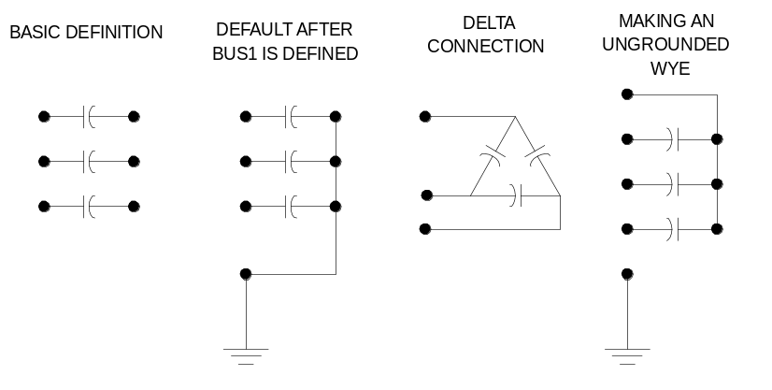
Figure 17: Definition of Capacitor Object
If you specify the connection to be "delta" then the second terminal is eliminated.
If you wish a series capacitor, simply specify a second bus connection.
If you wish an ungrounded wye capacitor, set all the second terminal conductors to an empty node on the first terminal bus, e.g.:
Bus1=B1 bus2 = B1.4.4.4 ! for a 3-phase capacitor

Of course, any other connection is possibly by explicitly specifying the nodes.
While the Capacitor object may be treated as if it were a single capacitor bank, it is actually implemented as a multistep tuned filter bank. Many of the properties can be specified as arrays. See Numsteps property.
If you wish to represent a filter bank, specify either the XL or Harm property. When a Capcontrol object switches a capacitor, it does so by incrementing or decrementing the active step.
Properties, in order, are:
Bus1= Definition for the connection of the first bus. When this is set, Bus2 is set to the same bus name, except with all terminals connected to node 0 (ground reference). Set Bus 2 at some time later if you wish a different connection.
Bus2= Bus connection for second terminal. Must always be specified after Bus1 for series capacitor. Not necessary to specify for delta or grd-wye shunt capacitor. Must be specified to achieve an ungrounded neutral point connection.
Phases= Number of phases. Default is 3.
Kvar= Most common of three ways to define a power capacitor. Rated kvar at rated kV, total of all phases. Each phase is assumed equal. Normamps and Emergamps automatically computed. Default is 600.0 kvar. Total kvar, if one step, or ARRAY of kvar ratings for each step. Evenly divided among phases. See rules for NUMSTEPS.
Kv= Rated kV of the capacitor (not necessarily same as bus rating). For Phases=2 or Phases=3, enter line-to-line (phase-to-phase) rated voltage. For all other numbers of phases, enter actual can rating. (For Delta connection this is always line-to-line rated voltage). Default is 12.47 kV.
Conn= Connection of bank. One of {wye | ln} for wye connected banks or {delta | ll} for delta (line-line) connected banks. Default is wye (or straight-through for series capacitor).
Cmatrix= Alternate method of defining a capacitor bank. Enter nodal capacitance matrix in μf. Can be used to define either series or shunt banks. Form should be:
Cmatrix=[c₁₁ | -c₂₁ c₂₂ | -c₃₁ -c₃₂ c₃₃]
All steps are assumed the same if this property is used.
Cuf= Alternate method of defining a capacitor bank. Enter a value or ARRAY of values for C in μf. ARRAY of Capacitance, each phase, for each step, microfarads. See Rules for NumSteps.
R = ARRAY of series resistance in each phase (line), ohms. Default is 0.0
XL = ARRAY of series inductive reactance(s) in each phase (line) for filter, ohms at base frequency. Use this OR "h" property to define filter. Default is 0.0.
Harm = ARRAY of harmonics to which each step is tuned. Zero is interpreted as meaning zero reactance (no filter). Default is zero.
Numsteps = Number of steps in this capacitor bank. Default = 1. Forces reallocation of the capacitance, reactor, and states array. Rules: If this property was previously =1, the value in the kvar property is divided equally among the steps. The kvar property does not need to be reset if that is correct. If the Cuf or Cmatrix property was used previously, all steps are set to the value of the first step. The states property is set to all steps on. All filter steps are initially set to the same harmonic. If this property was previously >1, the arrays are reallocated, but no values are altered. You must SUBSEQUENTLY assign all array properties.
states = ARRAY of integers {1|0} states representing the state of each step (on|off). Defaults to 1 when reallocated (on). Capcontrol will modify this array as it turns steps on or off.
Normamps= Normal current rating. Automatically computed if kvar is specified. Otherwise, you need to specify if you wish to use it.
Emergamps= Overload rating. Defaults to 135% of Normamps.
Faultrate= Annual failure rate. Failure events per year. Default is 0.0005.
Pctperm= Percent of faults that are permanent. Default is 100.0.
Basefreq= Base frequency, Hz. Default is 60.0
Like= Name of another Capacitor object on which to base this one.

Line Object
The Line element is used to model most multi-phase, two-port lines or cables. It is a “Pi” model with shunt capacitance. This is a Power Delivery element described by its impedance. Impedances may be specified by symmetrical component values or by matrix values. Alternatively, you may simply refer to an existing LineCode object from which the impedance values will be copied. Or you may specify an existing Geometry object and the line impedances will be computed.
You can define the line impedance at a base frequency directly in a Line object definition or you can import the impedance definition from a LineCode object. Both of these definitions of impedance are quite similar except that the LineCode object can perform Kron reduction. (See LineCode Object).
If the Geometry property is specified, all previous definitions are ignored. The DSS will compute the impedance matrices from the specified geometry each time the frequency changes.
Whichever definition is the most recent applies, as with nearly all DSS functions.
Note the units property; you can declare any length measurement in whatever units you please. Internally, everything is converted to meters. Just be sure to declare the units. Otherwise, they are assumed to be compatible with other data or irrelevant.
The default Line object is a 1000-ft overhead line with 336 MCM ACSR conductor on a 8-ft crossarm. It is defined by symmetrical component values:
R1 = 0.0580 ohms per 1000 ft
X1 = 0.1206 ohms per 1000 ft
R0 = 0.1784 ohms per 1000 ft
X0 = 0.4047 ohms per 1000 ft
C1 = 3.4e-9 nF per 1000ft
C0 = 1.6e-9 nF per 1000ft

The corresponding values of Rg and Xg for Rho=100 and 60 Hz are:
Rg = 0.01805 ohms per 1000 ft
Xg = 0.155081 ohms per 1000 ft

The properties, in order, are:
bus1= Name of bus for terminal 1. Node order definitions optional.
bus2= Name of bus for terminal 2.
Linecode= Name of an existing LineCode object containing impedance definitions.
Length= Length multiplier to be applied to the impedance data.
Phases= No. of phases. Default = 3. A line has the same number of conductors per terminal as it has phases. Neutrals are not explicitly modeled unless declared as a “phase”, and the impedance matrices must be augmented accordingly. For example, a three-phase line has a 3x3 Z matrix with the neutral reduced, or a 4x4 Z matrix with the neutral retained.
Symmetrical Component Impedance Definition Properties
If any of the following properties are used, the Line object primitive Y matrix is computed using the present values of the other symmetrical component line properties. This is the default method. One limitation to using the symmetrical component method is you can’t correctly represent asymmetrical line constructions. Use the matrix properties or the Geometry property to overcome this limitation.
R1= positive-sequence resistance, ohms per unit length.
X1= positive-sequence reactance, ohms per unit length.
R0= zero-sequence resistance, ohms per unit length.
X0= zero-sequence reactance, ohms per unit length.
C1= positive-sequence capacitance, nanofarads per unit length.
C0= zero-sequence capacitance, nanofarads per unit length.

Normamps= Normal ampacity, amps.
Emergamps= Emergency ampacity, amps. Usually the one-hour rating.
Faultrate= Number of faults per year per unit length. This is the default for this general line construction.
Pctperm= Percent of the faults that become permanent (requiring a line crew to repair and a sustained interruption).
Repair= Hours to repair.
BaseFreq= Base Frequency at which the impedance values are specified. Default = 60.0 Hz.
Matrix Impedance Definition Properties
You may define line impedances in a Line object definition using matrices. If you use any of the following properties and do not supercede it with a symmetrical component property or either a LineCode or Geometry property, the primitive Y matrix is computed assuming you wish to use the quantities defined through the matrix properties below. The default matrix values correspond to the symmetrical component defaults described above. The remain at those values until you change them. Matrix properties allow you great flexibility in modeling all sorts of line asymmetries. If you will be solving at some frequency other than the base frequency, be sure to define Rg and Xg (see LineCode object description).
Rmatrix= Series resistance matrix, ohms per unit length. See Command Language for syntax. Lower triangle form is acceptable.
Xmatrix= Series reactance matrix, ohms per unit length.
Cmatrix= Shunt nodal capacitance matrix, nanofarads per unit length.
Switch= {y/n | T/F} Default= no/false. Designates this line as a switch for graphics and algorithmic purposes. SIDE EFFECT: Sets R1=0.001 X1=0.0. You must reset if you want something different.
Rg= Carson earth return resistance per unit length used to compute impedance values at base frequency. For making better frequency adjustments. Applies to line impedances defined using the Line object properties described here or to impedances defined by LineCode objects. Does not apply to impedances defined by Geometry. See explanation in LineCode object. Default values are same as for default LineCode object, which corresponds to the default Line object impedances. Set both Rg and Xg = 0 if you do not wish for earth return correction to be adjusted when the frequency of the solution is different than the base frequency.
Xg= Carson earth return reactance per unit length used to compute impedance values at base frequency. For making better frequency adjustments. Applies to line impedances defined using the Line object properties described here or to impedances defined by LineCode objects. Does not apply to impedances defined by Geometry. See explanation in LineCode object. Default values are same as for default LineCode object, which corresponds to the default Line object impedances. Set both Rg and Xg = 0 if you do not wish for earth return correction to be adjusted when the frequency of the solution is different than the base frequency.
Rho= Earth resistivity used to compute earth correction factor. Overrides Line geometry definition if specified. Default=100 meter ohms.
Geometry= Geometry code for LineGeometry Object. Supercedes any previous definition of line impedance. Line constants are computed for each frequency change or rho change. CAUTION: may cause the number of phases to be redefined.
EarthModel One of {Carson | FullCarson | Deri}. Default is the global value established with the Set EarthModel option. See the Options Help on EarthModel option. This is used to override the global value for this line. This option applies only when the "geometry" property is used.
Units= Length Units = {none | mi | kft | km | m | Ft | in | cm } Default is None - assumes length units match impedance units.
Like= Name of an existing Line object to build this like.

Reactor Object
The Reactor element is implemented with basically the same philosophy as a Capacitor (and a Fault object). It is a constant impedance element that may be configured into a variety of connections. Like the Capacitor, the second terminal defaults to a Wye connection to ground if not specified. In that case, it is flagged as a Shunt element. It is a constant impedance element entirely represented by its primitive Y matrix.
The reactor may be conceived as a series R-L or a parallel R-L connection (see Parallel property). By default it is an inductance with series resistance. You may also specify a resistor, Rp, in parallel with the entire branch. These options allow the Reactor impedance characteristic to have different frequency response characteristics, which are often useful for some Harmonics-mode simulations, particularly for filters. In the case of a shunt reactor, the Rp value is used for no-load losses.
Zero-impedance devices cannot exist in OpenDSS. However, either R or X can be zero in this model. A Reactor element can be used for source equivalent or other equivalent impedances where the capacitance of a Line element is unnecessary. Use a 1-phase reactor to model neutral reactors in transformers, generators, or loads. See the Tech Notes on the OpenDSS Wiki for further details.
By default, the Reactor has no coupling between the phases. Shunt reactors would typically be defined by kV and kvar properties, similar to a capacitor. Series reactors without mutual coupling would be defined by the R and X properties. Of course, either could be used in all circumstances.
Note that if the connection is specified as “delta” only the first terminal matters; there is no second terminal. This applies only to shunt reactors. By leaving the Conn property as wye and specifying both terminal connections explicitly, nearly any reactor configuration can be achieved. Mutual coupling between phases can be achieved by specifying Rmatrix and Xmatrix properties. Note that the matrix specification is mutually exclusive with the other means of specifying the reactance values. Of course, the Rmatrix and Xmatrix properties may be defined with zero mutual coupling. The Parallel property applies to the Rmatrix and Xmatrix specification.
phases Number of phases.
bus1 Name of first bus. Examples:
bus1=busname
bus1=busname.1.2.3
bus2 Name of 2nd bus. Defaults to all phases connected to first bus, node 0. (Shunt Wye Connection)
Not necessary to specify for delta (LL) connection
kv For 2, 3-phase, kV phase-phase. Otherwise specify actual coil rating.
kvar Total kvar, all phases. Evenly divided among phases. Only determines X. Specify R separately
conn ={wye | delta |LN |LL} Default is wye, which is equivalent to LN. If Delta, then only one terminal.
Parallel {Yes | No} Default=No. Indicates whether Rmatrix and Xmatrix are to be considered to be in parallel. Default is series. For other models, specify R and Rp.
R Resistance (in series with reactance), each phase, ohms.
Rmatrix Resistance matrix, lower triangle, ohms at base frequency. Order of the matrix is the number of phases. Mutually exclusive to specifying parameters by kvar or R.
Rp Resistance in parallel with R and X (the entire branch). Assumed infinite if not specified.
X Reactance, each phase, ohms at base frequency.
Xmatrix Reactance matrix, lower triangle, ohms at base frequency. Order of the matrix is the number of phases. Mutually exclusive to specifying parameters by kvar or X.
Properties inherited from the circuit element class:
normamps Normal rated current.
emergamps Maximum current.
repair Hours to repair.
faultrate No. of failures per year.
pctperm Percent of failures that become permanent.
basefreq Base Frequency for ratings.
enabled {Yes|No or True|False} Indicates whether this element is enabled.
like Make like another object, e.g.:
New Reactor.R2 like=R1 ...

Transformer Object
The Transfomer is implemented as a multi-terminal (two or more) power delivery element.
A transfomer consists of two or more Windings, connected in somewhat arbitrary fashion (with a default Wye-Delta connection). You can specify the parameters one winding at a time or use arrays to set all the winding values at once. Use the "wdg=…" parameter to select a winding for editing.
Transformers have one or more phases. The number of conductors per terminal is always one more than the number of phases. For wye- or star-connected windings, the extra conductor is the neutral point. For delta-connected windings, the extra terminal is open internally (you normally leave this connected to node 0).
Properties, in order, are:
Phases= Number of phases. Default is 3.
Windings= Number of windings. Default is 2.
For defining the winding values one winding at a time, use the following parameters. Always start the winding definition with "wdg = …" when using this method of defining transformer parameters. The remainder of the tags are optional as usual if you keep them in order.
Wdg= Integer representing the winding which will become the active winding for subsequent data.
Bus= Definition for the connection of this winding (each winding is connected to one terminal of the transformer and, hence, to one bus).
Conn= Connection of this winding. One of {wye | ln} for wye connected banks or {delta | ll} for delta (line-line) connected banks. Default is wye.
Kv= Rated voltage of this winding, kV. For transformers designated 2- or 3-phase, enter phase-to-phase kV. For all other designations, enter actual winding kV rating. Two-phase transfomers are assumed to be employed in a 3-phase system. Default is 12.47 kV.
Kva= Base kVA rating (OA rating) of this winding.
Tap = Per unit tap on which this winding is set.
%R = Percent resistance of this winding on the rated kVA base. (Reactance is between two windings and is specified separately -- see below.)
rneut = Neutral resistance to ground in ohms for this winding. Ignored if delta winding. For open ungrounded neutral, set to a negative number. Default is –1 (capable of being ungrounded). The DSS defaults to connecting the neutral to node 0 at a bus, so it will still be ground when the system Y is built. To make the neutral floating, explicitly connect it to an unused node at the bus, e.g., Bus=Busname.1.2.3.4, when node 4 will be the explicit neutral node.
xneut = Neutral reactance in ohms for this winding. Ignored if delta winding. Assumed to be in series with neutral resistance. Default is 0.

Use the following properties to set the winding values using arrays (setting of wdg= … is ignored). The names of these properties are simply the plural form of the property name above.
Buses = Array of bus definitions for windings [1, 2. …].
Conns = Array of winding connections for windings [1, 2. …].
KVs = Array of kV ratings following rules stated above for the kV field for windings [1,2,…].
KVAs = Array of base kVA ratings for windings [1,2,…].
Taps = Array of per unit taps for windings [1,2,…].
%Rs = Array of percent resistances for windings [1, 2. …]
Use the following propertis to define the reactances of the transformer. For 2- and 3-winding transformers, you may use the conventional XHL, XLT, and XHT parameters. You may also put the values in an array (xscarray), which is required for higher phase order transformers. There are always n*(n-1)/2 different short circuit reactances, where n is the number of windings. Always use the kVA base of the first winding for entering impedances. Impedance values are entered in percent.
XHL = Percent reactance high-to-low (winding 1 to winding 2).
XLT = Percent reactance low-to-tertiary (winding 2 to winding 3).
XHT = Percent reactance high-to-tertiary (winding 1 to winding 3).
XscArray = Array of n*(n-1)/2 short circuit reactances in percent on the first winding's kVA base. "n" is number of windings. Order is (12, 13, 14, …1n, 23, 24, … 34, …)

General transformer rating data:
Thermal = Thermal time constant, hrs. Default is 2.
n = Thermal exponent, n, from IEEE/ANSI C57. Default is 0.8.
m = Thermal exponent, m, from IEEE/ANSI C57. Default is 0.8.
flrise = Full-load temperature rise, degrees centigrade. Default is 65.
hsrise = Hot-spot temperatire rise, degrees centigrade. Default is 15.
%Loadloss = Percent Losses at rated load.. Causes the %r values to be set for windings 1 and 2.
%Noloadloss = Percent No load losses at nominal voltage. Default is 0. Causes a resistive branch to be added in parallel with the magnetizing inductance.
%imag = Percent magnetizing current. Default is 0. An inductance is used to represent the magnetizing current. This is embedded within the transformer model as the primitive Y matrix is being computed.
Ppm_Antifloat = Parts per million for anti floating reactance to be connected from each terminal to ground. Default is 1. That is, the diagonal of the primitive Y matrix is increased by a factor of 1.000001. Prevents singular matrix if delta winding left floating. Set this to zero if you don’t need it and the resulting impedance to ground is affecting the results. Is inconsequential for most cases.
NormHKVA = Normal maximum kVA rating for H winding (1). Usually 100 - 110% of maximum nameplate rating.
EmergHKVA = Emergency maximum kVA rating for H winding (1). Usually 140 - 150% of maximum nameplate rating. This is the amount of loading that will cause 1% loss of life in one day.
Faultrate = Failure rate for transformer. Defaults to 0.007 per year. All are considered permanent.
Basefreq= Base frequency, Hz. Default is 60.0
Like= Name of another Transformer object on which to base this one.
Sub = Yes/No. Designates whether this transformer is to be treated as a substation. Default is No.

GICTransformer Object
The GICTransformer model is used in combination with the GICLine model for the calculation of geomagnetically induced current (GIC). The GICLine model contains the source representing the induced voltage. Transformers with a connection to ground provide a return path for the resulting current.
Power transformers are represented by their dc equivalent circuits, and only windings with connection to ground are included in the analysis. The model is a resistor network for the purposes of computing GIC in transformers. Only frequency domain models are necessary.

Generator Step-Up Banks
A common transformer connection in large networked power systems is the grounded-wye delta connected generator step-up transformer (GSU). A three-phase model of a GSU used in GIC calculations is shown in Figure 18.
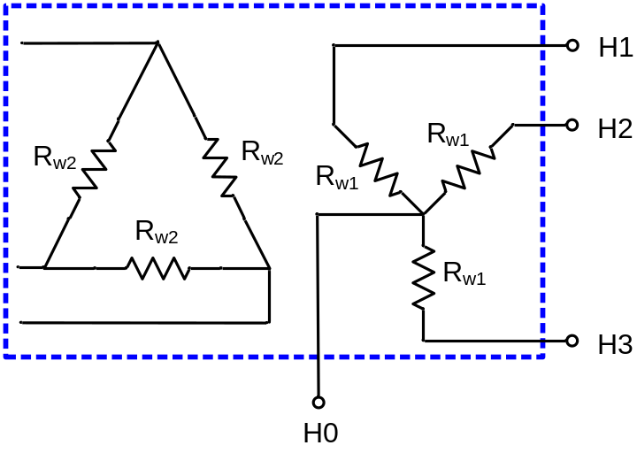
Figure 18. Three-phase Model of a Generator Step-Up Transformer

Note that the delta winding does not have any connection to the external network since it is not physically connected to ground and is open to the zero sequence. Thus, it is not included in the OpenDSS model. The HO terminal refers to the neutral point, and is modeled explicitly. R_{w1} and R_{w2} are defined as the dc winding resistance values of the high voltage or extra-high voltage and medium voltage windings, respectively.
Transformer windings are modeled with resistive branch circuits as shown in Figure 19.

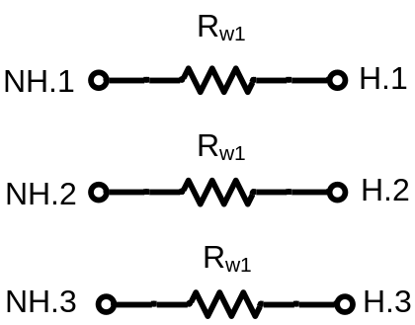
Figure 19. GSU Model in OpenDSS

The winding terminals designated as NH.1, NH.2, and NH.3 in Fig. 23 must be connected together to construct the wye winding. The bus number is arbitrary, but typically the name of the high side bus is used with the next available terminal number. An example OpenDSS script with high voltage bus named ‘Bus1’ and dc winding resistance of 0.1 Ω/phase is as follows:
New GICTransformer.T1 busH=Bus1.1.2.3 busNH=Bus1.4.4.4 R1=0.1 type=GSU

To illustrate the previous comment of utilizing the next available terminal value for the neutral bus, two identical GSUs in parallel can be described by the following:
New GICTransformer.T1 busH=Bus1.1.2.3 busNH=Bus1.4.4.4 R1=0.1 type=GSU
New GICTransformer.T2 busH=Bus1.1.2.3 busNH=Bus1.5.5.5 R1=0.1 type=GSU

Naming the neutral buses in this manner allows for the creation of individual neutral buses for each GSU which is necessary when modeling GIC blocking devices.

Three-Winding Transformers
A three-phase model of a three-winding transformer used in the calculation of GIC is shown in Figure 20. Note that the delta tertiary winding is not included in the model since it does not have any physical connection to ground. Thus, the same model can be used for both two winding and three winding transformers. The neutral nodes of both of the wye windings (i.e. X0 and H0) are modeled explicitly. In some cases, either the X0 or H0 bushing may be ungrounded. In the GIC model, the node can be grounded through a large resistance, e.g. 1 MΩ to represent such connections.
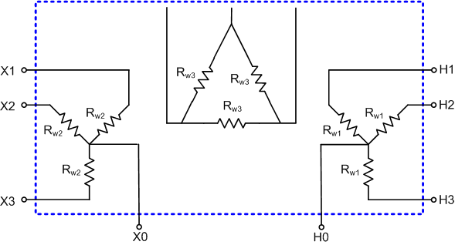
Figure 20. Three-phase Model of a Three-Winding Transformer (Grounded-Wye, Grounded-Wye, Delta)

R_{w1} and R_{w2} are defined as the dc winding resistance values of the high voltage or extra-high voltage and medium voltage windings, respectively. R_{w3} is defined as the dc winding resistance values of the low voltage tertiary winding; however, it is not included in the DSS model since it has no physical connection to ground.
Transformer windings are modeled in DSS with resistive branch circuits as shown in Figure 21.
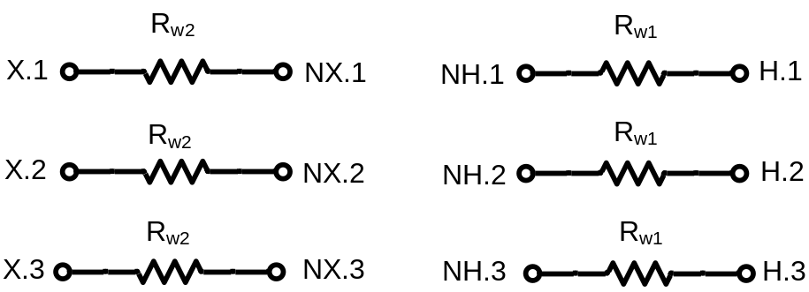
Figure 21. Two-winding and Three-winding Transformer model in DSS

The winding terminals designated as NH.1, NH.2, NH.3 and NX.1, NX.2, NX.3 in Figure 21 must be connected together to construct each of the wye windings. The bus numbers are arbitrary, but typically the name of the high side bus is used with the next available terminal number. An example OpenDSS script with high voltage bus named ‘Bus1’, low voltage bus named ‘Bus2’, dc winding resistance of 0.2 Ω/phase for the H winding and 0.1 Ω/phase for the X winding is as follows:
New GICTransformer.T1 busH=Bus1.1.2.3 busNH=Bus1.4.4.4 busX=Bus2.1.2.3 busNX=Bus1.5.5.5 R1=0.2 R2=0.1 type=YY

Autotransformers
A three-phase model of an autotransformer used in determining GIC flow is shown in Figure 22. Note that the delta tertiary winding (if applicable) is not included in the DSS model since it does not have any physical connection to ground. The common autotransformer neutral (H0/X0) is modeled explicitly.

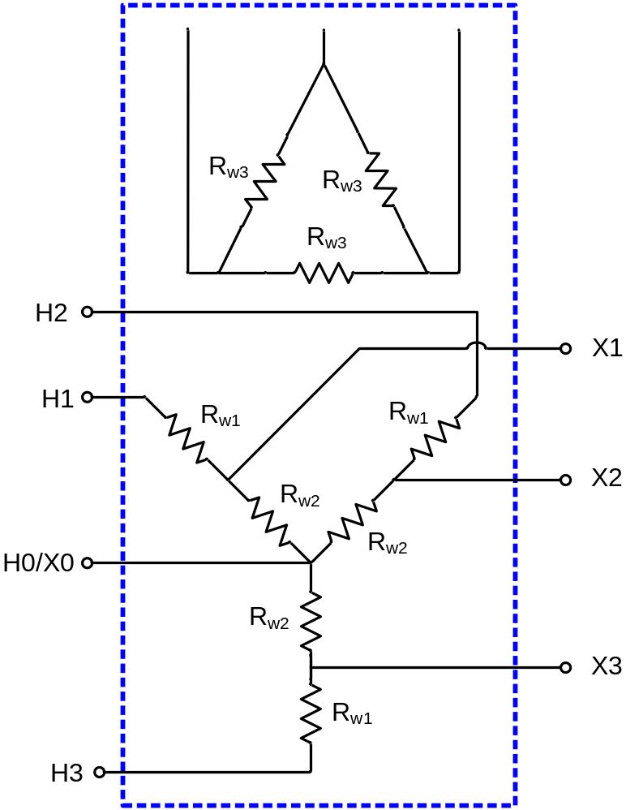
Figure 22 Three-phase Model of a Three-Winding Autotransformer

R_{w1} and R_{w2} are defined as the dc resistance values of the series and common windings, respectively. Transformer windings are modeled in DSS with resistive branch circuits as shown in Figure 23.
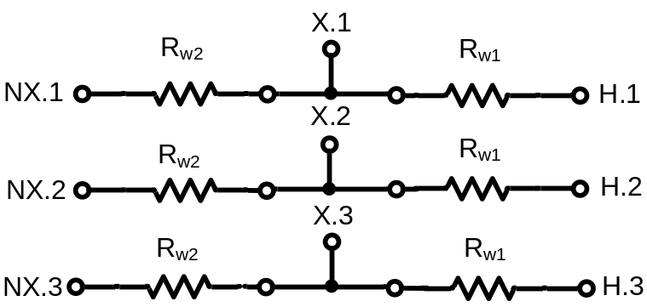
Figure 23. Two-winding and Three-winding Autotransformer model in DSS

The winding terminals designated as NX.1, NX.2, and NX.3 in Figure 23 must be connected together to construct the neutral connection. The bus numbers are arbitrary, but typically the name of the high side bus with the next available terminal number is used to designate the neutral bus. An example OpenDSS script with high voltage bus named ‘Bus1’, low voltage bus named ‘Bus2’, dc winding resistance of 0.1 Ω/phase for the series winding and 0.2 Ω/phase for the common winding is as follows:
New GICTransformer.T1 busH=Bus1.1.2.3 busX=Bus2.1.2.3 busNX=Bus1.4.4.4 R1=0.1 R2=0.2 type=auto

The properties of the GICTransformer model, in order, are:
Basefreq= Inherited Property for all PCElements. Base frequency for specification of reactance value.
busH= Name of bus High-side (H) bus. Node order definitions optional.
busNH= Name of Neutral bus for H, or first, winding. Defaults to all phases connected to H-side bus, node 0, if not specified and transformer type is either GSU or YY. (Shunt Wye Connection to ground reference)For Auto, this is automatically set to the X bus.
busNX= Name of Neutral bus for X, or Second, winding. Defaults to all phases connected to X-side bus, node 0, if not specified. (Shunt Wye Connection to ground reference).
busX= Name of bus Low-side (X) bus. Node order definitions optional.
emergamps= Maximum current. Typically not specified in GIC calculations.
enabled= {Yes|No or True|False} Indicates whether this element is enabled. Default is Yes/True.
faultrate= Number of failures per year. Typically not specified in GIC calculations.
like= Make like another object, e.g. New GICTransformer.T2 like=T1 ...
normamps= Normal rated current. Typically not specified in GIC calculations.
pctperm= Percent of failures that become permanent. Typically not specified in GIC calculations.
phases= Number of phases. Default is 3.
R1= Resistance, each phase, ohms for H winding, (Series winding, if Auto). Default is 0.0001.
R2= Resistance, each phase, ohms for X winding, (Common winding, if Auto). Default is 0.0001.
repair= Hours to repair. Typically not specified in GIC calculations.
Type= Type of transformer: {GSU* | Auto | YY}. Default is GSU.

Power Conversion Elements (PCelement)

GICLine Object
The GICLine model is used in the calculation of geomagnetically induced current (GIC). Normally, one would think of a Line element as a power delivery device, but in GIC analysis a Line is actually a source. Each phase of the transmission line is represented by a quasi-dc induced voltage (0.1 Hz) in series with the dc resistance of the line. The resulting model is depicted in Figure 24.

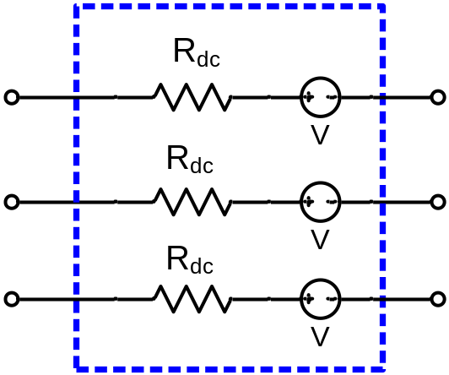
Figure 24. GICLine Model

The induced voltage shown in Figure 17 can be computed internally by the program or supplied via the Volts property of the GICLine model. The following describes the procedure utilized by OpenDSS to compute the induced voltage.

The induced voltage shown in Figure 17 is determined by an application of Faraday’s Law:

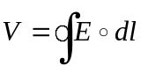
where is the electric field vector at the location of the transmission line, and 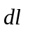is the incremental line segment length including direction. Because the distance between the source of the induced geoelectric field (electrojet) and the earth’s surface is generally on the order of 100-200 km, the electric field at the height of the transmission line can assumed to be the same as that of the earth’s surface. If the geoelectric field is assumed constant in the geographical area of a transmission line, then only the coordinates of the end point of the line are important, regardless of routing twists and turns. The resulting incremental length vector 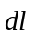, becomes . The induced voltage can therefore be computed as follows:
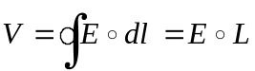
The vector , representing the length and direction of the line between end points can be constructed using an arbitrary reference; however, such methods can introduce error. An improved method is to construct the vector , by computing the distance in the Northward and Eastward directions independently as depicted in Figure 25.

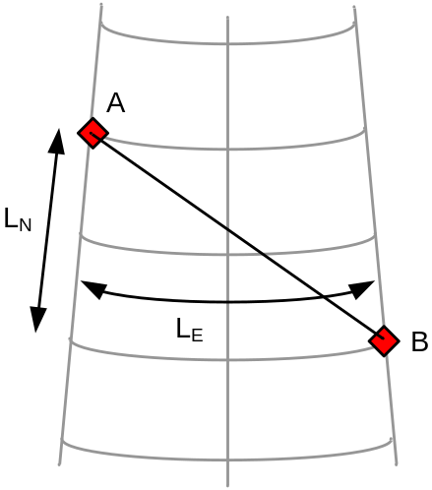
Figure 25. Substation Location Coordinates

Recall that the dot product of two vectors A and B can be computed using:
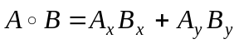
Thus, the dot product of the induced electric field and the length vector can be approximated by:
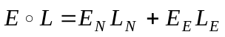
where E_{N} is the northward electric field (V/km), E_{E} is the eastward electric field (V/km), L_{N} is the northward distance (km), and L_{E} is the eastward distance (km).
The following procedure can be used to compute northward and eastward distances. Consider a transmission line between substations A and B as shown in Fig. 18. The northward distance can be computed using:
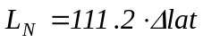
where ∆lat is the difference in latitude (degrees) between the two substations A and B. The eastward distance can be computed using:
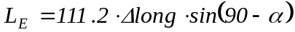
where ∆long is the difference in longitude (degrees) between the two substations A and B, and α is defined as the average of the two latitudes:
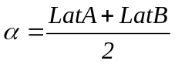
The properties of the GICLine model, in order, are:
Angle= Phase angle in degrees of first phase. Default=0.0. See Voltage property
Basefreq= Inherited Property for all PCElements. Base frequency for specification of reactance value.
bus1= Name of bus for terminal 1. Node order definitions optional.
bus2= Name of bus for terminal 2.
C= Value of line blocking capacitance in microfarads. Default = 0.0, implying that there is no line blocking capacitor.
EE= Eastward Electric field. If specified, Voltage and Angle are computed from EN, EE, lat and lon values.
EN= Northward Electric field. If specified, Voltage and Angle are computed from EN, EE, lat and lon values.
enabled= {Yes|No or True|False} Indicates whether this element is enabled.
frequency= Source frequency. Defaults to 0.1 Hz.
Lat1= Latitude of Bus 1 (degrees)
Lat2= Latitude of Bus 2 (degrees)
like= Make like another object
Lon1= Longitude of Bus 1 (degrees)
Lon2= Longitude of Bus 2 (degrees)
Phases= No. of phases. Default = 3. A line has the same number of conductors per terminal as it has phases. Neutrals are not explicitly modeled unless declared as a “phase”, and the impedance matrices must be augmented accordingly. For example, a three-phase line has a 3x3 Z matrix with the neutral reduced, or a 4x4 Z matrix with the neutral retained.
R= Resistance of line, ohms of impedance in series with GIC voltage source.
Spectrum= Inherited Property for all PCElements. Name of harmonic spectrum for this source. Default is "defaultvsource", which is defined when the DSS starts.
Volts= Voltage magnitude, in volts, of the GIC voltage induced across this line. When spedified, voltage source is assumed defined by Voltage and Angle properties. Specify this value OR EN, EE, lat1, lon1, lat2, lon2. Not both!! Last one entered will take precedence. Assumed identical in each phase of the Line object.
X= Reactance at base frequency, ohms. Default = 0.0. This value is generally not important for GIC studies but may be used if desired.

Load Object
A Load is a complicated Power Conversion element that is at the heart of many analyses. It is basically defined by its nominal kW and PF or its kW and kvar. Then it may be modified by a number of multipliers, including the global circuit load multiplier, yearly load shape, daily load shape, and a dutycycle load shape.
The default is for the load to be a current injection source. Thus, its primitive Y matrix contains only the impedance that might exist from the neutral of a wye-connected load to ground. However, if the load model is switched to Admittance from PowerFlow (see Set LoadModel command), the load is converted to an admittance and included in the system Y matrix. This would be the model used for fault studies where convergence might not be achieved because of low voltages.
Loads are assumed balanced for the number of phases specified. If you would like unbalanced loads, enter separate single-phase loads.
There are three legal ways to specify the base load:
- kW, PF
- kw, kvar
- kVA, PF
If you sent these properties in the order shown, the definition should work. If you deviate from these procedures, the result may or may not be what you want. (To determine if it has accomplished the desired effect, execute the Dump command for the desired load(s) and observe the settings.)
The properties, in order, are:
bus1= Name of bus to which the load is connected. Include node definitions if the terminal conductors are connected abnormally. 3-phase Wye-connected loads have 4 conductors; Delta-connected have 3. Wye-connected loads, in general, have one more conductor than phases. 1-phase Delta has 2 conductors; 2-phase has 3. The remaining Delta, or line-line, connections have the same number of conductors as phases.
Phases= No. of phases this load.
Kv= Base voltage for load. For 2- or 3-phase loads, specified in phase-to-phase kV. For all other loads, the actual kV across the load branch. If wye (star) connected, then specify phase-to-neutral (L-N). If delta or phase-to-phase connected, specify the phase-to-phase (L-L) kV.
Kw= nominal kW for load. Total of all phases. See kVA.
Pf= nominal Power Factor for load. Negative PF is leading. Specify either PF or kvar (see below). If both are specified, the last one specified takes precedence.
Model= Integer defining how the load will vary with voltage. Presently defined models are:
1: Normal load-flow type load: constant P and Q.
2: Constant impedance load
3: Constant P, Quadratic Q (somewhat like a motor)
4: Linear P, Quadratic Q (Mixed resistive, motor)
5: Rectifier load (Constant P, constant current)
6: Constant P; Q is fixed at nominal value
7: Constant P; Q is fixed impedance at nominal value
8: ZIP model
"Constant" values may be modified by loadshape multipliers. "Fixed" values are always the same -- at nominal, or base, value.
Yearly= Name of Yearly load shape.
Daily= Name of Daily load shape.
Duty= name of Duty cycleload shape. Defaults to Daily load shape if not defined.
Growth= Name of Growth Shape Growth factor defaults to the circuit's default growth rate if not defined. (see Set %Growth command)
Conn= {wye | y | LN} for Wye (Line-Neutral) connection; {delta | LL} for Delta (Line-Line) connection. Default = wye.
Kvar= Base kvar. If this is specified, supercedes PF. (see PF)
Rneut= Neutral resistance, ohms. If entered as negative, non-zero number, neutral is assumed open, or ungrounded. Ignored for delta or line-line connected loads.
Xneut= Neutral reactance, ohms. Ignored for delta or line-line connected loads. Assumed to be in series with Rneut value.
Status= {fixed| variable}. Default is variable. If fixed, then the load is not modified by multipliers; it is fixed at its defined base value.
Class= Integer number segregating the load according to a particular class.
Vminpu = Default = 0.95. Minimum per unit voltage for which the MODEL is assumed to apply. Below this value, the load model reverts to a constant impedance model.
Vmaxpu = Default = 1.05. Maximum per unit voltage for which the MODEL is assumed to apply. Above this value, the load model reverts to a constant impedance model.
VminNorm = Minimum per unit voltage for load EEN evaluations, Normal limit. Default = 0, which defaults to system "vminnorm" property (see Set Command under Executive). If this property is specified, it ALWAYS overrides the system specification. This allows you to have different criteria for different loads. Set to zero to revert to the default system value.
VminEmerg = Minimum per unit voltage for load UE evaluations, Emergency limit. Default = 0, which defaults to system "vminemerg" property (see Set Command under Executive). If this property is specified, it ALWAYS overrides the system specification. This allows you to have different criteria for different loads. Set to zero to revert to the default system value.
XfkVA = Default = 0.0. Rated kVA of service transformer for allocating loads based on connected kVA at a bus. Side effect: kW, PF, and kvar are modified. See PeakCurrent property of EnergyMeter. See also AllocateLoads Command. See kVA property below.
AllocationFactor = Default = 0.5. Allocation factor for allocating loads based on connected kVA at a bus. Side effect: kW, PF, and kvar are modified by multiplying this factor times the XFKVA (if > 0). See also AllocateLoads Command.
kVA = Definition of the Base load in kVA, total all phases. This is intended to be used in combination with the power factor (PF) to determine the actual load. Legal ways to define base load (kW and kvar):
kW, PF
kW, kvar
kVA, PF
XFKVA * Allocationfactor, PF
kWh/(kWhdays*24) * Cfactor, PF
%mean = Percent mean value for load to use for monte carlo studies if no loadshape is assigned to this load. Default is 50.
%stddev = Percent Std deviation value for load to use for monte carlo studies if no loadshape is assigned to this load. Default is 10.
CVRwatts = Percent reduction in active power (watts) per 1% reduction in voltage from 100% rated. Default=1. Typical values range from 0.4 to 0.8. Applies to Model=4 only. Intended to represent conservation voltage reduction or voltage optimization measures.
CVRvars = Percent reduction in reactive power (vars) per 1% reduction in voltage from 100% rated. Default=2. Typical values range from 2 to 3. Applies to Model=4 only. Intended to represent conservation voltage reduction or voltage optimization measures.
kWh = kWh billed for this period. Default is 0. See help on kVA and Cfactor and kWhDays.
kWhDays = Length of kWh billing period in days (24 hr days). Default is 30. Average demand is computed using this value.
CFactor = Factor relating average kW to peak kW. Default is 4.0. See kWh and kWhdays. See kVA.
CVRCurve = Default is NONE. Curve describing both watt and var factors as a function of time. Refers to a LoadShape object with both Mult and Qmult defined. Define a Loadshape to agree with yearly or daily curve according to the type of analysis being done. If NONE, the CVRwatts and CVRvars factors are used and assumed constant for the simulation period.
NumCust = Number of customers, this load. Default is 1.
spectrum = Name of harmonic current spectrum for this load. Default is "defaultload", which is defined when the DSS starts.
Basefreq = Base frequency for which this load is defined. Default is 60.0.
Like = Name of another Load object on which to base this one.

Generator Object
A Generator is a Power Conversion element similar to a Load object. Its rating is basically defined by its nominal kW and PF or its kW and kvar. Then it may be modified by a number of multipliers, including the global circuit load multiplier, yearly load shape, daily load shape, and a dutycycle load shape.
For power flow studies, the generator is essentially a negative load that can be dispatched. For Harmonics mode, the generator is converted to a voltage source behind the value specified for Xd” that approximately matches the power flow solution. For dynamics mode, the generator is converted to a voltage source behind an impedance with the impedance dependent on the model chosen.
If the dispatch value (DispValue property) is 0, the generator always follows the appropriate dispatch curve, which is simply a Loadshape object. If DispValue>0 then the generator only comes on when the global circuit load multiplier exceeds DispValue. When the generator is on, it always follows the dispatch curve appropriate for the type of solution being performed.
If you want to model a generator that is fully on whenever it is dispatched on, simply designate "Status=Fixed". The default is "Status=Variable" (i.e., it follows a dispatch curve. You could also define a dispatch curve that is always 1.0.
Generators have their own energy meters that record:
1. Total kwh
2. Total kvarh
3. Max kW
4. Max kVA
5. Hours in operation
6. $ (Price signal * energy generated)

Generator meters reset with the circuit energy meters and take a sample with the circuit energy meters as well. The Energy meters also used trapezoidal integration so that they are compatible with Load-Duration simulations.
Generator power models for power flow simulations are:
- Constant P, Q (* dispatch curve, if appropriate).
- Constant Z (For simple, approximate solution)
- Constant P, |V| somewhat like a standard power flow with voltage magnitudes and angles as the variables instead of P and Q.
- Constant P, fixed Q. P follows dispatch; Q is always the same.
- Constant P, fixed reactance. P follows dispatch, Q is computed as if it were a fixed reactance.
- User-written model
- Current-limited constant P, Q model (like some inverters).
Most of the time you will use #1 for planning studies. All load models can follow loadshapes. Some follow only the P component while the Type 1 can follow both a P and Q characteristic.
The default is for the generator to be a current injection source. Thus, its primitive Y matrix is similar to a Load object with a nominal equivalent admittance included in the primitive Y matrix and the injection current representing the amount required to compensate. However, if the generator model is switched to Admittance from PowerFlow (see Set Mode command), the generator is converted to strictly an equivalent admittance and included in the system Y matrix.
Generators are assumed balanced over the number of phases specified. If you would like unbalanced generators, enter separate single-phase generators.
The properties, in numerical order, are:
bus1= Name of bus to which the generator is connected. Include node definitions if the terminal conductors are connected unusually. 3-phase Wye-connected generators have 4 conductors; Delta-connected have 3. Wye-connected generators, in general, have one more conductor than phases. 1-phase Delta has 2 conductors; 2-phase has 3. The remaining Delta, or line-line, connections have the same number of conductors as phases.
Phases= No. of phases this generator.
Kv= Base voltage for generator. For 2- or 3-phase generators, specified in phase-to-phase kV. For all other generators, the actual kV across the generator branch. If wye (star) connected, specify the phase-to-neutral (L-N) kV. If delta or phase-to-phase connected, specify the phase-to-phase (L-L) kV.
Kw= nominal kW for generator. Total of all phases.
Pf= nominal Power Factor for generator. Negative PF is leading (absorbing vars). Specify either PF or kvar (see below). If both are specified, the last one specified takes precedence.
Model= Integer defining how the generator will vary with voltage. Presently defined models are:
1: Generator injects a constant kW at specified power factor.
2: Generator is modeled as a constant admittance.
3: Const kW, constant kV. Somewhat like a conventional transmission power flow P-V generator.
4: Const kW, Fixed Q (Q never varies)
5: Const kW, Fixed Q(as a constant reactance)
6: Compute load injection from User-written Model.(see usage of Xd, Xdp)
7: Constant kW, kvar, but current limited below Vminpu

Yearly= Name of Yearly load shape.
Daily= Name of Daily load shape.
Duty= name of Duty cycle load shape. Defaults to Daily load shape if not defined.
Dispvalue= Dispatch value. If = 0.0 then Generator follows dispatch curves. If > 0 then Generator is ON only when the global load multiplier exceeds this value. Then the generatorfollows dispatch curves (see also Status)
Conn= {wye | y | LN} for Wye (Line-Neutral) connection; {delta | LL} for Delta (Line-Line) connection. Default = wye.
Kvar= Base kvar. If this is specified, will supercede PF. (see PF)
Rneut= Neutral resistance ohms. If entered as negative, non-zero number, neutral is assumed open, or ungrounded. Ignored for delta or line-line connected generators. Default is 0.
Xneut= Neutral reactance, ohms. Ignored for delta or line-line connected generators. Assumed to be in series with Rneut value.
Status= {fixed | variable}. If Fixed, then dispatch multipliers do not apply. The generator is always at full power when it is ON. Default is Variable (follows curves).
Class= Integer number segregating the generator according to a particular class.
Maxkvar = Maximum kvar limit for Model = 3. Defaults to twice the specified load kvar. Always reset this if you change PF or kvar properties.
Minkvar = Minimum kvar limit for Model = 3. Enter a negative number if generator can absorb vars. Defaults to negative of Maxkvar. Always reset this if you change PF or kvar properties.
Pvfactor = Convergence deceleration factor for P-V generator model (Model=3). Default is 0.1. If the circuit converges easily, you may want to use a higher number such as 1.0. Use a lower number if solution diverges. Use Debugtrace=yes to create a file that will trace the convergence of a generator model.
Debugtrace = {Yes | No } Default is no. Turn this on to capture the progress of the generator model for each iteration. Creates a separate file for each generator named "GEN_name.CSV".
Vminpu = Default = 0.95. Minimum per unit voltage for which the Model is assumed to apply. Below this value, the generator model reverts to a constant impedance model.
Vmaxpu = Default = 1.05. Maximum per unit voltage for which the Model is assumed to apply. Above this value, the generator model reverts to a constant impedance model.
ForceON = {Yes | No} Forces generator ON despite requirements of other dispatch modes. Stays ON until this property is set to NO, or an internal algorithm cancels the forced ON state.
kVA = kVA rating of electrical machine. Defaults to 1.2* kW if not specified. Applied to machine or inverter definition for Dynamics mode solutions.
MVA = MVA rating of electrical machine. Alternative to using kVA=.
Xd = Per unit synchronous reactance of machine. Presently used only for Thevinen impedance for power flow calcs of user models (model=6). Typically use a value from 0.4 to 1.0. Default is 1.0
Xdp = Per unit transient reactance of the machine. Used for Dynamics mode and Fault studies. Default is 0.27.For user models, this value is used for the Thevinen/Norton impedance for Dynamics Mode.
Xdpp = Per unit subtransient reactance of the machine. Used for Harmonics. Default is 0.20.
H = Per unit mass constant of the machine. MW-sec/MVA. Default is 1.0.
D = Damping constant. Usual range is 0 to 4. Default is 1.0. Adjust to get damping
UserModel = Name of DLL containing user-written model, which computes the terminal currents for Dynamics studies, overriding the default model. Set to "none" to negate previous setting.
UserData = String (in quotes or parentheses) that gets passed to user-written model for defining the data required for that model.
ShaftModel = Name of user-written DLL containing a Shaft model, which models the prime mover and determines the power on the shaft for Dynamics studies. Models additional mass elements other than the single-mass model in the DSS default model. Set to "none" to negate previous setting.
ShaftData = String (in quotes or parentheses) that gets passed to user-written shaft dynamic model for defining the data for that model.
spectrum = Name of harmonic voltage or current spectrum for this generator. Voltage behind Xd" for machine - default. Current injection for inverter. Default value is "default", which is defined when the DSS starts.
Basefreq= Base frequency for which this generator is defined. Default is 60.0.
Like= Name of another Generator object on which to base this one.

Control Elements
One of the distinctive capabilities of the OpenDSS is that control elements are modeled separately from the power-carrying elements. This provides significant flexibility to create new models. Initially, control objects reflected only standard utility distribution system control devices. More recently, new, innovative models have been developed. Currently, there are nine controls provided with the program with more planned soon. This section gives some idea of how the control objects work and how you might exploit them.
Control elements are polled after a power flow solution has been obtained. If any control needs to operate, it places a message on the Control Queue. When it comes time for the control to operate, the message is popped off the queue and the command executed. This allows for the simulation of controls that have time delays in their operation.
Refer to the Doc folder on the OpenDSS website for additional information.

CapControl Object
The capacitor control monitors the voltage and current at a terminal of a PDelement or a PCelement and sends switching messages to a Capacitor object. The CapControl contains essential features of many typical utility capacitor controls.
Example:
New CapControl.C1ctrl element=Line.L1 Capacitor=C1
~ Type=Current ON=400 OFF=300 Delay=30

This control monitors the current in Line.L1 and switches Capacitor.C1 based on current magnitude. This is one of the simpler controls to implement. The capacitor will switch ON when the current in the monitored phase (defaults to 1) after a delay of 30 s. If the current drops below 400 A before 30 s has elapsed, the control resets (ignores the message from the control queue). After energization, the capacitor switches off when the current drops below 300 with the default DelayOFF.
Element Full object name of the circuit element, typically a line or transformer, to which the capacitor control's PT and/or CT are connected.There is no default; must be specified.
Capacitor Name of Capacitor element which the CapControl controls. No Default; Must be specified.Do not specify the full object name; "Capacitor" is assumed for the object class. Example:
Capacitor=cap1
Type {Current | voltage | kvar | PF | time } Control type. Specify the ONsetting and OFFsetting appropriately with the type of control. (See help for ONsetting)
CTPhase Number of the phase being monitored for CURRENT control or one of {AVG | MAX | MIN} for all phases. Default=1. If delta or L-L connection, enter the first or the two phases being monitored [1-2, 2-3, 3-1]. Must be less than the number of phases. Does not apply to kvar control which uses all phases by default.
CTratio Ratio of the CT from line amps to control ampere setting for current and kvar control types.
DeadTime Dead time after capacitor is turned OFF before it can be turned back ON. Default is 300 sec.
Delay Time delay, in seconds, from when the control is armed before it sends out the switching command to turn ON. The control may reset before the action actually occurs. This is used to determine which capacity control will act first. Default is 15. You may specify any floating point number to achieve a model of whatever condition is necessary.
DelayOFF Time delay, in seconds, for control to turn OFF when present state is ON. Default is 15.
EventLog {Yes/True* | No/False} Default is YES for CapControl. Log control actions to Eventlog.
OFFsetting Value at which the control arms to switch the capacitor OFF. (See help for ONsetting)For Time control, is OK to have Off time the next day ( < On time)
ONsetting Value at which the control arms to switch the capacitor ON (or ratchet up a step).
Type of Control:
Current: Line Amps / CTratio
Voltage: Line-Neutral (or Line-Line for delta) Volts / PTratio
kvar: Total kvar, all phases (3-phase for pos seq model). This is directional.
PF: Power Factor, Total power in monitored terminal. Negative for Leading.
Time: Hrs from Midnight as a floating point number (decimal). 7:30am would be entered as 7.5.
PTPhase Number of the phase being monitored for VOLTAGE control or one of {AVG | MAX | MIN} for all phases. Default=1. If delta or L-L connection, enter the first or the two phases being monitored [1-2, 2-3, 3-1]. Must be less than the number of phases. Does not apply to kvar control which uses all phases by default.
PTratio Ratio of the PT that converts the monitored voltage to the control voltage. Default is 60. If the capacitor is Wye, the 1st phase line-to-neutral voltage is monitored. Else, the line-to-line voltage (1st - 2nd phase) is monitored.
terminal Number of the terminal of the circuit element to which the CapControl is connected. 1 or 2, typically. Default is 1.
VBus Name of bus to use for voltage override function. Default is bus at monitored terminal. Sometimes it is useful to monitor a bus in another location to emulate various DMS control algorithms.
Vmax Maximum voltage, in volts. If the voltage across the capacitor divided by the PTRATIO is greater than this voltage, the capacitor will switch OFF regardless of other control settings. Default is 126 (goes with a PT ratio of 60 for 12.47 kV system).
Vmin Minimum voltage, in volts. If the voltage across the capacitor divided by the PTRATIO is less than this voltage, the capacitor will switch ON regardless of other control settings. Default is 115 (goes with a PT ratio of 60 for 12.47 kV system).
VoltOverride {Yes | No} Default is No. Switch to indicate whether VOLTAGE OVERRIDE is to be considered. Vmax and Vmin must be set to reasonable values if this property is Yes.

RegControl Object
This control is designed to emulate a standard utility voltage regulator or LTC control. It is attached to a particular winding of a transformer as the winding to monitor. It generally also adjusts the taps in that winding but could also be directed to control the taps in another winding.
The control has line drop compensator modeling by setting the R, X, CTprim, and ptratio properties. The control can also monitor the voltage at a remote bus to emulate various Smart Grid devices. This is a useful function for performing volt/var optimization.
To understand how regulator controls work, refer to W. H. Kersting’s book on Distribution System Modeling. A simple example of a regulator on a 12.47 kV system:
New RegControl.Reg1 Transformer=T1 Winding=2 Vreg=122 band=3 ptratio=60

With a line-drop compensator, the definition might look like
New RegControl.Reg1 Transformer=T1 Winding=2 Vreg=122 band=3
~ ptratio=60 CTprim=300 R=2 X=0

Controlling a bus at the end of the feeder to 118 V:
New RegControl.Reg1 Transformer=T1 Winding=2 Vreg=118 band=2 bus=MyEndBus

transformer Name of Transformer element to which the RegControl is connected. Do not specify the full object name; "Transformer" is assumed for the object class. Example:
Transformer=Xfmr1
winding Number of the winding of the transformer element that the RegControl is monitoring. 1 or 2, typically. Side Effect: Sets TAPWINDING property to the same winding.
vreg Voltage regulator setting, in VOLTS, for the winding being controlled. Multiplying this value times the ptratio should yield the voltage across the WINDING of the controlled transformer. Default is 120.0
band Bandwidth in VOLTS for the controlled bus (see help for ptratio property). Default is 3.0
delay Time delay, in seconds, from when the voltage goes out of band to when the tap changing begins. This is used to determine which regulator control will act first. Default is 15. You may specify any floating point number to achieve a model of whatever condition is necessary.
ptratio Ratio of the PT that converts the controlled winding voltage to the regulator voltage. Default is 60. If the winding is Wye, the line-to-neutral voltage is used. Else, the line-to-line voltage is used.
CTprim Rating, in Amperes, of the primary CT rating for converting the line amps to control amps.The typical default secondary ampere rating is 0.2 Amps (check with manufacturer specs).
R R setting on the line drop compensator in the regulator, expressed in VOLTS.
X X setting on the line drop compensator in the regulator, expressed in VOLTS.
PTphase For multi-phase transformers, the number of the phase being monitored or one of { MAX | MIN} for all phases. Default=1. Must be less than or equal to the number of phases. Ignored for regulated bus.
tapwinding Winding containing the actual taps, if different than the WINDING property. Defaults to the same winding as specified by the WINDING property.
bus Name of a bus (busname.nodename) in the system to use as the controlled bus instead of the bus to which the transformer winding is connected or the R and X line drop compensator settings. Do not specify this value if you wish to use the line drop compensator settings. Default is null string. Assumes the base voltage for this bus is the same as the transformer winding base specified above. Note: This bus (1-phase) WILL BE CREATED by the regulator control upon SOLVE if not defined by some other device. You can specify the node of the bus you wish to sample (defaults to 1). If specified, the RegControl is redefined as a 1-phase device since only one voltage is used.
debugtrace {Yes | No* } Default is no. Turn this on to capture the progress of the regulator model for each control iteration. Creates a separate file for each RegControl named "REG_name.CSV".
EventLog {Yes/True* | No/False} Default is YES for regulator control. Log control actions to Eventlog.
inversetime {Yes | No* } Default is no. The time delay is adjusted inversely proportional to the amount the voltage is outside the band down to 10%.
maxtapchange Maximum allowable tap change per control iteration in STATIC control mode. Default is 16.
Set this to 1 to better approximate actual control action.
Set this to 0 to fix the tap in the current position.
revband Bandwidth for operating in the reverse direction.
revDelay Time Delay in seconds (s) for executing the reversing action once the threshold for reversing has been exceeded. Default is 60 s.
reversible {Yes |No*} Indicates whether or not the regulator can be switched to regulate in the reverse direction. Default is No.Typically applies only to line regulators and not to LTC on a substation transformer.
revNeutral {Yes | No*} Default is no. Set this to Yes if you want the regulator to go to neutral in the reverse direction.
revR R line drop compensator setting for reverse direction.
revThreshold kW reverse power threshold for reversing the direction of the regulator. Default is 100.0 kw.
revvreg Voltage setting in volts for operation in the reverse direction.
revX X line drop compensator setting for reverse direction.
tapdelay Delay in sec between tap changes. Default is 2. This is how long it takes between changes after the first change.
vlimit Voltage Limit for bus to which regulated winding is connected (e.g. first customer). Default is 0.0. Set to a value greater then zero to activate this function.

Meter Elements

EnergyMeter Object
An EnergyMeter object is an intelligent meter connected to a terminal of a circuit element. It simulates the behavior of an actual energy meter. However, it has more capability because it can access values at other places in the circuit rather than simply at the location at which it is installed. It measures not only power and energy values at its location, but losses and overload values within a defined region of the circuit.
The operation of the object is simple. It has several registers that accumulate certain values. At the beginning of a study, the registers are cleared (reset) to zero. At the end of each subsequent solution, the meter is instructed to take a sample. Energy values are then integrated using the interval of time that has passed since the previous solution.

Registers
There are two types of registers:
- Energy Accumulators (for energy values)
- Maximum power values ("drag hand" registers).
The energy registers may use trapezoidal integration (system option), which allows for somewhat arbitrary time step sizes between solutions with less integration error. This is important for using load duration curves approximated with straight lines, for example.
The present definitions of the registers are, for example for a 22 kV system:
Hour
"kWh"
"kvarh"
"MaxkW"
"MaxkVA"
"ZonekWh"
"Zonekvarh"
"ZoneMaxkW"
"ZoneMaxkVA"
"OverloadkWhNormal"
"OverloadkWhEmerg"
"LoadEEN"
"LoadUE"
"ZoneLosseskWh"
"ZoneLosseskvarh"
"ZoneMaxkWLosses"
"ZoneMaxkvarLosses"
"LoadLosseskWh"
"LoadLosseskvarh"
"NoLoadLosseskWh"
"NoLoadLosseskvarh"
"MaxkWLoadLosses"
"MaxkWNoLoadLosses"
"LineLosses"
"TransformerLosses"
"LineModeLineLosses"
"ZeroModeLineLosses"
"3-phaseLineLosses"
"1-and2-phaseLineLosses"
"GenkWh"
"Genkvarh"
"GenMaxkW"
"GenMaxkVA"
"22kVLosses"
"Aux1"
"Aux6"
"Aux11"
"Aux16"
"Aux21"
"Aux26"
"22kVLineLoss"
"Aux2"
"Aux7"
"Aux12"
"Aux17"
"Aux22"
"Aux27"
"22kVLoadLoss"
"Aux3"
"Aux8"
"Aux13"
"Aux18"
"Aux23"
"Aux28"
"22kVNoLoadLoss"
"Aux4"
"Aux9"
"Aux14"
"Aux19"
"Aux24"
"Aux29"
"22kVLoadEnergy"
"Aux5"
"Aux10"
"Aux15"
"Aux20"
"Aux25"
"Aux30"

Registers are frequently added for various purposes. You can view the present meters simply by solving and taking a sample. Then do Show Meters. The Aux registers listed in the example above are used for keep track of losses at up to 7 different voltage levels in the meter zone.

Meter Zones
The EnergyMeter object uses the concept of a zone. This is an area of the circuit for which the meter is responsible. It can compute energies, losses, etc for any power delivery object and Load object in its zone (Generator objects have their own intrinsic meters).
A zone is a collection of circuit elements "downline" from the meter. This concept is nominally applicable to radial circuits, but also has some applicability to meshed circuits. The zones are automatically determined according to the following rules:
Start with the circuit element in which the meter is located. Ignore the terminal on which the meter is connected. This terminal is the start of the zone. Begin tracing with the other terminal(s).
(Note: These rules imply that the meter should usually be placed at the source end of the circuit element it is monitoring.)
Trace out the circuit, finding all other circuit elements (loads and power delivery elements) connected to the zone. Continue tracing out every branch of the circuit. Stop tracing a branch when:
- The end of the circuit branch is reached
- A circuit element containing another EnergyMeter object is encountered
- A OPEN terminal is encountered. (all phases in the terminal are open.)
- A disabled device is encountered.
- A circuit element already included in another zone is encountered.
- There are no more circuit elements to consider.

Zones are automatically updated after a change in the circuit unless the ZONELOCK option (Set command) is set to true (Yes). Then zones remain fixed after initial determination.
In order to apply the Reconductor command, both lines must be in the same meter zone. The upline/downline orientation of the line segments is established when the zones are built. Otherwise, the DSS has no concept of radiality.
The Parent property available in the Lines interface in the COM interface is set when the zone is established. This allows users to programmatically trace back up the circuit toward the Energymeter. The total number of customers served downline is determined during the establishment of the meter zone.

.Zones on Meshed Networks
While the concept of zones nominally applies to radial circuits, judicious placement of energy meters can make the concept useful for meshed networks as well. Keep in mind that there can be many EnergyMeter objects defined in the circuit. Their placement does not necessarily have to represent reality; they are for the reporting of power and energy quantities throughout the system.
The automatic algorithm for determining zones will determine zones consistently for meshed networks, although the zones themselves may not be radial. If there are several meters on the network that could be monitoring the same zone, the first one defined will have access to all the elements except the ones containing the other meters. The others will have only one element in their zone, as in Figure 14.
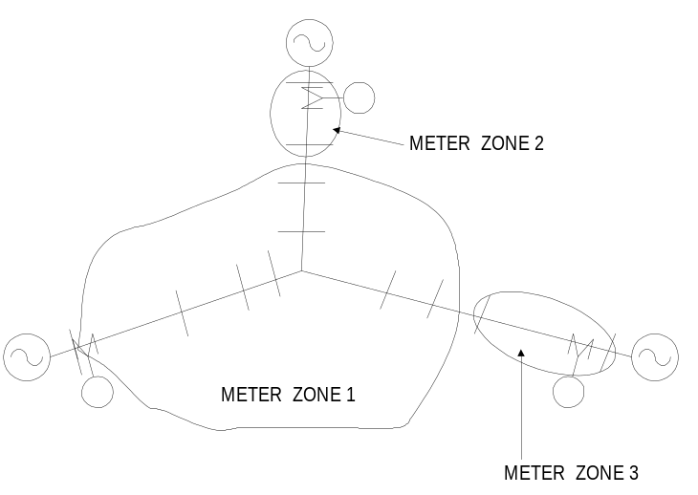
Figure 26. Default Meter Zones for a Simple Network

Don't put any load at tie point or take care in processing meter information so that it isn't counted more than once. All three of the meters added would see the center-most bus in Figure 15.
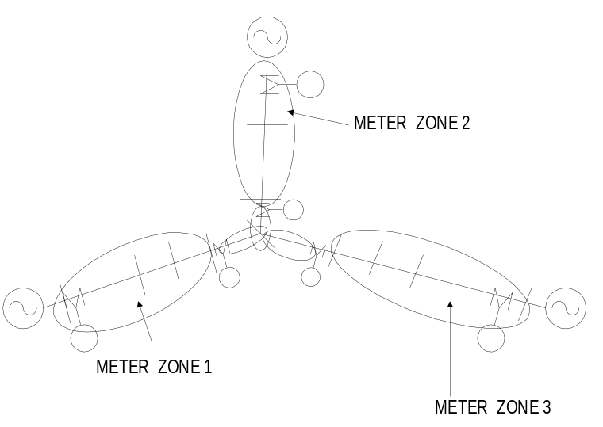
Figure 27. Using Additional Meters to Control the Definition of Meter Zones

Sampling
The sampling algorithms are as follows:
Local Energy and Power Values: Simply compute the power into the terminal on which the meter is installed and integrate using the interval between the present solution and the previous solution. This operation uses the voltage and current computed from the present solution.
Losses in Zone: Accumulate the kW losses in each power delivery element in the zone.
Load in Zone: While sampling the losses in each power delivery element, accumulate the power in all loads connected to the downline bus(es) of the element.
Overload Energy in Zone: For each power delivery element in the zone, compute the amount of power exceeding the rating of the element compared to both normal and emergency ratings.
EEN and UE in Zone: For each load in the zone marked as exceeding normal or unserved, compute the present power. Integrate to get energies.

EEN and UE Definitions
EEN refers to load energy considered unserved because the current or voltage exceeds Normal ratings. UE refers to load energy considered unserved because the power (actually the current) exceeds Emergency, or maximum, ratings.
On radial systems (default), a load is marked as unserved with respect to either normal or emergency ratings if either:
The voltage at the load bus is below minimum ratings
The current in any power delivery element supplying the load exceeds the current ratings.
Either the entire load or just the portion above rating at the bus that is considered unserved is counted as unserved, depending on whether the Excess option or the Total option have been specified.

EnergyMeter EEN and UE Registers
Register 9 through 12 on the EnergyMeter are confusing to both new and experienced OpenDSS users. Hopefully, this explanation will help shed some light on the contents of these registers.
EEN = Energy Exceeding Normal: The energy served over a selected period of time above the “Normal” rating of power delivery devices (lines, transformers, switches, etc.). It is assumed that there is sufficient engineering margin in the power system to continue to operate, but that a failure (1st contingency) will require curtailment of load. This is the primary quantity used for measure of risk.
UE = Unserved Energy: The energy over a selected period of time projected to be above the Emergency, or Maximum, rating of power delivery equipment. It is assumed that some load will have to be curtailed to bring the power down to a manageable level.
These concepts have evolved since 1994 as we began to look for some means to measure risk in planning, particularly as it applies to distributed generation. We quickly learned that distribution planners were not comfortable with pure probabilistic planning. They prefer methods based on concrete limits. Therefore, we adapted some traditional planning concepts to achieve a measure of risk. Many traditional methods used two limits for power delivery equipment: Normal and Emergency. Planning studies are triggered when the peak demand exceeds the Normal limits. Exceeding the Emergency limit requires immediate curtailment. The usual intent was to get something built before the Emergency limit was projected to be exceeded. By using power demand alone, new construction is frequently very conservative. Distributed generation muddies the waters for planning with demand alone because it is often unclear how much capacity is actually achieved by DG.
Our extension of the concept was to use energy in addition to simply power to determine the risk. One would defer investing in new infrastructure until the energy exceeding the limits was sufficient to justify it.
For more on this subject, see the following papers for reference on this subject:
R. C. Dugan, “Computing Incremental Capacity Provided By Distributed Resources For Distribution Planning,” IEEE PES General Meeting, 2007.
Roger Dugan and Marek Waclawiak, “Using Energy as a Measure of Risk in Distribution Planning,” Paper 0822, CIRED 2007, Vienna.

Registers 9 and 10: Overload EEN and UE
As the Energymeter element sweeps through its zone, it queries each series power delivery element encountered for the kW above Normal and Emergency limits. The value recorded in these two registers is the largest kW amount encountered. In other words, the value is the maximum overload in terms of actual kW.
Most of the time, this is what you want. However, there are cases where data errors can skew the results. For example, if the data show a 15 kVA transformer serving an apartment building with over 150 kVA load, this will consistently show up as a 135 kVA overload, which might be the largest overload in the problem. However, you would not build a new feeder because a small transformer is overloaded. You would change out the transformer (or correct the data error). Such errors are common in distribution data where it may take a while for transformer changeouts to get properly entered.
Excess or Total: There are two ways these registers can record the results. They can simply record the excess kW over the limits. This is the default behavior. However, they can also record the total kW flowing through the element. The latter method is for cases where it is assumed that the feeder branch in question must be switched off completely if an overload occurs. This reflects a more conservative planning approach.
Registers 11 and 12: Load EEN and UE
These two registers record a different approach to compute EEN and UE values: They ask each Load element in the zone if it is “unserved.” The nominal criterion is undervoltage.
If you set Option=Voltage for an Energymeter object, only the voltage is used. The global options NormVminpu and EmergVminpu are used for this value. If the voltage is between NormVminpu and EmergVminpu, the EEN is proportioned to how far below the NormVminpu it is. If the voltage is less than EmergVminpu, the UE value for the load is computed in proportion to the degee it is below EmergVminpu, continuing on the same slope as the EEN calculation. In multi-phase elements, the lowest phase voltage is used.
The default behavior (Option=Combined) is to consider both line overload and undervoltage. If a line, or other power delivery element, serving the load is overloaded, the load is considered unserved in the same percentage that the line is overloaded. This actually takes precedence over the voltage criteria, which assumes that any undervoltage is due to the line overload. A line is considered to serve the load if it is between the EnergyMeter and the load. Note that some inaccuracies can occur if the meter zone is not properly defined, such as if loops exist.

Properties
The properties, in order, are:
Element= Name of an existing circuit element to which the monitor is to be connected. Note that there may be more than one circuit element with the same name (not wise, but it is allowed). The monitor will be placed at the first one found in the list.
Terminal= No. of the terminal to which the monitor will be connected, normally the source end.
Action= Optional action to execute. One of
Clear = reset all registers to zero
Save = Saves (appends) the present register values to a file. File name is MTR_metername.CSV, where metername is the name of the energy meter.
Take = Takes a sample at the present solution.
Option = Options: Enter a string ARRAY of any combination of the following. Options processed left-to-right:
(E)xcess : (default) UE/EEN is estimate of only energy exceeding capacity
(T)otal : UE/EEN is total energy after capacity exceeded.
(R)adial : (default) Treats zone as a radial circuit
(M)esh : Treats zone as meshed network (not radial).
(C)ombined: (default) Load UE or EEN are computed from both overload and undervoltage criteria.
(V)oltage: Load UE/EEN are computed only from the undervoltage criteria.
Example: option=(E, R, C)
In a meshed network, the overload registers represent the total of the power delivery element overloads and the load UE/EEN registers will contain only those loads that are "unserved", which are those with low voltages. In a radial circuit, the overload registers record the max overload (absolute magnitude, not percent) in the zone. Loads become unserved either with low voltage or if any line in their path to the source is overloaded.
KWNorm = Upper limit on kW load in the zone, Normal configuration. Default is 0.0 (ignored). If specified, overrides limits on individual lines for overload EEN. KW above this limit for the entire zone is considered EEN.
KWEmerg = Upper limit on kW load in the zone, Emergency configuration. Default is 0.0 (ignored). If specified, overrides limits on individual lines for overload UE. KW above this limit for the entire zone is considered UE.
Peakcurrent = ARRAY of current magnitudes representing the peak currents measured at this location for the load allocation function (for loads defined with xfkva=). Default is (400, 400, 400). Enter one current for each phase.
Zonelist = ARRAY of full element names for this meter's zone. Default is for meter to find it's own zone. If specified, DSS uses this list instead. It can access the names in a single-column text file. Examples:
zonelist=[line.L1, transformer.T1, Line.L3]
zonelist=(file=branchlist.txt)
LocalOnly = {Yes | No} Default is NO. If Yes, meter considers only the monitored element for EEN and UE calcs. Uses whole zone for losses.
Mask = Mask for adding registers whenever all meters are totalized. Array of floating point numbers representing the multiplier to be used for summing each register from this meter. Default = (1, 1, 1, 1, ... ). You only have to enter as many as are changed (positional). Useful when two meters monitor same energy, etc.
Losses = {Yes | No} Default is YES. Compute Zone losses. If NO, then no losses at all are computed.
LineLosses = {Yes | No} Default is YES. Compute Line losses. If NO, then none of the line losses are computed.
XfmrLosses = {Yes | No} Default is YES. Compute Transformer losses. If NO, transformers are ignored in loss calculations.
SeqLosses = {Yes | No} Default is YES. Compute Sequence losses in lines and segregate by line mode losses and zero mode losses.
3PhaseLosses = {Yes | No} Default is YES. Compute Line losses and segregate by 3-phase and other (1- and 2-phase) line losses.
VbaseLosses = {Yes | No} Default is YES. Compute losses and segregate by voltage base. If NO, then voltage-based tabulation is not reported. Make sure the voltage bases of the buses are assigned BEFORE defining the EnergyMeter to ensure that it will automatically pick up the voltage bases. Or, issue the CalcVoltageBases command after defining the EnergyMeter. Each voltage base has four(4) loss registers: total, line, load, and no-load, respectively. There are sufficient registers to report losses in five (5) different voltage levels.
BaseFreq = Base frequency for ratings.
Enabled = {Yes|No or True|False} Indicates whether the element is enabled.
Like= Name of another EnergyMeter object on which to base this one.

Monitor Object
A monitor is a benign circuit element that is connected to a terminal of another circuit element. It takes a sample when instructed, recording the time and the complex values of voltage and current, or power, at all phases. Other quantities may be saved depending on the setting of the Mode property. The data are saved in a file stream (a separate one for each monitor) at the conclusion of each step of a multistep solution (e.g., daily or yearly, or harmonics) or each solution in a Monte Carlo calculation. In essence, it works like a real power monitor. The data in the file may be converted to CSV form and, for example, brought into Excel. You may accomplish this by either the Show Monitor command or the Export Monitor command.
For Monte Carlo runs, the hour is set to the number of the solution and seconds is set to zero. For Harmonic solutions, the first two fields are changed to Frequency and Harmonic.
Monitors may be connected to both power delivery elements and power conversion elements.
Parameters, in order, are:
Element= Name of an existing circuit element to which the monitor is to be connected. Note that there may be more than one circuit element with the same name (not wise, but it is allowed). The monitor will be placed at the first one found in the list.
Terminal= No. of the terminal to which the monitor will be connected.
Mode= Integer bitmask code to describe what it is that the monitor will save. Monitors can save two basic types of quantities: 1) Voltage and current; 2) Power. The Mode codes are defined as follows:
0: Standard mode - V and I,each phase, complex
1: Power each phase, complex (kw and kvars)
2: Transformer taps (connect Monitor to a transformer winding)
3: State variables (connect Montor to a PCElement)

+16: Sequence components: V₀₁₂, I₀₁₂
+32: Magnitude only
+64: Pos Seq only or Average of phases, if not 3 phases
For example, Mode=33 will save the magnitude of the power (kVA) only in each phase. Mode=112 saves Positive sequence voltages and currents, magnitudes only.
Action= {clear | save} parsing of this property forces clearing of the monitor's buffer, or saving to disk.
The name of the file created appears in the Result window.

Default Circuit
When a new circuit is instantiated, it is created as a 3-phase voltage source named "Source" connected to a bus named "SourceBus" with a reasonable short circuit strength for transmission systems feeding distribution substations.

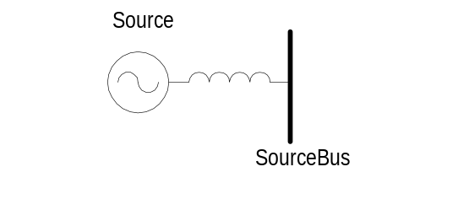
Figure 28. Default Circuit

The default values for the source are (see Vsource object definition):
115 kV
3000 MVA short circuit
Thus, the circuit can be immediately solved, albeit with a trivial result.
The circuit is also immediately available for adding a substation and/or lines for a quick manual circuit modeling task.
The default circuit model does not include a substation transformer because the user may wish to study more than one substation connected by a non-trivial transmission or subtransmission network.

Examples

Example Circuit 1

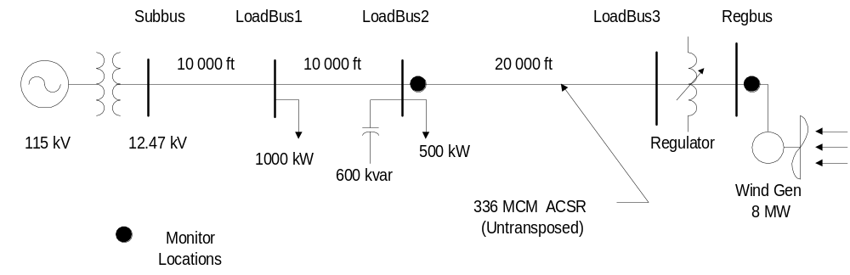

DSS Circuit Description Script

new object=circuit.DSSLLibtestckt
~ basekv=115 1.00 0.0 60.0 3 20000 21000 4.0 3.0 !edit the voltage source

new loadshape.day 24 1.0
~ mult=(.3 .3 .3 .35 .36 .39 .41 .48 .52 .59 .62 .94 .87 .91 .95 .95 1.0 .98 .94 .92 .61 .60 .51 .44)
new loadshape.year 24 1.0 ! same as day for now
~ mult=".3 .3 .3 .35 .36 .39 .41 .48 .52 .59 .62 .94 .87 .91 .95 .95 1.0 .98 .94 .92 .61 .60 .51 .44"
new loadshape.wind 2400 0.00027777 ! unit must be hours 1.0/3600.0 = .0002777
~ csvfile=zavwind.csv action=normalize ! wind turbine characteristi

! define a linecode for the lines - unbalanced 336 MCM ACSR connection
new linecode.336matrix nphases=3 ! horizontal flat construction
~ rmatrix=(0.0868455 | 0.0298305 0.0887966 | 0.0288883 0.0298305 0.0868455) ! ohms per 1000 ft
~ xmatrix=(0.2025449 | 0.0847210 0.1961452 | 0.0719161 0.0847210 0.2025449)
~ cmatrix=(2.74 | -0.70 2.96| -0.34 -0.71 2.74) !nf per 1000 ft
~ Normamps = 400 Emergamps=600

! Substation transformer
new transformer.sub phases=3 windings=2 buses=(SourceBus subbus) conns='delta wye' kvs="115 12.47 " kvas="20000 20000" XHL=7

! define the lines
new line.line1 subbus loadbus1 linecode=336matrix length=10
new line.line2 loadbus1 loadbus2 336matrix 10
new line.line3 Loadbus2 loadbus3 336matrix 20

! define a couple of loads
new load.load1 bus1=loadbus1 phases=3 kv=12.47 kw=1000.0 pf=0.88 model=1 class=1 yearly=year daily=day status=fixed
new load.load2 bus1=loadbus2 phases=3 kv=12.47 kw=500.0 pf=0.88 model=1 class=1 yearly=year daily=day conn=delta status=fixed

! Capacitor with control
new capacitor.C1 bus1=loadbus2 phases=3 kvar=600 kv=12.47
new capcontrol.C1 element=line.line3 1 capacitor=C1 type=current ctratio=1 ONsetting=60 OFFsetting=55 delay=2

! regulated transformer to DG bus
new transformer.reg1 phases=3 windings=2
~ buses=(loadbus3 regbus)
~ conns='wye wye'
~ kvs="12.47 12.47"
~ kvas="8000 8000"
~ XHL=1 !tiny reactance for a regulator

! Regulator Control definitions
new regcontrol.sub transformer=sub winding=2 vreg=125 band=3 ptratio=60 delay=10
new regcontrol.reg1 transformer=reg1 winding=2 vreg=122 band=3 ptratio=60 delay=15

! define a wind generator of 8MW
New generator.gen1 bus1=regbus kV=12.47 kW=8000 pf=1 conn=delta duty=wind Model=1

! Define some monitors so's we can see what's happenin'

New Monitor.gen1a element=generator.gen1 1 mode=48
New Monitor.line3 element=line.line3 1 mode=48
New Monitor.gen1 element=generator.gen1 1 mode=32

! Define voltage bases so voltage reports come out in per unit
Set voltagebases="115 12.47 .48"
Calcv

Set controlmode=time
Set mode=duty number=2400 hour=0 h=1.0 sec=0 ! Mode resets the monitors

Example Circuit 2

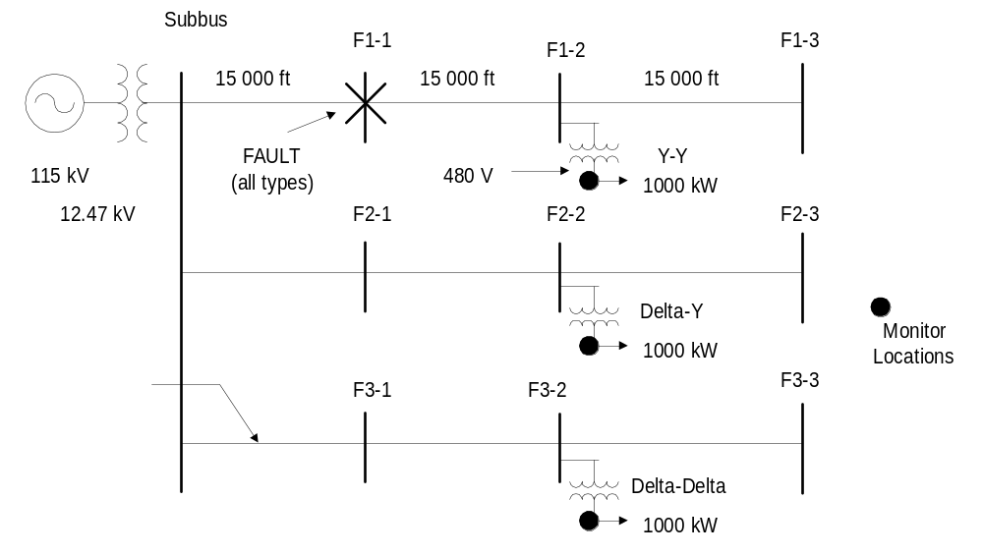

DSS Circuit Description Script

new object=circuit.DSSLLibtestckt
~ basekv=115 1.00 0.0 60.0 3 20000 21000 4.0 3.0 !edit the voltage source

! define a linecode for the lines - unbalanced 336 MCM ACSR connection
new linecode.336matrix nphases=3 ! horizontal flat construction
~ rmatrix=(0.0868455 | 0.0298305 0.0887966 | 0.0288883 0.0298305 0.0868455) ! ohms per 1000 ft
~ xmatrix=(0.2025449 | 0.0847210 0.1961452 | 0.0719161 0.0847210 0.2025449)
~ cmatrix=(2.74 | -0.70 2.96| -0.34 -0.71 2.74) !nf per 1000 ft
~ Normamps = 400 Emergamps=600

! Substation transformer
new transformer.sub phases=3 windings=2 buses=(SourceBus subbus) conns='delta wye' kvs="115 12.47 " kvas="20000 20000" XHL=7

! define the lines (Make sure they have unique names!)

! Feeder 1
new line.line1-1 subbus F1-1 336matrix 15
new line.line1-2 F1-1 F1-2 336matrix 15
new line.line1-3 F1-2 F1-3 336matrix 15

! Feeder 2
new line.line2-1 subbus F2-1 336matrix 15
new line.line2-2 F2-1 F2-2 336matrix 15
new line.line2-3 F2-2 F2-3 336matrix 15

! Feeder 3
new line.line3-1 subbus F3-1 336matrix 15
new line.line3-2 F3-1 F3-2 336matrix 15
new line.line3-3 F3-2 F3-3 336matrix 15

! Define 3 transformer of different connections on each feeder midpoint
new transformer.TR1 phases=3 windings=2
~ buses=(F1-2 Genbus1)
~ conns='wye wye'
~ kvs="12.47 0.48"
~ kvas="5000 5000"
~ XHL=6

new transformer.TR2 phases=3 windings=2
~ buses=(F2-2 Genbus2)
~ conns='delta wye'
~ kvs="12.47 0.48"
~ kvas="5000 5000"
~ XHL=6

new transformer.TR3 phases=3 windings=2
~ buses=(F3-2 Genbus3)
~ conns='delta delta'
~ kvs="12.47 0.48"
~ kvas="5000 5000"
~ XHL=6

! put some loads on the transformers
new load.load1 bus1=Genbus1 phases=3 kv=0.48 kw=1000.0 pf=0.88 model=1
new load.load2 bus1=Genbus2 phases=3 kv=0.48 kw=1000.0 pf=0.88 model=1
new load.load3 bus1=Genbus3 phases=3 kv=0.48 kw=1000.0 pf=0.88 model=1 conn=delta

! Define monitors at the secondary buses to pick up voltage magnitudes

New Monitor.TR1 element=Transformer.TR1 2 mode=32
New Monitor.TR2 element=Transformer.TR2 2 mode=32
New Monitor.TR3 element=Transformer.TR3 2 mode=32

! Define voltage bases so voltage reports come out in per unit
Set voltagebases="115 12.47 .48"
Calcv

! define all kinds of faults at one bus (will be moved later)
! in Monte Carlo Fault mode, only one will be chosen at a time
New Fault.F1 bus1=F1-1.1 phases=1 r=2
New Fault.F2 bus1=F1-1.2 phases=1 r=2
New Fault.F3 bus1=F1-1.3 phases=1 r=2
New Fault.FALL bus1=F1-1 phases=3 r=2
New Fault.F12 bus1=F1-1.1 bus2=F1-1.2 phases=1 r=2
New Fault.F23 bus1=F1-1.2 Bus2=F1-1.3 phases=1 r=2

Set loadmodel=a
Set Toler=0.001 Random=uniform

COM Interface Reference
OpenDSSEngine.DSS Interface Definition

Interfaces
This section lists the Classes exposed by OpenDSSEngine. For each class, the methods and events are listed.

---- The COM interface reference has been moved to another document ----
See the DOC folder on the OpenDSS Wiki site.

Example MS Excel VBA Code for Driving the COM Interface

The code below was extracted from a simple MS Excel example for driving the OpenDSS for compiling an arbitrary circuit script file.

Declarations
This section of the code declares some public variable for accessing the OpenDSS object and directly accessing two of the interfaces once the OpenDSS is instantiated. The DSSobj variable is required. DSSText and DSSCircuit are optional but allow for shorthand access to the Text interface and the active circuit interface.
Option Explicit

Public DSSobj As OpenDSSengine.DSS
Public DSSText As OpenDSSengine.Text
Public DSSCircuit As OpenDSSengine.Circuit

Startup
This subroutine first instantiates the OpenDSS object, setting it to the DSSobj variable. The DSSText variable can be set at this time, so that is done. Note that the DSSCircuit variable cannot be set because no circuit exists yet. Then the OpenDSS is started by invoking the Start method. The argument is ignored in this version. This initializes the OpenDSS and gets it ready for doing its work.
Public Sub StartDSS()

' Create a new instance of the DSS
Set DSSobj = New OpenDSSengine.DSS

' Assign a variable to the Text interface for easier access
Set DSSText = DSSobj.Text

' Start the DSS
If Not DSSobj.Start(0) Then MsgBox "DSS Failed to Start"

End Sub

Compiling the Circuit
This subroutine illustrates using the Text interface Command property to compile the circuit script file the user has specified. The filename is specified in a cell in the workbook labelled “fname”.
When the Compile has completed, there will be an active circuit and the current directory will have been switched to the script file directory. Unless changed in the script, this is where the results files will reside. Now that there is an active circuit, the DSSCircuit variable can be assigned to it.
Public Sub LoadCircuit(fname As String)

' Always a good idea to clear the DSS when loading a new circuit
DSSText.Command = "clear"

' Compile the script in the file listed under "fname" cell on the main form
DSSText.Command = "compile " + fname

' The Compile command sets the current directory the that of the file
' Thats where all the result files will end up.

' Assign a variable to the Circuit interface for easier access
Set DSSCircuit = DSSobj.ActiveCircuit

End Sub

Solving the Circuit
Solving can be accomplished by sending “solve” to the DSSText.Command interface. However, this example illustrates directly accessing the Solve method in the Solution object of the active circuit. This shows the expanded code. Since the DSSCircuit interface has been set, one could also invoke the Solve method by “DSSCircuit.Solution.Solve” which is a bit shorter.
Public Sub Solve()

' Execute the Solve method in the Solution interface of the active circuit
DSSobj.ActiveCircuit.Solution.Solve

End Sub

Bringing Results into the Spreadsheet
There are a number of ways to bring results from inside the OpenDSS into a spreadsheet. One obvious method is to export a CSV file and open the file in MS Excel. The two subroutines below illustrate how to do a couple of things programmatically. The first function loads the sequence voltages for all buses into a worksheet. The second loads the complex per unit voltages into another worksheet.
These routines take advantage of the ability to transfer variant arrays across the COM interface that is inherent in VBA and supported in OpenDSS. With one simple line of code, such as:
V = DSSBus.SeqVoltages

A whole array of values are brought into the program to be exploited however the user desires. The SeqVoltages property is associated with the Bus interface. When invoked, it causes the sequence voltages to be computed for the bus for the most recent solution and marshalled into a variant array of doubles. (The OpenDSS does not work in symmetrical components, so these values must be computed post-solution.)
In these examples, the values are simply deposited into certain cells along with the bus name. The bus name is extracted from the DSSCircuit.ActiveBus interface.
Public Sub LoadSeqVoltages()

' This Sub loads the sequence voltages onto Sheet1 starting in Row 2

Dim DSSBus As OpenDSSengine.Bus
Dim iRow As Long, iCol As Long, i As Long, j As Long
Dim V As Variant
Dim WorkingSheet As Worksheet

Set WorkingSheet = Sheet1 'set to Sheet1 (target sheet)

iRow = 2
For i = 1 To DSSCircuit.NumBuses ' Cycle through all buses

Set DSSBus = DSSCircuit.Buses(i) ' Set ith bus active

' Bus name goes into Column 1
WorkingSheet.Cells(iRow, 1).Value = DSSCircuit.ActiveBus.Name

' Load sequence voltage magnitudes of active bus into variant array
V = DSSBus.SeqVoltages

' Put the variant array values into Cells
' Use Lbound and UBound because you don't know the actual range
iCol = 2
For j = LBound(V) To UBound(V)
WorkingSheet.Cells(iRow, iCol).Value = V(j)
iCol = iCol + 1
Next j
iRow = iRow + 1
Next i

End Sub

Public Sub LoadVoltageMags()

' This Sub loads the per unit complex voltages onto Sheet3 starting in Row 2

Dim DSSBus As OpenDSSengine.Bus
Dim iRow As Long, iCol As Long, i As Long, j As Long
Dim V As Variant
Dim WorkingSheet As Worksheet

Set WorkingSheet = Sheet3 'For Example

iRow = 2
For i = 1 To DSSCircuit.NumBuses ' Cycle through all buses

Set DSSBus = DSSCircuit.Buses(i) ' Set i-th bus active

' Bus name goes into Column 1
WorkingSheet.Cells(iRow, 1).Value = DSSCircuit.ActiveBus.Name

' Loads pu voltages (complex) at active bus as variant array of doubles
V = DSSBus.puVoltages

' Put values in Variant array into cells in sequence provided by DSS
iCol = 2
For j = LBound(V) To UBound(V)
WorkingSheet.Cells(iRow, iCol).Value = V(j)
iCol = iCol + 1
Next j

iRow = iRow + 1
Next i

End Sub

In MS Excel VBA, you may easily view the other properties and methods available through the various interfaces in the OpenDSSEngine by including the OpenDSSEngine on the Tools | References list and displaying the Object Browser (see Figure 29 and Figure 30). A simple one-line help string is available for each item.

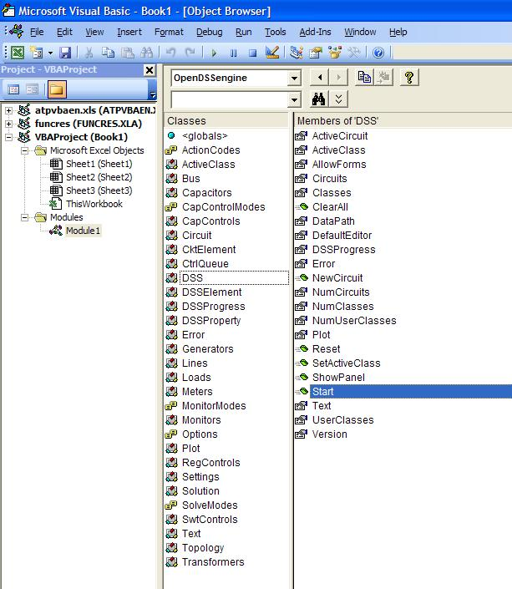
Figure 29. OpenDSSEngine COM interface as seen with MS Excel VBA

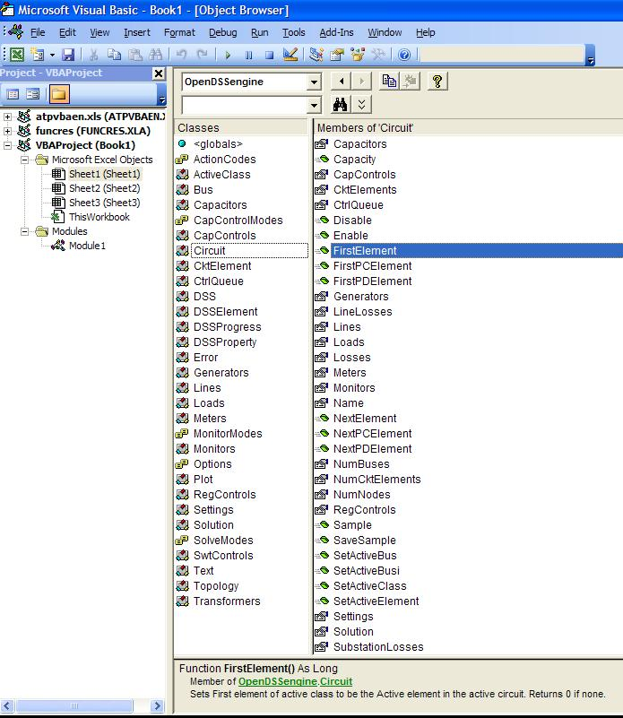
Figure 30. VBA Object Browser listing of the OpenDSS Circuit Interface

Example: Obtaining all Capacitor Names and Locations in Microsoft Excel VBA

This Excel subroutine will cycle through all the Capacitor objects in the circuit and put the names and bus connections in an Excel spreadsheet. It uses Ctk24 from the EPRI Test Circuits (on the OpenDSS site).
Attribute VB_Name = "Module1"
Option Explicit

Public DSSObj As OpenDSSengine.DSS
Public DSSText As OpenDSSengine.Text

Public Sub LoadInCapLocations()

Set DSSObj = New OpenDSSengine.DSS
Set DSSText = DSSObj.Text

If DSSObj.Start(0) Then

DSSText.Command = "Compile [C:\Users\prdu001\OpenDSS\EPRITestCircuits\ckt24\master_ckt24.dss]"
DSSObj.ActiveCircuit.Solution.Solve

DSSObj.ActiveCircuit.SetActiveClass "Capacitor"

Dim MyCap As Integer, iRow As Integer
Dim BusNameArray As Variant

ActiveSheet.Cells(1, 1).Value = DSSObj.ActiveClass.ActiveClassName
ActiveSheet.Cells(1, 2).Value = "Bus1"
ActiveSheet.Cells(1, 3).Value = "Bus2"

iRow = 2

MyCap = DSSObj.ActiveClass.First
Do While MyCap > 0
ActiveSheet.Cells(iRow, 1).Value = DSSObj.ActiveClass.Name
BusNameArray = DSSObj.ActiveCircuit.ActiveCktElement.BusNames ' gets all bus names for this device
ActiveSheet.Cells(iRow, 2).Value = BusNameArray(0) ' Bus1
ActiveSheet.Cells(iRow, 3).Value = BusNameArray(1) ' Bus2
iRow = iRow + 1
MyCap = DSSObj.ActiveClass.Next
Loop

End If

Set DSSObj = Nothing ' Be a good citizen

End Sub

Example: GIC Calculation
The example system represents a hypothetical 20 bus EHV network consisting of 500 kV and 345 kV lines and transformers. Figure 31 shows a single-line diagram of the network. The network includes single transmission lines as well as some that occupy the same transmission corridor. The substations feature both conventional transformers and autotransformers. Also included are series (series capacitors) and neutral connected GIC blocking devices.
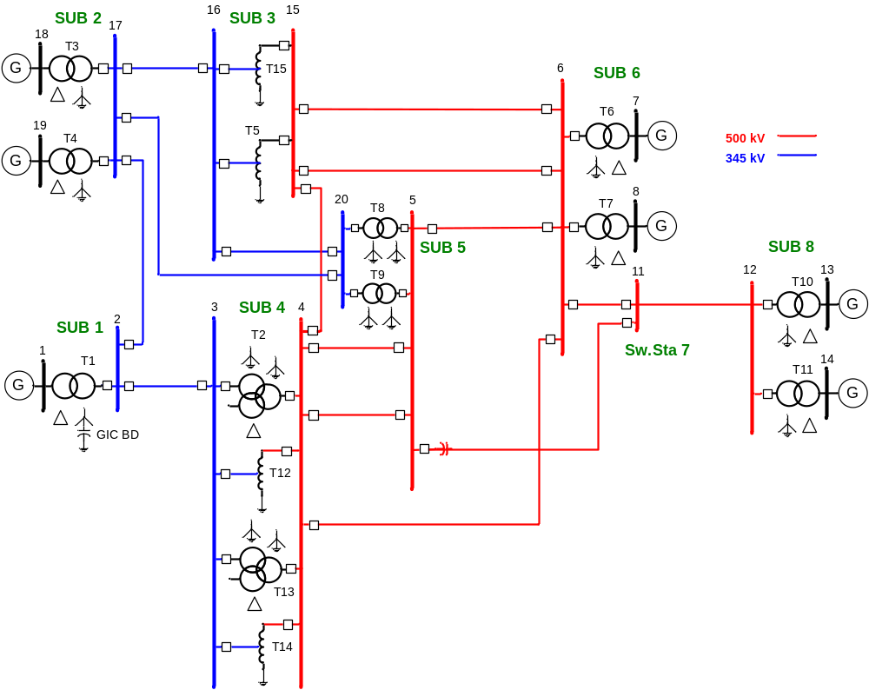
Figure 31. One Line Diagram of Example GIC System

Data for the system described in Figure 31 are provided in Tables 1-3.

Table 1.
GIC Example Substation Location and Grid Resistance
Name | Latitude | Longitude | Grounding Resistance (Ohm)
Sub 1 | 33.613499 | -87.373673 | 0.2
Sub 2 | 34.310437 | -86.365765 | 0.2
Sub 3 | 33.955058 | -84.679354 | 0.2
Sub 4 | 33.547885 | -86.074605 | 1.0
Sub 5 | 32.705087 | -84.663397 | 0.1
Sub 6 | 33.377327 | -82.618777 | 0.1
Sub 7 | 34.252248 | -82.836301 | N/A
Sub 8 | 34.195574 | -81.098002 | 0.1

Table 2.
GIC Example Transmission Line Data
Line | From Bus | To Bus | Voltage  (kV-LL) | Length (miles) | Resistance (ohm/phase)
1 | 2 | 3 | 345 | 77.18 | 3.512
2 | 2 | 17 | 345 | 77.47 | 3.525
3 | 15 | 4 | 500 | 87.51 | 1.986
4 | 17 | 16 | 345 | 102.54 | 4.665
5 | 4 | 5 | 500 | 103.31 | 2.345
6 | 4 | 5 | 500 | 103.31 | 2.345
7 | 5 | 6 | 500 | 131.05 | 2.975
8 | 5 | 11 | 500 | 154.57 | 3.509
9 | 6 | 11 | 500 | 63.59 | 1.444
10 | 4 | 6 | 500 | 205.57 | 4.666
11 | 15 | 6 | 500 | 128.81 | 2.924
12 | 15 | 6 | 500 | 128.81 | 2.924
13 | 11 | 12 | 500 | 102.39 | 2.324
14 | 16 | 20 | 345 | 88.98 | 4.049
15 | 17 | 20 | 345 | 152.53 | 6.940

Table 3.
GIC Example Transformer Data
Name | Type | Resistance W1  (Ohms/phase) | Bus No. | Resistance W2  (Ohms/phase) | Bus No.
T1 | GSU w/ GIC BD | 0.1 | 2 | N/A | 1
T2 | GY-GY-D | 0.2 | 4 | 0.1 | 3
T3 | GSU | 0.1 | 17 | N/A | 18
T4 | GSU | 0.1 | 17 | N/A | 19
T5 | Auto | 0.04 | 16 | 0.06 | 15
T6 | GSU | 0.15 | 6 | N/A | 7
T7 | GSU | 0.15 | 6 | N/A | 8
T8 | GY-GY | 0.04 | 5 | 0.06 | 20
T9 | GY-GY | 0.04 | 5 | 0.06 | 20
T10 | GSU | 0.1 | 12 | N/A | 13
T11 | GSU | 0.1 | 12 | N/A | 14
T12 | Auto | 0.04 | 4 | 0.06 | 3
T13 | GY-GY-D | 0.2 | 4 | 0.1 | 3
T14 | Auto | 0.04 | 4 | 0.06 | 3
T15 | Auto | 0.04 | 15 | 0.06 | 16

OpenDSS Script for Example System
The following scripts can be used to model the example system in OpenDSS with an Eastward electric field of 1 V/km. See Examples\GICExample on the OpenDSS Website.
Transmission Lines
Note: Lines appear wrapped in this document due to Word limitations, but are all one OpenDSS statement in the actual DSS script file.
!GIC Line Data
New GICLine.1-Bus2-Bus3 bus1=2 bus2=3 R=3.512 Lat1=33.613499 Lon1=-87.373673 Lat2=33.547885 Lon2=-86.074605 EE=1.00 EN=0.00
New GICLine.2-Bus2-Bus17 bus1=2 bus2=17 R=3.525 Lat1=33.613499 Lon1=-87.373673 Lat2=34.310437 Lon2=-86.365765 EE=1.00 EN=0.00
New GICLine.3-Bus15-Bus4 bus1=15 bus2=4 R=1.986 Lat1=33.955058 Lon1=-84.679354 Lat2=33.547885 Lon2=-86.074605 EE=1.00 EN=0.00
New GICLine.4-Bus17-Bus16 bus1=17 bus2=16 R=4.665 Lat1=34.310437 Lon1=-86.365765 Lat2=33.955058 Lon2=-84.679354 EE=1.00 EN=0.00
New GICLine.5-Bus4-Bus5 bus1=4 bus2=5 R=2.345 Lat1=33.547885 Lon1=-86.074605 Lat2=32.705087 Lon2=-84.663397 EE=1.00 EN=0.00
New GICLine.6-Bus4-Bus5 bus1=4 bus2=5 R=2.345 Lat1=33.547885 Lon1=-86.074605 Lat2=32.705087 Lon2=-84.663397 EE=1.00 EN=0.00
New GICLine.7-Bus5-Bus6 bus1=5 bus2=6 R=2.975 Lat1=32.705087 Lon1=-84.663397 Lat2=33.377327 Lon2=-82.618777 EE=1.00 EN=0.00
New GICLine.8-Bus5-Bus11 bus1=5 bus2=11 C=32.0 R=3.509 Lat1=32.705087 Lon1=-84.663397 Lat2=34.252248 Lon2=-82.836301 EE=1.00 EN=0.00
New GICLine.9-Bus6-Bus11 bus1=6 bus2=11 R=1.444 Lat1=33.377327 Lon1=-82.618777 Lat2=34.252248 Lon2=-82.836301 EE=1.00 EN=0.00
New GICLine.10-Bus4-Bus6 bus1=4 bus2=6 R=4.666 Lat1=33.547885 Lon1=-86.074605 Lat2=33.377327 Lon2=-82.618777 EE=1.00 EN=0.00
New GICLine.11-Bus15-Bus6 bus1=15 bus2=6 R=2.924 Lat1=33.955058 Lon1=-84.679354 Lat2=33.377327 Lon2=-82.618777 EE=1.00 EN=0.00
New GICLine.12-Bus15-Bus6 bus1=15 bus2=6 R=2.924 Lat1=33.955058 Lon1=-84.679354 Lat2=33.377327 Lon2=-82.618777 EE=1.00 EN=0.00
New GICLine.13-Bus11-Bus12 bus1=11 bus2=12 R=2.324 Lat1=34.252248 Lon1=-82.836301 Lat2=34.195574 Lon2=-81.098002 EE=1.00 EN=0.00
New GICLine.14-Bus16-Bus20 bus1=16 bus2=20 R=4.049 Lat1=33.955058 Lon1=-84.679354 Lat2=32.705087 Lon2=-84.663397 EE=1.00 EN=0.00
New GICLine.15-Bus17-Bus20 bus1=17 bus2=20 R=6.940 Lat1=34.310437 Lon1=-86.365765 Lat2=32.705087 Lon2=-84.663397 EE=1.00 EN=0.00

Transformers
Note: Lines appear wrapped in this document due to Word limitations, but are all one OpenDSS statement in the actual DSS script file.
New GICTransformer.T1 busH=2 busNH=2.4.4.4 R1=0.1 type=GSU_
New GICTransformer.T2 busH=4 busNH=4.4.4.4 busX=3 busNX=4.4.4.4 R1=0.2 R2=0.1 type=YY
New GICTransformer.T3 busH=17 busNH=17.4.4.4 R1=0.1 type=GSU
New GICTransformer.T4 busH=17 busNH=17.4.4.4 R1=0.1 type=GSU
New GICTransformer.T5 busH=15 busX=16 busNX=15.4.4.4 R1=0.04 R2=0.06 type=Auto
New GICTransformer.T6 busH=6 busNH=6.4.4.4 R1=0.15 type=GSU
New GICTransformer.T7 busH=6 busNH=6.4.4.4 R1=0.15 type=GSU
New GICTransformer.T8 busH=5 busNH=5.4.4.4 busX=20 busNX=5.4.4.4 R1=0.04 R2=0.06 type=YY
New GICTransformer.T9 busH=5 busNH=5.4.4.4 busX=20 busNX=5.4.4.4 R1=0.04 R2=0.06 type=YY
New GICTransformer.T10 busH=12 busNH=12.4.4.4 R1=0.10 type=GSU
New GICTransformer.T11 busH=12 busNH=12.4.4.4 R1=0.10 type=GSU
New GICTransformer.T12 busH=4 busX=3 busNX=4.4.4.4 R1=0.04 R2=0.06 type=Auto
New GICTransformer.T13 busH=4 busNH=4.4.4.4 busX=3 busNX=4.4.4.4 R1=0.2 R2=0.1 type=YY
New GICTransformer.T14 busH=4 busX=3 busNX=4.4.4.4 R1=0.04 R2=0.06 type=Auto
New GICTransformer.T15 busH=15 busX=16 busNX=15.4.4.4 R1=0.04 R2=0.06 type=Auto
New Capacitor.T1 bus1=2.4 bus2=2.5 phases=1 cuf=10

D.H. Boteler, R.J. Pirjola, “Modeling Geomagnetically Induced Currents Produced by Realistic and Uniform Electric Fields”, IEEE Transactions on Power Delivery, Vol. 13, No. 4, pp. 1303-1308, October 1998.

