Weekly Meeting Report — Technical Handover
Oct 22, 2026 · @amit

Purpose and scope
The Weekly Meeting report gives the Emollient study team a site-wise summary for the weekly internal meeting. It runs for any date range, normally one meeting week (Wednesday to Tuesday), and is generated on Tuesday night or Wednesday.
# | Section | Date field | Added
1 | Pre-Screening | baby_datetime | Apr 2026
2 | Screening & Enrollment | baby_datetime / enr_datetime | Apr 2026
3 | Discharge, Milestones, 29-Day Follow-up | per metric (dis_datetime, pd_datetime, sae_datetime, sw_datetime, fu28_datetime) | Apr 2026
4 | Sepsis & Blood Workup, incl. culture results pending from earlier weeks | nss_datetime | Oct 2026
5 | Emolliation Stopped (baby-, instance- and day-wise, with reasons) | int_datetime | Oct 2026
- URL: ?project=Emollient&report=WeeklyMeeting&format=html, plus &date_from=, &date_to=, &sites= and optionally &sepsis_exclusive=0.
- Formats: html (summary on screen), download_html, csv (all five sections as rows), excel (baby-wise detail sheets for verification).
- Hosts: dev on the ThinkPad, production at reporting.cel-one.org. Repo root /var/www/reports, branch main.
This document covers the whole report, with most detail on sections 4 and 5. A separate user guide explains how to read the figures.

Architecture
The engine runs one main REDCap pull for sections 1-3. WeeklyMeetingAggregator then runs two small pulls of day-event data for enrolled babies only, and hands each to its own helper.
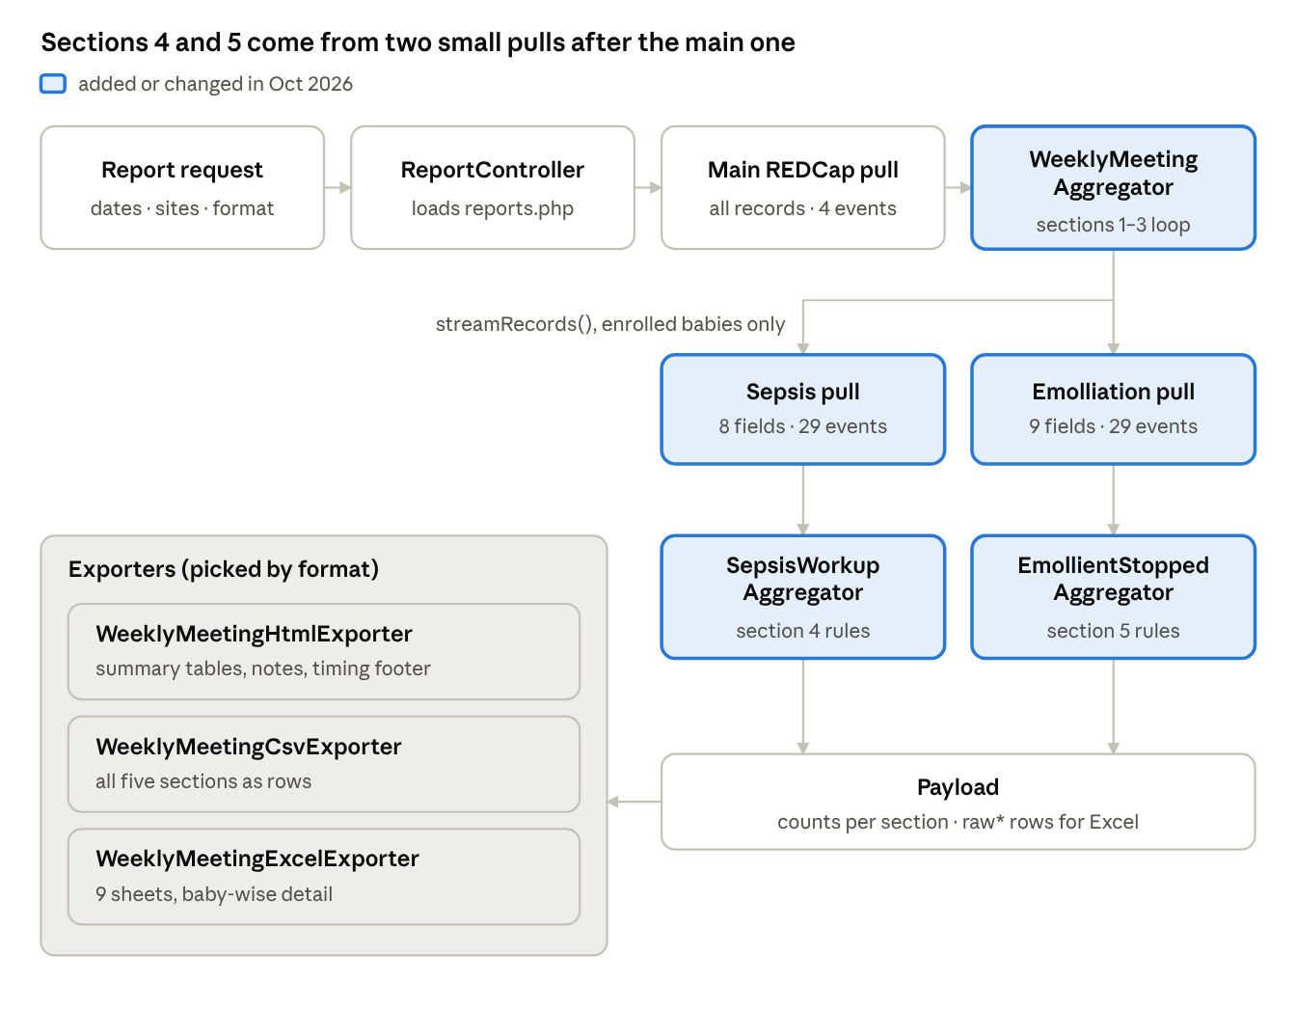
request flow · main pull, two detail pulls, three exporters
AggregatorRegistry builds the aggregator with the sepsis options and a fetcher closure. The closure reads projects/Emollient/config.php and calls RedcapApiClient::streamRecords(). ExporterRegistry picks the exporter from the format: weekly_meeting, weekly_meeting_csv or weekly_meeting_excel.

Files
All paths are under /var/www/reports. Status shows what was added or changed for sections 4 and 5 in October 2026.
File | Role | Status
projects/Emollient/reports.php | Report definition: main-pull events and fields, detail_fetch, sepsis options | changed
projects/Emollient/Aggregator/AggregatorRegistry.php | Builds WeeklyMeetingAggregator; reads ?sepsis_exclusive; builds the detail fetcher from detail_fetch | changed
projects/Emollient/Aggregator/WeeklyMeetingAggregator.php | Main loop for sections 1-3; collects enrolled babies; runs the two detail pulls; calls the section 4-5 helpers; builds the payload and timings | changed
projects/Emollient/Aggregator/SepsisWorkupAggregator.php | Section 4 rules: Confirmed / Suspected babies, test window, culture result, pending cultures | new
projects/Emollient/Aggregator/EmollientStoppedAggregator.php | Section 5 rules: instances, days, babies, full-day rule, reasons | new
projects/Emollient/Aggregator/RedcapFieldReader.php | Shared helpers: checkbox codes, dates, period check, dictionary labels | new
projects/Emollient/Export/WeeklyMeetingHtmlExporter.php | HTML page; renderMetaSection() draws sections 4-5; notes; timing footer; CSV / Excel buttons | changed
projects/Emollient/Export/WeeklyMeetingCsvExporter.php | CSV of all sections; metaRows() for sections 4-5 | changed
projects/Emollient/Export/WeeklyMeetingExcelExporter.php | Excel sheets from sheetDefs(); PhpSpreadsheet path plus a no-dependency fallback | changed
shared-lib/src/Infrastructure/Redcap/RedcapApiClient.php | streamRecords(): pull for a given list of record IDs | changed
reporting-engine/public/assets/css/weekly_meeting.css | Note row and timing footer styles | changed
projects/Emollient/config.php | REDCap API URL and token, read by the detail fetcher | unchanged
projects/Emollient/site_labels.php | Site code to display name, sets column order | unchanged
shared-lib/src/Domain/Export/ExporterRegistry.php | Maps weekly_meeting, weekly_meeting_csv, weekly_meeting_excel | unchanged
reporting-engine/public/assets/js/weekly_meeting.js is no longer used for CSV: the Export CSV button now requests format=csv from the server.

Configuration
Everything tunable lives in the WeeklyMeeting entry of projects/Emollient/reports.php. URL parameters override per request, and the CSV / Excel buttons keep the URL, so downloads match the page.
Key | Value | Effect
events | day0_arm_1, discharge_arm_1, other_forms_arm_1, day29_arm_1 | Main pull for sections 1-3. Must not include day events (see Performance).
fields | 44 fields | Main pull fields, unchanged since sections 1-3
detail_fetch.sepsis | day0 + DAILY_EVENTS; 8 nss_* fields; chunk_size 100 | Second pull, section 4
detail_fetch.emollient | day0 + DAILY_EVENTS; 9 int_* fields; chunk_size 100 | Third pull, section 5
sepsis_exclusive | true | true: Suspected = babies never confirmed in the period. false: a baby with both counts in both. URL: &sepsis_exclusive=0
sepsis_lookback_days | 2 | Tests counted from this many days before the first Confirmed / Suspected form
sepsis_pending_max_days | null | null = every pending culture however old. A number limits the sepsis pull to babies enrolled that many days (+35) before date_from.
site_labels_path | site_labels.php | Column names and order
Standard engine parameters also apply: date_from, date_to (inclusive, whole days) and sites (comma-separated codes).
Code constants worth knowing: DETAIL_WINDOW_DAYS = 35 in WeeklyMeetingAggregator, FULL_DAY_ENTRIES = 3 in EmollientStoppedAggregator, and CRP_MISSING = 9999999999 in SepsisWorkupAggregator.

Section 4: Sepsis & Blood Workup rules
All counts are babies, not forms. The section reads every neonatal_sepsis_screening form of the fetched babies dated up to date_to. Forms dated later are ignored, so a re-run gives the same figures "as of date_to".
Site: nss_hosp_code of the form, else the baby's enr_hosp_code.

Part A: sepsis marked this period
Row | Rule
Babies with confirmed sepsis | ≥ 1 form in the period with nss_sepsis = SEPSIS_IMPRESS_CONF
Babies with suspected sepsis | ≥ 1 form in the period with nss_sepsis = SEPSIS_IMPRESS_SUSP; with sepsis_exclusive = true, only babies never confirmed in the period
Test window | From sepsis_lookback_days (2) days before the baby's first CONF / SUSP form in the period, up to date_to. Any sepsis form in the window counts, whatever its impression.
CBC done | nss_tests___sepsis_tests_cbc = 1 on a form in the window
CRP done | nss_crp filled and not 9999999999
Blood Culture done | nss_blood_culture = 'Y', or a culture result entered
Culture result | From any form dated on or after the first culture in the window, up to date_to. One per baby: Positive > Negative > other code > Awaited.
No blood test done | None of CBC, CRP, culture in the window
Only exact Y counts as done; N, NI and blank are not done. SEPSIS_IMPRESS_PROB alone never puts a baby in the section, but a test on a PROB form inside the window counts.

Part B: culture results pending from earlier weeks
Row | Rule
Babies with culture result pending at start of period | The baby's last culture before date_from has no result on any form from that culture up to date_from. No age limit unless sepsis_pending_max_days is set.
Result received this period: Positive / Negative / other | A result on a form dated date_from..date_to
Still awaited | No result up to date_to
Part B ignores the impression. A baby can appear in both parts when a new episode starts while an old culture is still pending.
Percentages: test rows are % of babies in the group; culture-result rows are % of babies with culture done; pending rows are % of babies pending.

Section 5: Emolliation Stopped rules
Source is daily_interventionemolliation_form, a repeating form with up to 3 entries per study day on day0_arm_1..day28_arm_1. An entry counts when int_emoliate_baby is filled and int_datetime falls in the period. Site: int_hosp_code, else enr_hosp_code.
Level | Row | Rule
Baby | Babies with emolliation recorded | ≥ 1 entry in the period
Baby | Babies with ≥ 1 instance stopped | ≥ 1 entry with int_emoliate_baby = N
Baby | Babies with ≥ 1 full day stopped | ≥ 1 fully stopped study day (rule below)
Baby | Babies with a doctor-deny / SAE reason | ≥ 1 stopped entry with that detail field filled
Instance | Emolliation instances recorded / stopped | One entry = one instance
Day | Study days with ≥ 1 instance stopped | One baby on one study day (event) counts once
Day | Study days fully stopped | See rule below
Reason | int_no_emol_reason codes, plus "Reason not recorded" | Per stopped instance
Reason detail | int_doctor_deny_reason_list, int_sae_reasons codes | Per stopped instance; checkbox or dropdown both handled
Fully stopped day:
- Day 1 to Day 28: at least 3 entries recorded and all are N.
- Day 0: all recorded entries are N, because 1-3 sessions are expected depending on enrolment time.
- A day with only 1-2 entries, all N, is not a full day. It may be incomplete data entry or a discharge-day case, and it is listed per baby in Excel (days_all_n_lt3_entries).
A study day is the REDCap event, not the calendar date, so a form entered under the wrong event counts on that event's day.
Worked example: Day 5 N N N, Day 6 N Y Y, Day 7 N only gives 5 instances stopped, 3 days with a stop, 1 fully stopped day, and Day 7 flagged as all N with fewer than 3 entries.
An instance can carry more than one reason, so reason rows can add up to more than the stopped count. Codes are shown raw (e.g. MD, DOC_UNSTABLE) because no data dictionary is passed to the aggregator.

Payload and Excel sheets
WeeklyMeetingAggregator::aggregate() returns one array that all three exporters read. Summary data is metric-major: [$metric][$siteCode] plus a Total key. The section 4-5 helpers work site-major internally and are converted by toMetricMajor().
Key | Holds | Read by
prescreening, screening, discharge, metricMeta | Sections 1-3 | HTML, CSV
sepsis, sepsisMeta | Section 4 counts; row label, role (primary / sub / sub2), section heading, pct_of | HTML, CSV
sepsisNotes | undated, no_site, other_result_codes, exclusive, lookback_days | HTML notes
emollient, emollientMeta, emollientNotes | Section 5, same shape | HTML, CSV
timing | Seconds and row counts per pull, *_error per detail pull | HTML footer
raw* arrays | One list of rows per Excel sheet | Excel
period | date_from, date_to | all
Each Excel sheet has a meta line in row 1, headers in row 2, a frozen header and an autofilter. Sheets are defined once in WeeklyMeetingExcelExporter::sheetDefs(), which both build paths use.
Sheet | Payload key | One row per
Pre-Screening | rawPrescreening | screening instance in period
Discharge | rawDischarge | baby discharged in period
28-Day Status | rawDay28Status | baby with a discharge record (no date filter)
29-Day Follow-up | rawFollowup29 | follow-up in period
Sepsis PerBaby | rawSepsisPerBaby | baby per counted group (test window, tests, culture date, result, result form date)
Sepsis Forms | rawSepsisForms | sepsis form inside a counted baby's test window
Sepsis Pending | rawSepsisPending | baby pending at period start, oldest first, with age_days and status
Emollient PerBaby | rawEmolPerBaby | baby with ≥ 1 stopped instance (days with a stop, full days, days_all_n_lt3_entries, reasons)
Emollient Stopped | rawEmolStopped | stopped instance, with reason, detail and free text
Sheets carry record IDs only; no names, addresses or phone numbers.
To add a row to section 4 or 5, add it to the helper's metricMeta() and increment it in aggregate(). The HTML and CSV renderers draw whatever the meta lists, in order, so they need no change.

Performance
Keep day events out of the main pull: adding them is what made the report take about 4 minutes. RedcapApiClient::stream() fetches every record ID in the project (about 12,000, mostly prescreened babies never enrolled). With 28 day events and ~90 fields on every chunk, the pull grew to tens of thousands of rows. chunk_size barely helped because it changes the number of calls, not the volume.
The fix keeps the main pull as it was and adds two targeted pulls through streamRecords():
Pull | Records | Events | Fields
Main (engine) | all records in the project | 4 | 44
Sepsis | consented babies enrolled up to date_to (about 940) | 29 | 8
Emolliation | consented babies enrolled from 35 days before date_from to date_to | 29 | 9
The site filter is applied on enr_hosp_code before fetching. The page footer shows seconds and rows for each pull and the total; it is hidden when printing. If the sepsis pull becomes slow as enrolment grows, set sepsis_pending_max_days (e.g. 90).
If a detail pull fails (e.g. REDCap HTTP 429), sections 1-3 still render and the affected section shows the error in red.

Deployment and testing
The workflow is develop on the ThinkPad, commit and push to main, then pull on production.
- Stage only the report's files, by name, never git add .. Unrelated changes (e.g. projects/iKMC/sync.php) stay out.
- Commit and push: git commit -m "...", then git push origin main.
- Pull on production: cd /var/www/reports && git status, which must be clean, then git pull --ff-only origin main, then git log -1 --stat.
- Check the page: open the report for last week. Check sections 4-5 and the footer, then download CSV and Excel.
Permissions: files copied from a zip once arrived as 600, and the web server could not read reports.php. Use chmod 644 for files and 755 for directories. Git itself stores 644.
PHP reload: production has no php8.1-fpm unit. Find the service with systemctl list-units --type=service | grep -Ei 'php|apache|httpd|nginx'. PHP normally picks up changed files within seconds anyway.
Testing: each change was run locally against synthetic REDCap rows, with stub engine classes, through the aggregator and all three exporters. That covered:
- the 2-day look-back
- a result entered after date_to
- pending cultures received or still awaited
- the full-day rule, including Day 0
- the exclusive switch
- a failed detail pull
- the no-PhpSpreadsheet Excel fallback
None of this has been checked against live REDCap data by a second person yet.

Known limitations and open items
- Culture result typed into the original culture form. The report cannot tell when it was added, so the baby drops out of "pending" instead of showing as "received this period". "Still awaited" stays correct. A culture report date field would fix this.
- Data-entry lag. Monday and Tuesday forms may not be entered by Tuesday night, so the last days can show "awaited" or "no test done" that later corrects. The pending block picks these up the following week.
- Raw reason codes. Section 5 shows int_no_emol_reason, doctor-deny and SAE codes as stored. EmolliationCoverageDashboardAggregator already maps these to labels and could be reused.
- Full-day rule on Day 0 uses "all recorded entries N". The alternative is to leave Day 0 out of the fully stopped count.
- Sepsis pull size grows with enrolment. Watch the footer and set sepsis_pending_max_days if needed.
- Unused file. weekly_meeting.js is no longer used for CSV and can be removed or left as is.
- Credential rotation on the reporting platform is still open from the production deployment. The detail fetcher reads projects/Emollient/config.php, so rotate there.

