Photo: 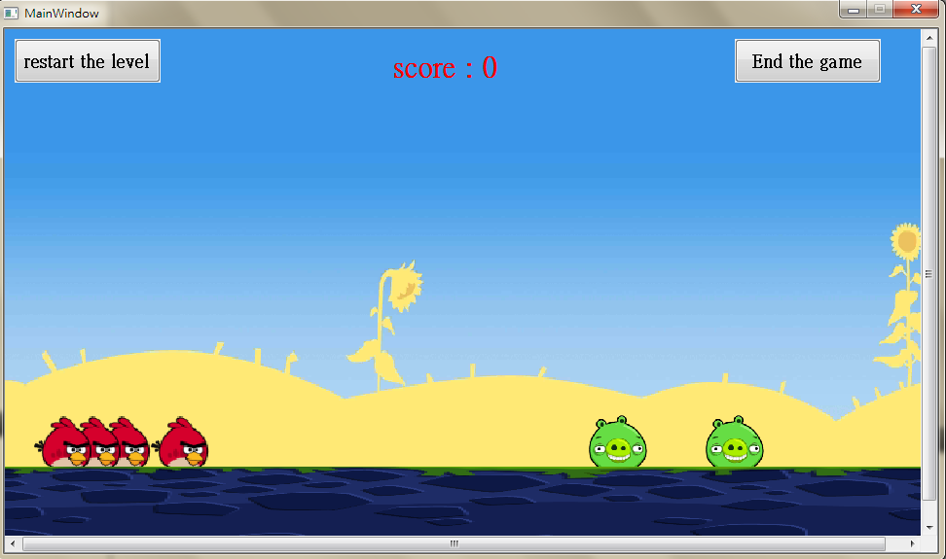

How to play:

Hold Mouseleftbutton to set power

Double click Mouserightbutton to use special tech

The first one is normal, the rest all have their special power.

When kill a pig, your score will + the_bird_you_rest*11111.

Have fun!