Analyst Desk Current Implementation Gap Analysis
The current web application implements a working research foundation, but it does not yet conform to all finalized product policies or the required frontend-message contract. Critical gaps affect publication eligibility, complete claim review, risk-change evidence, metric intent and memory boundaries. Merging the policy documents into Main did not implement their controls.
This report compares the running Main revision 875438652f2230103175332a7519064ecb482d02 with the final v1.0 specifications. Original web observations and source review were captured on 6 November 2026 at http://127.0.0.1:7861/. The report records existing behaviour and required changes; it does not change the application or approve any research note. The 7 November revision adds original-brief decisions, eighteen plain-language worked examples and nine further read-only screenshots from the same Main revision. Original policy ratings remain unchanged.

Executive verdict
Are all rules implemented? No. Are all 28 requested messages implemented? No. There are partial equivalents for some messages, but none of the 28 exact specified templates was identified by the bounded runtime-source scan. Literal wording absence alone does not prove behavioural absence, so each message has a separate functional assessment below.
The implementation already provides cached public SEC data, declared company/year coverage, numerical figure insertion, selected numerical checks, parallel specialists, bounded automated revisions, exact-content signatures, saved checkpoints, note memory and monitoring. These mechanisms are valuable. They do not establish complete source compatibility, narrative support, authorised review or safe publication.
The most urgent change is to make failed checks and incomplete claim review block final approval and publication at the graph, API and portal boundaries. A visible warning and a human Approve click must not waive a known unsupported result.

Evidence method and rating meaning
The review combines direct read-only browser inspection, pinned source references, selected public source passages and isolated synthetic component probes. Loading a saved run displays existing state; no run was resumed. No paid model request, live portal write, live deletion, code edit, commit or push was performed. The synthetic publication probe used an in-memory SQLite database and a synthetic key, never the real portal or approval key.
Followed means the specifically scoped control is supported by the inspected source and available evidence. Partial means a useful mechanism exists but material clauses or paths remain incomplete. Gap means a central required behaviour is absent or contradicted. Unverified means actual source eligibility, human review, execution or independent measurement cannot be established from this review.
These are grouped requirements, not atomic sentences or an exhaustive branch-test suite. Several groups deliberately overlap across policies. Do not add counts into a compliance percentage or treat Partial as half a pass. Source-confirmed behaviour is not the same as a completed live end-to-end test.
Inventory | Groups | Followed | Partial | Gap | Unverified
Financial rules | 38 | 3 | 12 | 19 | 4
Evidence and approval rules | 17 | 2 | 6 | 8 | 1
Memory and scoring rules | 22 | 1 | 7 | 13 | 1
Frontend message behaviour | 28 | 0 | 16 | 12 | 0

The three rule inventories contain 77 grouped assessments. Their section indexes cover the substantive sections of the nine domain-policy documents; the frontend inventory separately covers all 28 catalogue IDs. Ratings concern the reviewed requirements, not project completion, research accuracy or capstone marks.

Capstone requirements and acceptable limits
This section answers a different question from the original policy audit: what must be closed to demonstrate the capstone brief, and what may remain outside a candidly bounded demonstration? The original Followed, Partial, Gap and Unverified ratings remain unchanged. A project-policy gap is not automatically a separate capstone failure. Conversely, a documented policy or an attractive screen is not evidence that a required behaviour works.
The decisions below are an engineering reading of the original brief, not a mark prediction or an instructor-approved waiver. Each grouped finding can contain a mandatory core and optional implementation detail. Minimum actions and acceptable limits must be read together. Narrowing the assessed scope must be explicit and consistent with the application, demonstration and evaluation; a disclaimer cannot excuse a known wrong answer or an unmet mandatory core.
A narrower capstone implementation also does not silently amend the team's finalized project policies. Additional-policy controls remain tracked project commitments until the team explicitly changes the scope or implements them.

Meaning of the capstone decisions
Decision | Meaning
Must fix | Close the missing mandatory core or supply the required execution evidence before claiming the assessed behaviour works. A particular parser, banner or database design is not prescribed.
Conditional | Fix the core whenever the affected case or capability is supported. A simpler safe fallback or enforced, accurately disclosed scope restriction may be sufficient.
Additional policy | The detailed control exceeds an explicit brief minimum. It can be deferred for capstone scope if its minimum grounding and safety obligations still hold; retain the project-policy gap unless formally changed.
Verify evidence | Locate and independently check the actual data, labels, tests or run records before deciding that the requirement is complete or missing.
Preserve | Keep the narrowly scoped working control and its demonstration evidence; this is not a claim that all related controls pass.

The 77 existing rule groups receive the following separate decisions. These counts overlap in subject matter and are not counts of unique tickets, atomic clauses or capstone marks.
Decision | Rule groups
Must fix | 36
Conditional | 19
Additional policy | 8
Verify evidence | 8
Preserve | 6

The frontend catalogue is assessed separately: 15 message groups require a missing core behaviour, and 13 depend on the supported scenario. None of the 28 exact banner wordings is independently mandated by the brief. Equivalent clear wording is acceptable when the actual state, permitted action and backend enforcement are correct. These message counts overlap the underlying rule groups.

What the brief explicitly requires
The original PDF has nine physical pages; the Analyst Desk section is physical pages 7-8, carrying printed page numbers 15-16. Other page references below use physical PDF pages unless a printed page is explicitly identified.
Brief area | Required minimum and boundary
Grounded research | Physical pp7-8, Analyst Desk steps 3-6 and Signature A: cite the actual evidence, link every number to an XBRL fact or table cell, check numbers in code, review each substantive claim against its passage, and use compatible fiscal periods and units.
Human control | Physical pp2-3 and pp7-8: visible editable plans, replanning when evidence contradicts the plan, explicit human review at world-changing actions, and approval of the exact note before the portal write; changed payloads invalidate approval.
Bounded correction | Physical pp7-8: the critic/writer may make at most two revisions. Exhausting that limit does not make an incorrect result correct. Named HOLD states and a particular UI layout are implementation choices.
Declared corpus | Physical p8: 10-15 companies, two sectors, three years each, Item-aware 10-K parsing with tables and company/year/Item metadata. The exact fifteen tickers, FY2022-FY2024, arbitrary new tickers and live latest-period ingestion are not prescribed.
Retrieval and evaluation | Physical pp3,5-6,8: hybrid retrieval and reranking, labelled retrieval measurement, independently prepared expected outcomes, protected held-out evaluation, human risk-change labels for ten company-years, judge calibration and required experiments. This audit does not certify those requirements merely from source code.
Memory and lessons | Physical pp3,5-6,8: a written save/read/correct/delete policy, real memory-on/off comparison, relevant preferences/coverage/past notes, private-watchlist boundary, development-only reviewed lessons and a frozen playbook before held-out use.
Operations | Physical pp3,8: persistent checkpoints, visible traces, Docker Compose, monitoring and the required alert. The below-98% verified-share threshold is an operations alert, not permission to publish known wrong values.

Source: Original capstone brief. The row-by-row decision register later in this report supplies a minimum closure, acceptable limit and page reference for every rule and message.
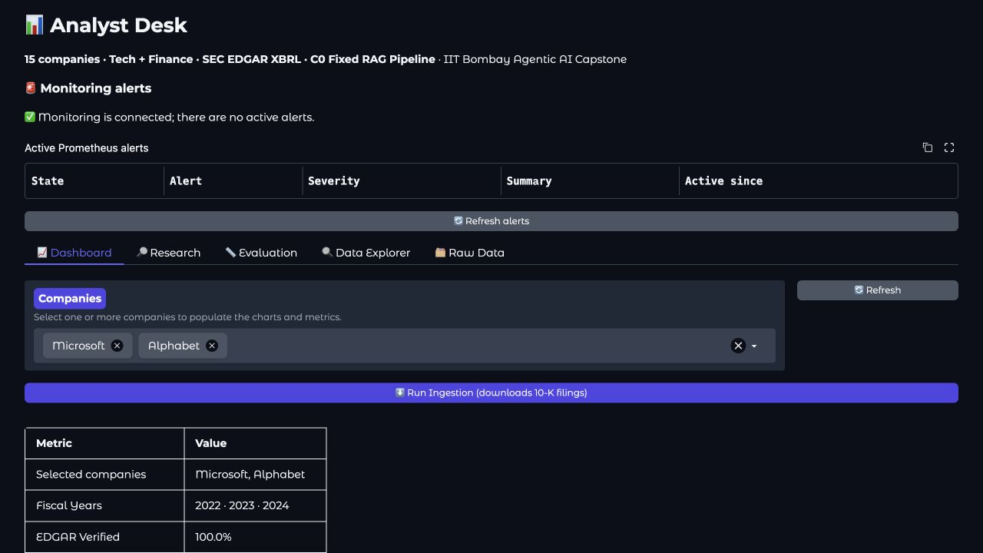
Current dashboard declares fifteen companies and FY2022 to FY2024 coverage and a fixed historical corpus is acceptable when accurately stated

Minimum release plan
First, make numerical and semantic review complete for the supported output, preserve critic failures as incomplete, prevent known failed results from being signed/published, and correct the unsupported saved demonstration note. Keep exact-note edit invalidation and the two-revision limit.
Second, preserve the requested supported company/year/metric comparison, make missing evidence visible, and use compatible financial inputs with traceable sources. A fixed historical corpus and an honestly unavailable answer are acceptable. Silently dropping a requested company or substituting a different metric or baseline is not.
Third, demonstrate the genuine memory follow-up and memory-off comparison; keep private watchlists inside the permitted boundary; review genuine development lessons and freeze the actual playbook used for held-out runs. A public-only single-analyst demo may simplify identity and retention architecture only if those limits are enforced and private/multiuser readiness is not claimed. The required private-watchlist security test still needs a safe demonstration, such as an isolated synthetic sentinel rather than real private holdings.
Finally, verify the actual corpus, expected answers, human labels, calibrated judge, fair experiments, security tests and operational demonstrations. Missing inspection is not proof those assets are absent. Confirm their existence and quality before treating them as closed.

What can remain outside the minimum
Arbitrary ticker entry, unlimited years, live latest-period ingestion, quarterly calendarisation, FX, Capital IQ integration, full-section word-count analytics and earnings-correlation modelling can be deferred. Unsupported requests must receive an accurate limitation or a revised supported plan.
Exact HALF_UP ties, universal two-decimal margins, a particular HOLD label, checksums and policy hashes on every output, enterprise SSO, full automated withdrawal chains and exactly-once publication infrastructure are not independently prescribed minima. Their simpler substitutes must still deliver correct interpretation, actual human approval, truthful write outcomes and the required privacy/security boundaries. Existing project-policy promises must not be represented as implemented when deferred.

Policy baseline
The baseline consists of final project specifications. Document finalization is complete; implementing and independently verifying those requirements remains separate work.
Document | Required use and current position
Problem Statement | Product direction matches the research application. Complete evidence, safe publication and measured outcomes remain open. F30/F33/F34, AE01-AE08.
User Needs and Workflow | Source-to-model workflow is documented. This review does not establish expert prototype inspection, expectation-baseline support or measured time savings. AE06, F34.
Supported Research Scope | Declared coverage exists. Relative dates, unsupported selections, optional length/correlation work and complete outputs have gaps. F01-F05/F19/F30-F37.
Bank Metrics and Comparison Rules | Metric labels/calculations exist; explicit intent, compatible inputs and consistent mixed-metric controls are incomplete. F04-F07/F13/F17/F18/F38.
Fiscal Periods and Units Rules | USD facts and some date metadata exist. Full period validation, unit identity, precision and HALF_UP are incomplete. F07-F13/F17-F22/F38.
Filing Version Policy | Original/later selection exists. Approved basis/cutoff, reliable version classification and non-reliance handling are missing. F14-F16/F23-F29/F36.
Evidence Risk Change and Uncertainty Policy | Selected numerical/claim checks exist. Complete claim inventories, paired coverage and fail-closed review are missing. AE01-AE06/AE08/AE17.
Acceptance and Publication Policy | Exact-content signatures and gates exist. Eligibility, identity/context, unknown outcomes and lifecycle recovery are incomplete. AE07-AE16.
Memory and Privacy Policy | Separate stores and some controls exist. Ownership, off-mode enforcement, retention and lifecycle guarantees are incomplete. M01-M12.
Memory and Privacy Rules and Examples | History/preferences/lessons exist. Suppression, restore, immutable releases and matched benefit evidence are incomplete. M01-M12/L01-L04.
Golden Answers and Scoring Rules | Published reference cases are not wired to a verified frozen scoring release. Existing scorer has association, sign and completeness defects. G01-G06.
Frontend Messages and Trigger Conditions | All 28 IDs reviewed separately below. Exact catalogue wiring is absent; 16 have partial functional equivalents and 12 have central gaps.
Product Checklist | Written definitions are marked complete and execution evidence remains open. The current audit supplies findings, not proof those open tasks have been completed.
Project Work and Decision Log | Specification milestones are recorded. Per-run effective policy/source decisions and actual implementation verification remain to be recorded. F36/F37.

Current web evidence

W01 Green checks do not establish the requested analysis
Saved C2 run d7706851 is waiting for note approval. The screen displays 11/11 recognised numerical values verified and 5/5 selected cited claims supported. The wording correctly calls these cited claims; it does not say that all assertions were reviewed. Nevertheless, the board labels the critic passed and exposes Approve and publish.
The note admits that exact word counts were not provided and uses qualitative additions as a proxy for length. It subsequently describes increased disclosure length and concludes there is no evident positive or negative correlation with subsequent earnings. No full-section count series, validated extraction boundary, stated word-count method, lagged earnings dataset or correlation calculation is presented. Correct revenue-growth figures do not establish that result. Relevant requirements: F32/F33, AE02-AE06, E01/E02/E03/A01.
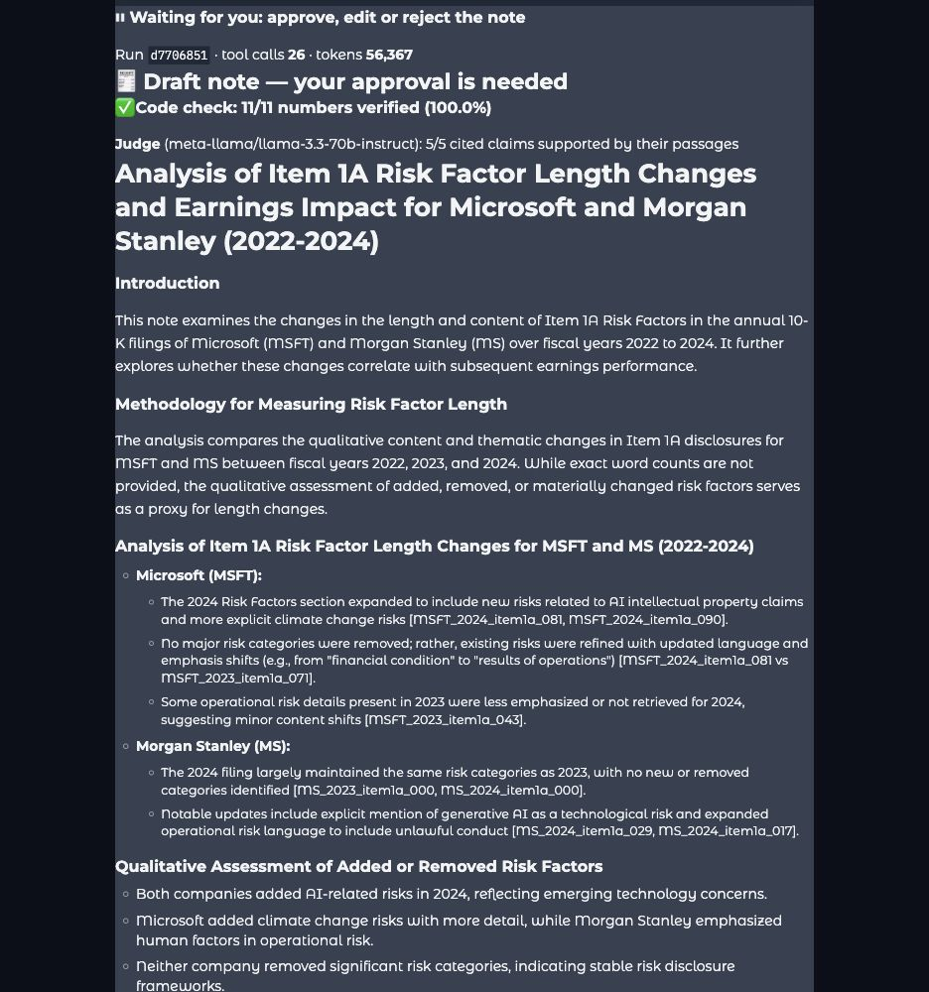
Current note shows green numerical and selected-claim checks while admitting word counts were not performed

W02 A climate novelty claim conflicts with the available earlier passage
The same note says Microsoft added climate-change risks with more detail. The cited FY2024 climate paragraph already appears in the reviewed FY2023 cache. A whitespace-normalized comparison of the complete climate paragraph is identical. This is positive earlier evidence, rather than an inference from a failed search.
The appropriate limited conclusion is that this reviewed climate paragraph is already present in both periods. This comparison does not establish that the entire filings are identical, or that no other climate wording changed. A separate reviewed IP paragraph does add explicit AI-training/output language in 2024; that narrower wording observation must not be converted into proof of a new economic risk or increased whole-section length.
Earlier evidence: MSFT_2023_item1a_079. Later evidence: MSFT_2024_item1a_090. Local exact-comparison record: climate_exact_comparison.json. Requirements: AE04/AE05 and E01/E02.

W03 Required evidence errors and an unfinished placeholder do not prevent the approval control
The saved team activity records BUDGET_EXCEEDED in both risk-diff branches. The quant branch records an execution error followed by a successful retry. A recovered error is not automatically a final failure; the unresolved question is whether sufficient reviewed evidence remains. The current note provides no complete comparable-coverage verdict that resolves that question.
The literal {WHAT_CHANGED} token remains visible near the conclusion. It is outside the financial-placeholder regex, and the current checker does not identify it as a blocking incomplete output. No approval or publication was performed during this review. The observed fact is an enabled approval control next to this unfinished note, not an observed bad portal write.
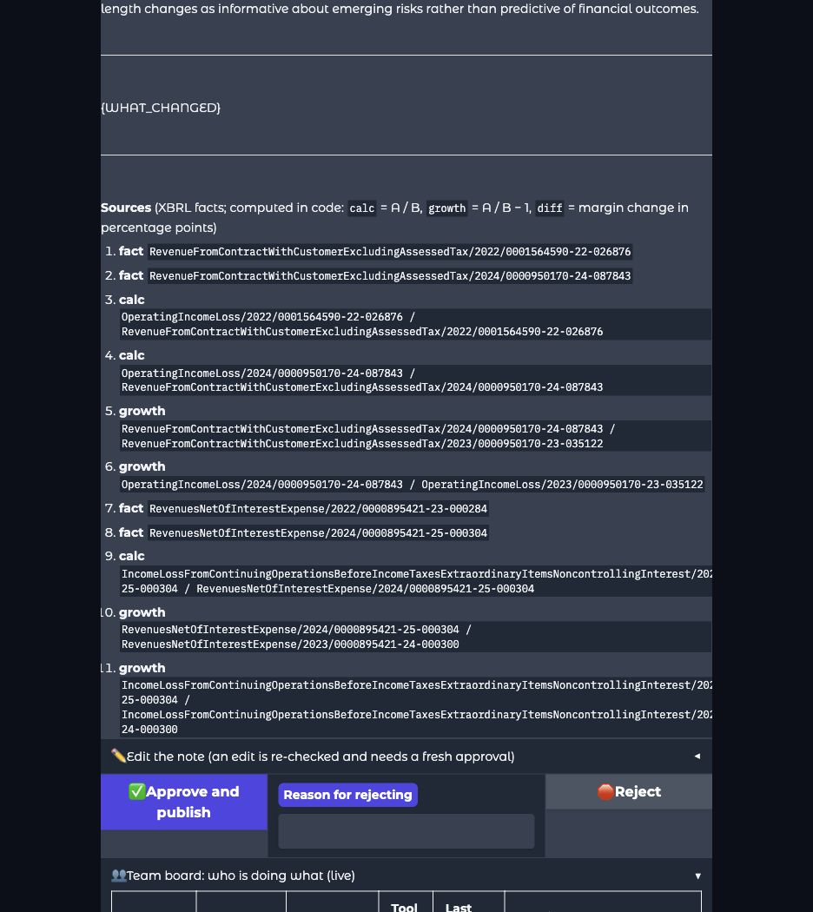
Current note retains the unresolved WHAT_CHANGED placeholder and exposes the approval control
R1 recommendation for this version: withhold approval until unsupported length, novelty and correlation statements are corrected or replaced by accurate limitations; resolve the placeholder; review complete claim/quantity coverage; and obtain fresh checks and the applicable exact-version decision. This recommendation does not change the app's stored note status.

W04 Fiscal differences and display precision need clearer treatment
Dashboard data shows FY2022-FY2024 and period-end dates, but no prominent historical-coverage notice or full reporting-window qualification. Microsoft FY2024 covers July 2023-June 2024; a December-year-end issuer covers a different window. Dashboard margins use one decimal, such as 44.6%, while the final rules require two decimal places. A fiscal-year label alone does not establish a calendar-aligned comparison.

W05 Mixed metrics have labels but incomplete comparison controls
The dashboard can place Microsoft operating margin and Morgan Stanley pre-tax margin on one axis. The legend distinguishes the two, which is useful. No shared gap/ranking/average was observed in this chart, so the screenshot is not evidence that the dashboard calculated one. The missing visible qualification and inconsistent controls across chart/research paths still create a comparability gap.
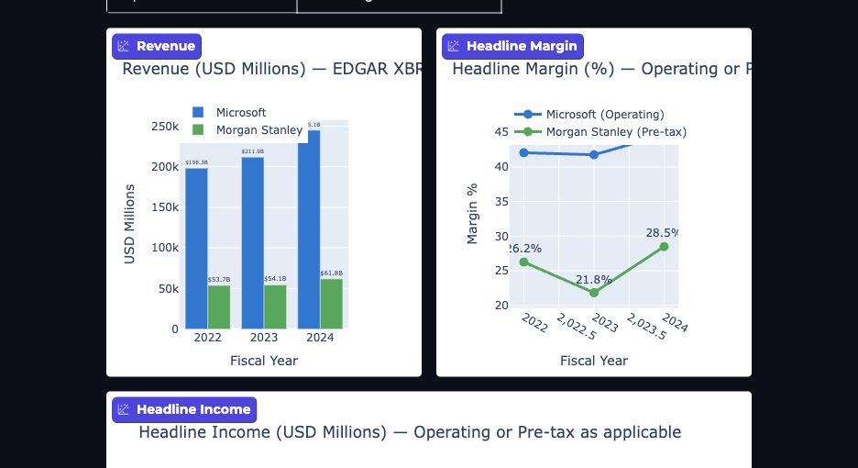
Dashboard overlays operating and pre tax margins with basis labels but without a prominent comparison limitation
An earlier saved C1 run 47598533 requested latest operating margins and shows Microsoft operating margin alongside Morgan Stanley pre-tax margin, described as latest FY2024. Its activity also records an edited-and-approved plan. Consequently this artifact alone does not prove an unauthorised metric substitution; the source-level typed metric/revised-task guarantee remains absent. The historical meaning of latest and non-comparability still need explicit explanation. C1 provides numerical checks rather than the C2 semantic critic.

W06 Memory and source disclosures need to match their actual boundaries
The UI describes memory as the analyst's own coverage and provides a name field, memory deletion and a memory-off rerun. Source inspection finds globally ticker-keyed history, editable identity and an available history tool even in memory-off mode. No other user's records were sought and no leak was demonstrated. These are missing enforcement boundaries confirmed in source, not a tested cross-user disclosure.
Sources in a note are largely printed identifiers rather than direct filing/table drill-down links. This is a usability gap for inspecting the evidence; the identifiers themselves are useful provenance and should be retained. The new Prometheus alert panel works and showed no active alerts during inspection. Its presence does not establish complete claim review or safe publication.

Worked examples and additional screen evidence
The following eighteen examples explain the most important overlapping findings in plain language. They are selected teaching cases, not one independent example or screenshot for each of the 77 groups. Hypothetical figures are labelled; synthetic probes are distinguished from browser observations. No new live research, model call, approval, deletion, lesson decision or publication was performed to create this revision.
Nine additional unaltered screenshots were captured on 7 November 2026 from the same Main revision. Together with the three original exhibits, this report contains twelve screenshots. Loading saved runs displays their historical state; it does not rerun today's checker or establish that the originally generated note is currently correct. Screenshots prove the visible controls and recorded state, not every backend consequence. Source references and isolated probes establish the separately identified backend findings.

Example 1 A detected wrong number can still reach the approval gate
Related findings: AE08, F16, frontend A01/A02. Decision: Must fix the publication prerequisite.
Simple example: revenue 100 million and operating income 20 million imply a 20% operating margin. A draft saying 25% is wrong. Two unsuccessful correction rounds do not change that arithmetic. The isolated probe shows that a failed result can reach signing and an in-memory portal; it did not publish a real note.
Additional observed evidence: saved run e058f0ea, last updated 25 October, displays 18/23 numbers verified and only 2/4 selected claims supported. The current UI still exposes its approval gate. These are two views of the same saved run, not a new failed model request. No approval button was activated.
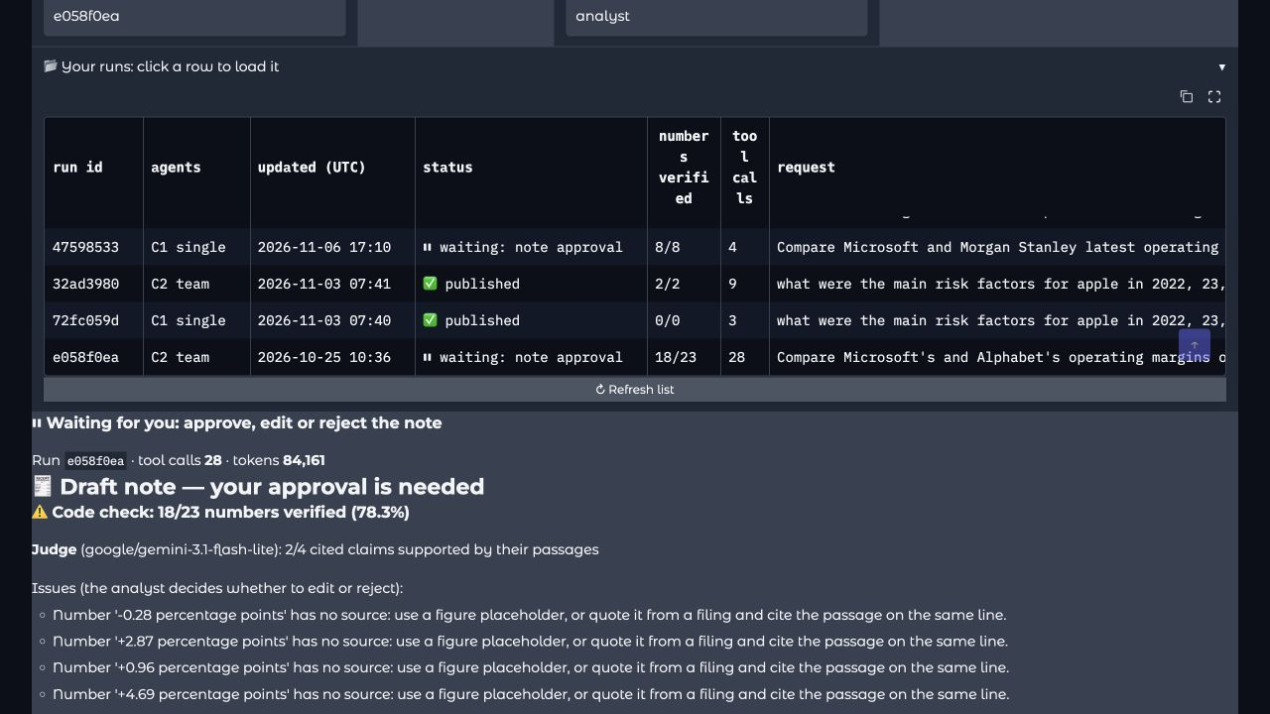
Saved run e058f0ea shows failed numerical checks and partial selected-claim support when loaded on 7 November
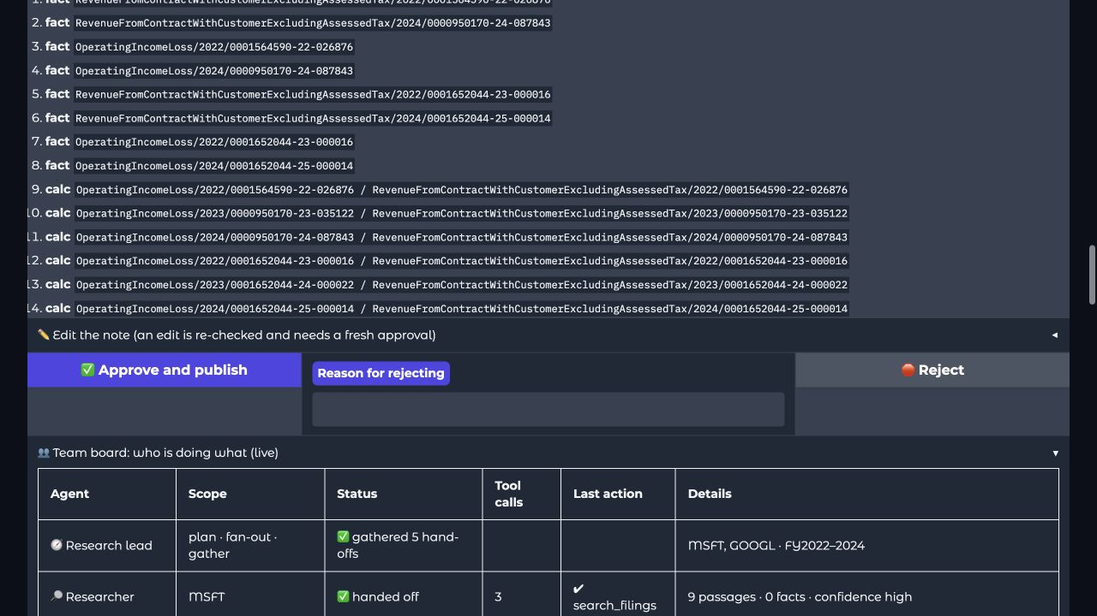
The same saved run exposes Approve and publish despite its failed stored checks and no approval was performed
Expected product behaviour: keep the draft readable, show the exact unresolved issue, and prevent final signing and portal insertion until the supported note is corrected and checked. A suitable message is: Publication blocked. The stated margin is 25.00%; verified inputs produce 20.00%.
Minimum versus extra: preventing known wrong publication is core. The exact status name and banner wording are optional. A warning plus an enabled publication path does not close the gap.

Example 2 Selected claims are not all claims
Related findings: AE01/AE02, F33, frontend E02/E03. Decision: Must fix complete review of the supported note.
Hypothetical source: a filing says cyberattacks could disrupt operations. A note makes three claims: the company discloses that potential risk, a major attack actually occurred, and the attack caused earnings to fall. Only the first claim has a valid passage citation. Current selection can send only that first line to the judge, producing 1/1 supported while the other two assertions are not reviewed.
Observed screen: W01 shows 5/5 cited claims supported. That wording accurately limits the displayed subset, but does not establish a complete claim inventory. The current selector also caps eligible lines at ten and truncates supplied context.
Expected product behaviour: identify all substantive claims, require valid evidence and a verdict for each, and show reviewed versus total scope. For this example: Review incomplete. Three claims identified; one supported and two lack evidence. A title or uncited conclusion must not evade review.
Minimum versus extra: the brief requires each-claim review. A specific claim-ID schema or dependency-graph design is optional; sampling alone cannot establish a full-note pass.

Example 3 A missing critic verdict is not a supported verdict
Related findings: AE03, frontend E03. Decision: Must fix truthful incomplete status and safe progression.
Simple example: one claim is submitted. The critic fails, or returns an empty verdict list. The request-failure probe produces no blocking issue and an overall check.ok true. The empty-list probe incorrectly produces 1/1 supported because the implementation subtracts reported unsupported verdicts from selected claims: 1 minus 0 equals 1. No actual support verdict was supplied.
Evidence boundary: these are source-confirmed, isolated test results. No live critic-outage screenshot was captured, and the ordinary green screenshot must not be presented as proof of a provider failure. In the failure fixture the current renderer can show a green code-check heading with Judge None/1 while hiding the stored judge-unavailable explanation.
Expected product behaviour: Critic review incomplete. One claim submitted; zero valid verdicts received. Preserve the draft and actual error, and prevent an incomplete required review becoming a pass. Validate missing, duplicate and out-of-range verdict identities.
Minimum versus extra: completed honest claim review is core. Automatic provider retries are optional; stopping safely is acceptable. A deliberately critic-off baseline or ablation must remain labelled as such and is not a fully reviewed production note.

Example 4 Added and Removed need evidence from both sides
Related findings: AE04/AE05, F30, frontend E01. Decision: Must fix unsupported classification; verify the required human labels.
Observed example: the saved note says Microsoft added climate-change risk with more detail. The complete reviewed climate paragraph appears in both FY2023 and FY2024 and is identical after whitespace normalisation. The supported conclusion is Unchanged in this reviewed paragraph, not a newly added risk. This does not establish that the entire filings are unchanged.
Hypothetical Removed mistake: a cyber-risk paragraph moves from Technology Risks to Operational Risks. Searching only the old heading fails, and the agent labels it Removed. The disclosure still exists elsewhere.
Expected product behaviour: retain the before/after passages, requested year pair and reviewed scope. Use Insufficient evidence when an absence claim cannot be established. Newly added disclosure wording does not by itself prove a new underlying economic risk. W02 links both actual climate passages; W01 shows the disputed statement.
Minimum versus extra: the brief explicitly requires added/removed/materially-changed risk comparison and human-labelled questions for ten company-years. Exact Unchanged/Insufficient evidence labels and the record schema are our implementation choices.

Example 5 More retrieved text does not mean a longer filing section
Related findings: AE05, F32/F33, frontend E01/E02/R02. Decision: fix unsupported conclusions; defer optional analytics if needed.
Hypothetical lengths: the complete section has 10,000 words in FY2023 and 8,000 in FY2024, a 20% decrease. Search retrieves 600 words from FY2023 and 1,200 from FY2024. Retrieved text doubled because of query/ranking limits; the complete section became shorter. Selected snippets cannot establish whole-section length, complete absence or a relationship with later earnings.
Observed screen: W01 admits no exact word counts and uses qualitative additions as a proxy. The additional team view below records risk-diff budget errors beside a passed critic. An error may be recoverable; it requires a sufficiency decision, not an automatic conclusion that every downstream statement is wrong or that coverage is complete.
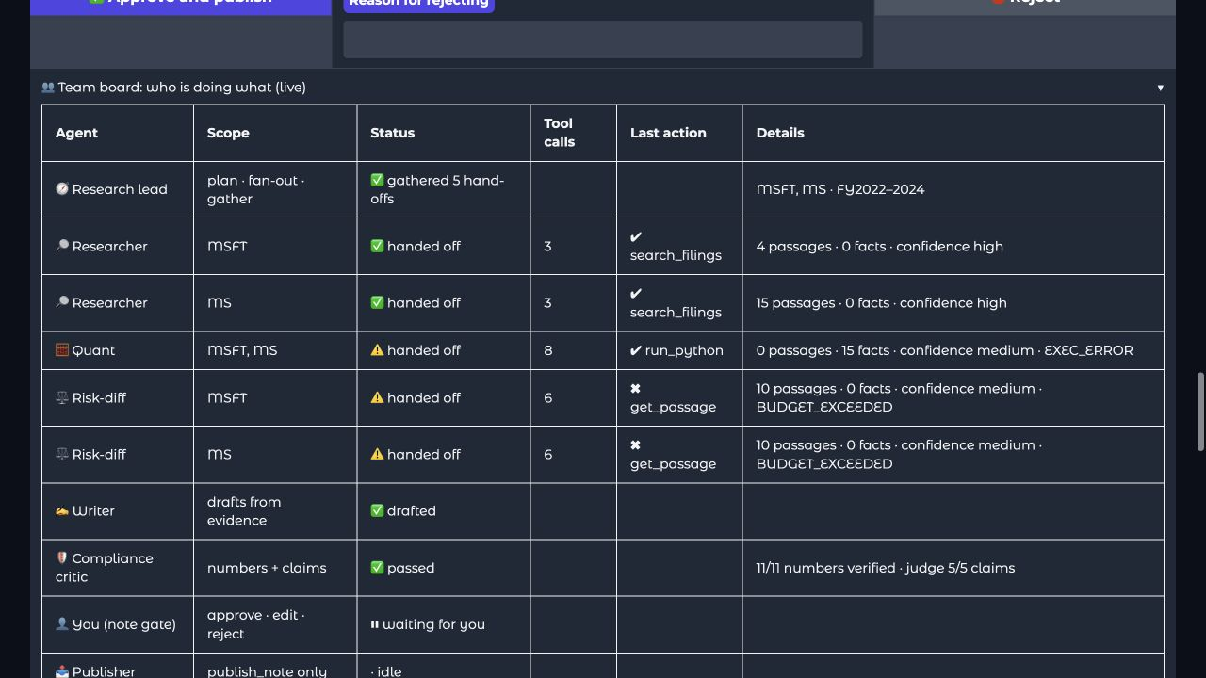
Saved run d7706851 shows risk-diff budget errors beside a passed critic and no new request was made
Expected product behaviour: Partial source coverage. Selected Item 1A passages were compared; full-section length and subsequent-earnings correlation were not assessed. Remove or narrow unsupported conclusions as well as adding the limitation.
Minimum versus extra: accurate grounding and limits are mandatory. Full-section word-count and earnings-correlation features are optional. A focused claim can be supported by a focused passage; every question does not require reading the entire filing.

Example 6 A correct partial answer can miss the requested task
Related findings: F02/F19, AE06/AE04, frontend S02/S03. Decision: Must fix silent scope loss; a bounded supported plan is acceptable.
Hypothetical request: compare Microsoft and Apple risk disclosures between FY2022 and FY2024. If the planner retains only Microsoft, an allowed-company filter can still pass because Microsoft is supported. Separately, the specialist supplies latest=max(years) and prior=latest-1, directing FY2023/FY2024 even when FY2022/FY2024 was requested. The complete plan is also in the prompt, so this is conflicting task direction rather than proof that every run necessarily uses the wrong pair.
Expected product behaviour: show each requested comparison and its Completed, Unavailable or Not assessed outcome; preserve a missing Apple row; explain a proposed baseline change before proceeding under the revised scope. Figures being correct does not establish that the user's whole question was answered.
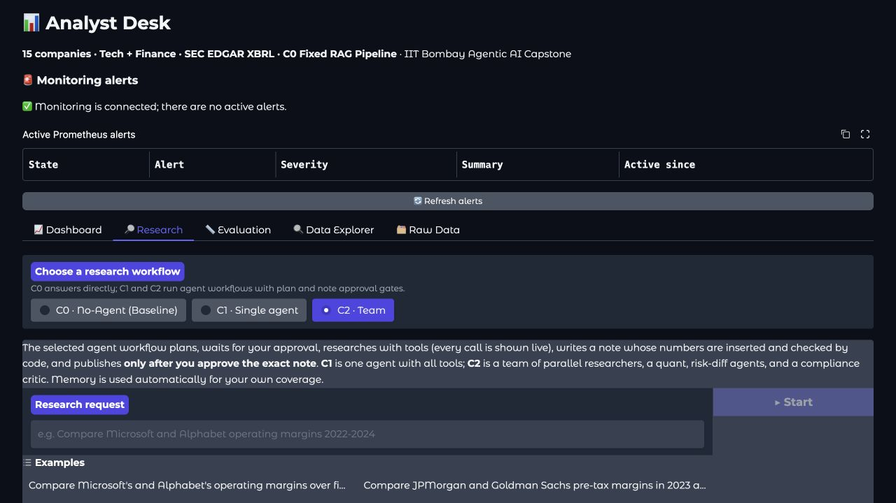
Current team-workflow screen describes planning and approvals but does not itself prove every requested comparison is preserved
Minimum versus extra: scope checks, an editable plan and required replanning are core. Arbitrary new tickers and unlimited years are optional. This screenshot is control context, not evidence that a particular requested company was dropped.

Example 7 Different margins cannot be called one margin advantage
Related findings: F04/F05/F07 and frontend B01-B03. Decision: Must fix misleading metric substitution; unsupported alternatives may be declined.
Hypothetical figures: Company A operating margin is 20%; Bank B pre-tax margin is 30%. The arithmetic difference is ten percentage points, but it is not a ten-point operating-margin advantage because the definitions differ.
Expected product behaviour: label both bases, avoid a shared like-for-like ranking/gap, and clarify or decline an unsupported bank operating-margin request. W05 shows an actual dashboard with useful distinct Operating and Pre-tax legend labels; it does not show a computed shared gap or ranking.
Minimum versus extra: truthful like-for-like interpretation is core. Supporting every bank ratio or using a specific metric-choice modal is optional. Offering a pre-tax alternative must not silently change an approved task.

Example 8 The same fiscal label can cover different dates
Related findings: F03/F08/F09 and frontend F01-F03. Decision: Must fix misleading period interpretation; calendarisation can be deferred.
Illustrative windows: Company A FY2024 runs 1 July 2023 to 30 June 2024; Company B FY2024 runs 1 January to 31 December 2024. Each margin uses its own matching annual income/revenue. They can be compared as issuer FY2024, with the date difference stated, but not described as an aligned calendar-2024 comparison.
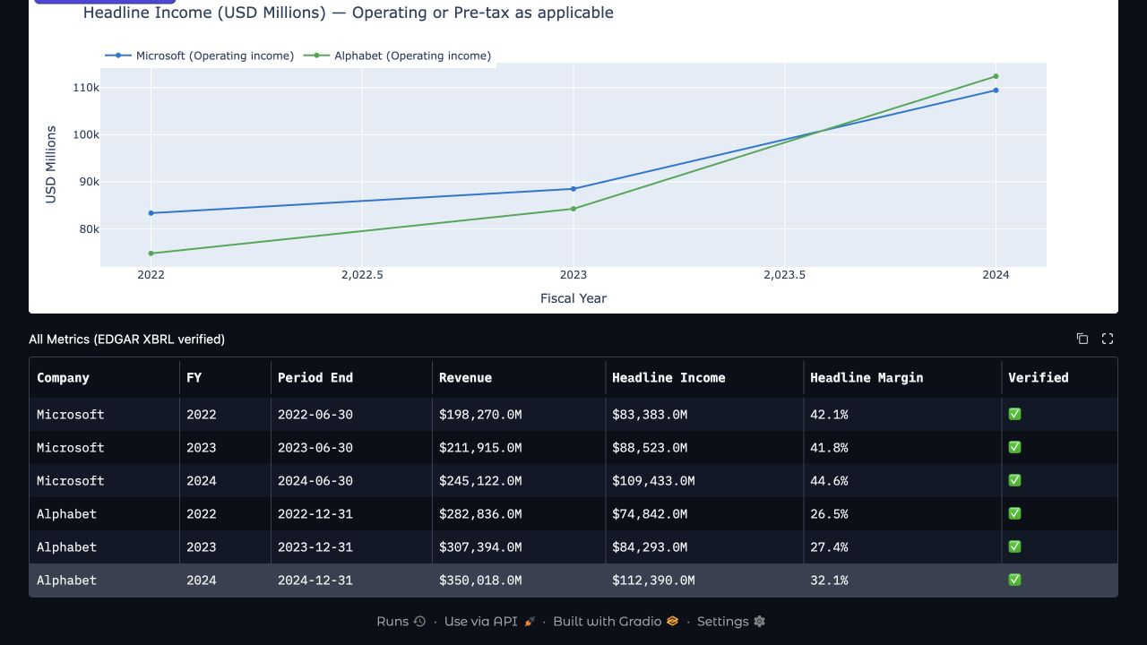
Dashboard displays June and December period ends for the same FY label and one-decimal margins without full annual windows
Expected product behaviour: Fiscal-year comparison. Reporting windows differ; results are not calendar-aligned. If the user specifically requests calendar alignment and the dataset cannot provide it, state unavailable or propose a revised task. Mention relevant 52/53-week differences rather than inventing a normalisation.
Minimum versus extra: compatible periods and honest qualification are core. Quarterly calendarisation, automatic week adjustment and a particular date-banner layout are optional. One-decimal display alone is not a brief violation.

Example 9 Matching digits can hide a millionfold unit error
Related findings: F11/F22, AE01. Decision: Must fix verification of currency and scale.
Hypothetical quote: the note says USD2.2 thousand but the cited source says USD2.2 billion. That is 2,200 versus 2,200,000,000, a factor of 1,000,000, even though both contain 2.2. Similarly, a generic dollar symbol does not establish USD rather than AUD.
Expected product behaviour: fail or correct the quote before approval and preserve the actual table currency and unit header. A suitable message is: Calculation unavailable. Source units or currency do not match the stated amount.
Minimum versus extra: correct unit associations are explicit in the brief. An FX conversion feature and support for every possible unit spelling can be deferred when unsupported inputs are clearly rejected.

Example 10 Rounding choices and exceptional baselines need different decisions
Related findings: F12/F13/F17/F18/F20/F21/F38, G02. Decision: preserve correct arithmetic; distinguish project convention from supported-case semantics.
Rounding: an exact 20.125% displays as 20.13% under HALF_UP and can display as 20.12% under a stated ties-to-even convention. The brief does not choose HALF_UP; the finalized project policy does. Do not describe every alternative tie convention as mathematically wrong.
Raw inputs: calculating from display-rounded amounts can change the actual answer, as the audit fixture's 20.00% versus original-input 20.03% shows. Keep original precision through the calculation, then round the output.
Loss and zero cases: a prior amount of -20 and current -10 is an improvement of 10; an unexplained -50% growth headline misleads. A margin moving from 0% to 5% changes by +5 percentage points and must not disappear because earlier income was zero. Division by zero must produce unavailable, not an invented ratio.
Expected product behaviour: state the supported calculation and exceptional-case limitation. A small nonzero amount can be shown in rounded millions if clearly approximate; use a smaller unit when calling it zero would change the meaning.
Minimum versus extra: correct interpretation and calculation are core. Exact final precision, universal HALF_UP, the blanket negative-revenue exclusion and one particular loss-growth formula are project decisions; transparently exclude unsupported exceptional cases if necessary.

Example 11 Mixing filing versions creates a third unsupported margin
Related findings: F07/F14-F16/F23-F27/F36. Decision: Must fix incompatible facts and unsupported explanations; a reviewed fixed source basis can suffice.
Hypothetical figures: original presentation revenue 100 and income 20 gives 20.00%. A later presentation revenue 95 and income 18 gives about 18.95%. Mixing original income 20 with later revenue 95 gives about 21.05%, which is neither presentation's supported margin.
Expected product behaviour: identify and use compatible facts, explain the selected source basis and withhold an unresolved comparison. Do not call any later difference a restatement until the issuer's explanation supports that classification. A governance-only amendment does not automatically supersede the financial statements. If a figure is known to be affected by non-reliance, do not keep presenting it as trustworthy.
Minimum versus extra: reliable traceable like-for-like facts are core. Every intermediate version, arbitrary historical knowledge cutoffs and a checksum/policy hash on every output are not separate minima. A fixed reviewed eligible corpus is an acceptable simpler basis when honestly disclosed.

Example 12 Memory off must really exclude optional history
Related findings: M06/L04, frontend M01. Decision: Must fix the no-memory comparison.
Simple example: automatic memory injection is disabled, but a risk agent calls get_past_notes and uses an earlier approved conclusion. That run is still influenced by analyst history and cannot be scored as the memory-off arm.
Expected product behaviour: block optional history tools and indirect history routes for that arm and record the actual setting. Public SEC retrieval and the current run's working checkpoint may remain. Memory off does not mean delete saved history.
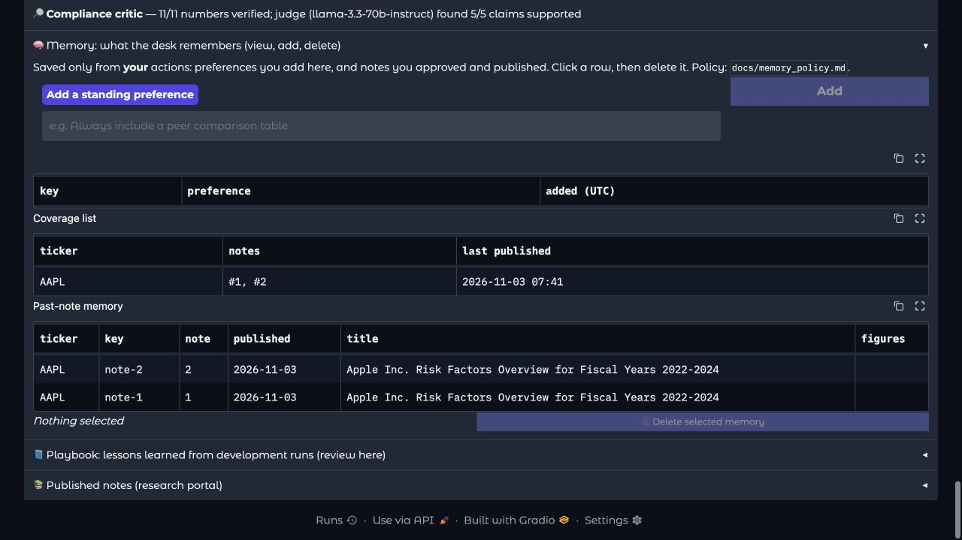
Memory screen exposes preferences and dated prior-note memory and no record was added or deleted during inspection
Minimum versus extra: a genuine on/off demonstration is required. A specific toggle design is optional, but the declared setting must govern all optional long-term history routes.

Example 13 Deletion must not silently undo itself
Related findings: M02/M07/M08/M10/M12 and frontend M04. Decision: Conditional on the promised deletion and resume scope.
Hypothetical journey: a preference is deleted from active memory. A later checkpoint reload or backfill recreates it and the next note follows it. The exercised deletion promise was ineffective.
Expected product behaviour: prevent that reactivation, or disable the affected old-run/backfill route and require a fresh run after changes. Explain what was removed, what public research record remains and what is outside the active-store deletion scope.
Minimum versus extra: the written policy must accurately explain saving, correcting and deleting memory and the demonstrated actions must work. Universal erasure from every backup and automated retention machinery are extra. The audit did not execute a live deletion or demonstrate that a particular user's record was resurrected.

Example 14 A typed name is not a private-user boundary
Related findings: AE11/M03/M04/M10/M11. Decision: Conditional identity controls and mandatory private-watchlist protection.
Simple example: two analysts type different names but can retrieve ticker-global history. If those notes are declared shared public demo material for one desk, that is a bounded design choice. It cannot be advertised as private per-user research isolation. Real private preferences or holdings require an enforced authorised boundary and suitable data minimisation.
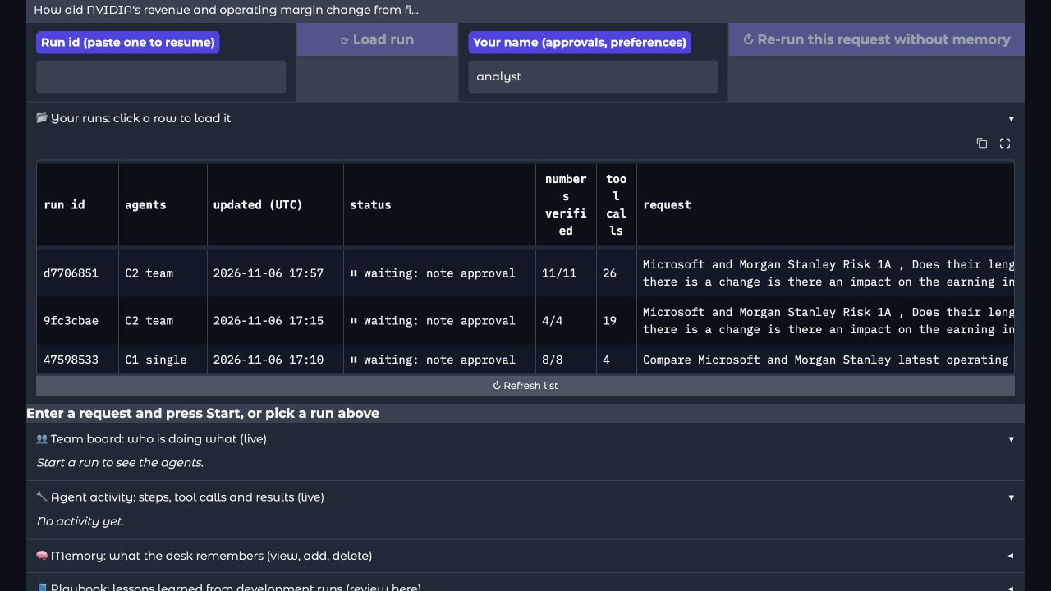
Research UI uses a typed analyst name and exposes saved-run controls and this screenshot does not demonstrate another user data leak
Expected product behaviour: declare and enforce Single analyst public demonstration scope until shared/private access controls are ready. Demonstrate the brief's private-watchlist boundary with a synthetic sentinel kept out of model/tool/export paths; do not put real holdings into an unprepared demo.
Minimum versus extra: privacy and least-privilege boundaries are required. Enterprise SSO is not prescribed. A local display name alone proves neither identity nor a human decision.

Example 15 A frozen playbook must stay the same during evaluation
Related findings: L01-L04/M08, G05, frontend L01/L02. Decision: Must fix a usable freeze and verify actual review evidence.
Hypothetical sequence: playbook A is frozen, the held-out run starts, then a lesson is changed in the same store while the run still says frozen. Scores no longer describe one fixed intervention. A current mutable flag alone does not establish a stable evaluated release.
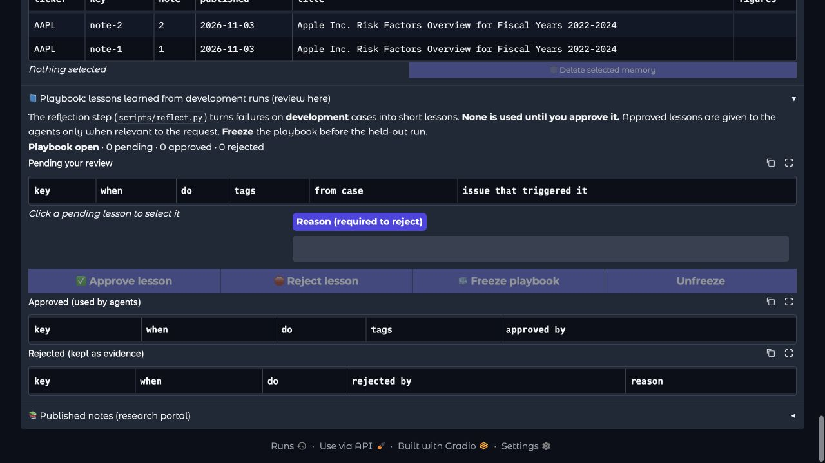
Playbook panel has review and freeze controls with zero recorded lessons in this view and no decision was made
Expected product behaviour: pin an identifiable unchanged lesson set for the evaluation, retain actual development proposal/approval/rejection records and keep held-out cases out of lesson generation. A read-only versioned file or equivalent stable snapshot can be enough; a complex release service is unnecessary.
Evidence boundary: an empty inspected panel does not prove the team has no review evidence elsewhere. Locate genuine records, including a rejected lesson and its reason, before declaring the requirement missing or complete.

Example 16 Correct digits can still be the wrong answer
Related findings: G01-G06/AE01. Decision: Must fix scored meaning and protected evaluation; exact case IDs are additional policy.
Hypothetical association: expected MSFT margin 20% and GOOGL 30%; the answer swaps the companies. Both digits appear, but both company associations are wrong. Similarly, FY2024 25% minus FY2023 20% is +5 percentage points; -5 is wrong despite the same absolute magnitude.
Expected product behaviour: score company, metric, period, source, sign and required precision together; require narrative support where the case asks for it; preserve known failures even when another step times out. Record Incomplete separately from a clean pass and protect held-out assets from agent context.
Minimum versus extra: independently fixed expected outcomes, correct meaningful scoring, calibrated judgement and protected held-out evaluation are core. The exact DG001-DG008 project identifiers/adapters are not prescribed; a different valid executable case set can satisfy the brief's required evaluation coverage. Eight cases alone do not establish the required 60-plus case set.

Example 17 A lost publication response is not proof that nothing was saved
Related findings: AE13-AE16, frontend A04/A05. Decision: Must report actual writes; sophisticated recovery can be deferred.
Hypothetical journey: the portal commits note N, but the response times out. Blindly reporting Not published or submitting a changed duplicate can create a misleading record. Separately, if the portal saves N but derived-memory sync fails, the note remains saved even though the follow-up memory is incomplete.
Expected product behaviour: state Publication outcome unconfirmed until the original operation is reconciled. After a confirmed portal commit, show Published and a separate Memory update failed status when applicable; do not republish to repair memory. Verify a matching saved-note identity rather than accepting a bare success flag.
Minimum versus extra: truthful actual publication and the working normal memory story are core. A safe stop with manual reconciliation can be sufficient in the controlled demo. Full exactly-once infrastructure, automatic withdrawals and a complete lifecycle service can be deferred if not claimed.

Example 18 Code and a document do not establish measured completion
Related findings: F06/F30/F31/F34/F37, AE17, L01/G05. Decision: Verify actual evidence before declaring the requirement complete or absent.
Simple example: a scorer function exists and a policy says human risk labels are required. Neither proves that labels were independently created before agent runs or that a protected held-out experiment was executed. Conversely, this source-focused audit not opening protected records does not prove the team failed to create them.
Expected evidence: source-accepted corpus and relevant tables/items, independently fixed expected answers, human risk labels for ten company-years, a separate twenty-plus-item judge-calibration set, the required development/held-out coverage and repeated evaluation runs, applicable security tests, measured time/cost/quality including failures, and the required operational/demo evidence.
Minimum versus extra: the brief's actual evaluation and demonstration obligations remain mandatory. Broad commercial adoption, every optional project task family and certification of every stricter policy rule are not required. Verify existing assets before creating duplicate work.

Financial rules
All 38 groups below are assessed against the four financial/scope policies. Source and isolated component evidence must not be read as a fresh production financial audit. Company-year eligibility and actual dataset review remain Unverified where stated.
ID | Rating | Rule and gap | Evidence and owner
F01 | Followed | Required: Retain the 15-company, two-group list and FY2022–FY2024 contract. Present: Exact fifteen-company list, two groups and three fiscal years are defined; MCP tools reject unsupported explicit years. Gap: No gap in the declared-list contract; acceptance of all 45 company-years remains unverified under F31. | scope.py:29, common.py:39, edgar_server.py:145 Evidence: Source inspection only; no live behaviour or end-to-end success claimed. Owners: R2/R3/R4/R5
F02 | Partial | Required: Reject or explicitly account for every unsupported company/year without silently dropping it. Present: Agents reject detected unsupported years and requests without recognised companies; tools enforce covered tickers. Gap: Mixed unknown entities lack complete accounting; planner years can default broadly, while edited plans lack equivalent scope checks. | graph.py:190, query.py:44, graph.py:240, graph.py:256, scope.py:94 Evidence: Source inspection only; no live behaviour or end-to-end success claimed. Owners: R3/R4/R6/R5
F03 | Gap | Required: Clarify latest/last-three-years and aligned-calendar requests against the historical window. Present: Numeric-year parsing and historical FY2022–FY2024 defaults exist. Gap: No explicit relative-date clarification or aligned-calendar contract prevents historical fiscal defaults from replacing the requested period. | query.py:67, llm.toml:31, graph.py:76, app.py:427 Evidence: Source inspection only; no live behaviour or end-to-end success claimed. Owners: R3/R4/R6/R5
F04 | Gap | Required: Preserve an operating-margin request; offer bank pre-tax only through a revised approved task. Present: Five bank settings select pre-tax numerators and label the resulting placeholders. Gap: Requested metric intent is absent from the plan/renderer contract; bank membership can drive substitution without a revised pre-tax decision. | scope.py:42, figures.py:41, llm.toml:31, graph.py:76 Evidence: Source inspection plus isolated synthetic component evidence; no live request, provider call or actual user record. Owners: R3/R4/R6/R2/R5
F05 | Partial | Required: Prevent mixed-metric gaps/rankings and apply task-specific peer comparability. Present: C0 chart guards reject mixed margin bases and inappropriate operating/pre-tax chart requests. Gap: Agent difference checks and all dashboards lack equivalent deterministic metric/peer validation. | chat_chart.py:86, edgar_server.py:74, checks.py:155, app.py:95 Evidence: Source inspection only; no live behaviour or end-to-end success claimed. Owners: R3/R4/R2/R6/R5
F06 | Unverified | Required: Verify bank total net revenue, pre-tax perimeter and reported consolidated basis for each company-year. Present: Bank mappings prefer net-of-interest revenue concepts and a continuing-operations pre-tax concept. Gap: Tag mappings do not establish eligible statement labels, consolidated perimeter or reviewed bank inputs; independent source acceptance was not assessed. | edgar.py:72, edgar_server.py:52 Evidence: Unverified data/domain/execution acceptance; source inspection only, no actual records or live requests. Owners: R2/R3/R4/R5
F07 | Gap | Required: Validate the identity and compatibility of every numerator/denominator before accepting arithmetic. Present: Facts expose metadata, but arithmetic verification largely consumes numeric values. Gap: Wrong metrics and incompatible versions can pass. Different issuers may legitimately use different accessions; compatibility must not require one globally shared document. | figures.py:39, checks.py:63 Evidence: Source inspection plus isolated synthetic component evidence; no live request, provider call or actual user record. Owners: R2/R3/R4/R5
F08 | Partial | Required: Confirm issuer fiscal labels and normal annual durations rather than using year-end/threshold alone. Present: Annual selection checks FY flags, form, end-year and minimum duration. Gap: No upper-duration or issuer-year confirmation exists; a synthetic two-year value was accepted as annual. | edgar.py:179, edgar_server.py:123 Evidence: Source inspection plus isolated synthetic component evidence; no live request, provider call or actual user record. Owners: R2/R4/R3/R5
F09 | Partial | Required: Show actual start/end windows and relevant duration differences consistently. Present: MCP facts carry start/end dates; writer prompts mention different fiscal year ends. Gap: Plan, baseline, placeholders and dashboard lack mandatory complete windows and 52/53-week qualifications. | edgar_server.py:52, figures.py:47, graph.py:76, note.py:30, llm.toml:48, app.py:170 Evidence: Source inspection only; no live behaviour or end-to-end success claimed. Owners: R2/R3/R6/R4/R5
F10 | Followed | Required: Keep companyfacts USD monetary values in base dollars before downstream display conversion. Present: USD-bucket facts remain raw values, and MCP monetary values use an integer base-USD contract. Gap: No gap in this narrow ingestion path; table currency/scale and downstream display remain separate checks. | edgar.py:164, edgar_server.py:52 Evidence: Source inspection only; no live behaviour or end-to-end success claimed. Owners: R2/R4/R3/R6/R5
F11 | Gap | Required: Verify quoted currency and scale, not just digits. Present: Quote checks recognise selected scale suffixes, percentages and a dollar symbol. Gap: K/thousand lacks mandatory scale matching; synthetic $2.2K matched $2.2 billion. Dollar-country identity remains unresolved. | checks.py:75 Evidence: Source inspection plus isolated synthetic component evidence; no live request, provider call or actual user record. Owners: R2/R3/R4/R5
F12 | Gap | Required: Apply Decimal ROUND_HALF_UP to final ratio, amount and percentage-point displays. Present: Renderers use float formatting and checker round/tolerance comparisons. Gap: Decimal HALF_UP is absent: an exact 20.125% fixture displayed 20.12% instead of 20.13%. | figures.py:45, checks.py:126 Evidence: Source inspection plus isolated synthetic component evidence; no live request, provider call or actual user record. Owners: R3/R4/R6/R5
F13 | Gap | Required: Reject zero or negative revenue denominators for this version. Present: Zero and missing revenue are generally excluded from margin calculations. Gap: Negative revenue is accepted; a synthetic 20/−100 fixture rendered −20.00% instead of unavailable. | figures.py:53, checks.py:136, baseline.py:41 Evidence: Source inspection plus isolated synthetic component evidence; no live request, provider call or actual user record. Owners: R3/R4/R6/R5
F14 | Partial | Required: Establish the original annual filing and preserve the complete version chain and supported classification. Present: The selector returns earliest cached value and at most a latest unequal amount. Gap: Earliest cache position does not prove original authority; intermediate changes and explanations are missing from returned comparison history. | edgar.py:190, edgar_server.py:60, baseline.py:77 Evidence: Source inspection plus isolated synthetic component evidence; no live request, provider call or actual user record. Owners: R2/R3/R4/R6/R5
F15 | Gap | Required: Bind an explicit filing basis, reviewed eligibility, snapshot and knowledge cutoff to the approved task. Present: Plans contain companies, fiscal years, subquestions and outline; selection follows earliest-value logic. Gap: No explicit later-reviewed basis, cutoff exclusion or approved snapshot contract prevents unsupported source-version selection. | graph.py:76, edgar.py:148 Evidence: Source inspection only; no live behaviour or end-to-end success claimed. Owners: R2/R3/R4/R6/R5
F16 | Gap | Required: Unresolved mandatory financial/source failures must remain HOLD and cannot be overridden by ordinary approval. Present: Failed checks receive bounded revisions and then reach human review; exact approved content can be published. Gap: Graph/API approval and portal insertion lack a mandatory passed financial/source-eligibility prerequisite after revision exhaustion. | graph.py:339, api.py:169, portal.py:142, graph.py:351 Evidence: Source inspection only; no live behaviour or end-to-end success claimed. Owners: R3/R4/R6/R5
F17 | Partial | Required: Accept valid zero/negative income while preserving signed monetary facts in verification. Present: Renderer supports signed income margins; a zero-income fixture produced 0.00%. Gap: Negative dollar facts can escape recognition, producing zero checked quantities and an apparent 100% verification share. | figures.py:49, checks.py:36 Evidence: Source inspection plus isolated synthetic component evidence; no live request, provider call or actual user record. Owners: R3/R4/R6/R5
F18 | Gap | Required: Use a conventional growth percentage only with a positive earlier amount. Present: Growth construction rejects missing or zero earlier amounts. Gap: Negative earlier values remain allowed; −20→−10 generates −50% growth rather than the required amounts and+10 signed change. | figures.py:58, checks.py:144 Evidence: Source inspection plus isolated synthetic component evidence; no live request, provider call or actual user record. Owners: R3/R4/R6/R5
F19 | Partial | Required: Preserve every requested company-period row and give an accurate missing-input reason. Present: Baseline retains requested rows and missing-data warnings; charts can preserve missing values. Gap: Agent placeholders lack a complete expected-row inventory; missing chart rows do not consistently receive specific reasons. | baseline.py:73, figures.py:43, checks.py:106, chat_chart.py:145 Evidence: Source inspection only; no live behaviour or end-to-end success claimed. Owners: R2/R3/R6/R4/R5
F20 | Gap | Required: Never reuse display-rounded amounts or ratios as calculation inputs. Present: Agent figure calculations generally use raw source values. Gap: Baseline/C0 preparation pre-rounds inputs; a fixture produced 20.00% instead of 20.03% from the original amounts. | figures.py:55, baseline.py:24, c0_pipeline.py:58 Evidence: Source inspection plus isolated synthetic component evidence; no live request, provider call or actual user record. Owners: R3/R4/R6/R5
F21 | Gap | Required: Render named currency, scale and required precision, including meaningful small nonzero amounts, across outputs. Present: Agent displays use one-decimal millions and two-decimal ratios. Gap: Dashboard ratios use one decimal; no smaller-unit fallback prevents a nonzero USD1 amount becoming $0.0M. | figures.py:45, app.py:109, note.py:94 Evidence: Source inspection plus isolated synthetic component evidence; no live request, provider call or actual user record. Owners: R3/R6/R2/R4/R5
F22 | Gap | Required: Validate table currency/header/scale and unit type; block unsupported FX or mixed-unit calculations. Present: Table parsing preserves rows/context, while the monetary API restricts facts to USD. Gap: No typed per-cell scale/conversion contract or approved FX workflow exists; quote matching does not distinguish AUD from USD. | ingest.py:238, edgar_server.py:52, checks.py:75 Evidence: Source inspection plus isolated synthetic component evidence; no live request, provider call or actual user record. Owners: R2/R4/R3/R6/R5
F23 | Gap | Required: Classify later differences only from supported issuer/audit explanations. Present: Tools and memory detect some later numeric differences. Gap: They label differences restated without issuer/audit explanation distinguishing error correction, recast, perimeter change or unresolved presentation difference. | edgar.py:203, edgar_server.py:60, memory.py:166 Evidence: Source inspection only; no live behaviour or end-to-end success claimed. Owners: R2/R3/R4/R6/R5
F24 | Gap | Required: Preserve source locations, complete snapshots/checksums and a replayable version history. Present: Caches persist responses; passages retain company, year, item, accession and text. Gap: Source-file/date/checksum context, full returned version chains and frozen per-run snapshot binding are incomplete. | edgar.py:121, ingest.py:89, ingest.py:451, filings_kb.py:39, edgar.py:194 Evidence: Source inspection only; no live behaviour or end-to-end success claimed. Owners: R2/R4/R6/R3/R5
F25 | Gap | Required: Inspect what each 10-K/A or later presentation changes before assigning authority. Present: Selection includes 10-K/A facts and matching-year 10-K narrative documents. Gap: No reviewed amendment-scope control identifies governance-only changes or relevant financial/ comparative-statement revisions. | edgar.py:182, ingest.py:116 Evidence: Source inspection only; no live behaviour or end-to-end success claimed. Owners: R2/R3/R4/R5
F26 | Gap | Required: Override routine original selection when known non-reliance or an affected confirmed correction makes it unsuitable. Present: Original selection and later-difference warnings exist. Gap: Plans/facts lack affected-figure reliability status or a non-reliance override; warnings still instruct using original amounts. | edgar.py:190, edgar_server.py:154, graph.py:76, edgar_server.py:52 Evidence: Source inspection only; no live behaviour or end-to-end success claimed. Owners: R2/R3/R4/R6/R5
F27 | Gap | Required: Distinguish source-version change from economic change and match commentary to the selected presentation. Present: Financial and narrative selection are separate; numeric annual changes are calculated. Gap: No compatibility/explanation binding prevents original commentary explaining recast figures or incompatible source changes becoming economic-growth conclusions. | edgar.py:179, ingest.py:116, figures.py:57, memory.py:166 Evidence: Source inspection only; no live behaviour or end-to-end success claimed. Owners: R2/R3/R4/R6/R5
F28 | Followed | Required: Require fresh exact-content approval after final-note edits and reject content changed after signing. Present: Edited notes re-enter checking; hashes bind title/body/tickers, and portal verification rejects changed content. Gap: No gap in narrow exact-content integrity; trusted identity, financial eligibility and source-basis approvals remain separate requirements. | graph.py:351, approval.py:57, portal.py:147 Evidence: Source inspection only; no live behaviour or end-to-end success claimed. Owners: R3/R4/R6/R5
F29 | Partial | Required: Keep prior approved research identifiable, use relevant eligible history, and link corrections/supersession. Present: Portal appends content-hashed notes; confirmed publication creates note-ID memory and identifiable follow-ups. Gap: History lacks source eligibility, withdrawal/supersession links and reliable relevant-version selection beyond bounded ticker-based lookup. | portal.py:48, graph.py:373, memory.py:95, graph.py:279, memory.py:114 Evidence: Source inspection only; no live behaviour or end-to-end success claimed. Owners: R2/R3/R4/R6/R5
F30 | Partial | Required: Provide mechanisms for the six supported annual-research task families without confusing text change with economic novelty. Present: Researcher, quant, risk-diff and prior-note mechanisms exist with source-oriented prompts. Gap: Prompts do not establish complete risk evidence, every requested year pair or usefulness; risk branches assume latest year and its predecessor. | team.py:183, llm.toml:69, figures.py:31, graph.py:279 Evidence: Source inspection only; no live behaviour or end-to-end success claimed. Owners: R1/R2/R3/R4/R5/R6
F31 | Unverified | Required: Accept the dataset only after section, table and source-completeness review. Present: Ingestion uses section/title heuristics, table chunks and annual-exhibit fallback. Gap: These mechanisms do not prove boundary/table accuracy or 45 company-year acceptance; standalone Item 8/notes are not retrieval targets. | ingest.py:31 Evidence: Unverified data/domain/execution acceptance; source inspection only, no actual records or live requests. Owners: R2/R1/R4/R5/R6
F32 | Gap | Required: Keep optional extensions outside the assessed annual core until their separate scope/evidence decision. Present: Covered-company tools limit arbitrary issuers; quarterly data/chart mechanisms also exist. Gap: Quarterly capability lacks a separate approved task transition. Missing optional connectors are not themselves failures. | c0_pipeline.py:79, chat_chart.py:91 Evidence: Source inspection only; no live behaviour or end-to-end success claimed. Owners: R1/R3/R4/R6/R5
F33 | Partial | Required: Require a complete question-answering note with source support, limitations and truthful verification status. Present: Drafting, number/citation checks, partial critic review and diagnostics exist. Gap: No complete-note contract guarantees coverage, all claims or required review; critic sampling/failure handling and fact-ID-only checks cannot establish full correctness. | graph.py:293, llm.toml:47, graph.py:83, checks.py:106, team.py:129, note.py:74, app.py:178 Evidence: Source inspection only; no live behaviour or end-to-end success claimed. Owners: R3/R4/R6/R1/R5
F34 | Unverified | Required: Measure relevance, correction burden, total research/review effort and comparable baselines before claiming benefit. Present: Metrics capture durations, tokens and revisions; evaluation code supports C0/C1/C2. Gap: Mechanisms do not establish observed workflow baselines, reviewer effort, useful coverage, adoption or measured improvement. | observability.py:92, run_eval.py:43 Evidence: Unverified data/domain/execution acceptance; source inspection only, no actual records or live requests. Owners: R1/R5/R2/R3/R6
F35 | Partial | Required: Decline investment recommendations, return promises and unsupported adverse-event forecasting. Present: Phrase guards and prompts reject common advice and target-price wording. Gap: Phrase matching and incomplete claim review do not establish a full semantic boundary for promises, forecasting or investment-quality conclusions. | graph.py:199, checks.py:46, llm.toml:33 Evidence: Source inspection only; no live behaviour or end-to-end success claimed. Owners: R3/R4/R1/R5/R6
F36 | Gap | Required: Record effective policy version, approved evidence basis/snapshot and change decisions on every affected run/output. Present: State stores plans, drafts and exact-note approval hashes. Gap: Contracts/exports lack effective policy, selected source basis, cutoff and snapshot links needed for reproducible changed-evidence decisions. | graph.py:76, note.py:87, portal.py:48 Evidence: Source inspection only; no live behaviour or end-to-end success claimed. Owners: R2/R3/R4/R6/R5
F37 | Unverified | Required: Supply implementation-owner and independent-verification evidence for the final specification requirements. Present: Final documents assign implementation roles and execution responsibilities. Gap: Assignments do not establish source acceptance, enforcement verification or independent regressions. This audit does not claim tests are absent. | SUPPORTED_RESEARCH_SCOPE.md:94, BANK_METRICS_AND_COMPARISON_RULES.md:148, FISCAL_PERIODS_AND_UNITS_RULES.md:148, FILING_VERSION_POLICY.md:134 Evidence: Unverified data/domain/execution acceptance; source inspection only, no actual records or live requests. Owners: R1/R5
F38 | Partial | Required: Calculate signed percentage-point changes consistently, including a valid change from zero income. Present: Normal margin changes use raw ratios, signed pp labels and arithmetic checks. Gap: A truthy prior-income condition omits a valid change from zero; input compatibility and Decimal rounding also remain unresolved. | figures.py:68, checks.py:155, figures.py:64 Evidence: Source inspection plus isolated synthetic component evidence; no live request, provider call or actual user record. Owners: R3/R4/R6/R5

Evidence and approval rules
ID | Rating | Rule and gap | Evidence and owner
AE01 | Partial | Required: Verify every financial quantity and its company, metric, period, units, operations and source association across the complete note. Present: Code checks tagged facts, ratios, changes, some quoted units and passage existence. Gap: Title and uncited quantity coverage are incomplete; fact validation discards company/context metadata; thousands quotes can match billions; zero recognized values show 100%. | checks.py:35, checks.py:59, checks.py:75, checks.py:106, graph.py:324, edgar_server.py:52 Evidence: Offline: detects wrong 25% versus 20%, but misses bare amounts and wrong-company association; thousands/billions quote mismatch passes. Owners: R2/R3/R4; R5 verifies; R6 displays
AE02 | Gap | Required: Review all substantive assertions, including uncited/title claims, preserving attribution, conditional meaning and independent support for causes. Present: The judge assesses selected cited lines against supplied passages using a support prompt. Gap: Only cited lines longer than 30 characters are selected; at most ten claims and truncated context are reviewed. No complete claim inventory or omissions denominator exists. | team.py:127, team.py:137, llm.toml:90, graph.py:324 Evidence: Offline: eleven eligible cited lines yield ten checked; an uncited substantive claim yields zero checked and no issues. Owners: R1/R2/R3/R4; R5 verifies
AE03 | Gap | Required: Treat judge failures and incomplete or invalid verdict coverage as unresolved review; ordinary approval cannot create a semantic pass. Present: Judge exceptions retain an error field; C2 combines judge issues with numerical issues. Gap: Exceptions return no blocking issues; verdict completeness, unique IDs and strict booleans are not validated. Empty verdict lists can report all selected claims supported; C1 lacks semantic review. | team.py:137, team.py:148, graph.py:330, runtime.py:138, agent_ui.py:209 Evidence: Offline: judge exception produces check.ok=true; one selected item with an empty verdict list reports supported=1. Owners: R3/R4; R5 verifies; R6 displays
AE04 | Gap | Required: Retain every requested comparison pair; validate both-period coverage, finding labels and separate significance/materiality rationale. Present: Risk prompts request both years; handoffs retain passage IDs and tool errors. Gap: Specialist pair defaults to maximum year and preceding year. Output format lacks Unchanged/Insufficient evidence; no typed pair/coverage contract exists. Risk scoring checks citation years, not interpretation. | team.py:61, team.py:194, llm.toml:83, evaluation.py:95 Evidence: Source-confirmed contract/scoring gaps; no live risk classification or protected answer was exercised. Owners: R1/R2/R3/R4; R5 verifies
AE05 | Gap | Required: Preserve source/version context, sufficient reviewed scope, exclusions and uncertainty; do not infer absence, economic risk or confidence from retrieval alone. Present: Handoffs retain findings, passage/fact IDs and tool errors; fact results provide some source metadata. Gap: No typed reviewed-section coverage, snapshot or rationale contract; findings and judge context are truncated. High confidence follows successful tools plus IDs, without semantic coverage validation. | team.py:61, team.py:117, team.py:131, graph.py:267, graph.py:312, edgar_server.py:52 Evidence: Source-confirmed metadata/truncation/confidence gaps; live extraction validity and actual reviewed source coverage were not inspected. Owners: R1/R2/R3/R4; R5/R6 verify and display
AE06 | Partial | Required: Account for requested scope, reviewed limitations, dated expectations and causes; require revised approval for material changes and reject prohibited instructions/content. Present: Input scope/advice checks, untrusted-text prompts, writer constraints and NOT_IN_COVERAGE replanning are present. Gap: No complete requested-set, metric/source/cutoff/expectation or reviewed-limitation contract. Other tool failures need not trigger scope review; prompts and advice regexes do not establish complete security enforcement. | graph.py:76, graph.py:189, graph.py:239, team.py:234, checks.py:202, llm.toml:30 Evidence: Source-confirmed partial scope/content controls; no live attack success, leakage or legitimate limited-answer acceptance is claimed. Owners: R1/R2/R3/R4; R5/R6 verify and display
AE07 | Followed | Required: Bound automated writer repair to two revisions without resetting its counter to manufacture acceptance. Present: MAX_REVISIONS=2, conditional retry and explicit increments are shared by C1/C2; human edits do not reset that counter. Gap: No gap found in this narrowly scoped counter. Unsafe routing after exhaustion is a separate AE08 failure; other run-budget enforcement is outside this rating. | graph.py:68, graph.py:339, graph.py:344, graph.py:351, team.py:263 Evidence: Offline: failed check at revisions=2 routes to note review rather than another automated writer revision. Owners: R3; R4/R5 verify
AE08 | Gap | Required: Prevent final approval and publication while known errors, incomplete required review or other acceptance blockers remain. Present: Checks record issues and revision exhaustion eventually reaches a human note interrupt. Gap: Exhausted failures still reach approval; the note gate, API and portal do not enforce acceptance eligibility. An approval click can sign a known wrong result. | graph.py:339, graph.py:348, api.py:151, portal.py:142, agent_ui.py:378, agent_ui.py:472 Evidence: Offline extracted checker/gate/signer/portal: detected wrong 25% versus 20% is approved and inserted into SQLite :memory: only; no live publication. Owners: R3/R4; R5 verifies; R6 displays
AE09 | Partial | Required: Only explicit valid authorised actions may affect the correct gate/version; empty, unknown, stale or mismatched actions must not approve. Present: HTTP action Literal and gate-specific validation reject unknown actions; the graph plan gate also validates actions and supports cancel. Gap: The raw shared note gate treats non-edit/non-reject actions as approval. HTTP validation mitigates that path but omits cancel; graph and interface contracts differ. | api.py:34, api.py:151, graph.py:250, graph.py:348, agent_ui.py:460 Evidence: Offline raw note gate approves empty, unexpected and cancel actions. This does not show those actions bypassing the typed HTTP validator. Owners: R3/R4; R5 verifies; R6 controls
AE10 | Followed | Required: Return edited content to checks and require a new exact-content approval before publication. Present: Title/body/canonical tickers are hashed; verifier rejects changed content. The note edit route returns to checks and another human interrupt. Gap: No gap found in this scoped content-binding/edit route. Context, authority and write-time eligibility gaps remain separately assessed in AE11/AE12. | approval.py:57, approval.py:74, approval.py:86, graph.py:351, portal.py:147 Evidence: Offline synthetic-key verifier rejects changed body; extracted edit routes to check. Ticker case/order normalization is not a semantic-edit bypass. Owners: R3/R4; R5 verifies; R6 displays
AE11 | Gap | Required: Verify reviewer authority and record exact claim/evidence human-review decisions separately from final approval. Present: Human interrupts accept reviewer names; API requires a nonblank approver for note approval. Gap: Names are request fields rather than verified principals; research/decision routes supply no identity/ownership dependency. No separate claim-level human semantic-completion schema or workflow exists. | api.py:27, api.py:86, api.py:129, graph.py:348, agent_ui.py:441, app.py:569 Evidence: Source-confirmed identity/review-record gaps; deployment perimeter controls and unauthorised live actions were not tested. Owners: R1/R3/R4/R6; R5 verifies
AE12 | Gap | Required: Bind approval to plan, operation/destination, sources, policy and checks; enforce current eligibility and revocation at publisher and portal. Present: Content signatures include approver and approval time and are checked before insertion. Gap: Signatures and portal omit plan/snapshot/policy/check identities, destination, revocation and acceptance eligibility. Unchanged text can retain a content token despite material context changes. | approval.py:74, approval.py:86, graph.py:76, graph.py:348, portal.py:142 Evidence: Offline synthetic signature contains only approved_at, approver and note_sha256; no live approval token or key was read. Owners: R2/R3/R4; R5 verifies
AE13 | Partial | Required: Confirm a durable saved record matching the exact approved operation/version and destination before declaring Published. Present: Normal portal insertion commits transactionally and returns note ID, hash and publication time. Gap: The graph accepts ok=true alone, without requiring an ID or matching hash/destination, and does not preserve the returned hash as an explicit result field. | portal.py:66, portal.py:95, portal.py:152, graph.py:370 Evidence: Offline synthetic {ok:true} response yields Published with note_id=None; the real portal normally returns a structured receipt. Owners: R2/R3/R4/R6; R5 verifies
AE14 | Partial | Required: Reconcile identical retries to one durable operation result and retain unknown-write status until a matching receipt is established. Present: UNIQUE content hash prevents a second identical portal row, including competing duplicate inserts. Gap: Content deduplication lacks operation identity and receipt reconciliation. Duplicate response omits existing ID; non-ok becomes publish_failed and timeout propagates without an explicit unknown-write state. | portal.py:48, portal.py:152, graph.py:370, api.py:195, agent_ui.py:577 Evidence: Offline duplicate leaves one in-memory row but returns ALREADY_EXISTS without ID; synthetic timeout propagates. No real write ambiguity was induced. Owners: R3/R4/R6; R5 verifies
AE15 | Partial | Required: Update approved history only after confirmed eligible publication; preserve Published when separate memory sync fails and repair without republishing. Present: Graph calls history update after portal ok only when memory is enabled; memory-off skips the automatic update. Gap: Memory update occurs before returning publication state; its exception propagates without separate sync status or repair route. Receipt trust and eligibility remain incomplete. | graph.py:370, runtime.py:98, api.py:208 Evidence: Offline synthetic success receipt followed by an intercepted failing memory stub raises RuntimeError instead of returning Published plus sync failure. Owners: R2/R3/R4/R6; R5 verifies
AE16 | Gap | Required: Link checked, freshly approved corrections and propagate superseded/withdrawn status through portal history and follow-ups without claiming universal deletion. Present: The append-only portal preserves earlier rows rather than silently overwriting them. Gap: Note schema lacks status, correction/supersession links and withdrawal reason. Tools only retrieve and insert; retrieval has no superseded/withdrawn filtering or enforced correction lineage. | portal.py:48, portal.py:81, portal.py:109, graph.py:370 Evidence: Source-confirmed schema/workflow gap; no live historical correction or external withdrawal process was inspected. Owners: R1/R2/R3/R4/R6; R5 verifies
AE17 | Unverified | Required: Preserve genuine paired-source human risk labels, separate judge calibration, independent fixed expectations and versioned implementation/review evidence. Present: A calibration script supplies human-label collection, minimum twenty labels, agreement and Cohen’s kappa calculations. Gap: Source alone cannot establish actual human annotation, calibration, independent review or scoring-release completion. Protected assets, live histories and label/result records were deliberately not opened. | calibrate_judge.py:1, calibrate_judge.py:41, calibrate_judge.py:78, evaluation.py:46, evaluation.py:83 Evidence: Unverified execution/human evidence; calibration and evaluation code were read only, never imported or run. Owners: R5 independently; R1/R2 support; R3/R4/R6 evidence

Memory and scoring rules
ID | Rating | Rule and gap | Evidence and owner
M01 | Followed | Required: Separate public evidence, working checkpoints and long-term memory Present: Separate memory/checkpoint databases and a dedicated public-passage loader exist. Gap: Store separation alone does not certify access controls or lifecycle enforcement. | memory.py:47, runtime.py:23, ingest.py:485 Evidence: Source inspection only; no live write, private data read or model request. Owners: R2 primary; R3 and R6 supporting.
M02 | Partial | Required: Save preferences only through a declared action and support governed correction Present: Explicit preference Add and delete controls exist; saved text informs planning and writing. Gap: No versioned correction, purpose record or relevance selection; preference conflicts are not rejected at the save boundary. | agent_ui.py:603, memory.py:80, graph.py:219 Evidence: Source inspection only; no live write, private data read or model request. Owners: R2 primary; R3/R4 controls; R1 wording; R6 UI.
M03 | Gap | Required: Use verified identity for memory, run and review actions Present: Editable analyst names and run identifiers select records and decisions. Gap: Inspected UI/API paths lack trusted owner verification; another typed name can select its preference namespace. | agent_ui.py:441, agent_ui.py:590, api.py:27, api.py:227 Evidence: Source inspection only; no live write, private data read or model request. Owners: R4 primary; R2/R3 and R6 supporting.
M04 | Gap | Required: Apply the approved owner or workspace audience to prior-note history Present: Ticker-based note history, latest-note lookup and a global memory panel exist. Gap: No approved owner/workspace audience boundary; different analysts share ticker context, and bounded search cannot prove complete eligible history. | memory.py:103, memory.py:114, agent_ui.py:597, portal.py:111 Evidence: Source inspection only; no live write, private data read or model request. Owners: R2 primary; R4 permission boundary; R3 scoped retrieval; R6 UI.
M05 | Partial | Required: Derive approved history only from an eligible confirmed publication and preserve its outcome Present: Derived memory follows portal success and the per-run derived-write setting. Gap: Failed checks can still be approved; displayed values are copied without revalidation. A derived-memory exception lacks a separate durable Published/synchronisation outcome. | graph.py:371, graph.py:339, graph.py:348, memory.py:56 Evidence: Source inspection only; no live write, private data read or model request. Owners: R3 primary; R4 publication guard; R2 derived history; R6 truthful outcome and recovery.
M06 | Gap | Required: Memory off must disable every optional history route Present: Automatic preference/history injection and derived writes are skipped; rerun creates a fresh run. Gap: get_past_notes remains available to C1 and C2 risk agents, allowing earlier research despite memory off. | graph.py:213, graph.py:377, runtime.py:24, __init__.py:21, agent_ui.py:707 Evidence: Source inspection only; no live write, private data read or model request. Owners: R3 primary; R4 scoped-tool enforcement; R2 context selection; R6 clear settings.
M07 | Gap | Required: Deletion must reconcile coverage and prevent silent restoration Present: Confirmation and deletion of one selected store key exist. Gap: Coverage and checkpoint copies remain; no suppression record prevents backfill from silently recreating deleted derived memory. | agent_ui.py:630, memory.py:138, backfill_memory.py:36 Evidence: Source inspection only; no live write, private data read or model request. Owners: R2 primary; R3 resume/backfill workflow; R4 authority; R6 maintenance and backup handling.
M08 | Gap | Required: Resume and replan must revalidate saved memory and lesson snapshots Present: Persistent checkpoints restore stored context and workflow state. Gap: Nonempty saved memory and lesson snapshots are reused without current authority, deletion, withdrawal or version reconciliation. | runtime.py:100, graph.py:212, graph.py:225 Evidence: Source inspection only; no live write, private data read or model request. Owners: R3 primary; R2 lifecycle metadata; R4 authority; R6 recovery; R5 verification.
M09 | Gap | Required: Reuse only currently eligible historical research with traceable comparison semantics Present: Prior-note identifiers, tagged figures and code-generated comparisons exist. Gap: No withdrawal/supersession filter or complete period/review context; rounded displays drive changes, and every same-year difference is labelled restatement. | portal.py:48, memory.py:103, memory.py:161 Evidence: Source inspection only; no live write, private data read or model request. Owners: R2 primary; R1 financial interpretation; R3 comparison workflow; R4 lifecycle controls.
M10 | Gap | Required: Configure category retention and backup or restore rules before private-data use Present: Persistent stores and an unconditional portal backfill exist. Gap: No inspected category retention configuration or private-storage gate; external maintenance and backup arrangements remain unverified. | memory.py:47, backfill_memory.py:36 Evidence: Source inspection only; no live write, private data read or model request. Owners: R2 primary; R4 access/lifecycle policy; R6 backup, maintenance and restore; R5 verification.
M11 | Gap | Required: Authorize and minimise private context entering models, tools, logs and exports Present: Preferences enter prompts, tool arguments enter events, and LangChain trace content defaults off. Gap: No private-field allow-list, disclosure authorisation record or complete redaction boundary; arbitrary private preference text follows the model route. | agent_ui.py:603, graph.py:219, runtime.py:30, hooks.py:72, observability.py:67 Evidence: Source inspection only; no live write, private data read or model request. Owners: R4 primary; R2 context categories; R3 prompt/tool minimisation; R6 logging/disclosure; R5 adversarial verification.
M12 | Partial | Required: Select relevant bounded context and distinguish missing history from unavailable history Present: Lookup bounds, context trimming and some count/ticker usage tracing exist. Gap: No selection-completeness or preference-version inventory; bounded missing history is described as nothing to compare, without a required scope/settings decision. | memory.py:87, graph.py:158, graph.py:289 Evidence: Source inspection only; no live write, private data read or model request. Owners: R2/R3 primary; R4 scope/settings authority; R6 accurate missing/unavailable display; R1 wording.
L01 | Partial | Required: Create lesson proposals only from genuine development evidence Present: Reflection gates on development labels, skips uneventful rows and creates pending proposals with source case/configuration/issue. Gap: Provenance relies on supplied labels and truncated issues; immutable evidence links and genuine human-reviewed/rejected lesson completion remain unverified. | reflect.py:44, reflect.py:63 Evidence: Source inspection only; no live write, private data read or model request. Owners: R3 primary; R1 applicability review; R2 provenance; R4 controls; R5 independently verifies evidence.
L02 | Partial | Required: Separate lesson review decisions from note approval and retrieve only applicable accepted lessons Present: Separate review statuses/history and top-three positive relevance selection exist; UI rejection requires a reason. Gap: Reviewer identity and content version are not bound; core review accepts empty reasons, and duplicate merging can alter metadata under an existing status. | lessons.py:177, lessons.py:213, agent_ui.py:964 Evidence: Source inspection only; no live write, private data read or model request. Owners: R3/R2 primary; R4 exact review identity/version; R1 applicability; R5 benefit/harm verification.
L03 | Gap | Required: Freeze an immutable identifiable playbook release before protected evaluation Present: A mutable frozen flag blocks ordinary proposal and review actions. Gap: No immutable release/hash is bound to runs; unfreeze edits the same store, listing can deduplicate, and older lesson snapshots persist. | lessons.py:141, lessons.py:147, lessons.py:170, graph.py:225 Evidence: Source inspection only; no live write, private data read or model request. Owners: R2/R3 primary; R4 immutable release/control; R5 evaluation ownership; R6 release capture.
L04 | Partial | Required: Measure memory and lesson benefit separately under matched conditions Present: Memory on/off and no-lessons helpers capture string indicators, tokens and timing. Gap: No complete matched manifest, semantic/harm scoring or lesson-generation cost accounting; the history-tool bypass undermines a strict no-memory comparator. | memory_compare.py:36, run_eval.py:49 Evidence: Source inspection only; no live write, private data read or model request. Owners: R5 primary; R1 usefulness/harm criteria; R2/R3 controlled contexts/releases; R6 matched manifest, cost and latency evidence.
G01 | Gap | Required: Execute the eight published development contracts through declared adapters and a frozen scoring release Present: The guide defines eight development contracts; runtime loads a separate existing twenty-case schema. Gap: DG001–DG008 are not bound to this loader; controlled synthetic adapter absence is infrastructure pending, not an observed production calculation failure. | GOLDEN_ANSWERS_AND_SCORING_RULES.md:81, GOLDEN_ANSWERS_AND_SCORING_RULES.md:188, evaluation.py:46, eval_ui.py:144 Evidence: Source inspection only; no live write, private data read or model request. Owners: R5 primary; R1 domain handoff; R2 source eligibility; R3/R4 controlled adapters; R6 reproducibility.
G02 | Gap | Required: Score financial associations, signs and specified final precision rather than digit occurrence Present: Scorer searches numbers anywhere with unit matching and float tolerances. Gap: Company/source keys are ignored; absolute percentage-point matching accepts wrong signs and blanket tolerances accept incorrect rounding and amounts. | evaluation.py:63, evaluation.py:91 Evidence: Four isolated figure_present probes accepted incorrect association, sign, rounding and amount. Owners: R5 primary; R1 financial rubric; R2 associations; R3 implementation; R6 diagnostic evidence.
G03 | Gap | Required: Preserve mandatory semantic failures and distinguish Fail, Incomplete and disputed cases Present: Boolean success, citation-pattern checks and error/timeout counters exist. Gap: Semantic support and completed review are not mandatory; timeout replacement can erase established-failure context. Incomplete/disputed outcomes and separate correctness/completion are absent. | evaluation.py:83, team.py:148 Evidence: Source inspection only; no live write, private data read or model request. Owners: R5 primary; R1 semantic rubric; R3 review/status propagation; R6 results display.
G04 | Gap | Required: Keep evaluator assets outside application-readable context and isolate evaluation state Present: Prompts receive questions rather than expected fields; reflection has development-label gating. Gap: Evaluation assets remain app-readable; UI displays development gold, protected-file counting loads those paths, and evaluation checkpoints share ordinary saved-run storage. | evaluation.py:140, compose.yaml:150, eval_ui.py:47, evaluation.py:139 Evidence: Source inspection only; no live write, private data read or model request. Owners: R5 primary; R4 process/file/tool isolation; R2/R3 state segregation; R6 deployment.
G05 | Unverified | Required: Independently verify expected answers and source eligibility before a scoring freeze Present: The guide specifies original sources, independent decimal expectations and unchecked execution requirements. Gap: No eligible-source checksum release, independent R2/R5 acknowledgement or scoring freeze record was inspected; completion is unverified. | GOLDEN_ANSWERS_AND_SCORING_RULES.md:52, GOLDEN_ANSWERS_AND_SCORING_RULES.md:188 Evidence: Published requirements inspected; independent review and freeze records were not inspected. Owners: R5 primary; R2 source eligibility; R1 domain adjudication; R6 evidence/version capture.
G06 | Partial | Required: Calibrate the critic using genuinely comparable human labels and report incomplete judgements Present: Blind sampling, a twenty-label minimum and Cohen’s kappa machinery exist. Gap: Sampling mixes unfiltered runs; judge replay drops the second human passage, unavailable judgements become No, and degenerate agreement returns an unqualified 1.0. | calibrate_judge.py:41 Evidence: Source inspection only; no live write, private data read or model request. Owners: R5 primary; R4 evaluator/private-data separation; R2 evidence matching; R3 judge status; R6 reproducible reports.

Frontend message catalogue
Every specified ID appears below with its exact required copy and trigger. The behavioural ratings are zero Followed, sixteen Partial and twelve Gap. All exact fixed template fragments were absent from the bounded scan of 40 runtime Python/configuration files; documentation files and test fixtures were excluded. This result is a literal-copy check, not proof that the app has no useful messages.
For example, the UI already has an out-of-scope state, edit/recheck controls, publication feedback and tool-error events. Those partial equivalents do not meet the complete trusted-trigger, authorised-action, explanation and recovery contracts. No deliberate live 429, failed publication, deletion or policy bypass was invoked just to trigger a banner. The message ratings therefore combine current screen observations and the specific source paths, rather than 28 live success/failure tests.
R6 owns visible copy, explanation, accessibility and conditional buttons for every row. The listed backend roles supply the trusted status and enforcement. R1 reviews meaning; R5 verifies both blocked and legitimate cases. Adding text alone does not close a missing backend control.
Message | Required banner and trigger | Current behaviour and gap | Owners and evidence
S01 Partial | Banner: Annual evidence available: {years}. Select explicit fiscal years. When: Verified annual coverage is available. | Current: Dashboard lists 2022-2024; C0 text names the default years. Gap: No prominent historical-coverage notice or deterministic clarification of latest/relative requests before planning. | R2/R3/R4/R6. app.py:425, graph.py:190
S02 Partial | Banner: {selection} is outside supported coverage. Choose a supported selection or revise the request. When: Requested company or year is unsupported. | Current: Out-of-scope states and tool errors exist. Gap: Mixed supported/unsupported requests are not fully accounted for; the exact message and selection-preserving choices are absent. | R2/R3/R4/R6. graph.py:190, agent_ui.py:392
S03 Partial | Banner: Research scope changed. Review and approve the revised plan before continuing. When: Material research scope or basis changed. | Current: A revised plan and human plan gate exist for a narrow replan path. Gap: Metric, source basis, snapshot and cutoff changes lack a complete typed scope contract and mandatory revised decision. | R3/R4/R6. graph.py:76, team.py:234
B01 Gap | Banner: Which margin do you want? Operating and pre-tax margins use different inputs. When: Requested margin is ambiguous. | Current: Bank examples use pre-tax terminology. Gap: No deterministic ambiguous-margin clarification or metric-choice banner before plan approval. | R2/R3/R4/R6. scope.py:42, llm.toml:31
B02 Partial | Banner: Operating-margin comparison unavailable for the selected bank. When: Bank operating-income input is unavailable. | Current: C0 charting refuses unsupported operating-margin chart requests. Gap: Agent-note generation still uses configured bank pre-tax figures; no universal unavailable-operating row and separately approved alternative. | R2/R3/R4/R6. chat_chart.py:97, figures.py:41
B03 Partial | Banner: Different margin definitions: a common ranking, gap or average is unavailable. When: Requested ranking or gap mixes margin definitions. | Current: C0 charting refuses mixed margin definitions. Gap: Equivalent gap/ranking checks do not govern every agent/dashboard path; shared-axis labels lack the required comparison qualification. | R3/R4/R6. chat_chart.py:86, app.py:95
F01 Gap | Banner: These figures cover different annual reporting windows. When: Valid own-FY comparison has different annual windows. | Current: Dashboard shows period-end dates; some notes state year ends. Gap: Full annual windows and the explicit different-calendar-period qualification are not consistently displayed. | R2/R3/R4/R6. app.py:172, agent_ui.py:371
F03 Gap | Banner: Requested period unavailable for {company}. Review the evidence limit or a revised plan. When: Selected evidence lacks the requested aligned period. | Current: A chart can report no available period data. Gap: Aligned calendar-period intent is not enforced across research; no reliable affected-row limitation and revised-plan route. | R2/R3/R4/R6. query.py:44, graph.py:240
F02 Gap | Banner: Reporting durations differ: {weeks}. Reported growth is not a calendar-adjusted or organic-growth measure. When: Reviewed periods have different annual durations. | Current: Annual facts contain date metadata. Gap: No 52/53-week comparison flag or visible duration qualification is enforced. | R2/R3/R6. figures.py:31, app.py:172
F04 Partial | Banner: Calculation unavailable: {reason}. Check the input periods, units and financial basis. When: Calculation inputs are incompatible or unverified. | Current: Numerical checks catch some unknown facts, units and bad calculations. Gap: No complete currency, operations, period and presentation compatibility verdict or calculation-unavailable banner. | R2/R3/R4/R6. checks.py:106, figures.py:31
V01 Partial | Banner: Source basis: {basis}. Selected filing: {filing_date}. {cutoff_summary} When: Approved basis and eligible filing are selected. | Current: Source identifiers and original/later fact metadata exist. Gap: No approved source-basis, filing-date and cutoff disclosure bound to the plan and every result. | R2/R3/R4/R6. edgar.py:179, graph.py:76
V02 Gap | Banner: Filing-version comparison unavailable: {reason}. The affected result is on hold. When: Required version is unresolved or unreliable. | Current: Later-value warnings exist in parts of the data path. Gap: No non-reliance, unresolved-version or incompatible-presentation HOLD state at publication. | R2/R3/R4/R6. edgar_server.py:154, graph.py:339
E01 Gap | Banner: Insufficient evidence for the year-over-year risk classification. When: Paired disclosure coverage is insufficient. | Current: Risk specialists retrieve passages from two years. Gap: No complete comparable-coverage verdict; current note makes absence/expansion claims despite limited passages and failed retrieval steps. | R2/R3/R4/R6. team.py:194, team.py:113
E02 Partial | Banner: Explanation unsupported: {claim}. Correct arithmetic does not establish its business cause. When: Evidence does not support a causal explanation. | Current: The judge can flag selected unsupported cited claims. Gap: Uncited and omitted claims escape the inventory; causal and correlation conclusions can remain without adequate review. | R3/R4/R6. team.py:127, agent_ui.py:209
E03 Gap | Banner: Review incomplete. Final approval is unavailable. When: Required semantic review is incomplete. | Current: An error field can be retained for a judge failure. Gap: Missing, sampled or malformed review does not enforce incomplete status or disable final approval. | R3/R4/R6. team.py:148, graph.py:324
A01 Gap | Banner: HOLD: {reason}. Correct and recheck before final approval. When: An authoritative acceptance blocker remains. | Current: Issues are shown and automated repair is bounded. Gap: Known failed checks can still reach approval and signing; no enforced HOLD prerequisite at the portal boundary. | R3/R4/R6. graph.py:339, portal.py:142
A02 Partial | Banner: Ready for your review. Approve this exact note to save it. When: Backend eligibility permits exact-note final review. | Current: The note gate displays the draft with an Approve and publish button. Gap: Readiness is not derived from complete eligibility; presenting the final decision is possible with unresolved failures. | R3/R4/R6. agent_ui.py:378, agent_ui.py:463
A03 Partial | Banner: Approval no longer covers this version. Review the rechecked note and approve it again. When: Approved content or material context changed. | Current: Body edits return to checks and a fresh human gate; content signatures reject changes. Gap: Source, policy, reviewer-authority and evidence-context changes are not fully bound or revalidated. | R3/R4/R6. graph.py:348, approval.py:30
A04 Gap | Banner: Save outcome unknown. Check the original save before retrying. When: Portal write may have committed but is unconfirmed. | Current: Portal failures can surface in activity. Gap: No distinct unknown-write state, stable operation reconciliation or safe retry UI. | R3/R4/R6. graph.py:371, agent_ui.py:181
A05 Partial | Banner: Published as {note_id}. When: Matching durable portal publication is confirmed. | Current: Successful portal responses can display a note ID and published state. Gap: The graph accepts ok=true without a complete matching durable receipt; memory-sync failure has no separate confirmed-publication recovery. | R2/R3/R4/R6. graph.py:371, agent_ui.py:181
M01 Gap | Banner: Saved analyst memory is off for this run. When: Backend accepted and enforces saved-memory off. | Current: A fresh run can be requested without automatic saved-context injection. Gap: The history tool remains available; no enforced all-route exclusion or storage/deletion explanation supports the required banner. | R2/R3/R4/R6. agent_ui.py:707, runtime.py:24
M02 Partial | Banner: Saved context is unavailable for this request. When: Saved context is missing or not authorised. | Current: Some missing-history responses exist. Gap: No trustworthy authorised-viewer check or complete missing-versus-inaccessible-history distinction. | R2/R4/R6. memory.py:114, portal.py:48
M03 Gap | Banner: Saved-history retrieval did not complete. An eligible prior note may or may not be available. When: Permitted history retrieval failed. | Current: Load errors have generic diagnostics. Gap: No history-retrieval-unavailable state distinguishes an outage from proof that no prior note exists. | R2/R3/R4/R6. graph.py:279, agent_ui.py:716
M04 Partial | Banner: Deletion result: {removed_scope}. {retained_or_pending_summary}. When: Authorised deletion returned verified results. | Current: Deletion confirmation and a Memory deleted response exist. Gap: No declared removed/retained/pending scope, coverage reconciliation, checkpoint suppression or protection against backfill restoration. | R2/R3/R4/R6. agent_ui.py:630, memory.py:138
L01 Partial | Banner: Lesson proposed. It is not active. Review its evidence before accepting or rejecting it. When: A genuine development lesson awaits exact review. | Current: Pending lessons have separate approve/reject controls. Gap: Exact evidence/version binding and verified reviewer identity are missing; the specified proposal banner is absent. | R2/R3/R4/R6. lessons.py:177, agent_ui.py:510
L02 Partial | Banner: Frozen playbook {version} selected. Only accepted, applicable lessons from this version may guide this run. When: An applicable frozen reviewed release is selected. | Current: A freeze flag and relevant-approved-lesson lookup exist. Gap: No immutable identified release is bound to the run; no version-bearing banner. | R2/R3/R4/R6. lessons.py:141, graph.py:225
R01 Gap | Banner: This operation stopped after AI-provider rate limiting. Earlier usage remains recorded. When: Operation stopped after allowed provider recovery. | Current: Run state retains some usage and generic provider exceptions. Gap: No verified rate-limit stop/recovery state and explicit earlier-usage/remaining-authorisation message are implemented as specified. | R3/R4/R6. agent_ui.py:329, runtime.py:30
R02 Partial | Banner: A required evidence step failed. Review the affected missing evidence before continuing. When: A required evidence or tool operation failed. | Current: Tool error codes and warning handoffs are visible in the current run. Gap: Required-evidence failure does not force a reviewed limitation/HOLD; the critic can still appear passed. | R2/R3/R4/R6. agent_ui.py:157, team.py:113

The A05 explanation must separately show a memory-sync failure after a confirmed publication. M01 needs the checkpoint/storage explanation; it must not imply that memory-off deletes stored data. M04 needs removed/retained/pending scope and restore suppression. R01 must preserve earlier usage and cannot authorise a model/budget change. R02 must distinguish a recovered tool error from unresolved essential evidence. These requirements are part of the message contract, not optional extra copy.

Isolated counterexamples and evidence limits
These probes executed selected current-source functions with synthetic fixtures. They do not constitute full application tests, scored DG cases, red-team suite results or evidence of live provider behaviour.
Probe | Observed isolated result | Required behaviour | Related checks
Wrong result reaches publication | The checker rejects 25.00% when 20/100 gives 20.00%; after two revisions the gate signs it and the portal algorithm inserts one synthetic row. | Wrong financial/source status must block at graph, API and portal. | AE08/F16
Judge outage appears non-blocking | A simulated judge exception returns no issues; the graph sets check.ok true. | Retain incomplete semantic review and prohibit final approval without the permitted recorded completion route. | AE03
Malformed judge coverage | An empty verdict array for one selected claim reports 1/1 supported; eleven eligible cited lines are capped at ten. | Validate one verdict per inventoried claim; report reviewed versus total scope accurately. | AE02/AE03
Unrecognised amount denominator | Bare monetary prose and a negative dollar fact can produce total=0 and a 100% share. | Inventory every substantive financial assertion, including signed values, title and tables. | F17/AE01
Incompatible currency or scale | AUD wording can satisfy a generic dollar quote; a thousands quote can match billions. | Verify the specific currency, scale and source/table context. | F11/F22/AE01
Rounding tie | A synthetic exact 20.125% displays 20.12%. | Under the finalized project policy, Decimal ROUND_HALF_UP displays 20.13%; the brief itself does not prescribe that tie convention. Do not reuse rounded calculation inputs. | F12
Growth from a loss base | Synthetic -20 to -10 produces -50% growth. | Use the amounts and signed +10 change; do not emit conventional growth from a nonpositive earlier base. | F18
Rounded inputs and missing zero change | A synthetic baseline gives 20.00% instead of 20.03%; a zero-to-positive income case omits a valid margin change. | Calculate from original precision and retain valid zero-income transitions. | F20/F38
Scorer wrong association and sign | The numeric scorer accepts the right digits for the wrong company and +12.53 pp supplied as -12.53 pp. | Associate values with company/metric/period/source and verify sign and specified precision. | G02
Publication receipt and retry | An ok=true response without an ID is accepted; duplicate insertion refusal lacks the existing record identity. | Require a matching durable receipt and reconcile the original operation. | AE13/AE14
Useful content-binding control | A changed body fails the existing content signature. | Preserve this working control and extend it to the full review/source/authority context. | AE10/F28

Evidence is retained locally in the financial, acceptance and memory audit notes, their machine-readable matrices, the financial synthetic observations, offline_acceptance_probe_results.json, and the scoring probe described in memory_scoring_audit.md. The publication reproduction used SQLite :memory: and a synthetic key. No real note was written or deleted to produce this evidence.

Implementation priorities
Fixes should follow the dependency order below. Closing a finding requires implementation evidence and an independent regression, rather than a changed status label.
Priority | Work | Completion requirement | Owners | Checks
P0 | Block invalid publication | Require complete financial/source/claim eligibility before signing and again before portal commit; reject unknown gate actions. | R3/R4; R5 verifies; R6 controls | AE08/AE09/AE11/AE12, F16
P0 | Complete and fail close claim review | Inventory every substantive claim; validate critic verdict coverage; preserve unavailable review and exact human completion records. | R3/R4/R2; R1 meaning; R5 tests | AE01-AE05, E01-E03/A01-A02
P0 | Correct the current note | Remove unsupported length/correlation/novelty conclusions, account for missing evidence, resolve WHAT_CHANGED and recheck the exact result. | R1 reviews; R3/R4 implement; R2 evidence | W01-W03, AE02-AE06
P0 | Enforce memory and reviewer boundaries | Verified identity/audience, memory-off tool filtering, private-context minimisation and lifecycle revalidation. | R2/R3/R4; R6 disclosures; R5 tests | M03/M04/M06-M11
P1 | Carry metric period and source intent | Typed metric/operations/date-window/basis/cutoff/snapshot contract; bank clarification and explicit revised tasks; compatible inputs. | R2/R3/R4; R6 messages | F02-F09/F14-F16/F23-F27/F36
P1 | Make arithmetic and displays consistent | Decimal HALF_UP, positive denominators, valid loss/zero cases, raw-input arithmetic, explicit currency/scale and two-decimal margins. | R3/R4/R6; R2 metadata; R5 tests | F10-F13/F17-F22/F38
P1 | Implement all 28 message contracts | Use authoritative backend states, complete expanded explanations and conditional actions across UI/API/recovery. | R6 primary; backend owners per row; R1/R5 review | All S/B/F/V/E/A/M/L/R message IDs
P1 | Correct scoring before trusting success rates | Implement DG adapters and frozen evidence/rubric releases; associations, signs, semantic failures, Incomplete/disputed cases and isolated evaluator assets. | R5 primary; R1/R2/R3/R4/R6 support | G01-G06
P2 | Complete lifecycle and operational recovery | Stable publication operation/receipt, memory-sync recovery, correction/withdrawal propagation, suppression and backup/restore rules. | R2/R3/R4/R6; R5 verifies | AE13-AE16, M07-M10
P2 | Supply actual acceptance evidence | Expert inspection, reviewed sources/human labels, matched outcome measurements, immutable playbook evidence and recorded end-to-end demonstrations. | R1 and responsible owners; R5 independent | F06/F31/F34/F37, AE17/G05/L04

Capstone decision register
The following register covers every original rule group and every frontend message ID. The decision is separate from the original implementation rating; it does not overwrite a Gap with a pass. Read Minimum together with Acceptable limit. Conditional restrictions must be enforced or the affected behaviour fixed. Additional-policy status is a scope recommendation, not a silent waiver of the team's finalized specification.

Financial rules decisions
ID | Decision | Minimum action and acceptable limit | Brief basis
F01 | Preserve | Minimum: Retain and demonstrate a coherent 10–15-company, two-sector, three-year corpus; verify actual source coverage separately under F31. Acceptable limit: The existing 15-company FY2022–FY2024 choice is acceptable when its historical limit is clear. | PDF p8
F02 | Must fix | Minimum: Make the effective supported companies and periods explicit. Do not silently answer a narrower or different request; explain exclusions or obtain a clarified plan. Acceptable limit: A clear refusal or agreed supported subset is sufficient; on-demand ingestion is unnecessary. | PDF p3, PDF p7, PDF p8
F03 | Must fix | Minimum: State the available historical window and resolve relative-date requests before presenting historical data as latest or as a different requested period. Acceptable limit: A visible fixed-dataset notice plus an explicit FY-labelled plan can meet the minimum; calendar-aligned calculations can remain unsupported. | PDF p3, PDF p6, PDF p7, PDF p8
F04 | Must fix | Minimum: For included banks, do not silently replace requested operating margin with pre-tax margin. Explain the distinction and clarify the task, or decline that metric. Acceptable limit: Separately labelled pre-tax analysis after clarification, or an honest unavailable operating-margin answer, avoids a misleading substitution. | PDF p3, PDF p7, PDF p8
F05 | Must fix | Minimum: Prevent cross-basis differences or rankings being presented as like-for-like operating-margin comparisons. Keep each calculated comparison consistent in meaning and evidence. Acceptable limit: Separate labelled series with a clear non-comparability qualification are acceptable; the observed mixed dashboard did not calculate a shared gap. | PDF p7, PDF p8
F06 | Verify evidence | Minimum: Verify the statement labels, currency, period and consolidated perimeter of the bank facts actually used; withhold an unsupported bank comparison. Acceptable limit: A smaller verified supported metric subset with accurate exclusions can be demonstrated within the required overall company coverage. | PDF p7, PDF p8
F07 | Must fix | Minimum: Code-check every presented calculation against compatible fact identities: company, concept, period, units and selected filing basis, rather than numeric values alone. Acceptable limit: Different companies may use different filings; the evidence must support each compatible operand, not one globally shared accession. | PDF p2, PDF p7, PDF p8
F08 | Must fix | Minimum: Confirm that inputs represent the intended fiscal year and annual reporting duration. Reject or clearly exclude a two-year fact treated as one annual amount. Acceptable limit: A reviewed annual dataset with correct periods is sufficient; broad transition-year automation can be excluded. | PDF p7, PDF p8
F09 | Must fix | Minimum: Show enough fiscal-window context for the analyst to understand differences and avoid calling own-fiscal-year comparisons calendar aligned. Qualify material duration differences. Acceptable limit: A clear comparison table or adjacent explanation can meet the minimum; full start/end banners in every widget are unnecessary. | PDF p8
F10 | Preserve | Minimum: Preserve correct numeric values and currency/scale through ingestion and calculation; retain the current base-USD fact path and verify downstream conversion separately. Acceptable limit: Raw dollars, Decimal dollars or another correctly documented internal scale can work. | PDF p8
F11 | Must fix | Minimum: Validate the currency and scale of every quoted quantity. A thousands quote must not pass by matching a billions figure with the same digits. Acceptable limit: Limit quoted units/currencies to those the checker supports and reject or explain unsupported forms. | PDF p7, PDF p8
F12 | Additional policy | Minimum: Use a documented, consistent rounding convention while checking arithmetic at sufficient precision; retain traceable underlying values. Acceptable limit: An honestly labelled rounded 20.12% under a stated alternative convention is not by itself a capstone failure. | PDF p2, PDF p8
F13 | Conditional | Minimum: Handle zero denominators safely. If negative-revenue cases are supported, define their interpretation or return unavailable rather than presenting an unsupported conventional margin. Acceptable limit: Exclude exceptional negative-revenue cases transparently from the assessed slice; zero/missing cases must not produce invented ratios. | PDF p2, PDF p8
F14 | Conditional | Minimum: Use an identified, reliable reported filing basis. If an answer says original or compares versions, verify that description against the actual issuer presentations. Acceptable limit: A fixed, reviewed eligible presentation can support the minimum without returning every intermediate version. | PDF p7, PDF p8
F15 | Additional policy | Minimum: Identify the filing basis actually used and avoid unsupported as-of or original-version claims. Retain source facts adequate for the cited analysis. Acceptable limit: A verified fixed corpus with disclosed dates/basis is acceptable when no historical knowledge-cutoff claim is made. | PDF p3, PDF p7, PDF p8
F16 | Must fix | Minimum: Stop final acceptance and publication when a required numerical or source-support check is known to fail or remains unresolved; ordinary signing must not turn it into a passed result. Acceptable limit: Return a clear limited answer or require correction/review; the exact internal HOLD label is optional. | PDF p2, PDF p7, PDF p8
F17 | Must fix | Minimum: Recognise and code-check signed and zero amounts that the note presents. Do not report all numbers verified when negative monetary facts escaped the inventory. Acceptable limit: Valid zero/negative income can remain; unavailable must be distinguished from zero and unchecked from checked. | PDF p7, PDF p8
F18 | Conditional | Minimum: If changes from non-positive baselines are presented, avoid misleading conventional growth claims. Show the signed amounts/change or explicitly define the calculation and its limitation. Acceptable limit: For −20 to −10, report an improvement of 10 and avoid an unexplained −50% growth headline. | PDF p7, PDF p8
F19 | Must fix | Minimum: Account for requested supported company-period results or state accurately which evidence/calculations are unavailable; do not silently omit part of the approved question. Acceptable limit: Explicit unavailable rows or a clearly agreed limited answer are sufficient. | PDF p3, PDF p6, PDF p7, PDF p8
F20 | Must fix | Minimum: Calculate from sufficient underlying source precision; avoid display-rounding inputs that changes the reported result from the source-grounded answer. Acceptable limit: Display rounded values after calculation, with the source values retained for verification. | PDF p2, PDF p8
F21 | Additional policy | Minimum: Use clear currency/scale and honest rounding; do not describe an approximation as an exact zero where that changes the interpretation. Acceptable limit: One-decimal margins and appropriately labelled rounded millions can satisfy the brief when no material meaning is lost. | PDF p8
F22 | Must fix | Minimum: Ensure cited table cells and calculations have compatible currency, units and scale; prevent unsupported FX or mixed-unit results being accepted as verified. Acceptable limit: Support USD-only and reject other currencies rather than implementing FX; preserve the relevant table header context. | PDF p7, PDF p8
F23 | Must fix | Minimum: Do not assert an issuer restatement merely because later cached values differ. Use a supported explanation or accurately label the difference as unresolved. Acceptable limit: A neutral later-presentation difference warning can replace a definitive restated classification. | PDF p7, PDF p8
F24 | Conditional | Minimum: Demonstrate a resolvable source/date trail for assessed passages and facts. If a source cannot be traced, fix that before using its result as verified. Acceptable limit: Stable passage/fact IDs mapped to cached filings and dates can meet the minimum without checksums on every output. | PDF p3, PDF p7, PDF p8
F25 | Conditional | Minimum: When an amended filing or later presentation affects an answer, verify what it changes before relying on it or claiming unchanged/original figures. Acceptable limit: Use a reviewed unamended presentation for the assessed corpus and disclose unsupported amendment cases. | PDF p7, PDF p8
F26 | Conditional | Minimum: Do not knowingly use affected non-reliable numbers as trustworthy facts. Review source eligibility for assessed cases and block or replace a known affected figure. Acceptable limit: Keep known non-reliance cases outside the supported slice with an honest limitation; no actual issuer non-reliance event was established by this audit. | PDF p7, PDF p8
F27 | Must fix | Minimum: Do not mix incompatible versions within a calculation or attribute a source-presentation change to economic performance without evidence. Match explanatory claims to the figures used. Acceptable limit: A clearly identified consistent presentation plus a limitation can suffice without exhaustive version archaeology. | PDF p7, PDF p8
F28 | Preserve | Minimum: Retain edit-to-check and fresh exact-note approval; verify payload changes invalidate the previous approval in the live demonstration. Acceptable limit: The existing content hash route can support this narrow requirement; identity and publication eligibility remain separate checks. | PDF p2, PDF p8
F29 | Conditional | Minimum: Demonstrate relevant prior-note retrieval for what changed and keep the comparison attributable to the appropriate dated note. Do not reuse known erroneous/superseded claims as current fact. Acceptable limit: An identified earlier approved note with dates and a verified follow-up can meet the memory demo. | PDF p7, PDF p8
F30 | Verify evidence | Minimum: Demonstrate the brief’s margin/peer-year analysis, cited this-year-versus-last-year risk changes, and memory follow-up with trustworthy results. Confirm the intended risk period pair. Acceptable limit: The brief’s specific annual core can be shown without proving every project-defined task family or every historical pair in every request. | PDF p7, PDF p8
F31 | Verify evidence | Minimum: Show that the required corpus preserves relevant items/tables, citations and usable facts. Provide the required retrieval labels/measurement and hand-labelled risk evidence for ten company-years. Acceptable limit: A deliberately re-scoped, verified 10-company/two-sector/three-year corpus meets the numerical minimum; disclose any change to the project’s declared 15-company scope. | PDF p3, PDF p5, PDF p6, PDF p7, PDF p8
F32 | Additional policy | Minimum: Keep the assessed annual-filings core clear and do not claim optional extensions meet it without appropriate evidence. Acceptable limit: Quarterly features may remain separately labelled; arbitrary issuers, FX, Excel connectors and live latest-period coverage can be deferred. | PDF p3, PDF p7, PDF p8
F33 | Must fix | Minimum: Make complete-note checks truthful: every presented number needs code verification and substantive claims need evidence review; do not equate a selected sample with full-note correctness. Acceptable limit: An accurately limited answer is acceptable; disclose unperformed analysis rather than asserting unsupported conclusions or leaving unresolved placeholders. | PDF p6, PDF p7, PDF p8
F34 | Verify evidence | Minimum: Provide actual measured outcomes and fair configuration comparisons, including quality, cost/time and failed runs; distinguish mechanisms from measured benefits. Acceptable limit: A bounded measured user task/outcome with candid limitations is sufficient; broad adoption or commercial impact is unnecessary. | PDF p5, PDF p6, PDF p8
F35 | Must fix | Minimum: Demonstrate no-advice/return-promise guardrails and the required injected-buy test; unsupported forecasting or causal claims must not pass as source-supported research. Acceptable limit: A scoped research assistant can decline advice and unsupported predictions; perfect security is not claimed and measured failures must be reported. | PDF p7, PDF p8
F36 | Additional policy | Minimum: Retain versioned prompt/model configuration, evaluation configuration and enough actual source context to interpret results accurately. Acceptable limit: Configuration records plus source/date-linked outputs can meet the brief without a policy hash on every note. | PDF p3, PDF p5, PDF p8
F37 | Verify evidence | Minimum: Supply contribution/ownership records, tool tests, checker/evaluation evidence and the required independent held-out/attack separation; demonstrate the stated behaviours rather than treating role assignments as proof. Acceptable limit: Use focused evidence for the explicit minimum and signature challenges; this audit did not establish that tests are absent. | PDF p3, PDF p4, PDF p5, PDF p6, PDF p8
F38 | Must fix | Minimum: Correct or explicitly decline a requested percentage-point change from valid zero income; compute current margin minus prior margin without treating zero as missing. Acceptable limit: A valid change from 0.00% to 20.00% is +20.00 percentage points; final display precision may follow a documented convention. | PDF p2, PDF p8

Evidence and publication decisions
ID | Decision | Minimum action and acceptable limit | Brief basis
AE01 | Must fix | Minimum: Check every financial quantity that reaches an accepted note, including its company, period, concept, scale and source. Do not count unrecognised quantities as verified or confuse thousands with billions. Acceptable limit: A narrower supported output and an honest unavailable result are acceptable. No known wrong value or association can be excused by a high overall verified share. | PDF p7, PDF p8
AE02 | Must fix | Minimum: Review every substantive retained claim against adequate evidence, detecting uncited or otherwise skipped assertions. Remove or narrow unsupported assertions rather than reporting selected-line success as full-note review. Acceptable limit: Shorter notes, claim batching and bounded context are acceptable if all retained claims receive adequate review. A sample can be reported as a sample, not as a completed critic pass. | PDF p6, PDF p7
AE03 | Must fix | Minimum: Validate review completion and verdict-to-claim correspondence. Preserve judge outages, missing verdicts and malformed responses as incomplete or failed; do not turn an empty issue list into semantic success. Acceptable limit: Stopping or inviting a properly recorded evidence review is acceptable. An unavailable automated critic must remain an automated failure; ordinary approval cannot retroactively make it a passing critic run. | PDF p6, PDF p7, PDF p8
AE04 | Must fix | Minimum: Compare the stated company/year pairs using adequate paired Item 1A evidence, and validate added, removed or changed conclusions against that evidence. Preserve unsupported or unavailable comparisons visibly. Acceptable limit: A declared fixed dataset and refusal of unsupported pairs are acceptable. Unchanged or insufficient-evidence outcomes are legitimate; the brief does not require manufacturing a change in every case. | PDF p3, PDF p7, PDF p8
AE05 | Must fix | Minimum: Retain sufficient source/date/company/period context for the asserted scope. Do not infer whole-section absence, increased length or later-earnings relationships from a few retrieved excerpts. Acceptable limit: Partial excerpts are acceptable for explicitly limited observations. Full-section word counts and earnings correlations may be omitted entirely because they are not mandatory signature features. | PDF p3, PDF p6, PDF p7, PDF p8
AE06 | Must fix | Minimum: Account for requested companies, years and comparisons; show unsupported or missing coverage and revise the plan when evidence contradicts it. Keep injected instructions, private data and prohibited advice out of accepted outputs. Acceptable limit: Limiting coverage to the declared ten-to-fifteen companies, two sectors and three years is acceptable. Refuse or transparently narrow unsupported work rather than silently substituting another task. | PDF p2, PDF p3, PDF p6, PDF p7, PDF p8
AE07 | Preserve | Minimum: Keep the existing two-revision bound and retained counter. Verify the demonstrated workflow uses that bound; address unsafe exhaustion routing separately under AE08. Acceptable limit: The existing narrow counter behaviour can remain. Two revisions need not guarantee success, and exhaustion can end in a truthful failed or incomplete result. | PDF p7, PDF p8
AE08 | Must fix | Minimum: Prevent known wrong or unsupported results from becoming accepted publications after repair exhaustion. Route them to correction, an honestly limited reviewed answer, or a safe stop; a generic Approve click cannot establish correctness. Acceptable limit: Failed runs and retained drafts are acceptable evidence when reported honestly. A supported limited answer may be accepted after its retained claims and scope are properly reviewed. | PDF p3, PDF p7, PDF p8
AE09 | Conditional | Minimum: Reject empty, unknown or mismatched decisions at every reachable approval/resume entry. Keep the HTTP typed-action validation and ensure any exposed raw graph route cannot convert a non-approval action into signing. Acceptable limit: With an exclusively validated entry boundary, the existing HTTP rejection mitigates the raw-gate weakness. This is not evidence that an unknown HTTP action or browser click currently bypasses approval. | PDF p2, PDF p3, PDF p8
AE10 | Preserve | Minimum: Preserve exact-content signature verification and the edit-to-check-to-new-human-gate route. Demonstrate invalidation live as the brief requires. Acceptable limit: The existing scoped content-binding behaviour can remain. Canonical ticker case/order does not constitute a semantic note edit. | PDF p2, PDF p3, PDF p8
AE11 | Conditional | Minimum: Ensure the final decision comes from a real human at the intended gate. Enforce identity and access boundaries wherever shared deployment, private watchlists or claim-level human completion are enabled; a typed name alone cannot establish those boundaries. Acceptable limit: A controlled single-analyst local demo may use a modest identity mechanism rather than enterprise SSO, provided it does not claim cross-user privacy or treat model-supplied names as human decisions. | PDF p2, PDF p3, PDF p8
AE12 | Conditional | Minimum: Keep the published payload tied to the actual human-approved note and enforce current numerical/evidence eligibility. When mutable evidence or context makes approval no longer applicable, recheck and obtain the required decision. Acceptable limit: A controlled immutable run context with exact-content binding can satisfy the brief without encoding every policy, snapshot, destination and checker ID in one token. AE08 still requires preventing known bad publication. | PDF p2, PDF p3, PDF p8
AE13 | Must fix | Minimum: Declare Published only after confirming the actual portal write corresponds to the approved note. Reject malformed success responses that cannot establish a saved record; retain an identifiable result for the demonstration. Acceptable limit: The normal transactional portal write and returned note ID can remain. A minimal confirmed record is sufficient for a controlled capstone demo without a production receipt service. | PDF p3, PDF p5, PDF p6, PDF p8
AE14 | Conditional | Minimum: If a write times out or its result is lost, state that persistence is unconfirmed and verify the original operation before claiming success or retrying in a way that may duplicate it. Acceptable limit: A controlled demonstration can stop safely on uncertain outcomes and require manual reconciliation. Exactly-once operation infrastructure is not an explicit minimum; no false Published claim is acceptable. | PDF p3, PDF p5, PDF p6, PDF p8
AE15 | Conditional | Minimum: Ensure the ordinary approved-note-to-history path supports the required memory follow-up. If memory synchronisation fails after a portal commit, preserve the actual saved-note outcome and disclose the failed follow-up update. Acceptable limit: A failed memory update can remain a reported failed operation with manual repair in a controlled demo, provided the saved note is not falsely described as absent and the required normal memory story works. | PDF p5, PDF p6, PDF p8
AE16 | Additional policy | Minimum: Continue checking and freshly approving any corrected note that is actually published. Define a truthful way to correct/delete saved memory under the required written policy without claiming a full publication lifecycle exists. Acceptable limit: A supervised capstone may omit automated portal withdrawal, supersession chains and lifecycle-wide filtering if those capabilities are not claimed and stored notes are not silently reused as fresh source truth. | PDF p2, PDF p3, PDF p8
AE17 | Verify evidence | Minimum: Locate and independently verify actual human labels for ten company-years, separate twenty-plus judge-calibration labels, expected-outcome timing and reported agreement/results. Code and empty forms do not establish completion. Acceptable limit: A label set may already exist outside inspected source; this audit deliberately did not inspect protected answers or private result records. Missing inspection is not proof the team did no work. | PDF p3, PDF p5, PDF p8

Memory lessons and evaluation decisions
ID | Decision | Minimum action and acceptable limit | Brief basis
M01 | Preserve | Minimum: Retain the existing separation of public evidence, working checkpoints and long-term analyst memory, and demonstrate what each store contains. Acceptable limit: Separate stores can remain in the current simple implementation. Separation is not evidence that access control or deletion is complete. | PDF p3, PDF p8
M02 | Conditional | Minimum: Make the exercised preference save, inspect, correct and delete paths match the written policy. A clear delete-and-replace correction is sufficient if it actually takes effect in subsequent runs. Acceptable limit: A single-analyst demo can use explicitly saved non-sensitive preferences and simple correction. Do not claim versioned correction or multiuser governance that is not implemented. | PDF p3, PDF p8
M03 | Conditional | Minimum: Either enforce an actual user boundary for private or multi-analyst use, or constrain the demonstration to one analyst and public/non-sensitive content without claiming cross-user isolation. Acceptable limit: Full SSO can be deferred for an explicitly single-analyst local demo with the private/multiuser paths excluded. An editable display name is not verified identity. | PDF p2, PDF p3
M04 | Conditional | Minimum: Ensure any private or analyst-scoped history is inaccessible outside its authorised audience. Otherwise restrict the shared history to declared public demo notes for the single analyst. Acceptable limit: Ticker-global history is acceptable only as an explicitly shared, public, single-desk demo scope. It cannot support a claim of private multiuser note isolation. | PDF p3, PDF p8
M05 | Must fix | Minimum: Prevent failed mandatory financial or claim checks from becoming approved history. Tie the write to the exact reviewed note, confirm the portal result, and distinguish successful publication from a subsequent memory-sync error. Acceptable limit: A simple implementation can inspect the portal result and safely repair a failed history update. It must not falsely report an already completed publication as an uncommitted write or silently duplicate it on retry. | PDF p7, PDF p8
M06 | Must fix | Minimum: Disable every optional analyst-history route in a memory-off run, including explicit past-note tools and indirect specialist paths. Retain only public source evidence and the current run state needed to execute the task. Acceptable limit: The off arm may still use public filings, their retrieval index and the current run checkpoint. If optional history remains accessible, do not present that arm as memory off or use it to claim a valid memory ablation. | PDF p3, PDF p8
M07 | Conditional | Minimum: Implement and demonstrate deletion for the declared active-memory scope, and ensure the exercised reload or backfill paths do not silently reactivate a deleted item. Explain separately retained research records and checkpoint limits. Acceptable limit: A narrow active-store deletion policy can suffice for a public single-analyst demo if it is accurate and backfill cannot undo the promised deletion. Disabling affected backfill or old-run resume is an acceptable simple control. | PDF p3, PDF p9
M08 | Conditional | Minimum: Do not resume a run with memory or lessons that have become disallowed for that run. For changed memory settings, deletions or withdrawn lesson permissions, invalidate the affected snapshot or require a fresh run. Acceptable limit: The live public-data resume can use an unchanged authorised snapshot and pinned frozen playbook. A documented restart requirement after memory or lesson changes avoids a complex reconciliation engine. | PDF p3
M09 | Must fix | Minimum: Preserve the company, metric, fiscal window, units and source association when reusing prior notes. Recompute comparisons from suitable verified inputs, and do not label an ordinary difference as a restatement without supporting filing evidence. Acceptable limit: The follow-up can be limited to a confirmed approved public note with its known inputs. If the prior note is unavailable or unsuitable, explain the limitation and offer a separately approved narrower task rather than fabricate a comparison. | PDF p7, PDF p8
M10 | Additional policy | Minimum: State actual retention and deletion limits, exclude private-data use from an unprepared demo, and identify the controls still needed before a real-user pilot. Acceptable limit: A single-analyst public-only demo may defer category-specific TTLs and backup/restore suppression machinery. It cannot claim certified erasure or private-data production readiness. | PDF p3, PDF p6, PDF p9
M11 | Must fix | Minimum: Keep private watchlist contents out of external model prompts, search queries, exported traces and repository material. Enforce the boundary in tool/context controls, and demonstrate the specified attack using synthetic private content. Acceptable limit: Relevant non-sensitive preferences may be used by the authorised model workflow. A public-only demo can avoid real private data while still implementing and testing the private-watchlist boundary with a synthetic fixture. | PDF p6, PDF p8
M12 | Conditional | Minimum: Keep injected context bounded and relevant. Where the follow-up depends on history, distinguish a successful empty lookup from a failed or unavailable lookup, and avoid a false claim that no earlier note exists. Acceptable limit: The existing size limits and simple relevant-note selection can remain if demonstrated. An unavailable history route may produce a clear limitation and fresh-run option instead of a new retrieval subsystem. | PDF p3, PDF p8
L01 | Verify evidence | Minimum: Produce the existing development trace and review records showing a genuine applicable lesson proposal and one genuine rejected lesson with its reason. Verify that no held-out case informed lesson generation. Acceptable limit: The implemented development/pending-review path can be retained. The audit did not inspect the private review records and therefore does not establish whether the required examples are absent or already available. | PDF p3, PDF p8
L02 | Conditional | Minimum: Use a distinct explicit lesson-review decision, require the rejection reason in the exercised interface, and retrieve only reviewed applicable lessons. Edits must not silently preserve acceptance of changed content. Acceptable limit: A single authorised demo reviewer and a simple review record can suffice. Note approval is not lesson approval; pending or rejected lessons must stay inactive. | PDF p3, PDF p8
L03 | Must fix | Minimum: Create a usable immutable reviewed playbook snapshot, pin its identity for the held-out run, and prevent mutation, deduplication changes or unfreezing from changing that snapshot during evaluation. Acceptable limit: A reviewed exported file committed or checksummed before the run, loaded read-only with its identity recorded, is sufficient in principle. A complex release database is unnecessary. | PDF p3, PDF p5, PDF p6
L04 | Must fix | Minimum: Run and report valid memory-on/off and frozen-playbook before/after comparisons as separate interventions. Hold relevant models, tools, budgets and cases fixed, evaluate real task outcomes, include lesson cost and harms, and report failures and required repeated-run spread. Acceptable limit: Simple configuration files and a transparent result table can suffice. Marker strings, token counts or latency alone cannot establish that memory or lessons improved research quality. | PDF p3, PDF p6
G01 | Additional policy | Minimum: Meet the required golden-set coverage with independently prepared expected outcomes and an honest executable harness. If claiming that DG001–DG008 are implemented, supply the declared source/fixture adapters and evidence for those claims. Acceptable limit: The exact eight project case IDs and every adapter contract are not mandated by the brief. A different valid development pack can satisfy the brief. Eight draft cases alone do not establish the required 60-case set or evaluation completion. | PDF p5, PDF p8
G02 | Must fix | Minimum: Score the correct company/metric/year/unit/source association, arithmetic and sign. Accept only a declared justified rounding tolerance; do not pass a result because the expected digits occur elsewhere or an absolute difference discards the sign. Acceptable limit: Correct equivalent USD scales and unambiguous formatting variants may pass when the question does not prescribe a presentation scale. A clearly specified computational method can meet the brief without requiring a particular numeric library. | PDF p5, PDF p8
G03 | Must fix | Minimum: Do not pass a case when a required semantic or numeric check is unavailable or incomplete. Preserve an already established mandatory failure if a later timeout occurs, and report both correctness and execution completeness. Acceptable limit: Existing boolean success fields can be supplemented with explicit completion/error reasons. The literal labels Pass, Fail, Incomplete and Disputed are not mandated if the reported outcomes remain unambiguous and honest. | PDF p3, PDF p5, PDF p6
G04 | Must fix | Minimum: Make held-out assets inaccessible to the agent process and tools; keep expected answers evaluator-side and out of ordinary context/checkpoints. Separate development tuning and lesson generation from protected evaluation. Acceptable limit: A simple evaluator-only directory/process or read-only isolated run boundary can suffice. Humans/evaluator interfaces may legitimately inspect development expected answers; the violation is exposing protected answers or future cases to the agent, not human access itself. | PDF p5, PDF p6
G05 | Verify evidence | Minimum: Verify existing independent expected-answer, source-eligibility and pre-run freeze records. Confirm numeric associations, eligible filing versions and human risk labels before relying on scores. Acceptable limit: A reviewed fixed case file with dated/versioned expected answers can provide the necessary evidence. This audit did not inspect protected assets or private sign-offs and does not establish that the records are absent. | PDF p5, PDF p8
G06 | Must fix | Minimum: Compare judge and human decisions on genuinely equivalent claim/evidence inputs. Treat an unavailable judgement as incomplete rather than a negative label, handle undefined/degenerate agreement honestly, and verify at least 20 valid manual labels before relying on the judge. Acceptable limit: A small development-only calibration sheet and correct calculation are sufficient. Preserve the different-family judge. Existing label records and completed calibration results need evidence verification; their absence has not been established. | PDF p3, PDF p5, PDF p6

Frontend message decisions
Message IDs belong to the frontend catalogue and may repeat financial-rule IDs. Exact copy and a particular button layout are additional design choices. A missing mandatory backend behaviour cannot be fixed by text alone.
Message | Decision | Minimum action and acceptable limit | Brief basis
S01 | Must fix | Minimum: Make supported fiscal years clear when a request could be mistaken for current or latest coverage; resolve ambiguous relative dates before presenting a completed answer. Acceptable limit: The declared FY2022-FY2024 dataset is acceptable if its historical scope is unambiguous. Arbitrary new years and live SEC ingestion are not required. | PDF p3, PDF p6, PDF p7, PDF p8
S02 | Must fix | Minimum: Account visibly for every requested selection, including mixed supported/unsupported requests; refuse unsupported work or offer a transparent supported scope. Acceptable limit: A fixed covered-company/year list is acceptable. Equivalent clear scope messages can replace the exact catalogue sentence. | PDF p3, PDF p6, PDF p7, PDF p8
S03 | Must fix | Minimum: Show material scope changes in an updated editable plan rather than continuing as if the original task were unchanged; preserve the exact-note human decision. Acceptable limit: The brief permits a simple visible editable replan. Apply the project's stronger revised-plan approval gate without claiming that its exact hash protocol is mandated by the brief. | PDF p3, PDF p6, PDF p7, PDF p8
B01 | Conditional | Minimum: If an offered bank task leaves margin meaning ambiguous, clarify the intended metric or state an explicit basis before calculating; do not silently equate operating and pre-tax margin. Acceptable limit: The app may refuse unsupported bank operating-margin tasks or expose an unambiguous supported metric. Bank-specific research is not itself required if the declared two-sector coverage uses other eligible companies. | PDF p3, PDF p7, PDF p8
B02 | Conditional | Minimum: When bank operating-income evidence is unavailable, report that requested calculation as unavailable. Any pre-tax alternative must be clearly labelled as a different task, not completion of the original operating-margin request. Acceptable limit: A safe refusal is sufficient for the unsupported bank task. An operating-margin feature for every bank is not a minimum requirement. | PDF p3, PDF p6, PDF p7, PDF p8
B03 | Conditional | Minimum: If a ranking, gap or average is offered across different margin definitions, refuse it or make a genuinely comparable separate analysis. Keep differing definitions unmistakable in mixed displays. Acceptable limit: A clearly labelled side-by-side display without a false common ranking can be acceptable. The observed chart labels its two bases and did not demonstrate a computed mixed ranking. | PDF p6, PDF p8
F01 | Must fix | Minimum: Identify actual annual reporting windows where different fiscal calendars affect interpretation; do not present own-FY results as the same calendar period. Acceptable limit: Comparing each company's own FY2024 can be valid with accurate period context and limitations; forced calendar realignment is not always necessary. | PDF p3, PDF p8
F03 | Conditional | Minimum: If the request requires a period not supported by the evidence, state the affected company's unavailable period instead of substituting an own-FY result as if aligned. Acceptable limit: Refuse unsupported calendar alignment or present a transparent revised own-FY comparison. Building new quarterly aggregation is not a brief minimum. | PDF p3, PDF p6, PDF p7, PDF p8
F02 | Conditional | Minimum: When unequal reporting durations affect a comparison, state the duration difference and avoid presenting reported growth as duration-adjusted or organic growth without support. Acceptable limit: Use valid reported annual values with a truthful qualification; a 52/53-week normalisation engine is not required. | PDF p6, PDF p8
F04 | Must fix | Minimum: Do not publish a numeric result computed from incompatible or unverified periods, units, currency or concepts. Return an explicit unavailable/error reason or use valid supported inputs. Acceptable limit: Safe refusal or unavailable cells with clear reasons are acceptable. The app need not implement currency conversion or every alternative financial basis. | PDF p6, PDF p7, PDF p8
V01 | Conditional | Minimum: Keep filing/date/period provenance sufficient to identify the reported figure. If source-basis or as-of choices are offered, state the chosen basis and do not silently mix incompatible versions. Acceptable limit: A single declared fixed source basis with accurate traceable facts can satisfy the minimum without a selectable original-versus-latest mode or general as-of service. | PDF p3, PDF p7, PDF p8
V02 | Conditional | Minimum: If a required figure's version is known unreliable or unresolved, withhold the affected result and explain the limitation rather than treating it as verified. Acceptable limit: A safe unavailable result or exclusion of unsupported version-comparison tasks is sufficient. A full filing-version comparison feature is not mandatory. | PDF p6, PDF p7, PDF p8
E01 | Must fix | Minimum: When paired evidence cannot establish added, removed or changed status, state the comparison limitation and avoid a definitive change or absence conclusion. Acceptable limit: An explicitly limited description of available current text is acceptable. The app need not assert a risk change for every topic. | PDF p6, PDF p7
E02 | Must fix | Minimum: Remove, narrow or adequately support asserted business causes and correlations; a correct numerical movement alone is not evidence of its cause. Acceptable limit: The app may omit optional causal/correlation analyses and report only verified movements with a transparent unsupported-explanation limitation. | PDF p6, PDF p7
E03 | Must fix | Minimum: Keep failed, missing or partial required claim review visibly incomplete; do not present it as a completed semantic pass or use ordinary approval to manufacture one. Acceptable limit: A safe stop or properly recorded evidence-review route is acceptable for the live note. A human resolution must not relabel an automated failure as an automated success. | PDF p6, PDF p7, PDF p8
A01 | Must fix | Minimum: Block accepted publication of known wrong or unsupported findings, including after two repairs; offer correction, a supported limited answer or a safe stop. Acceptable limit: Retaining a failed draft and showing its issues is acceptable; allowing generic final approval to legitimise a known error is not. | PDF p3, PDF p7, PDF p8
A02 | Must fix | Minimum: Present final sign-off truthfully: required checks and review must be complete for an accepted note, and the human must see the exact content to be saved. Acceptable limit: A simple eligible-note preview and approve/edit/reject gate can satisfy the minimum; no particular readiness badge is required. | PDF p3, PDF p7, PDF p8
A03 | Conditional | Minimum: Preserve the existing edit/recheck/new-approval behaviour. If material source or review context changes make the unchanged text no longer reliable, re-evaluate it before relying on old approval. Acceptable limit: The existing exact-content binding can remain for controlled immutable contexts. Missing extra context fields alone does not negate the narrow content-edit control already followed. | PDF p2, PDF p3, PDF p8
A04 | Conditional | Minimum: If a save may have committed but is unconfirmed, do not claim success or definite non-persistence; stop and check the original attempt before a potentially duplicating retry. Acceptable limit: A truthful unconfirmed-save warning with manual reconciliation can be sufficient for a controlled capstone demonstration. | PDF p3, PDF p6, PDF p8
A05 | Must fix | Minimum: Show Published only after the actual approved note has been saved, with an identifiable record. Do not accept an unverifiable success response as proof of persistence. Acceptable limit: A transactional save and meaningful returned note ID can satisfy the controlled demonstration; a production receipt framework is not required. | PDF p3, PDF p6, PDF p8
M01 | Must fix | Minimum: Make memory-off effective for the stated comparison: optional saved history must not still be reachable through an overlooked tool while the run is represented as memory-off. Acceptable limit: A fresh run that excludes optional saved context can satisfy the comparison; ordinary checkpoint retention can remain if its distinct role is explained. | PDF p3, PDF p8
M02 | Conditional | Minimum: When private or per-analyst context is offered, enforce the declared reader boundary and do not reveal inaccessible records through a name field or misleading missing-history response. Acceptable limit: A controlled single-analyst setup with no cross-user privacy claims can use a simple reader model. Enterprise SSO is not specifically mandated. | PDF p3, PDF p8
M03 | Conditional | Minimum: If prior-note retrieval fails, distinguish that failure from a verified absence of earlier notes; avoid unsupported What changed conclusions based on a missing baseline. Acceptable limit: Stop the follow-up or state its unavailable baseline and allow a safe supported task. Automated retrieval recovery is not required. | PDF p3, PDF p6, PDF p7, PDF p8
M04 | Must fix | Minimum: Define and implement the written memory correction/deletion scope, and report what the offered action actually removed. Do not imply erasure of checkpoints, portal notes or backups that remain. Acceptable limit: A documented scoped deletion action is acceptable; the brief does not require deleting every research artifact or retention copy. | PDF p3, PDF p6, PDF p8
L01 | Conditional | Minimum: Keep genuine human review before lesson activation and distinguish pending from active lessons. If lesson content can change under a reviewed status, ensure unreviewed changes are not silently admitted. Acceptable limit: The existing separate lesson approve/reject controls may remain; missing exact copy alone is not proof that no human lesson review occurs. | PDF p3
L02 | Must fix | Minimum: Ensure held-out runs use a genuinely frozen reviewed playbook that cannot change during evaluation, and make the used content identifiable enough for reproducible reported results. Acceptable limit: A controlled frozen copy/configuration is sufficient; the brief does not require a production release registry. | PDF p3
R01 | Conditional | Minimum: When rate limiting stops a run, report the failure and preserve incurred usage/cost in outcomes; do not imply a complete result or reset prior spending when resuming. Acceptable limit: A safe generic provider-failure stop can be sufficient if it is truthful and accounting remains intact. Automatic fallbacks and retries are optional. | PDF p3, PDF p6, PDF p8
R02 | Must fix | Minimum: If an essential evidence step remains failed, disclose the resulting missing support and withhold unsupported conclusions. A recovered error may continue normally once required evidence is actually restored. Acceptable limit: A supported limited answer or a safe stop is acceptable. Not every transient tool error must permanently fail a recovered run. | PDF p6, PDF p7

Policy coverage index
All substantive sections and worked control examples of the nine domain specifications were assigned to the grouped checks. The compact index below identifies the relevant groups per document. Detailed heading-to-check records are retained in financial_matrix.json, acceptance_matrix.json and memory_matrix.json. The frontend matrix covers each catalogue ID, ownership/display contract, expanded explanation and recovery qualification. The four project-definition/tracking documents are assessed in the Policy baseline section.
This is coverage of the review inventory. It does not assert that every normative sentence was executed as a test, that every data row is valid, or that the unverified human and independent-evaluation requirements are complete.
Policy document | Covered grouped checks
SUPPORTED_RESEARCH_SCOPE.md | F01, F02, F03, F04, F05, F06, F07, F08, F09, F10, F11, F15, F16, F19, F21, F22, F24, F28, F29, F30, F31, F32, F33, F34, F35, F36, F37
FISCAL_PERIODS_AND_UNITS_RULES.md | F01, F02, F03, F04, F07, F08, F09, F10, F11, F12, F14, F15, F16, F17, F18, F19, F20, F21, F22, F27, F28, F32, F33, F36, F37, F38
BANK_METRICS_AND_COMPARISON_RULES.md | F02, F04, F05, F06, F07, F08, F09, F10, F12, F13, F15, F16, F17, F18, F19, F20, F21, F22, F24, F26, F27, F28, F33, F36, F37, F38
FILING_VERSION_POLICY.md | F05, F07, F08, F12, F14, F15, F16, F18, F19, F20, F23, F24, F25, F26, F27, F28, F29, F33, F36, F37, F38
EVIDENCE_RISK_CHANGE_AND_UNCERTAINTY_POLICY.md | AE01, AE02, AE03, AE04, AE05, AE06, AE07, AE08, AE09, AE10, AE11, AE12, AE15, AE17
ACCEPTANCE_AND_PUBLICATION_POLICY.md | AE01, AE02, AE03, AE04, AE05, AE06, AE07, AE08, AE09, AE10, AE11, AE12, AE13, AE14, AE15, AE16, AE17
MEMORY_AND_PRIVACY_POLICY.md | G01, G02, G03, G04, G05, G06, L01, L02, L03, L04, M01, M02, M03, M04, M05, M06, M07, M08, M09, M10, M11, M12
MEMORY_AND_PRIVACY_RULES_AND_EXAMPLES.md | G01, G02, G03, G04, G05, G06, L01, L02, L03, L04, M01, M02, M03, M04, M05, M06, M07, M08, M09, M10, M11, M12
GOLDEN_ANSWERS_AND_SCORING_RULES.md | G01, G02, G03, G04, G05, G06, L03, L04, M05

The current Main implements mechanisms rather than the complete final acceptance contract. Continue development against the verified findings above. Do not describe the merged documents, the new monitoring panel, or a green recognised-number count as completion of all product rules.

