**PDS-flutter: Flow diagram with class, package, and method details**

An app to detect disease of Tomato, Potato and Maze crop locally. Following diagram shows the application flow with class, package, and method name.

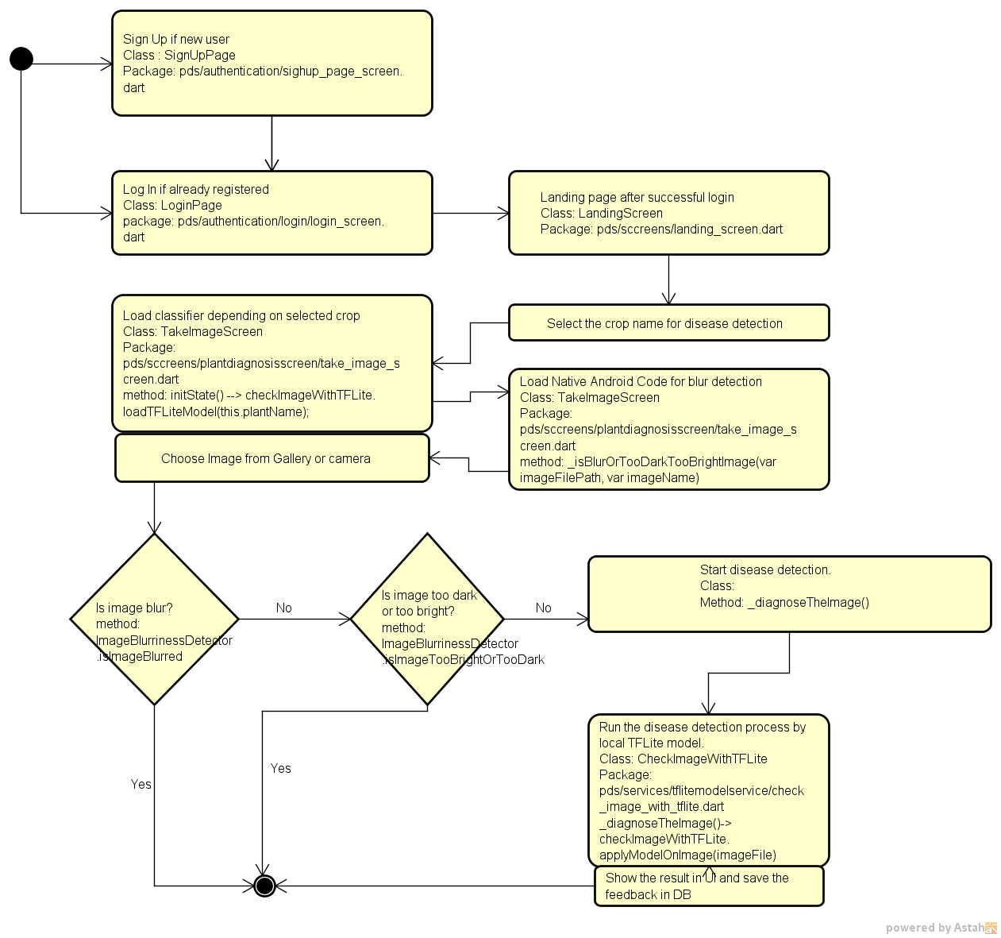

Figure: App flow diagram

**Sequence diagram**

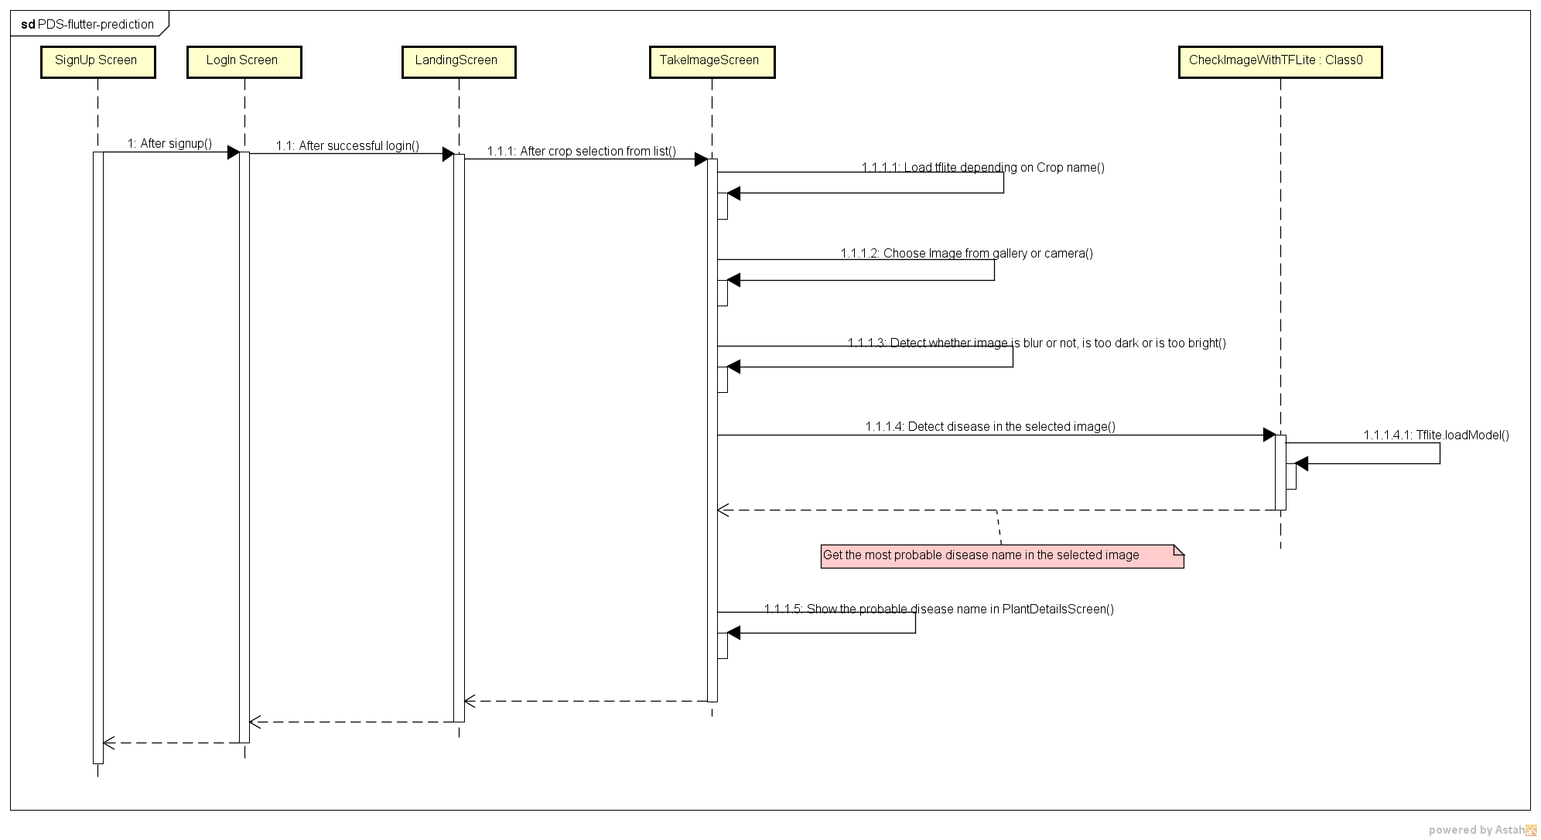

Figure: App sequence diagram