PDS_Merged iOS App Configuration

1. First of all, open global terminal and
2. Uninstall the cocoapods by the command ‘$sudo gem install cocoapods’.
3. Then reinstall the cocoapods by the command ‘$sudo gem install cocoapods’.
4. Go to the root directory of the project.
5. Find and go to the ‘ios’ directory.

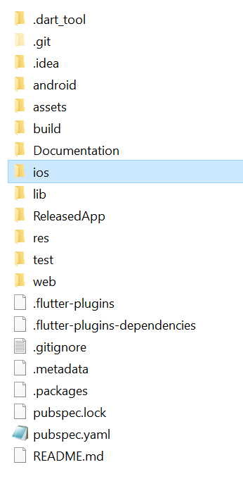

1. Remove the ‘Podfile’ and ‘Podfile.lock’.

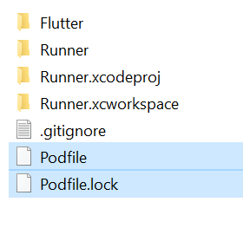

1. Open terminal in the project root directory and Execute those commands synchronously
2. $flutter clean
3. $flutter pub get
4. $flutter upgrade
5. Open terminal in the ‘ios’ directory and execute the command ‘$pod install’.
6. From the ‘ios’ directory open the ‘Podfile.lock’ in editor.
7. Edit the TensorFlowLiteC (xyz.xyz.xyz), whatever the version just changes it to (2.2.0).

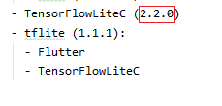

1. If got “**'vector' file not found**" issue then follow those steps bellow:
2. Open ios/Runner.xcworkspace in Xcode, click Runner > Tagets > Runner > Build Settings, search Compile Sources As, change the value to Objective-C++
3. Go to iOS>flutter>Release.xcconfig, add those and save

“#include "Pods/Target Support Files/Pods-Runner/Pods-Runner.release.xcconfig"

#include "Pods/Target Support Files/Pods-Runner/Pods-Runner.profile.xcconfig"”

1. Go to Runner directory from the ios directory and open Info.plist file in editor.
2. Inside the ‘<dict></dict>’ tag, in the bottom (after the <false/>) just before the closing tag(</dict>) add those lines by copy and paste.

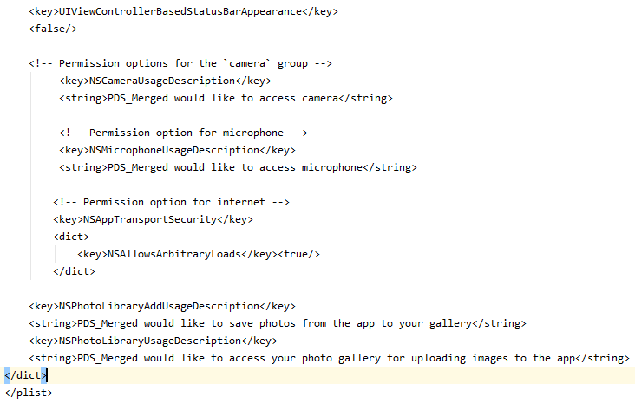

The lines are.

<!-- Permission options for the `camera` group -->

<key>NSCameraUsageDescription</key>

<string>PDS_Merged would like to access camera</string>

<!-- Permission option for microphone -->

<key>NSMicrophoneUsageDescription</key>

<string>PDS_Merged would like to access microphone</string>

<!-- Permission option for internet -->

<key>NSAppTransportSecurity</key>

<dict>

<key>NSAllowsArbitraryLoads</key><true/>

</dict>

<key>NSPhotoLibraryAddUsageDescription</key>

<string>PDS_Merged would like to save photos from the app to your gallery</string>

<key>NSPhotoLibraryUsageDescription</key>

<string>PDS_Merged would like to access your photo gallery for uploading images to the app</string>

1. Start Simulator and run the Project.