**Project 1**

Title

**WAR**

**Card Game**

Course

**CSC-5**

Section

**46091**

Due Date

**July 21, 2015**

Author

**Tiffany Ward**

**Introduction:**

Name of Game: WAR

In the game of War, the deck is split evenly between two players (or more; however, only two players were utilized in this game.) Each player places a card face up. The player with the higher value card takes both cards. In the event that both cards are the same value, War is declared.

In the event of War, each player places five cards face down and one card face up. Whose ever face up card is of a higher value keeps all cards in play. War is repeated if face up cards are once again the same.

The game continues until one player obtains all 52 cards.

**Summary:**

Project size: 208 lines

Number of variables: 7

Number of methonds: approx. 7

I used many if/else and do/while loops in implementing my program. I also utilized the random, string, switch, and counter functions.

I begin my program by asking the user to enter their name.

I use the random and switch functions to output the user and computer cards. I then use if/else statements to determine if the computer or the player have a higher value card. I then use the counter function to increase or decrease scores by one.

If the computer and player have the same value card, War is declared. I use a do/while loop to continue dealing cards until displayed cards have different values. I used the counter function to increase or decrease scores by five every time war is played.

After every round, the winner of the round is displayed. The score is also displayed. The score is displayed depending on who has the higher score at the time. The score used to represent how many cards each player has remaining. These outputs are done using if/else loops.

Also after every round, the user is able to continue to the next round or end the game. This is done by a do/while loop. If the user chooses to end the game, the final score is displayed. Again, the score is displayed using an if/else loop. Along with the final score, “you win,” “you lose,” or “tie” is also displayed.

I did the best I could with the knowledge I have regarding coding. However, I do have some unresolved issues. The deck does not function like a real deck. There is not only 4 of each card and the card does not go out of play once it has been played. Instead, a random care, 2 through Ace, is displayed independent of any other cards previously played. Also, I was not able to get the game to end once a player reaches the score of 52; representing one player obtaining the whole deck. Instead, the numbers begin to go into the negative for the losing player. However, I was able to successfully make the total always equal 52.

**Psuedo Code**

*/\**

*\* File: main.cpp*

*\* Author: Tiffany Ward*

*\* Created on July 18, 2015, 8:03 PM*

*\* Purpose: Project - WAR!*

*\*/*

*//System Libraries*

*//I/O Library*

*//IO Manipulators*

*//C standard library*

*//C Time library*

*//String library*

*//Namespace for iostream*

*//User Libraries*

*//Global constants*

*//Function Prototypes*

*//Execution Begins Here!*

*//Declare Variables Here*

*//comp=computer card*

*//plyr=player card*

*//compTTL=computer score*

*//plyrTTL=player score*

*//war=add to scores during war*

*//ans=deal next round?*

*//name=Player enters name*

*//Prompt user to enter name in order to begin game*

*//Begin game*

*//Determines what card computer plays*

*//Determines what card player plays*

*//Output cards played*

*//Use switch: If 11-14, display name of face card instead of number*

*//If else loop to check value of cards*

*//Declare WAR! if computer and player card is the same*

*//Do/while to continue to play WAR until cards are no longer the same*

*//Computer plays new card*

*//Player plays new card*

*//Use switch: If 11-14, display name of face card instead of number*

*//Points to add/subtract to scores once WAR has ceased*

*//If/else loop to display score and winner of round after war*

*//If/else loop to decide what score to display first*

*//Ask user if they would like to go to the next round*

*//If computer card>player card*

*//Increase computer score by 1 and decrease player score by 1*

*//If/else loop to decide what score to display first*

*//Ask user if they would like to go to the next round*

*//If computer card<player card*

*//Increase player score by 1 and decrease computer score by 1*

*//If/else loop to decide what score to display first*

*//Ask user if they would like to go to the next round*

*//Do/while - If user does not want to go to the next round,*

*//If/else loop display final score*

*//If player has a higher score,*

*//output player score first*

*//and output "You Win!!!"*

*//If computer has a higher score,*

*//output computer score first*

*//and output "You Lose :("*

*//If scores are the same,*

*//Output "TIE!"*

*//END OF GAME*

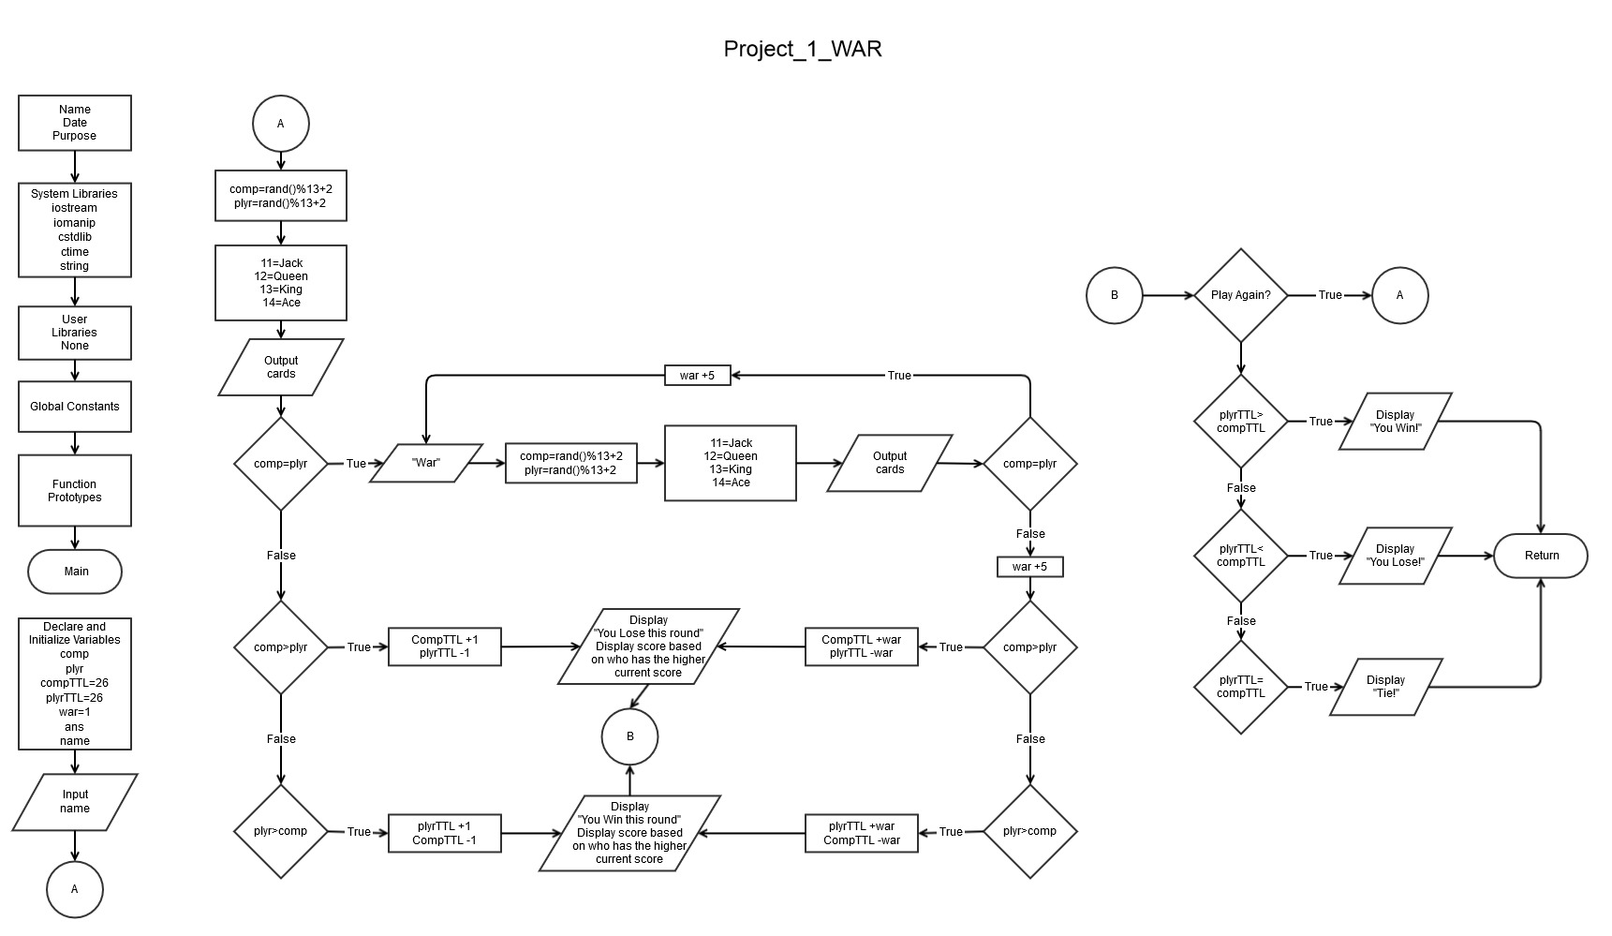**Flow Chart**

**Program**

#include <iostream>

#include <iomanip>

#include <cstdlib>

#include <ctime>

#include <string>

using namespace std;

int main(int argc, char** argv){

srand((unsigned)time(0));

int comp=0;

int plyr=0;

int compTTL=26;

int plyrTTL=26;

int war=1;

char ans;

string name;

cout<<"Let's Play WAR\n";

cout<<"Please enter your name: ";

cin>>name;

do{

comp=rand()%13+2;

plyr=rand()%13+2;

cout<<endl;

cout<<"Computer:\n";

switch(comp){

case 11:cout<<"Jack\n";

break;

case 12:cout<<"Queen\n";

break;

case 13:cout<<"King\n";

break;

case 14:cout<<"Ace\n";

break;

default: cout<<comp<<endl;}

cout<<endl;

cout<<name<<":\n";

switch(plyr){

case 11:cout<<"Jack\n";

break;

case 12:cout<<"Queen\n";

break;

case 13:cout<<"King\n";

break;

case 14:cout<<"Ace\n";

break;

default: cout<<plyr<<endl;}

cout<<endl;

if (comp==plyr){

cout<<"WAR!!!\n";

do{

war+=5;

comp=rand()%13+2;

plyr=rand()%13+2;

cout<<endl;

cout<<"Computer:\n";

switch(comp){

case 11:cout<<"Jack\n";

break;

case 12:cout<<"Queen\n";

break;

case 13:cout<<"King\n";

break;

case 14:cout<<"Ace\n";

break;

default: cout<<comp<<endl;}

cout<<endl;

cout<<name<<":\n";

switch(plyr){

case 11:cout<<"Jack\n";

break;

case 12:cout<<"Queen\n";

break;

case 13:cout<<"King\n";

break;

case 14:cout<<"Ace\n";

break;

default: cout<<plyr<<endl;}

}while (comp==plyr);

if (comp>plyr){

compTTL+=war;

plyrTTL-=war;

cout<<endl;

cout<<"You Lose This Round\n";

if (compTTL>plyrTTL){

cout<<"Computer: "<<compTTL<<" ... "<<name<<": "<<plyrTTL<<endl;

cout<<endl;

}else{

cout<<name<<": "<<plyrTTL<<" ... "<<"Computer: "<<compTTL<<endl;

cout<<endl;}

}else{

compTTL-=war;

plyrTTL+=war;

cout<<endl;

cout<<"You Win This Round!\n";

if (compTTL>plyrTTL){

cout<<"Computer: "<<compTTL<<" ... "<<name<<": "<<plyrTTL<<endl;

}else{

cout<<name<<": "<<plyrTTL<<" ... "<<"Computer: "<<compTTL<<endl;}

cout<<endl;}

cout<<"Next Round (y/n)?: ";

cin>>ans;

}else if (comp>plyr){

compTTL+=1;

plyrTTL-=1;

cout<<"You Lose This Round\n";

if (compTTL>plyrTTL){

cout<<"Computer: "<<compTTL<<" ... "<<name<<": "<<plyrTTL<<endl;

cout<<endl;

}else{

cout<<name<<": "<<plyrTTL<<" ... "<<"Computer: "<<compTTL<<endl;

cout<<endl;}

cout<<"Next Round (y/n)?: ";

cin>>ans;

}else{

compTTL-=1;

plyrTTL+=1;

cout<<"You Win This Round!\n";

if (compTTL>plyrTTL){

cout<<"Computer: "<<compTTL<<" ... "<<name<<": "<<plyrTTL<<endl;

cout<<endl;

}else{

cout<<name<<": "<<plyrTTL<<" ... "<<"Computer: "<<compTTL<<endl;

cout<<endl;}

cout<<"Next Round (y/n)?: ";

cin>>ans;}

}while ((ans=='Y')||(ans=='y'));

cout<<endl;

cout<<"FINAL SCORE\n";

cout<<endl;

if (compTTL<plyrTTL){

cout<<name<<": "<<plyrTTL<<endl;

cout<<"Computer: "<<compTTL<<endl;

cout<<"YOU WIN!!!\n";

}else if (plyrTTL<compTTL){

cout<<"Computer: "<<compTTL<<endl;

cout<<name<<": "<<plyrTTL<<endl;

cout<<"YOU LOSE :(\n";

}else{

cout<<"TIE!\n";

cout<<name<<": "<<plyrTTL<<endl;

cout<<"Computer: "<<compTTL<<endl;

}

return 0;

}