MySQL setup demonstration: (Persons table found from W3Schools as an example).
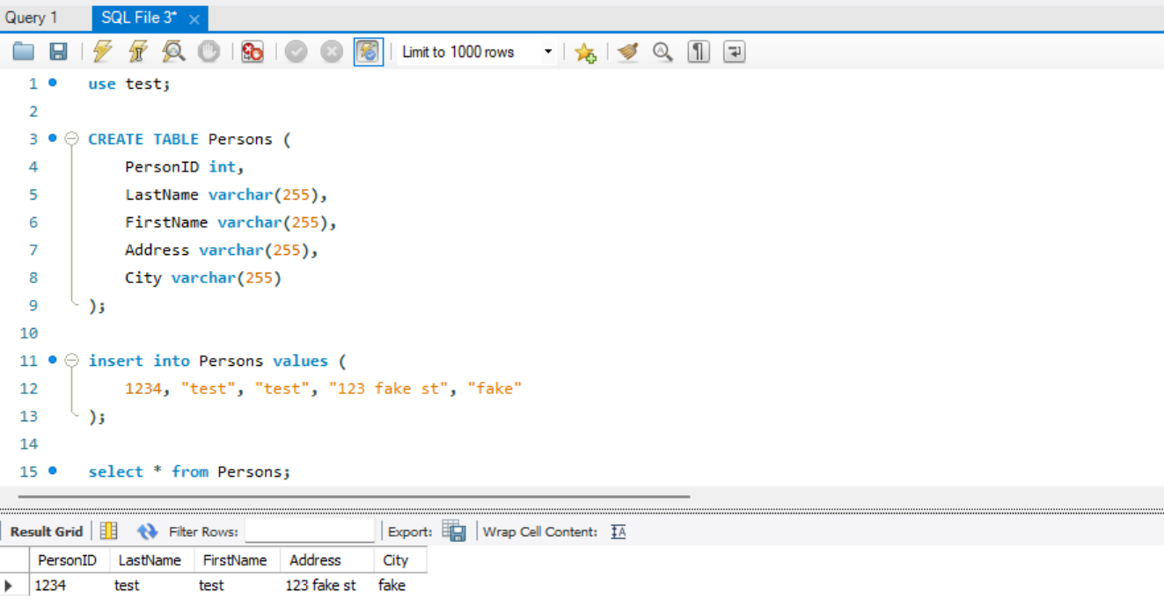
Normalization and Relations
Relation – a mathematical term, meaning there is some connection between two things. In the case of databases, the relation is a correlation between two entities and the properties they share. A customer and a business have a relation, as the customer BUYS from the business. BUYS would be the relation that connects the customer and business entity.
Normalization – just refers to making sure that the database conforms to a standard. Similar to the statistical notion of normalization, where you try to make sure that your distribution is a standardized form regardless of where the data comes from. The standardization in the database case is that the database has reduced duplication in an attempt to increase accuracy over transactions. By definition, the normal forms are cumulative. If a database satisfies the conditions for a specific normal form, it satisfies the conditions for all previous normal forms.
Normalization is a trade-off in a business sense. The more normalized the database, the more safeguards for accuracy that you have in place, but it usually adds complexity and slows down working with the database. As such, many businesses choose whether to normalize and, if they normalize, what level is worth trying to get to based on their specific use cases.

Normal forms:
1st Normal Form – requires simple, atomic values and a unique identifier. Classic example of atomic values is an address, which is made up of multiple parts. City, street address, area code, etc.
2nd Normal Form – requires that the relation has partial dependencies removed. A partial dependency is where there is no single candidate key which all the fields of the relation are defined by. 2nd normal form is the removal of those partial dependencies into their own entity, creating a relation between them.
3rd Normal Form – requires that transitive dependencies are removed. A transitive dependency is similar to a partial dependency but the dependency is between two non-candidate attributes. The solution is the same – break the attributes that have the transitive dependency into a separate lookup table. A common stopping point for normalization as the trade-off between normalization and time taken normalizing and running queries is usually not worth the added cost.
4th Normal Form – requires that the relation have no multivalued dependencies. A multivalue dependency is one which, while satisfying all the previous normal forms (so it does not qualify as a transitive or partial dependency), has more than a single set of dependencies. A key is supposed to identify the entire dataset, not just a subset. That’s the issue with transitive and partial dependencies, as well. A subset of the data is not dependent on the key. Most databases will either not have these dependencies or the dependency is not cost effective to root out, so 4th normal form is often not worried about.
5th Normal Form – requires that any valid decomposition of the table is also valid and results in no lost accuracy of the data. As with 4th normal form, this normal form is usually not worried about as the database is usually already in this form or the business case is not cost effective to worry about.

