**Assignment No.1**

1. **Hello World Program**: Write a Java program that prints "Hello World!!" to the console.

**Solution--** public class A1_Q6{

public static void main(String[] args)

{

System.out.println("Hello World!!");

}

}

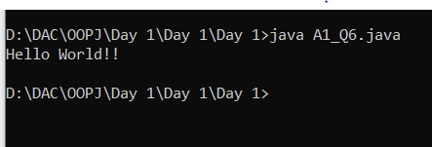

1. **Compile with Verbose Option**: Compile your Java file using the -verbose option with javac. Check the output.

**Solution** ---

-verbose option shows all the runtime activites of the compiler for thr current JAVA file.

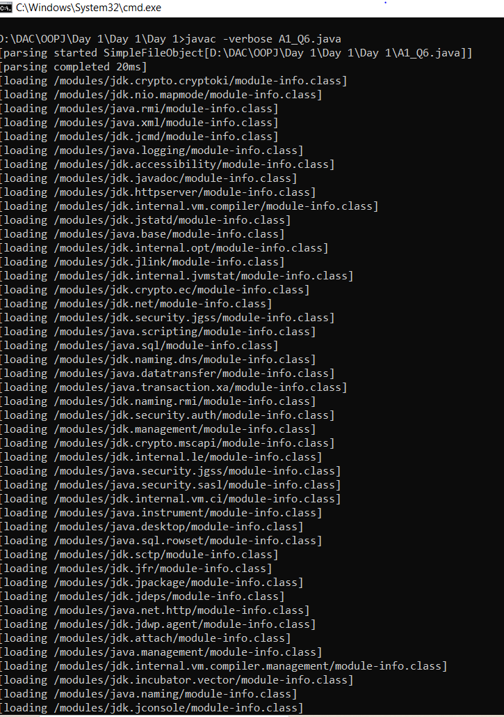

1. **Inspect Bytecode**: Use the javap tool to examine the bytecode of the compiled .class file. Observe the output.

**Solution--**

javap tool breaks down the compiled bytcode (class file) of the current java file in a more human readable format. Hence, it is also known as the Java Disassembler.It comes with various options such as –verbose etc.

