Experimental Investigation of Thermal Performance in TPMS Lattice Structures with Phase Change Materials: A Comparative Study of Gyroid, IWP, and Primitive Architectures

Abstract
Triply periodic minimal surface (TPMS) lattice structures integrated with phase change materials (PCMs) offer a promising approach for advanced passive thermal management of high-power electronic devices. However, experimental comparisons of different TPMS topologies under controlled thermal loading remain scarce, and no prior study has simultaneously compared three TPMS architectures in PCM-integrated lattice structures. This study presents a systematic experimental investigation of the thermal performance of three TPMS architectures—Gyroid, IWP (I-Wrapped Package), and Primitive (Schwarz-P)—integrated with paraffin-based PCM. Lattice structures were fabricated from AlSi10Mg alloy via laser powder bed fusion additive manufacturing, with specimen dimensions of 50 × 50 × 20 mm³. A commercial paraffin wax with a phase change temperature of 42 °C was vacuum-infused into the lattice pores. Transient heating experiments were conducted at three constant power levels (10 W, 20 W, and 30 W) under uniform heat flux boundary conditions, with nine thermocouples distributed across three vertical layers to capture the spatiotemporal evolution of temperature fields. Results reveal a critical power-dependent performance ranking reversal: at 10 W heating, IWP achieves the longest melting duration (12.33 min) compared to Gyroid (11.83 min) and Primitive (9.43 min); however, at 20 W and 30 W, the ranking reverses completely, with Gyroid achieving 2.22 min and 0.62 min respectively, compared to IWP's 0.93 min and 0.40 min. Gyroid consistently demonstrates superior thermal uniformity across all power levels (A–B gradient: 4.43–15.75 °C vs. 6.12–19.76 °C for IWP and 7.44–24.13 °C for Primitive) and exhibits the lowest power sensitivity (melting duration reduction factor of 19.1× from 10 W to 30 W, compared to 30.8× for IWP and 33.7× for Primitive). These findings establish power-dependent topology selection criteria: Gyroid is optimal for wide power range and high-power applications, while IWP excels in low-power precision thermal management.
Keywords: TPMS lattice; Gyroid; IWP; Primitive; Phase change material; Thermal management; Additive manufacturing; Temperature uniformity; Power sensitivity

1. Introduction
The relentless miniaturization and performance escalation of modern electronic devices have imposed increasingly stringent thermal management demands. As power densities in electronics continue to rise—exceeding 100 W/cm² in advanced microprocessors and high-power LEDs—conventional passive cooling strategies such as fin arrays and heat spreaders are approaching their fundamental limits [1]. Efficient thermal management is critical for ensuring device reliability and maintaining performance stability under transient thermal loads, driving sustained research interest in advanced thermal regulation technologies that accommodate high heat fluxes within compact form factors.
Phase change materials (PCMs) have emerged as a compelling solution for passive thermal energy storage and transient thermal management. By absorbing and releasing large quantities of latent heat during solid–liquid phase transitions at nearly constant temperatures, PCMs can effectively buffer thermal spikes and maintain component temperatures within safe operating windows [2]. Paraffin waxes are widely employed owing to their high latent heat capacity, chemical stability, and suitable phase change temperatures for electronics cooling. However, their inherently low thermal conductivity (typically 0.2–0.4 W/m·K) severely limits heat absorption and release rates, resulting in sluggish thermal response and incomplete latent heat utilization. Overcoming this limitation requires high-conductivity structural scaffolds that enhance effective thermal transport throughout the PCM volume.
Metallic lattice structures have attracted considerable attention due to their high surface-area-to-volume ratios, interconnected pore networks, and mechanically efficient topologies [3,4]. TPMS structures are defined by zero-mean-curvature surfaces that partition three-dimensional space into two continuous, interpenetrating sub-volumes. Several distinct TPMS topologies exist, each offering unique channel geometry and flow characteristics that profoundly influence heat transfer performance. The Gyroid surface features a single continuous channel with chiral symmetry, generating helical flow paths that promote fluid mixing and secondary convection [5]. The Primitive (Schwarz-P) surface comprises two independent, mutually interpenetrating channel networks connected through periodic openings, yielding bidirectional transport pathways with distinct tortuosity. The IWP (I-Wrapped Package) surface similarly partitions space into two independent interpenetrating channel networks, yet differs fundamentally from the Primitive in its wrapping topology: the IWP channels exhibit a more complex cage-like enclosure with higher genus and greater surface area per unit volume, producing enhanced flow confinement and altered thermal transport pathways [3]. These three topologies thus span a rich design space of channel connectivity, tortuosity, and confinement, making their systematic comparison essential for advancing TPMS-based thermal management (see Fig. 1 for a visualization of the three TPMS architectures).
Recent studies have demonstrated the potential of TPMS-based structures for enhanced PCM thermal management. Qureshi et al. [6] experimentally characterized a finned metal foam-phase change material (FMF-PCM) heat-sink system incorporating triply periodic minimal surface structures and reported enhanced heat-transfer performance and temperature uniformity for PCM thermal management. In a related study, Qureshi et al. [7] thermally characterized 3D-printed TPMS lattices embedded with an organic phase change material, demonstrating that periodic architectures printed by laser powder bed fusion can serve as PCM scaffolds with tailored thermal response. Gado [8] numerically investigated PCM-based TPMS heat sinks for electronics thermal management and showed that lattice topology strongly affects melting behavior and heat-transfer enhancement. Qin et al. [9] analyzed convective heat transfer in Gyroid-type TPMS structures and showed how mathematical regulation of the surface geometry controls secondary flows and thermal transport enhancement. Zhao et al. [4] reported conformal Gyroid lattice designs that enhance the thermal-hydraulic performance of TPMS heat-exchanger channels.
The advent of additive manufacturing (AM), particularly laser powder bed fusion (L-PBF), has enabled the fabrication of TPMS lattice structures with unprecedented geometric accuracy and surface quality [7,10]. Unlike conventional methods constrained by mold design and demolding complexity, AM allows direct realization of mathematically defined TPMS geometries with precise control over strut dimensions, porosity, and unit cell size. Guo et al. [11] demonstrated a 3D-printed lattice-structure heat sink packaging phase change material for electronics cooling and reported that the printed conductive lattice reduced peak temperatures during transient operation. Zhang et al. [12] experimentally characterized the melting heat transfer of paraffin/metal-foam composite phase change materials and highlighted the importance of pore-scale morphology in determining effective thermal performance.
Despite these advances, a significant gap remains in the experimental understanding of TPMS-PCM coupled thermal systems. The majority of existing studies have relied on numerical simulations or analytical models to predict the thermal behavior of TPMS-PCM configurations [8,10]. Experimental studies of PCM embedded in printed TPMS lattices have only recently begun to appear [13]; to the authors' knowledge, none has yet simultaneously compared three TPMS topologies under identical boundary conditions. The influence of heating power on the transient thermal response, phase change dynamics, and spatial temperature distribution across these three topologies has not been systematically characterized through experiments. Understanding these relationships is essential for validating computational models, establishing power-dependent performance rankings, and providing design guidelines for practical engineering applications.
This study presents the first systematic experimental investigation of the thermal performance of three TPMS lattice topologies—Gyroid, Primitive, and IWP—integrated with paraffin-based PCM. The TPMS lattice structures were fabricated from AlSi10Mg alloy using L-PBF additive manufacturing, with sample dimensions of 50 × 50 × 20 mm³. A paraffin-based PCM with a phase change temperature of 42 °C was infiltrated into the lattice pores. Transient heating experiments were conducted at three power levels (10 W, 20 W, and 30 W) under constant heat flux boundary conditions. Multiple thermocouples were strategically positioned at three vertical layers to capture the spatial and temporal evolution of temperature fields during the heating and phase change processes. The primary objectives of this study are: (1) to compare the thermal performance of Gyroid, Primitive, and IWP TPMS lattices in terms of temperature uniformity, thermal gradients, and PCM melting dynamics; (2) to characterize the effect of heating power on the transient thermal response and phase change behavior across all three topologies; (3) to establish a power-dependent performance ranking of the three TPMS structures, identifying optimal topology selection criteria for different operating conditions; and (4) to provide experimental benchmark data that can inform the design optimization of TPMS-based PCM thermal management systems for electronics cooling applications.

2. Wetting of Thermocouples by the Molten PCM
In PCM-integrated lattice specimens, the embedded thermocouples interact with the phase change medium itself, and this interaction must be considered when interpreting contact temperature measurements. Before melting, heat transfer between the solid paraffin and each thermocouple bead occurs across an imperfect solid–solid interface and micron-scale air gaps, introducing a finite thermal contact resistance at the sensor. Once the local temperature reaches the phase change temperature (42 °C), the paraffin melts and the liquid phase wets the thermocouple bead, the adhesive fillet, and the adjacent strut surfaces. Liquid paraffin exhibits low surface tension (approximately 25–30 mN/m) and contact angles well below 90° on the oxidized aluminum and ceramic-adhesive surfaces of the assembly, so the melt spontaneously spreads into the micron-scale voids surrounding the embedded sensors, replacing the initial air-gapped point contact with a continuous liquid bridge. This wetting transition lowers the local thermal contact resistance and tightens the thermal coupling between the bead and the surrounding PCM.
The wetting transition leaves characteristic traces in the recorded temperature signals: small step-like perturbations superimposed on the otherwise smooth melting plateau, and enhanced short-time fluctuations caused by buoyancy-driven convection cells of the liquefied wax around the beads. In the present records these perturbations remained small (within ±1 °C; for example, a brief −0.4 °C excursion of the bottom-surface channel during the 30 W melting plateau), consistent with an improved rather than degraded thermal coupling after wetting. At higher power levels, the mobility and thermal expansion of the melt (on the order of 10% volume expansion upon melting) can additionally exert drag on the fine (0.25 mm) thermocouple wires and displace poorly secured sensors. In one early 30 W IWP run, a middle-layer channel exhibited a transient non-physical excursion (readings up to approximately 406 °C for about 15 s, while all adjacent channels remained below 66 °C) that began before the melt front reached the middle layer; this was identified as a sensor/contact fault rather than a thermal event, the channel was excluded from the analysis, and the sensors were re-secured, after which all channels in the final experimental series remained within physical bounds. These effects are an inherent aspect of contact thermometry in phase change media; channel-by-channel screening was therefore applied before the analysis, and the area-averaged middle-layer temperature and the non-contact infrared top-surface measurements adopted in this study are robust against them.

Figures
Fig. 3. Comprehensive comparison of thermal performance across three TPMS structures (Gyroid, IWP, Primitive) at 10 W, 20 W, and 30 W heating power. (a) Melting duration comparison showing the performance ranking reversal between IWP and Gyroid. (b) A–B temperature gradient at T₁ = 42 °C. (c) A–B gradient expansion rate from 42 °C to 55 °C. (d) Time for T₁ to reach 42 °C. (e) Time for T₉ to reach 42 °C. (f) A–B temperature gradient at T₁ = 55 °C. (g–i) T₁ temperature evolution curves at 10 W, 20 W, and 30 W respectively.
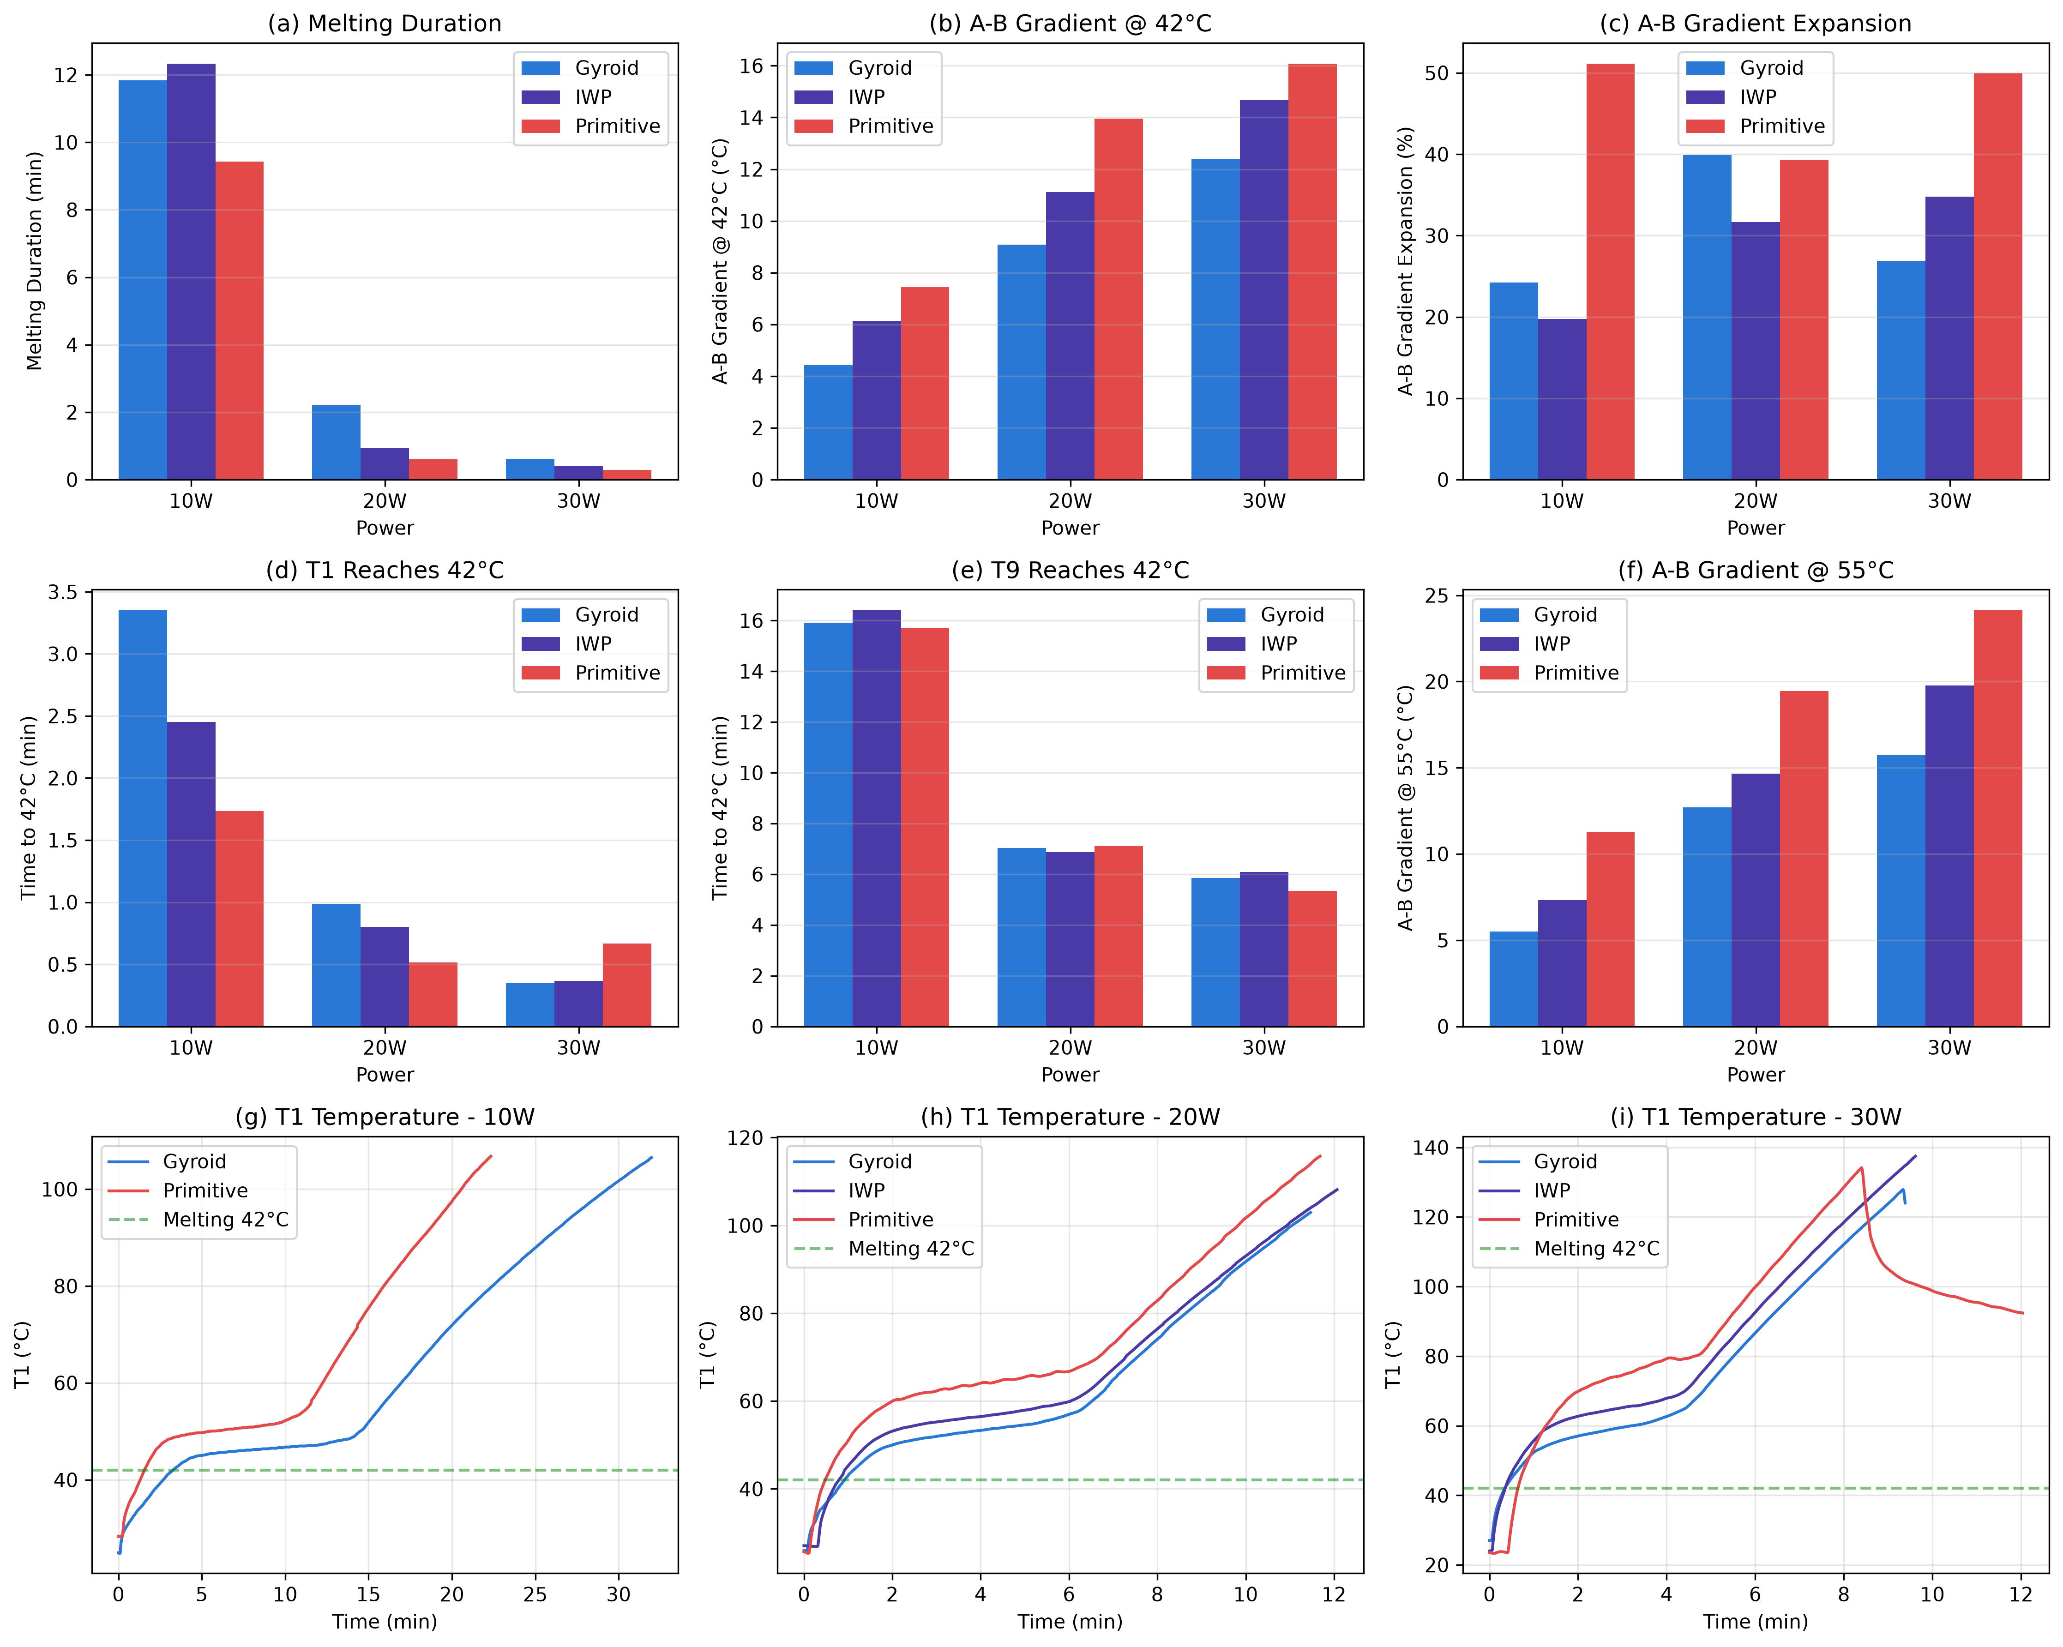
Fig. 4. Temperature evolution curves for three TPMS structures at different heating powers. (a–c) T₁ temperature vs. time at 10 W, 20 W, and 30 W respectively. (d–f) B-group (middle layer) average temperature vs. time. (g–i) C-group (top surface) temperature vs. time. The dashed green line indicates the PCM melting temperature of 42 °C.
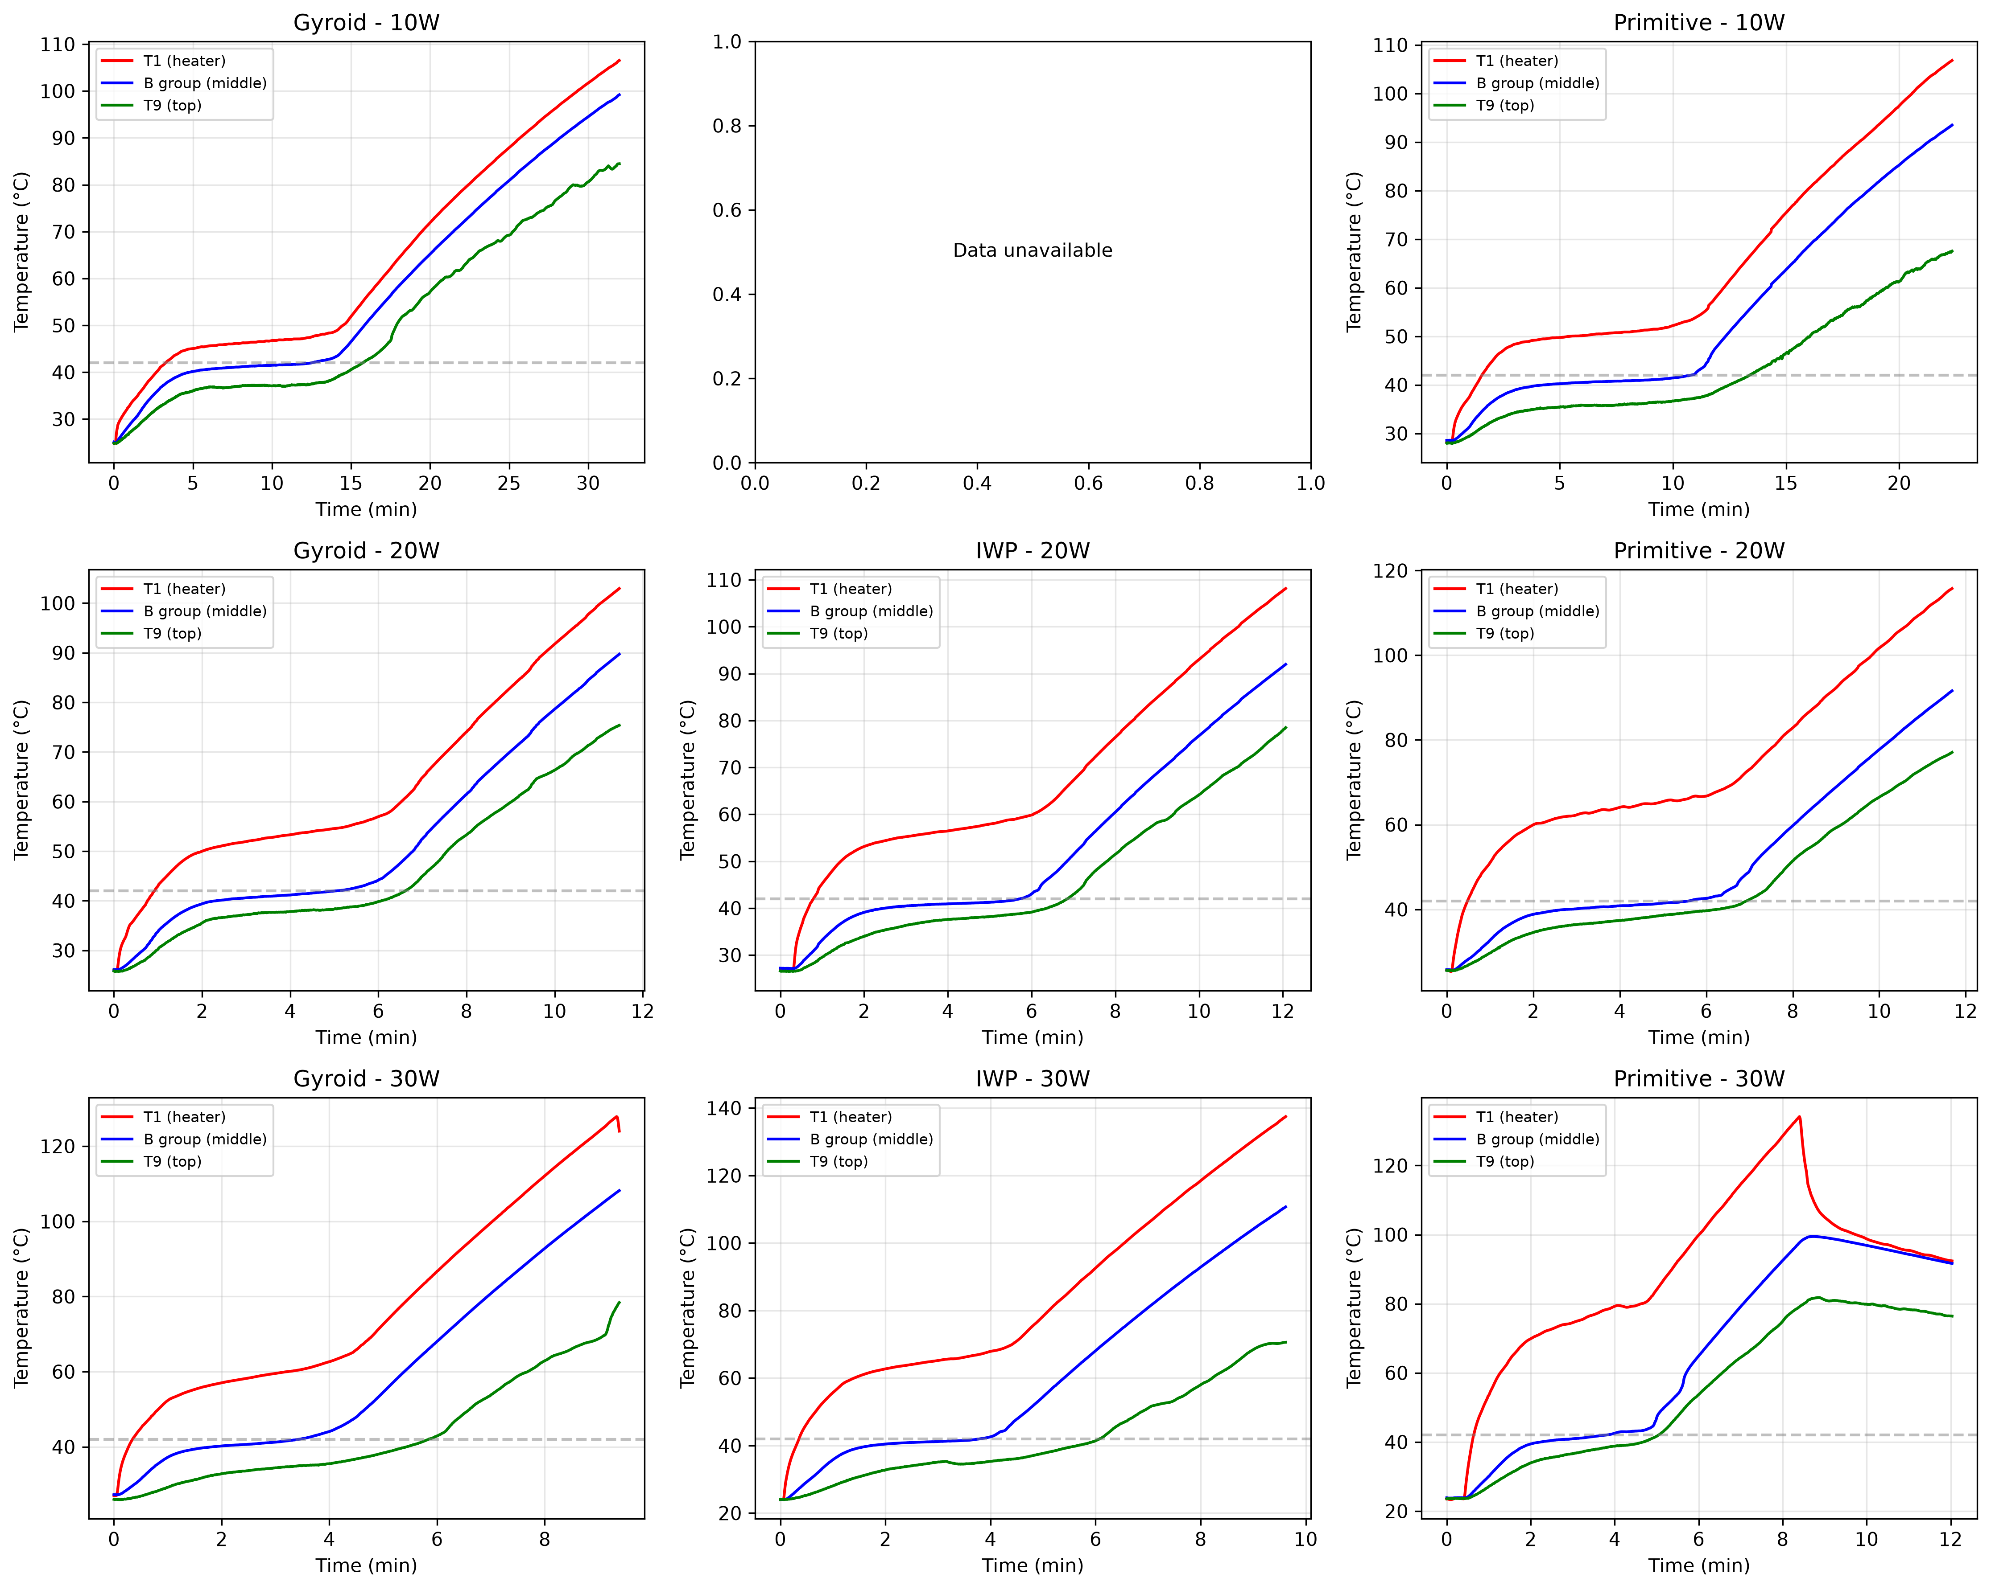
Fig. 5. Power sensitivity analysis of three TPMS structures. (A) Melting duration reduction factor from 10 W to 20 W and 30 W. (B) A–B gradient increase factor from 10 W to 20 W and 30 W. Gyroid exhibits the lowest power sensitivity, making it the most robust choice for variable power applications.
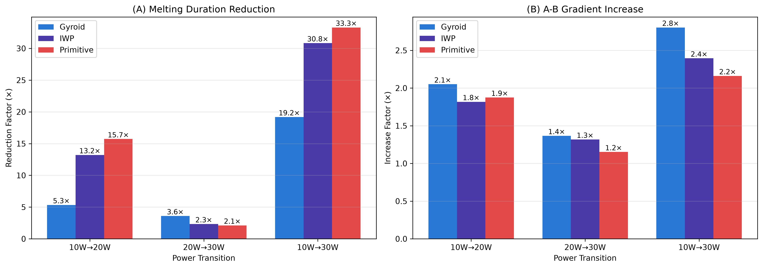
Fig. 6. Performance ranking comparison at different power levels. At 10 W, IWP achieves the longest melting duration; at 20 W and 30 W, Gyroid becomes dominant. This reversal demonstrates the critical importance of power-dependent topology selection.
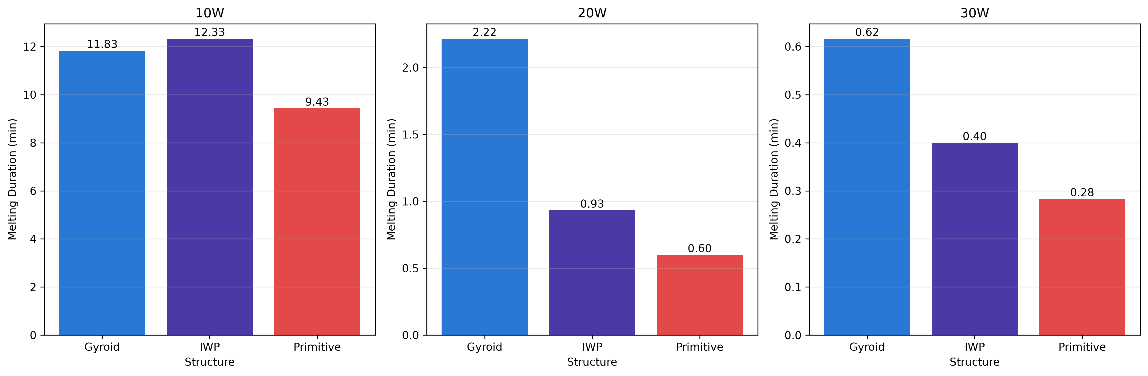

References
[1] Ebrahimi K., Jones G.F., Fleischer A.S. A review of data center cooling technology, operating conditions and the corresponding low-grade waste heat recovery opportunities. Renewable and Sustainable Energy Reviews 2014;31:622-638. DOI: 10.1016/j.rser.2013.12.007.
[2] Kandasamy R., Wang X.Q., Mujumdar A.S. Transient cooling of electronics using phase change material (PCM)-based heat sinks. Applied Thermal Engineering 2008;28:1047-1057. DOI: 10.1016/j.applthermaleng.2007.06.010.
[3] Qureshi Z.A., Al-Omari S.A.B., Elnajjar E., Al-Ketan O., Abu Al-Rub R. Nature-inspired triply periodic minimal surface-based structures in sheet and solid configurations for performance enhancement of thermal systems. International Journal of Thermal Sciences 2022;173:107361. DOI: 10.1016/j.ijthermalsci.2021.107361.
[4] Zhao W., Deng H., Xiao Y., Yan K. Conformal design of Gyroid TPMS lattices for enhanced thermal-hydraulic performance in U-shaped and arc-shaped heat exchanger channels. Applied Thermal Engineering 2026;303:132046. DOI: 10.1016/j.applthermaleng.2026.132046.
[5] Peng H., Hu Z.C. Experimental and numerical study of a Gyroid TPMS microchannel heat sink with supercritical CO2 as the coolant. Applied Thermal Engineering 2025;279:127707. DOI: 10.1016/j.applthermaleng.2025.127707.
[6] Qureshi Z.A., Elnajjar E., Al-Ketan O., Al-Rub R.A., Al-Omari S.B. Heat transfer performance of a finned metal foam-phase change material (FMF-PCM) system incorporating triply periodic minimal surfaces. International Journal of Heat and Mass Transfer 2021;170:121001. DOI: 10.1016/j.ijheatmasstransfer.2021.121001.
[7] Qureshi Z.A., Al Omari S.A.B., Elnajjar E., Mahmoud F., Al-Ketan O., Al-Rub R.A. Thermal characterization of 3D-printed lattices based on triply periodic minimal surfaces embedded with organic phase change materials. Case Studies in Thermal Engineering 2021;27:101315. DOI: 10.1016/j.csite.2021.101315.
[8] Gado M.G. Thermal management and heat transfer enhancement of electronic devices using integrative phase change material (PCM) and triply periodic minimal surface (TPMS) structures. Applied Thermal Engineering 2025;258:124504. DOI: 10.1016/j.applthermaleng.2024.124504.
[9] Qin K., Yang S., Lv T., Zhao X., Tang X. Mathematical regulation of Gyroid-type TPMS structures for enhanced convective heat transfer. International Journal of Heat and Fluid Flow 2026;118:110227. DOI: 10.1016/j.ijheatfluidflow.2025.110227.
[10] Qureshi Z.A., Al-Omari S.A.B., Elnajjar E., Al-Ketan O., Al-Rub R.A. On the effect of porosity and functional grading of 3D printable triply periodic minimal surface (TPMS) based architected lattices integrated with phase change materials. International Journal of Heat and Mass Transfer 2022;183:122111. DOI: 10.1016/j.ijheatmasstransfer.2021.122111.
[11] Guo Y., Yang H., Lin G., Jin H., Shen X., He J., et al. Thermal performance of a 3D printed lattice-structure heat sink packaging phase change material. Chinese Journal of Aeronautics 2021;34:373-385. DOI: 10.1016/j.cja.2020.07.033.
[12] Zhang P., Meng Z., Zhu H., Wang Y., Peng S. Melting heat transfer characteristics of a composite phase change material fabricated by paraffin and metal foam. Applied Energy 2017;185:1971-1983. DOI: 10.1016/j.apenergy.2015.10.075.
[13] Arqam M., Raffa L.S., Ryall M., Islam M.S., Bennett N.S. Numerical and experimental analysis of triply periodic minimal surface (TPMS)-based metal lattice heat sinks integrated with different phase change materials. Journal of Energy Storage 2025;132:117784. DOI: 10.1016/j.est.2025.117784.

