教材范例3_13
代码:
#include<string>
#include<iostream>
using namespace std;
class student
{
char *specialty;
public:
student(char *pspec);
~student( );
void show();
};
student::student(char *pspec)
{
if (pspec)
{
specialty = new char[strlen(pspec) + 1];
strcpy_s(specialty, strlen(pspec) + 1, pspec);
}
else
{
specialty = 0;
}
}

student::~student()
{
if (specialty)
delete[]specialty;//specialty的储存空间由new运算符分配,需要delete释放
}
void student::show()
{
cout << "specailty" << specialty << '\n';
}

int main()
{
student zhang("computer");
student wang(zhang);
zhang.show();
wang.show();
system("pause");
return 0;
调试图片:
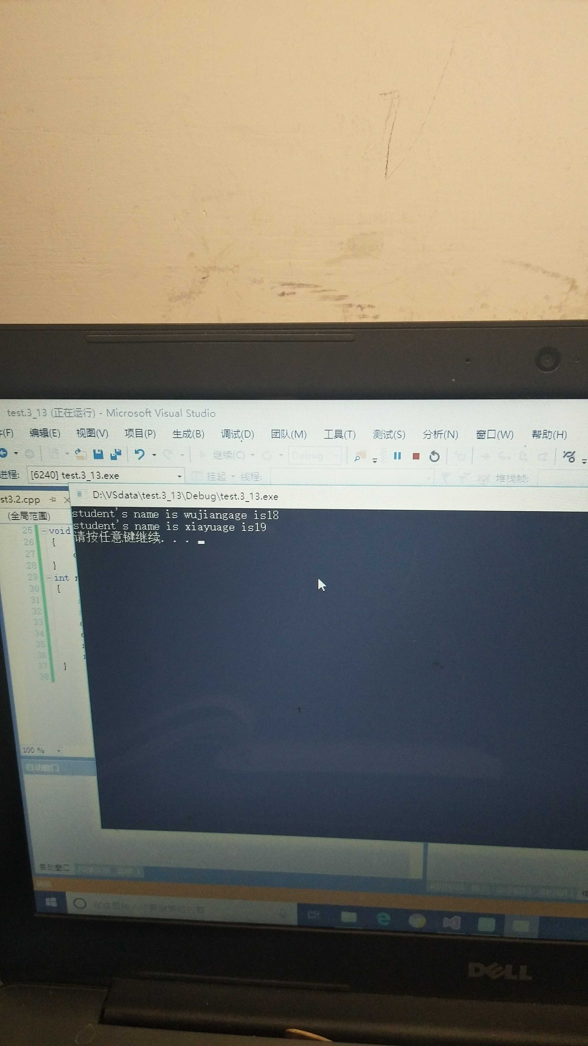
结果分析:写一个构造函数,作用是判断输入的数据是否为空.不为空则赋给指针specialty,然后输出.第二个输出为系统自带的拷贝函数

课后习题第三题(1)
代码:
#include<iostream>
using namespace std;
class b
{
int x, y;
public:
b()
{
x = y = 0;
cout << "con1\t";
}
b(int i)
{
x = i; y = 0;
cout << "cont2\t";
}
b(int i, int j)
{
x = i; y = j;
cout << "cont3\t";
}
~b()
{
cout << "des\t";
}
};
int main()
{
b *ptr;
ptr = new b[3];
ptr[0] = b();
ptr[1] = b(1);
ptr[2] = b(2, 3);
delete[]ptr;

system("pause");
return 0;
}
调试图片:
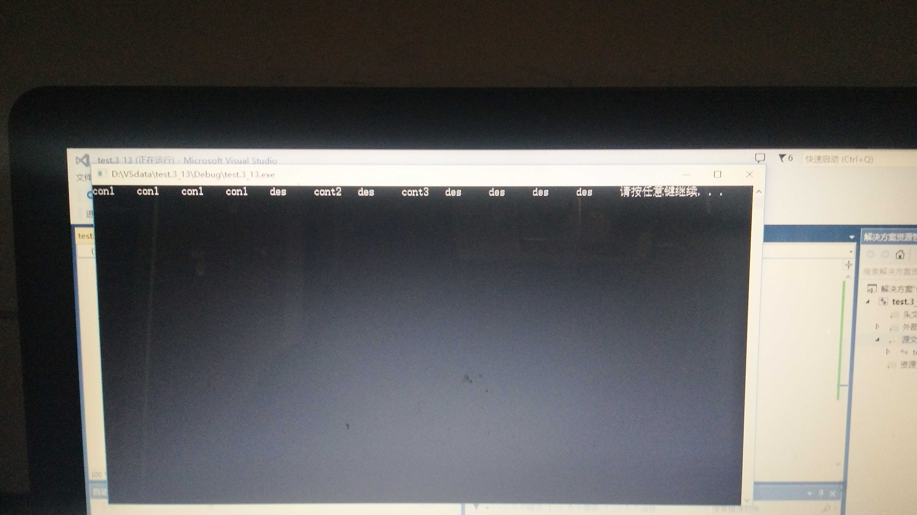
结果分析:此调试为构造函数的引用.用new默认为空函数.而b(); b(1);b(2, 3);需要匹配

课后习题第三题(1)
代码:#include<iostream>
#include<string>
using namespace std;
class student
{
public:
student(int m, char *n)
{
age = m;
name = new char[strlen(n) + 1];
strcpy_s(name, strlen(n) + 1, n);
}
friend void disp(student&);//将函数disp()声明为自己的友元函数
~student()
{
cout << "delete it." << name << endl;
delete[]name;
}

private:
int age;
char *name;

};
void disp(student & p)
{
cout << "student's name is " << p.name << "age is" << p.age << endl;
}
int main()
{
student a(18, "wujiang");
student b(19,"xiayu");
disp(a);
disp(b);
system("pause");
return 0;
}

调试图片:
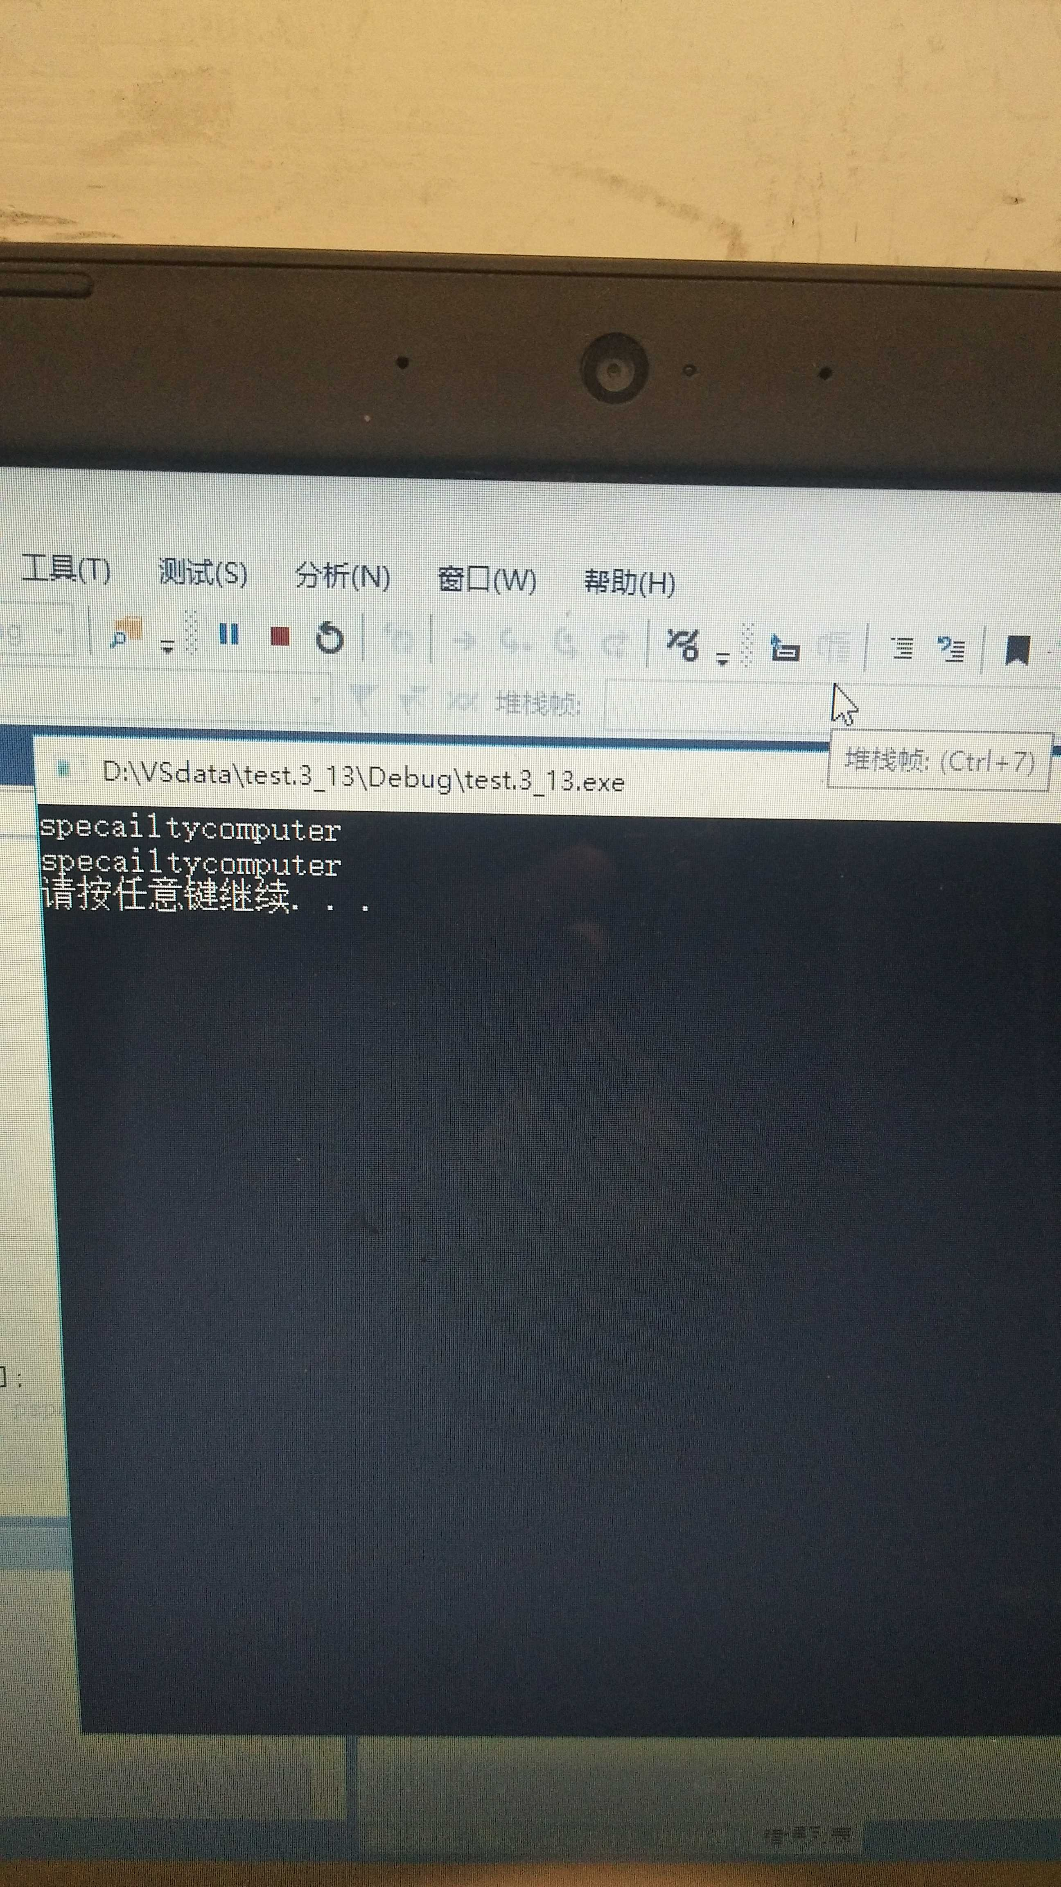
结果分析:利用指针的复制功能给char型赋值.不是char型可以直接赋值

