一：
程序源码：
【例3.13】
#include <string>
#include <iostream>
using namespace std;
class student
{
char *spacialty;
public:
student(char *pSpec=0);
~student();
void Show();
student(const student &r);
};
student::student (const student &r)
{
if(r.spacialty)
{
spacialty=new char[strlen(r.spacialty)+1];
strcpy(spacialty,r.spacialty);
}
else spacialty=0;
}
student::student(char *pSpec)
{
if(pSpec)
{
spacialty=new char[strlen(pSpec)+1];
strcpy(spacialty,pSpec);
}
else spacialty=0;
}
student::~student()
{
if(spacialty)
delete []spacialty;
}
void student::Show()
{
cout<<"speciality="<<spacialty<<endl;
}
int main()
{
student zhang("computer");
student wang(zhang);
zhang.Show();
wang.Show();
system("pause");
return 0;
}

运行截图

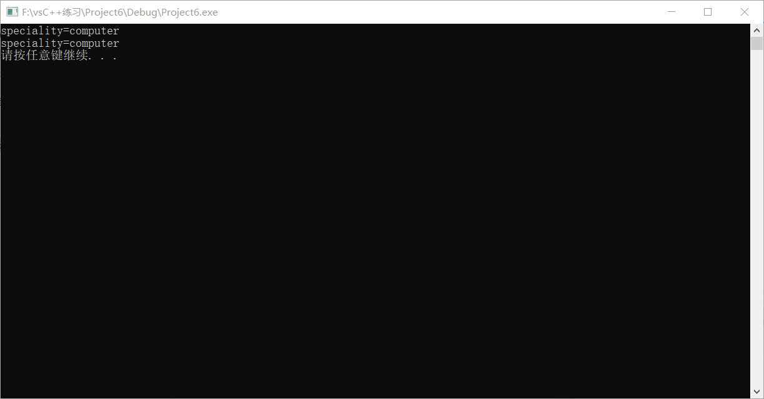

二：
第三大题第二小题
程序源码：
#include "iostream"
using namespace std;
class B
{
int x,y;
public:
B()
{
x=y=0;
cout<<"con1\t";
}
B(int i)
{
x=i; y=0;
cout<<"con2\t";
}
B(int i,int j)
{
x=i;y=j;
cout<<"con3\t";
}
~B()
{
cout<<"Des\t";
}
};
int main()
{
B *ptr;
ptr=new B[3];
ptr[0]=B();
ptr[1]=B(1);
ptr[2]=B(2,3);
delete [ ]ptr;
system("pause");
return 0;
}

程序运行截图：
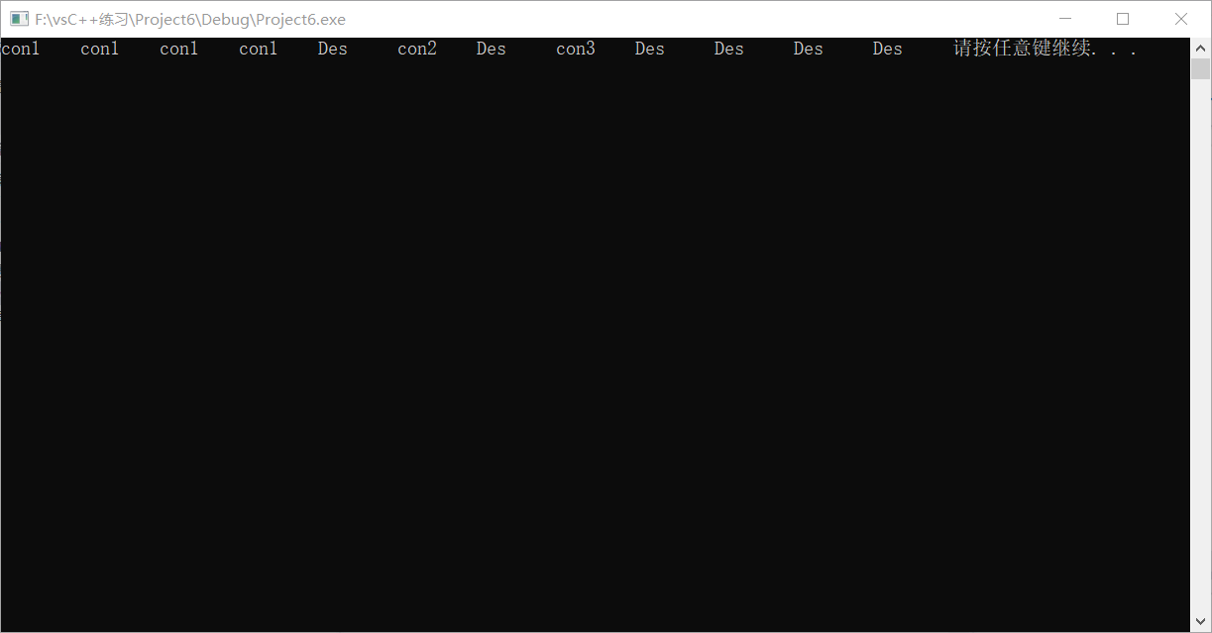

第二题
程序源码：
#include<iostream>
#include<string>
using namespace std;
class student
{
int age;
char *name;
public:
student(int m,char *n)
{
age=m;
name=new char[strlen(n)+1];
strcpy(name,n);
}
friend void disp(student&);
~student()
{
cout<<"delete it."<<name<<endl;
delete [ ]name;
}
};
void disp(student&p)
{
cout<<"student's name is "<<p.name<<",age is "<<p.age<<endl;
}
int main()
{
student A(18,"wujiang");
student B(19,"xiayu");
disp(A);
disp(B);
system("pause");
return 0;
}

运行截图为：
