|  |  |  |  |  |  |  |  |  |  |  |  |  |  |  |  |  |  |  |  |  |
| --- | --- | --- | --- | --- | --- | --- | --- | --- | --- | --- | --- | --- | --- | --- | --- | --- | --- | --- | --- | --- |
|  | | | | Health , Safety & Environmental M anagem ent System  Job Safety Analysis (JSA) | | | | | | | | | | | Doc No : | R.r-H E 002 | | | |  |
| " ev No : | Cl | | | |  |
| Rev Date · | C /0 5/; t 21 | | | |  |
| J OB D ETAI LS | | | | | | | | | | | | | | | | | | | |  |
| Date: | |  | | Time: |  | | | Issue Based RA No .: | | | | |  | | | Proje ct:\ BELSTO I E/ BREI DBACH61754 | | | |  |
| Job Location: KING WILLIAMS TOWN | | | | | | | | Task/ s: | |  | | | | | | | | | |  |
| JSA Team Leader CR 8( 2 ) / CR 8(7) | | | | Nam e: |  | | | | | | Sign ature : | |  | | | Em ergency Conta ct /Name & *Phone* l'lo./ | | | |  |
| JSA Developme nt Team M embe rs: | | | | HSE Rep : | |  | | | | | Em ergen cy Coo r d i n ator: | | NOLUTHANDO MA YEKISO | | |  | **084** 293 **3144** | | |  |
| Rrst Al der : | |  | | | | | Fire Fight er: | |  | | |
| - PERMIT S | | | Will Permi ts be requ ir ed? | | | | 0 | | Yes 0 No | | | *Refer to loco/ sitt requln ments on rmir conditions} (P1* ri *tPlnl'lt* p,,n!f!flO./ | | | | | |  |  |  |
| ® | Permi t to Work  Have all contractors been approved.  H;w e all employee s been inducted | | | *@j* | Ho t Work  i;;  Activities that generate an ignition  source | | |  | | Isolation / l ock Out  a  Activities that requir e a grou p isol at ion  for energy sources | | | & | Po w er lin e Servi tu de  **C** Activities with in 10 m of a  po we r lin e servitu de | |  | **Won.,q•**  0 ....·- e --- | .- ..,. | * ..c:.ci |  |
|  | Rigging Study  COmple.x hfts or lifts over 5 Tons | | | @ | Man Cage  □ Activ it ies tha t require use of a Man  ca ge wit h a cran e | | |  | | Excavati on / Penetrati on  Activ ities t h at r equire excavat ion *or*  penetration Into walls | | |  | 0 | |  | u | | |  |
| *(!)* | 1 1 Oth er Perm its : | | | | | | | | | | | | | | | | | | |  |
| **- OTHERREQUIREMENTS** | | | ***(Please tick rele vant re quirements )*** | | | |  | |  | | |  | | | | | |  |  |  |
|  | **CJ** Fi re Equipme nt | | | **9** | **C** Emergency Shower & Eye Wash | | | {} | | CJ First Aid | | | **0·** | **C** Spill Kit | | **8·** | I ...: - ---4 :"?C:--:,- | | |  |
| (j) | **L** Ccmms | | | CD | **11** Gas Monit or | | | @ | | w Sa fety Data Sh eets | | | *(*  *'.!-=/* | Lifti nc Tackle  □ Certified, inspecte d & colour  cod ed | | *@>* | **0** s1 --i! -e | | |  |
| © | **r:** l>arr icading & Bollards | | | 0 | **El** Other : | |  | |  | | |  | | | | | |  |  |  |
| **- LICENSES** & **COMPETENCIES** | | | 8 | | | |  | | Will spe cifi c lice nses or com pe ten cies be req uir e d?  e | | | D Yes 0 **No *(Please* td**  ® - @ \ \ | | | | | |  |  |  |
|  |  | | |  |  | | |  | |  | | |  |  | |  |  | | | |
| @ | **0** Scaf fold,ng | | | @ | I Trades | | | 0 | | n Other: | | | | | | | | | | |

|  |  |  |  |  |  |  |  |  |  |  |  |  |  |
| --- | --- | --- | --- | --- | --- | --- | --- | --- | --- | --- | --- | --- | --- |
|  | D  **D**  0  D | Trip hazards  Slip hazards  Working at h e1gh11  Rot ating paru  Sh e r points  Cut , crush & impact | 0  @ | □  □  □  **D**  □  **0** | Falling ob jects  Susp ended load s | 0  @ | Com pressed air  **0** Elast ic energy **1&l**Pressuris ed fluids 0 Lightning storms   * High winds * H eavy ram | 0 | **D** | N1ghtwor Poor hght,ng |  |  |  |
| Unstabl e objects |  |  |  |  |  |  |
| Powe r lines  Ele c t ri cal equipm ent | 0 | **D**  **D** | \ Vor l.mg n ..H  Entull, i, nt | \\ | .Jt | r |
| @ |
| Wat• r v [lectrlclty |  |  |  |  |  |  |

[Powered by **CamScanner**](https://v3.camscanner.com/user/download)

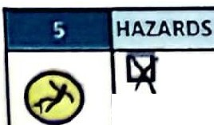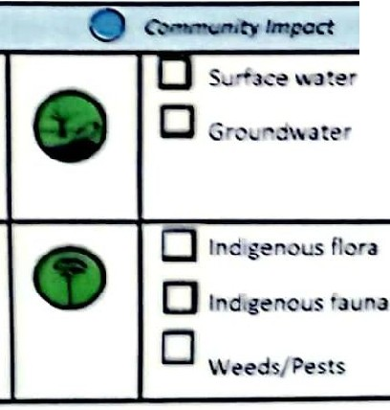

(Pl ease Tick)

Key: Q

***Health*** *&* ***Safety Ha z a rd***

**4'** Ehviron ntol *lmpoct*

u ...\\ Jte r

###### 

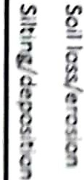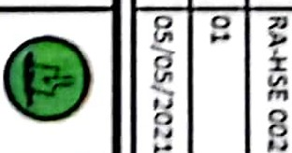

,

.,I

@

*V ,*

□CJ □

,,,,'

,. *'*,*l*,*.*

!

,,

*(*

,,j

,,

...,..

!

,',I,

"

-

,,

.;I-

f,,

* *_J*

***f***

*li*

I\

._

**0***er* ,

**V)**

*'$*

,-,:

*tl'*

.

II.I

®

,*r*..,*t*.

-<

r

::,

).>

□□ □

[

§

**'1.1** [

-

,.

f

,:.r,

*(>*

-r;

*r*

*7*

,. a

,".,

-

<

._

-·

**VI**

**V,**

,.,

::,

! *7*

...

3

Q.

";i- ,:;;

-

**V,**

3

).>

*t*

,..

ii

*'i5*

*::,*

*rs*

,:;;

3

r

"*::*'*,*

G)

,. :

**g**-n

**ogp**,**a**.,

C,

*::,*

***V,***

g

Q.

,.

,., ,.,

0 z

.,

< i

*i1*

z

.0,

0;;.

.*-:*,*:r*

g-

8

*::,*

:;

"o''

.*::*,*,*

er

□□□

u

J

.i!,

I

[Powered by **CamScanner**](https://v3.camscanner.com/user/download)

**D r..1" t,n. n, ht•._.:.ttt**

11.-;ilth., S11lct v & I nvh onmr n, t, t M.rn i;.i•mr nt Sv trm

##### Job Safety Analysis (JSA)

**\l'INS 11, 1,) l( y: lln11tll** II **tuJ rr *1111,nrd***

l\l.rn l\l r h11, .. 1n1, .. f., c

@

0.-• N.-, · rA 1,•1r OOJ

· 01

***U& v N n***

**!11"1 \l {'l;, 1.s,**

**lnw1onntf'n!t1I ln1r11<1**

**I**  -***J,AJ*** 1111;11

11ol< c l<'v, I

u< t

[**Cl)**](https://v3.camscanner.com/user/download)

[**C:**](https://v3.camscanner.com/user/download)

[**C:**](https://v3.camscanner.com/user/download)

[**ruo**](https://v3.camscanner.com/user/download)

[**V')**](https://v3.camscanner.com/user/download)

### [E](https://v3.camscanner.com/user/download)

[**uro**](https://v3.camscanner.com/user/download)

[..>c­](https://v3.camscanner.com/user/download)

["O](https://v3.camscanner.com/user/download)

@ □ , ''.n'-

**D ."t J S *r*** c( --.."'

G **D , A :,-- · t ' "'..t l *f" "t" S***

**0** N011•Cc111 pllJ n t m.,chl nr s /

\.- 0 !' <'1,ll(lrS

r,,,.,cl c:t>11d1t h.ms

□

R<'lll,>t!' W".'2rl.

@

**0** Lc-nc \\u rl.

Ce 11 t ,rnt n o l,

**0** Nc1 hlmw ro m pl.1l11ts

**0** Co1111mrr11ty riat

□,L. bour un st

**nl/1ro nm" "' ,1I nor, ,.** [Q)](https://v3.camscanner.com/user/download)

a[0](https://v3.camscanner.com/user/download)..

, l d "' • '

**D** Rr ourn , **"'J lt t'**

***· ttt*** u**/!<trt** <'/ **111.u.. *lltfe,*** It!***gmup pmcrdu s Jot* !pf'ffflc *rrqul tMnts}***

:-..:.. 9 0 **..... .r** I\' **E..;..·;;.-: · ""t**

@) **C** Cenfin ,•d Spncc E:11,t r,

**C** Li.; ht Vahrcle Opc rJ tlo n

@ **C** Wc r, rr a. •t H i " ts

.

<

I \

\\...

**n .. t:,**

*\*\:.:*-:*

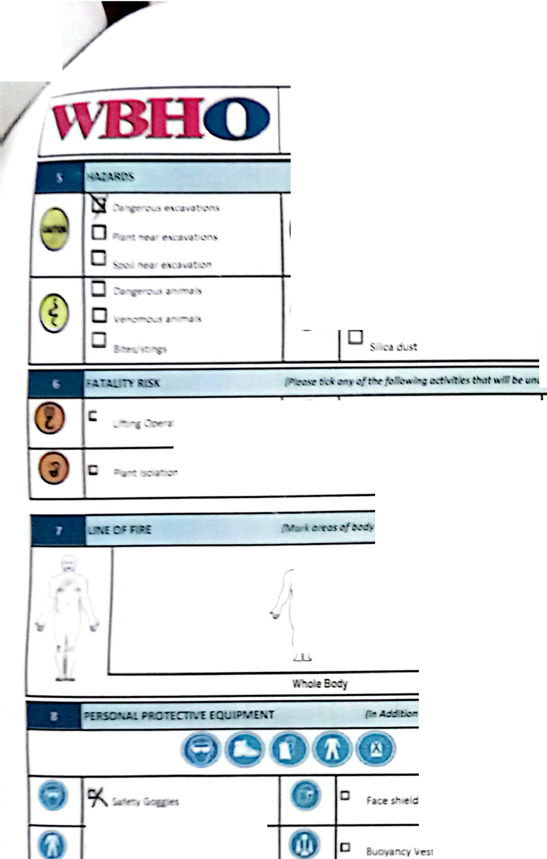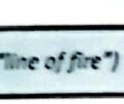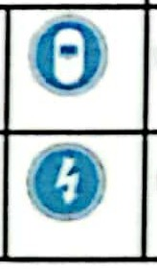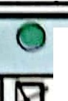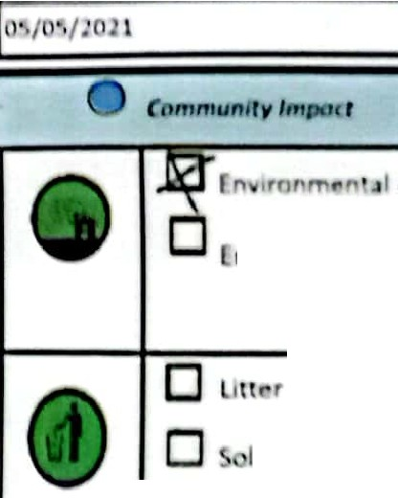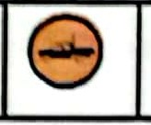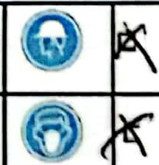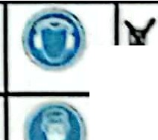

(?')

**C**

**C** -:.

,. _- .- .

*~-,;!::tary PPE pf- tidr rNlUiTC'd PPEJ*

**0(** l\:a datcry PPE

**C** We lding Shie ld

□ High Volt age Equi p ment

Hard Hat I **\\..W,,J' *V'\.*** f-,t,J nn11 Protect ron

Dust l\ l ask **I V '** □ R sp,ra tor

u FJII Arr est 10 **C** Otht> r:

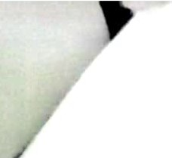**V/M3101 1**

Health, Safety & Environmental Management System Doc No.: RA -HSE 002 Rev No.: 01

Job Safety Analysis {JSA}

Rev Date: 05/05/2021

[C:](https://v3.camscanner.com/user/download)

[cuo](https://v3.camscanner.com/user/download)

[V)](https://v3.camscanner.com/user/download)

[E](https://v3.camscanner.com/user/download)

[uco](https://v3.camscanner.com/user/download)

[*.D*>­](https://v3.camscanner.com/user/download)

["O](https://v3.camscanner.com/user/download)

[Q)](https://v3.camscanner.com/user/download)

['--](https://v3.camscanner.com/user/download)

[Q)](https://v3.camscanner.com/user/download)

- \\' ORKSHffi

-- .•

Activity

*Worksheet No.:*

. Hazard - Planned Cont rols ..

l *of*

•· · : • Risk Assessmen t ... .,• . -

..

. . - - .

[a*0*..](https://v3.camscanner.com/user/download)

## ,o

\Wt,1t usk are you performing ?)

*j) ,, II L ._'-* c+ *I I'\ A'i '* -

,/J u

(What ct-uld cause harm?)

#### \ rl

(How doyou prevent harm?)

*W P.a i, oJw*

. .

. ProbablHty · ·. •

--

Severity/

Loss ;

.

- : 'I..:,

.:· Risk

.. -.

...

*...)*

\

NotJe *Cf*

*Yfl+=.* / ) V

*'-..)*

I I I

I

*I*

I

*I I*

*I I*

*{ I*

*I I* I

*I I*

*I* 7 j



Healt h, Salety &. Environ mental Management System Doc No.: RA-HSE 002

[(uQ](https://v3.camscanner.com/user/download)

[V)](https://v3.camscanner.com/user/download)

[E](https://v3.camscanner.com/user/download)

[u(Q](https://v3.camscanner.com/user/download)

**,JBHO \**

,\'OltlCSH EET CH NGE \IJ\ N GE\11\EN'T - CO\11\P\ltsOR't F'IER l\lNCH S'TOP &. ASSESSMEN'T

*Worl<sheet No.:*

t\iv\\y

I

\

Hazard

'

-

Planned Controls

It

I , ·. ··· *·:* . . "'-'',*·:, ;-,ii* **Risk Assessment *r-.,i.;***

i" _.,. ,

-

*1*

*of*

I

L

\

\

- -

(How do you prevent harm?}

-

-

* **Severity/ ·**

**loss**

- lJC

(Wl\a\ \is\,.are you performing?)

\What could cause harm?}

**Probability**

-

*_•r_.* , *r* .,'!l ·•. _ . .

' Rbit'· t'·;• ·"'

-

I

I

* , ".,,:, :'..""e c·e 'c" t e n sk mat rix, hierarchy of controls and risk accep -&critena

lob Safet'y Ana\vsis USA)

Rev No.: Rev Date:

01

05/ 05/2021

[.c>­](https://v3.camscanner.com/user/download)

["O](https://v3.camscanner.com/user/download)

[Q)](https://v3.camscanner.com/user/download)

[I,_](https://v3.camscanner.com/user/download)

[Q)](https://v3.camscanner.com/user/download)

[$'.](https://v3.camscanner.com/user/download)

[a*0*..](https://v3.camscanner.com/user/download)

,

I AUnt ORISAll ON (Must be completed by Supervisor prior to Commencement of Work)

-

o .. Q a

o ..

o..

o..

□--

Co nt rols for fat a llty risks ha ve been verified

I

O •o

Ha za rd s have been adeq ua tely addressed by co nt rols

D o

Ha za rd s have bee n adequate ly iden tifie d

D o

The re has been adequate consultation

Q a

The correct JSA process has been fo\\owe d

Nam ·

Signature:

Date :

*tJv S1c,nlny 011 tu t lil sr 1 A*

*t lmvr ,*

*rm/ umJ ,m rl*

*o, om J 1l1r JS.A urul*

*so ll -..Jlr d Ou• thhs. u11• u -; low u 1; r,-u,r,uriol,ly 1J1mtlu1l,/t•)*

-

-

Date

*Timr*

MANAGEM ENT Of CHANGE / REVISION - This section Is compulsory after lunch or when changes occur *(As the JSA is amended enter summary details of the change}*

' I

_

J

Change

[**cCo:**](https://v3.camscanner.com/user/download)

[**u**](https://v3.camscanner.com/user/download)

[**V)**](https://v3.camscanner.com/user/download)

[**E**](https://v3.camscanner.com/user/download)

[**uco**](https://v3.camscanner.com/user/download)

[*.D*>­](https://v3.camscanner.com/user/download)

["O](https://v3.camscanner.com/user/download)

[Q)](https://v3.camscanner.com/user/download)

['--](https://v3.camscanner.com/user/download)

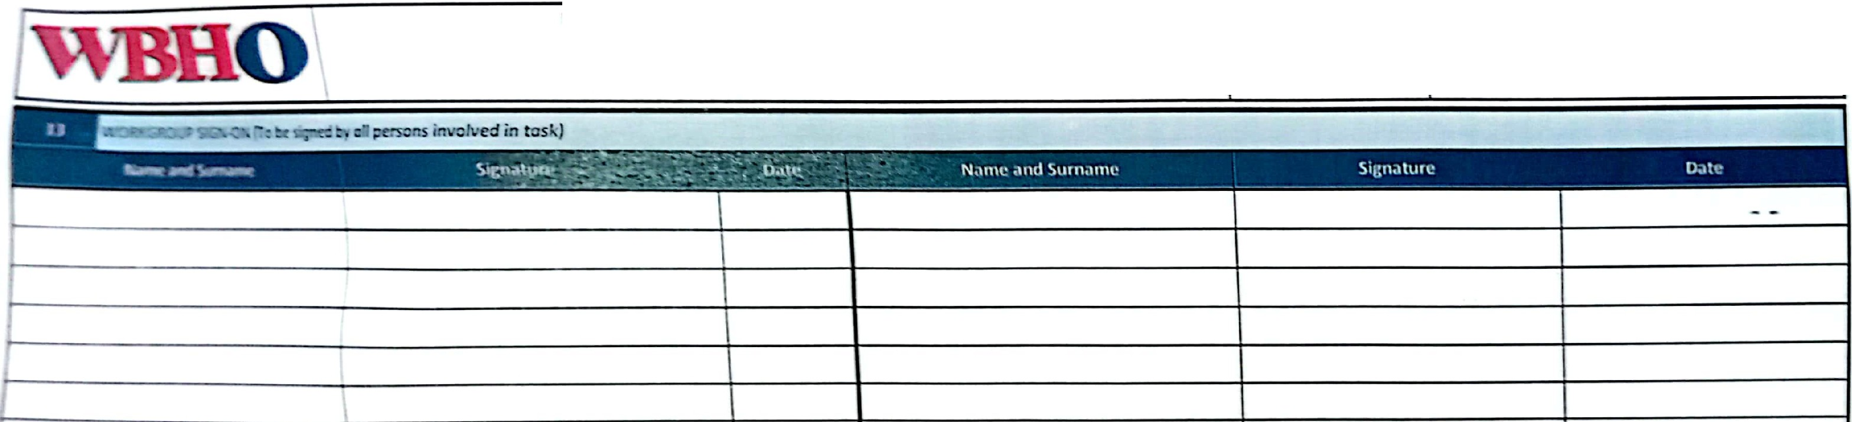

|  |  |  |
| --- | --- | --- |
| He alth , Safet y & Environmental Management System  **lob Safety Analysis llSA)** | Doc No.: | RA-HSE 002 |
| Rev No .: | 01 |
| **Rev Dat e:** | OS/ 05 /2 0 Jl |

[Q)](https://v3.camscanner.com/user/download)

[a*0*..](https://v3.camscanner.com/user/download)

[**u(Q**](https://v3.camscanner.com/user/download)

[**V)**](https://v3.camscanner.com/user/download)

[**E**](https://v3.camscanner.com/user/download)

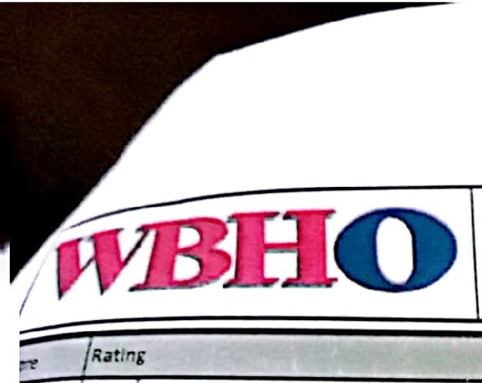[**u(Q**](https://v3.camscanner.com/user/download)

[**.**>**c**­](https://v3.camscanner.com/user/download)

|  |  |  |  |
| --- | --- | --- | --- |
| He alth, Saf e t y & Environ men tal Man age ment Syst em  **Job Safety Analysis {JSA)** |  | Doc No.: | RA-HSE 002 |
| Rev No.: | 01 |
| Re v Date : | 05/05/2021 |

["O](https://v3.camscanner.com/user/download)

[**Q)**](https://v3.camscanner.com/user/download)

[I,...](https://v3.camscanner.com/user/download)

[Q)](https://v3.camscanner.com/user/download)

[$'.](https://v3.camscanner.com/user/download)

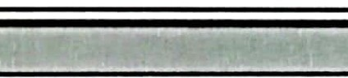 **J** [**a***0* **..**](https://v3.camscanner.com/user/download)

|  |  |  |
| --- | --- | --- |
|  | A= | The Job was earned out as planned wit ho ut ny i nc idents or near hits |
| B = ! | The Job was ca m ed out but res ulted in an accide nt that could have caused harm to peo ple, the envir onme nt o r the co mm unity |
| C = | \The 10b was earn ed out but re sult e d In an ·incident caus ing harm \o people, the e nvironm ent or the comm unity |
| :ould you do di ffe re ntl y ne• t Ume? | | |
|  | | |

!

**,TR I X**

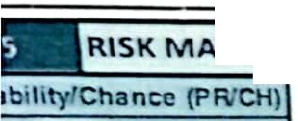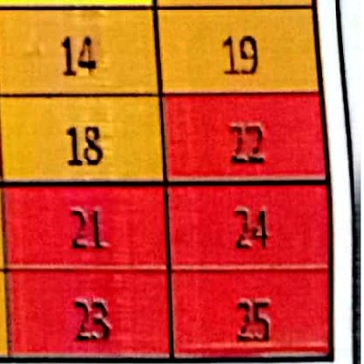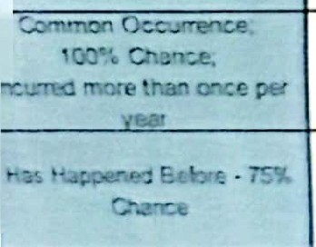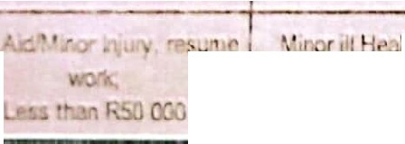

SEVERITY/CONSEQUENCE(SV/Con)

# I

I, ---- ,_ **Ri sk Rating**

**Lil<t!lihoocl**

I Score I

- - Safety Health Environmental Legal & Regulatory

**( o er**

**RISK** I

**Probability**

lrre-.ersible damage and/or Major breach of Iha Law; I Ir I

I I

**s** I Multiple Fataliti es/ Multiple Fatalities penmanent impact on considerable prosecution and

More than R2.5 Mil **en\Aronment** penalties

I **1** I **2** I **3** I **4** I **s**

Fatality/

Single Fatality,

Long term damageand/or Major legal iss ue;

**l l 1**

**RATING**

**4** I RSOO 000 to **R2** 5 M,I

I Occupatlonal 1njunes - unemployable widespread1mpac1on noncompliance ar,j breaches **5**

I en.i ronment ofl he Law

**1**

I **10** I **15**

**.t.- • 0 -;Jhll'\.'.: lr-;11;,**

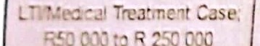

Pe1mancnt ,II heJlth defect: An Long tenm eco disturbance *Very* considerable penalties &

I -



###### 

**4**

**7**

**3** I c: *:* " :o ;;" G 0

/ occupal0l11al i1ln ss r.)QU1ring removal

and/or, s gnificanl impact on prosecutions. Multipel law **5 2**

m normal worl< dut,es en ronment suits & jail terms

Lest 1ime CJsc; An occupational illness Any justi fiable complaint. Serious breach of Law;

monitored b)• a medical practitioner. The Incident or spillage not inltls tigation/report to **5**

I

pcr.;on cJn continue 1111h his nomml contained, on site pollution, authority/prosecullon Jndior

**Severity** I **3**

**8** I **13**

,. I I

dc1y short term damage. moderate penalty possible

I - . th Case, Might Require Ecological stress and /or

*ri or* ,100119, E, posure of a health risk nuisance to enlironrnent. Lower le1el Legal Issue 1

n" l)Ort!'d

I **5** I

11 1 I

**12 17**

**16 20**