**Use case 13**

|  |
| --- |
| **Use case name:** Books Appointment |
| **Participant actors:** Patient |
| **Flow of events:**  1. Patient type URL adress of the LFH system to the browser.  2. Patient enter his/her TC and password and send LFH system an login request if the TC and password match with the TC and password which is stored in database, Patient authenticates.  3. Patient clicks ‘book appointment’ button to be navigated to the book appointment page.  4. LFH system provides available dates for specific doctor, departments and polyclinic in the books appointment page.  5. Patient select polyclinic, date, doctor and department to book an appointment.  6. Patient clicks ‘send for approval’ to get appointment. LFH system check the information which is provided by the patient. LFH system navigate patient to the confirmation page.  7. Patient checks his/her information which he/she selected in the book appointment page.  8. Patient confirm his/her information.  9. Patient get the appointment. |
| **Entry Condition:** Patient wants to get an appointment. |
| **Exit Condition:** Patient can’t authenticate with the LFH system. - OR - There is no available date for the Patient. |

**Use case 14**

|  |
| --- |
| **Use case name:** List Appointments |
| **Participant actors:** Patient |
| **Flow of events:**   1. Patient type URL adress of the LFH system to the browser. 2. Patient enter his/her TC and password and send LFH system an login request if the TC and password match with the TC and password which is stored in database, Patient authenticates. 3. Patient clicks ‘list appointments’. 4. LFH system navigate Patient to the list appointment page. 5. Patient select his/her appointment. 6. LFH system navigate Patient to the appointment information page. 7. Patient check his appointment information. |
| **Entry Condition:** Patient wants to list his/her appointment information. |
| **Exit Condition:** Patient can’t authenticate with the LFH system. - OR - There is no current appointment in Patient-dashboard. |

**Use case 15**

|  |
| --- |
| **Use case name:** Edit the Appointment |
| **Participant actors:** Patient |
| **Flow of events:**  1. Patient type URL adress of the LFH system to the browser.  2. Patient enter his/her TC and password and send LFH system an login request if the TC and password match with the TC and password which is stored in database, Patient authenticates.  3. Patient clicks ‘book appointment’ button to be navigated to the book appointment page.  4. LFH system provides available dates for specific doctor, departments and polyclinic in the books appointment page.  5. Patient select polyclinic, date, doctor and department to book an appointment.  6. Patient clicks ‘send for approval’ to get appointment. LFH system check the information which is provided by the patient. LFH system navigate patient to the confirmation page.  7. Patient checks his/her information which he/she selected in the book appointment page.  8. Patient clicks the edit the appointment.  9. Patient is navigated to the page ‘book appointment’.  10. Patient fill the wrong filled boxes again.  11. Patient clicks ‘send for approval’ to get appointment.  12. LFH system check the information which is provided by the patient. LFH system navigate patient to the confirmation page.  13. Patient confirm his information. |
| **Entry Condition:** Patient wants to edit his appointment before he/she get it. |
| **Exit Condition:** Patient can’t authenticate with the LFH system. |

**Use case 16**

|  |
| --- |
| **Use case name:** Cancel an Appointment |
| **Participant actors:** Patient |
| **Flow of events:**   1. Patient type URL adress of the LFH system to the browser. 2. Patient enter his/her TC and password and send LFH system an login request if the TC and password match with the TC and password which is stored in database, Patient authenticates. 3. Patient clicks list appointment. 4. LFH system navigate Patient to the list appointment page. 5. Patient select his/her appointment which he/she want to make a difference on it. 6. LFH system navigate Patient to the appointment information page. 7. Patient selects the ‘cancel the appointment’ section. 8. Patient cancels the appointment. 9. LFH system automatically navigate Patient to the patient-dashboard page. |
| **Entry Condition:** Patient wants to get an appointment. |
| **Exit Condition:** Patient can’t authenticate with the LFH system. - OR - There is no current appointment in Patient-dashboard. |

**Use case 17**

|  |
| --- |
| **Use case name:** Login for Patient |
| **Participant actors:** Patient |
| **Flow of events:**   1. Patient type URL adress of the LFH system to the browser. 2. Patient clicks login section. 3. Patient is navigated to the login page by LFH system. 4. Patient fills the TC and Password fields. 5. Patient clicks to the login button. 6. By clicking login button Patient sends a login request to the LFH system. 7. LFH system checks the TC and Password with the data which is stored while the Patient registered if the information match patient authenticates. |
| **Entry Condition:** Patient wants to login to the system. |
| **Exit Condition:** Patient is not registered. - OR – Patient forgot his account details. |

**Use case 18**

|  |
| --- |
| **Use case name:** Mark an Appointment |
| **Participant actors:** Patient |
| **Flow of events:**  1. Main page that includes a patient login button, patient login button and register button opens.  2. User(patient) enter password and TC number to login the system.  3. User clicks the patient login button.  4. The patient is logged in the system.  5. The patient(user) clicks the view an appointment button to display the appointment system previously recorded by staff.  6. When user click the button,new page open that include appointments.  7. Patient follow his/her all appointments from this page.  8. If patient come to his/her appointment,system mark an this appointment.  9. When all appointment finished,user log off. |
| **Entry Condition:** *User login the system.  *User must click the view an appointment button.  *User(patient) wants to view an appointments. |
| **Exit Condition:** *Users can not login.  * If there is no registered appointment on the System  * There isn’t any patient come to hospital for their appointments. |
| **Quality Requirements:** 2* If User enter password incorrect,system displays “your password is incorrect”.  5*System displays “you have not an appointment for today”message if there is no registered appointment on the system . |

**Use case 19**

|  |
| --- |
| **Use case name:** Password Reminder |
| **Participant actors:** Patient |
| **Flow of events:**   1. User starts browser and types URL of the LFH. 2. Main page that includes a patient login button and register button opens. 3. User clicks the patient login button. 4. User(patient) enter incorrect password or forget his/her password. 5. If still unable to login to the system,user clicks password reminder button. 6. System open new page to password reminder. 7. Then,user enter e mail address in the releated part on this page. 8. System send his/her password to e-mail adrees that entered by user. 9. Finally he/she log off |
| **Entry Condition:** *User want to login on this system and he/she can not remember his/her password.  *To view an appointment.  *To follow his/her appointment |
| **Exit Condition:** * Users received an e-mail that include password or give up to login the system. |
| **Quality Requirements:** 4**\***System displays a “incorrect password” message if user enter incorrect password.  5*User can try enter password one or more time. |

**Use case 21**

|  |
| --- |
| **Use case name:** Forget password |
| **Participant actors:** Patient, OR Personel, |
| **Flow of events:**   1. When user authenticate he/she forget the password. 2. He/she click Password reminder button. 3. User enters his/her TC number. 4. LFH checks if the TC number on database and send a mail which have a new password to user’s mail. 5. User check his/her mail. 6. Users can login with password which received by e-mail. |
| **Entry Condition:** User forgot password. |
| **Exit Condition:** User can not access e-mail. |

**Use case 22**

|  |
| --- |
| **Use case name:** Register |
| **Participant actors:** Patient |
| **Flow of events:**   1. User starts browser and types URL of the LFH system 2. User click patients button. 3. User click register button. 4. User fill blank his/her Personal information. 5. User create a new password on password field. |
| **Entry Condition:** Users want to get an appointment and visits the LFH Home Page and choose patients |
| **Exit Condition:** TC number which entered user and TC number which registered on database is not matching. |

**Diagram**

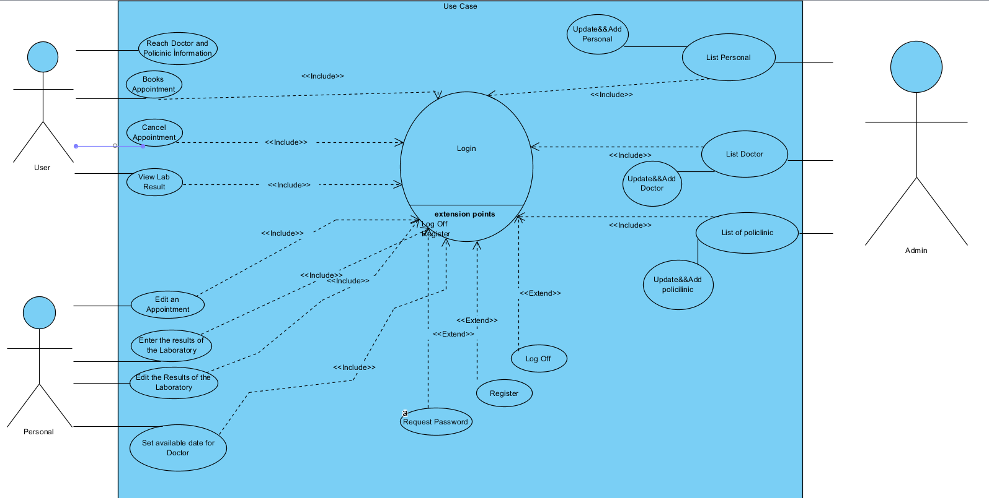

### Object model