<Online Hospital System>

System Design Document

<0.1>

<Date>

<Selin Atalay

Hasan Cihan Akpınar

Murat Akalın

Tolga Şıvgın>

Prepared for

SE301 Software Engineering



Table of Contents

1. Introduction 1

1.1. Purpose of the System 1

1.2. Design Goals 1

1.3. Definitions, Acronyms, and Abbreviations 1

1.4. References 1

2. Current Software Architecture 1

3. Proposed Software Architecture 1

3.1. Overview 1

3.2. System Decomposition 1

3.3. Hardware Software Mapping 2

3.4. Persistent Data Management 2

3.5. Access Control and Security 2

3.6. Global Software Control 2

3.7. Boundary Conditions 2

4. Subsystem Services 2

5. References 2

**Personnel management subsystem**

This subsystem is managing personnel actor’s function, offers personnel side to its functions after authenticate. The sub-system that manages the Access of employees can arrange the appointment of patient, enter a patient’s laboratory results, organize laboratory results, and Schedule doctors’ working times.

**The operations provided by this subsystem are:-**

* Edit an Appointment ()
* Enter the results of the Laboratory ().
* Edit the Results of the Laboratory ()
* Set available date for Doctor ()

**Database subsystem**

This subsystem will be implemented by relational database management system used to store the persistent data. All subsystems are related and having service with this subsystem

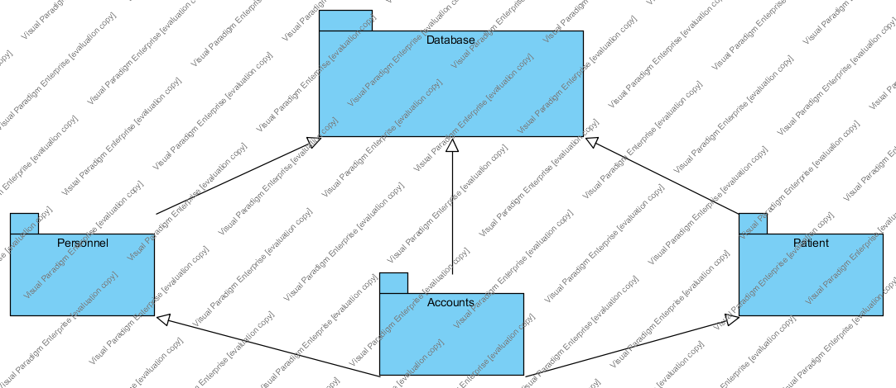

## 3.3.Hardware Software Mapping

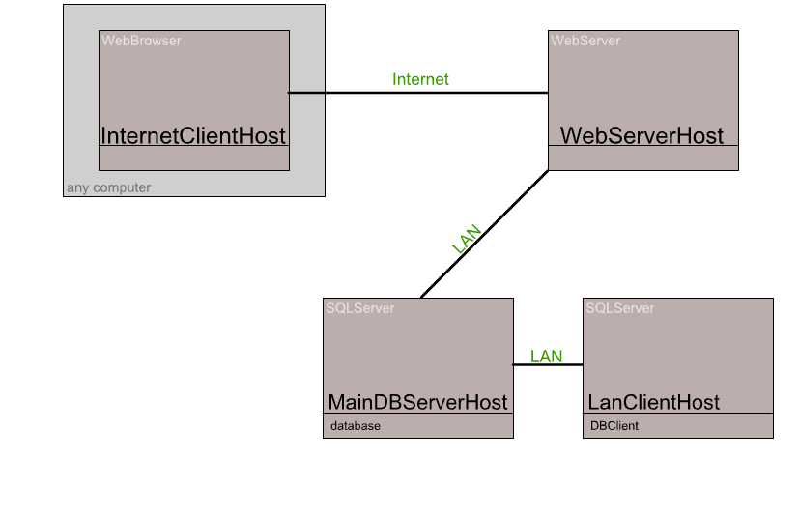

## 3.4.Persistent Data Management

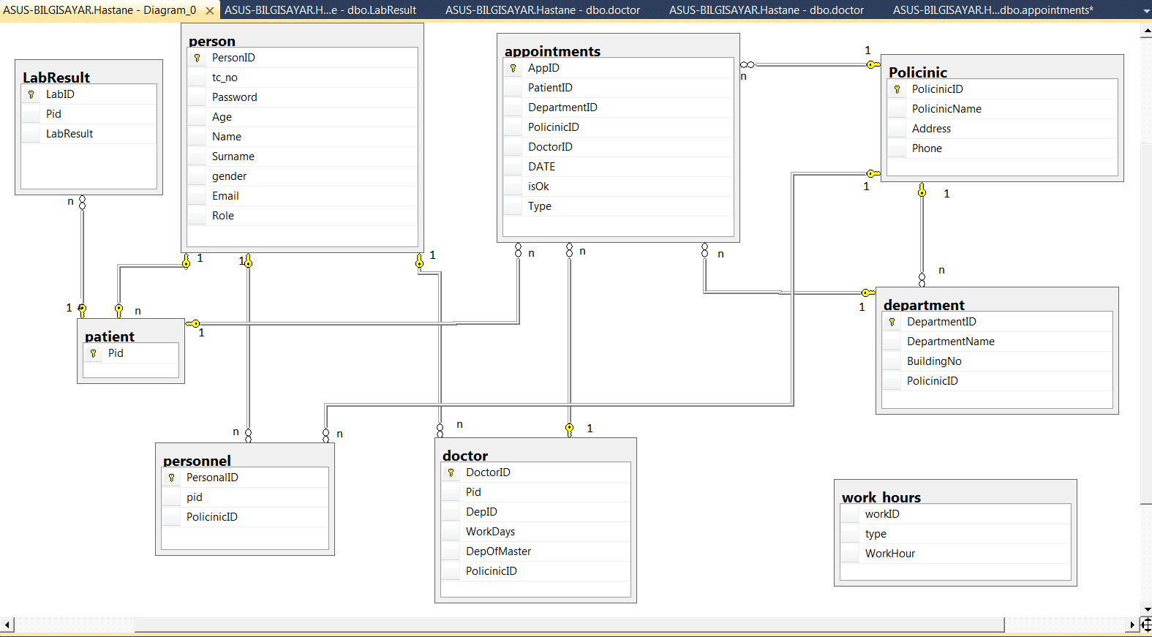

**3.5 ACCESS CONTROL AND SECURITY**

The application is a multiuser application so it consists of 3 types of users which are patient, personal and administrator. Because of this, the application will provide different interfaces for each user type.

First, administrator will login to the system with the belonging interface, and do admin's own duties about the system such as adding, updating, editing, deleting etc. By the way, registration is not needed for the administrator via the system's website, because administrator's information will be entered to the database manually in the beginning of the system and administrator is the authority who will access database directly. The registration process of personnel which is another type of user will be done by administrator too. Personal is responsible with the registration of doctors. As a summary, administrator does not need to register, because he/she is initially registered to the database and system. Administrator makes the registration of personals, and personals make the registration of doctors. Every registration process included personnel registration done by administrator, will be done with system user interfaces. The system will save all information to the database and in login processes again the system will use them by fetching data from database. The information from database will be used both confirmation and system usage for users. All of the user types have to login to the system with their personal id as username and password.

After these steps, the system will be ready for patient appointment. Normal users such as patients will register to the application, and system will add a new user to the database. Then, patients will login to the system with their information such as patient number and password. During login procedure, data from the user database table will be fetched and compared with the data entered by the user. Since this operation requires a read-only access to the database, it can be performed from different points of access simultaneously.

During registration, the filling of the fields requires no database access, whereas finalizing the process requires data to be written to the database which requires read-write access to the database. In that case, necessary fields of the database will be blocked and simultaneous access from multiple users will be denied.

For some situation like updating or deleting information requires updating one of the tables in the database in its finalization phase and therefore must be handled with greater care since multiple users may be cause to update the table at the same time. This will also be prevented by blocking.

Finally, viewing of the information or lists requires again a read-only access to the database. Therefore, multiple user access imposes no problems and new restrictions.

Lastly, the usernames and passwords for users will be stored in user table. No one else accept administrator can access this information.