**II) Personnel mode**

* **Authentication;**

Personnel part is like Admin Authenticationand Patient Authentication. In this authentication , personnel can login on system with TC number and password. Password is given by the Admin.

* **Edit appointment information;**

Personnel update information which must be change, on saved program by personnel.

* **Enter Lab Resut;**

Personnel record all Lab Result in system. Personnel do enter Patient information and enter Lab Result of Patient.

* **Edit Lab Result information;**

Personnel update information which must be change, on saved program by personnel.

* **Log Off;**

Personnel exit the system when they finished the operations on the system.

* **Set Available Date for Doctor ;**

First of all personnel choose hospital which he/she is work there. Then enter information (department, doctor, date and hour) which are contained monthly work program. Monthly program is given to him/her by doctors.

**III) Admin mode**

* **Authentication;**

Admin part on home page, admin can login on system with TC number and password.

* **List the Upcoming Doctor**

Admin sees doctor who working on the hospital.

* **Add Doctor;**

Admin updates which is necessary such as a doctor come to work the hospital.

* **Delete Doctor;**

Admin update which is necessary such as a doctor arrive the hospital.

* **Edit Doctor;**

Admin update doctor information such entered wrong information of doctor.

* **List the Personal**

Admin sees all personal.

* **Add Personal;**

Admin updates which is necessary such as a new personal come to work the hospital.

* **Delete Personal;**

Admin update which is necessary such as a personal arrive the hospital.

* **Edit Personal;**

Admin update personal information such entered wrong information of personal.

* **List the Policlinic;**

Admin sees all policlinic

* **Add Policlinic;**

Admin can add new policlinic this policlinic can be made new

* **Delete Policlinic;**

Admin any policlinic can be shed such policlinic has been demolished

* **Edit Policlinic;**

Admin update policlinic information such entered wrong information of policlinic.

* **Log Off;**

Doctors exit the system when they finished their operations on the system.

## 3.2.System Decomposition

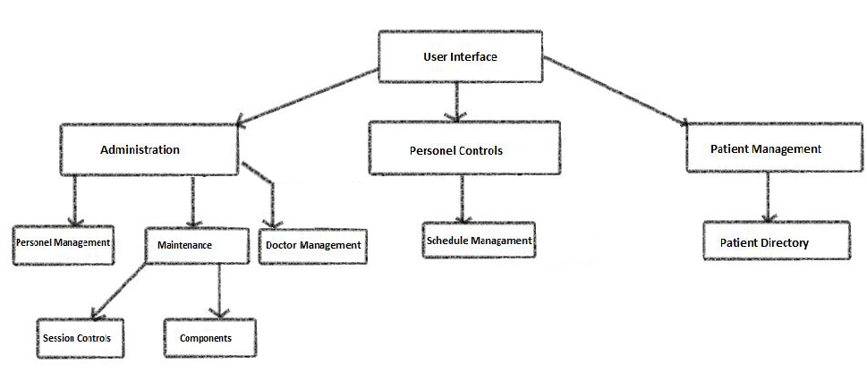

The decomposition shows the existence of the following subsystems:

* Account management subsystem
* Patient management subsystem
* Personel management subsystem
* Database subsystem

**Account management subsystem**

This subsystem managing user accounts. It offers perform for creating an account, and close an account. Admin is the only Show list personnel, policinic, add doctor. Create and update functions are accessed by admin and personnel. This subsystem uses login services of the patient management and personnel management subsystems.

**The operations provided by this subsystem are:-**

* Login ()
* Change password ().
* Create account ()
* Update account ()
* Close account ()

**Patient management subsystem**

This subsystem is managing patient actor’s function, offers patient side to its functions after authenticate. Managing patient access to make an appointment, see an appointment, cancel an appointment. Laboratory results are accessible after viewing and viewing functions, entering staff information.

**The operations provided by this subsystem are:-**

* Books Appointment ()
* Cancel Appointment ().
* View Lab Result ()