**Android App Proposal**

**DPS924**

**Oct 12th 2016**

**Sallie Jiang**

**Business Statement**

FoodHax is an app based on the growing trend of healthy living and more specifically, macro tracking. Macro tracking is based off keeping track of what you eat and how they contribute to your overall nutrition. The app’s main focus is to help everyday people track their macronutrients (protein, carbs and fats). There are already a number of different apps that do this through user input. However, the twist is that FoodHax will also allow users to input entire recipes instead of only ingredients. The difference between saying you ate 100g of chicken and 100g of iceberg lettuce and simply one serving of Caesar salad. It will also allow users to search recipes and create their own recipes and save them for repeated easy tracking.

**Similar Apps**

Macro Tracking

<https://play.google.com/store/apps/details?id=com.johnugwuadi.simplemacro>

<https://play.google.com/store/apps/details?id=com.ontheregimen.otrmacros>

Recipes Finder

<https://play.google.com/store/apps/details?id=com.mufumbo.android.recipe.search>

<https://play.google.com/store/apps/details?id=dk.boggie.madplan.android>

**What’s Different?**

Essentially what makes this app unique from the ones shown above is that it integrates the main functions of both a macro tracker and a recipe finder app. Generally when we cook there is a recipe, either in our minds or a new one we find. It seems second nature to input recipes into a macro tracker rather than specific foods such as “chicken (white meat) 100g” or “spinach (raw) 100g”.

**End-user Needs and Business Values**

Typical end-users of macro tracker apps generally use the app for a short period of time because it becomes tedious. The goal of my app is to be easier to use than other apps by having a clear and concise display as well as an efficient inputting system. Users will be able to input through traditional ways of individual ingredients, as well as, entire meals based on recipe.

I believe that macro tracking and recipe finding go hand in hand. FoodHax has potential business values because users will be attracted to how convenient it is to use. There are also opportunities for revenue generation through product placement in certain recipes. The app could be used to promote certain products such as nutrition bars or workout supplements.

**Use-Cases**

Track macros - All use cases related to macro tracking

* + Switching views
    - Users can toggle between seeing visual representation or detailed view of their daily or weekly macros on the home page of app
    - Can review their food journal, weekly and daily views
  + Adding a specific food item to food journal
    - Users will be taken to item search page where they can select an item
    - Once the item is selected they are asked to input quantity
  + Adding a recipe to food journal
    - Users will be taken to a recipe search page where they can search for a recipe
    - Displays a list of recent recipes used and favorites for ease of selection
    - Once recipe is selected they are asked to input quantity (portions based on recipe)

Recipes – All use cases related to recipes

* + Create recipe
    - User is asked to name the recipe
    - Enter all ingredients
    - Enter all steps, including time taken in each step (optional)
    - Once confirmed, this is saved to the users phone (can be accessed when adding foods for daily intake)
  + Search recipes
    - User can search recipe based on name, ingredient and related keywords
    - Will display all matches in a list view format
    - Can expand to detailed view when selected and can be favorited for ease of use later

**System Diagram**

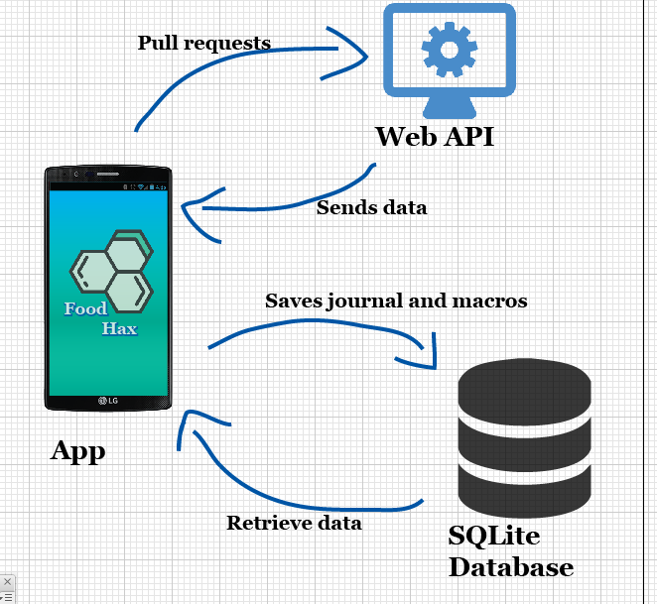

**Wireframes**

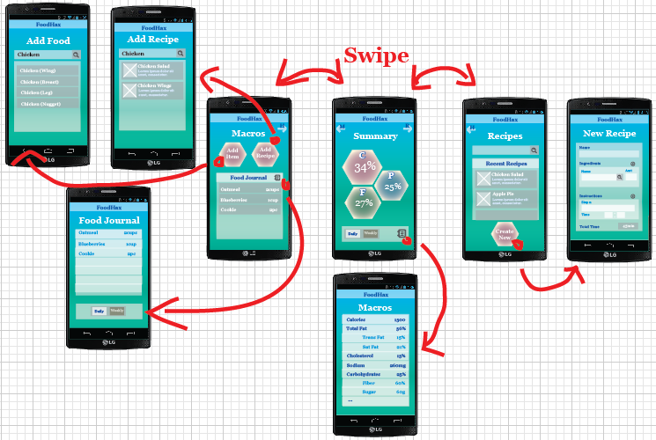

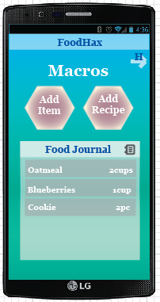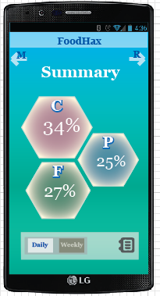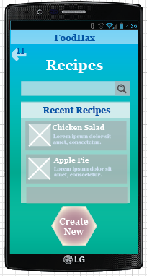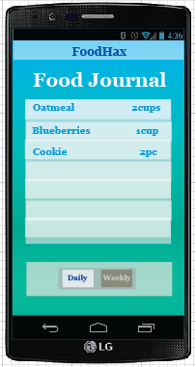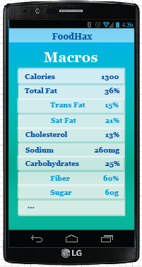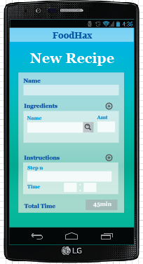 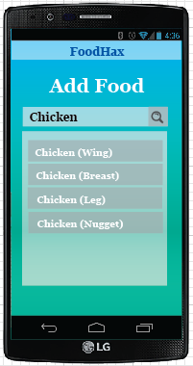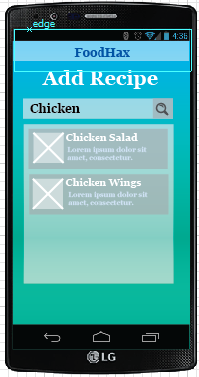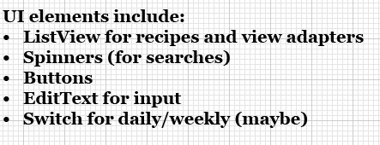

**Error Handling and Data Validation**

The user will be enter data when entering items/recipes into the food journal and when they are creating new recipes. The amount of food/portion will be an integer value which will be validated based on the unit of measurement (varies with food types). There will be validation done for duplication of recipe names. Most likely an alert dialog box type of prompt will be used to notify the user.

The nutritional facts generated for user created recipes are not 100% accurate. If there is a problem with the data, the user will be notified and prompted to enter nutritional facts as a back-up plan.

**Core Features**

* Macro tracking
  + General overview (visual representation of macros on home screen, daily/weekly)
  + Detailed values (daily/weekly)
* Food journal
  + Save food journal entries daily
  + Add specific food items/portions based on recipes
* Search recipes
  + Search by name, ingredient and related keywords
  + Save recipes as favorites/recent
* Create recipes
  + Automatically generate nutrition information based on API data
  + Save recipes

**Additional Features**

* Allow for alternative ingredients in recipes
  + recalculate nutrition values automatically
* Interactive display of macros summary page
  + the hexagons will change size based on macro percentages
* Sugar, vitamins and calorie tracking
  + add hexagons to the summary page, based on user preference
* Personalization of the app
  + include weekly goals and user profile

**Testing Plan**

First step is to create a simple mock up and work with the API. Once that is done I will organize the data into my own classes so I can transfer them onto the layout. Once this is done I will have a barebones version of my app and can let my friends who work in the Seneca gym and teammates try it out. I will also be testing the app by using it to track my diet for a couple of days. This will give me time to work on the appearance of the app while I gather information about what bugs to fix.

**Feedback**

User 1

The app seems to be simpler to use than current apps. Really liked the swipe feature to move from screen to screen. It would be good to have more personalized features such as a separate page for input personal goals and information. (Conclusion: could be an additional feature, personalization)

User 2

The home page display is good but the details button and swiping features are not intuitive, so you have to show user how to use these. (Conclusion: find a way to make UI clearer, and easier for users to understand, more descriptive button symbols. Additional feature, tutorial. )

User 3

The app is made for people that are health conscious, maybe add a feature to remind them to use it in the first place. It’s good to have the journal so that you can look back on what you ate in the past. (Conclusion: add a journal page, so users could not only review macros but also their intake)