Manual Morse Key LA4ZCA

## DESCRIPTION

This is a compact 3D-printed manual Morse key. The design offers precise movement with adjustable force and travel, in a very simple 3D-printed design. Compact and lightweight, the key is suitable for portable use. There is a choice of different knob shape options (according to parameter "knobtype" in the code). The default type is the most mature design. The key design is parametric so that dimensions can be varied to suit different tastes. It is also easy to adjust the code to accommodate printer tolerances, or different screw dimensions.

Spring force is adjusted by moving the spring closer or further away from the hinge. Stroke length is adjusted by the end stop screw accessible from the top. The key needs attachment to a steady surface for good ergonomy. Holes for attachment screws are provided. Alternatively, an adhesive can be used: "Blu-tack" putty works well and is removable.

## ASSEMBLY

Materials:

* two printed parts, base and arm
* five M3 screws, 1x 16 to 18mm, 2x 8 to 10mm and 2x 5mm length
* cable, 3-4 mm in diameter, with plug as needed

First, prepare the 3D-printed parts by removing support material under the arm and in the ends of the cable holes. Also remove any protuding edges and bumps by gently filing the surfaces. In particular, ensure that the arm has a loose fit between the side walls of the base, and that the oversized hole in the middle of the arm, for the end stop screw, is fully open.

Enter the 5mm screws as contact pads in the base and underneath the knob of the arm, as shown in the picture below. Do not screw all the way in yet, but leave room for clamping wires underneath the screw heads. Also mount the arm onto the base with two 8 to 10 mm screws as hinges.The screw holes should be tight enough that the screws self-thread into the plastic wall. Some tuning of the dimensions may be needed, depending on the 3D printer. Some force may be needed to enter screws into their holes.

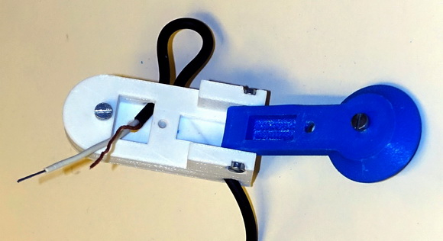

The cable is routed through holes in the base forming a 90-degree bend, which acts as a strain relief: First, route the cable into the well underneath the knob by making a loose bend outside the "window" in the side wall, as shown in the picture above. Then compress the bend and pull out excess cable to make a sharp bend inside the base. From the wire well under the arm, route the two conductors to the top and bottom contact screws on the base and the arm. Clamp the bare wire ends under their respective screws.

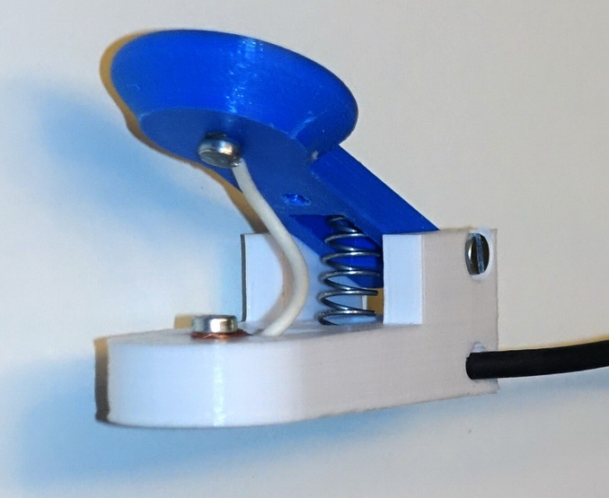

Prepare a spring with a diameter that nearly fills the slots in the arm and base. Put the spring in place in the slot underneath the arm. Make an initial adjustment of spring force by pulling the spring to permanently increase its length, and/or by cutting it. Set the length so that the force is approximately as desired when the spring is in the middle of the slot.

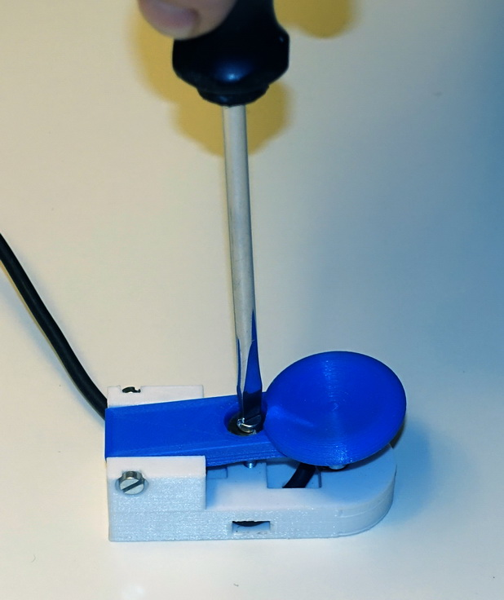

The key can now be mounted to a heavier piece of wood or metal to make it more sturdy, if desired. Use screws through the two holes in the base, underneath the hinge and in the bottom of the wire well.

Finally, enter the end stop screw from the top. For a firm end stop, first place an M4 washer in the bottom of the recess on the top of the arm, and glue it in place, then enter the screw. The arm should move freely without friction in the hinge, side walls or end stop screw.

73 de Torbjorn, LA4ZCA (tskauli@gmail.com)

